Module: Network Operating Systems and Services
Module code: ACCA5023
Assignment Title: Research, build, and deploy, a Virtualised network
Student Name: Maria Sanchez
Student ID: 2328383
Lecturer: Sadeque Imam Shaikh


Contents

Task 1 3
Research on Hypervisor 3
Research on IP Addressing 5
Research on Routing 7
Research on Network Services 9
Task 2 10
2.1 Hypervisor Selection and Justification 10
2.2 Download and Setup 11
2.2.1 Download the Hypervisor and Operating Systems 11
2.2.2 Network Deployment 15
2.3 Configure IP Addressing 17
2.4 Connectivity Testing 19
Outcome 1 – Successful connectivity within same networks 19
Outcome 2 – Unsuccessful connectivity between different networks 22
Task 3 23
3.1 Technical Reflection 23
3.2 Personal Reflection 24
References 25

Task 1

Research on Hypervisor

Virtualisation has become a fundamental component of modern enterprise IT because it enables multiple operating systems and services to run efficiently on shared hardware while maintaining isolation, flexibility, and efficient resource allocation. It also reduces hardware costs, improves resource utilisation, simplifies system management, and supports business continuity through virtual machine portability, backup, and recovery.
Hypervisors are classified into two types: Type 1 (bare-metal) and Type 2 (hosted). Type 1 hypervisors, such as Microsoft Hyper-V and VMware ESXi, run directly on the hardware, providing lower overhead, stronger isolation, and greater scalability, making them well suited to production environments. In contrast, Type 2 hypervisors run on a host operating system, resulting in slightly higher overhead but offering a practical solution for education, software testing, and small-scale deployments because they are easy to install and require no dedicated server infrastructure. [1]
The selected hypervisor must support both Windows and Linux operating systems because the proposed topology includes Windows Server 2019, Windows 10, Debian Server CLI, and Debian Desktop. Cross-platform compatibility simplifies administration, allows future expansion, and enables all required virtual machines to coexist within a single infrastructure.
The proposed NOSSLONDON2026 infrastructure consists of a Windows Server 2019 virtual machine, a Debian CLI server, and Windows and Debian clients. In the completed enterprise environment, the Windows Server is intended to host the BIRMINGHAM.ACCA Active Directory domain. Protecting the underlying hypervisor is therefore essential because a compromise could affect every hosted virtual machine and the availability of critical network services.
Considering the project requirements, Oracle VM VirtualBox is the most suitable virtualisation platform. Although Type 1 hypervisors such as Microsoft Hyper-V provide better performance, stronger isolation, and more advanced management features, these advantages offer limited practical value in a laboratory environment with only four virtual machines. Oracle VM VirtualBox supports all required operating systems, is freely available, requires minimal hardware resources, and is straightforward to configure, making it particularly suitable for educational environments and coursework projects.
If NOSSLONDON2026 were expanded to include services such as DNS, DHCP, Certificate Services, secondary domain controllers, or multiple branch offices, migrating to a Type 1 hypervisor would become a more appropriate long-term solution. Enterprise platforms such as Microsoft Hyper-V provide greater scalability, higher availability, stronger security, and more efficient resource management for business-critical workloads. Consequently, the choice of hypervisor should reflect the size, complexity, and operational requirements of the infrastructure rather than assuming that the most advanced platform is always the most appropriate solution.

Research on IP Addressing

Effective IP addressing is fundamental to enterprise networks because it enables reliable communication between devices across different network segments. A well-designed addressing scheme reduces broadcast traffic, simplifies administration, and supports future network growth. In the proposed NOSSLONDON2026 topology, the Birmingham (172.16.1.0/24) and London (172.16.2.0/24) LANs are connected through a dedicated 10.0.0.0/30 point-to-point network, maintaining logical separation while providing the physical connectivity required for communication once routing is configured. [3]
Data is transmitted in packets containing source and destination IP addresses. Routers use these addresses to forward traffic between networks, while switches use MAC addresses to deliver frames within a local network. Consequently, communication between the Birmingham and London LANs depends on accurate IP addressing and correct routing.
Although IPv4 fully satisfies the requirements of the proposed virtual environment, it offers limited long-term scalability. IPv6 overcomes this limitation by providing a significantly larger address space, improved auto-configuration, and better support for end-to-end connectivity. Therefore, while IPv4 is appropriate for this coursework, IPv6 should be considered if NOSSLONDON2026 expands into a larger enterprise or cloud-based infrastructure. [4][5]
The proposed addressing scheme uses three networks: the Birmingham LAN (172.16.1.0/24), the London LAN (172.16.2.0/24), and the 10.0.0.0/30 point-to-point link between the Windows Server and Debian Server. This design reduces broadcast traffic, simplifies management, and allows each site to operate independently. The /30 subnet is particularly suitable because it provides exactly two usable host addresses without wasting address space.

Figure 1. Proposed IP addressing scheme for the NOSSLONDON2026 virtual network.
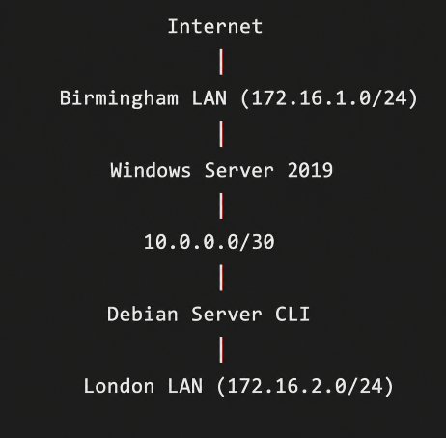

Separating devices into different subnets also improves security by limiting broadcast domains and enabling better traffic control. Although Coursework 1 uses static IP addressing for deployment and testing, enterprise networks generally rely on DHCP to automate address allocation and reduce configuration errors. In Coursework 2, DHCP will centralise IP address management across both LANs, with the Debian Server acting as a DHCP Relay to support clients on the remote subnet.
Overall, the proposed IP addressing scheme provides a simple, efficient, and scalable solution for the NOSSLONDON2026 infrastructure. It simplifies administration and provides a solid foundation for the routing, DHCP, and additional enterprise services introduced in Coursework 2.

Research on Routing

Routing is essential in enterprise networks because it enables communication between different IP subnets and ensures that data reaches its destination through the most appropriate path. Beyond forwarding packets, routing improves network reliability, scalability, and resource utilisation.
Routing protocols exchange routing information between routers, allowing routing tables to be created and updated so that the best path can be selected. Routers use metrics such as hop count, bandwidth, and cost to determine the preferred route.
Table 1 summarises the main differences between static and dynamic routing.
Static Routing | Dynamic Routing
Manual configuration | Automatic route learning
Requires manual updates | Adapts automatically to failures
Low resource usage | Higher CPU and bandwidth usage
High security | More routing traffic
Best for small, stable networks | Best for large and changing networks
No protocol required | Requires OSPF/RIP/EIGRP

As shown in Table 1, the choice between static and dynamic routing depends on the network's size, complexity, and expected growth of the network. [6]
The proposed NOSSLONDON2026 topology consists of the Birmingham (172.16.1.0/24) and London (172.16.2.0/24) LANs connected through a single 10.0.0.0/30 point-to-point network between the Windows Server and Debian Server. Since there is only one communication path between the two sites, the routing requirements are straightforward and predictable. Static routing is therefore the most appropriate choice, as the topology is stable and does not require automatic route discovery or alternative path selection.
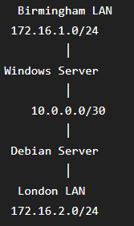
Figure 2. Simplified routing topology.

In the enhanced topology introduced in Coursework 2, the Debian Server will function as a DHCP Relay, forwarding client requests between network segments. This requires reliable routing so that DHCP requests and responses can cross subnet boundaries, allowing clients in both LANs to obtain IP configuration from the Windows Server.
For the current NOSSLONDON2026 network, static routing provides the best balance between simplicity, reliability, and ease of administration while ensuring effective communication between both sites. Although dynamic routing protocols such as OSPF can automatically adapt to topology changes, these capabilities are unnecessary in the current laboratory environment. However, if the organisation were to expand by adding additional branch offices or redundant links, OSPF would become a more appropriate solution because of its automatic route convergence, improved scalability, and greater fault tolerance. [7]

Research on Network Services

Modern enterprise networks depend on integrated services rather than isolated technologies. In the proposed NOSSLONDON2026 topology, VPN, DHCP, Active Directory Domain Services (AD DS), and Certificate Authorities (CAs) provide secure communication, centralised management, efficient resource allocation, and scalability. For an organisation operating across Birmingham and London, a VPN enables secure communication over public networks. However, its effectiveness depends on strong authentication and ongoing security management, making multi-factor authentication and regular certificate renewal essential. [9]
DHCP simplifies network administration by reducing manual configuration and addressing errors. In this topology, the Debian Server operates as a DHCP Relay, allowing the Windows Server to allocate IP addresses centrally without requiring a DHCP server on each subnet. [8]
Active Directory Domain Services provides centralised authentication and policy management for the BIRMINGHAM.ACCA domain, simplifying user and computer administration while ensuring consistent access control. Following the principle of least privilege, performing regular security audits, and protecting the domain controller are essential because a compromise could affect authentication across the entire domain. [10]
Certificate Authorities strengthen security by issuing digital certificates that verify the identity of users, devices, and services. This supports encrypted communication and mutual authentication while reducing the risk of impersonation attacks. Although implementing a CA increases administrative complexity, the security benefits generally outweigh this drawback. Protecting the root CA and automating certificate renewal are recognised best practices for maintaining a secure Public Key Infrastructure (PKI). [11]
Overall, integrating these network services provides a secure, manageable, and scalable infrastructure for the proposed NOSSLONDON2026 topology. Together, they support secure communication, automated network configuration, centralised identity management, and trusted authentication, providing a solid foundation for future organisational growth.

Task 2

2.1 Hypervisor Selection and Justification

Based on the research conducted in Task 1, Oracle VirtualBox was selected as the hypervisor for implementing the NOSSLONDON2026 virtual network. Although Type 1 hypervisors such as Microsoft Hyper-V offer superior performance and stronger isolation, these advantages are primarily intended for production environments with dedicated server hardware. As the proposed topology consists of only four virtual machines (Windows Server 2019, Debian Server CLI, Windows 10, and Debian Desktop), a Type 2 hypervisor is the more practical and resource-efficient choice. [2]
Oracle VirtualBox supports all operating systems required for this assessment while providing multiple virtual networks, snapshots, and flexible network adapters (NAT, Internal Network, and Host-Only). These features are essential for implementing the Birmingham and London topology and testing network connectivity throughout the practical tasks.
A further advantage is that the same virtual infrastructure will be used in Coursework 2. VirtualBox allows virtual machines to be modified, duplicated, and restored through snapshots, reducing configuration errors when deploying additional services such as Active Directory Domain Services, DHCP, DNS, VP N, and Certificate Services. This flexibility supports incremental network development without rebuilding the environment.
Oracle VirtualBox is also freely available from Oracle, actively maintained, and widely used in higher education for networking and system administration laboratories. Its compatibility with standard desktop hardware enables the complete enterprise topology to be deployed without enterprise-grade servers, making it well suited to both the coursework requirements and the available hardware.
For these reasons, Oracle VirtualBox is the most suitable hypervisor for the NOSSLONDON2026 project because it combines compatibility, flexibility, low hardware requirements, and ease of management while providing a scalable platform for both Coursework 1 and Coursework 2.

2.2 Download and Setup

2.2.1 Download the Hypervisor and Operating Systems

Figure 1 – Downloading Oracle VM VirtualBox from the official website.
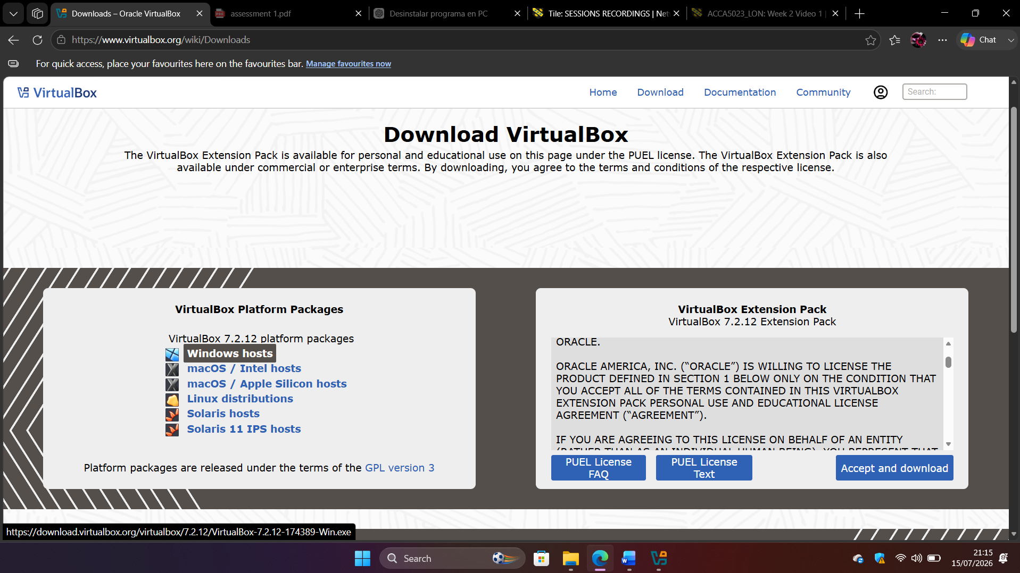

Figure 2 – Oracle VM VirtualBox successfully installed.
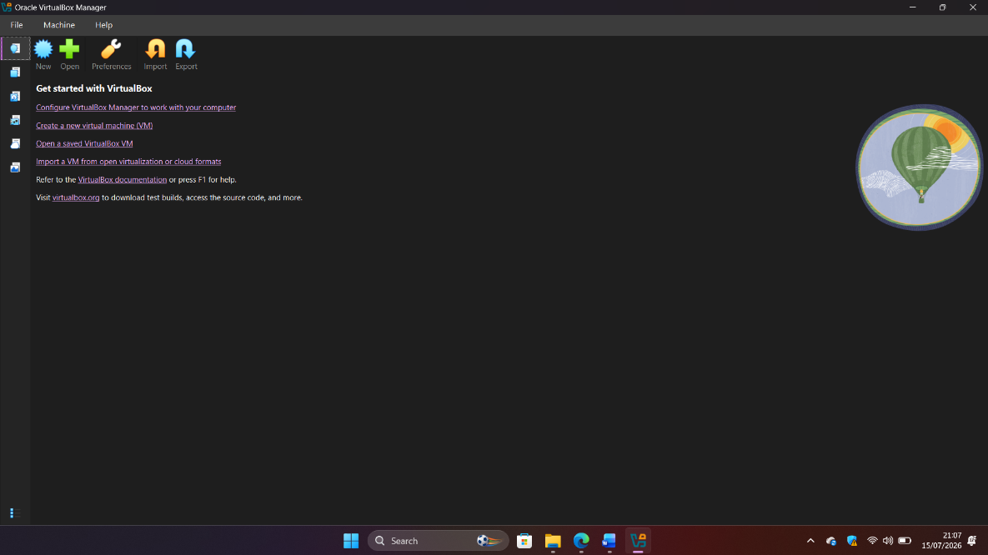

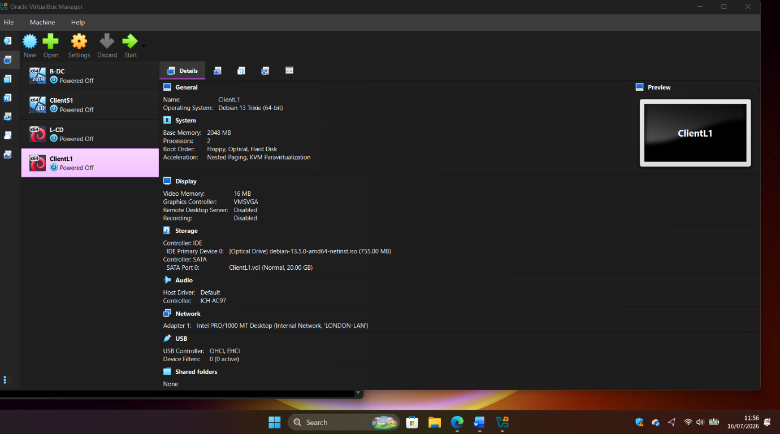
Figure 3 – Windows and Debian virtual machines created in Oracle VM VirtualBox.

Note: Windows Server 2019 was used instead of Windows Server 2022 because it was the version used during practical laboratory sessions. This does not affect the implementation of the networking tasks required for Coursework 1, as both versions provide the necessary functionality for virtualisation, IP addressing, and connectivity testing.

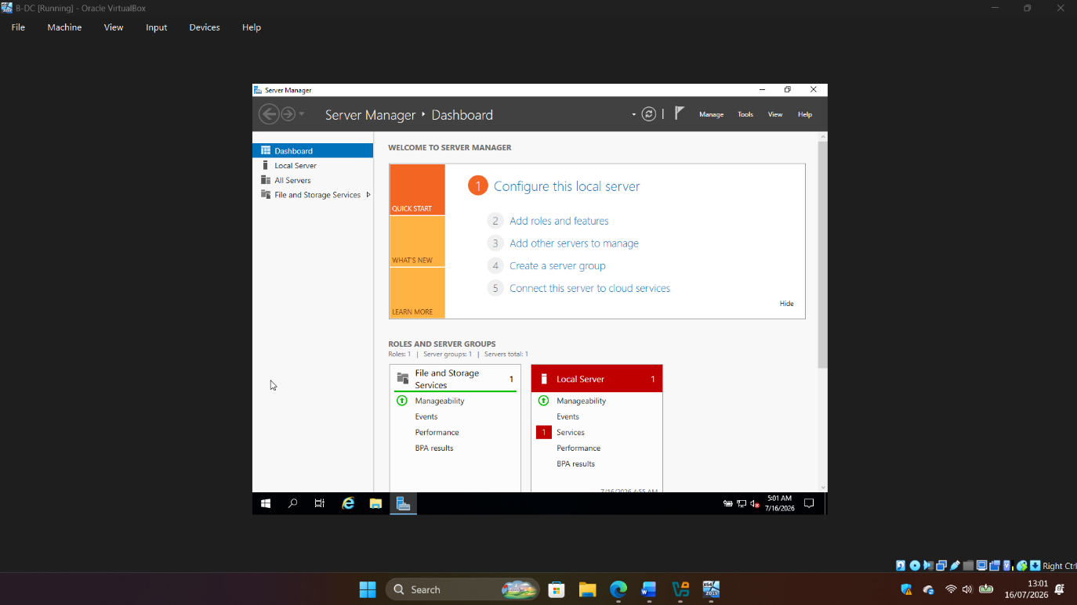
Figure 4 – Windows Server 2019 successfully installed on the B-DC virtual machine.
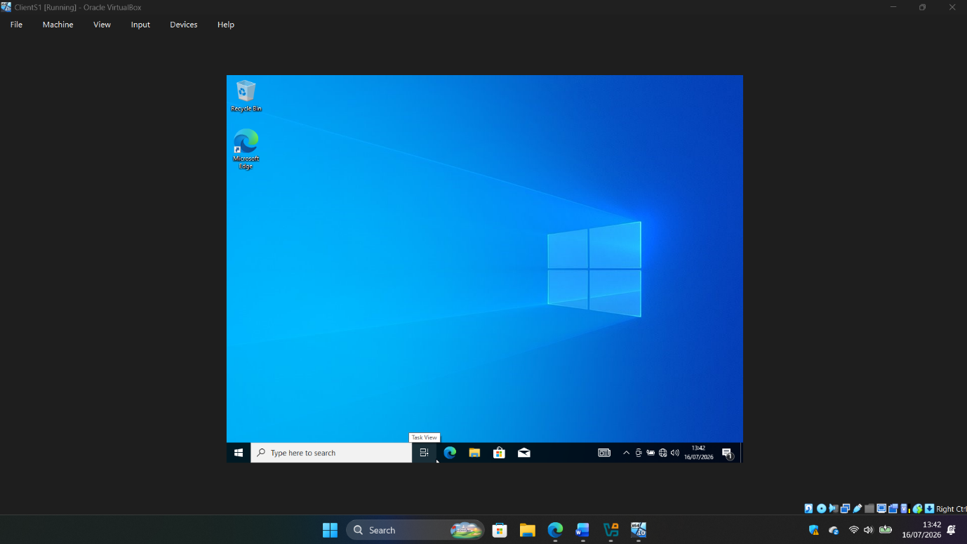
Figure 5 – Windows 10 successfully installed on the ClientS1 virtual machine.

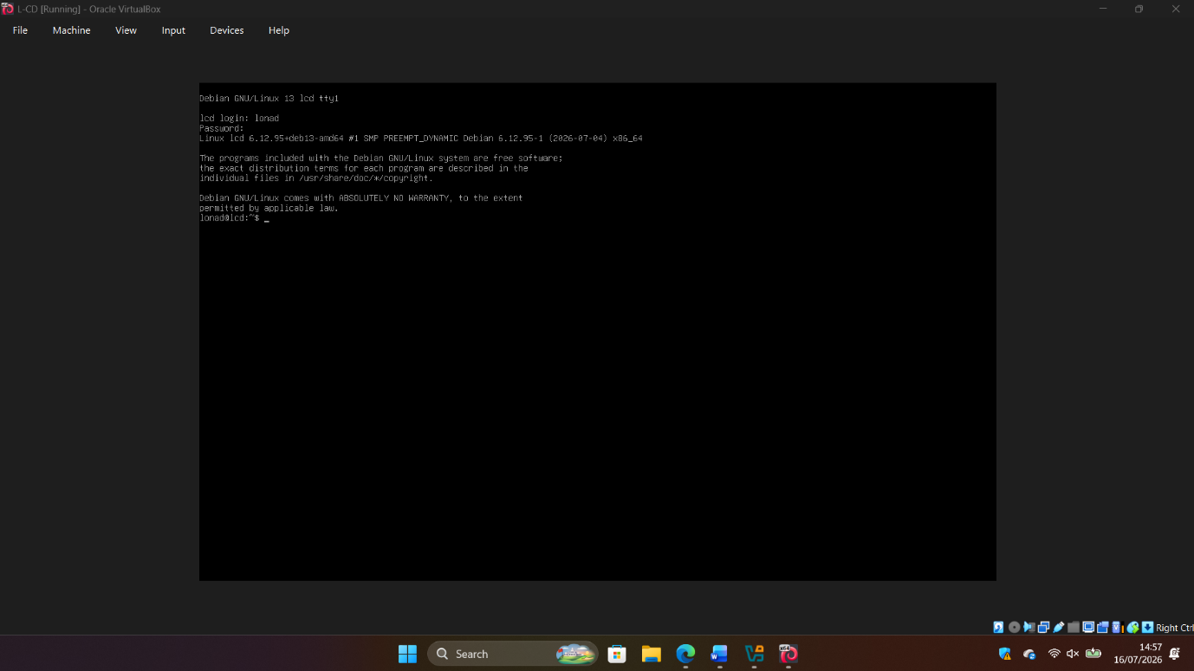
Figure 6 – Debian Server (L-CD) successfully installed and logged in.

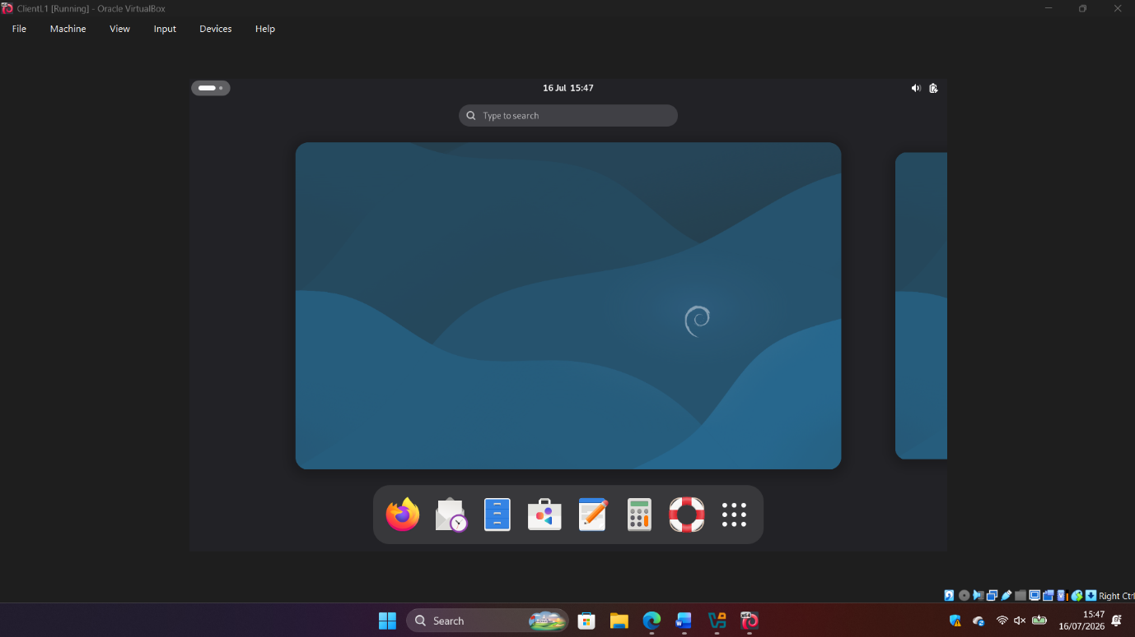
Figure 7 – ClientL1 Debian Desktop successfully installed in Oracle VM VirtualBox.

2.2.2 Network Deployment

This section describes the deployment and configuration of the virtual network according to the topology provided in the assignment.

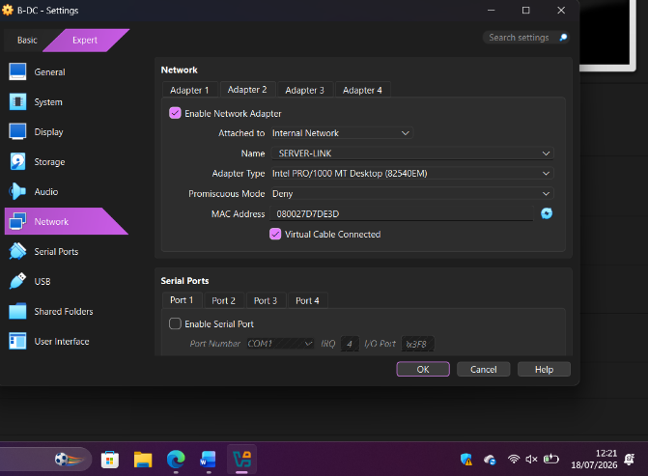
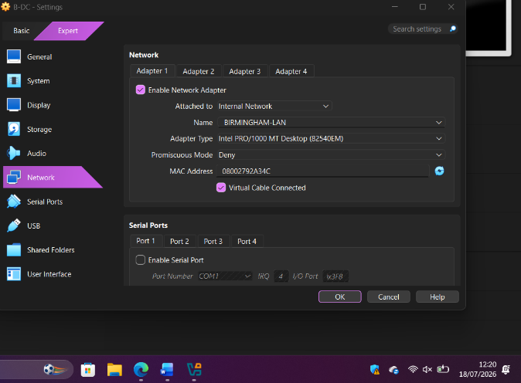
Figure 8 – Virtual network configuration of the B-DC server showing the BIRMINGHAM-LAN and SERVER-LINK internal networks.

Figure 9 – ClientS1 network adapter configured to the BIRMINGHAM-LAN network.
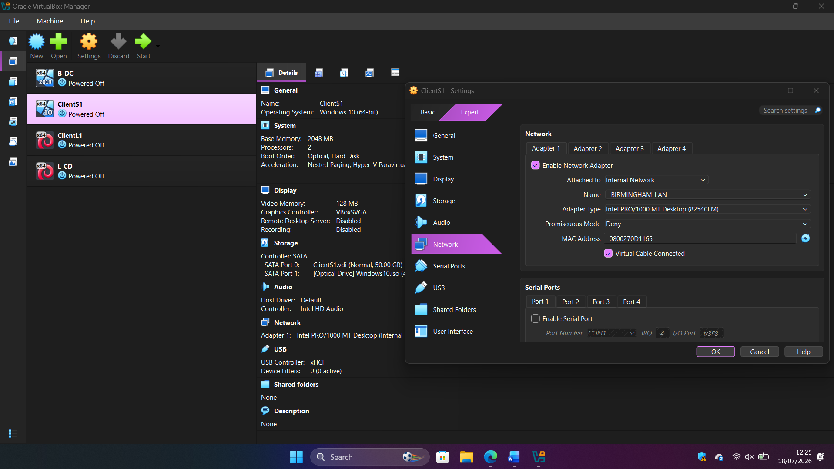

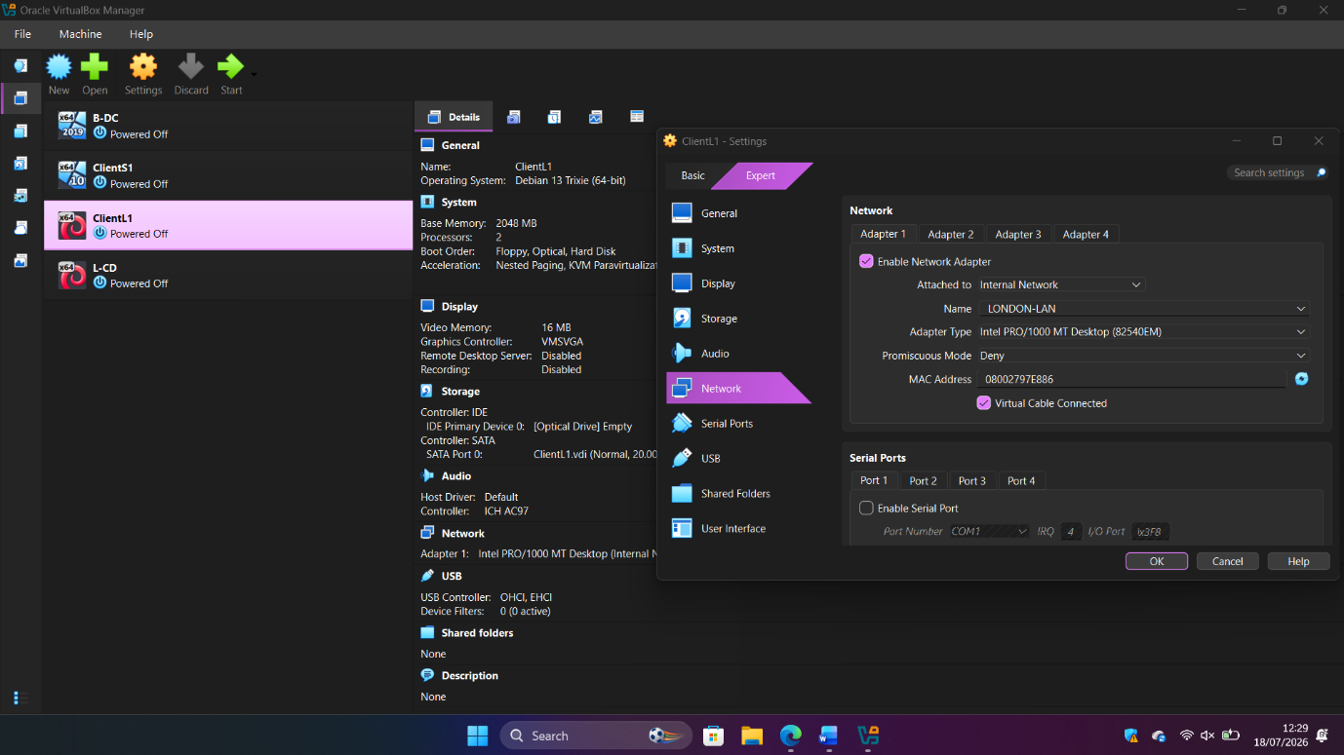
Figure 10 – ClientL1 network adapter configured to the LONDON-LAN internal network.

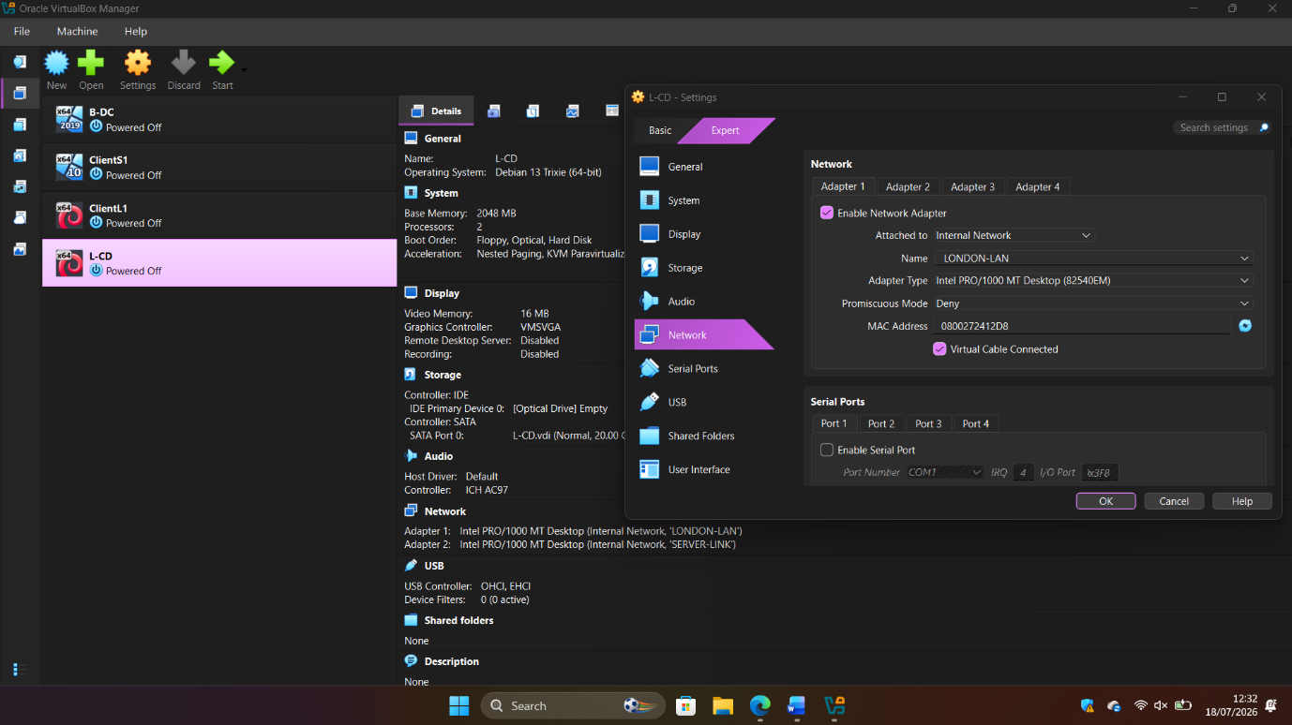
Figure 11 – L-CD network adapters configured for the LONDON-LAN and SERVER-LINK internal networks.

2.3 Configure IP Addressing

Figure 12 – IP configuration of the B-DC server showing the static IPv4 addresses 10.0.0.1/30 (SERVER-LINK) and 172.16.1.1/24 (BIRMINGHAM-LAN).
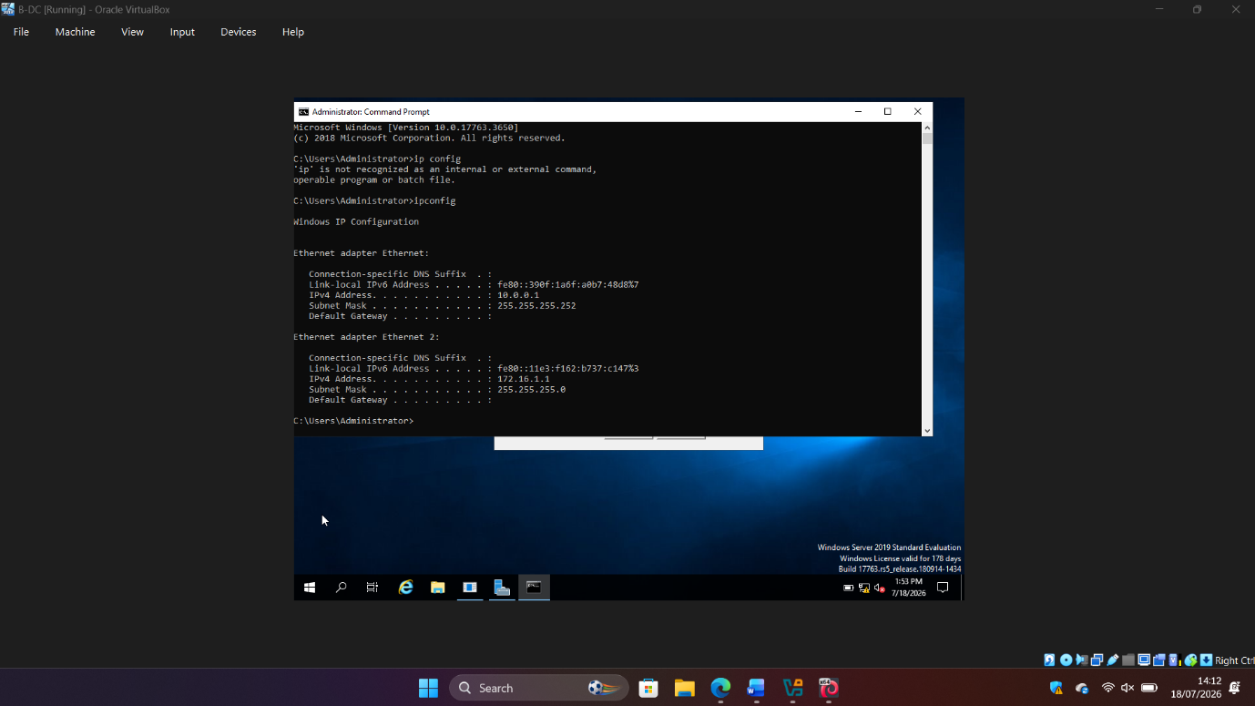

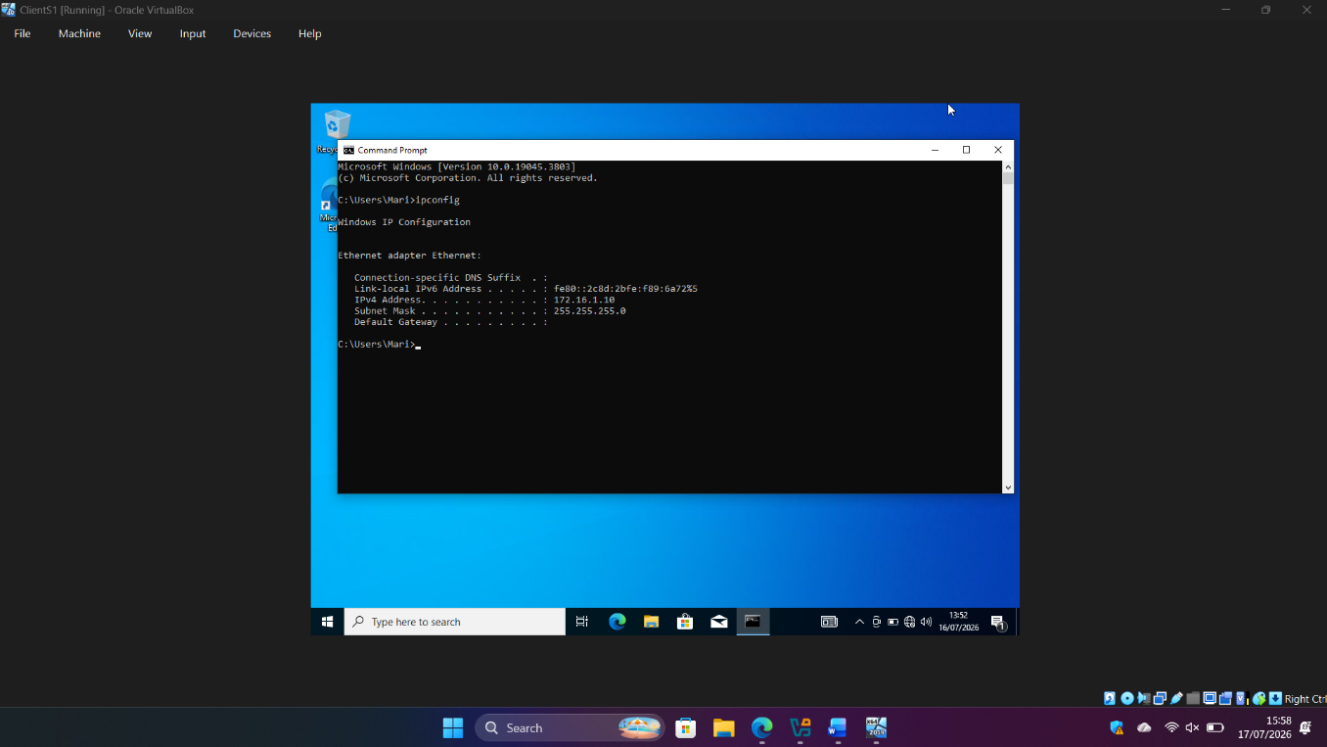
Figure 13 – IP configuration of ClientS1 showing the static IPv4 address 172.16.1.10/24.
Figure 14 – IP configuration of the L-CD server showing the static IPv4 addresses 172.16.2.1/24 and 10.0.0.2/30.
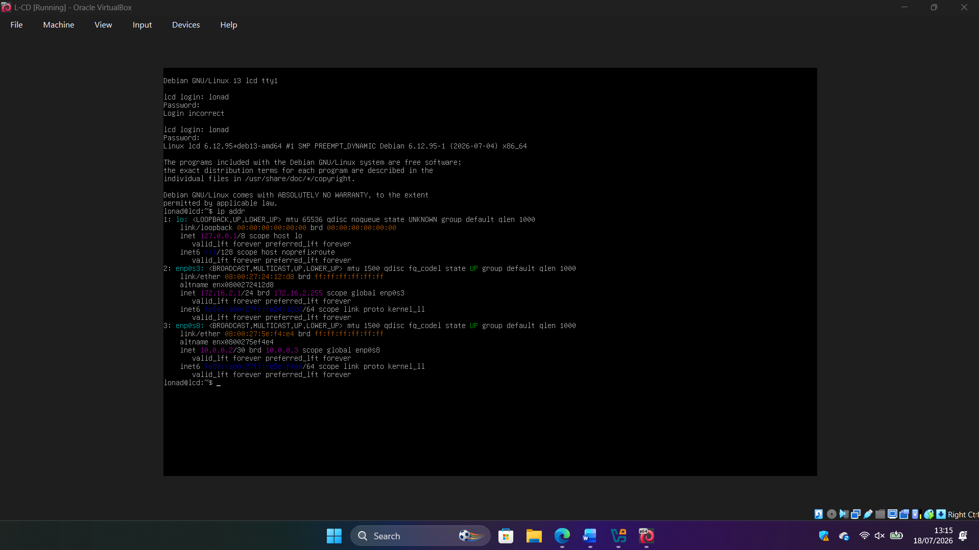

Figure 15 – IP configuration of ClientL1 showing the static IPv4 address 172.16.2.10/24.
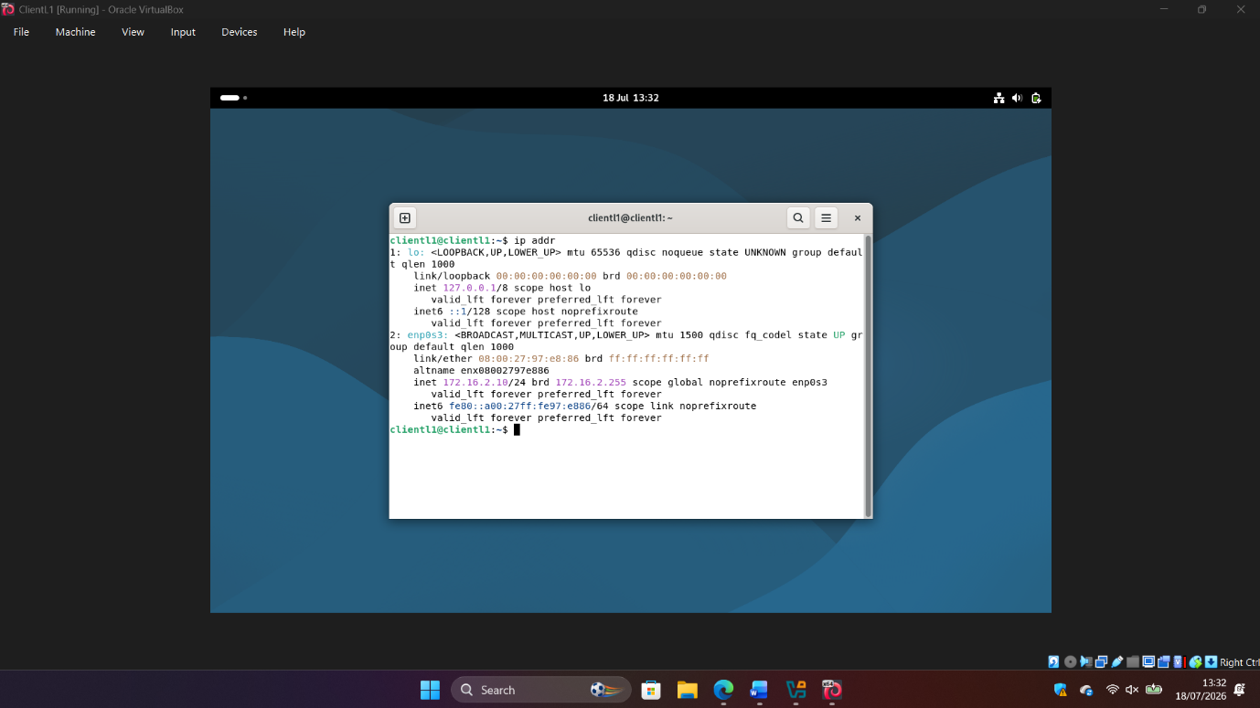

2.4 Connectivity Testing

After configuring the static IPv4 addresses, connectivity testing was performed to verify communication between devices located on the same subnet and to confirm that communication between different networks was unavailable because routing had not yet been implemented.

Outcome 1 – Successful connectivity within same networks

2.4.1 ClientS1 : B-DC

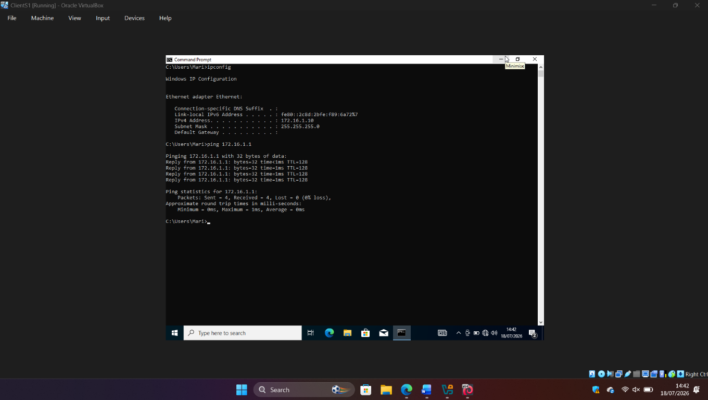
Figure 16 – Successful connectivity test between ClientS1 and the B-DC server using ICMP ping.

2.4.2 B-DC : ClientS1

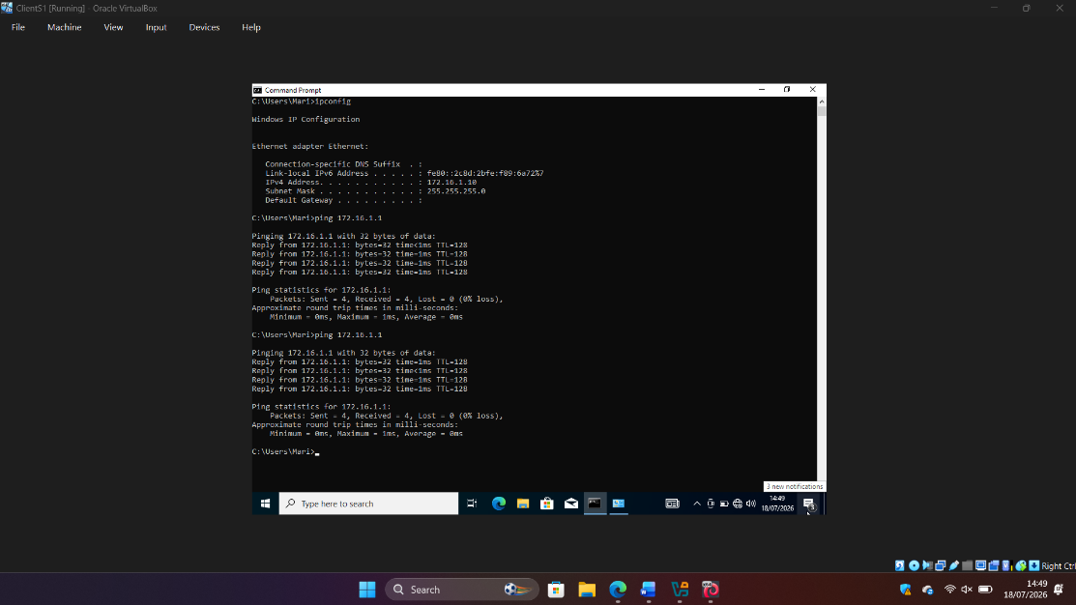
Figure 17 – Successful ICMP ping test from the B-DC server to ClientS1 (172.16.1.10), confirming connectivity within the BIRMINGHAM-LAN with 0% packet loss.

2.4.3. ClientL1 : L-CD

Figure 18 – Successful ICMP connectivity test from ClientL1 to the L-CD server (172.16.2.1), confirming connectivity within the LONDON-LAN with 0% packet loss.
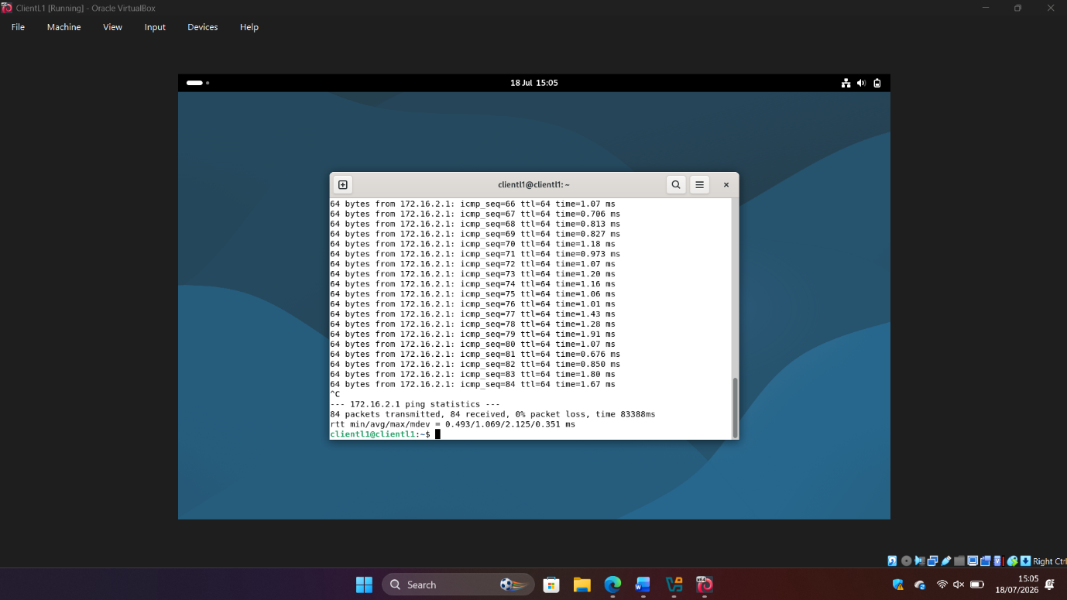

2.4.4. L-CD : ClientL1

Figure 19 – Successful ICMP connectivity test from the L-CD server to ClientL1 (172.16.2.10), confirming connectivity within the LONDON-LAN with 0% packet loss.
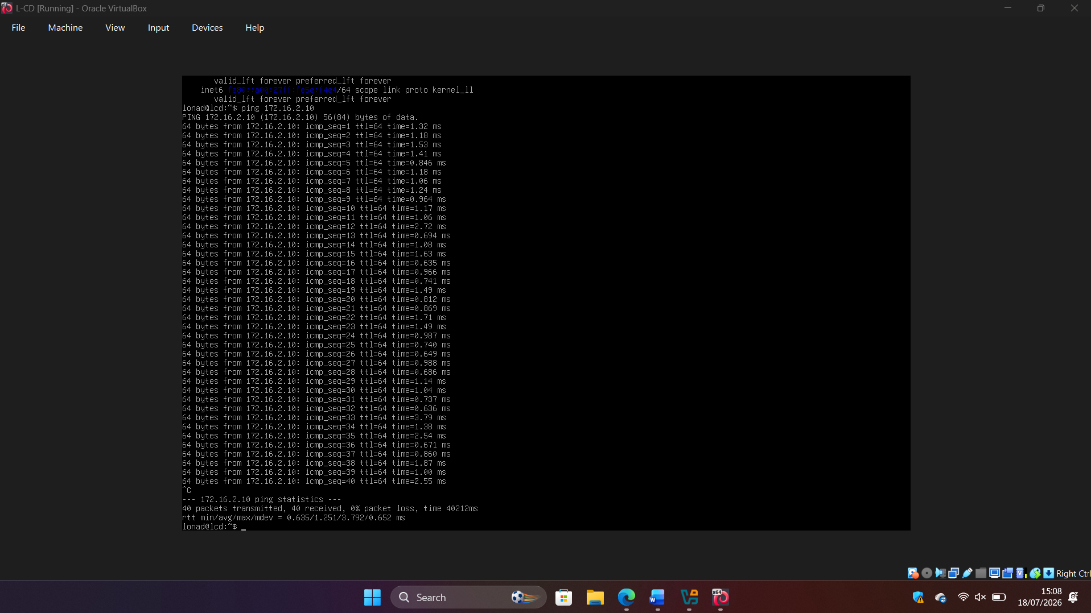

Outcome 2 – Unsuccessful connectivity between different networks

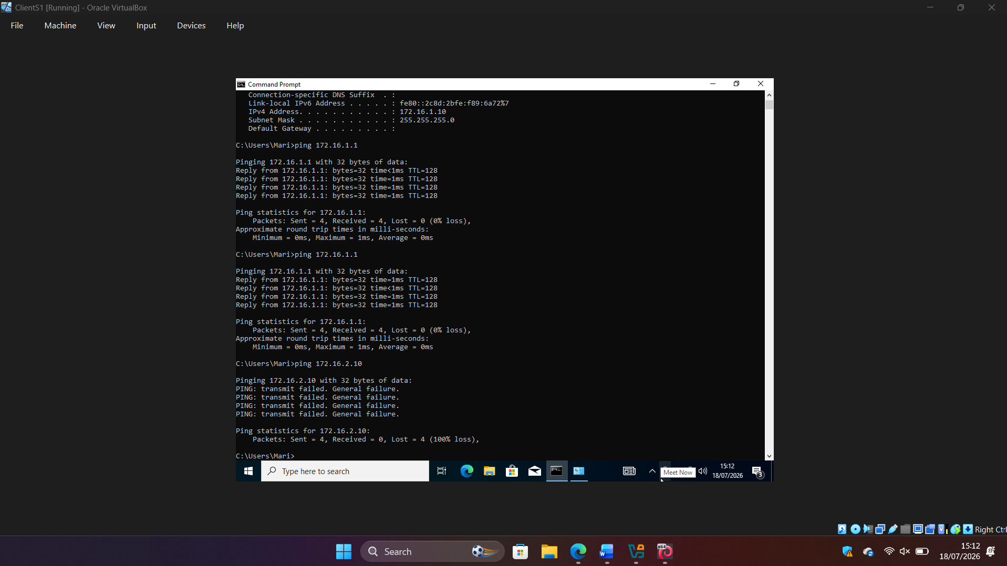
Figure 20 – Unsuccessful ICMP connectivity test from ClientS1 (172.16.1.10) to ClientL1 (172.16.2.10), demonstrating that communication between different networks is unavailable without routing.

Task 3

3.1 Technical Reflection

During the deployment and testing of the virtual network, several technical challenges were encountered and resolved through a systematic troubleshooting process. The first challenge involved configuring the virtual network adapters correctly in VirtualBox. Initially, the network topology was not configured as required because the adapters were connected using an incorrect network mode. After reviewing the network design, the adapters were reconfigured using the appropriate Internal Network settings for the BIRMINGHAM-LAN, LONDON-LAN and SERVER-LINK networks.
Another challenge occurred during the configuration of static IP addresses on the virtual machines. Each device was manually assigned the IP addresses specified in the network topology, and the configuration was verified using ipconfig on Windows and ip addr on Debian Linux to ensure that the correct addresses had been applied.
During the connectivity tests, ICMP ping requests between the Windows machines initially failed despite the IP configuration being correct. The issue was diagnosed by verifying the network adapter settings, checking the assigned IP addresses, and performing ping tests in both directions. The root cause was identified as the Windows Defender Firewall blocking ICMP Echo Requests. After temporarily disabling the firewall for testing purposes, connectivity was successfully established between devices on the same network.
The final connectivity tests confirmed successful communication between devices within the same local network, while communication between different networks was unsuccessful because no routing had been configured. This behaviour matched the expected outcome of the network design and demonstrated the importance of both correct IP addressing and routing in network communication.

3.2 Personal Reflection

This practical assignment provided valuable hands-on experience in deploying and testing a virtual network using VirtualBox. It allowed me to apply theoretical networking concepts in a practical environment while improving my confidence in configuring Windows and Linux virtual machines.
The activity also improved my troubleshooting skills by teaching me the importance of following a structured diagnostic process. Instead of making random configuration changes, I learned to verify the network topology, confirm IP addressing, and test connectivity step by step until the root cause of each issue was identified.
Completing this assignment strengthened my understanding of virtual networking, static IP configuration, connectivity testing, and the impact of firewall settings on network communication. Overall, the experience enhanced both my technical knowledge and my problem-solving abilities, providing a strong foundation for future networking modules.
The experience also provided a solid foundation for Coursework 2, where routing, Active Directory, DHCP, DNS, VPN and other enterprise services will be deployed using the virtual infrastructure created in this assignment.

References

[1].) Difference between hypervisors. Available at: https://aws.amazon.com/compare/the-difference-between-type-1-and-type-2-hypervisors/ (Accessed: 15 July 2026).

[2] Virtualbox. Available at: https://forum.virtualbox.org/manual/topics/Introduction.html (Accessed: 15 July 2026).

[3] TCP/IP addressing and subnetting - windows client | Microsoft learn. Available at: https://learn.microsoft.com/en-us/troubleshoot/windows-client/networking/tcpip-addressing-and-subnetting (Accessed: 15 July 2026).

[4] IPv4 vs ipv6 - difference between internet Protocol versions - AWS. Available at: https://aws.amazon.com/compare/the-difference-between-ipv4-and-ipv6/ (Accessed: 15 July 2026).

[5] (2025) Internet Protocol version 6 (ipv6) header - geeksforgeeks. Available at: https://www.geeksforgeeks.org/computer-networks/internet-protocol-version-6-ipv6-header/ (Accessed: 15 July 2026).

[6] Professor Messer. Dynamic Routing - CompTIA Network+ N10-009 - 2.1 - youtube, Dynamic Routing - CompTIA Network+ N10-009 - 2.1. Available at: https://www.youtube.com/watch?v=YRZxshxI1xs (Accessed: 19 July 2026).

[7] Jeremy’s IT Lab (no date) Free CCNA | ospf part 1 | day 26 | CCNA 200-301 complete course - youtube, CCNA gratuito | OSPF Parte 1 | Día 26 | Curso completo CCNA 200-301. Available at: https://www.youtube.com/watch?v=pvuaoJ9YzoI (Accessed: 15 July 2026).

[8] Dynamic host configuration protocol (DHCP) meaning. Available at: https://www.fortinet.com/uk/resources/cyberglossary/dynamic-host-configuration-protocol-dhcp (Accessed: 15 July 2026).

[9] What is a VPN? | Microsoft azure. Available at: https://azure.microsoft.com/en-us/resources/cloud-computing-dictionary/what-is-vpn (Accessed: 16 July 2026).

[10] Active Directory Domain Services overview | microsoft learn. Available at: https://learn.microsoft.com/en-us/windows-server/identity/ad-ds/get-started/virtual-dc/active-directory-domain-services-overview (Accessed: 16 July 2026).
[11] What is the Certification Authority Role Service in Windows Server? | Microsoft learn. Available at: https://learn.microsoft.com/en-us/windows-server/identity/ad-cs/certification-authority-role (Accessed: 17 July 2026).

[12] Windows server 2019 | Microsoft Evaluation Center. Available at: https://golf.rendering.prod.mscas.io/en-us/evalcenter/download-windows-server-2019 (Accessed: 17 July 2026).

[13] Download Windows 10. Available at: https://www.microsoft.com/en-gb/software-download/windows10 (Accessed: 18 July 2026).

[14] Crosstalk Solutions. Planning your First network deployment? start here - youtube, Planning Your First Network Deployment? Start Here. Available at: https://www.youtube.com/watch?v=nq_rZNucgPI (Accessed: 18 July 2026).

[15] Essential Network Settings and Tasks in Windows. Available at: https://support.microsoft.com/en-us/windows/experience/connectivity-networking/essential-network-settings-and-tasks-in-windows (Accessed: 18 July 2026).

[16] Connectivity Tests overview. Available at: https://docs.cloud.google.com/network-intelligence-center/docs/connectivity-tests/concepts/overview (Accessed: 19 July 2026).

[17] PowerCert Animated Videos (no date) Ping Command - Troubleshooting Networks, Comando PING - Solución de problemas de redes. Available at: https://www.youtube.com/watch?v=IIicPE38O-s (Accessed: 19 July 2026).

[18] University of Wales Trinity Saint David, Network Operating Systems and Services Module Resources, Moodle Virtual Learning Environment, 2026.

