

ASSESSMENT 2 - Portfolio: Brand Extension
Program Name: Master of Business Administration
Module Name: Marketing Management
Module Code: LCMB7024
Lecturer’s Name: Dr Haoran Liu
Student Name: Karan Kumar Vaghela
Student Id: 2418331
Word count: 3140
Submission Date: 28th April,2025

Executive summary
The report shows that brand product extension is the process of deploying a strategic launch of fresh products across similar or dissimilar markets. The plan of product or service extension focuses on using the strong reputation elements to increase customer acceptance rates and decrease the expenses tied to launching a new brand. For accomplishing the portfolio assessment, Zara has been selected as the company, as this brand entails a fast-forward image to align with emerging consumer demands as per the evolving market scenario.

Table of Contents
Introduction and background 2
New brand extension for Zara for the product “Zara Home Fitness Collection” with theoretical interventions 3
Segmentation, targeting and positioning for Zara Home Fitness Collection 5
A detailed customer personal profile for the new brand extension, including demographic and psychographic information 8
The marketing mix strategies for the new brand extension 7Ps 10
Conclusion 13
References 14

Introduction and background
Introduction
Brand product extension is the process of deploying a strategic launch of fresh products across similar or dissimilar markets. The plan of product or service extension focuses on using the strong reputation elements to increase customer acceptance rates and decrease the expenses tied to launching a new brand. For accomplishing the portfolio assessment, Zara has been selected as the company, as this brand entails a fast-forward image to align with emerging consumer demands as per the evolving market scenario. Zara is positioned as a well-structured venture within the lifestyle product line and ensures the well-being of its customers. This portfolio adheres to the “Zara’s Home Fitness Collection” that actively complements the fashion-forward image of Zara. Lastly, this assessment describes the targeted customers of this “Zara Home Fitness Collection” by underscoring demographic and psychological needs.
Company background
Zara is one of the flagship brands within the Spanish multinational Inditex, and this brand is known for its fast fashion strategies for offering trend-driven clothing at an affordable price range. Zara has acquired over 2000 stores within approximately 90 nations and is positioned as a renowned brand for fashion-conscious customers who seek both style with quality (Zara, 2024). Therefore, Zara has underscored the requirement of swiftly altering the fashion trends to earn a loyal customer base.
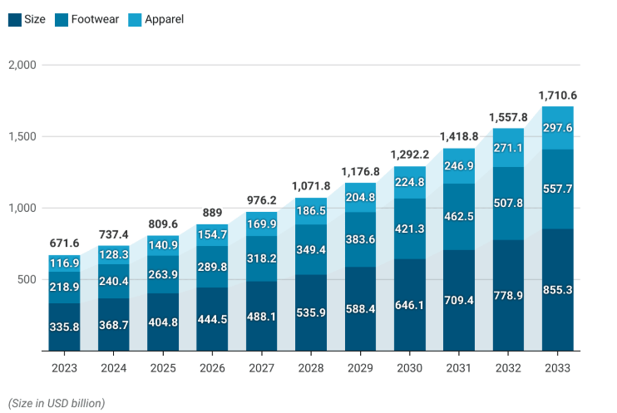
Figure 1: Estimated market value of Global sports equipment
(Source: News.market, 2024)
As per the above figure, the global sports equipment and apparel market size value has reached USD 542 billion in 2022. Additionally, Zara aims to expand within the fitness and wellness segment through brand extension through “Zara’s Home Fitness Collection”, Zara ActiveLiving, to grab the fastest-growing global market of sports apparel (Zara, 2024). As per the market forecast report, the global sports market is estimated to reach an expected value of USD 1030 billion with a 7.4% CAGR by 2030 (Statista, 2024). The considerate growth outlines the increasing consumer interest in fitness and wellness lifestyle items. Therefore, with the launch and expansion of Zara’s Home Fitness Collection “ZaraActiveLiving”, Zara is catering for the market demand and profitability with sustainability.

New brand extension for Zara for the product “Zara Home Fitness Collection” with theoretical interventions
The Zara Home Fitness Collection orients as a key brand extension strategy for Zara to combine quality active wear with fitness components, home exercise equipment, and wellness products. The strategic extension of Zara through “Zara Home Fitness Collection” ensures the accomplishment of growing marketing demand for the customers in lifestyle and wellness products (Zara, 2024). The key theoretical approach that can be adhered to for Zara’s brand extension is the Ansoff Matrix to assess the feasibility of growth extension in the home fitness and lifestyle section.
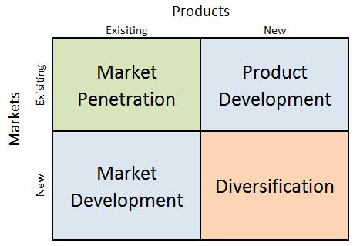
Figure 2: Ansoff matrix
(Source: Influenced by Qomaro et al. 2024, p.51)
As per the above figure, the Ansoff matrix maps the key strategic growth paths for business, such as market penetration, product development, market development and diversification. Qomaro et al. (2024, p.52) stated that, Ansoff Matrix is a framework that helps in assessing the growth initiatives by businesses to conceptualise the stakeholders with risk assessments. The product extension of Zara in the “Zara Home Fitness Collection” entails the product development aspect, and it mainly involves introducing a new line of products to the existing market. The “global home fitness market” is currently holding a value of USD11.60 billion in 2023, and it is aiming to reach USD18.94 billion by the end of 2032 (Statista, 2024). Zara is expanding the “Zara Home Fitness Collection” by widening the scope of the new lifestyle experience for its existing customers within the realm of the personal wellness and fitness sector. Zara is also aiming to introduce the “Zara Home Fitness Collection” at an affordable range to acquire a huge number of eager customers to purchase sports apparel. Zara is also nurturing 200 different teams that travel throughout the global regions to understand fashion-trends, and consistent reporting of Zara helps in creating 40000 new designs annually (Zara, 2024). Therefore, “Zara Home Fitness Collection”, Zara reassures its commitment to maintain innovation and lifestyle relevance with consistent external research to offer consumers a comprehensive brand experience in the wellness sector.

Segmentation, targeting and positioning for Zara Home Fitness Collection
STP element | Segmentation category | Description
Segmentation | Demographic  Geographic  Psychographic  Behavioural | Age: 20 to 45 years  Gender: Both male and female from Urban regions  Income: Middle to upper  Occupation: Urban professionals
Segmentation | Demographic  Geographic  Psychographic  Behavioural | Geographic  Mostly, the Urban areas have access to the Zara stores and e-commerce platforms  Major cities in Europe, the USA, and southern Asia
Segmentation | Demographic  Geographic  Psychographic  Behavioural | Psychographic  Zara is targeting the health-conscious customers and eco-conscious buyers, and minimalists
Segmentation | Demographic  Geographic  Psychographic  Behavioural | Behavioural  For the Behavioural aspect, Zara is targeting the online shoppers who seek both convenience and comfort and are also interested in functional fashion items
Targeting | Primary and secondary target | - Primary target market for Zara “Zara Home Fitness Collection” is the Urban millennials and Gen Z people who are conscious of fitness maintenance and also aim to work out in settings and have sustainable active wear  - The secondary target market of Zara is the parents and working women who are fitness enthusiasts and seeking “home-based workout” options
Positioning | Core value proposition | The core value proposition for the “Zara Home Fitness Collection” is “Style meets wellness: bring the Zara aesthetic into your fitness routine.”
Positioning | Positioning strategy | The strategy of differentiation is solely oriented towards the minimalist design, sustainable materials and affordable premium segments for lifestyle and active wear items
Positioning | Brand messaging | Zara home fitness collection is strategically designed for a modern lifestyle that caters for fitness, sustainability and fashion context
Positioning | Brand Identity | The “Zara Home Fitness Collection” is estimated to be accessible, ecologically sustainable, and affordable
Table 1: Segmentation, targeting and positioning for Zara Home Fitness Collection
(Source: Self-created)
Segmentation Analysis
Zara segments operations into multiple dimensions when it comes to market expansion. Zara specifically focuses on customers between 20 to 45 years old since this segment intensely participates in fashion and wellness routines for “Zara Home Fitness Collection”. As part of the marketing approach, Zara focuses on the present-day consumer base, which is looking for stylish utility in all daily needs.
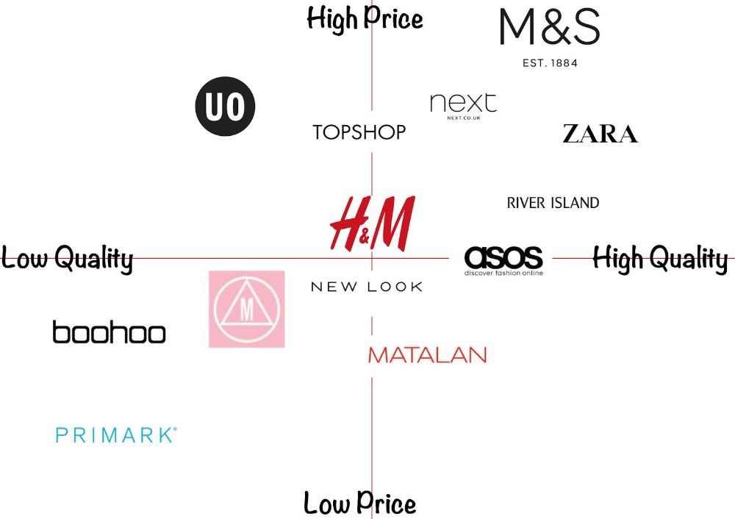
Figure 3: Positioning map of Zara in the fashion retail sector
(Source: Influenced by Zara, 2024)
The selection of this segment enables Zara to grab the growing style-conscious fitness market that drives both brand relevance and reviews through the diversification of lifestyle items. The shopping behaviour of the Gen Z population emphasises convenience and prefers online shopping methods, while the purchase depends on minimalistic product designs that match the interiors (Wibowo and Zainudin, 2024, p.236). Geographically, Zara is targeting the metropolitan cities with a higher rate of internet penetration, and fitness has become a necessity. Lastly, Zara is focusing on the convenience-seeking customers who prefer to shop online and are influenced by multifunctional lifestyle items.
Targeting Strategy
Zara is estimated to implement a differentiated targeting strategy that caters to two types of customer segments for “Zara Home Fitness Collection” items. The targeting approach at Zara is oriented toward delivering sustainable-focused product ranges and branding materials for multiple consumer groups that intersect with each other (Scrip, 2024). The main customer segment of Zara consists of configured urban professionals who embrace fitness while possessing financial capacity and social styling preferences that support the intersecting customer acquisition strategy of Zara. The secondary market includes home-based workers, busy parents and students who initiate wellness practices in need of stylish fitness equipment. The brand strength of Zara assists in gathering fashion-forward customers who need such a physical exercise regimen that incorporates individual design choices.
Positioning analysis
Zara positions itself as a home fitness collection brand by promoting an intersection of fashion, function, and wellness. As per the above figure of positioning, Zara offers high-quality products at a high price among the major fashion brands. Similarly, Zara leverages the trendy designs to enhance the aesthetic of home-workouts with a core brand messaging “style meets wellness”. Nevertheless, with the help of the core messaging of the brand, “where style meets wellness,” Zara can make itself different from other fitness and lifestyle brands (Forbes, 2024). Therefore, the differentiable market strategy of Zara allows it to acquire a unique space within the fitness industry for delivering a cohesive experience to the targeted audiences

A detailed customer personal profile for the new brand extension, including demographic and psychographic information
Demographics | Name: Sarah Johnson  Gender: Female  Age: 40  Location: Birmingham, UK  Occupation: Owner of a small boutique clothing and accessory shop  Income level: £40000 per year | 
Psychographic | - Sarah is health conscious and values aesthetics by following the wellness trends for both herself and her business.  - She prefers functional products from the affordable to mid-premium price range
Profile | - Sarah has a boutique in Birmingham, UK, that offers customers customisable design outfits and accessories  - Sarah is highly intended to maintain her fitness regimen, specifically in home settings, due to having a busy lifestyle
Motivation | - Sarah maintains a balanced lifestyle by accumulating wellness within her daily routine, by not compromising the convenience and design  - Sarah is also aiming to pursue a quality life while maintaining both personal and professional needs
Goals | - Her personal goal is to stay fit even within her comfort zone  - Sarah has selected the durable product items and also prefers to buy from online shopping
Pain Points | - Sarah has a limited space to purchase gym items  - She dislikes the boring-looking gym apparel  - Sarah has limited time for personal shopping
Table 2: Customer Persona
(Source: Self-created)
As per the above consumer persona, Sarah Johnson is a 40-year-old boutique owner in Birmingham who serves as Zara's targeted customer group for Home Fitness Collection. The demographic and psychographic qualities Zara is oriented to attract a working professional similar to Sarah Johnson, who maintains a stable income together with fashion and wellness interests. Sarah, as a Zara target customer, prefers Zara's unique offerings of fitness equipment, which combines functionality with modern home designs.
Sarah shows psychographic traits indicating her focus on wellness, together with her desire for stylish products that also serve sustainability and practicality requirements. Sudirjo (2023, p.65) stated that targeting the ideal customers for brands is essential to ensure that all sorts of marketing efforts are effective and products can be met with specific consumer needs. As per the key, Zara appeals to preferences by Sarah by providing fitness products with minimalistic designs that fit efficiently into her home space instead of bothering her visual flow and aesthetic choices. Additionally, fitness solutions provided by Zara match the fitness needs of Sarah, which include desirable characteristics of stylish design combined with eco-friendliness and compact functionality for home workouts. Zara establishes an online shopping platform that eliminates hassle and solves the displeasure with ordinary fitness equipment that aligns with the specific customer requirements. Therefore, catering for the ideal customer groups can help Zara to understand specific customers' needs, and it also widens the scope of revenue acquisition.

The marketing mix strategies for the new brand extension 7Ps
7ps element | Description
Product | Stylish and space-saving home fitness equipment with modern design, such as a gym mat, apparel and gym accessories
Price | Mid and premium pricing reflecting the aesthetic appeal that reflects quality and aesthetic appeal
Place | This product range is available in both online and offline stores of Zara
Promotion | The key promotional strategies for promoting the “Zara Home Fitness Collection” can be digital campaigns, social media ads and influencer marketing
People | Zara is targeting the urban population who prefer in-house fitness regime for “Zara Home Fitness Collection”
Process | Zara aims to deliver an online shopping experience to the targeted customers with the help of a fast delivery method
Physical Evidence | Zara also aims to acquire a cohesive “in-store display” with premium packaging that matches the aesthetic need of the consumer for “Zara Home Fitness Collection”
Table 3: Marketing mix
(Source: Self-created)
Product
The Zara Home Fitness Collection presents its customers with stylish fitness equipment that occupies minimal space within the home-setup. Yuwei (2024., p.15) stated that consumers seek certain home-goods that can fit perfectly into residential areas without compromising on the operational capacity. Therefore, Zara implements significant importance on design elements within “Zara Home Fitness Collection” as it encompasses the core values of Zara fashion-design expertise to maintain brand loyalty.
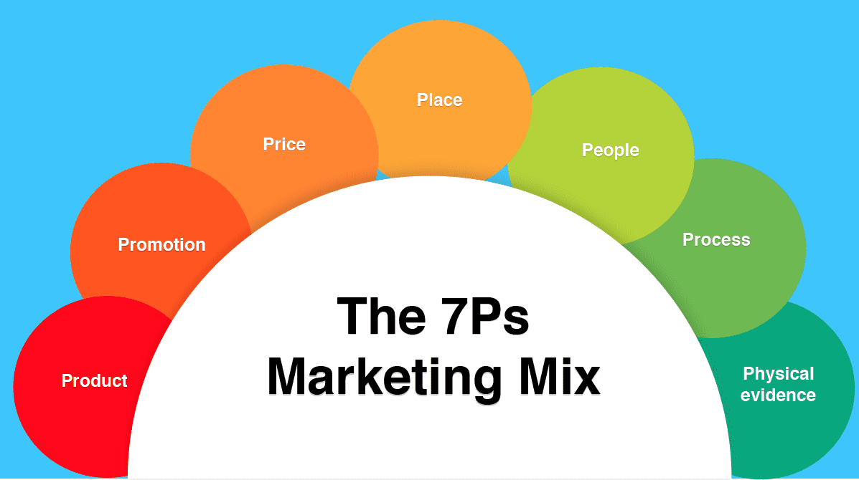
Figure 4: Marketing Mix 7ps
(Source: Influenced by Siripipatthanakul and Chana, 2021, p.242)
Price
The price positioning of “Zara Home Fitness Collection” products sets standard rates and higher-end categories to match both the consumer value and operational performance. The price strategy of Zara includes competitive pricing for “Zara Home Fitness Collection”. Competitive pricing for luxury items targets customers who choose luxury goods by bridging functionality and lifestyle aspects to cover a wider customer base (Khattak and Khattak, 2024, p.38). Therefore, Zara has implemented competitive pricing to grab more consumer base and also to nurture a loyal customer base by fulfilling the demand.
Place
Zara concentrates its marketing activities through e-commerce platforms and some Zara Home retail locations in Urban regions. The geographical segregation of product positioning enables companies to deliver specific brand branding while maintaining identical shopping environments (Czinkota et al. 2021, p.283). Therefore, the feature of “Zara Home Fitness Collection” through online accessibility addresses consumer needs and also helps the customers to have the product without being physically available at stores.
Promotion
Zara implements its brand growth through digital promotional branding and social media marketing with influencer content to shape awareness toward a digitally naive consumer base. Knihová (2021, p.162) stated that digital branding with content content-focused marketing strategy works as a communication medium for brands to understand specific consumer needs. Thus, the marketing content for “Zara Home Fitness Collection” can highlight the ways by which the collection provides lifestyle advantages which feature home-friendly design, wellness capabilities, and convenient household use.
People
Zara designs promotional strategies to reach urban customers interested in stylish fitness tools for their home training needs. Selecting the right people management strategy supports the brand to reach targeted objectives within the minimal time duration (Dwivedi et al. 2021, p.33). Zara also aims to train the people with the right upskilling strategy to resolve customer queries at the stores to fulfil the demand of convenience-seeking customers.
Process
Zara is aiming to ensure a smooth purchasing experience for its targeted audiences to enhance the user experience. Additionally, the user experience gets improved through streamlining operations, which cuts down cart abandonment and builds trust among consumers (Rosário and Raimundo, 2021, p.3003). Lastly, Zara aims to streamline the product manufacturing with personalised consumer-specific people management strategies to enhance user confidence and also to aim for a larger customer base.
Physical Evidence
High-end packaging envelopes with “Zara Home Fitness Collection” by implementing minimalistic lifestyle displays. Premium branding stands strengthened through minimalist feature displays, which enable direct sensory experiences for the customers with product visual and physical aesthetics (Nawar et al. 2024, p.259). Therefore, the marketing mix evaluation ensures Zara aligns with the customer expectations with the projected goods and also drives brand loyalty with increased sales.

Conclusion
Therefore, it can be concluded that the Home Fitness Collection from Zara implements a design capability with its established brand status to expand into the expanding wellness market segment. Zara positions itself as a lifestyle brand through strategic segmentation and marketing mix implementation, which fulfils contemporary consumer requirements so customers view it as a brand integrating fashion along with functionality and fitness into daily life.

References
Czinkota, M.R., Kotabe, M., Vrontis, D., Shams, S.R., Czinkota, M.R., Kotabe, M., Vrontis, D. and Shams, S.R., (2021). Market segmentation, positioning, and branding. Marketing Management: Past, Present and Future, pp.283-340.
Dwivedi, R., Prasad, K., Mandal, N., Singh, S., Vardhan, M. and Pamucar, D., (2021). Performance evaluation of an insurance company using an integrated Balanced Scorecard (BSC) and Best-Worst Method (BWM). Decision Making: Applications in Management and Engineering, 4(1), pp.33-50.
Forbes (2024). Why Zara Succeeds: It Focuses On Pulling People In, Not Pushing Product Out. Available at: https://www.forbes.com/sites/pamdanziger/2018/04/23/zaras-difference-pull-people-in-not-push-product-out/ [Accessed: 10th April 2025]
Khattak, K. and Khattak, J., (2024). Market Positioning And Competitive Advantage: A Case Study Of Luxury Fashion Brands. Competitive Research Journal Archive, 2(02), pp.38-49.
Knihová, L., (2021). The role of educational content in a digital marketing strategy. Communication Today, 12(1), pp.162-179.
Nawar, S.H., Etawy, M.S., Nassar, G.E., Mohammed, N. and Hassabo, A.G., (2024). The impact of cmf design on product design. Journal of Textiles, Coloration and Polymer Science, 21(2), pp.259-272.
News.market (2024). Sportswear Statistics 2025 By Best Varieties Available at: https://www.news.market.us/sportswear-statistics/ [Accessed: 10th April 2025]
Qomaro, G.W., Nasrulloh, N. and Salleh, A.Z., (2024). Leveraging The Ansoff Matrix for Strategic Growth in Packaged Food Micro-Enterprises. Dinar: Jurnal Ekonomi dan Keuangan Islam, 11(1), pp.51-66.
Rosário, A. and Raimundo, R., 2021. Consumer marketing strategy and E-commerce in the last decade: a literature review. Journal of theoretical and applied electronic commerce research, 16(7), pp.3003-3024.
Scrip (2024). Sustainable Retailing Performance of Zara during COVID-19 Pandemic .Available at: https://www.scirp.org/journal/paperinformation?paperid=108440 [Accessed: 10th April 2025]
Siripipatthanakul, S. and Chana, P., (2021). Service marketing mix (7Ps) and patient satisfaction in clinics: A review article. International Journal of Trend in Scientific Research and Development (IJTSRD), 5(5), pp.842-850.
Sudirjo, F., (2023). Marketing strategy in improving product competitiveness in the global market. Journal of Contemporary Administration and Management (ADMAN), 1(2), pp.63-69.
Wibowo, M.C. and Zainudin, A., (2024). The Influence of Minimalist Design Elements on Visual Preferences of Generation Z: A Quantitative Study. International Journal of Graphic Design, 2(2), pp.236-247.
Yuwei, L., (2024). Market Positioning & Operational Strategy To Start Home Goods Retail Business In Indonesia. Devotion: Journal of Research and Community Service, 5(12), pp.1507-1523.
Zara (2024). Zara Inditext report. Available at: https://static.zara.net/static/joinlife/2020_Inditex_Annual_Report.pdf [Accessed: 10th April 2025]
Zara (2024). Zara Investment Holdings. Available at: http://zaraholding.com/images/menus/Annual-en/2023EN.pdf [Accessed: 10th April 2025]
Zara (2024). Zara Store experience. Available at: https://www.zara.com/in/en/help-center/StoreMode [Accessed: 10th April 2025]

