Ransomware report – Tyler Bate
Table of Contents
Contents 1
1. Introduction 1
1.1 Reasons why I am writing this report. 1
2. Ransomware 1
2.1 What is ransomware? 1
2.2 How is ransomware dangerous? 1
2.3 How ransomware works 1
2.4 Problems that are caused by ransomware. 1
3. Cryptowall 1
3.1 what is Cryptowall? 1
3.2 Why was it created? And who did it target? 1
3.3 Why is Cryptowall dangerous? 1
3.4 How was Cryptowall removed? 1
3.5 How you could recover files lost to Crytowall. 1
4. Precautionary measures 1
4.1 Back up solutions (how to make one) 1
4.2 Antivirus software’s 1
4.3 RDP Logs 1
4.4 VPN/ Jump server logs 1
5. References 1
6. Website and photos used references. 1

Contents

Introduction
This report details Ransomware as it is a huge threat to companies and individuals in this age of technology, Ransomware has little to no limitations on who and how it can affect businesses and technology users. it is important to be knowledgeable on this topic because it could compose not only financial problems, but also puts critical information at risk to businesses.

Ransomware

What is ransomware?
Since the release of the NCSC's 2017 report on online criminal behaviour, ransomware has emerged as the most significant advancement in cybercrime. [1] Malicious malware known as ransomware encrypts your files to prevent you from accessing your device and the data on it. Usually, a gang of thieves will ask for money in exchange for supplying the decryption key. This may lead to the data being encrypted, stolen, or deleted, or the computer locking up. Threats to reveal the stolen data may also be made by the offenders.
Unfortunately, one of the most valuable targets for cybercriminals is the United Kingdom, because our companies and institutions are among the top in the world, they have three very attractive things that malicious actors want to have: money, important knowledge, and the power to really mess things up if things go wrong. [2]

How is ransomware dangerous?
Ransomware attacks are extremely dangerous because they can have disastrous consequences for both people and organisations. These attacks have far-reaching consequences that go well beyond the financial losses—which can range from hundreds of thousands to millions of dollars. Data breaches could still occur even if the ransom is paid because hackers might not be able to decrypt files or might steal data.
Furthermore, business disruptions are common, forcing some companies to halt operations for days or even weeks at a time. Reducing the risks and lessening the damage brought on by ransomware attacks requires keeping up with the latest developments and putting appropriate preventive measures in place, given the attackers' constantly changing tactics. [3]

How ransomware works
Generally speaking, ransomware operates in six distinct stages: infecting targets with malware, establishing command and control, investigating and moving laterally, obtaining data without authorization and encrypting files, extortion, finally, removal. [4] This is carried out through various methods, included Phishing, This is the most widespread kind of social engineering and remains to be the main way that different kinds of malware attacks are started. Adversaries insert what appear to be trustworthy links and attachments into emails to trick recipients into inadvertently downloading and installing malicious software. Attackers use a variety of techniques, the most common being a phishing link via email or attachment, to trick victims into installing malware. [5]

Problems that are caused by ransomware.
Ransomware is a significant threat to organisations and one of the most urgent cybersecurity issues facing the internet today. This type of malicious software, also called malware, affects everything from a single PC to entire networks, including servers, by encrypting files and documents.
After the ransomware encrypts files, victims are left with few options: they can pay the attackers a ransom to unlock their network, restore their data from backups, wait for a decryption key to become available, or start the recovery process over.
Some ransomware infections start when a person working for an organisation clicks on an attachment that looks harmless. When the attachment is opened, the malicious payload is downloaded and the network is encrypted. [6]

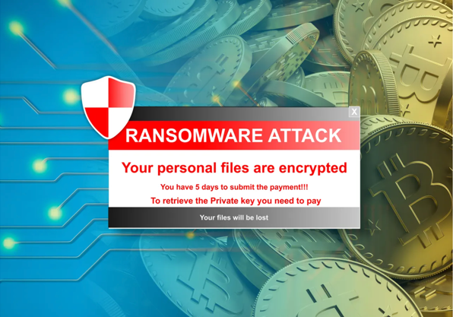
An example of what a Ransomware attack might look like. [7]

Cryptowall

what is Cryptowall?
Cryptowall operates similarly to a ransomware virus, encrypting files on the computer it targets and requesting payment in exchange for the decryption key. It usually spreads by using a Trojan horse to deliver its harmful payload, such as spam phishing emails, malicious ads, hacked websites, or other malware.
CryptoWall is a malware variant that has evolved since 2015 when security companies and government agencies from all over the world worked together to take down CryptoLocker. Even so, the recovery happened with CTB Locker, which was followed by CryptoWall 3.0, which led to a major attack on German users at that time.
Like a lot of ransomware and malware that steals data, CryptoWall primarily disseminates through phishing and spam campaigns, enticing users to click on malicious links or open email attachments. Concurrently, cybercriminals have incorporated CryptoWall code into website advertisements to enhance its online proliferation.
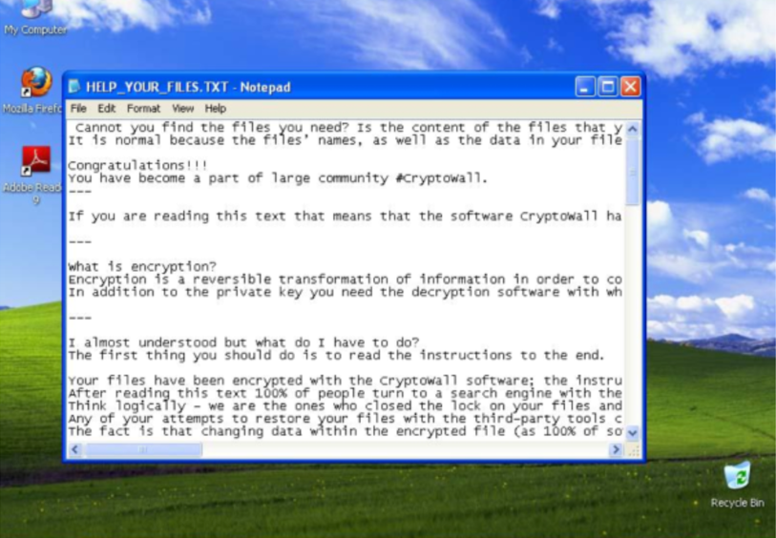
Here you can see an example of what would be shown on your computer device which has been infected by a variant of Crytowall. [8]

Why was it created? And who did it target?
Malware developers employed the CryptoLocker code as a foundation to craft CryptoWall, a novel form of ransomware, following the termination of CryptoLocker by researchers in 2015. Initially, CryptoWall functioned as a basic ransomware that established communication with a command-and-control server through HTTP.
Frequently, larger companies relying on outdated legacy systems that have not undergone recent updates become prime targets for attackers. The WannaCry ransomware attack, widely considered one of the most infamous ransomware incidents, significantly disrupted major corporations globally in 2017. This attack forced entities like Spanish telecom giant Telefónica, British National Health Service hospitals, and Taiwan Semiconductor Manufacturing Co. (TSMC), an Apple chip supplier, to suspend operations for a period of four days. The total impact extended to over 230,000 computers worldwide. [9]
Presently, CryptoLocker stands as a widely recognized malware with significant potential harm, especially for organizations heavily dependent on data. Once executed, the code encrypts files on desktops and network shares, effectively putting them under "ransom," necessitating payment to unlock the files. Consequently, CryptoLocker and its variants are commonly categorized as "ransomware." Malicious software like CryptoLocker can breach a secure network through diverse channels like email, file-sharing sites, and downloads. Despite the effectiveness of antivirus and firewall technologies, newly evolved variants have proven successful in bypassing them. Anticipating the emergence of more such variants in the future, it is prudent to enhance security measures by implementing detective and corrective controls. Additionally, strengthening access controls is recommended to minimize the potential damage that an infected host can inflict. [10]
The ransomware Cryptowall predominantly targets Windows Operating systemed computers as the files were designed for these devices. Cryptowall is a ransomware virus delivered through the use of a Trojan horse.

How is Cryptowall removed?
Never disregard that paying an online fraudster a ransom is never a smart move. How come? due to the lack of assurance that you will receive your files back. You will lose thousands of dollars in addition to your data if that occurs.
The most challenging part of incident response is not removing CryptoWall from a system. While a trustworthy antivirus program can successfully remove CryptoWall, it is unable to decrypt files. The private key, essential for decryption, is encrypted, making it impossible to uncover. Without the private key, files remain inaccessible and unrecoverable. [11]

How you could recover files lost to Crytowall.
It is recommended to use a file recovery service that is built for file recovery from ransomware and cryptowall built decryption software’s. There are many online tools for this such as: Wondershare RecoverIt, SalvageData. It is more than likely you will not be able to recover 100% of the files you have lost to a ransomware infection, but you might be able to regain access to vital files that you have lost. But never forget, do not pay the ransom to the attackers, as it is never guaranteed that they will give you access to your files back.

Precautionary measures
Thankfully, there are various strategies to defend against ransomware infections. Given the dynamic nature of ransomware threats, it is crucial to remain vigilant, adhere to basic cybersecurity practices to ensure that neither you nor your company is ever vulnerable to such risks. Ensure that the latest versions of your operating system, web browser, antivirus program, and any other software in use are consistently installed. Given the constant evolution of viruses, ransomware, and malware, which introduce new versions capable of circumventing outdated security measures, it is essential to regularly update everything.
Traditionally, malware infections have predominantly resulted from email phishing attacks. In 2020, 54% of managed service providers (MSP) identified phishing as the most prevalent method for distributing ransomware. A distinct report from the Federal Bureau of Investigation (FBI) highlighted phishing scams as the primary cybercrime in 2020, contributing to over $4.2 billion in losses or theft. [12]

Back up solutions (how to make one)
Establishing a backup on a cloud server or an external hard drive is a straightforward method to mitigate risk. To prevent data loss in the event of a ransomware attack, users should back up their most important data weekly and organisations should aim to back up their data at the end of every day. This means that the users can do a factory reset of their device and create a clean slate without any potential risk of malware remnants and allows for the user to restore any lost data in case of an attack.
A widely adopted strategy is to follow the 3-2-1 rule, aiming to maintain three distinct copies of data - one offline and two on different storage types. Introducing a second copy to an indelible (unerasable) or immutable (unchangeable) cloud storage server can add an additional layer of complexity to the process. [13]

Antivirus software’s
Frequently, the initial defence against external attacks is a firewall, serving as the first step of protection. Capable of thwarting attacks on both hardware and software, firewalls play a vital role in private or business networks. Their ability to filter and block suspicious data packets makes them essential for safeguarding the system.
Using strong antivirus software is one of the most common ways to defend against ransomware. Cyber threats can be scanned for, identified, and dealt with by these tools. Nevertheless, since antivirus software functions internally and can only detect an attack after it has entered the system, it is imperative that you configure your firewall as well. [14]

References

[1] | S. F. Martin P, “Ransomware and the cyber crime ecosystem,” NCSC Publications, 11 September 2023. [Online]. Available: https://www.ncsc.gov.uk/blog-post/ransomware-cyber-crime-ecosystem. [Accessed 8 November 2023].
[2] | N. C. S. Centre, “Ransomware, extortion and the cyber crime ecosystem,” NCSC Publications, 11 September 2023. [Online]. Available: https://www.ncsc.gov.uk/whitepaper/ransomware-extortion-and-the-cyber-crime-ecosystem. [Accessed 8 November 2023].
[3] | A. Frisina, “Why is Ransomware dangerous?,” 20 June 2023. [Online]. Available: https://sunlightmedia.org/why-is-ransomware-dangerous/#:~:text=Ransomware%20is%20the%20most%20damaging,access%20to%20their%20data%20forever.. [Accessed 8 November 2023].
[4] | A. I. Sharon Shea, “What is ransomware? How it works and how to remove it,” October 2023. [Online]. Available: https://www.techtarget.com/searchsecurity/definition/ransomware. [Accessed 8 November 2023].
[5] | A. I. Sharon Shea, “What is ransomware? How it works and how to remove it,” October 2023. [Online]. Available: https://www.techtarget.com/searchsecurity/definition/ransomware. [Accessed 8 November 2023].
[6] | C. O. Danny Palmer, “What is ransomware? Everything you need to know and how to reduce your risk,” 19 October 2023. [Online]. Available: https://www.zdnet.com/article/what-is-ransomware-everything-you-need-to-know-and-how-to-reduce-your-risk/. [Accessed 8 November 2023].
[7] | C. O. Danny Palmer, “What is ransomware? Everything you need to know and how to reduce your risk,” ZDNet, 19 October 2023. [Online]. Available: https://www.zdnet.com/article/what-is-ransomware-everything-you-need-to-know-and-how-to-reduce-your-risk/. [Accessed 8 November 2023].
[8] | A. Zaharia, “Everything You Need To Know About Cryptowall,” Heimdal, 14 February 2022. [Online]. Available: https://heimdalsecurity.com/blog/cryptowall-ransomware/. [Accessed 10 November 2023].
[9] | K. Chin, “How to Prevent Ransomware Attacks: Top 10 Best Practices in 2023,” 25 July 2023. [Online]. Available: https://www.upguard.com/blog/best-practices-to-prevent-ransomware-attacks#:~:text=Backing%20up%20your%20data%20to,at%20least%20once%20per%20day.. [Accessed 10 November 2023].
[10] | M. Buckbee, “CryptoLocker: Everything You Need to Know,” Varonis, 26 May 2023. [Online]. Available: https://www.varonis.com/blog/cryptolocker. [Accessed 10 November 2023].
[11] | proofpoint, “What is CryptoWall Ransomware?,” proofpoint, [Online]. Available: https://www.proofpoint.com/uk/threat-reference/cryptowall-ransomware#:~:text=Removing%20CryptoWall%20from%20a%20system,encrypted%20and%20protected%20from%20discovery.. [Accessed 10 November 2023].
[12] | K. Chin, “How to Prevent Ransomware Attacks: Top 10 Best Practices in 2023,” 25 July 2023. [Online]. Available: https://www.upguard.com/blog/best-practices-to-prevent-ransomware-attacks#:~:text=Backing%20up%20your%20data%20to,at%20least%20once%20per%20day.. [Accessed 10 November 2023].
[13] | K. Chin, “How to Prevent Ransomware Attacks: Top 10 Best Practices in 2023,” 25 July 2023. [Online]. Available: https://www.upguard.com/blog/best-practices-to-prevent-ransomware-attacks#:~:text=Backing%20up%20your%20data%20to,at%20least%20once%20per%20day.. [Accessed 10 November 2023].
[14] | K. Chin, “How to Prevent Ransomware Attacks: Top 10 Best Practices in 2023,” 25 July 2023. [Online]. Available: https://www.upguard.com/blog/best-practices-to-prevent-ransomware-attacks#:~:text=Backing%20up%20your%20data%20to,at%20least%20once%20per%20day.. [Accessed 10 November 2023].

