Personal Learning Environment

A personal Learning Environment is a concept in education that refers to the learning space created by an individual to support their personal and professional growth.
Personal learning environment are dynamic, learner-centered ecosystems that combine tools, resources, and networks selected and managed by the learner. A personal learning Environmentbis the set of sources, tools, information sources, and people that a student uses to enrich their learning in a autonomous and personalized way.
In this portofolio i will try to relate all my ideas and goals for effective learning.
Although I reached a certain age and went through different schools, I didn't really pay enough attention to how I manage my time, and what is the most useful way to learn, and what is my style, and I consider this to be essential for my professional development, understanding my own way of learning and organizing my time efficiently.

LEARNING OBJECTIVES
- EFFICIENT TIME ORGANIZATION
Although today everything is against the clock, the most important thing is the organization of time. Having the tendency to always solve as much as you have and to divide us more and more often between tasks, a balance must be built between learning moments, personal activities and time spent with loved ones, because this is the only way I can develop a good organizational skill. After researching on many sites, I discovered that planning your time in the form of lists, such as: 'To do', 'important', 'priority' makes it much easier to organize your time and at the same time your learning time, because with the help of perfect organization you can reserve a well-defined quality time.
- TO BECOME FOCUSED AND CONSTANT
It is very important because no success comes without effort.
Even if in everyday life there are good days and bad days, I think that each of us must clearly establish some limits and clear objectives in order to focus as much as possible and become as constant as possible.
Many studies show that performance comes from a well-established routine and discipline.
- IMPROVING THE WAY TO PERCEIVE AND SOLVE EFFICIENTLY
Over time I realized that it is not enough to just read and memorize information. Until you simplify them and understand their meaning and context, you can say that you have assimilated some information and that's it.
For me, a clear objective is to analyze how well you are and not to have everything done.

BLOG 1
MY LEARNING STYLE
Understanding my learning style has beeb an important step in improving my academic performance.
In the past, I considerate myself a fast learner because i was able to memorize information quickly. I often forgot what a had learned shortly after. /this made me realize that my aproach to learning was no effective in the long term.
What serprised me most was that my previous learning method was no aligned with how i actually process information. I used to reply heavily on readind and memorising, which is not my stronggest learning preference. This realisation has changed my perspective on studying, asI now understand the importance of adapting my methods to my personal learning style.
BLOG 2
MY LEARNING PLAN
Looking for different learning sources, I discovered that what I knew and what I was doing was not enough.
My plan is to organize my time as well as possible, to prioritize study and research even when I don't have exams, even for basic studies.
The most important thing for me, and what I aim to deepen, is to learn to be constant and to improve my way of learning.
Another thing I would like to integrate into my routine is to ask for help when needed, because another thing I learned is to share with my colleagues and the people around me, my accumulated knowledge, but also to share the things I don't know yet, without fear of being judged.
This plan will help me prosper in all plans and activities throughout my life. The purpose of this personal plan is to improve my learning methods, strengthen my discipline, and develop a progress-oriented mindset.
To achieve this goal, I aim to set clear objectives, maintain a consistent learning routine, manage my time more efficiently, deepen the knowledge I acquire, and, most importantly, develop the ability to learn independently.
Work Strategy
Regarding my approach, I intend to adopt an efficient learning system based on daily study, organizing information into structured frameworks, and consistently reviewing the material to ensure better retention.
Priorities and Mindset
In order to succeed, I consider it essential to adopt the right mindset. It is important to be aware and accept that progress comes as a result of the learning process, which inevitably involves mistakes and challenges.
Self-Assessment and Continuous Improvement
As part of my routine, I will introduce a process of self-assessment of the knowledge I have acquired. Additionally, I will regularly evaluate my results in order to identify areas that require improvement and continuously optimize my learning process.
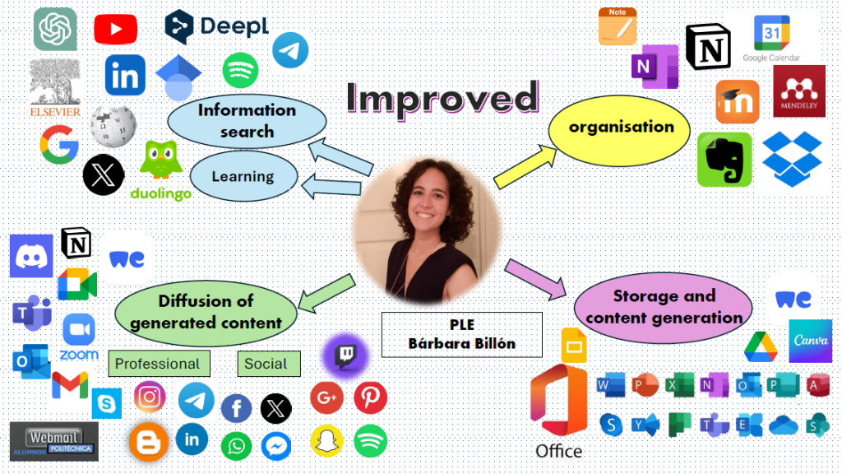

PLAN FOR BUILDING A PROFESSIONAL IDENTITY AND PARTICIPATING IN ORGANIZATIONAL AND BUSINESS COMMUNITIES
In order to develop a clear professional identity, I will begin by reflecting on my own values, skills, and interests.
At the same time, I believe that a professional identity is built and shaped much more effectively when I get involved, communicate, and collaborate with other people, rather than when I limit myself only to studying.

PRIORITIES
• The first step will be to develop my professional online portfolio, especially on LinkedIn, in order to shape my profile as effectively as possible. I will aim to personalize my profile as much as I can by adding an appropriate photo, a short description, and by including my interests as well as the skills I have acquired over the years, such as communication, teamwork, and organization.
Another important step is to try to get involved as much as possible in educational and professional activities, as well as group projects, which will allow me to learn from the experiences of others.
As privilege and a great opportunity, in my opinion, would be to participate in networking events and conferences, whether online or offline, as they provide me with the opportunity to meet new people, ask questions, and discover new career paths.
In conclusion, my plan is to build my professional identity through LinkedIn and active participation in communities, considering that these will help me develop my skills and create useful connections for my future career.

REFERENCED
Mafawez T. Alharbi, Amelia Platt, Ali H. Al-Bayatti Software Technology Research Laboratory De Montfort University, Leicester, UK
International Jurnal for e-Learning Security (lJeLS), Volume 3,Issues 1/2, March/ June 2013
Trey Martindale, 421C Ball Hall, University of Memphis, Memphis, TN 38152 ,
Michael Dowdy 421C Ball Hall, Universiyu of Memphis Memphis, TN 38152,
Allen, C(2004, October 14). Tracing the Evolution of Social Software. http/www.lifewithalacrity.com/2004/10/tracing_the_evo.html
Wenger, E, (1998). Comunities of practice- learning, meaning and identity, Cambridge, UK, New York, Cambridge University Press.
Gallego, MJ, & Gamiz, V.M. (2014) Personal Learning Environments (PLE), in the Academic Achievement of University Student, Australian Educational Computing , 29 (2). Retrieved from http//journal.acce.edu.au/index.php/AEC/article/view/30
Personal Learning Environment(PLE), Academic Achievement, University Student, Educational Technology, Higher Education, www.digibug.ugr.es
https//smowl.net/en/blog/personal-learning-environments/

