

LOCATION: BIRMINGHAM
LEVEL 4 | LEFEL 4
EXAMINATION PERIOD | CYFNOD ARHOLIADAU
SEPTEMBER 2021 | mEDI 2021

MODULE CODE: ACCA4017
SOFTWARE DEVELOPMENT
TIME: 2 HOURS
ANSWER ALL Question/s in PArt one
answer aNY TWO questions IN PART TWO

Equipment or materials required – Computers with Python installed or Google Colab

Valentin Blazhev
2026380

PART ONE: ANSWER ALL QUESTIONS

1. a) What variable type would Python infer for the following values:

1.32 float

124 integer

Hello string

-34.62 float

[-562] list

[1 mark each - 5 marks total]

1. b) Spot the errors in the following program to calculate the area of a circle and write the error-free program in the empty box.

Program with errors | Error-free program
print("Enter the radius)  radus = input()  area = 3.14*radius*radius  PRINT(" The area of the circle is : " area) | print(“Enter the radius:”)  radius=input()  area=3.14*radius*radius  print(“The area of the circle is:”+area)

[1 mark each mistake identified - 5 marks total]

1. c) How many iterations do the following loops have?

- for i in range(50):
print(i) 0 to 49 =50 interations

- for i in range(1,10,2):
print(i)
1,3,5,7= 5 interations

[2 marks each - 4 marks total]

1.d) What is the value of the integer variable total after the following code is executed?

total=0
for x in range(10):
total=total+x
if(x = = 5):
total=0 10 [4 marks total]

1.e) Given the following program:

Temp = [23,24,25,29,40,56]

i) Write the code you would use to print the value stored in the third element of the array on the screen
Temp = [23,24,25,29,40,56]
print(Temp[2])

ii) Write the code you would use to sum up the first and last elements of the array

Temp = [23,24,25,29,40,56]
res = [ Temp[i] for i in (0, -1) ]
print ("The first and last element of list are : " + str(res))

[1 mark each - 2 marks total]

[20 marks total for Question 1]

Part TWO (Answer any two questions)

1. Calculating the volume of a hemisphere

The volume of a hemisphere (half-sphere) is calculated using the formula:
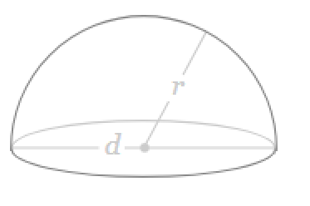

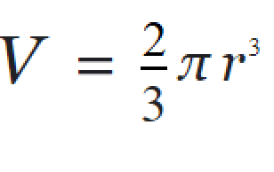

Task:
Write a program to calculate the volume using the above formula.

Allow the user to enter the measurement for r. You may set π as 3.142

import math
gvn_radus = float(input("Enter measurment = "))
valof_pi = 3.14
hemi_surfceara = 3*valof_pi*math.pow(gvn_radus, 2)
hemi_volum = (2.0/3.0)*valof_pi*math.pow(gvn_radus, 3)
print("The Surface Area of the given Hemisphere with radius {",
gvn_radus, " } = ", hemi_surfceara)
print("The Volume of the given Hemisphere with radius {",
gvn_radus, "} = ", hemi_volum)

[20 marks total]

2. Using List

Task:
Define a list called height and enter the following values:

height= [122,145,163,122,121,141,170,180].

Use the list functions available to do the following:
- Display the created list.
- Append 190 to the list.
- Display total number of elements in the list.
- Sort the list in ascending order and display the modified list.
- Display the list in reverse order.
my_list = [122,145,163,122,121,141,170,180]
print(my_list)
my_list2 = [190]
my_list.append(my_list2)
print(my_list)
print(len(my_list))
my_list.sort()
print("Ordered list: ", my_list)
my_list.reverse()
print(my_list)

[4 marks each - 20 marks total]

3. Using Turtle

Using Python with Turtle, draw the following shapes:
- A triangle with black background



import turtle

board = turtle.Turtle()

board.forward(100) # draw base

board.left(120)
board.forward(100)

board.left(120)
board.forward(100)

turtle.done()

[5 marks total]

- An octagon with yellow background and sides in alternative colours (red and black)

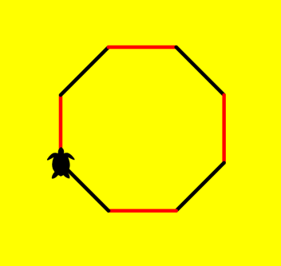

lenghtSide = 75
numSides = int(input("Enter number of sides:"))
angle = 360/numSides

initializeTurtle()
bgcolor("yellow")
for index in range(numSides):
if index%2==0:
color("red")
forward(lenghtSide)
right(angle)
else:
color("black")
forward(lenghtSide)
right(angle)

[15 marks total]

[20 marks total for Question 3]

Diwedd/End

