

LEVEL 7 ASSESSMENT SPECIFICATION

Student name: | Mahendra Vadhel | Student ID number: | 2430466
Programme: | MSc Public Health and Social Care in Practice
Module: | Population Health and Digital Health Promotion
Module code: | LCHS7009
Lecturer: | Dr Besty Jose
Assignment Title: | Component 1  2 Blogs

Blog 1
Improving Cardiovascular Care in the NHS Through Digital Innovation
Cardiovascular disease is considered to be one of the biggest causes of death across the entire UK. The British Heart Foundation declared that heart care waiting lists are now one of the major concerns that went up to 414596 in March 2024 in England (Escardio, 2025).
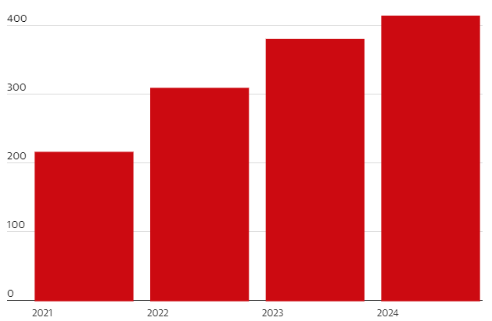
Image: Heart care waiting list
Weblink: https://www.theguardian.com/society/article/2024/may/19/heart-patients-wait-year-treatment-england-disease-waiting-lists
Why it is a concern
Cardiovascular diseases are determined by extremely prevalent risk factors, including cholesterol, diabetes, hypertension, obesity, and physical inactivity (Escardio, 2025). However, denied and late diagnosis impacts mortality as well as health conditions to a great extent. Henceforth, it can be stated that it is important to include more preventive measures for cardiovascular disease and streamline clinical pathways for individuals who are suffering from this disease (The Guardian, 2024).
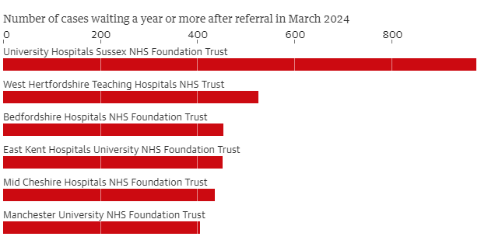
Image: Long waiting times at NHS Trusts for CDV
Weblink: https://www.theguardian.com/society/article/2024/may/19/heart-patients-wait-year-treatment-england-disease-waiting-lists
Digital technology in health promotion and addressing the public health problem
Application of Remote Patient Monitoring or RPM with app-based cardiac solutions is a key initiative in addressing the health problem and promoting prevention. In addition, Remote Patient Monitoring with the use of wearable sensors is impactful to gather data related to activities and psychology. The digital solution will help to understand and monitor heart failure symptoms. Additionally, it is proven that RPM and digital technologies can systematically review cardiac problems by reporting issues and improvements (Pannunzio et al., 2024). The integration of remote monitoring eliminates the need for hospitalization by almost 44% (Kassaw et al., 2024). Wearable devices are also promoting innovative solutions in terms of heart rate monitoring as well as screening. Alternatively, the NHS already raised funds for supporting the rapid growth of remote monitoring technologies for detecting heart failures and issues (NHS, 2025).
Advantages and disadvantages
The use of RPM will significantly improve uptake and access (Tan et al., 2024). In fact, early detection and prevention are the key advantages of using the particular digital solution in mitigating cardiovascular disease. RPM also supports optimization of resources that can eliminate burden on inpatient services, variables and applications are impactful to drive higher patient engagement. However, clinical validation along with data quality are the key concerns related to the use of the technology. In fact, challenges are also associated with integration and monitoring health records to effectively transfer data.
Ways to address the shortfalls
Considering the practical benefits and challenges, it can be advised that increasing digital literacy is important for health promotion. Integrating quality data into workflows will help to increase authenticity. At the same time, integration of robust evaluation methods is important for generating evidence-based care.

References
Escardio, 2025. The British Cardiovascular Society is a member of the European Society of Cardiology. Available at: https://www.escardio.org/The-ESC/Member-National-Cardiac-Societies/British-Cardiovascular-Society [Accessed on 27th Oct 2025].
Kassaw, M., Amare, G., Shitu, K., Tilahun, B. and Assaye, B.T., 2024. Willingness to use remote patient monitoring among cardiovascular patients in a resource-limited setting: a cross-sectional study. Frontiers in Digital Health, 6, p.1437134.https://www.frontiersin.org/journals/digital-health/articles/10.3389/fdgth.2024.1437134/full
NHS, 2025. technology-nhs/supporting-the-innovation-collaboratives-to-expand-their-remote-monitoring-plans. Available at: https://transform.england.nhs.uk/covid-19-response/technology-nhs/supporting-the-innovation-collaboratives-to-expand-their-remote-monitoring-plans/ [Accessed on 27th Oct 2025].
Pannunzio, V., Morales Ornelas, H.C., Gurung, P., van Kooten, R., Snelders, D., van Os, H., Wouters, M., Tollenaar, R., Atsma, D. and Kleinsmann, M., 2024. Patient and staff experience of remote patient monitoring—what to measure and how: systematic review. Journal of Medical Internet Research, 26, p.e48463.https://www.jmir.org/2024/1/e48463/
Tan, S.Y., Sumner, J., Wang, Y. and Wenjun Yip, A., 2024. A systematic review of the impacts of remote patient monitoring (RPM) interventions on safety, adherence, quality-of-life and cost-related outcomes. NPJ Digital Medicine, 7(1), p.192.https://www.nature.com/articles/s41746-024-01182-w
The Guardian, 2024. Heart-patients-wait-year-treatment-england-disease-waiting-lists. Available at: https://www.theguardian.com/society/article/2024/may/19/heart-patients-wait-year-treatment-england-disease-waiting-lists [Accessed on 27th Oct 2025].

Blog 2
Using Digital Technology to Manage Chronic Sleep Disorders
Chronic sleep disorders such as sleep apnoea, insomnia, and other problems are perceived as a major public health concern in the United Kingdom and beyond. The NHS survey reported that sleep disorders are ranked as top 5 reasons for sleep disorder among adults (Mentalhealth-uk, 2025).
Why it is a concern
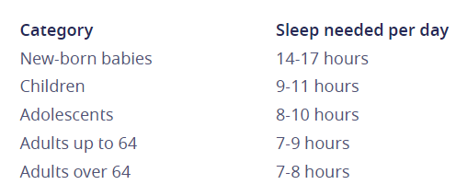
Image: Sleep pattern that should be followed
Weblink: https://mentalhealth-uk.org/help-and-information/sleep/
Reports reveal that almost 1 in 5 in the UK have sleep disorders, whereas 25% of adults in the country cited money-related issues, impacting their sleep cycle negatively (Mentalhealth-uk, 2025). The evidence demonstrates that poor sleep should be considered as a major public health issue and crisis globally. The growing concerns demand innovative and effective solutions that can help individuals to get relief.
Digital technology
In order to address the specific challenge, integration of a digital health platform that is empowered by wearable biosensors and AI-driven analytics would be a key solution in this context. In addition to this, inclusion of behavioral therapy sessions is also a major benefit of the proposed digital technology to reduce sleep disorders among people. The platform must be designed to perform as a sleep management system or tool that will also effectively work for people with sleep disorders. The platform will also cover continuous monitoring with robust cognitive behavioral support or CBT (Erten Uyumaz et al., 2021).
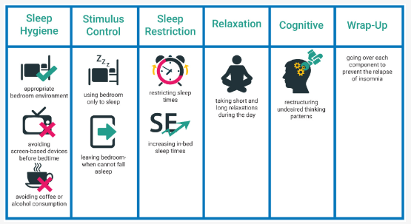
Image: CBT-I components
Weblink: https://www.mdpi.com/1660-4601/18/6/2929
How the digital technology will be used in health promotion and addressing the public health problem
The digital platform directly supports promoting health conditions by identifying modifiable sleep conditions and behaviors. Continuous monitoring and real-time feedback mechanisms are the fundamental pillars of the digital platform that will detect abnormalities in the sleep patterns. Based on the evidence collected of users, the AI-driven analytics can effectively produce personalized recommendations for addressing or mitigating the increasing or increasing health conditions (Cay et al., 2022).
Impact of the designed digital technology in health promotion
The designed technology significantly impacts sleep duration, movement patterns, heart rate variability by provoking a positive culture among people. The proposed digital platform offers robust monitoring and sleep management systems for large populations at the same time.
Advantages and disadvantages
The digital platform is also capable enough to provide personalized recommendations. In contrast, data privacy and security is a major concern in the legal context (Aziz et al., 2025). Similarly, algorithmic bias might also impact the therapy sessions and recommendations generated by the platform.
Ways to address the shortfalls
Based on the identified issues, it can be recommended that strong promotional activities are important to help people understand the benefit of a proper sleep pattern. Similarly, including governance structure, ethics, and a robust control system will help to comply with the GDPR regulations (Aziz et al., 2025).

References
Aziz, S., AM Ali, A., Aslam, H., A Abd-alrazaq, A., AlSaad, R., Alajlani, M., Ahmad, R., Khalil, L., Ahmed, A. and Sheikh, J., 2025. Wearable Artificial Intelligence for Sleep Disorders: Scoping Review. Journal of Medical Internet Research, 27, p.e65272.https://www.jmir.org/2025/1/e65272/
Cay, G., Ravichandran, V., Sadhu, S., Zisk, A.H., Salisbury, A.L., Solanki, D. and Mankodiya, K., 2022. Recent advancement in sleep technologies: A literature review on clinical standards, sensors, apps, and AI methods. IEEE Access, 10, pp.104737-104756.https://ieeexplore.ieee.org/abstract/document/9905578/
Erten Uyumaz, B., Feijs, L. and Hu, J., 2021. A review of digital cognitive behavioral therapy for insomnia (CBT-I apps): are they designed for engagement?. International journal of environmental research and public health, 18(6), p.2929.https://www.mdpi.com/1660-4601/18/6/2929
Mentalhealth-uk, 2025. help-and-information/sleep/. Available at: https://mentalhealth-uk.org/help-and-information/sleep/ [Accessed on 27th Oct 2025].

