

LOCATION: Swansea | LLEOLIAD: abertawe
LEVEL 4 | LEFEL 4
EXAMINATION PERIOD | CYFNOD ARHOLIADAU
May 2023 | MAI 2023

MODULE CODE: ACDA4004
Micros Peripherals and Interfaces
TIME: 2 HOURS
answer all questions

This Paper is marked out of 50. Allocate your time accordingly.

Equipment or materials required – Calculator
Adnoddau neu ddefnyddiau sydd eu hangen - Cyfrifiannell

ANSWER ALL QUESTIONS
(This Paper is marked out of 50. Allocate your time accordingly)

- The following comprise a number of mnemonics from the PIC16F887 microprocessor instruction set. Give the meaning of what each mnemonic stands for and explain what the instruction actually does:
  - BSF
[2 Marks]
  - BTFSC
[2 Marks]
  - ANDLW
[2 Marks]
  - MOVWF
[2 Marks]
  - INCF
[2 Marks]

- What is the resolution of a 10 bit ADC with a maximum input voltage of 2.5V? Give your answer in mV.
[4 Marks]

- For the Ramp Compare ADC shown in Fig Q3, explain the general principle of operation of the circuit.

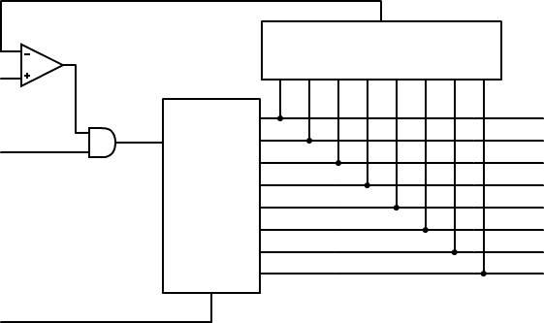
Analogue
input
Clock
Input
Reset
Digital
Output
Comparator
DAC
D7
D6
D5
D4
D3
D2
D1
D0
Q7
Q6
Q5
Q4
Q3
Q2
Q1
Q0
Binary
Counter

Fig Q3
[6 Marks]

- Draw the logic symbol for a NAND gate and provide the truth table for it.
[4 marks]

- The following circuit comprises two inputs, A and B. Construct a truth table, showing the output states of all the intermediate logic gates as well as the final, overall output. Provide a circuit diagram of a simplified circuit.

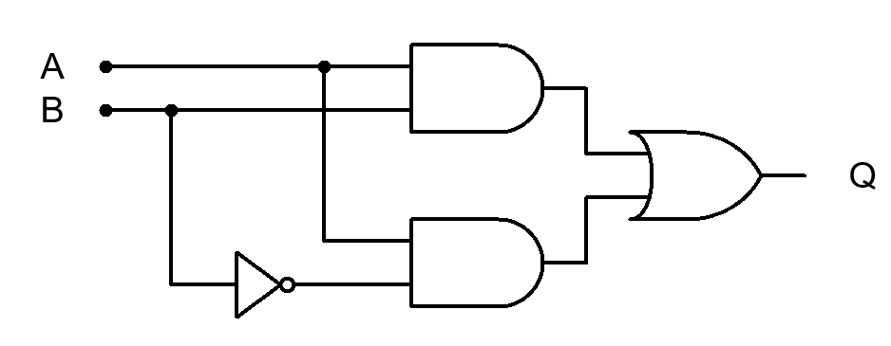

Fig Q5
[8 Marks]

- You are required to drive a traditional mechanical relay from a PIC output port. The PIC is powered from 5V, but the relay will require 48V DC and 120mA to operate it. Sketch a typical circuit configuration that you could use, explaining your reasoning for your choice of all components you use.
[8 Marks]

- In a typical Von Neumann architecture, the busses are labelled as ‘data’ ‘address’ and ‘control’ Describe what each bus is used for, and what the effect is of having different widths for the Data and address busses.
[10 Marks]

Diwedd/End

