

An Analysis of the Challenges of Digital Forensic Examinations of Mobile Phones in the Investigation of Online Grooming Offences, and How These Challenges Impact on a Police Investigation.

Darren Williams (2211518)
BSc Professional Investigation
3 November 2023

Word Count: 8,781

Declaration

This work has not previously been accepted in substance for any degree and is not being concurrently submitted in candidature for any degree.
Signed: 
Date: 21/09/2023
Statement 1:
This dissertation is being submitted in partial fulfilment of the requirements for the degree of BSc Professional Investigation.
Signed:
Date: 21/09/2023
Statement 2:
This dissertation is the result of my own independent work/investigation, except where otherwise stated.
Other sources are acknowledged by footnotes giving explicit references. A bibliography/reference list is appended.
Signed:
Date: 21/09/2023
Statement 3:
I hereby give consent for my dissertation, if accepted, to be available for photocopying and for interlibrary loan, and for the title and summary to be made available to outside organisations.
Signed:
Date: 21/09/2023

Statement 4:
I hereby give consent for my dissertation, if accepted, to be available on the university’s IT system to those who have consent to use the system.
Signed:
Date: 21/09/2023

Acknowledgement

I would like thank Dyfed Powys Police, my supervisor Cheryl Patrick, University lecturer Alison Cook and Learning Support specialist Afifa Zaman for their time and support whilst completing this dissertation.
I would also like to thank my wife for her continued support and guidance in helping me to stay focused and motivated throughout my studies whilst also fulfilling my obligations within Dyfed Powys Police. Without their support, none of this would have been possible.

Abstract

Considering the deliberate exploitation of technological advancements to facilitate criminal activities, law enforcement has found it imperative to undertake reassessment of their operational strategies, with a specific focus on harnessing digital forensic methodologies to investigate child grooming offences.
The primary objective of this dissertation is to analyse the evolving tactics employed by perpetrators in response to the dynamic landscape of technological progress. Additionally, it aims to elucidate the specific challenges confronted by law enforcement when employing digital forensic strategies in their investigative pursuits. Furthermore, this study examines the extent to which law enforcement agencies remain current with emerging forensic developments. In cases where they do not, it endeavours to offer recommendations for mitigating these challenges in future investigations.
Chapter two's literature review uncovers a correlation between the increase in reported child grooming offences and technological advancements, particularly in mobile phones. It delved into law enforcement's response strategies, examined challenges in deploying digital forensic software for evidence retrieval, yet underscores a deficiency in comprehending how these challenges affect investigations from the perspective of law enforcement.
As a result, a mixed-method approach was adopted, distributing targeted questionnaires to law enforcement personnel actively involved in child grooming investigations to address the gap in scholarly materials identified during the literature review.
Following the completion of this research, the dissertation achieved its aim by answering the question: An Analysis of the Challenges of Digital Forensic Examinations of Mobile Phones in the Investigation of Online Grooming Offences, and How These Challenges Impact on a Police Investigation.

Table of Contents
Declaration 1
Acknowledgement 3
Abstract 4
List of Figures 6
List of Appendices 7
List of Abbreviations 8
Chapter 1 - Introduction 9
1.1 Introduction 10
1.2 Background 10
1.3 Research Rationale 12
1.3.1 Unlocking Mobile Phones 13
1.3.2 Examination Software Limitations 13
1.3.3 Third Party Applications 13
1.3.4 The Demand for Mobile Phone Examinations in Investigations 13
1.4 Aims and objectives. 14
1.5 Structure 15
1.6 Conclusion 15
Chapter 2 - Literature Review 16
2.1 Introduction 16
2.2 Technological Advancements and Social Media Platforms 16
2.3 Increased Accessibility 17
2.4 Perpetrator Tactics and Police Response 17
2.5 General Digital Forensic Standardisation 18
2.6.1 Unlocking the Mobile Phones 19
2.6.2 Examination Software limitations 21
2.6.3 Third Party Applications 22
2.6.4 Demand in Digital Forensic Examinations in Investigations 23
2.6 Conclusion 24
Chapter 3 - Research Methodology 25
3.1 Introduction 25
3.2 The Research Strategy 26
3.2.1 Research Philosophy 27
3.2.2 Research Approach 27
3.2.3 Research strategy and choice 28
3.2.4 Time Horizon 29
3.3 Techniques: Data Collection and Analysis 29
3.3.1 Data Collection 29
3.3.2 Survey Design 29
3.3.3 Data Analysis 30
3.4 Reliability and Validity 30
3.5 Limitations 31
3.6 Ethical Considerations 31
3.7 Conclusion 32
Chapter 4 - Analysis of Results 33
4.1 Introduction 33
4.2 Data Analysis 33
4.3 Questionnaire findings 34
4.3.1 Theme One - Length of Service 34
4.3.2 Theme Two - Standardisation 34
4.3.3 Theme Three – Examination Software Limitations 35
4.3.4 Theme Four – Unlocking Mobile Phones. 37
4.3.5 Theme Five – Third Party Data 38
4.3.6 Theme Six – Demand in Digital Forensics. 39
4. 4 Summary of Findings 41
4.5 Conclusion 41
Chapter 5 - Conclusion and Recommendations 42
5.1 Introduction 42
5.2 Completion and Achievement of Objective 42
5.3 Main Findings 43
5.4 Recommendations 44
5.5 Limitations 45
5.6 Future Research 46
5.7 Conclusion 46
Chapter 6 - References 47
Chapter 7 – Appendices 61
Appendix A – Copy of the Questionnaires and the results. 61
Appendix B – Section 49 Powers 77
Appendix C – Dissertation Proposal 78

List of Figures

Figure 1.1 - Trends in child sexual abuse offences recorded nationally by police, April 2004 to March 2021 (Source: Skidmore, Aikenhead and Muir 2022).………………………………………………………………………………………...........P.11
Figure 1.2 - 5G revolution begins (Source: Drawing Capital, 2020) ……………………… P.11
Figure 2.1 – Mobile Encryption (Source: Shutterstock 2023) ………………………………P.20
Figure 2.2. - What Happens When You Press that Button? (Source: Cellebrite, 2014) ……………………………………………………………………………………........................P.21
Figure 3.1 – The Research Onion (Source: Saunders, Lewis, Thornhill 2019).………………………………………………………………………………………………P.26
Figure 3.2 - Deduction, induction, and abduction: from reason to research (Source: Saunders, Lewis, Thornhill 2019) ………………………………………………………………P.28
Figure 4.1 – Length of Service Response (Source Primary research questionnaire) ……………………………………………………………………………………………………...P.34
Figure 4.2 – ISO17 Accreditation Response (Source Primary research questionnaire) ……………………………………………………………………………………………………...P.35
Figure 4.3 – Software Limitations Response (Source Primary research questionnaire) ……………………………………………………………………………………………………...P.36
Figure 4.4 – Time to Research Response (Source Primary research questionnaire) ……………………………………………………………………………………………………...P.37
Figure 4.5 – S49 Application Response (Source Primary research questionnaire) ……………………………………………………………………………………………………...P.38
Figure 4.6 – Do current mobile forensic tools adequately extract third party application data…………………………………………………………………………………………………P.39
Figure 4.7 - Investigating Officer Awareness Response (Source Primary research questionnaire) …………………………………………………………………………………… P.40
Figure 4.8 – Frequency handsets are examined and received training (Source Primary research questionnaire) ……………………………………………………………………………………….....................P.40

List of Appendices

Appendix A – Copy of the Questionnaires and the Results…………………………… P.61 - 76
Appendix B – Section 49 Powers……………………………………………………………… P.77
Appendix C – Dissertation Proposal ……………………………………………………. P. 78 - 83

List of Abbreviations

UWTSD - University of Wales Trinity Saint David
DFE – Digital Forensic Examiner
IO – Investigating Officer
DFU – Digital Forensic Unit
CID – Criminal Investigation Department
FSR - Forensic Science Regulator
HMICFRS - His Majesty's Inspectorate of Constabulary and Fire & Rescue Services
CCTV – Closed Circuit television
SD Card – Secure Digital card.
SIM – Subscriber Identity Module
ISO17 - International Organisation for Standardisation
PIN - Personal Identification Number
RIPA - Regulatory Investigatory Powers Act

Chapter 1 - Introduction

1.1 Introduction

The primary objective of this dissertation is to understand digital forensics complexities in child grooming investigations and offer constructive recommendations for addressing these challenges in future investigations.
This chapter outlines the study's foundations, contextual relevance, and rationale for the chosen research topic.

1.2 Background

Addressing child sexual abuse has remained a focal point of public concern over many years. In the year 2021, the UK government introduced a comprehensive strategy titled "Tackling Child Sexual Abuse." This strategy set out the government's overarching objectives for the prevention, intervention, and response to incidents of child sexual abuse which also described child grooming as a form of child sexual abuse (HM Government, 2021).
Research reveals various definitions of child grooming, Kaylor et al., (2022); Lanning, (2017). While these definitions may vary slightly, they share a consistent core context. The NSPCC (2023) defines child grooming as the process wherein an individual builds a relationship, gains trust, and forms an emotional connection with a child or young person, intending to manipulate, exploit, and subject them to abuse.
Worryingly, multiple reports indicate an upward trend in reported child grooming offences. This statement finds support from NSPCC (2022), which underscores an 80% surge over a four-year period (Figure 1.1).
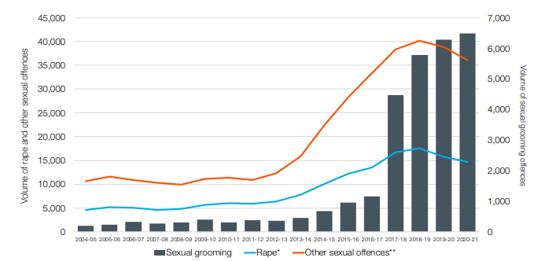
(Figure 1.1 - Trends in child sexual abuse offences recorded nationally by police, April 2004 to March 2021 - Skidmore, Aikenhead and Muir 2022, p.16)

It could be argued that one plausible rationale for this escalation could be attributed to advancements in mobile phone technology and the widespread availability of mobile phones globally.
Figure 1.2 follows the evolution of mobile phone capabilities over the past four decades, beginning with their limited function of voice calls in 1979 and progressing to include internet browsing, video streaming, and high-speed application access by 2019.

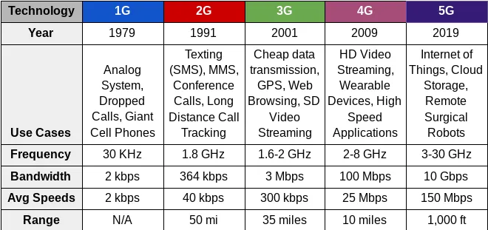
(Figure 1.2 - 5G revolution begins - Drawing Capital, 2020)
As these capabilities evolve, criminals are leveraging them to facilitate illegal activities, including the online grooming of young children through social networking platforms such as Facebook, Instagram, and Snapchat. These platforms, accessible via various devices, enable perpetrators to maintain anonymity and commit offences from their homes without physical contact with their victims.
Villacampa, Jesus, and Gomez (2016) found that children using mobile phones were at a higher risk of falling victim to this crime than those using desktop or laptop computers. This supports the hypothesis linking the rise in child grooming offences to advancements in mobile phone technology.
To tackle this issue, law enforcement employs digital forensic software like Cellebrite to analyse mobile phones for potential evidentiary data in criminal cases. Cellebrite (2022) claims their software legally accesses a wide array of mobile phones, extracting data like call records, text messages, third-party apps, and browsing history. This data aids police in suspect identification whilst proving or disproving their involvement in alleged crimes.
However, despite rising reports of such crimes, Skidmore, Aikenhead and Muir (2023, p. 38) suggests the success rate in court has declined, indicating potential shortcomings in current law enforcement strategies, and highlighting the need for a comprehensive review.

1.3 Research Rationale

The rationale for this research stems from the growing trend in reported child grooming cases. In our digitally driven society, especially with widespread mobile phone usage, criminals have capitalised on this medium to identify and groom children. Thus, it is vital for law enforcement to evaluate the efficacy of existing investigative strategies and, if deficiencies are identified, to understand their underlying causes and implement appropriate remedies.
This research is rooted in the findings of His Majesty Inspectorate of Constabulary and Fire & Rescue Services (2022), which indicated that police agencies exhibited inefficiencies in their utilisation of digital forensics during crime investigations, often lacking a comprehensive understanding of the potential data retrieval from mobile phones.
While scholarly literature such as Chow, Koltay, James (2018) and Mantas, Patsakis (2022) have previously discussed the domain of digital forensics, there is a notable shortage of research dedicated to the specific domain of online grooming offences and the strategies employed by law enforcement agencies in addressing the challenges posed by digital forensics within their investigations.
Whilst the compilation of challenges identified in mobile forensics within academic literature can be extensive, this study will focus on four specific challenges, which are summarised as follows:

1.3.1 Unlocking Mobile Phones

Mobile phone users commonly use screen locks. Occasionally, suspects may refuse to divulge their PINs, citing concerns about self-incrimination. Nakashima and Albergotti, (2021) suggests bypassing PIN locks has presented occasional challenges for law enforcement in the past.

1.3.2 Examination Software Limitations

Mobile forensic software adapts to new manufacturer updates, a process described as slow and time-consuming. As pointed out by Bennett (2012), this poses a significant challenge for law enforcement when trying to analyse modern devices.

1.3.3 Third Party Applications

Third-party applications represent an ever-present feature on mobile phones, granting users access to platforms encompassing social media, banking, and internet services. Consequently, data extracted from these applications may hold pivotal significance for investigative purposes. Nevertheless, Heath, MacDermott and Akinbu, (2023) observed, that encrypted data and disappearing messages pose a significant challenge for law enforcement agencies in data recovery.

1.3.4 The Demand for Mobile Phone Examinations in Investigations
Numerous sources highlight the crucial role of digital data in modern investigations, driven by technological advancements and their integration into daily life. Consequently, as noted by Anderson, Sampson, and Gilroy (2021, p. 596), investigations involving digital devices have seen significant growth. This has led to law enforcement agencies facing criticism for perceived delays in device examinations, resulting in a backlog of devices awaiting analysis.
Finally, Dyfed Powys Police is presently assessing its policies and strategies to enhance its digital capabilities, with the goal of establishing a nationally recognised centre of excellence for UK police forces. The research presented in this dissertation, which examines the challenges linked to digital forensic analysis of mobile phones in child grooming investigations, is expected to inform the development of innovative policies and strategies. These findings will influence future investigative procedures at the envisioned centre of excellence.

1.4 Aims and objectives.

This research aims to identify the challenges of examining mobile phones when dealing with online grooming offences, the impact these challenges have on an investigation, and highlight any recommendations to minimise the challenges in future investigations.

Objective(s):
- To research and analyse academic literature to understand the challenges of digital forensic examinations of mobile phones when dealing with online child grooming tactics and how these challenges impact a police investigation.

- To identify an appropriate research approach to recover primary data to explore how law enforcement manage these challenges to minimise the impact they have on an investigation.

- To analyse the data collected from primary research to better understand the challenges within mobile digital forensics from the standpoint of the Digital forensic examiners and Investigating officers.

- Purpose recommendations on how to improve police tactics when dealing with digital forensic examinations of mobile phones and minimise the impact the challenges have on police investigations.

1.5 Structure

To ensure the effective achievement of the stated objectives, individual chapters will be dedicated to the fulfilment of each specific objective.
Chapter two explores the evolution of online perpetrator tactics in parallel with digital advancements, assesses law enforcement's strategies involving digital forensics to counter these tactics, highlights digital forensic software challenges, and identifies research gaps in academic and governmental literature necessitating further investigation.
Chapter three explains the research method and methodology, aimed at identifying appropriate primary research techniques tailored to this study's objectives. This phase is designed to address research gaps and subsequently facilitate data analysis.
Chapter four is dedicated to the analysis of primary data obtained via the methods expounded in chapter three. The data will undergo rigorous statistical examination to unveil the research findings, which will then serve as the foundation for subsequent discussion and review.
Chapter five will engage in a thorough deliberation and review of the research's aim and objectives. Ultimately, it will culminate in a comprehensive discussion explaining the principal findings, recommendations, and the research's limitations.

1.6 Conclusion

Chapter one serves as the research introduction, suggesting that the increase in reported child grooming offences can be ascribed to advancements in mobile phone technology. This development has led law enforcement agencies to employ digital forensic tools in their investigations to combat the trend of perpetrators extending their criminal activities into the digital domain.
The subsequent chapter will conduct an in-depth literature review, facilitating a more extensive critical analysis of the matters introduced in chapter one.

Chapter 2 - Literature Review

2.1 Introduction

This chapter reviews current academic literature, critically analysing challenges in mobile phone forensics and assessing the effectiveness of existing investigative strategies in child grooming cases, with a primary emphasis on fulfilling the first dissertation objective.
- To research and analyse academic literature to understand the challenges of digital forensic examinations of mobile phones when dealing with online child grooming tactics and how these challenges impact a police investigation.

2.2 Technological Advancements and Social Media Platforms

Due to advancements in technology, Joleby et al., (2021) suggests there has been a growing academic and societal concern regarding individuals who exploit online communication capabilities to engage in the sexual grooming of children. According to NSPCC (2022), police-reported online grooming offences have surged by over 80% in the last four years, with 41 UK police forces reporting an 84% increase since 2017/18, totalling more than 27,000 offences since 2017. In 2021/22, there were 6,156 cases of sexual communication with a child, marking an increase from the previous year and an average of nearly 120 offences per week. Additionally, the Internet Watch Foundation (2023) reported that in 2022, over 63,000 child imagery reports were linked to children aged 7 to 10 who were coerced or tricked into performing sexual acts on camera by perpetrators, a 129% increase compared to 2021. Townsend (2021) highlights that 84% of victims targeted by perpetrators were female.
Academic research links the rise of online grooming to technological advancements, notably increased internet, and social media accessibility through third-party apps, granting children access to platforms like Facebook, Snapchat, and Instagram. According to Borj, Raja and Bours (2023); Kloess, Hamilton-Giachritsis and Beech (2017) and Children of the digital age (2023), these platforms have now become a target for criminality. Thukral and Kainya (2019) suggests this stems from perpetrators' ability to communicate with children without in-person contact, granting anonymity.
Whilst there are several social media platforms available to the public, Picheta (2019) and Byager (2019) suggest that Instagram has been recognised as the primary platform specifically targeted for grooming. This statement finds support by the BBC (2019), which revealed that out of the 1,944 child grooming incidents reported to the UK police during a six-month period in 2018, 32% occurred while the victim was engaged on Instagram. The NSPCC (2020) observed a subsequent rise in this statistic to 37% the following year, underscoring the ongoing trend of Instagram being a prominent platform for these criminal activities.

2.3 Increased Accessibility

With the continual advancement of digital capabilities, mobile phone users can easily connect to the internet and access social media via mobile applications. However, this increased accessibility may have adverse implications for child safety, potentially contributing to a surge in reported child grooming offenses.
Forbes (2023) explained that 99% of users accessed social media using mobile devices such as tablets or mobile phones, with 78% favouring mobile phones for this purpose. Furthermore, Ofcom (2023) indicated that children aged 3 to 17 were more likely to use mobile phones than any other device and Villacampa, Jesus, and Gomez (2016) reported that children with access to mobile phones are more vulnerable to becoming victims of grooming. Alarmingly, Statista (2023) revealed a significant global increase in the number of active mobile phones, with a billion more in 2021 compared to 2020, and this number was projected to further escalate by 2025 suggesting even more accessibility in the future.

2.4 Perpetrator Tactics and Police Response

When discussing perpetrator tactics in the pre-internet era, Ringenberg et al., (2022) noted that perpetrators aimed to isolate victims and induce general sexualisation, often employing substances or alcohol to secure secrecy. This necessitated physical proximity to the victim, increasing the risk of detection. Consequently, law enforcement relied on traditional investigative methods described by Nicol et al., (2004) as obtaining victim/witness statements, fingerprint/shoeprint analysis, and CCTV inquiries, However, the arrival of the internet and technological advancements has transformed perpetrator tactics, necessitating a corresponding evolution in law enforcement strategies.
Whilst Ringenberg et al., (2022) description of perpetrator tactics remains relevant, they have evolved to encompass targeting victims through various online channels described by Metropolitan Police (2023) as social media platforms, messaging apps, email, text, voice, video chats, forums, games, and apps, all while avoiding physical exposure or identification.
As a results, Law enforcement now employ digital forensic tactics within child grooming investigations, resulting in successful perpetrator identification and prosecution. Pidd's (2022) highlights a male convicted of 21 child sexual abuse and drug offences for posing as a 12-year-old girl online and grooming children for sexual activities. Digital forensic analysis uncovered numerous indecent images of children and explicit chats on his devices resulting in a conviction. Nonetheless, despite the effectiveness of digital forensic tactics in police investigations, significant challenges within this strategy have been identified.

2.5 General Digital Forensic Standardisation

Law enforcement relies on specialised Digital Forensic Examiners (DFEs) in designated Digital Forensic Units (DFUs) to identify and present digital evidence in complex cases like murder, child exploitation, and fraud by examining electronic devices. However, whilst the digital forensic recovery process has remained relatively unchallenged within the judiciary process, it has received criticism through academic literature and the media. According to Boddington (2015), digital forensic evidence submitted in court failed to meet the high standards compared to traditional forensic evidence such as fingerprint or footprint evidence. Sunde and Dror (2021) also argued that that digital forensic evidence that was relied on within the judicial process was bias and full of errors which could lead to wrongful convictions. This statement finds support from Osbourne (2022) where Police and Crown Prosecution Service were forced to apologise to a male accused of rape after the discovery of crucial text messages had not been extracted from a mobile device which casted doubt on the claim that the sexual activity was non-consensual. As a result of this failing, the investigation collapsed, and the male was released.
According to Du, Le-Khac, and Scanlon (2017) and Van Beek et al., (2020) An explanation for this criticism is that digital forensic science has been described as still being new and, in its infancy, therefore, open to interpretation. A further concern is the lack of a national standard meaning the police across the UK deal with digital forensics in their own way.
In consideration of the concerns raised, the Forensic Science Regulator (FSR) were given statutory powers under the Forensic Science Regulator Act (2021) which published a code of practice to ensure proper digital forensic techniques were adhered to under ISO 17025. Once proven, the respective law enforcement would receive an international accreditation through The United Kingdom and Accreditation Service (UKAS).
UKAS (2023) would suggest the advantages of this accreditation was that it provided an incorporating process that is internationally recognised, subjected to peer review, and demonstrated an approach centred on quality, this could be seen as a positive influence within the field of digital forensics. However, Sommer (2018) suggested that due to the complexity of digital forensics, the one strategy fits all route was a mistake and was not a solution to this issue, also HMICFRS (2022) suggested that to achieve and maintain these accreditations were nearly impossible in the long term.
This highlights that law enforcement is at a crossroads when attempting to provide an achievable and manageable national standard within digital forensics.

2.6 Mobile Forensics
Mobile phones store data in various locations, including the internal memory, SIM card, SD card, and cloud storage, rendering them valuable sources of information for investigations. To support this process, law enforcement agencies in the UK employ commercial tools like Cellebrite. Cellebrite (2023), Axiom, Magnet Axiom (2023), Grey Shift, Grey shift (2023) and XRY, XRY (2023). The benefits of employing these tools lie in their ability to utilise specialised software for data extraction, facilitating the creation of comprehensive reports. Consequently, investigating officers can access a wide range of data stored on the mobile handset which is described by Sammons (2014 p.150); RestoringData (2023) and Disklab (2017) as mobile logs, text messages, app data, images, videos, among others.
Nonetheless, mobile forensic tactics presents unique challenges alongside the standardisation issues encountered in digital forensics. A more detailed examination of these challenges is provided below.

2.6.1 Unlocking the Mobile Phones

To prevent unauthorised access to mobile phone data, users can activate the 'lock screen' feature, necessitating a code for entry. These security measures may take the form of a PIN code, pattern lock, biometrics, or facial recognition, effectively encrypting the data. Figure 2.1 demonstrates the appearance of these security options on a mobile handset.


(Figure 2.1 Mobile Encryption - Shutterstock 2023)

Law enforcement employ mobile forensics tools to attempt encryption bypass, commonly referred to as 'brute force,' although this method is constrained to alphanumeric PIN codes. Cellebrite (2023) states the advantage of this approach lies in the forensic examiner's ability to initiate the software to identify the code independently, allowing them to step away from the handset to continue with other work. While it may appear that utilising mobile forensic tools is an efficient strategy for circumventing a locked device, Da Silveira et al., (2020) suggests that without the user's cooperation in providing the PIN code, law enforcement frequently encounters difficulties in gaining access to the data. An illustrative case is reported by the BBC (2017), wherein the FBI was unable to access 7,000 encrypted mobile devices during an 11-month period.
However, previous research does not address law enforcement responses to this challenge but alternative methods for bypassing mobile encryption beyond mobile forensic tools are documented. Potovky and Stulrajter (2022) suggests that accessing data on a locked device is feasible even when the pinlock is unknown. Andriotis et al., (2016) support this notion, noting vulnerabilities in facial recognition software when a user's photo is presented to the handset and pattern locks were susceptible to memorable patterns like Z, M, N, and L. Additionally, Dee et al., (2022) highlighted potential biometric failures with printed fingerprints lifted from oil residue on the screen. This would present several different strategies available to law enforcement that fall outside of the digital forensic tools.
A further alternative method to digital forensics for obtaining access to a device's PIN is the use of S.49 Regulatory Investigatory Powers Act (RIPA) (2000), which authorises the issuance of a notice to compel the suspect to provide their device's PIN or code. This approach carries the benefit of motivating compliance by the person, as non-compliance could result in an additional 5-year sentence under S.53 Regulatory Investigatory Powers Act (RIPA) 2000. This notice can be reviewed in Appendix B.
Whilst this would suggest that are several tactics available to law enforcement to minimise these challenges, there is very little research discussing law enforcement awareness and adoption of these tactics.

2.6.2 Examination Software limitations

Law enforcement employs various digital forensic tools to extract data from mobile phones during investigations, many of which are developed and managed by forensic companies like Cellebrite and Greykey.
Research will show that there are three different levels of extraction available for mobile forensic examination. Forensic Colleges (2023) and Indian Legal System (2021) will describe these as Logical, File system and Physical extractions. Figure.2.2 lists what data can be recovered by each extraction and their limitations.

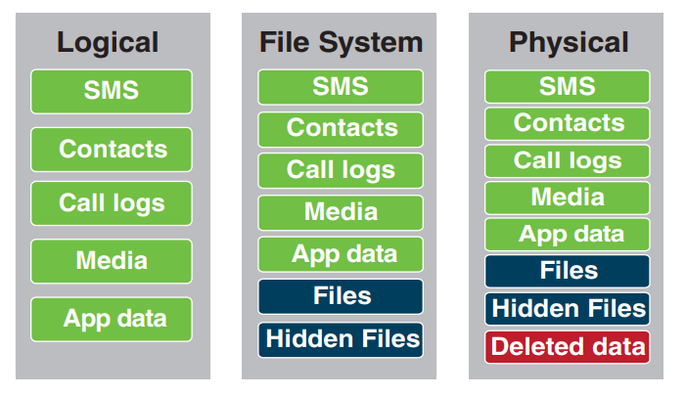
(Figure 2.2 – What happens when you press that button - Cellebrite 2014 p.4)

ADF Solutions (2023) assert that the benefits of using these forensic tools include their effectiveness in data collection and analysis, their ability to gather evidence from a range of devices, and their capability to preserve digital evidence in a forensically sound manner. Furthermore, offering three discrete tiers of data extraction affords digital forensic examiners a spectrum of choices and avenues for retrieving data in a manner conducive to its admissibility as evidence.
However, the drawbacks of relying on these mobile forensic tools include limitations on the number of supported devices and decreased effectiveness with newer handsets. Upon scrutinising Figure 2.2, it becomes evident that the amount of recoverable data in a forensic examination is reliant on the achievable level of extraction. Consequently, should the examiner not succeed in achieving a physical extraction, the subsequent alternative (file system extraction) will not encompass the recovery of deleted data, which may hold significant importance in an investigative context.
Packthub (2016) attributes these limitations to the vast array of hardware variations in the mobile phone market, encompassing various makes, models, and operating systems like Apple, Google Android, and Blackberry, each with multiple versions that undergo frequent updates. Consequently, Grayshift (2021) acknowledges that digital forensic tools lacking support for the latest devices may require months or even years to develop the capability for data access and extraction.
While law enforcement continues to use mobile forensics to preserve and secure digital evidence, academic research has provided limited insights into whether current mobile forensic tools align with the evolving digital landscape from the law enforcement perspective. Furthermore, it remains unclear whether any misalignment affects investigations. Hence, the primary research in this study aims to address this inquiry.

2.6.3 Third Party Applications

The ability of recovering data from third-party apps for evidential use remains a subject of contention. Mobile applications interact with various platforms on a device, including banking, social media, and games, among others, with the primary purpose of facilitating users' easy access to the internet and diverse platforms. Consequently, due to their functionality, Buildfire (2023) and Truelist (2023) note that there is a rising trend in user downloads of mobile apps.
This has the advantage of mobile apps having the capacity to store substantial amounts of data, an asset for law enforcement in their efforts to identify and prosecute online child grooming perpetrators. An illustrative case outlined by Everett (2022) involved a male who groomed a 12-year-old girl on Snapchat, subsequently meeting her, providing drugs, and committing rape. The data extracted from third-party applications on his mobile phone was utilised as evidence in court proceedings, ultimately contributing to a successful conviction. Nevertheless, the accessibility of recovering this data evokes mixed opinions. For instance, Dezfouli et al., (2016) conducted a study on data recovery from social network applications on mobile devices, revealing that data retrieval occurred through the binary data of extraction, which was absent in the chat logs. Menahil et al., (2021) also conducted a review on data recovery from various third-party applications like WeChat and Wickr through mobile forensics, yielding recovered data including usernames and chat content. However, contrary findings emerged from Kim et al., (2022) and Althebaity, Mishra and Shukla, (2020) asserting that the data was unrecoverable.
One plausible explanation for the variance in results is attributed to the extensive volume of hardware and app software updates by mobile manufacturers. These updates have the potential to modify the security configurations of specific apps on the device which Krishnan, Zhou and An, (2019, p.183) and Salamh et al., (2021) suggests potentially renders forensic software obsolete. This implies that the feasibility of data recovery from third-party applications can be marked by inconsistency and volatility.
This argument provides a contradiction in opinion in the ability of current mobile forensic tools which would requires further research.

2.6.4 Demand in Digital Forensic Examinations in Investigations

Caci (2022) and SCL (2021) suggest that over 90% of reported crimes in the UK incorporate a digital component, which is poised to exert a substantial impact on the operational demands faced by law enforcement agencies. From one vantage point, this development may be construed as advantageous, as it is anticipated to enhance the efficiency of law enforcement in terms of data identification and review as explained by Iris (2023) and Nakata (2016) as repetition-based optimisation. However, it is equally imperative to acknowledge the associated negative ramifications, as the heightened demand produced by this digital influx is likely to exert mounting pressure on law enforcement personnel.
Accurately gauging the national-level demand on law enforcement is challenging due to incomplete data; nonetheless, HMICFRS (2022) reported an increase from around 19,000 to approximately 25,000 seized devices between June 2020 and August 2022, marking a 32% rise. One suggested explanation for this increase came from Bowcott, (2018) who suggested the inadequate understanding and training of investigating officers in digital capabilities, leading to the unnecessary seizure of exhibits and consequently impacting the volume of devices requiring examination. Such circumstances can detrimentally affect the demand on DFE’s resulting the in the challenge in updating their expertise and skill set to align with evolving digital technologies. HMICFRS (2022) has cautioned that this pressure has the potential to render DFEs ineffective and obsolete.
To try to address this, DFEs collaborate with Investigating officers (IO’s) during investigations to alleviate the workload, yielding benefits in terms of data search and interpretation. However, drawbacks arise, as research indicates that IO’s often lack the necessary expertise compared to DFE’s. Langdon-Down (2018) found that trainee detectives had limited knowledge in searching and interpreting digital data, this statement finds support from BBC (2018) where an officer failed to uncover crucial evidence related to rape charge which resulted in its dismissal in court. Whilst current existing research suggests that both DFEs and IO’s face challenges in handling digital evidence, the adequacy of digital training both in their initial training and refresher courses, remains poorly researched.

2.6 Conclusion

In brief, the extant scholarly literature, corroborated by Hernandez et al., (2021), emphasises that technological progress has spurred shifts in the tactics employed by offenders. These shifts have led perpetrators to engage with victims on social media platforms, leveraging a certain level of anonymity, resulting in a notable increase of reported child grooming offences. It emphasised that law enforcement depends on digital forensics to detect and prosecute offenders of this offence type and while there is some evidence supporting the effectiveness of this approach, the review also underscored the nascent state of the digital forensics field, leaving room for interpretation and raising concerns about the data's ability to withstand judicial scrutiny.
The literature review examined multiple challenges within digital forensics and revealed ongoing research efforts aimed at mitigating these obstacles. Notably, there is a dearth of available material addressing whether law enforcement optimally leverages opportunities for data recovery in investigations by staying updated with emerging forensic developments or if they primarily depend on provided forensic software. Hence, an opportunity exists to conduct primary research involving both DFE’s and IO’s to gain insights into the challenges they encounter while employing digital forensic techniques in investigations.
The subsequent phase of this research project will focus on identifying an appropriate methodology for conducting primary research pertaining to the challenges highlighted in the literature review.

Chapter 3 - Research Methodology

3.1 Introduction

The literature review highlighted challenges in digital and mobile forensics, suggesting ongoing research and development efforts could address them. However, it highlighted law enforcement's ongoing struggle despite mitigation strategies. This review identified a pressing need for further research into the reasons behind this persistent challenge as previous research from the perspective of law enforcement was limited.
Collins dictionary (2023) and Walliman (2023) highlight that the definition of research is a subject of debate. An illustrative definition by the Cambridge Dictionary (2023) is a comprehensive investigation of a subject, often undertaken to uncover novel information or achieve fresh insights.
Bryman (2016) observes that within the realm of research, there exist two fundamental categories: Primary and Secondary research. This categorisation finds substantiation in academic literature such as Cummins et al., (2021) and Budianto (2020).
Understanding the difference between primary and secondary research was crucial for this study's completion. Saunders, Lewis, Thornhill (2019) explains that primary research constitutes the unprocessed data initially collected by the researcher, often gathered in a specific format and for a particular purpose. In contrast, secondary research encompasses data gleaned from prior studies, sourced from books and academic literature, conducted by different researchers with their distinct research objectives.
While the literature review primarily relied on secondary data as its foundation, this dissertation required the use of primary data to fill gaps in information unaddressed by the literature review.
The University of Derby (2023) underscores the benefits of primary research, offering current and directly relevant data. Yet, it acknowledges challenges such as the time-consuming aspects of data collection, analysis, and research planning. Despite the additional effort required, the up-to-date data holds immense value for this Dissertation. By completing primary research, this chapter seeks to achieve objective three:
- To identify an appropriate research approach to recover primary data to explore how law enforcement manage these challenges to minimise the impact they have on an investigation.

During this dissertation, the originally proposed objectives were restructured to better align with the overall dissertation structure. While the wording changed, the fundamental premise remained intact to address the dissertation question. The revised objectives are in the introduction, whilst the original is in Appendix C.

3.2 The Research Strategy

This Dissertation adopted the widely recognised research framework known as the “Research Onion” (Saunders, Lewis, Thornhill 2019). While Phair, Warren (2021) acknowledges its imperfections, the Research Onion, as indicated in the Academic Guide (2023), notes several benefits as It systematically navigates researchers through multiple research layers, facilitating a systematic and well-founded approach. Each layer progressively reinforces the research foundation, making a substantial contribution to the field's knowledge. Consequently, this framework is a prevalent choice in academic research projects and is deemed suitable for this dissertation.
This structure of the research onion has been broken down in Figure 3.1.
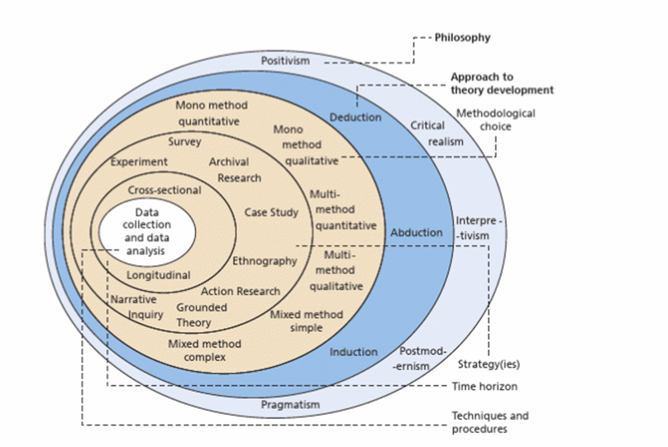
(Figure3.1 - The research onion, Saunders, Lewis, Thornhill 2019. p.130)

3.2.1 Research Philosophy

The outer layer of the research onion refers to the Research Philosophy which highlights the different philosophical considerations available to the researcher when completing a project.
This dissertation incorporated the interpretivism approach as Alharashesh, Pius, (2020) and Junjie, Yingxin, (2022) notes that this would allow a subjective perspective when considering the challenges of digital forensics from the standpoint of DFE’s and IO’s. (Saunders, Lewis, Thornhill 2019) also notes that this will be advantageous to the research as it will encompass individual interpretation and experiences within their responses which could not be predicted by the researcher as opposed to alternative research philosophies which provided Law like generalisations (Positivism) or give voice to marginalised views (Postmodernism).
In addition, utilising the interpretivism approach can also help corroborate current existing academic comprehension linked to this project or provide a different perspective which has yet been identified which could not be influenced by research bias.

3.2.2 Research Approach

The Research Onion discusses three research approaches accessible to researchers: deduction, abduction, and induction. These approaches have been described and discussed throughout academic literature such as Rashid, Rashid, Waseem (2019) and Folger, Stein (2017), which has been summarised within Figure 3.2.

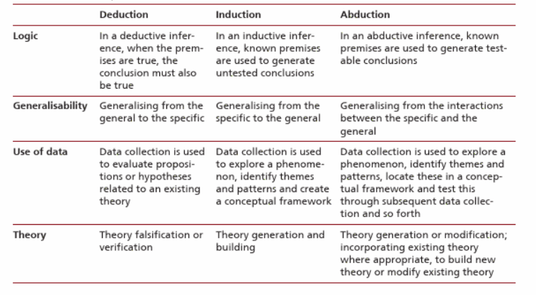
(Figure3.2 Deduction, induction, and abduction: from reason to research, Saunders, Lewis, Thornhill 2019. p.153)

This dissertation will employ the induction approach, formerly referred to as the inductive approach in previous editions of Saunders, Lewis, Thornhill (2016). Bryman et al., (2021) notes that this approach serves as an alternative strategy for bridging the gap between theory and research through a process of theoretical contemplation on a dataset. By adopting this methodology, the researcher endeavours to better understand the challenges within digital forensics from the standpoint of the DFE’s and IO’s.

3.2.3 Research strategy and choice

The research strategy will comprise of the Mixed – Method design where data will be collected in a form of questionnaires comprising of both qualitative and quantitative questions, these will be provided to IO’s within the CID and DFE’s within the DFU.
According to Goodwin and Goodwin (1996) qualitative and quantitative research can be used separately during a research project and still be useful to a researcher but combining both during a single study can provide a balanced and in-depth understanding to the research and its outcomes. Eyler (2021) supports this by suggesting that using mixed methods helps overcome limitations of using a single method by balancing the strengths and weaknesses of both quantitative and qualitative methods.
Distinct questionnaires will be furnished to each unit to gain deeper insights into the specific challenges confronting them. This approach enables the researcher to tap into the unique perspectives of both units, which are shaped by their respective backgrounds and experiences.

3.2.4 Time Horizon

The Time horizon aspect of the research onion relates amount of time the study will take. Saunders, Lewis, Thornhill (2019). As this research project will cover a short period of time, a cross sectional study will take place. Wang, Cheng (2020) notes the advantages of using a cross sectional study is that they are inexpensive and easy to complete however, associations identified might be difficult to interpret a prevalence.

3.3 Techniques: Data Collection and Analysis

3.3.1 Data Collection

There are many forms of collecting data as part of a research project, Cote (2021) notes these as surveys, interviews, focus groups, observations, and social media monitoring as a few examples. After careful consideration, the primary research for this research project will be completed in a form a questionnaire. Mcleod (2023) notes that a questionnaire is a research tool consisting with a series of questions by obtaining data from the respondents.

3.3.2 Survey Design

Two questionnaires will be completed which will be specific to each unit. Each questionnaire will comprise of 14 questions which will be a combination both qualitative and quantitative data.
Goodwin and Goodwin (1996) notes that data that is numerical, measurable and countable can be described as quantitative data whereas qualitative data is descriptive or interpretive data, whilst both data sets can provide an insight to the research on their own, the author suggested both methods should be combined during a single study as this will provide a balanced and in depth understanding of the research and its outcomes.
To create the questionnaires, the researcher will rely on the Microsoft forms software, this will then be dissemination to staff within the DFU and IO’s within the CID.
A copy of the questionnaires and the results has been provided in Appendix A of the dissertation.

3.3.3 Data Analysis

Following the administration of the questionnaire, the acquired data will be analysed utilising Microsoft's analysis software, specifically Microsoft Forms. Nonetheless, given the constraints of this software, which primarily presents data in pie charts, supplementary analytical graph structures will be generated to enhance the clarity of the analysis. These additional visual aids will be created using analytical tools within Microsoft Excel software.

3.4 Reliability and Validity

The reliability and validity of the data recovered from a research project is crucial to a researcher as this will determine the accuracy of the findings.
According to Saunders, Lewis, and Thornhill (2016), reliability pertains to replication and consistency, signifying that if another researcher were to conduct the same research with the same participants, they would obtain identical findings. Conversely, validity concerns the suitability of the measures employed for data collection and the accuracy of the researcher's analysis.
To safeguard both the reliability and validity of the primary data, the researcher has opted to distribute questionnaires exclusively to specific participants actively engaged in child grooming investigations or working in the domain of digital forensics within law enforcement. Specifically, this entails individuals serving IO’s within CID and DFE’s within DFU.
This is crucial to the research study as Saunders, Lewis, and Thornhill (2016) notes that by ensuring that the right participants are identified, this will ensure that the data recovered meets the aims and objectives of this research and the data is reliable and credible.
As previously mentioned, the primary research involves questionnaires. Pattern (2017) highlights potential drawbacks associated with questionnaire use in research. Firstly, questionnaires can lead participants to offer socially desirable responses, potentially impacting results. Secondly, questionnaire responses may offer only brief, unelaborated insights into decision-making, depending on the questionnaire's structure. To mitigate these issues, participants receive briefing packets emphasising the importance of anonymity to foster honest responses.
Lastly, to enhance the reliability and validity of the questionnaire, the final question was created as an open-ended question. As articulated by Weller et al., (2018), an open-ended question serves as a valuable tool for delving deeply into a subject, comprehending processes, and identifying observed correlations. This question offers respondents an unrestricted character limit, enabling them to potentially shed light on additional challenges not covered in the literature review.

3.5 Limitations

Sirisilla (2023) acknowledges that research invariably carries limitations, often rooted in methodology or research design. This study is no exception, with limitations stemming from the researcher's affiliation with law enforcement and constraints in accessing information.
The primary limitation lies in the researcher's current position within law enforcement, which could potentially introduce bias into the study. To mitigate this, the questionnaires were entrusted to the respective unit supervisors for distribution, ensuring the researcher's impartiality. This approach also guaranteed that the researcher had no influence over participant selection or responses. The questionnaire was closed upon reaching an adequate participation level,15 participants from each unit.
Another limitation is the study's focus on police tactics in identifying and prosecuting sexual grooming perpetrators. While there is previous research on these offences, the specific details of law enforcement tactics are highly sensitive and inaccessible for academic research. This constraint limited the available material for review and participant-provided data due to disclosure rules.

3.6 Ethical Considerations

Before commencing this dissertation, the researcher prepared a research proposal and underwent an ethics review process, which was assessed by the University of Wales Trinity Saint David. This process was aligned with the five fundamental ethical research principles elucidated as "Transparency, confidentiality, voluntary participation, non-harm, and impartiality" (Biggam, 2021, p. 29).
These principles were comprehensively explained in the research proposal and underwent a thorough review before obtaining project approval. In summary, each participant received a briefing outlining the research's aims and objectives. The primary data collection method involved the use of questionnaires, with no request for personal data. Participation was also entirely voluntary, and participants retain the right to withdraw their consent at any point without needing to provide a reason. Additionally, a comprehensive risk assessment was conducted as part of the ethics review process. Importantly, the researcher will exert no influence over how participants interpret and respond to the questionnaire, relying solely on their knowledge and experiences.

3.7 Conclusion

This chapter has discussed and demonstrated the methodology used to complete this research project as well as achieved objective three. The next chapter of this research project will present and analyse the data recovered from the Primary research.

Chapter 4 - Analysis of Results

4.1 Introduction

The methodology employed in this project has been thoroughly deliberated in the preceding chapter. The current chapter will shift its focus towards the third objective of the dissertation.
- To analyse the data collected from primary research to better understand the challenges within mobile digital forensics from the standpoint of the Digital forensic examiners and Investigating officers.

To accomplish this, this chapter will present and analyse primary research data collected from two online questionnaires distributed to both DFEs and IO’s. Available in Appendix A.

4.2 Data Analysis

Data analysis, as outlined by Kudyba (2014), involves intricate processes like data cleansing, inspection, transformation, and modelling, all aimed at uncovering new insights to support informed conclusions. For this dissertation, data collection and analysis will be conducted using Microsoft Forms, LouisevilleGeek (2023) suggests is a user-friendly software known for seamless compatibility with other Microsoft products. However, it has limitations, particularly in terms of customisation, which restricts the variety of questions and answer formats available.
Due to these constraints, a portion of the data will be processed in Microsoft Excel, where tables and graphs will be created to enhance data visualisation and comprehension.
Given that the collected data includes both qualitative and quantitative components, a systematic approach was adopted. Each participant received a unique identifier through the team's software and was categorised based on their respective units. This segmentation facilitated a systematic review, analysis, and comparison of responses, aligning with the research question's overarching objectives: "An analysis of the challenges of digital forensic examinations of mobile phones in the investigation of online grooming offences and how these challenges impact police investigations."

4.3 Questionnaire findings

4.3.1 Theme One - Length of Service

Both questionnaires began with an initial inquiry about the participants' length of service, and the results have been depicted below.

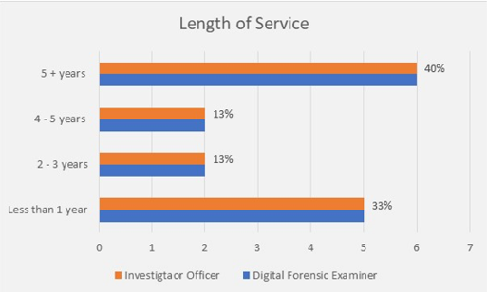
(Figure 4.1 – Length of Service Response)

4.3.2 Theme Two - Standardisation

Within the fifteen DFE participants, a significant majority, totalling 73%, shared the belief that acquiring and maintaining ISO17 accreditation was not sustainable in the long term. Additionally, they perceived law enforcement as placing a higher priority on this accreditation than on actual investigative work. Among this group, 13% strongly supported this perspective, while only 13% held a contrary opinion, indicating disagreement. Interestingly, none of the participants in this category strongly opposed the statement.
It is important to highlight that the IOs were not queried about standardisation within digital forensics, as this topic fell outside their area of expertise.
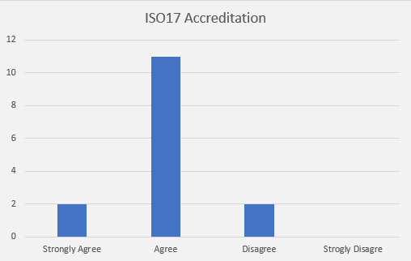
(Figure 4.2 – ISO17 Accreditation Response)

It is also noteworthy that the 13% of the participants who disagreed with the notion that ISO17 accreditation was nearly impossible to achieve and sustain long-term possessed between four to five years of service. This finding was unexpected, as it was anticipated that this response might come from less experienced DFEs who may have had limited exposure to the challenges of ISO17 accreditation within their limited careers. However, most participants (86%) concurred with the statement, aligning with the literature review, which indicates that challenges in forensic standardisation persist. This also supports the assertions made by HMICFRS (2022) that maintaining accreditation is exceedingly challenging.

Furthermore, in the absence of a nationally achievable standardisation, as noted by Boddington (2015), digital forensics may fall short of the rigorous standards upheld by traditional forensics. This deficiency, coupled with observations by Sunde and Dror (2021) that the evidence could be susceptible to bias and errors, raises concerns regarding the reliability of digital forensic evidence in the judicial process, despite its potential accuracy.

4.3.3 Theme Three – Examination Software Limitations

Both units were surveyed regarding digital forensic tools and their software limitations. Among the Fifteen DFE participants, a notable majority, totalling 60%, expressed the view that the current mobile forensic tools employed by law enforcement did not adequately meet the evolving demands of digital advancements. Participant ten elaborated on this issue in response to the qualitative question, citing it as one of the biggest challenges, stating, "Current forensic tools take up to 6 months to release new software updates that will provide updated capabilities to examine new devices. This can have a significant impact on an investigation."

However, it is noteworthy that 40% of the DFE participants disagreed with this perspective, indicating that they believed the current mobile forensic tools met or continued to meet the demands of digital advancements. This diversity of opinions within the DFE group underscores a mixed stance on this matter.

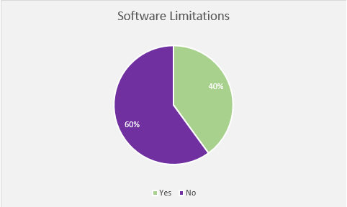
(Figure 4.3 – Software Limitations Response)

When analysing the data from the IO’s. The data supported the 60% of DFE’s, suggesting that the software limitations negatively impacted a police investigation. From the fifteen IO participants, 13% stated that these limitations frequently delayed their investigation and 53% stated that these limitations occasionally delayed their investigation whilst only 33% stated that it rarely delayed their investigation.

As a result of the primary research, the study was able to answer the outstanding questions within the literature review. in that the majority of the DFE’s believed that the forensic tools did not meet the demand of digital advancement and the majority of the IO’s believed that this frequently/ occasionally impacted their investigation.

4.3.4 Theme Four – Unlocking Mobile Phones.

Both units were surveyed regarding the challenges encountered when attempting to unlock mobile phones during investigations. A notable observation emerged from DFE participant six, who shared insights on this theme within the qualitative section of the questionnaire. Participant six underscored this as one of the most significant challenges, remarking, "An obvious issue is not being able to brute force devices running the newest software. This means we get no data from these devices."

Nonetheless, when the DFE’s were specifically inquired about whether they had adequate time to investigate alternative forensic methods for bypassing mobile pinlocks that extended beyond the capabilities of established mobile forensic tools such as Cellebrite and Greyshit, a unanimous response emerged. Every participant, comprising 100%, reported that they lacked the time for such research.

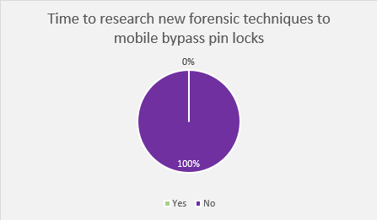
(Figure 4.4 – Time to Research Response)

The data will also demonstrate that when the IO’s were questioned about the frequency of their utilisation of Section 49 powers due to difficulties in accessing mobile handset data, none indicated "Frequently." Instead, 20% responded with "Occasionally," while a substantial 80% stated "Rarely."

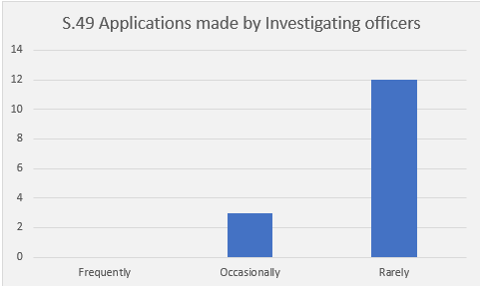
(Figure 4.5 – S.49 Application Response)

Participant six (IO) comments align with Da Silveira et al., (2020) perspective, highlighting that mobile encryption has indeed posed a substantial challenge for the mobile forensic tools employed by law enforcement. However, the data will also reveal that DFE’s encounter constraints when it comes to researching new forensic techniques to bypass these pinlocks, as elucidated in the literature review by Andriotis et al., (2016) and Dee et al., (2022). Consequently, the assertion made by Potocky and Stulrajter (2022), which posited that it was possible to bypass a locked device without knowledge of the pin code, would not be known to the DFE’s within this research as they do not engage in activities beyond the capabilities of their mobile forensic tools.

The literature review further underscored that in situations where a suspect declines to provide their pin code and mobile forensic tools encounter limitations preventing brute force access to the handset, law enforcement may resort to their Section 49 RIPA powers. The primary research addressed the frequency with which these powers are employed by law enforcement, a question left unanswered by the literature review, which indicated that such measures are rarely employed. This finding highlights a missed opportunity for accessing data on mobile devices which may be crucial to an investigation.

4.3.5 Theme Five – Third Party Data

Among the fifteen DFE participants, fourteen responded to a qualitative question inquiring about the biggest challenges encountered in mobile forensics. Out of these fourteen participants, ten emphasised that the retrieval of third-party application data remained a considerable challenge for them.

DFE’s rely on commercial tools like Cellebrite and Greyshift to extract this data. Out of the fifteen DFE participants, 53% believed that the current mobile forensic tools did not sufficiently extract third-party application data from mobile phones, while the remaining 47% stated that these tools were effective in this regard.

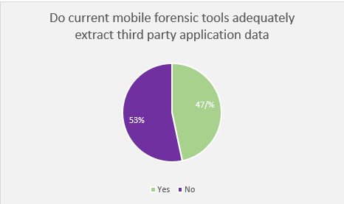
(Figure 4.6 – Do current mobile forensic tools adequately extract third party application data)

The literature review presented conflicting viewpoints regarding the efficacy of mobile forensic tools in retrieving data from third-party applications. The primary data recovered from the questionnaire could not resolve this contradiction as it also appeared within this research, this is evident from the response for this question as it was almost an even split.

4.3.6 Theme Six – Demand in Digital Forensics.

Within the literature Review, HMICFRS (2022) suggested that the number of devices awaiting to be examined had risen by 32% from 2020 to 2500 devices, however, there was little research to explain why this was the case. Consequently, the researcher endeavoured to uncover the reasons through primary research.
Among the fifteen DFE participants, a unanimous 100% indicated their belief that IO’s lacked sufficient awareness regarding the recoverable content from digital devices. Furthermore, a substantial 93% of participants believed that this dearth of awareness had an adverse impact on the backlog of devices awaiting examination, as devices were being submitted unnecessarily.
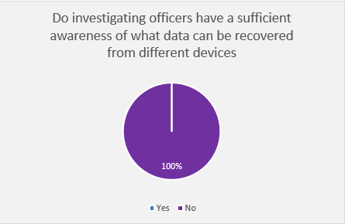
(Figure 4.7 – Investigating Officer Awareness Response)

This assertion finds reinforcement in the responses provided by the IO’s. A notable 93% of these officers disclosed that they frequently submitted mobile phones for examination as part of their investigations. Surprisingly, however, a substantial 80% indicated that they had not undergone any formal training pertaining to data collection and its significance.

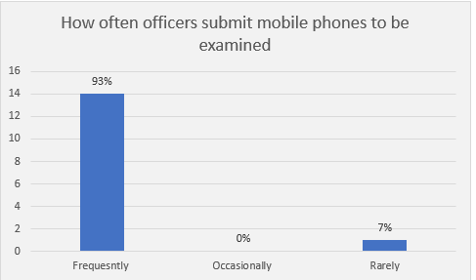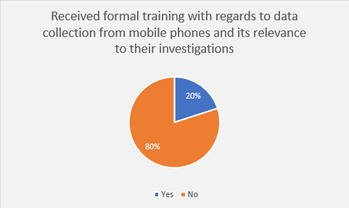
(Figure 4.8 – Frequency handsets are examined and received training)

This data aligns with the assertions made by sources such as Bowcott (2018) and HMICFRS (2022), which proposed that the upsurge in devices requiring examination is attributed to a deficiency in training and comprehension among IO’s. This, in turn, leads to the unnecessary seizure of exhibits.

4. 4 Summary of Findings

The data gleaned from participants in both the DFU and Criminal Investigation Department (CID) revealed a diverse range of lengths of service. This diversity in experience and knowledge levels allowed the primary research to tap into various depths of expertise.
Concerning the challenges of digital standardisation, the primary data corroborated the findings in the literature review, supporting the contention that achieving and maintaining ISO17 accreditation over the long term is an exceptionally daunting task, as suggested by HMICFRS.
Regarding the challenges associated with software limitations in digital forensic tools, most DFE’s expressed the view that current mobile forensic tools do not adequately meet the demands of digital advancements. Consequently, most IO participants reported that these limitations either frequently or occasionally caused delays in their investigations.
Concerning the challenges of unlocking mobile phones, DFE’s identified this as one of the foremost issues they face in their roles. However, they are not provided with the time to research new and alternative methods for bypassing pin locks that fall outside the capabilities of their mobile forensic tools. Additionally, the primary research revealed that IO’s are not frequently utilising their Section 49 (S49) Powers.
Regarding the challenges associated with the recovery of data from third-party apps, the primary data did not resolve the contradiction identified in the literature, as this issue persisted in the current research.
Concerning the challenges stemming from the demand within digital forensics, DFEs believed that IO’s lacked adequate awareness in the digital domain, resulting in a negative impact on the number of devices awaiting examination, as devices were being unnecessarily submitted. IO’s supported this perspective, with the majority indicating that they had received no training regarding data collection and its relevance from devices, yet they frequently submitted devices as part of their investigations.

4.5 Conclusion

This chapter has presented the results of the primary research, derived from questionnaires distributed to participants within the DFU and CID. Through this, the chapter has achieved objective three of this research, which entails the analysis of data obtained from primary research to gain deeper insights into the challenges within digital forensics as perceived by Digital Forensic Examiners and Investigating Officers.

Chapter 5 - Conclusion and Recommendations

5.1 Introduction

The previous chapter analysed primary research data and summarised the findings, fulfilling the third objective. This chapter will now focus on the dissertation's final objective:
- Purpose recommendations on how to improve police tactics when dealing with digital forensic examinations of mobile phones and minimise the impact these challenges have on police investigations.

In addition, it will provide a conclusion to the research question, “An analysis of the challenges of digital forensic examinations of mobile phones in the investigation of online grooming offences, and how these challenges impact on a police investigation.”

5.2 Completion and Achievement of Objective

This research study completed the following objectives:
- To research and analyse academic literature to understand the challenges of digital forensic examinations of mobile phones when dealing with online child grooming tactics and how these challenges impact a police investigation.
This objective was fulfilled in the second chapter, which examined existing literature on online predator grooming tactics and challenges in mobile digital forensics related to these offences. It also revealed a research gap in law enforcement's approach to these challenges, leading to the inclusion of primary research in this study.

- To identify an appropriate research approach to recover primary data to explore how law enforcement manage these challenges to minimise the impact they have on an investigation.
This objective was fulfilled in the third chapter of the dissertation, utilising the research onion framework by Saunders, Lewis, and Thornhill (2019). Two questionnaires, combining qualitative and quantitative aspects, were then distributed to DFE’s and IO’s.

- To analyse the data collected from primary research to better understand the challenges within mobile digital forensics from the standpoint of the Digital forensic examiners and Investigating officers.

This objective was fulfilled in the fourth chapter, the perspectives of both DFE’s and IO’s regarding the challenges in mobile forensics were clarified. These viewpoints were then juxtaposed with the findings of the literature review to facilitate the formulation of a comprehensive conclusion within this study.

- Purpose recommendations on how to improve police tactics when dealing with digital forensic examinations of mobile phones and minimise the impact the challenges have on police investigations.

This objective will be completed as part of this chapter.

5.3 Main Findings

As acknowledged in the literature (Du, Le-Khac, and Scanlon 2017; Van Beek et al., 2020), digital forensic science is still in its infancy, therefore poses inherent challenges. Nevertheless, given law enforcement's substantial reliance on mobile forensic tools in child grooming investigations, it is crucial to effectively address these challenges to ensure investigative integrity under judicial scrutiny.
A significant challenge identified in the literature review was the lack of standardisation, which was addressed by the FSR with a code of practice. However, HMICFRS (2022) argued that achieving and maintaining long-term standardisation was impractical, a view supported by 73% of DFE participants in the primary research.
The second challenge revolved around unlocking mobile phones using forensic tools. The literature review highlighted the feasibility but substantial difficulty of this task, with Da Silveira et al., (2020) suggesting that law enforcement often faced difficulties in recovering the data without the users providing pin codes. Primary research further emphasised this challenge, particularly in responses to the qualitative question. However, DFE’s were unable to explore alternative bypass methods, despite their existence in academic research.
The third challenge involved software limitations in mobile forensic tools. The literature and Forensic Focus (2021) both noted these tools had constraints, particularly in supporting newer devices, which could take years to address. Primary research findings supported these conclusions, with most DFE’s and IO’s expressing dissatisfaction with the tools' ability to keep pace with digital advancements, often impeding investigations.
The fourth challenge involved using mobile forensic tools to recover data from third-party applications. The literature review revealed conflicting opinions about the tools' efficacy in this regard. Primary research highlighted the retrieval of such data as a significant challenge, but it did not resolve the contradiction, as a similar divide of 53% to 47% emerged in participants' responses about the adequacy of these tools for data extraction.
The last challenge cantered on the demand for digital forensics and law enforcement's capacity to manage it. HMICFRS (2022) noted a backlog of 2,500 devices awaiting examination without a clear explanation. Primary research suggested that the backlog resulted from IO’s seizing devices without sufficient training in data collection and relevance, a perspective shared by investigating officers.

5.4 Recommendations

One of the main objectives of this study was to provide Dyfed Powys Police with insights into the challenges of mobile forensics in addressing online child grooming offences and to offer recommendations for improving their response as they establish the Centre of Excellence. Based on the research findings, the following recommendations are proposed:
It is imperative to acknowledge that the absence of digital forensic standardisation has been a recurring theme in prior research papers, and it has once again surfaced as a substantial challenge in this study. Despite the FSR stipulating the necessity for digital forensic methods to attain accreditation to withstand judicial scrutiny, the research has unmistakably demonstrated that achieving and sustaining this accreditation over the long term is an unattainable goal. This raises a critical concern when assessing the reliability of digital forensics as a viable investigative strategy for the future, warranting a thorough re-evaluation.
Additionally, while mobile forensic tools offer benefits in gathering evidence from mobile devices in police investigations, it is crucial to recognise their limitations and challenges. To address these issues, law enforcement should invest in researching and developing alternative forensic strategies that do not exclusively depend on these tools. For example, exploring alternative methods to bypass locked devices, as recommended by Panagiotis et al., (2016) and Dee et al., (2022), and leveraging Section 49 powers can serve as illustrative approaches. Currently, relying on these tools constrains the opportunities for DFE’s to succeed in mobile device examinations, potentially hindering investigations.
Lastly, the research conducted in this study underscores the rapid and exponential advancements occurring within the digital realm. It has become apparent that there is a deficiency in opportunities for both DFE’s and IO’s to either receive adequate training in digital disciplines or, in cases where training is provided, to have sufficient time to keep abreast of new developments. This issue was also highlighted in a report by HMICFRS (2020), and based on the findings of this research, it remains an unresolved challenge.

5.5 Limitations

One of the initial limitations encountered during this research project was the scarcity of relevant material available to the researcher within the field of digital forensics. As highlighted by Sunde and Dror (2021) and Robins (2021), the field of digital forensics is still relatively nascent. This limitation became apparent during the literature review, where the availability of material from reputable or peer-reviewed sources was notably limited. However, given the ongoing surge in digital advancements and the increasing susceptibility of this area to criminal activities, it is plausible that the body of research material pertaining to this subject matter will continue to expand, gradually mitigating this limitation.
The most significant limitation that surfaced during this study was the absence of perspectives from law enforcement. Despite being frequently scrutinised and criticised in the media for their investigative strategies (Lucas, 2022; Martin, 2022; Long, 2022), there remains a shortage of material presenting the viewpoints of law enforcement agencies. This study endeavoured to address this limitation by seeking the perspectives of law enforcement, aiming to offer an alternative and insightful understanding beyond the existing body of research.

5.6 Future Research

This research was conducted with a small number of participants, encompassing two units within the same police force. While the findings presented a novel perspective in a previously unexplored field, they were constrained by the limited number of participants. Future research conducted on a national scale, involving all 43 police forces, would yield a significantly larger dataset, offering a more comprehensive understanding of how the challenges within mobile forensics impact investigations at a national level. Such research could provide valuable insights to advance digital forensics in law enforcement investigations in the future.

5.7 Conclusion

In summary, this research explores how digital advancements have changed perpetrator tactics in targeting young children for online grooming and identifies challenges in mobile forensics for police investigations. It reveals ongoing research to address these challenges, but law enforcement is still adapting. The primary research offers a unique perspective, focusing on DFEs and IO’s in law enforcement, and suggests that future national-level research could further our understanding and mitigation of these challenges in investigations.

Chapter 6 - References

Academic guide (2023) Understanding Research Onion – A Detailed Guide with Examples Available at: https://www.academicguide.co.uk/2023/03/15/understanding-of-research-onion/ (Accessed: 15 September 2023).
ADF Solutions (2023) ‘The Benefits of Digital Forensic Software in Homeland Security Investigations’ ADF News, 7 June. Available at: https://www.adfsolutions.com/news/the-benefits-of-digital-forensic-software-in-homeland-security-investigations (Accessed: 05 September 2023).
Alharashesh, H.M. and Pius, A. (2020) ‘A Review of key paradigms: positivism VS interpretivism.’ Global Academic Journal of Humanities and Social Sciences, 2(3). pp. 39-43. Available at: 10.36348/gajhss.2020.v02i03.001(Accessed 23 June 2023).
Althebaity, M., Mishra, S., and Shukla, M.K. (2020) ‘Forensic Analysis of third- party mobile application’, Helix, 10 (4), pp. 32-38. Available at: https://doi.org/10.29042/2020-10-4-32-38 (Accessed 23 June 2023).
Anderson, P. Sampson, D. Gilroy, S. (2021) ‘Digital investigations: relevance and confidence in disclosure.’ ERA Forum, 22, pp. 587–599. Available at: https://link.springer.com/article/10.1007/s12027-021-00687-1. (Accessed 23 June 2023).
Andriotis, P., Oikonomou, G., Mylonas, A. and Tryfonas, T., (2016). ‘A study on usability and security features of the Android pattern lock screen.’ Information and Computer Security, 24(1), pp. 53-72. Available at: DOI:10.1108/ICS-01-2015-0001 (Accessed 23 June 2023).
BBC News (2017) ‘FBI failed to access 7,000 encrypted mobile devices.’ BBC News, 23 October. Available at: https://www.bbc.co.uk/news/technology-41721354 (Accessed 23 June 2023).
BBC News (2018) ‘Met Police apologise for Liam Allan rape case errors.’ BBC News, 30 January. Available at: https://www.bbc.co.uk/news/uk-england-42873618. (Accessed:16 August 2023).
BBC News (2019) ‘Instagram biggest for child grooming online - NSPCC finds.’ BBC News, 1 March. Available at: https://www.bbc.co.uk/news/uk-47410520. (Accessed 02 August 2023).
Bennett, D. (2012) ‘A Global Perspective: The challenges facing computer forensic investigators in obtaining information from mobile devices for the use in criminal investigations’, Information Security Journal: A Global Perspective, 21(3), pp. 159 –168. Available at: 10.1080/19393555.2011.65431717. (Accessed 23 June 2023).
Biggam, J. (2021) Succeeding with your master's dissertation, a step-by-step handbook. 5th edn. London: Open University Press.
Boddington, R (2015) The challenges of digital forensics. Available at: https://phys.org/news/2015-03-digital-forensics.html. (Accessed 17 June 2023).
Borj, PR. Raja, K. Bours, P. (2023) ‘Knowledge-based system, Online grooming detection: A comprehensive survey of child exploitation in chat logs’, Knowledge Based Systems, 259. Available at: https://www-sciencedirect-com.ezproxy.uwtsd.ac.uk/science/article/pii/S0950705122011327#sec4 (Accessed 23 June 2023).
Bowcott, O. (2018) Police mishandling digital evidence, forensic experts warn. Available at: https://www.theguardian.com/law/2018/may/15/police-mishandling-digital-evidence-forensic-experts-warn (Accessed 24 June 2023).
Bryman, A. (2016). Social Research Methods. 5th ed. Oxford: Oxford University Press.
Bryman, A. Sloan., Foster. L. and Clark, T. (2021) Social Research Methods. 6th edn. Oxford: Oxford University Press.
Budianto, A. (2020) Legal Research Methodology Reposition in Research on Social Science. Available at: https://d1wqtxts1xzle7.cloudfront.net/94536525/Legal_Research_Methodology_Reposition_in_Research_on_Social_Science-libre.pdf (Accessed 26 July 2023).
Buildfire (2023) Mobile App Download Statistics & Usage Statistics 2023. Available at: https://buildfire.com/app-statistics/. (Accessed: 23 June 2023).
Byager, L. (2019) Instagram is the most used platform for grooming crimes, report finds. Available at: https://mashable.com/article/instgram-grooming-child-offenses. (Accessed 02 August 2023).
Caci (2022) Maximising efficiency in policing through digital technology. Available at: https://www.caci.co.uk/insights/opinions/maximising-efficiency-in-policing-through-digital-technology/ (Accessed: 23 June 2023).
Cambridge dictionary (2023) The meaning of research in English. Available at: https://dictionary.cambridge.org/dictionary/english/research (Accessed: 26 July 2023).
Cellebrite (2014) What Happens When You Press that Button? Available at: https://smarterforensics.com/wp-content/uploads/2014/06/Explaining-CellebriteUFED-Data-Extraction-Processes-final.pdf (Accessed: 23 June 2023).
Cellebrite (2022) Cellebrite UFED. Available at: https://cellebrite.com/wp-content/uploads/2022/11/Solution_Overview_Cellebrite_UFED_LTR.pdf (Accessed: 08 June 2023).
Cellebrite (2023) Mobile Device forensics. Available at: https://cellebrite.com/en/digital-forensics/mobile-device-forensics/ Accessed 23 June 2023).
Children of the Digital Age (2023) 70% Increase in online grooming attributed to Facebook and Instagram. Available at: https://childrenofthedigitalage.org/70-increase-in-online-grooming-attributed-to-facebook-and-instagram/ (Accessed 13 June 2023).
Chow, KP. Koltay, A. James, J. (2018) ‘The Internet of Things and the Smart City: Legal challenges with digital forensics, privacy, and security.’ Security and Privacy, 1(3). Available at: https://onlinelibrary-wiley-com.ezproxy.uwtsd.ac.uk/doi/full/10.1002/spy2.23
Collins Dictionary (2023) Research. Available at: https://www.collinsdictionary.com/dictionary/english/research. Accessed 26 July 2023).
Cote, K. (2021) 7 Data collection methods in business analytics. Available at: https://online.hbs.edu/blog/post/data-collection-methods (Accessed 01 August 2023).
Cummins, L. Ebyarimpa, I., Cheetham. N., Brown, V. T., Brennan, K. and Panovska-Griffiths, J. (2021) ‘Factors associated with COVID-19 related hospitalisation, critical care admission and mortality using linked primary and secondary care data.’ Influenza, 15(5). Available at: https://onlinelibrary.wiley.com/doi/full/10.1111/irv.12864. (Accessed 23 June 2023).
Da Silveira, C.M., T. de Sousa Jr, R., de Oliveira Albuquerque, R., Amvame Nze, G.D., de Oliveira Júnior, G.A., Sandoval Orozco, A.L., García Villalba, L.J. (2020) ‘Methodology for Forensics Data Reconstruction on Mobile Devices with Android Operating System Applying In-System Programming and Combination Firmware’, Applied Sciences, 10(12), Article 4231, available: http://dx.doi.org/10.3390/app10124231. Available at: https://www.mdpi.com/2076-3417/10/12/4231 (Accessed 23 June 2023).
Dee, T., Richardson. and Tyagi, A. (2022) ‘Continuous Nonintrusive Mobile Device Soft Keyboard Biometric Authentication’, Basel, 6(2) Available at: 10.3390/cryptography6020014 (Accessed 23 June 2023).
Dezfouli, F., Dehghantanha, A., Eterovic-Soric, B and Choo, K.K.R. (2015) ‘Investigating Social Networking applications on smartphones detecting Facebook, Twitter, LinkedIn, and Google+ artefacts on Android and iOS platforms.’ Australian Journal of Forensic Science, 48(4) pp. 469 - 488 Available at: https://doi.org/10.1080/00450618.2015.1066854 (Accessed 23 June 2023).
Disklabs (2017) Mobile Phone Forensics. Available at: https://www.disklabs.com/forensics/mobile-phone-forensics/ (Accessed:23 June 2023).
Drawing Capital (2020) 5G revolution begins. Available at: https://drawingcapital.substack.com/p/5g-the-revolution-begins (Accessed: 06 June 2023).
Du, X. Le-Khac, NA. Scanlon, M. (2017) Evaluation of Digital Forensic Process Models with Respect to Digital Forensics as a Service. Available at: https://arxiv.org/abs/1708.01730 (Accessed 17 June 2023).
Dyfed Powys Police (2021) Digital forensic Investigator. Available at: https://policejobswales.tal.net/vx/mobile-0/appcentre-DyfedPowys/brand-0/candidate/so/pm/6/pl/17/opp/1910-Digital-Forensic-Investigator/en-GB (Accessed: 07 August 2023).
Everett, A. (2022) ‘Paedophile raped schoolgirl in fields after grooming her on Snapchat.’ Echo, 12 November. Available at: https://www.liverpoolecho.co.uk/news/liverpool-news/paedophile-raped-schoolgirl-fields-after-25494956 (Accessed 24: June 2023).
Eyler, A. (2021) Research Methods for public health. New York: Springer Publishing Company.
Folger, R. Stein, C. (2017) ‘Abduction 101: Reasoning processes to aid discovery.’ Human Resource Management Review, 27(2), pp. 306-315. Available at: https://doi.org/10.1016/j.hrmr.2016.08.007 (Accessed 26 July 2023).
Forbes (2023) ‘Top Social Media Statistics and Trends Of 2023.’ Forbes, 18 May. Available at: https://www.forbes.com/advisor/business/social-media-statistics/#:~:text=The%20most%20used%20social%20media,it%20doesn%27t%20stand%20alone. (Accessed: 03 August 2023).
Forensic Science Regulator Act (2021) Chapter 14. Available at: https://www.legislation.gov.uk/ukpga/2021/14/introduction/enacted (Accessed 15 September 2023).
Forensics College (2023) Mobile Forensics: How digital forensic experts extract from phones. Available at: https://www.forensicscolleges.com/blog/guide-to-mobile-forensics (Accessed: 23 June 2023).
Goodwin, W.L and Goodwin, L.D. (1996) Understanding Quantitative and Qualitative Research in Early Childhood Education. London: Teachers College Press.
Gray shift (2023) Revolutionary mobile forensic solutions for a safer world. Available at: https://www.grayshift.com/ (Accessed 23 June 2023).
GrayShift (2021) Without Access, Mobile Forensics Fails to Deliver. Available at: https://www.forensicfocus.com/news/without-access-mobile-forensics-fails-to-deliver/#:~:text=Legacy%20digital%20forensic%20investigative%20tools,in%20the%20area%20of%20analysis. (Accessed: 05 September 2023).
Hamilton- Giachritsis, C. Hansen, E. Whittle, H and Beech, A., (2017) A mixed methods study exploring how online and offline child sexual abuse impact young people and how professionals respond to it. Available at: https://learning.nspcc.org.uk/media/1123/impact-online-offline-child-sexual-abuse.pdf. (Accessed 01 August 2023).
Hasanabadi, S.S. Lashkari, A.H. Ghorbani, A.A. (2020) ‘A survey and research challenges of anti-forensics: Evaluation of game-theoretic models in simulation of forensic agents’ behaviour’. Forensic Science International: Digital Investigation. 35 (Dec) article 301024. Available at: https://www.sciencedirect.com/science/article/pii/S2666281720300925#bib49 (Accessed 23 June 2023).
Heath, H. MacDermott, A. Akinbi, A (2023) ‘Forensic Science international: digital investigation’ Forensic analysis of ephemeral messaging applications: Disappearing messages or evidential data, 46 (Sept) article 310585. Available at: https://www.sciencedirect.com/science/article/pii/S266628172300094X . (Accessed 21 July 2023).
Hernandez, M.P., Schoeps, K. Maganto, C. and Montoya-Castilla (2021) ‘The risk of sexual-erotic online behaviour in adolescents – Which personality factors predict sexting and grooming victimization’. Computers and human behaviour, 114 (Jan) article 106569. Available at: https://www.sciencedirect.com/science/article/pii/S0747563220303174. (Accessed 25 June 2023).
His Majesty Inspectorate of Constabulary and Fire & Rescue Services (2022), Digital Forensics, an inspection into how well the police and other agencies use digital forensics in their investigations. Available at: https://www.justiceinspectorates.gov.uk/hmicfrs/publications/how-well-the-police-and-other-agencies-use-digital-forensics-in-their-investigations/. (Accessed 19 June 2023).
HM Government (2021) Tackling Child Sexual Abuse Strategy. Available at: https://assets.publishing.service.gov.uk/government/uploads/system/uploads/attachment_data/file/973236/Tackling_Child_Sexual_Abuse_Strategy_2021.pdf (Accessed 06 June 2023).
HMICFRS (2022) Police forces overwhelmed and ineffective when it comes to digital forensics, new report finds. Available at: https://www.justiceinspectorates.gov.uk/hmicfrs/news/news-feed/police-forces-overwhelmed-and-ineffective-when-it-comes-to-digital-forensics/#:~:text=His%20Majesty%27s%20Inspector%20of%20Constabulary%20Matt%20Parr%20said%3A&text=But%20in%20our%20inspection%2C%20we,recover%20evidence%20from%20mobile%20phones. (Accessed 09 June 2023).
Horsman, G. (2020) ‘ACPO principles for digital evidence: Time for an update?’ Forensic Science International: Reports, 2 (Dec) article 100076. Available at: https://doi.org/10.1016/j.fsir.2020.100076 (Accessed 19 June 2023).
Ideausher (2023) Mobile App Industry 2023: Trends and Statistics. Available at: https://ideausher.com/blog/mobile-app-industry-trends-and-statistics/ (Accessed 23 June 2023).
Indian Legal System (2021) Methods of Mobile device extraction. Available at: https://indianlegalsystem.org/methods-of-mobile-device-extractions/ (Accessed 23 June 2023).
Internet watch foundation (2023) Sexual abuse imagery of primary school children 1,000 per cent worse since lockdown. Available at: https://www.iwf.org.uk/news-media/news/sexual-abuse-imagery-of-primary-school-children-1-000-per-cent-worse-since-lockdown/#:~:text=In%202022%2C%2063%2C050%20reports%20related,in%20this%20category%20in%202021. (Accessed 13 June 2023).
Iris (2023) 9 Benefits of Repetition for Learning (Read This First!), Available at: https://irisreading.com/9-benefits-of-repetition-for-learning/#:~:text=As%20you%20do%20the%20action,connections%20associated%20with%20that%20information. (Accessed 24 June 2023).
Joleby, M. Lunde, C. Landstorm, S and Jonsson, L.S. (2021) ‘Offender strategies for engaging children in online sexual activity’ Child abuse and Neglect, 120 (Oct) article 105214. Available at: https://doi.org/10.1016/j.chiabu.2021.105214 (Accessed 29 August 2023).
Junjie, M.A. Yingxin, M.A (2022) ‘The Discussions of Positivism and Interpretivism.’ Global Academic Journal of Humanities and Social Sciences, 4(1), pp. 10 – 14. Available at: DOI: 10.36348/gajhss.2022.v04i01.002. (Accessed 26 July 2023).
Kaylor, E., Winters, G.M., Jelic, E.L and Cilli, J. (2022) ‘An analysis of child sexual grooming legislation in the United States’ psychology, Crime & Law. 29 (9), pp. 982 – 1000. Available at: https://doi.org/10.1080/1068316X.2022.2043313. (Accessed 06 June 2023).
Kim, H., Shin, Y., Kim,S., Jo, W., Kim, M and Shon, T., (2022) ‘Digital Forensic Analysis to Improve User Privacy on Android’. Security and Privacy in Software Based Critical Contexts. 22(11), article 3971.Available at: https://www.mdpi.com/1424-8220/22/11/3971 (Accessed 23 June 2023).
Kloess, JA. Hamilton-Giachritsis, CE. Beech, AR (2017) ‘Offense Processes of Online Sexual Grooming and Abuse of Children Via Internet Communication Platforms’ Sexual Abuse, 31(1), pp. 73 - 96. Available at: https://doi-org.ezproxy.uwtsd.ac.uk/10.1177/1079063217720927 (Accessed 13 June 2023).
Kudyba, Stephan (2014) Big Data, Mining, and Analytics: Components of Strategic Decision Making. London: CRC Press.
Langdon-Down, G. (2018) Law enforcers struggle with electronic evidence challenges. Available at: https://www.lawgazette.co.uk/news/law-enforcers-struggle-with-electronic-evidence-challenges-/5066471.article (Accessed 09 August 2023).
Lanning, K. (2017) The evolution of grooming: Concept and term’. Journal of interpersonal Violence, 33(1) pp. 5 – 6. Available at: https://doi.org/10.1177/0886260517742046 (Accessed 06 June 2023).
Long, J (2022) ‘Police backlog of over 20,000 digital devices awaiting examination.’ Channel 4 News, 22 February. Available at: https://www.channel4.com/news/police-backlog-of-over-20000-digital-devices-awaiting-examination (Accessed: 19 June 2023).
Louisevillegeek (2023) Microsoft forms pros and cons. Available at: https://louisvillegeek.com/news/the-pros-and-cons-of-microsoft-forms/ (Accessed 01 August 2023).
Lucas, Z. (2022) UK police forces behind on the curve on technological advancements. Available at: https://thecrimereport.org/2022/12/13/report-uk-police-forces-behind-on-the-curve-on-technological-advancements/ (Accessed 19 June 2023).
Magnet Axiom (2023) Mobile Forensics. Available at: https://www.magnetforensics.com/products/magnet-axiom-v1/mobile/ (Accessed 23 June 2023).
Mantas, E. Patsakis.C (2022) ‘Who watches the new watchmen? The challenges for drone digital forensics investigations’ Array,14 (Jul) article 1000135. Available at: https://doi.org/10.1016/j.array.2022.100135 (Accessed 06 June 2023).
Martin, A. (2022) Frontline police not taught what evidence they can get from tech companies, training documents reveal. Available at: https://news.sky.com/story/frontline-police-not-taught-what-evidence-they-can-get-from-tech-companies-training-documents-reveal-12587312 (Accessed 19 June 2023).
McLafferty, S. (2010) Conducting questionnaire surveys, London: Sage.
Mcleod, S. (2023) Questionnaire: Definition, Examples, Design and Types. Available at: https://www.simplypsychology.org/questionnaires.html. (Accessed 17 August 2023).
Menahil, A. Iqbal, W. Iftikhar, M, Shahid, W.B, Mansoor, K and Rubab, S, (2021) Forensic Analysis of Social Networking Applications on an Android Smartphone. Mobile Intelligence Assisted by Data Analytics and Cognitive Computing 2021, 2021 (Sept) article 5567592Available at: https://doi.org/10.1155/2021/5567592 (Accessed 23 June 2023).
Metropolitan police (2023) Grooming. Available at: https://www.met.police.uk/advice/advice-and-information/gr/grooming/#:~:text=Grooming%20is%20when%20a%20person,also%20include%20other%20illegal%20acts (Accessed 13 June 2023).
Nakashima, E., Albergotti, R. (2021) The FBI wanted to unlock the San Bernardino shooter’s iPhone. It turned to a little-known Australian firm. Available at: https://www.washingtonpost.com/technology/2021/04/14/azimuth-san-bernardino-apple-iphone-fbi/ (Accessed 6 June 2023).
NSPCC (2020) Child sexual offences jump 57% in 5 years. Available at: https://www.nspcc.org.uk/about-us/news-opinion/2020/child-sexual-offences-rise/ (Accessed 25 June 2023).
NSPCC (2020) Instagram most recorded platform used in child grooming crimes during lockdown. Available at: https://www.nspcc.org.uk/about-us/news-opinion/2020/instagram-grooming-crimes-children-lockdown/ (Accessed 02 August 2023).
NSPCC (2022) Online grooming crimes have risen by more than 80% in four years. Available at: https://www.nspcc.org.uk/about-us/news-opinion/2022/online-grooming-crimes-rise/. (Accessed: 06 June 2023).
NSPCC (2023) What is grooming. Available at: https://www.nspcc.org.uk/what-is-child-abuse/types-of-abuse/grooming/#types (Accessed 06 June 2023).
Ofcom (2023) Children and parents: media use and attitudes. Available at: https://www.ofcom.org.uk/__data/assets/pdf_file/0027/255852/childrens-media-use-and-attitudes-report-2023.pdf (Accessed 13 June 2023).
Osbourne, S. (2022) Liam Allan: Met Police apologise to 22-year-old man falsely accused of rape after failing to disclose crucial text messages. Available at: https://www.independent.co.uk/news/uk/crime/liam-allan-met-police-rape-accusation-false-evidence-disclosure-arrest-mistake-detectives-a8184916.html (Accessed 28 August 2023).
Packthub (2016) Mobile Forensics and its Challenges. Available at: https://hub.packtpub.com/mobile-forensics-and-its-challanges/ (Accessed 28 August 2023).
Pattern, ML. (2017) Questionnaire Research. 4th edn. London: Routledge.
Phair, D. and Warren, K. (2021) Saunders’ Research Onion: Explained Simply. Available at: https://gradcoach.com/saunders-research-onion/ (Accessed 15 September 2023).
Picheta, R. (2019) ‘Instagram is leading social media platform for child grooming.’ CNN, 1 March. Available at: https://edition.cnn.com/2019/03/01/uk/nspcc-grooming-social-media-report-scli-gbr-intl/index.html (Accessed: 03 August 2023).
Pidd, H. (2022) Paedophile jailed after trying to groom children on social media. Available at: https://www.theguardian.com/uk-news/2022/may/10/paedophile-jailed-trying-groom-children-social-media. (Accessed 19 June 2023).
Potocky, S. Stulrajter, J. (2022) ‘The human interface device (HID) attack on android lock screen non- biometric protections and its computational complexity’. Science and Military, article 2022. Available at: DOI: 10.52651/sam.a.2022.1.29-36 (Accessed 23 June 2023).
Rashid, Y., Rashid, A., Warraich, M. A., Sabir, S. S., & Waseem, A. (2019). ‘Case Study Method: A Step-by-Step Guide for Business Researchers.’ International Journal of Qualitative. 18 (Jan - Dec). Available at: https://doi.org/10.1177/1609406919862424 (Accessed 26 July 2023).
Regulatory Investigatory Powers Act (2000) S.49. Available at: https://assets.publishing.service.gov.uk/government/uploads/system/uploads/attachment_data/file/742064/RIPA_Part_III_Code_of_Practice.pdf (Accessed 15 September 2023).
Regulatory Investigatory Powers Act (2000) Section 53. Available at: https://www.legislation.gov.uk/ukpga/2000/23/section/53#:~:text=53%20Failure%20to%20comply%20with%20a%20notice.&text=(1)A%20person%20to%20whom,the%20giving%20of%20the%20notice. (Accessed 15 September 2023).
Restoring data (2023) Mobile Forensics. Available at: https://www.restoringdata.ca/mobile-forensics-services.html (Accessed 23 June 2023).
Ringenberg, T.R., Seigfried-Spellar, K.C, Rayz, J.M. and Rogers M.K. (2022) ‘Child abuse and Neglect, enticements, coercion, isolation, substance abuse, gradual sexualization, and secrecy’. Child abuse and Neglect, 123 (Jan) article 105392. Available at: https://doi.org/10.1016/j.chiabu.2021.105392. (Accessed 13 June 2023).
Salamh, FE. Mirza, MM. Mirza, M.M., Hutchinson, S., Yoon, Y and Karabiyik (2021) What’s on the Horizon? An In-Depth Forensic Analysis of Android and iOS Applications.’ IEEE Access, 9, pp. 99421-99454. Available at: https:// doi: 10.1109/ACCESS.2021.3095562. (Accessed 23 June 2023).
Sammons, J. (2014) The Basics of Digital Forensics: The Primer for Getting Started in Digital Forensics. Waltham: Elsevier Inc.
Saunder, MK. Lewis, P. Thornhill, A (2016) Research Methods for Business Students. 7th edn. Essex: Pearson Education Limited.
Saunder, MK. Lewis, P. Thornhill, A (2019) Research Methods for Business Students. 8th edn. Essex: Pearson Education Limited.
Shutterstock (2023) Mobile encryption. Available at: https://www.shutterstock.com/image-vector/screen-lock-set-four-mobile-phone-1283669899?consentChanged=true (Accessed 07 August 2023).
Sirisilla (2023) Writing Limitations of Research Study — 4 Reasons Why It Is Important. Available at: https://www.enago.com/academy/limitations-of-research-study/ (Accessed 17 August 2023).
Skidmorem, M. Aitkenhead,B, Muir, R. (2022) Turning the tide against online child sexual abuse. Available at: https://www.police-foundation.org.uk/wp-content/uploads/2022/07/turning_the_tide_FINAL-.pdf (Accessed 09 June 2023).
Sommer, P. (2018) ‘Accrediting digital forensics: what are the choices. Digital Investigation, 25 (Jun) pp. 116 – 120. Available at: https://doi.org/10.1016/j.diin.2018.04.004 (Accessed 23 June 2023).
Sunde, N., Dror,I.E., (2021) ‘A hierarchy of expert performance (HEP) applied to digital forensics: Reliability and bias ability in digital forensics decision making’. Forensic Science International: Digital Investigation, 37 (Jun) article 301175. Available at: https://doi.org/10.1016/j.fsidi.2021.301175 (Accessed 18 June 2023).
The Association of Chief Police Officers (2012) ACPO good practice guide for digital forensics. Available at: https://www.digital-detective.net/digital-forensics-documents/ACPO_Good_Practice_Guide_for_Digital_Evidence_v5.pdf (Accessed 17 June 2023).
Thukral, P. and Kainya, V. (2019) ‘How Social Media Influence Crimes. Indian Journal of Law and Legal Research.’ Indian Journal of law and legal research, 5 (11), pp. 198 – 208. Available at: DOI: https://doi-ds.org/doilink/04.2022-64941518/IJLLR/V4/I2/A18 (Accessed 03 May 2023).
Townsend, M. (2021) Victims in 84% of online grooming cases are girls. Available at: https://www.theguardian.com/society/2021/mar/28/victims-in-84-of-online-grooming-cases-are-girls (Accessed 08 June 2023).
True List (2023) Apps Statistics 2023. Available at: https://truelist.co/blog/apps-statistics/ (Accessed 23 June 2023).
UKAS (2023) How accreditation benefits trade and professional bodies. Available at: https://www.ukas.com/accreditation/about/benefits-trade-professional-bodies/ (Accessed 23 June 2023).
University of Derby (2023) Dissertations - Skills Guide. Available at: 15 September 2023). https://libguides.derby.ac.uk/c.php?g=690330&p=4944393#:~:text=The%20advantages%20of%20conducting%20primary,directly%20answer%20your%20research%20question. (Accessed 15 September 2023).
Van Beek, H.M.A., Van den Bos, J. Boztaz, A. Van Eijk, E.L., Schramp, R and Ugen, M. (2020) ‘Digital forensics as a service: Stepping up the game.’ Forensic Science International: Digital investigations. 35 (Dec) article 301021 Available at: https://doi.org/10.1016/j.fsidi.2020.301021. (Accessed 17 June 2023).
Villacampa. C, Jesus Gomez. M (2016) Online child sexual grooming: Empirical findings on victimisation and perspectives on legal requirements. London: SAGE Publications.
Walliman (2023) Research Methods, the basics. 3rd Edn, Oxon: Routledge.
Wang, X. Cheng, Z. (2020) ‘Cross-Sectional Studies: Strengths, Weaknesses, and Recommendations’. Chest, 158(1), pp. 65 – 71. Available at: https://doi.org/10.1016/j.chest.2020.03.012 (Accessed 01 August 2023).
Weller, S.C., Vickers, B., Bernard, H.R., Blackburn, A.M., Borgatti, S., Gravlee, C.C. and Johnson, J.C. (2018). ‘Open-ended interview questions and saturation.’ Plos One, 13(6). Available at: https://doi.org/ 10.1371/journal.pone.0198606. (Accessed 17 August 2023).
XRY (2023) XRY – Mobile Forensics and Data Recovery Software. Available at: https://www.msab.com/product/xry-extract/ (Accessed 23 June 2023).

Chapter 7 – Appendices

Appendix A – Copy of the Questionnaires and the results.

Digital Forensic Investigator Questionnaire
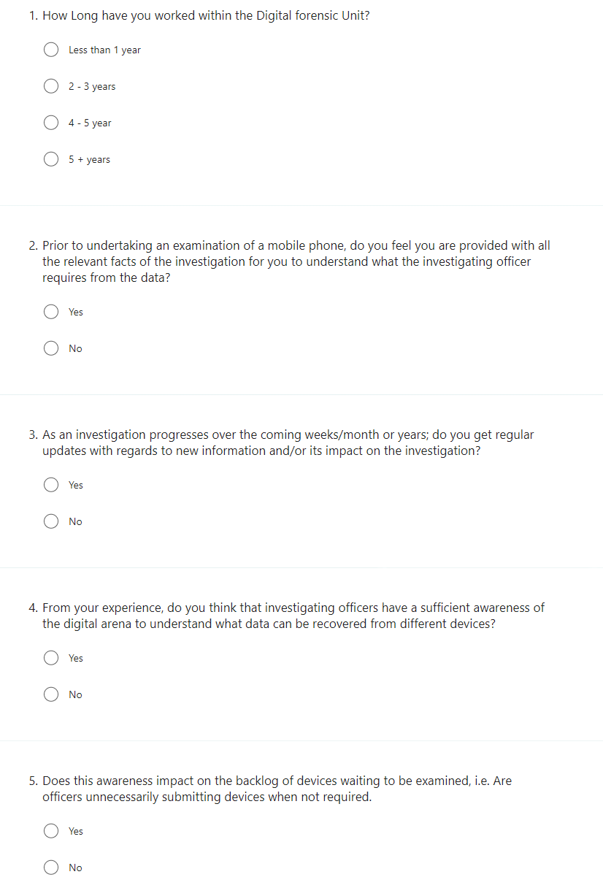
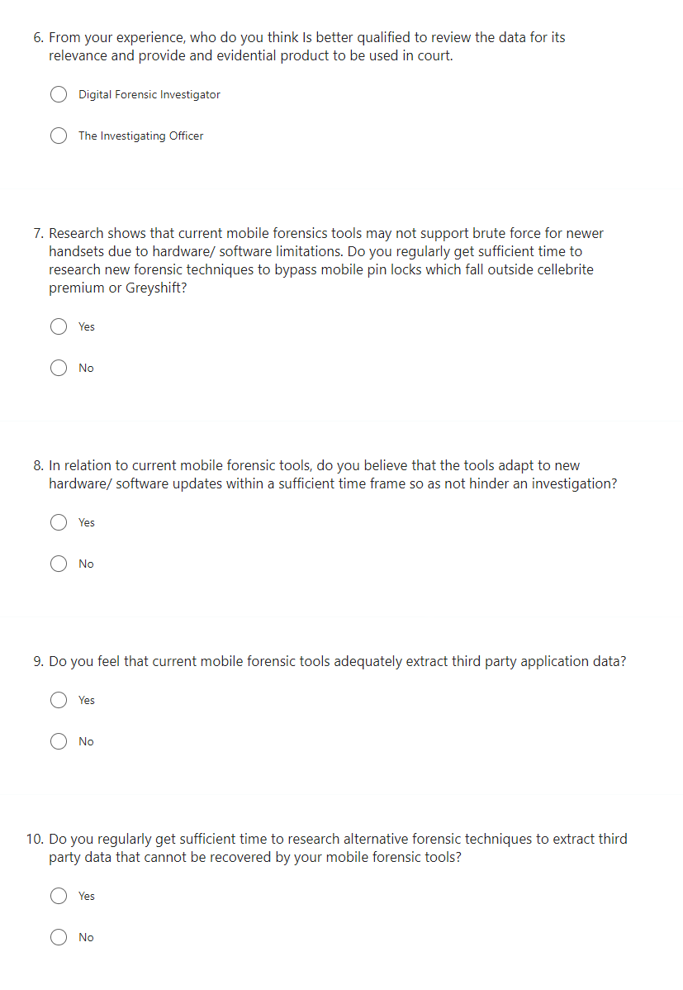

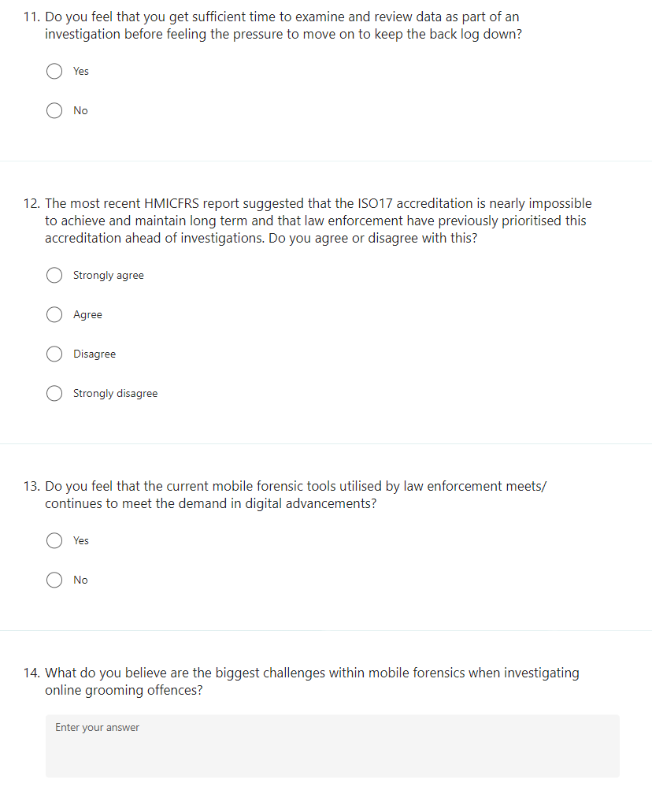

Digital Forensic Investigator Questionnaire Results

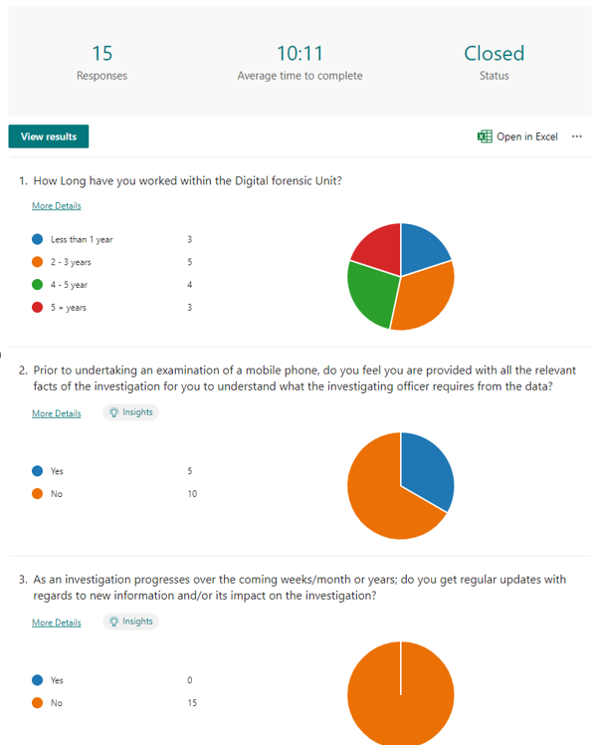
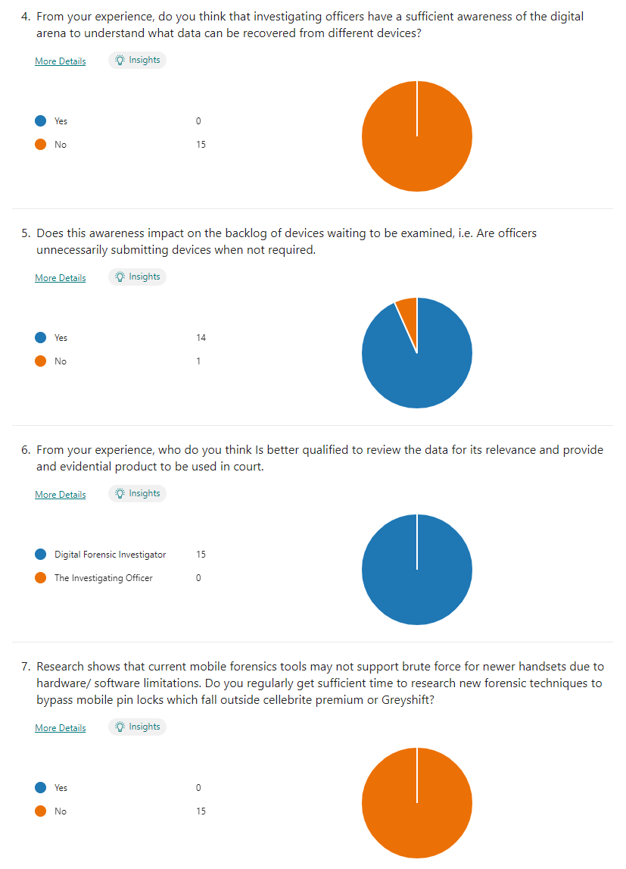
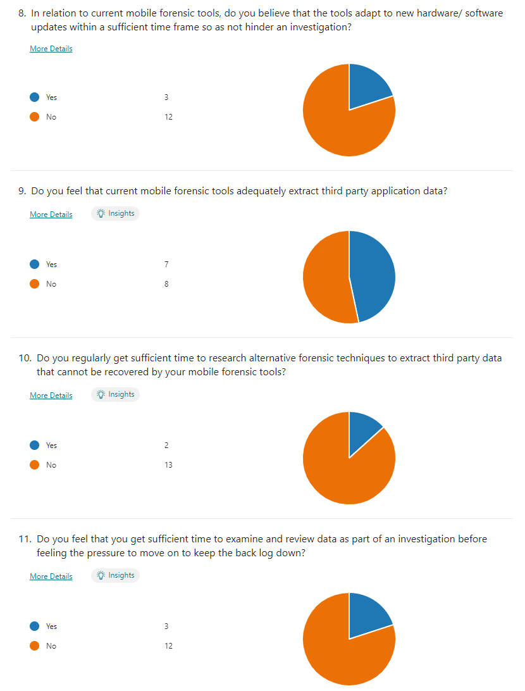
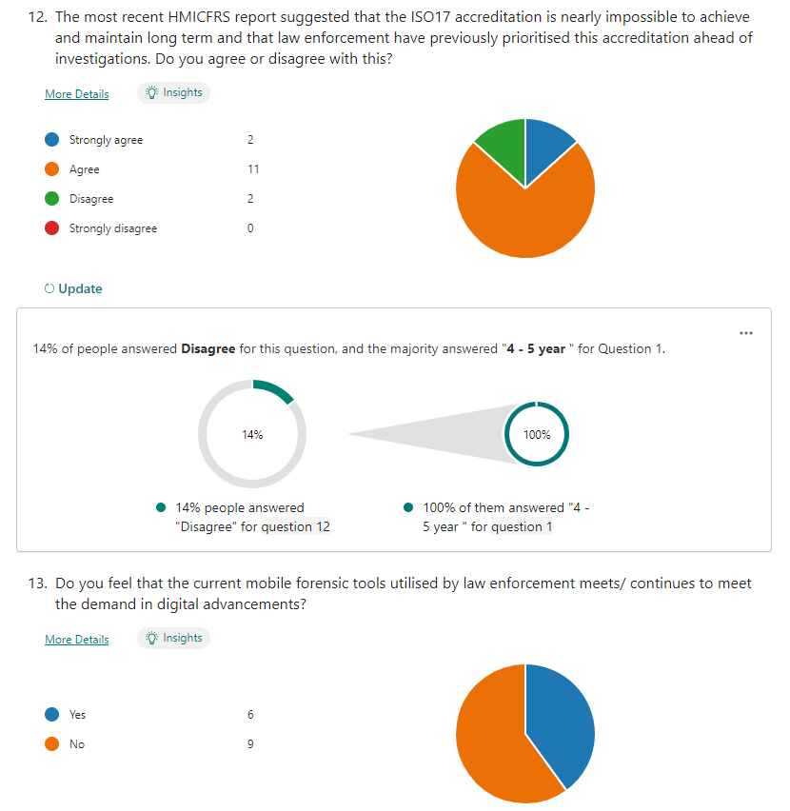
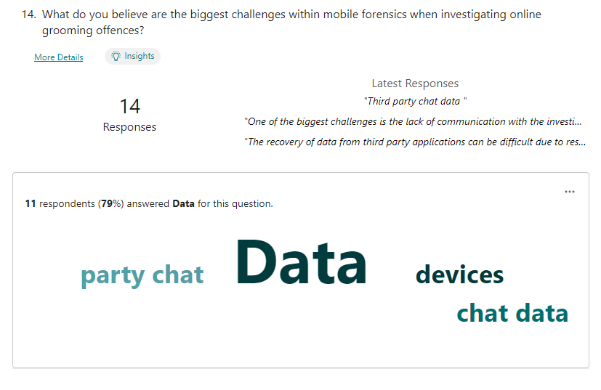
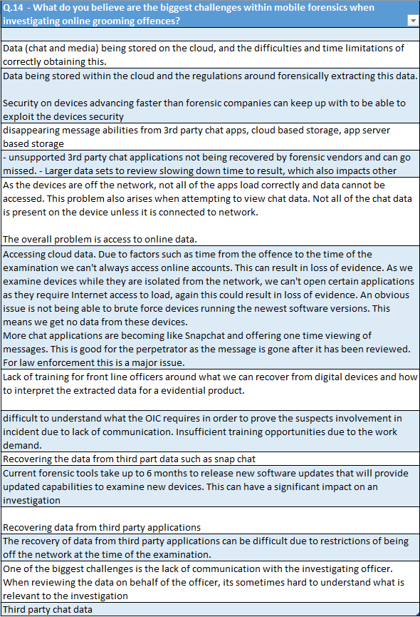
Investigating Officer Questionnaire
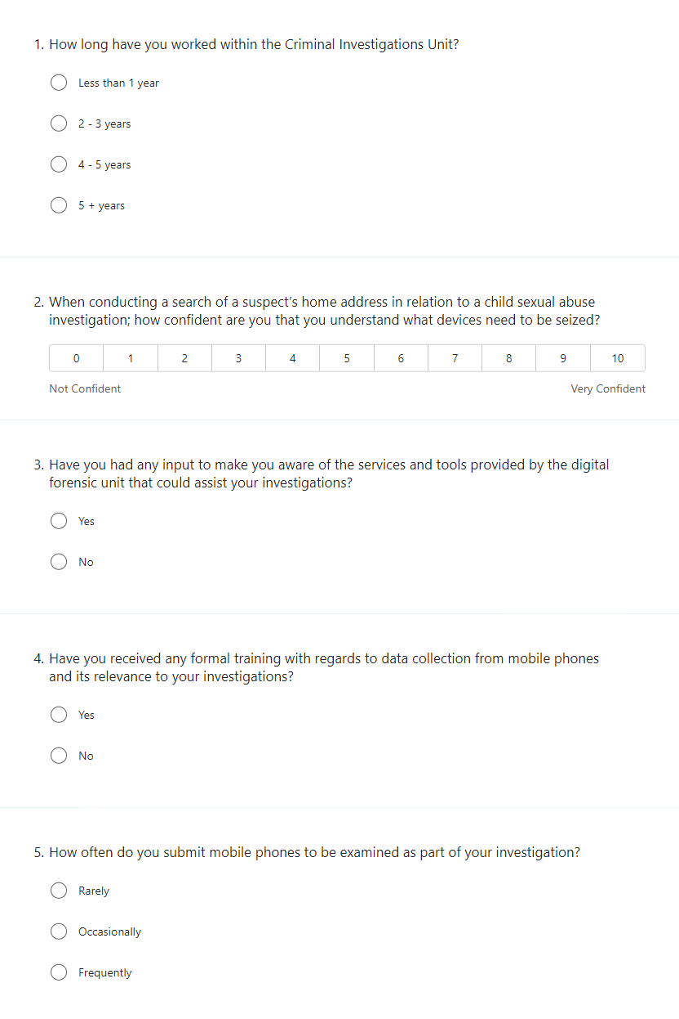
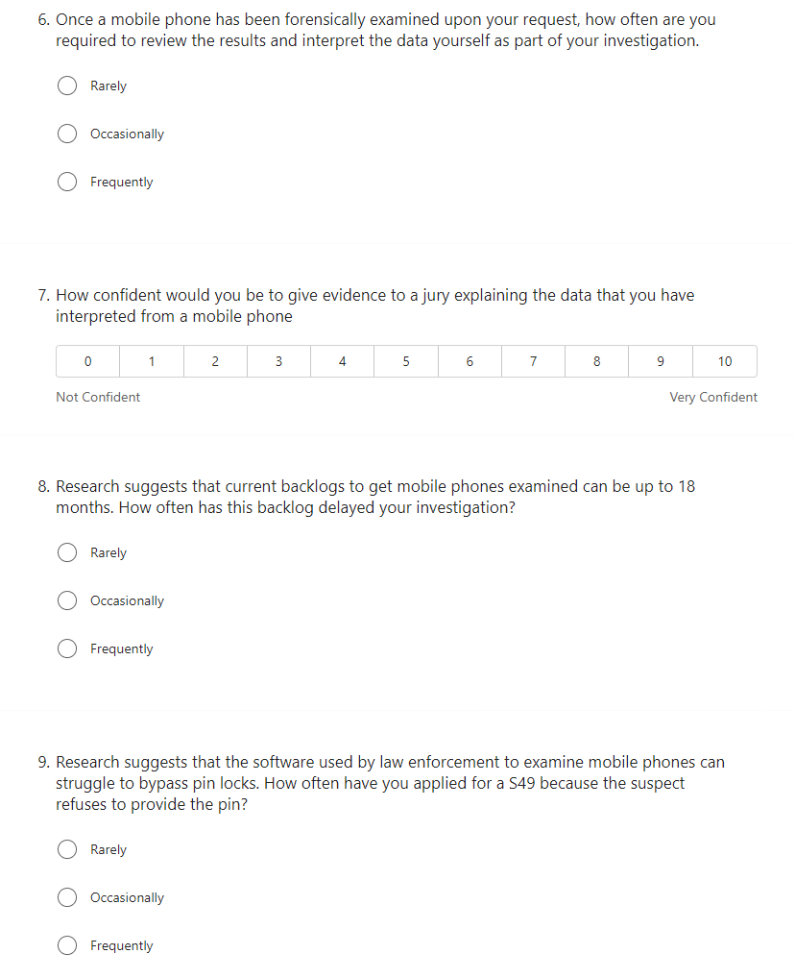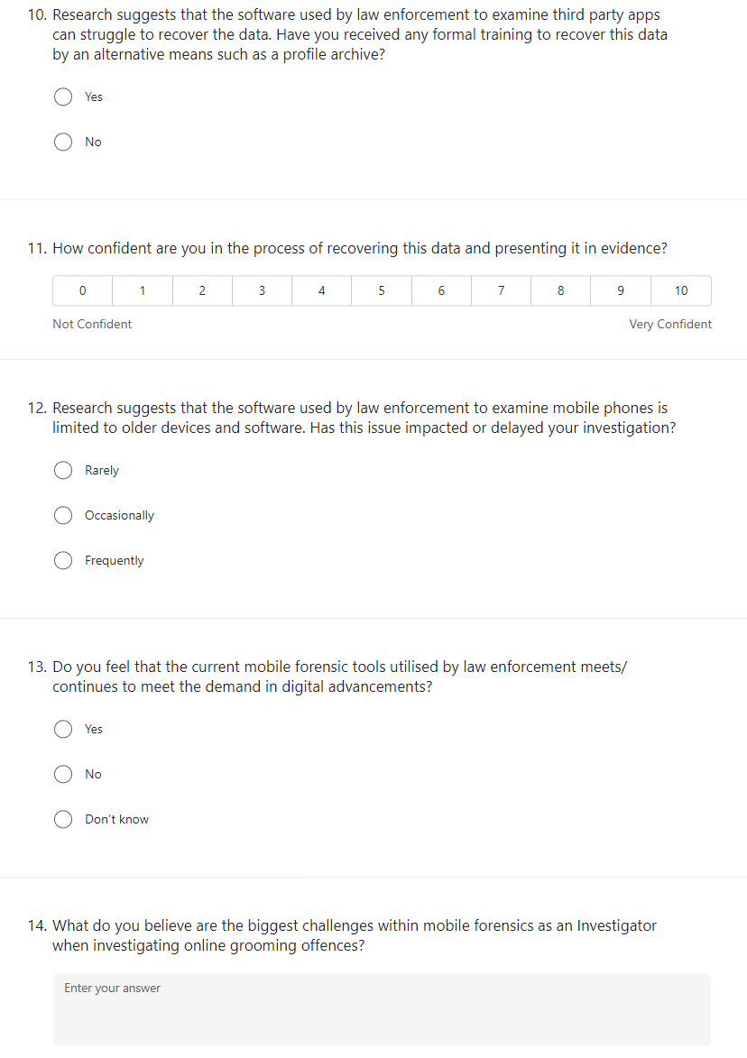

Investigating Officer Questionnaire Results
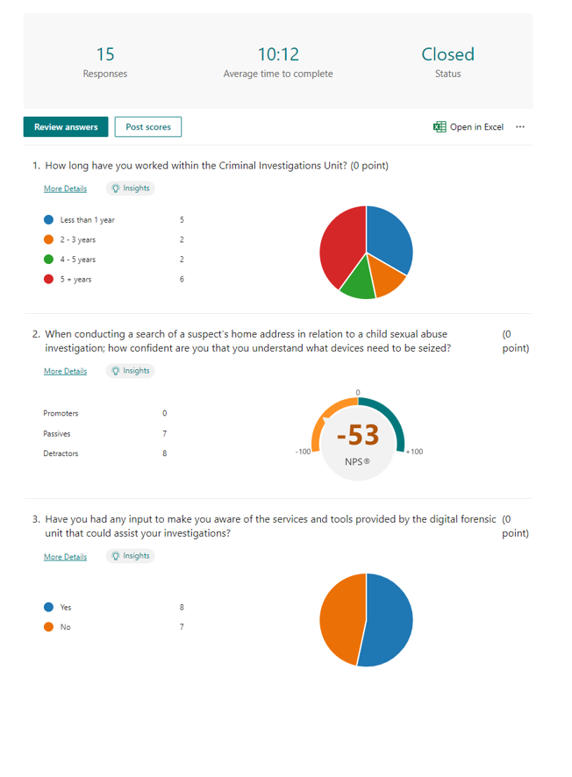
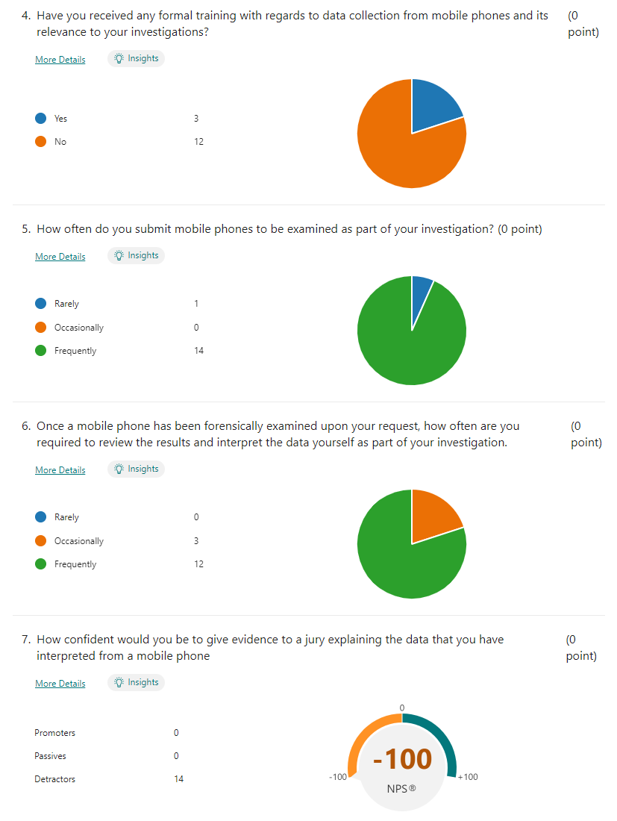

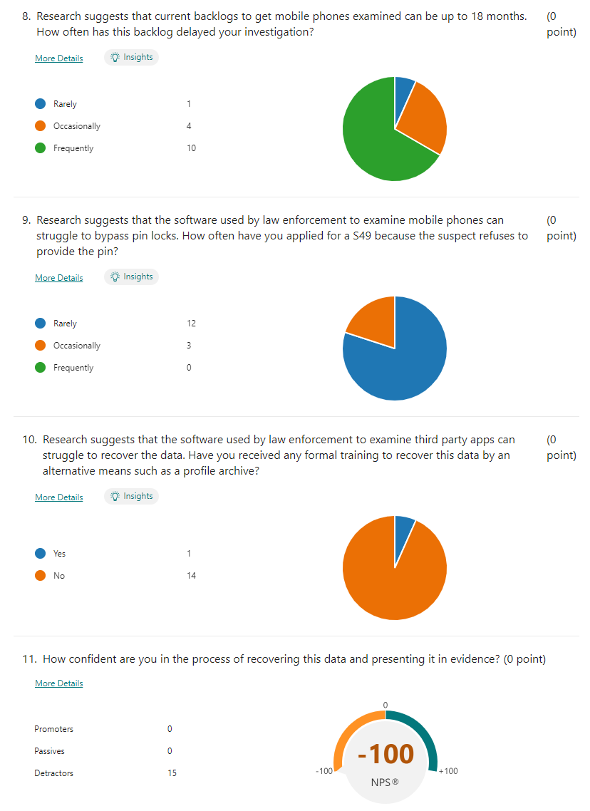

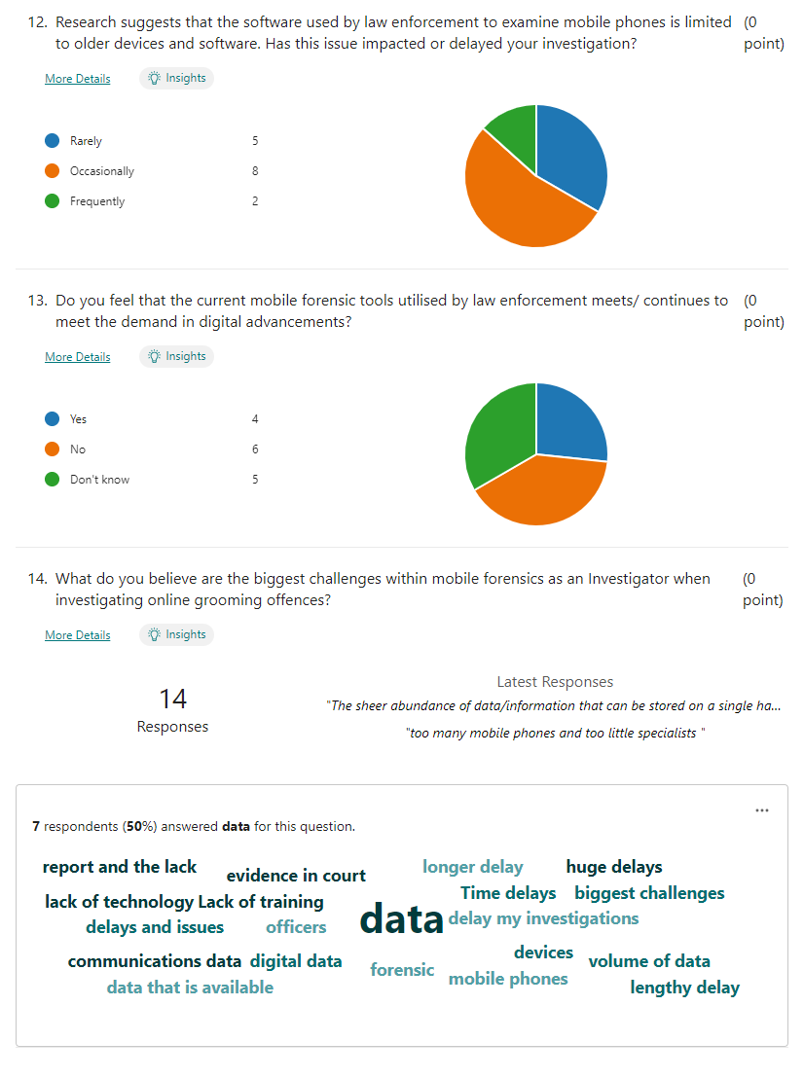

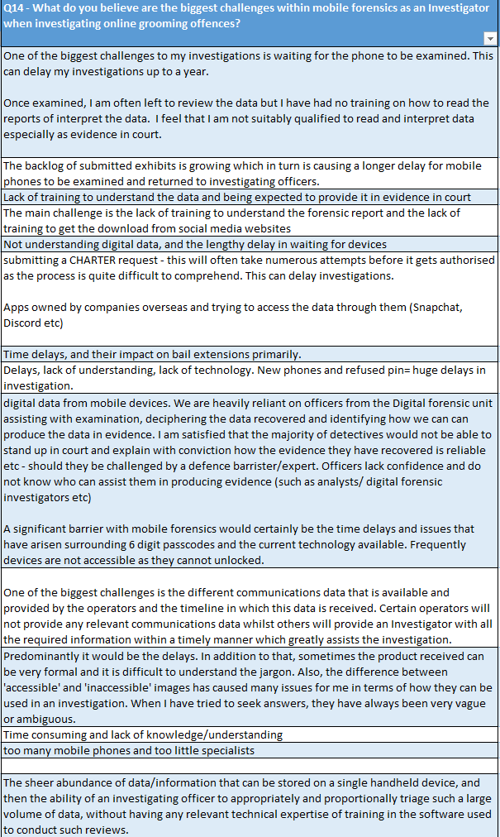

Appendix B – Section 49 Powers

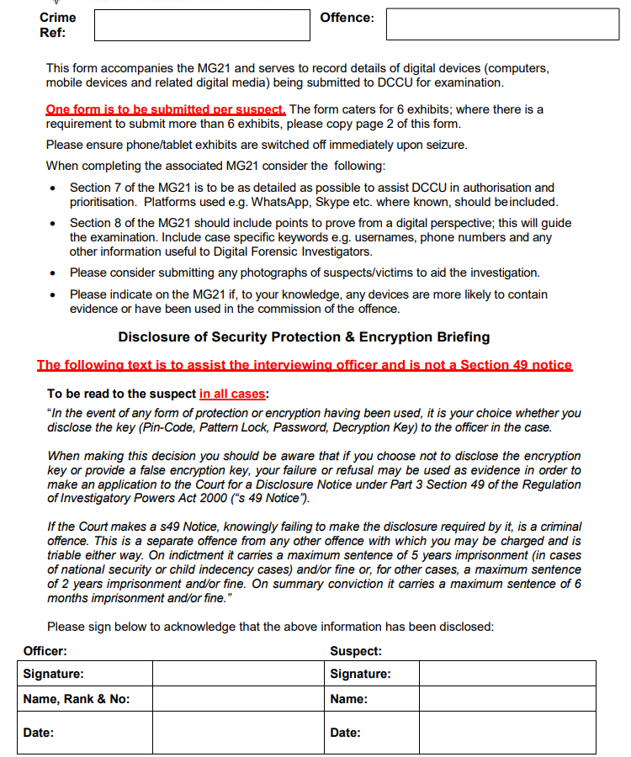

Appendix C – Dissertation Proposal

 BSc Professional investigation
Module BMPI6000 - Project Proposal
Student Name: Darren Williams
Supervisor Name: Alison Cooke

Research Question
An analysis of the challenges of digital forensic examinations of mobile phones in the investigation of online grooming offences, and how these challenges impact on a police investigation.

Literature Review
As digital capabilities develop, criminals are increasingly exploiting these developments to target vulnerable people within their criminality. An example of such exploitation is online grooming offences. One tactic exploited by perpetrators is by using social networks and chat sites such as snapchat and Chat Avenue to identify their targets. These platforms can be accessed through internet access on a computer or applications on a mobile device such as a smartphone.

The Statista (2018) website suggests that in 2007, the number of mobile phones sold worldwide was in the millions, whereas in 2021, the figures rose to 1.43 billion. As a result, the increase in the use of mobile phones worldwide would provide more opportunities of perpetrators to identify children and target them for their criminal activity.

When researching online sexual grooming, Villacampa, Jesus, and Gomez (2016), note that a higher number of children were victimised when they used a mobile phone compared to other devices such as a laptop or desk computer. A reason for this could be that mobile devices are harder to monitor by parents due to their ability to be carried and concealed compared to laptops and desktop computers.

Online grooming offences have increased over the years, which has had an impact on how police investigate this crime type. NSPCC (2022) published an article suggesting that data gathered from 41 UK police forces showed an 84% rise in this offence since 2017/18. This is an alarming increase in victim of crime.
A tactic utilised by police to deal with this increase is by way of a forensic examination of a perpetrator’s devices, however, “research will show that forensic science has been present for years; but digital forensics is still in its infancy” (Sammons, 2014, p. 2). As a result, the challenges of obtaining evidential data from device can have a negative impact on a police investigation.

Whilst the Forensic challenges can be an exhaustive list, The research will concentrate on the following four challenges:
Unlocking the mobile phone:
Occasionally, a suspect will not provide a pin code to a mobile phone which can be problematic in an investigation. Forensic companies are developing tactics to avoid such challenges, such as Cellebrite premium, where Before First Unlocking (BFU) and After First Unlocking (AFU) can be deployed. (Cellebrite, 2023). This research will discuss the strengths and weaknesses of these tactics.

Examination Software Limitations:
Current mobile phone examination software is limited when attempting to examine new handsets. This software is a reactive tool that requires research and development to adapt to the latest changes made by mobile phone manufacturers, "making it difficult for law enforcement agencies to remain current with new technologies" (Bennett, 2012, p.161).
Third-party applications:
One of the most impactive challenges of digital examinations, is extracting chat from third-party applications. Levinson, Stackpole, and Johnson (2011) noted that Mobile forensic software tools extract typical data such as call logs, SMS, and internet history but overlook the data contained in third-party applications. The extraction tools used by police to obtain third-party material are limited to grey key and Cellebrite. This research will discuss the strengths and weaknesses of the current tactics.
The demand for mobile phone Examination in investigations:
The use of mobile handsets within the public arena has drastically increased. A report completed by the HMICFRS (2022) highlighted that over 25,000 devices have been seized and are still awaiting to be examined; therefore, one of the challenges faced by Digital forensic Examiners is to try to reduce the backlog of devices.
The research will also discuss how these challenges impact or delay investigation and make recommendations on how to minimise these challenges. An example of a recommendation is Section 49 (2) Regulation of Investigatory Powers Act 2000 (Home Office, 2018) which gives an incentive to suspects to provide a pin when requested by police.
The rationale behind this research is that whilst there is a lot of material on digital forensics, it is suspected that there is a significant gap in knowledge between the Digital Forensic Investigator and the investigating officer when trying to negate the challenges within digital forensics, which in turn, has a negative impact on an investigation.
Method:
(Aim(s):
This research aims to identify the challenges of examining mobile phones when dealing with online grooming offences, the impact these challenges have on an investigation, and highlight any recommendations to minimise the challenges in future investigations.
Objective(s):
- Identify the tactics adopted by online perpetrators concerning online child grooming offences and the necessity of digital examination of mobile phones to investigate this type of offence.
- Review the tactics of digital forensic examinations of mobile phones and the challenges both examiners and Detective Constables face by completing this line of enquiry.
- Explore the impact these challenges have on an investigation and how investigating officers can help minimise them.
- Purpose recommendations on how to improve police tactics when dealing with digital forensic examinations of mobile phones and minimise the impact the challenges have on police investigations.

Design:
This project will rely on secondary data, which will be sought by accessing appropriate academic literature such as academic Journals, books, and online material, it will identify and highlight the necessity for forensic examinations of mobile phones when investigating child grooming offences.
This project will also rely on primary data recovered from a questionnaire; these questionnaires will be provided to participants within the field of Digital Forensics Investigators (DFI) and Detective Constables within the Criminal Investigation Department (CID). Goodwin and Goodwin (1996) note that qualitative and quantitative research can be beneficial separately on their own and can provide considerable knowledge and insight for the researcher; however, it also suggests that both methods should be combined during a single study as this will provide a balanced and in-depth understanding of the research and its outcomes. Therefore, this project will rely on both qualitative and quantitative questions within the questionnaire.
Sample:
The research will aim to have a minimum of 20 participants in total from two specialist units (Digital forensic Unit and Criminal Investigation Unit). A minimum of ten participants from each unit. It is hoped that 50 participants will take part in total.
The questionnaire will combine open-ended and closed questions to allow quantitative and qualitative analysis, which will be created and sent via 'teams forms' software.
Each participant will have 14 days to complete the questionnaire, the date to be determined.
The aim of having a variety of research methods over a variety of participants is to ensure a balanced and unbiased view across the project.
Ethics:
The research will follow the five core ethical research principles “Transparency, confidentiality, voluntary, do no harm, and impartiality “(Biggam, 2021, p.29).

The purpose of the research will be fully explained to the participants in a briefing document at the start of questionnaire; it will highlight what is expected from them and will cover the consent, highlighting that participation is voluntary, they are free to leave at any time and not all questions need to be answered.
There will be no age requirements as they will be targeted on their qualifications only. Each participant will, however, be required to be over 18.
Although the researcher is a serving officer for Dyfed Powys Police, the researcher will have no influence on how the participants manage the challenges mentioned in this research. Each investigation is conducted/ managed differently and is influenced by the persons knowledge and experience. Any working relationships will be fully explained in the dissertation.
The questionnaire will be anonymised to read participant one, participant two, etc.; the only detail of the participant will be the unit they work in. This will allow the researcher to analyse the data and identify the challenges from the perspective of both specialisms. By completing the questionnaire, this will imply that consent has been given.
Due to the nature of this project, the research does not deal with any controversial issues, involve any venerable people, and will not cause harm to the participants.
All the data recovered within this project will be electronically stored in a secure folder (password protected), only known to the researcher.
Analysis:
The data will be collated and analysed as a whole. The researcher will seek out any patterns in responses, outline the challenges and look for any similarities and differences between the group. This will help to identify the challenges and examine whether there is a gap in knowledge between the two groups.

Proposed Timeline
The Gant chart uses two colours. Blue signifies the time allocated to that task; Red signifies the week of the final deadline.

Anticipated Outcomes
I anticipate that this project will identify an increase in use of mobile phones by children and the current strategies used by suspects in the criminality.
It will show that digital forensic capabilities are still in its infancy and highlight some of the challenges that the DFI’s face whilst completing an examination. It will discuss the positives and negatives of digital forensics to an investigation and make recommendations that can help educate Investigation officers on how to minimise the impact these challenges have on their future investigations.
This can be achieved by online training that can be created and made available to all officers within the police. Completing this training is expected to significantly reduce the challenges highlighted in this project, decrease the demand on the digital forensic unit during an examination, and help decrease the current backlog of devices waiting to be examined.

