

Strategic Management (LCMB7003)
Strategic Analysis and Market Entry Plan for BYD in Poland

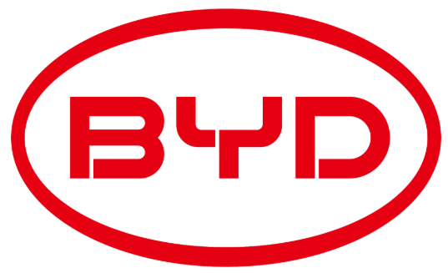

Lecture Name: Dr.Andry Rakotovololona
Student Name: Joseph Nirappel Mathew
Student ID: 2437157

Table of Contents

1. Introduction 4
2. Company Background - BYD 4
3. Target Market: Poland 6
4. Strategic Analysis 7
4.1 Macro-Environment Analysis 7
4.1.1 PESTEL Analysis 7
4.2 Micro-Environment Analysis 9
4.2.1 Industry Life Cycle: Polish EV Industry 9
4.2.2 Porter’s Five Forces Analysis 10
4.3 Internal Analysis 11
4.3.1 BYD’s Strategic Resources and Capabilities 11
Fig: Best-selling EV brands in Europe[Jan-Sept 2025](Autovista24, 2025a) 13
4.3.2 Value Chain Analysis 14
4.3.3 VRIO Analysis of Distinctive Resources and Capabilities 16
4.3.4 SWOT Analysis 17
5. Strategy Formulation for BYD’s Entry into Poland 18
5.1 Strategic Options - Ansoff Matrix 18
5.2 Competitive Positioning Strategy: Porter’s Generic Strategies 19
5.2.1 Cost Leadership 20
5.2.2 Differentiation 20
5.2.3 Recommended Positioning: Hybrid Advantage 20
5.3 International Strategy: Integration–Responsiveness Framework 21
5.3.1 Global Integration Pressures 21
5.3.2 Local Responsiveness Pressures 21
5.3.3 Recommended Strategy: Transnational Approach 22
5.4 Market Entry Mode Strategy 22
5.5 Risk Assessment and Mitigation 23
6. Strategies to Sustain Competitive Advantage 24
7. Growth Strategies 25
8. Green Strategy and CSR 26
9. Performance Evaluation Framework 28
9.1 Balanced Scorecard: Key KPIs and Success Metrics 28
9.2 Monitoring and Implementation Plan 29
10. Recommendations 29
11. Conclusion 30
12. References 32

1. Introduction
Strategic management involves the process of developing and executing long-term decisions that help organisations gain sustainable competitive advantage in dynamic and unpredictable environments(Do, 2020). In the modern global automotive industry, characterised by technological disruption, electrification, and accelerating internationalisation, companies need to be strategically agile to discover new opportunities and manage cross-border growth(Marković & Mijušković, 2022). Having been established in 1995, BYD Company Limited has become a leading global new energy vehicle (NEV) manufacture with over four million NEVs delivered in 2024 and strengthening presence in over 100 countries(BYD, 2024b). As the European Union is in the fast track of switching to zero-emission mobility, Poland represents an emerging and strategically significant market because of its rising automotive demand and changing EV infrastructure(PSNM, 2024).

This report examines the potential expansion of BYD into the Polish passenger vehicle market. It starts with the overview of the background and strategic mission of the company, and then follows the rationale choosing Poland as a target market. PESTEL, Industry Life Cycle and Porters Five Forces frameworks are used to analyse the external environment and the internal analysis is through the Value Chain, VRIO and SWOT tools. The report then develops an entry strategy for BYD’s Entry into Poland, sustainable competitive and growth strategies in Poland and suggests a performance measurement system to evaluate the performance of expansion. The report ends with strategic recommendations for successful market entry by BYD.

2. Company Background - BYD
BYD Company Limited (BYD) was founded in Shenzhen in 1995 as a manufacturer of rechargeable-battery, then subsequently entered the automotive business in 2003 with the establishment of BYD Auto(BYD, 2025a). Over the past 20 years, BYD has achieved rapid global growth through its vertically-integrated battery, electronics and vehicle manufacturing capabilities. In 2024 the company reported annual revenue of RMB777.1 billion (increased by 29 percent over the year) and a net profit of about RMB40 billion (approx. USD 5.63 billion)(BYD, 2024b).
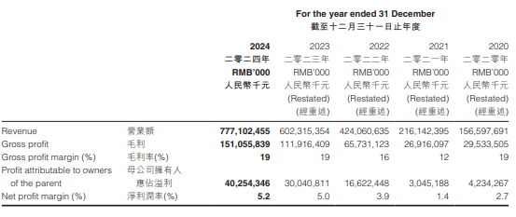
Fig: BYD Financial Highlights[2020-2024](BYD, 2024b)

In 2024, BYD made over 4 million NEV sales, becoming the largest NEV manufacturer in the world by volume for the third consecutive year(BYD, 2024b).
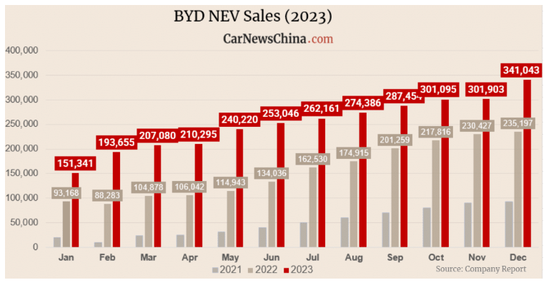
Fig: BYD NEW Sales [2021-2023](Shahan, 2023)
On the international level, BYD has operations across Europe, Latin America, Asia-Pacific, Middle East and Africa, with manufacturing facilities in Brazil, Thailand and Hungary and sales in more than 100 countries and regions(BYD, 2025a, 2025b).
The major business units of BYD are(BYD, 2023):
- Automobiles: electric buses, trucks and increasingly BEVs and PHEVs;
- Battery/energy storage solutions: With proprietary “Blade Battery” and large-scale energy-storage systems;
- New energy solutions: Solar, rail transit and other new-energy infrastructure.
These units allow BYD to have a diversified revenue sources and technological synergies that support its competitive position in electrified mobility.

2.1 BYD’s Mission and Objectives
The mission statement of BYD, “provide technological innovations for a better life”, covers the company's commitment to innovation, sustainability, and enhancing the quality of life for consumers and communities worldwide(BYD, 2025c). Its strategic goals include achieving 50% of total vehicles overseas sales by 2030 and establishing a leading global NEV brand(EV.com, 2025). BYD is also aiming at carbon-neutral operations along its value chain by 2045 with a mid-term goal of cutting carbon intensity in its operations by 50% by 2030(E. Magazine, 2025). These goals contribute to the aspirations of the firm to entrench itself as a global leader in EV markets, and be in line with global sustainability requirements.

3. Target Market: Poland
Poland is an interesting market where BYD Company Limited can grow its passenger-vehicle business due to its increasing automotive demand and the developing EV market. The number of new-car registrations in Poland reached 285311 units in the first half of 2025, 3% year-on-year increase, and battery electric vehicle (BEV) registrations increased by 60.9%, accounting for approximately 5% of overall market share(Autovista24, 2025b). Poland is among the fastest-growing EV markets in Europe with over 100,000 fully electric vehicles registered in the country as of late 2025 and a growth of about 94% on BEV registration recorded in the first eight months(NFP, 2025; Observatory, 2025).
The Polish motor industry benefits from its geographic position as a gateway to the Central and Eastern Europe (CEE) region as well as high investments in EU infrastructure and competitive cost base in comparison to the western Europe(Komornicki & Goliszek, 2023). These aspects align with the European strategy of BYD to use its Hungary facility and provide value conscious consumers with cost-effective EVs. The capabilities of BYD including vertically integrated battery production, affordability of NEVs, fast international roll-out, fit well with Poland’s developing EV ecosystem, with low current penetration (around 4% of new cars are EV/PHEV) offering a great growth potential(Manev, Pyk, Pendaroska, & Bartosik, 2025). Additionally, as Chinese and other foreign car manufacturers start catering directly to Poland, BYD will have the benefit of first-mover in the mass-market EV segment in this region. Poland, therefore, is a strategically sound market for BYD to combine its global leadership in EVs with local assembly or distribution, aligning international expansion objectives and the local market preparedness.

4. Strategic Analysis
The successful expansion of BYD to the Polish electric vehicle (EV) market requires a thorough strategic analysis. The strategic analysis integrates insights from the external macro-environment, industry related competition forces and internal resource base of the organisation to determine strategic fit and identify the opportunities for creating values(Henry, 2021).

4.1 Macro-Environment Analysis
The macro-environment shapes the opportunities and limitations that affect BYD’s expansion in Poland. With the PESTEL framework, it is possible to perform a systematic analysis of the political, economic, socio-cultural, technological, environmental, and legal forces influencing the EV uptake and the competitive environment(Perera, 2017).

4.1.1 PESTEL Analysis
Factor | Key Issues for BYD in Poland & EU Market
Political | EU Green Deal mandates zero-emission mobility by 2035 and Poland is granted EU funding of EUR25 billion for green transition. There are also political initiative to decrease the dependence on Russian energy imports(Commission, 2025). Policies favour EV imports, but increasing scrutiny on Chinese EVs can create regulatory issues(Z. Zhang, 2025).
Economic | The GDP in Poland is steadily rising at 2-3% a year. The automotive market is approximately 500,000 new cars/year, and the EV market is increasing more than 60 percent/year(Autovista24, 2025b; TVPWorld, 2025). Reduced labour cost compared to western Europe and inflation at 5%.
Socio-cultural | There is increase in green consciousness and growing demand in the areas of cost-effective EVs(Daniel, 2024). The growth of the middle-class income and the popularity of small SUVs fit well with the Dolphin, Atto 3, and Yuan Plus segments of BYD.
Technological | There is rapid development of EV infrastructure and by June 2024, there were 7,255 public charging points, a 41% increase from the previous year(Commission, 2024). BYD’s Blade Battery offers safety & cost advantage(BYD, 2025a).
Environmental | There is strong emissions-cutting pressure and Poland aims to reduce non-ETS greenhouse gas emissions by 7% in 2030(T&E, 2020). Growing air-quality issues in large cities and the need to find a sustainable mobility solution fits BYD with BYD’s zero-emission offering(E. Magazine, 2025).
Legal | EU vehicle safety and cybersecurity legislation, demanding homologation rules, and EU battery legislation (recycling, carbon footprint revelations)(Dong et al., 2025). Harmonised European trade regulations enable imports but potential anti-subsidy investigations tend to affect pricing.
(Developed by Author)
As much as PESTEL gives a systematic view of the external environment, it is limited. First, it analyses the factors separately and can ignore interactions, e.g., political climate has a direct impact on legal and environmental regulations(Buye, 2021). Second, PESTEL is not a predictive tool, but a descriptive one; it determines trends, but does not compare them in terms of their relative influence and probability. Third, the model fails to consider firm-specific capabilities; two organisations may face the same macro-environmental conditions and react differently based on their capabilities. Lastly, PESTEL becomes quickly outdated in a rapidly changing market such as EVs, where regulatory, technological and geopolitical changes happen at a very fast pace(Buye, 2021). Therefore, PESTEL needs to be supplemented by industry and internal analyses to create an integrated strategic perspective.

4.2 Micro-Environment Analysis
Micro-environment focuses on the competitive factors that influence profitability and market appeal of BYD in the EV market of Poland(Montes Torralbo, 2024).

4.2.1 Industry Life Cycle: Polish EV Industry
The Polish EV market is at the growth phase of the industry life cycle. Although the overall EV penetration is not too high, with 4-5% of all new vehicle registrations in 2024-25, the market is growing at a high pace, and the annual sales of BEVs are growing faster by over 60% year-on-year(Autovista24, 2025b). Increasing environmental awareness by consumers, falling costs of batteries, more charging stations, and the pressure from EU decarbonisation targets are growth drivers.
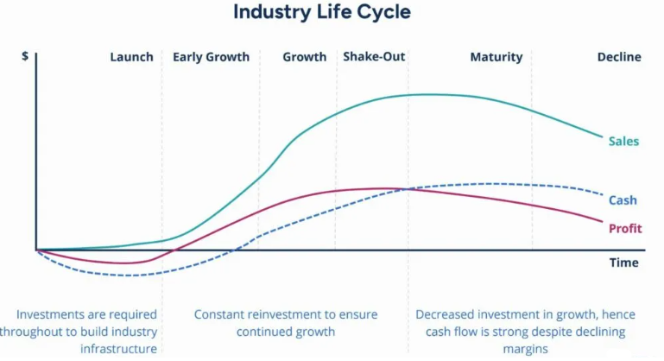

Fig: Industry Life Cycle stages(Karpenko et al., 2021)
The characteristics of the growth stage evident in Poland are:
- Rapid demand growth supported by policy incentives and increase in affordability.
- Entry of new competitors, such as Tesla, Volkswagen, Kia, Hyundai, and emerging Chinese companies.
- Increasing distribution networks and charging networks investments by both public and private actors.
- Competition, which is moderate and gradually rising, as the companies are competing based on prices, technology, and range performance.
For BYD, entering during the growth stage is strategically advantageous. The first-mover advantages in affordable battery-only EV market, where BYD is a strong competitor, are still there. Poland is also close to the Hungary plant of the firm and this can be exploited to have operational efficiencies(de Sousa, 2024). Nevertheless, with the transition to the maturity stage in the industry, the rivalry will increase, necessitating strong brand positioning and continued innovation.

4.2.2 Porter’s Five Forces Analysis
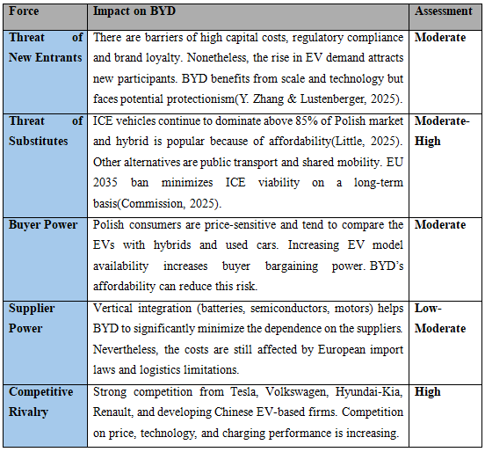
Developed by Author
Altogether, the Five Forces analysis implies that BYD is able to compete successfully due to its cost leadership, battery competence and diversified global supply chain. Nonetheless, the intense competition as well as market regulatory uncertainty necessitates BYD to adopt a differentiated, technology-based market entry strategy.

Despite the valuable information presented by the Porters Five Forces on the structure of industry, it has its weaknesses. The model presupposes a more stable and predictable market environment, which is quite opposite to the EV industry where the rapid change in the technological background and policy alter the competitive picture at a high pace(Adelakun, 2020). Moreover, the framework presupposes a zero-sum competition without taking the possibility of collaboration, i.e., joint venture or technology cooperation, which is becoming increasingly popular in the EV industry. Lastly, the model emphasises the industry forces, and it fails to account for BYD’s unique internal capabilities which could enable it to beat its rivals despite the structural challenges.

4.3 Internal Analysis
Internal analysis assesses whether BYD possesses the resources and capabilities needed to attain sustainable competitive advantage in the Polish EV market.

4.3.1 BYD’s Strategic Resources and Capabilities
Tangible Resources
The tangible resource base of BYD is broad as it has the large-scale production capacity, advanced manufacturing plants, and proprietary battery facilities. As of 2024, BYD had over 30 industrial parks worldwide, including those in China, Brazil, Thailand and its first European passenger car plant in Hungary(BYD, 2024b). It is the largest EV manufacturer in the world with an annual production capacity of over 4 million NEVs(Statista, 2025). Its production lines of Blade Battery provide cost-efficiency and increased safety contributing to the low-cost structure and low pricing of BYD in Europe.
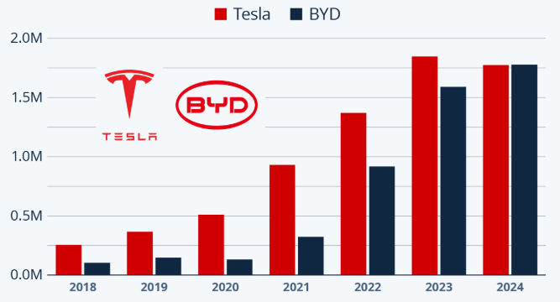
Fig: Annual battery electric passenger vehicle production
of Tesla and BYD(Statista, 2025)
Financially, BYD reported annual revenue of RMB777.1 billion in 2024 and had stable cash flows, which allows investing in R&D[invested approximately RMB54.2 billion in R&D in 2024], international dealerships and technology improvements(BYD, 2024b). Such financial resources also enhance the capacity of BYD to expand to new markets without being over dependent on external funding.

Intangible Resources
The competitive advantage of BYD is based on intangible assets. The company is a leader in technology with over 40,000 patents worldwide with deep technological expertise in batteries, power electronics, semiconductors, and EV architecture(BYD, 2025b). The brand equity is also increasing in Europe, with BYD already winning numerous international awards and gaining a presence in 29 European markets(Autovista24, 2025a). Its good safety reputation, affordability, and energy-saving supports its positioning in emerging EV markets like Poland.
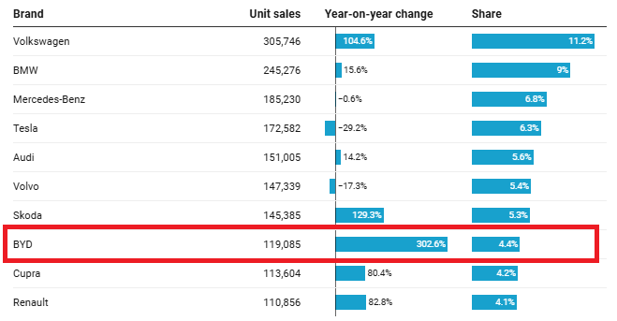

Fig: Best-selling EV brands in Europe[Jan-Sept 2025](Autovista24, 2025a)
Core Competencies
The core competencies of BYD are:
- Vertical integration: Controlling batteries, motors, chips, and vehicle assembly, minimising volatility in cost.
- Innovation in battery: Blade Battery offers high levels of safety, durability and cost-performance.
- R&D potentials: Number of employees who are engaged in R&D-related activities exceeds 90,000(BYD, 2024b).
- Cost leadership: BYD has maintained prices that are 10-20% below Euro competitors because of scale economies and in-house component production.
- Rapid innovation cycles: It takes shorter periods to develop its products than western OEMs, thus can easily respond to EU requirements.

All these resources make BYD prepared to perform well in Poland where the price-sensitive consumers and the rising EV align with the value proposition suggested by BYD.

4.3.2 Value Chain Analysis
The Value Chain framework can be used to determine the way in which BYD develops and maintains competitive advantage through activities that add value across its operations(Porter, 2008). The high level of vertical integration of BYD, which covers batteries, semiconductors, motors, and assembly of vehicles, offers the company substantial cost efficiency and strategic control, which makes it well-positioned to get into the Polish EV market(Wang, 2025).
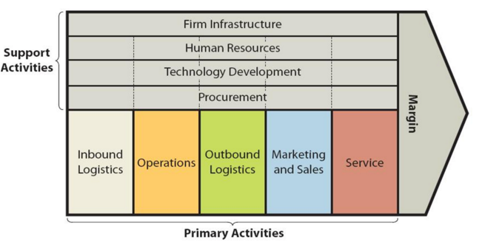

Fig: Value Chain Analysis(Porter, 2008)

1. Primary Activities
- Inbound Logistics: BYD have secure and efficient access to lithium iron phosphate (LFP) and important battery materials, with long term supplier deals and partial in-house sourcing. This leads to less reliance on commodity markets across the world and stabilisation of inputs(P. Magazine, 2025).
- Operations: The factories of the company are highly automated and the production systems are proprietary, including the Blade Battery and e-Platform 3.0 which makes the company have a higher cost efficiency and product reliability(BYD, 2025a). Vertical integration helps BYD to manufacture batteries, motors, and power electronics, thus saving assembly time and enhancing quality control.
- Outbound Logistics: BYD has the strength of a growing European distribution network supported by Hungary manufacturing site to deliver vehicles efficiently to Poland. This lowers logistics expenses as compared to exporting only from China.
- Marketing and Sales: BYD has a multichannel distribution approach that includes authorised dealers, online sales, and collaboration with big retailing groups(Indiran et al., 2023). In its promotion, it focuses on safety, low prices, and long battery life- features that are very relevant to the Polish, value-sensitive customers.
- After-Sales Service: Digital diagnostics and trusted EV architecture help BYD increase its European service presence. Its vertical integrated design reduces warranty complexity and increases customer satisfaction.

2. Support (Secondary) Activities.
- Procurement: Numerous essential parts such as batteries, semiconductors, drive systems are made in-house, decreasing the procurement risk and guaranteeing uninterrupted supply.
- Technology Development: One of its core competencies is R&D, with more than 90,000 employees engaged in research(BYD, 2024b). Its innovative systems like the Blade Battery and heat pump efficiency technology give competitive advantages in terms of safety and energy performance(BYD, 2025a).
- Human Resource Management: BYD is investing heavily in technical skills, ongoing training of engineers, and international hiring. It has competent R&D labour force that supports localisation and innovation capabilities in Europe.
- Firm Infrastructure: Good governance, financial stability and sustainability initiatives are in line with the EU regulations. The organisational structure of BYD facilitates quick decision-making and implementation of new technologies in new international markets.
Therefore, the integrated value chain of BYD offers major cost efficiencies, innovation capacity, and operational flexibility, placing the company strongly for entry into Poland.

4.3.3 VRIO Analysis of Distinctive Resources and Capabilities
The VRIO model determines whether BYD has the major resources and capabilities to offer a sustainable competitive advantage in the Polish EV market(Ariwibowo, Saputro, & Haryanto, 2021).
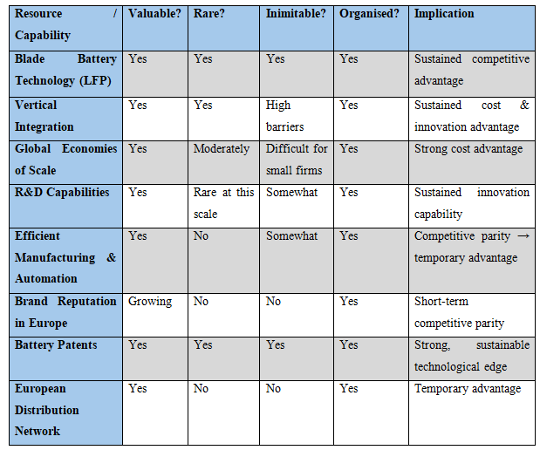
Developed by Author
The sustainable competitive advantages based on BYD Blade Battery, vertical integration, and mass scales R&D are all valuable, rare, and hard to recreate by competitors. The organisation of the firm, supported by globalisation of the supply chain, good manufacturing systems and a well-established governance system, allows the firm to maximise these strengths. Areas like brand strength and local distribution are emerging capabilities indicating the need for strategic partnerships and targeted marketing in Poland.

4.3.4 SWOT Analysis
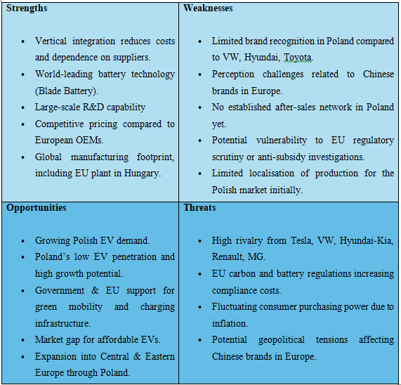
Developed by Author
Poland offers a good prospect to BYD because of the high rate of EV adoption, the strong policy support, and consumer demand of the company to purchase affordable, reliable electric vehicles. These market needs are directly aligned with the strengths of BYD which are battery leadership, cost advantages, and rapid innovation. The drawbacks, however, like low brand presence and after sales coverage need to be countered with local alliance, dealership chain and focused marketing programs. Externally, although the opportunities in Poland and the rest of the CEE area are significant, BYD has to overcome the threats of the EU regulatory inspection, the growing competitive pressure, and possible political conflicts that might interfere with Chinese automotive imports. On the whole, BYD has more strengths than weaknesses, suggesting strong potential for successful market entry.

5. Strategy Formulation for BYD’s Entry into Poland
This part formulates a coherent entry approach for BYD Company Limited into the Polish electric-vehicle (EV) market by connecting the strategic options with the capabilities of the company and the external opportunities.

5.1 Strategic Options - Ansoff Matrix
There are a number of strategic pathways that BYD can use to enter into Poland. The best option, according to Ansoff’s matrix, is market development, i.e., launching its current EV and plug-in hybrids in a new geographical field. Other potential alternatives are product development (developing Poland/ Europe specific low-cost or compact EVs) and diversification (new business models such as battery leasing, charging services)(Ansoff, 1957).
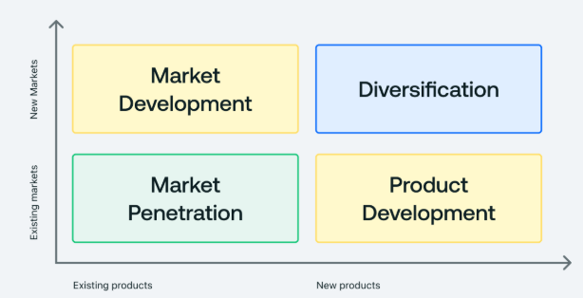
Fig: Ansoff’s matrix(Ansoff, 1957)

Strategic Options for BYD in Poland
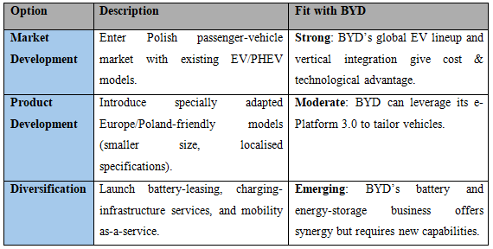Developed by Author
Overall, the market development option is closest to the corporate goal of BYD to grow its overseas sales (targeting approx.50% of total output) and its European expansion (BYD expects to expand its European network significantly by 2026) (EV.com, 2025). Adopting market development will enable BYD to leverage its core competencies that include cost-effective production, innovation in battery technology, and international supply chain to enter Poland without losing focus on strategic direction than over-diversifying too soon.

5.2 Competitive Positioning Strategy: Porter’s Generic Strategies
Porter (1985) proposes three generic strategies: cost leadership, differentiation, and focus(Porter, 2008). The competitive positioning of BYD in Poland must take a hybrid strategy, combining the elements of both cost leadership and differentiation.
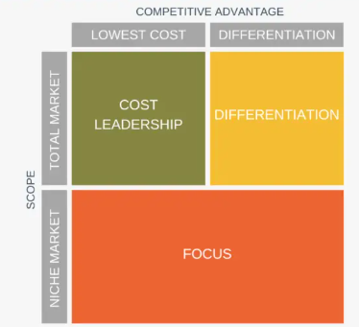
Fig:Porter’s generic strategies(Porter, 2008)

5.2.1 Cost Leadership
The vertical integrated value chain of BYD, including batteries, semiconductors, motors, and EV architecture lowers production expenses and leads to high efficiency. Its Blade Battery reduces material intensity and lowers cost per kWh relative to competitors, allowing BYD to set prices 10-20% lower than those of European incumbents(de Sousa, 2024). This cost advantage is an important point of distinction in the Polish value-sensitive market.

5.2.2 Differentiation
Cost advantages alone are insufficient in a technologically advanced industry. The differentiation of BYD is based on superior safety features (e.g. thermal stability of Blade Battery), high range performance, and high level of energy-efficiency systems. The consumers in Europe are more and more focused on quality, digital features, and environmental performance(Montes Torralbo, 2024). BYD can differentiate through technological credibility, reliability, and warranty strength.

5.2.3 Recommended Positioning: Hybrid Advantage
A hybrid value-tech leader strategy would enable BYD to attract both price-sensitive and quality-centric early EV adopters in Poland at the same time. This is also a strategic position that is hard to copy by the legacy manufacturers as BYD has its own battery technology and has in-house elements which forms its sustainable competitive advantage.

5.3 International Strategy: Integration–Responsiveness Framework
The Integration-Responsiveness (I-R) Framework evaluates the balance between global standardisation and local adaptation(TAN, 2021).
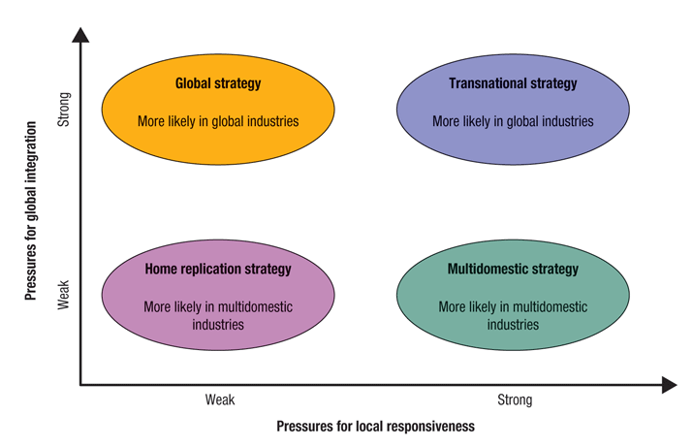
Fig: Integration-Responsiveness (I-R) Framework(TAN, 2021)

5.3.1 Global Integration Pressures
The harmonised vehicle regulations, unified standard of emissions and the requirements of the cross-border EV safety requirements in Europe promote standardisation. The global platforms (e- Platform 3.0), modular battery design, and scalability of R&D of BYD are advantageous for producing standardised models for all EU markets(BYD, 2024b).

5.3.2 Local Responsiveness Pressures
Poland is characterised by consumer preference such as:
- High value orientation,
- Preference for compact SUVs,
- Specialised charging norms and localisation of language.

5.3.3 Recommended Strategy: Transnational Approach
The transnational approach will enable BYD to capitalise on international economies of scale (battery platforms, scale of manufacturing) and customise the key characteristics to suit the Polish consumer preferences. Such a hybrid strategy is in line with the multinational EV market dynamics, and this approach will allow BYD to remain efficient and aligned with the consumers.

5.4 Market Entry Mode Strategy
Market entry mode determines the way BYD will distribute products to Poland at the lowest level of risk and resource commitment(Zhou, Gomes, & Vendrell‐Herrero, 2025).

Recommended Entry Mode:
- Exporting Supported by Dealership Partnerships (Phase 1)
- Regional Assembly via Hungary (Phase 2)

Phase 1: Exporting through Domestic Dealership Partners
- Enables rapid market entry.
- Minimum capital investment during initial market testing.
- Availability of local experience, existing selling and service networks.
- Quick exposure and customer-acquisition.

Phase 2: Hungary Regional Assembly
- The BYD factory in Hungary (intended to begin producing passenger-cars) is a capacity addition in the region(Reuters, 2025).
- Cuts down logistics expenses and delivery period to Poland.
- Mitigates EU tariff risk and anti-subsidy risk.
- Increases the legitimacy of BYD and its perceived localisation within the EU.
This phased strategy aligns with BYD’s globalisation objectives, balancing flexibility, cost efficiency, and political risk management.

5.5 Risk Assessment and Mitigation
Effective Market entry can be achieved by leveraging opportunities and anticipating and addressing potential risks. In the case of BYD, it would have to work around political, economic, operational, technological and competitive uncertainties in the European EVs environment for expanding to Poland. A systematic risk assessment will allow the organisation to assess the probability and effect of these risks and develop mitigation measures that ensure resilience and strategic alignment. The risk register below presents the most prominent risks that could affect the entry of BYD into the Polish market and outlines the proper mitigation strategies.

Risk Register for BYD’s Entry into Poland
Risk Category | Description | Likelihood | Impact | Mitigation Strategy
Political/Regulatory | EU anti-subsidy investigations and potential tariffs on Chinese EVs. | Medium | High | Local assembly via Hungary, regulatory engagement, and transparent pricing.
Economic | Inflation, fluctuating consumer demand, and financing constraints | High | Medium | Offer competitive pricing, financing options, and leasing models.
Operational | Limited after-sales infrastructure in Poland. | Low | Medium | Establish dealership/service partnerships and invest in training.
Technological | Battery recycling and EU Battery Regulation compliance. | Low | High | Partnerships with EU recyclers and product lifecycle management.
Competitive | High rivalry (VW, Hyundai-Kia, Tesla, MG) | High | Medium | Hybrid positioning, brand-building campaigns, and highlight safety & value.
Reputational | Perception of Chinese brands in EU markets | Medium | Medium | Emphasise quality, EU localisation, certifications, and warranty strength.
Developed by Author

With effective risk mitigation, BYD is in a good position to achieve success in Poland’s rapidly growing EV market.

6. Strategies to Sustain Competitive Advantage
To maintain its competitive advantage, BYD needs to continuously leverage its core capabilities and be able to align to the changes in the competitive environment in Poland and the European EV market. Continuous reinforcement of cost leadership and differentiation drivers helps maintain long-term competitive advantage(Porter, 2008). BYD should extend its technological advantage, especially its Blade Battery, which offers a higher level of safety and potentially lower cost to secure a sustainable position in the Polish market(de Sousa, 2024).
Continuous innovation is one of the strategies. BYD spends over RMB50 billion on research and development, which helps it to develop in battery chemistry, energy density, and platform efficiency(BYD, 2024b). The technological pipeline allows the company to regularly update the products and minimise the risk of imitation and enhance differentiation. In addition, BYD needs to reinforce its value network in Europe. The increased switching costs by expanding service centres, nurturing local supplier relationships and growing after sales capabilities will enhance customer loyalty which will be vital in a highly competitive market that is dominated by Volkswagen, Hyundai-Kia and Tesla. Localisation of the brand by targeted marketing, safety standards, and open communication will also help deal with reputational issues related to Chinese car manufacturers in Europe(Y. Zhang & Lustenberger, 2025).

Key Strategies to Sustain Advantage

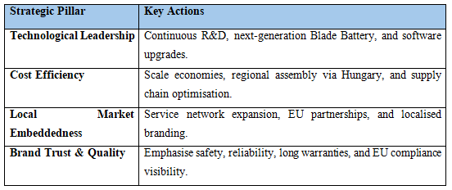
Developed by Author

7. Growth Strategies
BYD’s growth in Poland and the wider Central and Eastern European (CEE) region demands alignment with Ansoff’s Product-Market Growth Matrix, ensuring strategic consistency at various stages of expansion. The main method of expansion is the market development, which uses Poland as an entry point to the CEE markets, including Czechia, Slovakia, and Romania, where the adoption of EVs is expected to increase by 25-35% annually through 2030(IEA, 2025). The low-cost EV models of BYD supported by the regional assembly in Hungary offers scale efficiencies to accelerate this geographic expansion. Simultaneously, BYD could seek product differentiation, through Europe-specific variations of the EV products some of which would be compact urban models to attract the Polish and CEE consumer preferences for affordability and efficiency.

In the medium term, BYD has an option of diversifying in related areas and venturing into charging infrastructure and home energy-storage provision and battery-leasing programmes. Since BYD already has established strengths in energy storage and photovoltaics, diversification will make the company better positioned in the ecosystem and will help Poland in the efforts of implementing renewable energy integration.

BYD’s Growth Strategy Using Ansoff’s Matrix

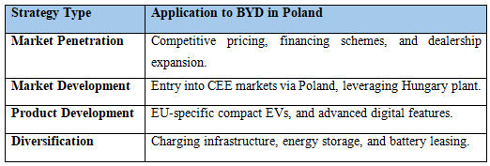
Developed by Author
By combining market development with focused product innovation and targeted diversification, BYD will be able to create a stable long-term growth curve in Poland and other countries.

8. Green Strategy and CSR
The entry of BYD into Poland presents an effective opportunity to enhance its international sustainability agenda, which aligns with its mission of cooling the Earth by 1 degree(BYD, 2024a). BYD’s sustainability philosophy of "DREAMS" is focused on seven key stakeholders including customers, employees, shareholders, suppliers, distributors and partners, government and industry associations, media and the public, identifying their sustainable development demands and combining BYD's sustainable development issues(BYD, 2024a).
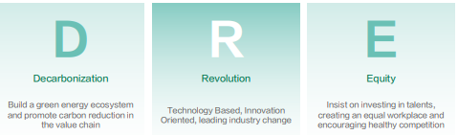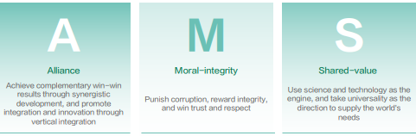
Fig: BYD’s sustainability philosophy(BYD, 2024a)
With environmental performance being the new focus of competitiveness in Europe, the green strategy of BYD needs to incorporate product sustainability, responsible manufacturing, and broader social responsibility. BYD currently has one of the biggest zero-emission supply chains in the world, and its Blade Battery is more energy-efficient and has excellent thermal safety, which leads to the reduction in the lifecycle emission levels in comparison with traditional lithium-ion systems(E. Magazine, 2025). These technological features help to comply with the Battery Regulation of the EU that requires a clear display of the carbon footprint and recycling routes. Other international sustainability practises of BYD include its commitment to the goal of carbon neutrality in its operations by 2045 and the target to cut its carbon intensity in operation by half by 2030(E. Magazine, 2025). Enhancing the community involvement, battery recycling initiatives and ethical sourcing of raw materials will provide further support to BYD in the Polish and EU market legitimacy.
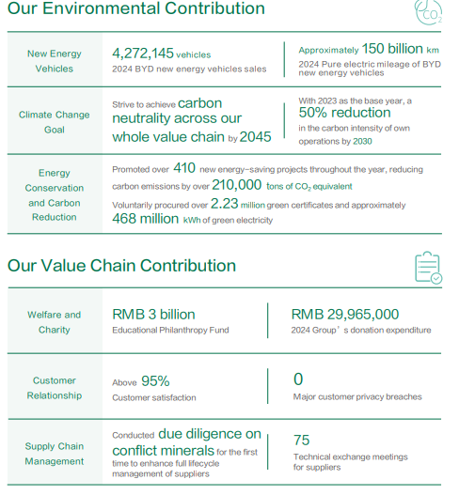
Fig: BYD’s sustainability performance(BYD, 2024a)
In Poland, BYD has an opportunity to build its Corporate Social Responsibility (CSR) by working in partnership with local renewable-energy suppliers, investing in the development of EV-charging infrastructure, and investing in skills training of the Polish technicians. Such projects are in line with the expectations of stakeholders and they will lead to national decarbonisation objectives.

9. Performance Evaluation Framework
Evaluating the success of BYD’s expansion into Poland requires the systematic performance measuring system that monitors the financial, operational, customer, and sustainability performance. The most appropriate framework is the Balanced Scorecard (BSC), developed by Kaplan and Norton (1996), which incorporates both financial and non-financial variables allowing the alignment with the strategic goals, and facilitates the continuous organisational learning, which is paramount in the case of the technology-driven multinational corporation, like BYD(Kaplan & Norton, 1996). The BSC is well-suited to assessing international expansion, as it not only focuses on short-term outcome (e.g., market penetration), but also on long-term capability-building (e.g., brand trust, innovation), unlike single-metric-based approaches.

9.1 Balanced Scorecard: Key KPIs and Success Metrics
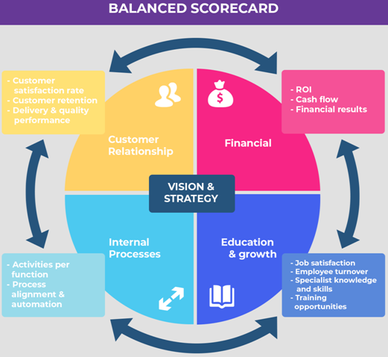
Fig: Balanced Scorecard(Kaplan & Norton, 1996)
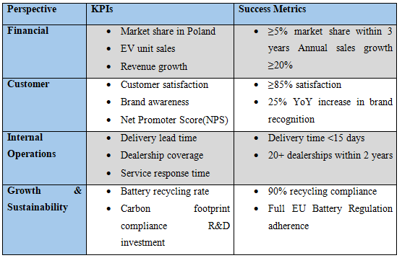
Developed by Author

9.2 Monitoring and Implementation Plan
The performance review should be conducted every quarter, and the annual strategy reviews yearly to adjust targets in accordance with the market conditions. Sources of data will be sales record, reports of dealership performance, customer surveys, audit of regulatory compliance, and sustainability disclosures. Accountability of performance monitoring should be shared among BYD Europe Strategy Office, dealership partners in Poland, and Sustainability Division. Powerful digital dashboards and analytics frameworks will facilitate real-time monitoring, which will help to make agile decisions. Using the Balanced Scorecard, BYD will be able to evaluate its market entry performance in an orderly manner and maintain strategic alignment, operational effectiveness, and sustainability in Poland.

10. Recommendations
Based on the strategic analysis and evaluation of the capabilities of BYD, external market conditions, and competitive environment in Poland, the following strategic recommendations are proposed to facilitate the successful market entry and future development.
- Focus on the gradual market entry approach: BYD needs to start with export supported by good dealership relationship to quickly create brand awareness and then shift to regional assembly through its plant in Hungary after 18-24 months to reduce logistic expenses and the risks associated with EU tariffs.
- Strengthen brand building efforts in Poland: The lack of awareness of Chinese automotive brands necessitates targeted marketing campaigns that will focus on safety, reliability of the model, and high performance of the Blade Battery. Consumer trust and awareness can be raised through demonstration events, strategic sponsorships, and online interaction.
- Develop an effective after sales services network: Collaboration with local service centres, training programmes of technicians, and digital servicing tools are necessary to enhance customer experience and decrease operation bottlenecks. BYD must target the nationwide coverage of service in three years.
- Increase the localisation by adapting products and features: Localisation of models to the preferences of the Polish consumer market, including providing competitive priced compact SUVs, digital interfaces in Polish language, and cold weather battery optimisation, will enhance market fit and competitiveness.
- Enhance sustainability and circular-economy practises: BYD should collaborate with the Polish and EU battery recyclers, ensure that it fulfills the requirements of the EU Battery Regulation, and encourage take-back programmes to improve environmental credibility.
- Use Poland as a launch pad to expand to CEE: For EU-backed EV expansion in Central and Eastern Europe, BYD should make Poland as a regional distribution and service hub to access neighbouring markets.

11. Conclusion
This report assessed the process of strategic expansion of BYD into Poland through a comprehensive analysis of its external environment, industry dynamics, and internal capabilities. The results show that Poland has a highly developing EV market with favourable EU policies, growing infrastructure investment, and the rising consumers interest, presenting a strong strategic opportunity for BYD. Internally, BYD stands at a good position to compete effectively with foreign and established automakers in Europe and globally due to its cost-effective vertical integration, advanced Blade Battery technology, and strong R&D capabilities. The suggested phased entry approach of initial exporting supported by dealership partnerships, followed by regional assembly offers optimal balance between speed, cost efficiency, and risk mitigation. To maintain the competitive advantage, BYD will have to encourage continuous innovation, develop service network, effective localisation, and solid CSR commitments. All in all, BYD is in a good position to use its global strengths to realise long-term growth and become a leader in Poland and the entire Central and Eastern European EV market.

12. References
- Adelakun, A. (2020). Should Porters Five Forces have value in businesses today. Computing for Business (BSC).
- Ansoff, H. I. (1957). Strategies for diversification. Harvard business review, 35(5), 113-124.
- Ariwibowo, P., Saputro, F. B., & Haryanto, H. (2021). Analysis of Strength & Weakness, Using the Concept of Resource-Based View with the VRIO Framework in Sharia Cooperatives. Jurnal Manajemen Strategi dan Aplikasi Bisnis, 4(1), 279-294.
- Autovista24. (2025a). BYD makes quick progress in the European EV market. Available at: https://autovista24.autovistagroup.com/news/byd-makes-quick-progress-in-the-european-ev-market [Last Accessed: 11/24/2025].
- Autovista24. (2025b). Mix of stability and concern for Poland’s automotive markets. Available at: https://autovista24.autovistagroup.com/news/mix-of-stability-and-concern-for-polands-automotive-markets [Last Accessed: 11/24/2025].
- Buye, R. (2021). Critical examination of the PESTEL Analysis Model. Project: Action Research for Development, 1-12.
- BYD. (2023). Hello! We are BYD! Available at: https://www.byd.com/eu/blog/Hello-we-are-BYD [Last Accessed: 11/24/2025].
- BYD. (2024a). 2024 Sustainability Report. Available at: https://www1.hkexnews.hk/listedco/listconews/sehk/2025/0324/2025032401244.pdf [Last Accessed: 11/24/2025].
- BYD. (2024b). Annual Report 2024. Available at: https://www1.hkexnews.hk/listedco/listconews/sehk/2025/0324/2025032401238.pdf [Last Accessed: 11/23/2025].
- BYD. (2025a). About BYD. Available at: https://www.bydglobal.com/cn/en/BYD_ENAboutByd/CompanyIntro_mob.html [Last Accessed: 11/24/2025].
- BYD. (2025b). About BYD Group. Available at: https://www.bydeurope.com/byd-group [Last Accessed: 11/24/2025].
- BYD. (2025c). Brand Mission. Available at: https://www.bydglobal.com/en/BrandConcept.html?scroll=true [Last Accessed: 11/24/2025].
- Commission, E. (2024). June 2024 Polish Electric Vehicle Market Overview. Available at: https://alternative-fuels-observatory.ec.europa.eu/general-information/news/june-2024-polish-electric-vehicle-market-overview [Last Accessed: 11/24/2025].
- Commission, E. (2025). The European Green Deal. Available at: https://commission.europa.eu/strategy-and-policy/priorities-2019-2024/european-green-deal_en [Last Accessed: 11/24/2025].
- Daniel, M. (2024). Post-COVID-19 electric vehicle market in Poland: Economic-based determinants. Annales Universitatis Mariae Curie-Skłodowska, Sectio H Oeconomia, 58(1), 57-77.
- de Sousa, C. D. M. (2024). Electric Vehicle Manufacturer BYD Expansion into Europe: A Case Study. ISCTE-Instituto Universitario de Lisboa (Portugal),
- Do, N. D. (2020). Integrating sustainability into strategic management to gain competitive advantage.
- Dong, L., Sun, X., Sun, L., Zhao, D., Wang, C., Gong, W. T., . . . Lei, Z. (2025). A comprehensive analysis on EU batteries regulation: lifecycle decarbonization, business challenge and compliance risk.
- EV.com. (2025). BYD Targets 50% Overseas Sales by 2030, Eyes Europe and Latin America. Available at: https://ev.com/news/byd-targets-50-percent-overseas-sales-2030 [Last Accessed: 11/24/2025].
- Henry, A. (2021). Understanding strategic management: Oxford University Press.
- IEA. (2025). Trends in electric car markets. Available at: https://www.iea.org/reports/global-ev-outlook-2025/trends-in-electric-car-markets-2 [Last Accessed: 11/24/2025].
- Indiran, L., Lei, J., Baskaran, S., Yaacob, T. Z., Kohar, U. H. A., & Senin, A. A. (2023). Disruptive Innovation: A Case Study of BYD's Business Model Canvas. International Journal of Academic Research in Business and Social Sciences, 13(9).
- Kaplan, R. S., & Norton, D. P. (1996). The balanced scorecard: translating strategy into action. Language, 11(322p), 23cm.
- Karpenko, Y., Kuznetsova, I., Chykurkova, A., Matveyeva, M., Hridin, O., & Nakonechna, K. (2021). Formation of the enterprise strategy based on the industry life cycle. Independent Journal of Management & Production, 12(3), s262-s280.
- Komornicki, T., & Goliszek, S. (2023). New transport infrastructure and regional development of Central and Eastern Europe. Sustainability, 15(6), 5263.
- Magazine, E. (2025). How Is BYD Driving Its Sustainability Strategy? Available at: https://evmagazine.com/news/what-is-the-sustainability-strategy-of-chinese-ev-giant-byd [Last Accessed: 11/24/2025].
- Magazine, P. (2025). BYD’s Commitment to Enhancing its Raw Material Supply Chain. Available at: https://procurementmag.com/supply-chain-management/byd-expands-into-brazils-lithium-valley-with-acquisition [Last Accessed: 11/24/2025].
- Manev, N., Pyk, A., Pendaroska, M., & Bartosik, A. (2025). Electric Vehicle Adoption in Poland: Insights from Academia and Technically Educated Youth. Sustainability, 17(11), 5179.
- Marković, D., & Mijušković, V. (2022). Disruptions and competitive strategies in the automotive industry. In Transdisciplinarity (pp. 207-227): Springer.
- Montes Torralbo, J. (2024). Electrification of Vehicles and the Future of the Automobile Industry in Europe.
- NFP. (2025). Number of fully electric passenger vehicles in Poland passes 100,000. Available at: https://notesfrompoland.com/2025/10/08/number-of-fully-electric-passenger-vehicles-in-poland-passes-100000 [Last Accessed: 11/24/2025].
- Observatory, E. A. F. (2025). Poland Reaches Over 100,000 BEVs. Available at: https://alternative-fuels-observatory.ec.europa.eu/general-information/news/poland-reaches-over-100000-bevs [Last Accessed: 11/24/2025].
- Perera, R. (2017). The PESTLE analysis (Vol. 1): Nerdynaut Avissawella, Sri Lanka.
- Porter, M. E. (2008). Competitive advantage: Creating and sustaining superior performance: simon and schuster.
- PSNM. (2024). 2024 in Polish New Mobility. Available at: https://psnm.org/wp-content/uploads/2025/01/PSNM_Year_2024_in_New_Mobility_in_Poland_Report_EN.pdf [Last Accessed: 11/23/2025].
- Reuters. (2025). Exclusive: BYD to delay mass production at new Hungarian plant, make fewer EVs, sources say. Available at: https://www.reuters.com/business/autos-transportation/byd-delay-mass-production-new-hungarian-plant-make-fewer-evs-sources-say-2025-07-22 [Last Accessed: 11/24/2025].
- Shahan, Z. (2023). BYD Is The 1st Company To Sell 3 Million Plugin Vehicles In A Year. Available at: https://cleantechnica.com/2024/01/02/byd-is-the-1st-company-to-sell-3-million-plugin-vehicles-in-a-year [Last Accessed: 11/24/2025].
- Statista. (2025). BYD Pulls Ahead of Tesla to Become Largest EV Maker. Available at: https://www.statista.com/chart/33709/tesla-byd-electric-vehicle-production/ [Last Accessed: 11/24/2025].
- T&E. (2020). Emissions reduction strategies for the transport sector in Poland. Available at: https://www.transportenvironment.org/articles/emissions-reduction-strategies-transport-sector-poland [Last Accessed: 11/24/2025].
- TAN, T. K. (2021). The impact of digitalization on international expansion: A study on market entry strategy based on the Integration-Responsiveness Framework.
- TVPWorld. (2025). Poland’s economy accelerates as GDP grows 3.7% in third quarter. Available at: https://tvpworld.com/89991075/poland-records-strong-37-gdp-growth-in-q3-2025 [Last Accessed: 11/24/2025].
- Wang, Z. (2025). Cost Management of Chinese Alternative Energy Vehicle Enterprises Based on Value Chain Analysis: Taking BYD Company as an Example. In Technological Horizons of Decarbonization Based on Environmental Innovations (pp. 253-257): Springer.
- Zhang, Y., & Lustenberger, U. (2025). Balancing Protectionism and Innovation: The.
- Zhang, Z. (2025). The European Union's Countervailing Duties on Electric Vehicles from China: Disputes and Prospects.
- Zhou, Y., Gomes, E., & Vendrell‐Herrero, F. (2025). Optimizing International Market Selection: A Dynamic Approach Integrating Export and FDI Entry Modes. Thunderbird International Business Review, 67(6), 739-755.

