Christopher Pace

1708232

Network Security - M7X01701

Simulation of a potential real life scenario

Dr Carlene Campbell

Table of Content
- Introduction
- List of figures and tables
- List of Acronyms
- Contingency policy
- Penetration testing framework
- Penetration testing tools
- Attacking the website
- Defence strategy
- Cost of Solution
- Bibliography

Introduction
Penetration testing, also commonly referred to as ethical hacking or black box testing is a widespread method used to test Web Application and/or Network Security.
A penetration test, is an approved methodical approach of searching for vulnerabilities within an application and/or network, with the ultimate goal to gain access to the system's inner workings.
In essence penetration testing is a structured form of hacking in which the ‘Tester' operates on the behalf of the computer system owner, to try an identify weaknesses that criminals may exploit.
Inappropriate system configuration, operational weaknesses in process, technical counter measures and known/unknown software and hardware flaws are just a few of the potential weaknesses the process of penetration testing is used to identify.
The ultimate aim of a penetration test is to mimic the methods used by illicit hackers eliminating the threat of causing damage. Best practice is to perform these tests out of business hours or when the applications and/or network is being utilised the least, thus minimising the impact on genuine user of the system.
The British Civil Society Organisation (BSCO) recently commissioned Tecomex Forensics Ltd to produce a contemporary and up-to-the-minute website called Citizens United for Peace and Stability (CUPS). The specification from BCSO was to construct a fast and secure website that is capable of streaming radio and TV broadcasts globally utilising the internet.

Due to the human rights, anti-corruption, mass enlightenment and empowerment activities of the CUPS organisation, http://cupstv.com has come under persistent attack from some illicit organisations that do not appreciate its activities. Fortunately, in light of these attacks, http://cupstv.com website has currently never been breached.

The purpose of this report is to perform a REAL Black Box penetration test on http://cupstv.com.

The penetration tests used during this process will be in line with the OWASP Top 10 (2017) and closely related to the OWASP Testing Guide v4. [1][2][3]

List of figures and tables
Figure 1 - OWASP Top 10 2017
Figure 2 - nslookup
Figure 3 - ID Serve lookup
Figure 4 - curl command
Figure 5 - Zenmap Output
Figure 6 - WinSCP FTP attempt
Figure 7 - Putty SSH attempt
Figure 8 - Netcraft Search Output 1
Figure 9 - Netcraft Search Output 2
Figure 10 - Netcraft Search Output 3
Figure 11 - Netcraft Search Output 4
Figure 12 - WPScan Output 1
Figure 13 - WPScan Output 2
Figure 14 - WPScan Output 3
Figure 15 - robots.txt output
Figure 16 - Reverse IP Domain Check
Figure 17 - SQL Injection 1
Figure 18 - SQL Injection 2
Figure 19 - SQL Injection 3
Figure 20 - SQL Injection 4
Figure 21 - Login Screen
Figure 22 - Login Screen Error Message
Figure 23 - Information Disclosure 1
Figure 24 - Information Disclosure 2
Figure 25 - Information Disclosure 3

List of Acronyms
OWASP - Open Web Application Security Project
SQL - Structured Query Language
OS - Operating System
LDAP - Lightweight Directory Access Protocol
ORMs - Object Relational Mapping Tools
API - application programming interfaces
XXE - XML External Entities
XML - Extensible Markup Language
XSD - XML Schema Definition
SAST - Source Code Analysis Tools
HTTP - Hypertext Transfer Protocol
PHP - Hypertext Preprocessor
XXS - Cross-site Scripting
CSP - Content Security Policy

Contingency policy
This agreement is between:-

Christopher Pace (The Tester) and
Tecomex Forensics (The Customer)

The following terms and conditions have been agreed between the Customer and the Tester: -

- The penetration test will be solely against http://cupstv.com and no other related web applications associated with the web servers where the web application is held.

- The Tester is only authorised to perform the penetration test between October 6th 2017 and December 15th 2017.

- The Tester and Customer will provide telephone number and email addresses that will be used to communicate details of the penetration test. No other telephone numbers or email addresses will be used during the penetration test to protect against security.

- The Customer can request the Tester to Immediately halt the test any time during the testing.

- The Tester agrees that it will perform the penetration tests in a professional and conscientious manner, and will endeavour not to amend any of the web applications settings, content.

- The Tester does not guarantee that the results of the penetration test guarantee that the web application is completely secure.

- The Customer guarantees that they are the legal owner of the web application, if not they have gained the necessary permission from the legal owner for the penetration test to be performed.

- The Tester will not be held responsible for any damage caused to the web application during the test.

- The Customer is solely responsible for the equipment and backing up of data involved in this penetration test, and will not seek compensation for any loss of data/equipment during this test.

- The Tester will not disclose and confidential information that has been exchanged between parties during the penetration test, all information is treated as highly confidential. This information will be only used during the penetration test, if this information needs to be disclosed to a third party, authorisation from the Customer will be obtained in writing.

- All confidential information will be destroyed after the penetration test has been performed and the Vulnerability Report has been compiled.

Signed: -

CHRISTOPHER PACE
The Tester

IDRIS AHMED
Tecomex Forensics

Penetration testing framework
The penetration testing framework being utilised within this report will be the OWASP Testing Guide v4.0, in conjunction with the OWASP Top 10 2017. These will be used as our base for our penetration test against the http://cupstv.com website.
These will be used only as a guide and not exclusively, as this OWASP Testing Guide contains far too many testing techniques to complete within the scope of this report/assignment.

What is the OWASP Top Ten?

The OWASP Top 10 is a document produced by the OWASP Foundation. The OWASP Foundations Core Purpose is to be the thriving global community that drives visibility and evolution in the safety and security of the world’s software[4].
The OWASP Top 10 document has been produced to spread the awareness of web application security flaws, and attempts to characterise the top 10 latest attack vectors a web application may face. The attack vectors contained within the report have been compiled by a variety of globally based security experts who have used their specialist, up-to-date knowledge to contribute towards the Top Ten list[5].
In collaborating the OWASP Top 10, data from 40+ Application Security specialist companies together with a comprehensive survey completed by in excess of 500 security professionals. Data contained within the document covers vulnerabilities assembled from hundreds of organisations and in excess of 100,000 real-world applications and APIs[2].
Prioritisation of the Top 10 has been decided on the frequency together with consensus estimates of exploitability, delectability and impact[2].

OWASP Top Ten 2013 v OWASP Top Ten 2017

Over recent years fundamental technologies and architectures have changed rapidly. Therefore, The OWASP Top 10 has had to adjust accordingly. Working with the Security community the Top Ten risks have been re-ordered, re-written, and the methodology has been overhaul ed.
This can been seen by the adjustment of some risks and the inclusive of others in the new list, this can be seen in the below table: -
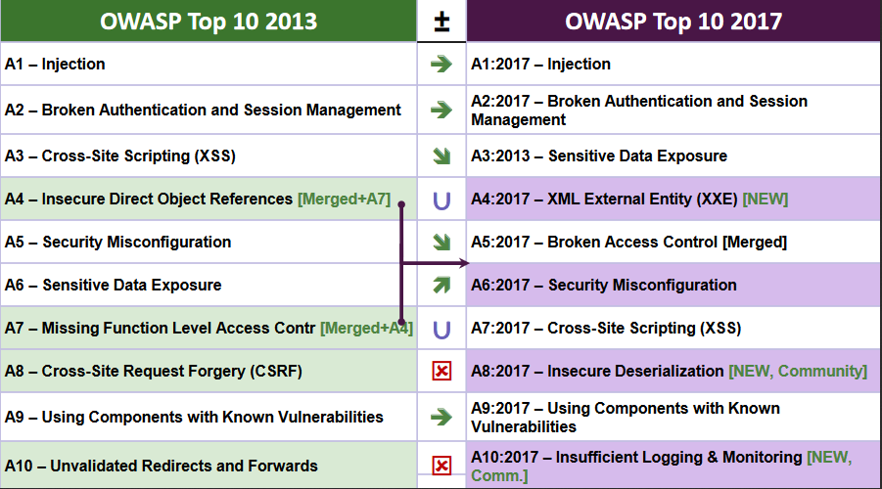
Figure 1 - OWASP Top 10 2017

OWASP Top 10 Risks Explained

This report will be based around the risks identified in the OWASP Top 10 2017, of which a brief description of each risk is given below: -

A1:2017- Injection
An Injection occurs when an attacker sends untrustworthy data to the interpreter in order to take advantage of a web applications insecure coding. This injected data can allow the attacker to perform unintentional commands or obtaining access to unauthorised data stored in the web application backend database. Injection points for this type of attack could be injection through user input, cookies or URLs. Some of the injection flaws commonly used today are Structured Query Language (SQL), Operating system (OS) and Lightweight Directory Access Protocol (LDAP) injection [2][6].

Prevention
- Using a secure API, thus evading the use of an interpreter completely, this removes the use of the interpreter completely . Alternatively migration onto Object Relational Mapping Tools (ORMs) would also help.
- Use server-side white listing of input. This can prove difficult with applications that require special characters, such as mobile applications.
- For dynamic queries, remove special characters with the specific escape syntax for that interpreter.

- Use inbuilt controls within SQL to prevent mass disclosure of information.

A2:2017-Broken Authentication
Web applications use authentication and session management to restrict access to resources. Session management is the administration of already logged in users, whereas, authentication is where access is granted/restricted to a particular resource.
Improper implementation of authentication and session management application functions can allow an attacker to masquerade as another user, on a temporary/permanent, allowing the attacker to tamper with session tokens or cookies or compromising a users password [2][6].

Prevention
- Use multifactor authentication
- Make sure default credentials are amended, particularly Administrator credentials
- Execute weak password checks, such as testing against well know password lists and password rotation, length and complexity checks.
- Use the same communication for all outcomes, of password recovery, registration etc.
- Limit logon attempts, implement delays in between unsuccessful attempts.
- Log all login attempt failures, alerting administrators of attempts to break the authentication
- Randomize session IDs, invalidate after logout, idle and timeout

A3:2017-Sensitive Data Exposure
application programming interfaces (API) and web applications often inadequately protect sensitive data. This sensitive data should be protected both at rest and in transit, otherwise this data can be exploited by an attacker. When data is stored in a database it should be encrypted even if this data is not directly accessible via the web application. Data transmitted between the database and the web browser should also be encrypted to prevent exploitation from an attacker [2][6].

Prevention
- Destroy unneeded sensitive data
- Classify data that is stored or transmitted by an application and apply controls relevant to their classification
- Data at rest and transit should be encrypted
- Make sure that Standard algorithms, protocols and key are kept up to date
- Caching should be disabled if sensitive data is involved
- Passwords should be stored using salted hashing
- Checks should be manual made to check the effectiveness of the above settings etc.

A4:2017-XML External Entities (XXE)
XML eXternal Entity injection (XXE) is an attack the tries to circumvent the application that parses XML input. Inadequately configured XML processors evaluate external entity references within XML documents, where untrusted XML input containing a reference to an external entity is processed. This attack may lead to the disclosure of internal files using the file URI handler, internal file shares, internal port scanning, remote code execution, and denial of service attacks [2][6] [7].

Prevention
- Upgrade and Patch all XML libraries and processors being used by the application or operating system.
- Disable DTD processing and XML eternal entity in every XML parsers within the application
- Server-side input validation should include white listing
- File upload functions should be checked that incoming XML is validated using XSD validation or similar
- XXE in source code can be detected using Source Code Analysis Tools (SAST) tools, but manual code reviewing is often preferred

A5:2017-Broken Access Control
Inappropriate restrictions being enforced on the access authenticated users are permitted to do are frequently overlooked. Attackers can exploit these weaknesses to access unauthorised data and/or functionality. If the web application fails to enforce adequate security checks for a particular object, the attacker will have access to a function they are not intended, such as access to sensitive information, ability to modify other users data and the escalation of privileges [2][6].

Prevention
- Deny by default, with exceptions made for public resources
- Access Control methods should be implemented once and utilised throughout a web application
- Accepting that the user can create, read, update, or delete any record should be avoided, access controls should make compulsory record ownership
- File metadata and backups should not be stored in web root, web server directory listing should also be disabled
- Access control failures should be alerted the administrators
- Protection against automated attack tooling can be achieved by rate limits on API and controller access

A6:2017-Security Misconfiguration
Often developers think that securing the web application is enough to protect their web application from exploitation. To ensure the security of a web application consideration should be made to ensure the web server configuration and operating system is secure and updated with the latest security patches, this also applies to the web frameworks used such as PHP or .Net as well as any other software utilised on the web server.
Verbose Error messages, misconfigured HTTP headers and insecure default/ad hoc configurations are just a few of the commonly seen security misconfiguration issues seen within web applications [2][6].

Prevention
- Remove unused features, components, samples or documentation
- Segmentation of application architecture
- Review and update configurations frequently
- A robust hardening process that makes it easy and fast to deploy a new secure environment

A7:2017- Cross-Site Scripting (XSS)
When an attacker injects malicious client-side script into a web application for future execution by the victim is know and Cross-site Scripting (XSS). XXS attacks are used to circumvent access controls and to masquerade as legitimate users, such as the web application admin. XSS allows attackers to run scripts in the victim’s web browser which can deface web sites, hijack user sessions or redirect the user to malicious sites.

Prevention
- Frameworks that automatically escape XSS should be utilised
- Escaping non trustworthy HTTP request data built on the context in the HTML output
- Context-sensitive encoding should be applied when modifying the browser document on the client side
- Content Security Policy (CSP) should be enabled giving a defense-in-depth extenuating control against XSS.

A8:2017- Insecure Deserialization
Insecure deserialization flaws can enable an attacker to remotely execute code in the web application. Remote code execution is not always required to exploit insecure deserialization, attacks can be performed using replay attacks, conducting injection attacks and escalation of privileges[2][6][8].

Prevention
- Integrity checks should be utilised, these can include digital signatures on any serialized objects to stop hostile object formation or data tampering.
- Enforcing strict type constraints during deserialization before object creation as the code typically expects a definable set of classes. Bypasses to this technique have been demonstrated, so reliance solely on this is not advisable.
- Code should be deserilaized in low privileged environments wherever possible.
- Deserialization exceptions and failures should be logged, this could include wher the incoming data type is unknown or where deserilisation throws up exceptions.
- Restricting or monitoring incoming and outgoing network connectivity from containers or servers that deserialize.
- Alerts should be triggered if a user deserializes constantly, this can be achieved with effective monitoring.

A9:2017-Using Components with Known Vulnerabilities
Web applications and APIs use components, such as frameworks, libraries and other software modules, these components run with identical privileges as the application itself. Using components with know vulnerabilities, allows an attacker to exploit these weaknesses. Web applications are built with the most stable and secure version at the time, administrators fail to update these components thus leaving the Vulnerabilities open to exploitation[2][6].

Prevention
- Unused dependencies, components, features, documentation and files should be removed
- Persistent monitoring of the versions of both server-side and client-side components and their dependencies. Use analysis tools to automate the process. Utilise email subscriptions services for security alerts related to components that are used within the web applications
- Component should be obtained from official sources only. Signed packages should be preferred to minimise the chance of malicious components
- Libraries and components should be monitored when they are not maintained or do not build security patches for older versions

A10:2017- Insufficient Logging & Monitoring
Logging and monitoring is an important tool in the prevention and detection of security breaches. Where logging and monitoring is not integrated with incident response, attackers can exploit this deficiency allowing maintaining persistence, pivoting to other systems, tampering, extracting or destroying data, and allowing the attacker to implement future attacks. Breaches are often identified by external parties, rather than with the use of internal monitoring or logging, studies show that breaches are not detects for circa. 200 days, thus showing the importance of logging and monitoring[2][6].

Prevention
- Ensure all login, access control failures, and server-side input validation failures can be logged with sufficient user context to identify suspicious or malicious accounts, and held for sufficient time to allow delayed forensic analysis.
- Logging should be formatted accordingly to enable a centralised management system to interpret them easily
- An audit trail should be available for high value transactions, the audit trail should be tamper prove
- Suspicious activity should be reported in a timely manner to enable an effective response
- An effective response/recovery plan should be adopted

Penetration testing tools
Windows Command Prompt
ID Serve
Kali shell
Zenmap
WinSCP
Putty
Netcraft
WPScan
Reverse IP Domain Check
ViewDNS.info

Attacking the website
Firstly we need to identify the IP address of website to enable us to perform the attacks/scans we intend. This can be achieved by simply performing a nslookup on cupstv.com: -
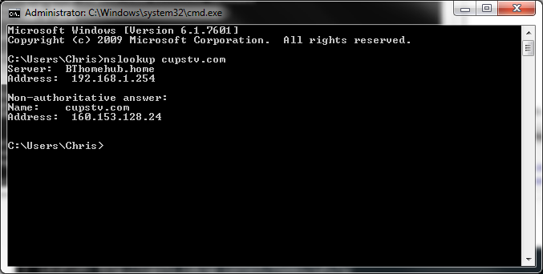
Figure 2 - nslookup
Using ID Serve we can identify the web server that is being used, as can be seen below, http://cupstv.com is using Apache. We can use this information to identify vulnerabilities related to this Server type.
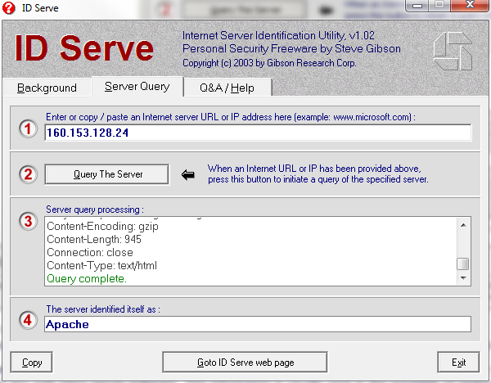
Figure 3 - ID Serve lookup

Using the curl command with the -I switch will fetch the HTTP-header only for the requested URL, using this on http://cupstv.com on port 80 we get the following output: -
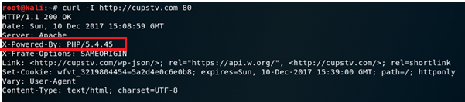
Figure 4 - curl command
From this information we can determine that the web application is utilising PHP version 5.4.45.
We can also perform a scan on http://cupstv.com to identify which ports are listening on the website. Below is the output from a Zenmap scan: -
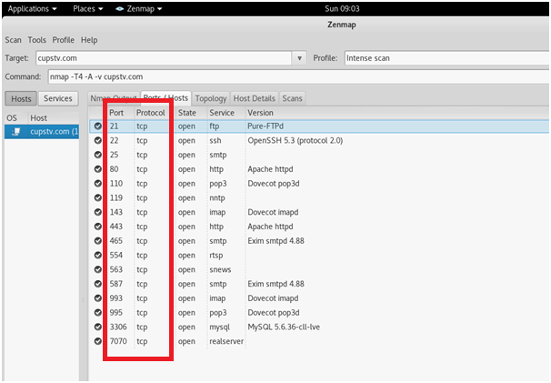
Figure 5 - Zenmap Output
From the output we can determine that the web server appears to be running email services, this is shown by the use of the following ports: - 25, 110, 1431 ,465, 993, 995.
We can also determine that Realserver is running on the server, this is shown by the use of the following ports: - 554 & 7070.
We can see from the output that port 21 (FTP) is open, we could potentially brute force attack or social engineer passwords to gain entry into this. Using WINSCP below you can see that the FTP is active: -
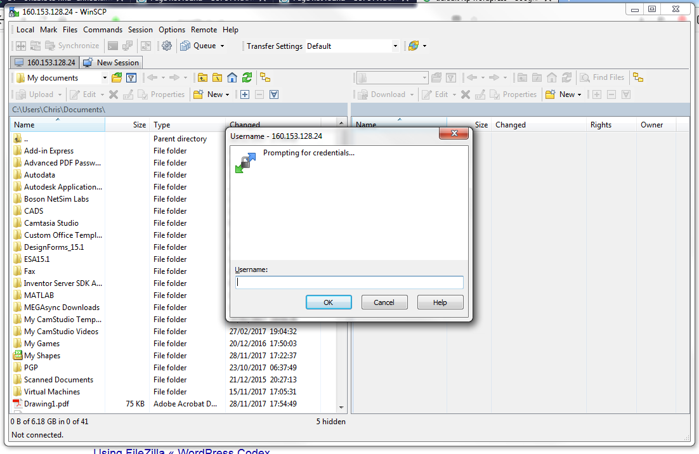
Figure 6 - WinSCP FTP attempt
Additionally you can see that port 22 (SSH) is also open, we could potentially brute force attack or social engineer passwords to gain entry into this. Using Putty below you can see that the SSH is active: -

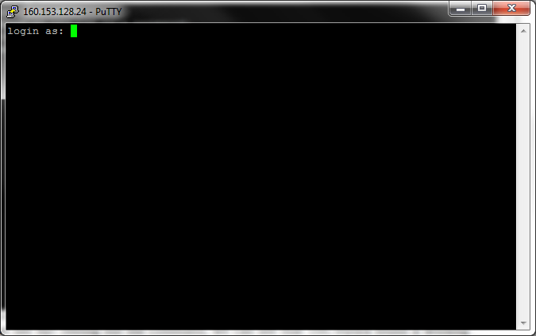
Figure 7 - Putty SSH attempt
Performing a search Netcraft search on http://cupstv.com, we can determine the following information about the web application: -
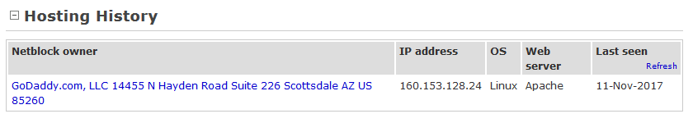
Figure 8 - Netcraft Search Output 1
We can again see that an Apache web server is being used and that it is being hosted by GoDaddy.
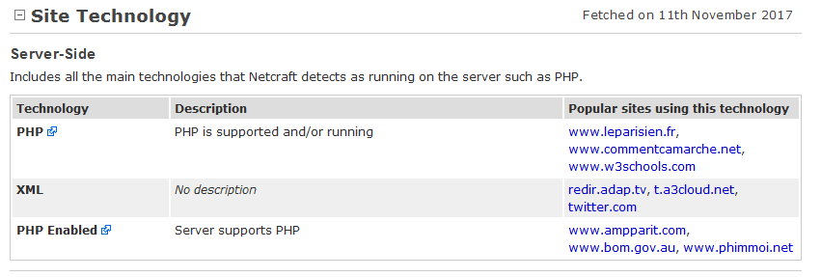
Figure 9 - Netcraft Search Output 2
We can also see that Server-side the web application is using XML and PHP.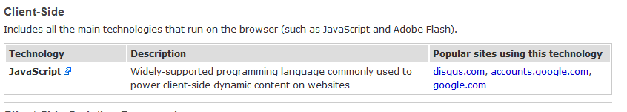
Figure 10 - Netcraft Search Output 3
Client-side the web application uses JavaScript.
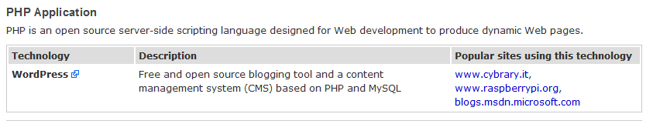
Figure 11 - Netcraft Search Output 4

We can also determine the web application is using WordPress. From this information we can perform a WPScan on the web application to identify any vulnerabilities associated to the Wordpress version, below you can see some output from this scan: -
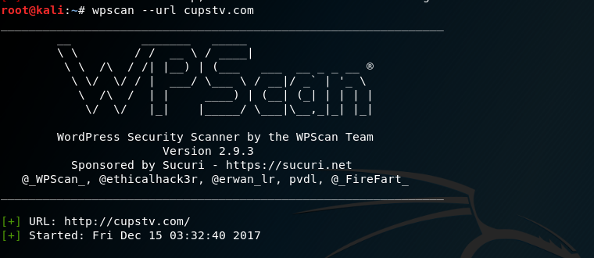
Figure 12 - WPScan Output 1
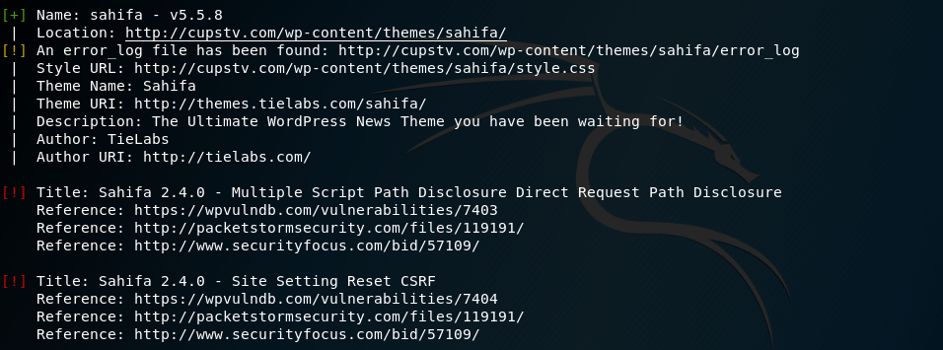
Figure 13 - WPScan Output 2
The above output has identified that http://cupstv.com is using the sahifa v5.5.8, this theme has 2 known vulnerabilities which can be exploited.
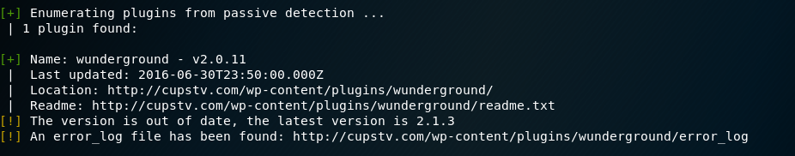
Figure 14 - WPScan Output 3
The scan has also identified an out-of-date plugin 'wunderground v2.0.11'.
WPScan has also found interesting entries from the robots.txt file, actual robots.txt file shown below: -

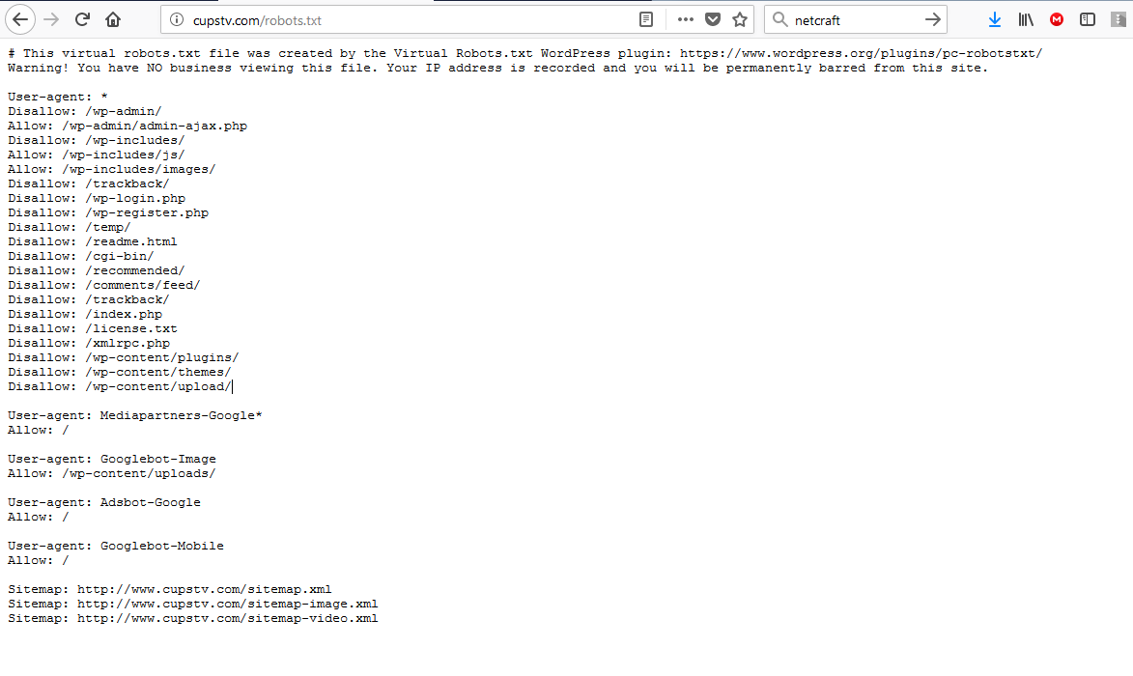
Figure 15 - robots.txt output
Performing a reverse IP lookup on http://cupstv.com we can determine that there are 45 other web application hosted on the web server, these can be seen below: -
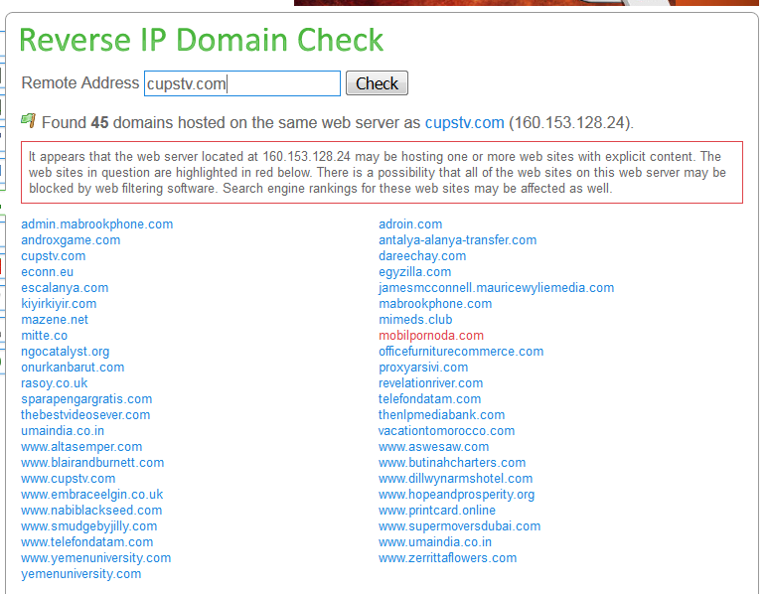
Figure 16 - Reverse IP Domain Check
We can also test for SQL Injection vulnerabilities, to do this we use the generic 1 OR 1=1 to test whether the code is being executed. This can be tested on all entry points on within the web application, show below: -
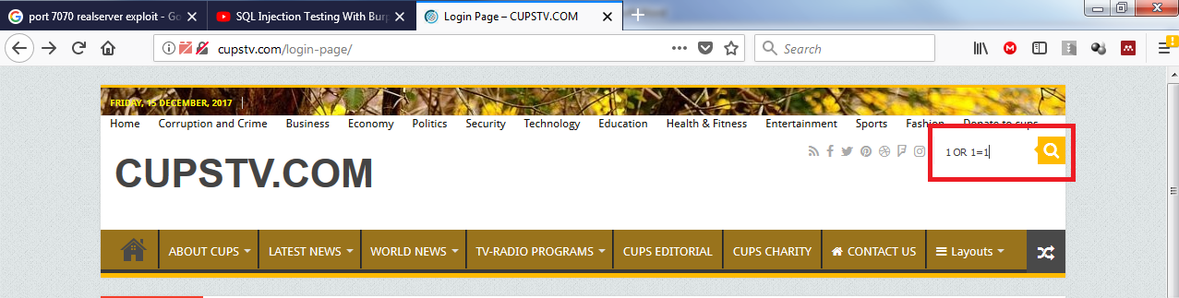
Figure 17 - SQL Injection 1
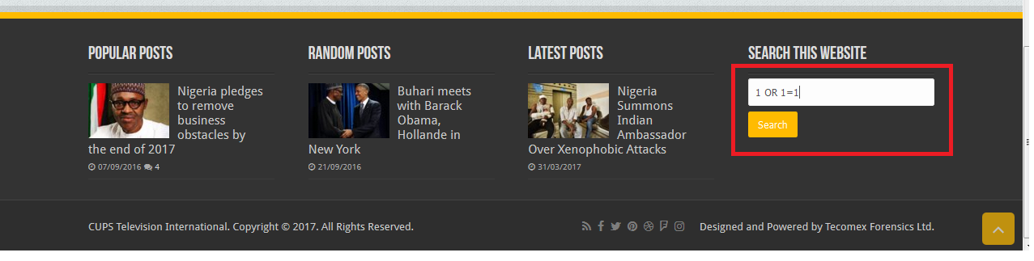
Figure 18 - SQL Injection 2
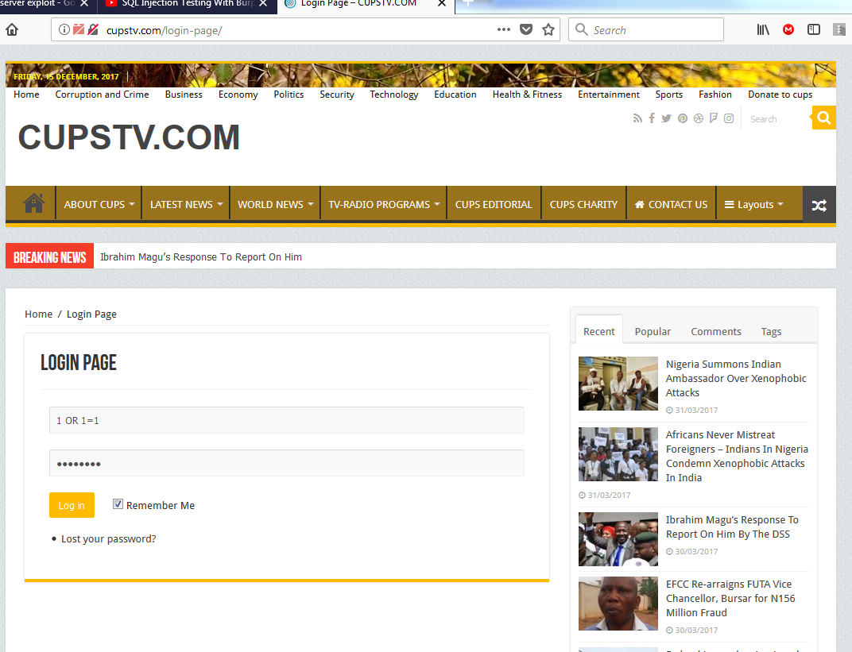
Figure 19 SQL Injection 3
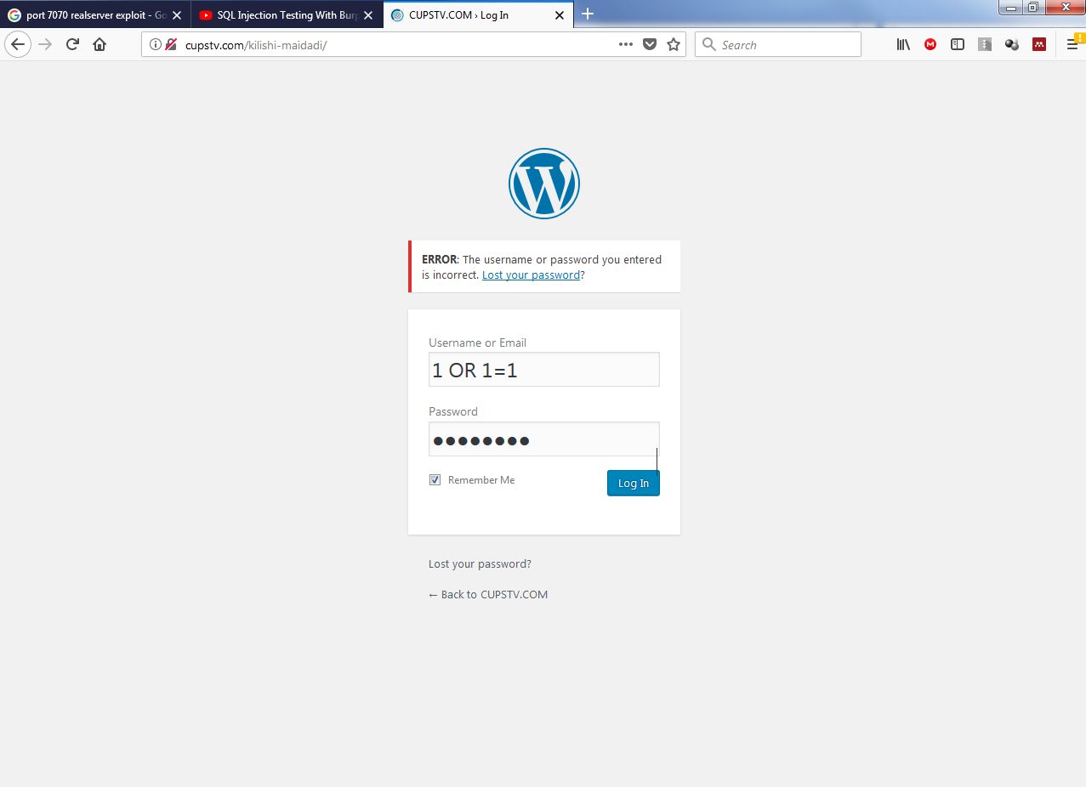
Figure 20 - SQL Injection 4
None of the above SQL Injection attempts worked, therefore there seems to be protections within the web application to prevent this type of exploit.
Additionally we could attempt to authenticate on the web application login page, we could potentially brute force attack or social engineer passwords to gain entry into this.

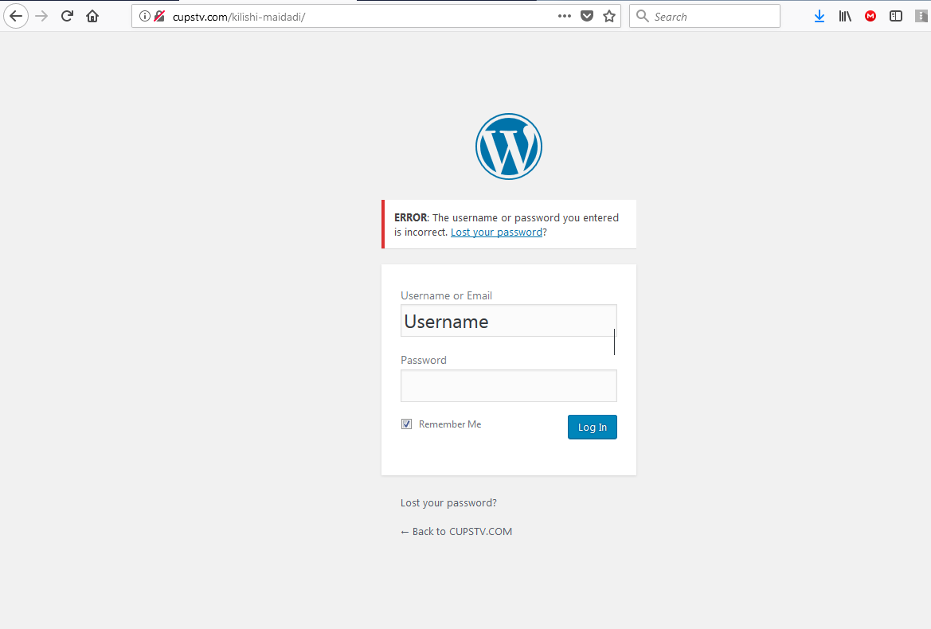
Figure 21 - Login Screen
As you can see below, there appears to be security measures in place to prevent this type of exploit. IPs are blocked after a number of unsuccessful attempts.
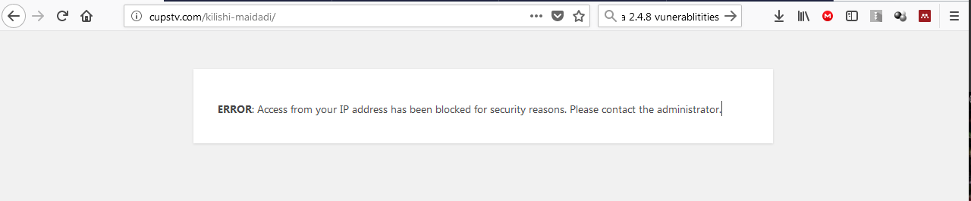
Figure 22 - Login Screen Error Message

Searching the website we can find some information regarding the owner, Idris Ahmed.
This includes 2 mobile telephone numbers and an email related to the site, see below: -
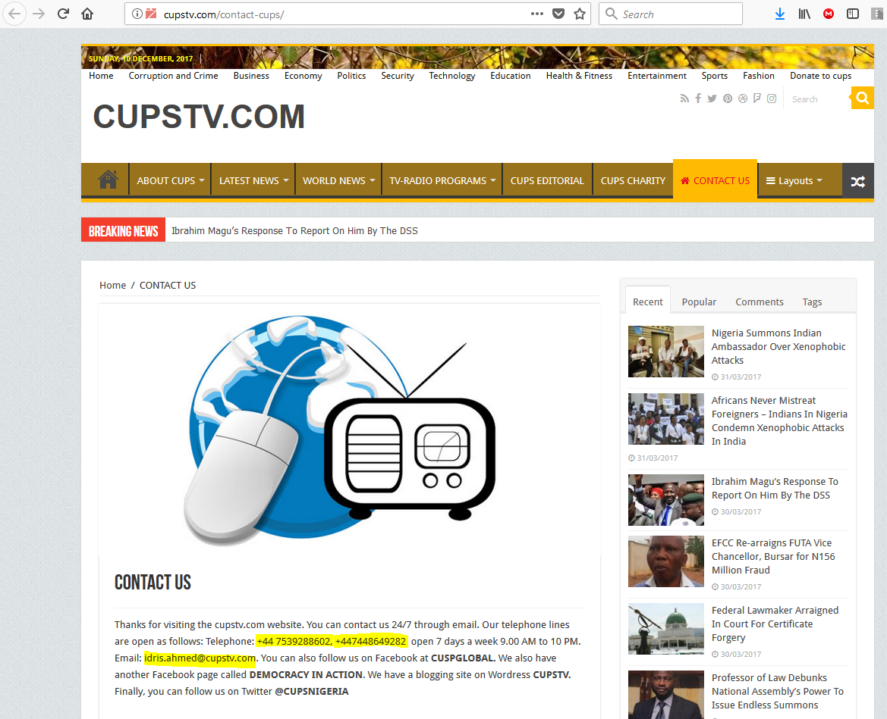
Figure 23 - Information Disclosure 1
Performing a whois lookup on http://cupstv.com we can also find a further personal email address and a Postal address, see below: -
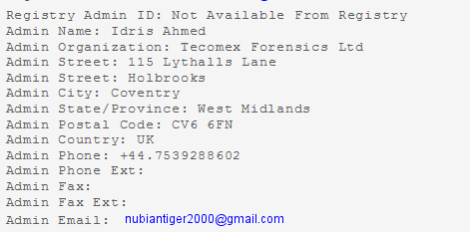
Figure 24 - Information Disclosure 2

From the email address nubiantiger2000@gmail.com we can also do a reverse whois lookup to find any other related websites linked that email address, as you can see below we have found an additional 4: -
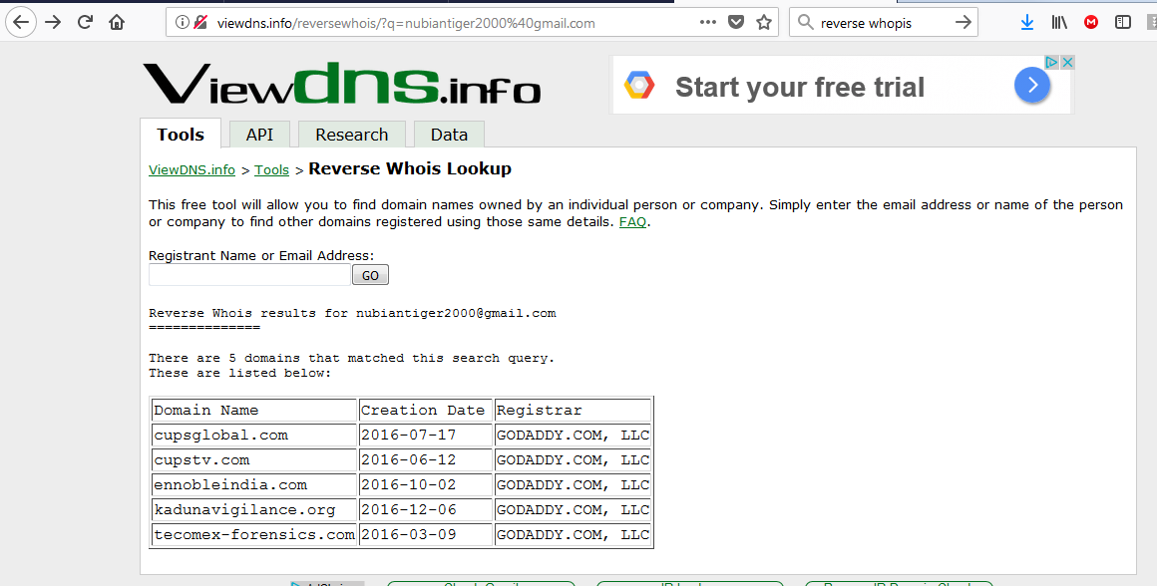
Figure 24 - Information Disclosure 3
Social engineering on the above information could be used to gain access to information which could be useful in taking down the web application.

Defence strategy
During the penetration testing we detected the presence of the Robots.txt file. Robots.txt is only used to instruct search robots which resources should be indexed and which ones are not.

We should ensure nothing sensitive is exposed within this file, such as the path of an administration panel. If disallowed paths are sensitive and you want to keep it from unauthorised access, do not write them in the Robots.txt, and ensure they are correctly protected by means of authentication.

We identified that the Web application is using an out-of-date plugin wunderground v2.0.11 this should be updated to v2.1.3.

We identified that the Web application is using an out-of-date Theme, sahifa v5.5.8. This theme contains 2 known vulnerabilities: -

- Sahifa 2.4.0 - Cross Site Request Forgery / Path Disclosure
- Sahifa 2.4.0 - Site Setting reset CSRF

Both of these vulnerabilities can be determinable to the web applications stability, and could possible result in the website becoming unavailable.

In order to protect against the above vulnerabilities, this theme to be updated to the latest stable version provided by the theme manufacturers, if the updated version still contains these vulnerabilities, possible removal of this theme should be considered and replacing with a stable and secure theme.

We also identified an Out‐of‐date PHP Version, the web application is currently running v5.4.45, this has 4 important and 20 other vulnerabilities, these 4 Important vulnerabilities are shown below: -

- PHP Remote Code Execution Vulnerability - CVE-2015-6831
- PHP Remote Code Execution Vulnerability - CVE-2015-6832
- PHP Remote Code Execution Vulnerability - CVE-2015-5590
- PHP Remote Code Execution Vulnerability - CVE-2015-6836

Each of the above vulnerabilities allows remote attackers to execute arbitrary via crafted serialized data that triggers, these can be determinable to the web applications stability, and could possible result in the website becoming unavailable. More information regarding these can be found on the https://cve.mitre.org/ using their CVE number.

Consideration should be given to upgrade the PHP version to the latest stable version currently v7.1.6.

During the penetration test we identified 45 other website hosted on the same infrastructure as http://cups.tv. Measures should be put in place to protect against attack via other web applications held on the same server. Consideration should be given to hosting the website on a dedicated web server, if financially possible.

Although, we were unable to determine the current version of Wordpress being used, consideration should also be given to upgrading to the most stable and secure available.
Any ports that are not necessarily needed for the stable running of the web application should be shut, particularly tcp/21 & tcp/22 as these are open to brute force password attempts.
Consideration should be given to remove any sensitive information from the web application which could potentially be socially engineered, i.e. telephone numbers/emails.
Also it may be considered appropriate to hide whois information by contacting your domain registrar and ask for a the private registration.
Consideration should also be given to utilising https as password are sent clear text during the login process, which could be exploited.
Password complexity and password expiry times should also be checked that they meet the necessary standards.

Cost of Solution
There are no potential software costs associated with the recommendations, although costs will be impaired in the physical installation of the updates.
Potentially the upgrading of the website will take circa. 2days, where costs will be at an hourly rate of £30 per hour.

Bibliography
[1] “Penetration testing from IT Governance.” [Online]. Available: https://www.itgovernance.co.uk/penetration-testing. [Accessed: 02-Dec-2017].
[2] OWASP, “OWASP Top 10 -2017 The Ten Most Critical Web Application Security Risks,” 2017.
[3] OWASP, “OWASP - Testing Guide 4.0,” no. Cc, 2014.
[4] “About The Open Web Application Security Project - OWASP.” [Online]. Available: https://www.owasp.org/index.php/About_The_Open_Web_Application_Security_Project#The_OWASP_Foundation. [Accessed: 03-Dec-2017].
[5] “Category:OWASP Top Ten Project - OWASP.” [Online]. Available: https://www.owasp.org/index.php/Category:OWASP_Top_Ten_Project. [Accessed: 03-Dec-2017].
[6] “OWASP Top 10 for 2013 Explained.” [Online]. Available: https://www.netsparker.com/blog/web-security/owasp-top-10-2013/.
[7] “XML External Entity (XXE) Prevention Cheat Sheet - OWASP.” [Online]. Available: https://www.owasp.org/index.php/XML_External_Entity_(XXE)_Prevention_Cheat_Sheet. [Accessed: 05-Dec-2017].
[8] “OWASP Top 10 Vulnerabilities | Veracode.” [Online]. Available: https://www.veracode.com/directory/owasp-top-10. [Accessed: 05-Dec-2017].

