Group 1
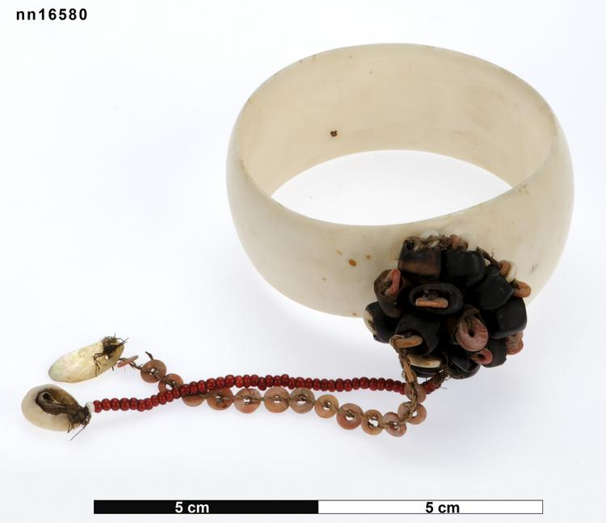
5 mwali (3 with prestige associations acquired as a prestigious bundle

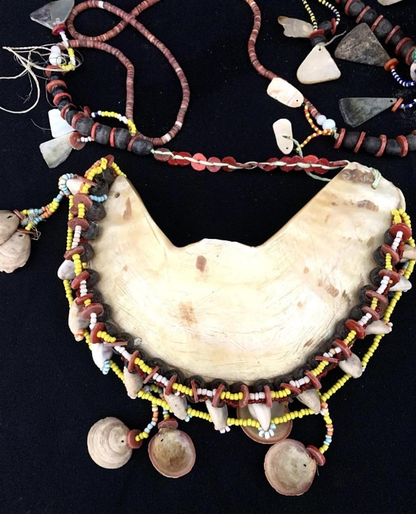

7 Soulava (2 pairs acquired as discrete bundles)

Group 2
10 mwali (5 very strong prestige/biography associations but acquired separately)

6 soulava

Group 3
1 mwali (quite new)
No soulava!

Group 4:
2 mwali: no real associations
1 soulava: very presitigious associations

