

Financial Management for the Hotel Industry
Module Code: BMIH5007
Andrei Florian Popa
2127688
Tristan Hawkins

Table of Contents
1 Introduction 4
2 Background 4
3 Financial management strategies and practices of Mandarin Oriental and Premier Inn 5
3.1 Total Revenue 5
3.2 Market Position 6
Figure 1 Key Insights of the UK Hospitality Industry 6
Figure 2: Popular Hotel in the UK 7
3.3 Growth Potential 7
Figure 3: Price to Earnings Ratio of Mandarin Oriental 8
3.4 Financial Commitment to CSR (Corporate Social Responsibility) 9
4 Summary 11
5 Recommendations 11
6 References 13

Introduction
The hotel sector faces severe competition and quick development, and as a result, it places great emphasis on achieving excellence in several areas, including financial management. This business research aims to conduct a comparative analysis of two prominent actors in the hotel sector, namely the Mandarin Oriental Hotel Group (MOHG) and Premier Inn. The objective of this study is to conduct a comprehensive examination of their financial management strategies and methodologies, focusing mainly on the key determinants that impact their profitability and sustainability.

Figure 1 Logo (Whitbread, 2023)
The MOHG has gained a reputation for providing high-quality services at a five-star level, whilst Premier Inn has established itself as a prominent brand in the market for offering affordable accommodations. This study will examine critical criteria such as the financial stability of the firm, its market position, potential for development, and expenditure on corporate social responsibility (CSR). Through the analysis of these components, our objective is to illuminate the strategies used by these enterprises in addressing the inherent obstacles encountered within the realm of hospitality. Furthermore, the report provide tangible recommendations for enhancing their operational efficacy.
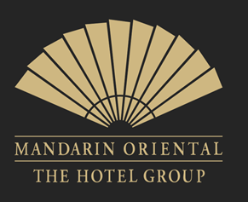
Figure 2 Logo (Airasia, 2020)

Background
The establishment of the MOHG took place in 1963, and since then, it has gained a reputation for providing luxurious rooms and exceptional service on a global scale. The esteemed reputation of the establishment facilitates its ability to attract clientele who are inclined to invest in accommodations, eating experiences, and many ancillary amenities. The organisation has positioned itself as a frontrunner in the upscale hospitality industry, strategically emphasising affluent travellers, prominent individuals, and corporate clientele. MOHG strategically expands its market presence in key global regions, focusing on Asia, Europe, and North America, to sustain its development trajectory. Furthermore, the company has shown a solid commitment to CSR via its focus on environmental practices and active involvement with the local communities around its sites.
Premier Inn, a prominent budget hotel chain in the United Kingdom, has been under the ownership of Whitbread PLC since 1987. The primary sources of revenue for the establishment are its accommodations and dining facilities, which appeal to a diverse range of travellers seeking affordable but superior-quality hotel options. Premier Inn positions itself as a brand that prioritises value, highlighting a solid commitment to both quality and affordability. The United Kingdom has had significant advancements in this sector, resulting in its near-exclusive dominance over the affordable hotel industry. Aligned with its organisational objective to provide superior accommodations while minimising its ecological impact, the firm has successfully executed many sustainability initiatives and actively participated in community engagement endeavours.

Financial management strategies and practices of Mandarin Oriental and Premier Inn

Total Revenue
The assessment of a company's financial well-being and operational effectiveness may be primarily accomplished by examining its aggregate revenue. MOHG mainly depends on its luxury hotel chain segment as a primary source of revenue. The Paradise Island resort in the Bahamas, which is affiliated with the Luxury Hotels of the World (LHW) group, has gained recognition for its extravagant amenities and lavish accommodations. The provision of room rents, high-priced meals, spa treatments, and many other premium services facilitates the generation of substantial revenue for institutions targeting the luxury market. Through consistently surpassing the expectations of consumers, MOHG has successfully cultivated a clientele characterised by both loyalty and financial stability.
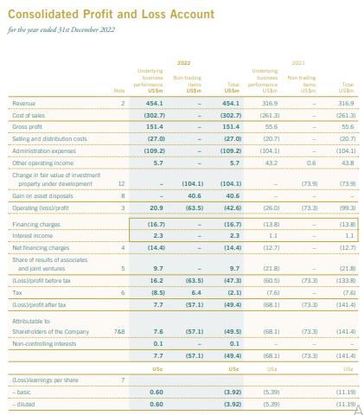
Figure 3 MOHG Annual Report of 2022 (MOHG, 2022)
In contrast, Premier Inn primarily derives a significant portion of its revenue from a distinct market segment characterised by affordable lodging options. Premier Inn distinguishes itself with its ability to provide superior quality accommodations at affordable prices. The primary source of revenue for the establishment mainly stems from the provision of lodging arrangements, supplemented by the provision of food and beverage services. Premier Inn's pricing strategy is designed to cater to a wide range of customers, including individuals with limited financial resources, families with children, and business travellers. The brand's reputation for consistently providing high-quality products at affordable prices ensures a consistent influx of customers, contributing to its substantial revenue. Both MOHG and Premier Inn have shown efficacy in augmenting their total revenue in their respective markets via the use of diverse operational strategies and distinct pricing approaches. The critical brand identities and customer bases of the organisations influence the methods of financial management.
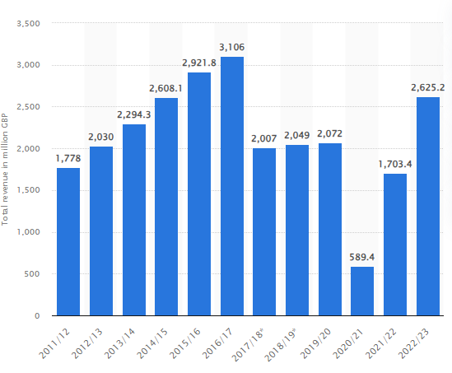
Figure 4 Premier Inn Total Revenue (Statista, 2022)

Market Position
The marketing term, market position, refers to the brand's position within the targeted market segment (Kalam and Kalam, 2020). It further includes consumers' perception of the brand compared to the other competing businesses within the same market segment competing over similar business products. It includes making the brand position and image in the consumer's mind and in the existing business market in order for the consumer to perceive the business and products in the way in which it is positioned. The brands usually relate and connect the brand to a specific occasion or thing (Heinberg et al., 2020). Some of the brands are known as and are positioned as the brands for happiness, such as Cadbury. As the mission of the Mandarin Oriental states, it is a brand of delights and mainly focuses on providing the customer with services that completely delight and satisfy the customers. The customer satisfaction is the utmost priority for the Mandarin Oriental. The premier inn, one of the top hotels in the UK, has positioned itself as a brand that cares about the guest's comfort. Furthermore, if anyone does not feel this way after spending days at the Premier Inn, they will get their money back. This brand offering has given the brand a competitive advantage as this is the first time anyone does this in the current competitive market (Coleman 2019).
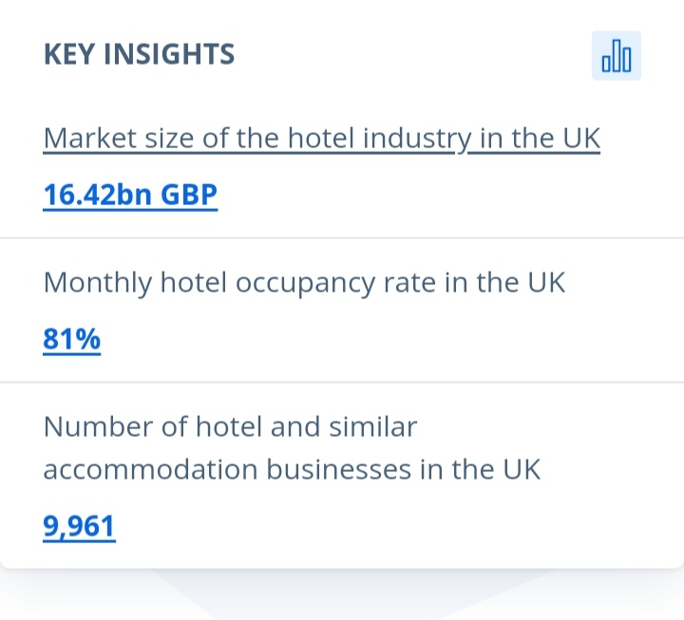
Figure 5 Key Insights of the UK Hospitality Industry
Source: Statista

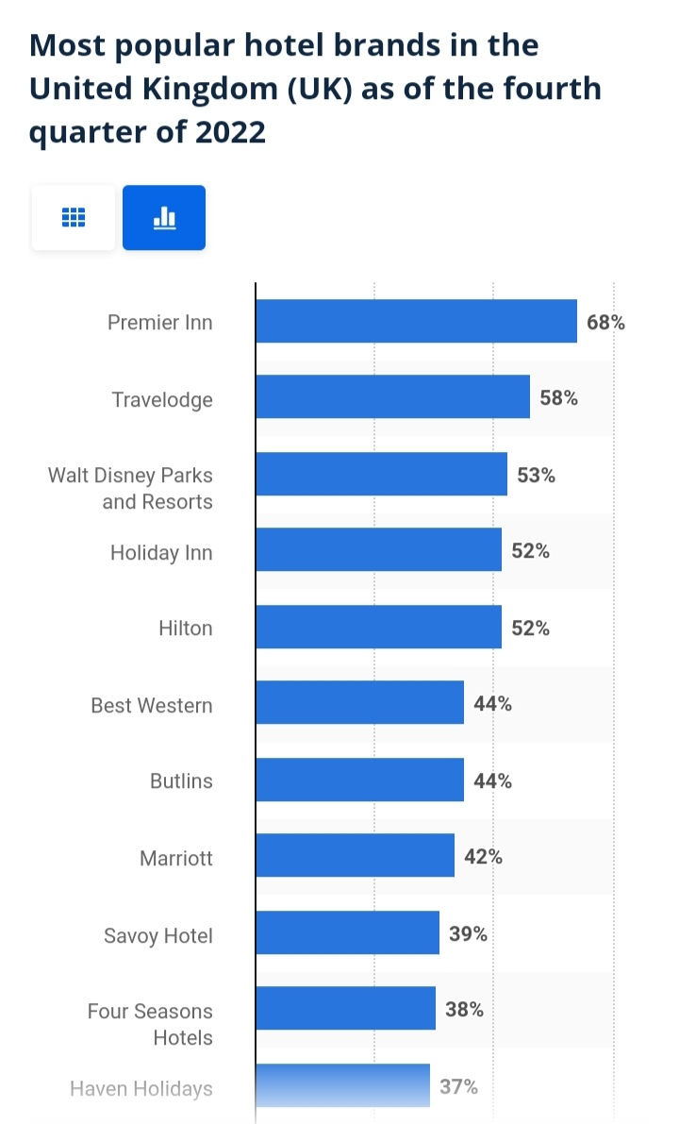
Figure 6: Popular Hotel in the UK
Source: Statista

Growth Potential
Growth potential is defined as the ability of the business to generate higher profits in the coming future by developing its workforce to increase overall production. Having the growth potential is very important in today's competitive environment. Growth potential is necessary for the competitive environment. If the business does not have the potential to grow in the upcoming years, the marketing and positioning strategy should be reviewed again. The price-to-earnings ratio determines the business's growth potential, as it provides a detailed examination of the stock. Comparing the price-to-earnings ratio with the previous year's P/E ratio will give the overall view of business growth as compared to the last year. Further, it will also provide the investors with a more comprehensive view of the profits, revenues and growth of the business. The average rate for the price-to-earnings ratio is 20% to 25%. Any ratio that is below the average is considered a good P/E ratio, and the ratio above the average point would be considered a bad P/E ratio. The P/E ratio for the Mandarin Oriental is given in Figure three, which shows that the P/E ratio for the current year is less than zero per cent. The Premier Inn in the UK is owned by the brand Whit Bread. The Premier Inn helped Whit Bread to increase its revenue for the first half year and showed robust performance. The revenues grew by 6.4% to £1.1bn, and the pre-tax profits improved in the first quarter of 2023 by £295m.

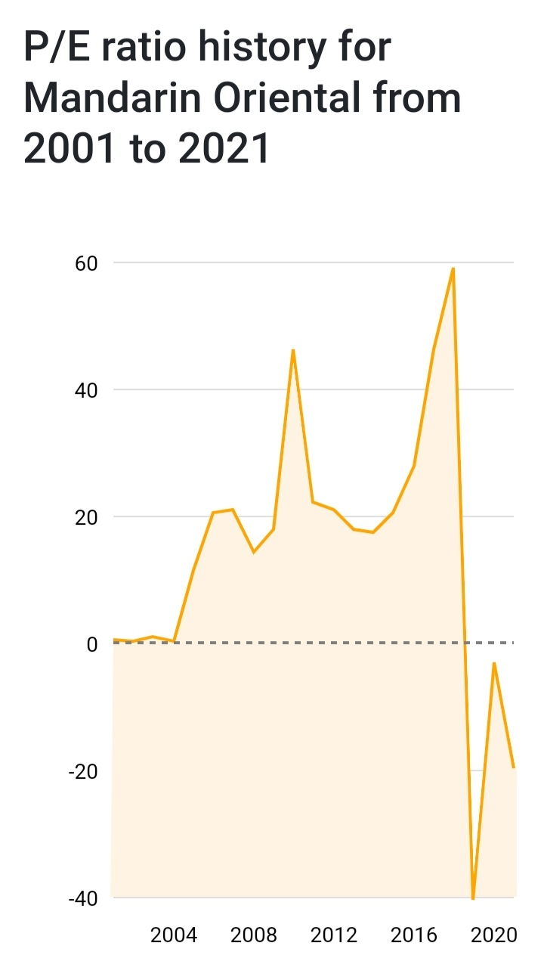
Figure 7: Price to Earnings Ratio of Mandarin Oriental
Source: Companies Market Cap

Financial Commitment to CSR (Corporate Social Responsibility)
Corporate social responsibility is a framwork by which a company takes accountability and ownership towards itself, the public, the planet and its stakeholders. It is regarded as a way of management by which organisations have incorporated social and environmental concerns within the operations. CSR enables a company to balance its social, environmental and economic imperatives (UNIDO 2023). The initiatives taken by SDGs have made companies fundamentally transform towards CSR because of its significant potential in increasing the economic value of innovation and shareholder value. Therefore, organisations are moving towards CSR by incorporating different responsibilities and financially contributing towards it (Fatima and Elbanna, 2023). Premier Inn Hotel has kept its strong focus on caring about teams, communities and the planet. It has initiated a campaign, namely Force for Good that has the core aim of ensuring people live and work under suitable conditions. For that, it makes significant contributions towards the communities by minimising carbon in order to support the impactful work of Great Ormond Street Hospital for many years. It is one of the luxury hotels in the UK that has been supporting communities by financially contributing to bring positive change. It donated more than half a billion worth of meals for the cause of charity in the year 2020, and it has partnered with the Real Junk Food Project and has donated over 400 tons of goods, which is equivalent to 335,000 meals. Furthermore, Premier Inn supports communities by sponsoring each team member at the new site to volunteer for the local cause, and it has pledged £20 million towards the GOSH charity to help children with cancer and save lives. Moreover, Premier Inn has made a potential contribution to driving a positive difference in the lives of individuals and communities through financial commitment towards CSR (Premier Inn, 2023). The MOHG has also shown financial commitment towards CSR by making significant financial contributions to the community to manage the environmental impacts and social commitments responsibly. It has enhanced our ESG policies and increased the overall sustainability governance structure, and it has reduced 30% carbon intensity by conducting regular audits at hotels for energy. The MOHG has minimised plastic use by excluding supplier packaging and has made a contribution of about USD M donation from the Mandarin oriental foundation for social causes. Mandarin oriental claims that it is on journey to make things naturally better for the communities and for planet by deeply ingraining the CSR values. The working force is strongly driven towards the identification of potential ways by which local communities can be supported by proactively engaging in taking essential steps. It has partnered with reach out to donate at least three times a week to the cause of charity. It is fully sponsoring disadvantaged individuals to attain training to break the poverty cycle by making financial contributions (Mandarin Oriental, 2023). Both organisations have shown significant financial commitment towards CSR and bring about a positive change towards communities and the planet.

Summary
HG offers high-end food and beverage services that are strategically positioned in the upper echelon of the market. These services are priced in a manner that aims to generate substantial revenue. The establishment's commitment to providing exceptional service has resulted in a favourable reputation among affluent leisure travellers and professionals. Furthermore, MOHG has shown its commitment to CSR by its prioritisation of environmentally sustainable business practices and its active engagement in philanthropic endeavours within the local community. On the contrary, Premier Inn is a prominent entity within the budget hotel sector, deriving its revenue from affordable room bookings and restaurant offerings. The primary advantage of this establishment is in its ability to provide high-quality accommodations at affordable rates, therefore attracting a diverse range of customers. Premier Inn places a high emphasis on CSR, actively participating in environmental initiatives and engaging in various types of community engagement. Both MOHG and Premier Inn operate in different market segments and use distinct pricing strategies. However, both companies have successfully optimised their total revenue within their respective market niches. The manner in which they manage financial resources serves as a direct manifestation of their core brands and their consumer base.

Recommendations
The MOHG should maintain its focus on enhancing the guest experience and preserving its premium reputation, considering its prominent standing within the luxury industry. It is essential for MOHG to allocate resources towards these endeavours in order to sustain its competitive edge. The following sections outline key focal areas for MOHG in order to attain sustainable development.
- The strategic expansion of MOHG should include a deliberate and calculated approach to increasing its presence in certain regions, particularly those that have growth potential in the luxury travel sector, such as Asia and the Middle East. The potential for growth may be maximised by diligent market analysis and strategic partnerships with local investors.
- To mitigate its dependence on hotel room income, MOHG should explore potential opportunities within other sectors of the luxury lifestyle business, such as wellness and entertainment. By leveraging its renowned brand, MOHG is able to provide affluent clientele exclusive and customised experiences that cater to their individual preferences.
- Sustain a prominent leadership role in CSR via the enhancement of activities aimed at mitigating the adverse environmental impact and fostering positive community engagement within the company's operational areas. In order to appeal to socially conscious visitors, it is advisable for MOHG to communicate its CSR endeavours transparently.

References
Coleman, D., 2019. Does brand purpose really serve a brand purpose? WARC exclusive, srpanj, pp.1-2.
Fatima, T. and Elbanna, S., 2023. Corporate social responsibility (CSR) implementation: A review and a research agenda towards an integrative framework. Journal of Business Ethics, 183(1), pp.105-121.
Heinberg, M., Katsikeas, C.S., Ozkaya, H.E. and Taube, M., 2020. How nostalgic brand positioning shapes brand equity: Differences between emerging and developed markets. Journal of the Academy of Marketing Science, 48, pp.869-890.
Kalam, K.K. and Kalam, K.K., 2020. Market segmentation, targeting and positioning strategy adaptation for the global business of Vodafone Telecommunication Company. International Journal of Research and Innovation in Social Science, 4(6), pp.427-430.
Mandarin Oriental (M04.SI) - P/E ratio (no date a) CompaniesMarketCap.com - companies ranked by market capitalisation. Available at: https://companiesmarketcap.com/mandarin-oriental/pe-ratio.(Accessed: 05 October 2023).
Mandarin Oriental 2023. Sustainability. [online] Available at; https://www.mandarinoriental.com/en/our-company/sustainability [Accessed on 5th October 2023]
Premier Inn 2023. We’re a Force for Good. [online] Available at https://www.premierinn.com/gb/en/why/force-for-good.html [Accessed on 5th October 2023]
Statista Research Department and 7, S. (2023a) Most Popular Hotel Brands UK 2022, Statista. Available at: https://www.statista.com/statistics/951262/most-popular-hotel-brands-uk/ (Accessed: 05 October 2023).
UNIDO 2023. Progress by innovation [online] Available at: https://www.unido.org/our-focus/advancing-economic-competitiveness/competitive-trade-capacities-and-corporate-responsibility/corporate-social-responsibility-market-integration/what-csr [Accessed on 5th October 2023]

