
GENERATING BUSINESS DATA AND ANALYSIS (BMSP4004)
DATA ANALYSIS AND REPORT

May 4, 2018
Oluwayemisi sobola
1601824

Contents
Executive summary for Part 1: Prosumer 2
Executive summary for Part 2 2
Part 1 Introduction: Prosumer 3
Part 2 Introduction 7
Benefits of Data Analysing 10
Recognising the Problem 11
Defining the Problem 12
Structuring the Problem 13
Analysing the Problem 15
Interpreting Results and Making A Decision 19
Visualisation: 19
Recommendation 27
Conclusion 30
Reference 32
Appendices 35

Executive summary for Part 1: Prosumer

This report will be analysing a variety of data using different concepts and principles of modelling and analysing data. Firstly, it will be discussing how the data was sourced/collected, stored, collated, analysed and then finally how they were presented using spreadsheets.

Executive summary for Part 2

Four sets of files will be analysed to retrieve information that can be used in future decisions about the respective businesses. Spreadsheet modelling is a very good tool to utilise for this exercise.

Part 1 Introduction: Prosumer

This paper will seek to explore the prosumer activities in different businesses, it will seek to understand who uses it and the participant. The paper will want to determine if it has benefits to the participants. The paper will seek find out whether prosumer applies to University as well.
The term prosumer is really new to me, but unknowingly, I have been participating in for a long time. As Mullins & Dettmer (2018) define prosumer as ‘consumers who share their knowledge with enterprises with the aim of creating values and benefits for enterprises and their own consumption’.
Prosumption is described by Tapscott & Williams (2006a) as “...where customers participate in the creation of products in an active and ongoing way”. Prosumption puts consumers to work, or it can also be likened to – do-it-yourself - by turning them into prosumers (Ritzer & Jurgenson, 2015, p.18-19). ‘As it is the process in which ‘prosumers share knowledge not only with enterprises, but also with other prosumers to produce things of value for enterprises, and also for themselves. They can share knowledge voluntary and do not expect any tangible benefits. Other times they share knowledge under the condition of obtaining certain benefits in return, such as rewards or fulfilling personal goals. To share their knowledge, individuals use information and communication technologies (ICT)’ (Mullins & Dettmer, 2018). Figure 1 shows the model of business processes with prosumers’ participation.

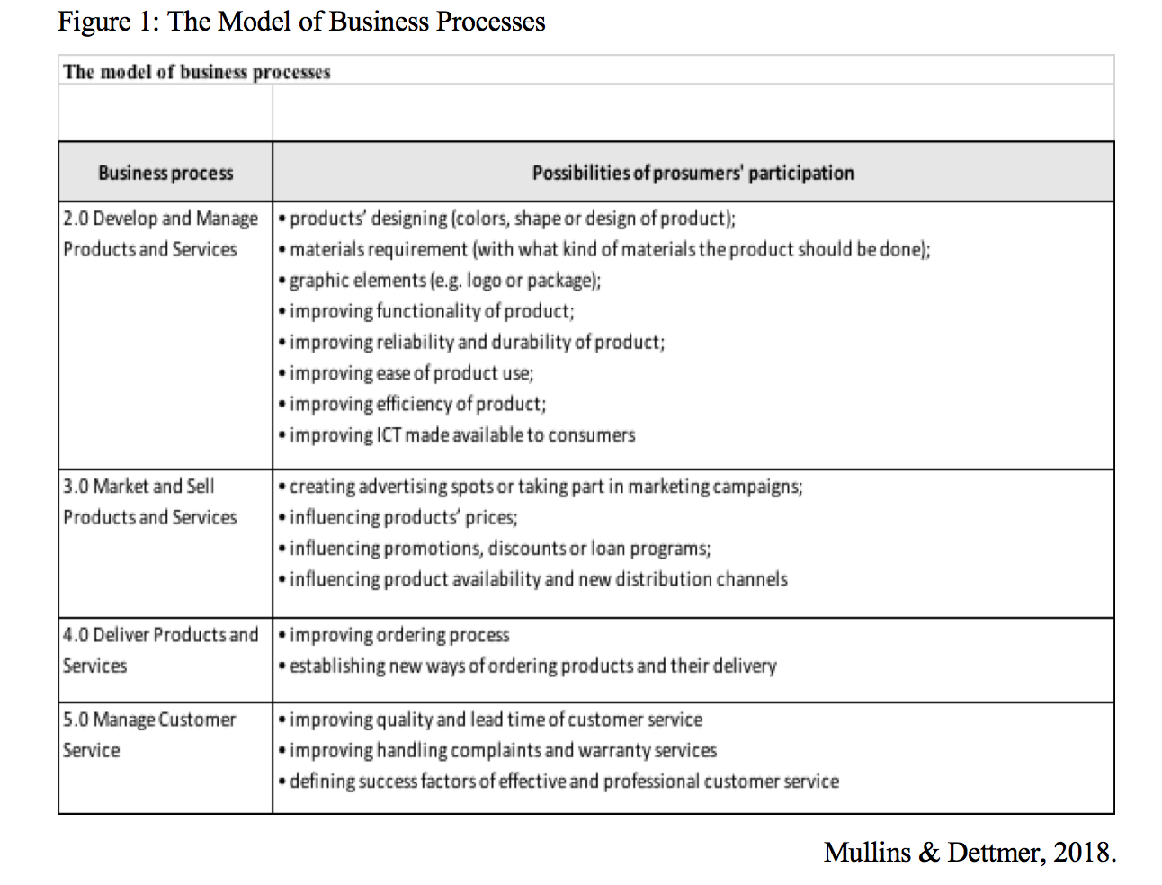
One can experience prosumers’ participation from when pumping one’s own gasoline at the filling station to participation on Facebook activities and other social networking websites, where users create profiles composed of videos, photos, and text, interact with one another, and build communities (Boyd, 2006, 2008a, 2008b; Appendix-1).
Furthermore, prosumer is a system where creativity meets consumption, it allows co-creation of product ideas and improvements, essentially, it is peer collaboration such as in 1998 when Lego Mindstorms allowed Lego customers and users to engage in program modification and software improvement activities, where prosumer community enhances innovation (Lego Mindstorms, 2017a; Figure 2; Ritzer & Jurgenson, 2015).

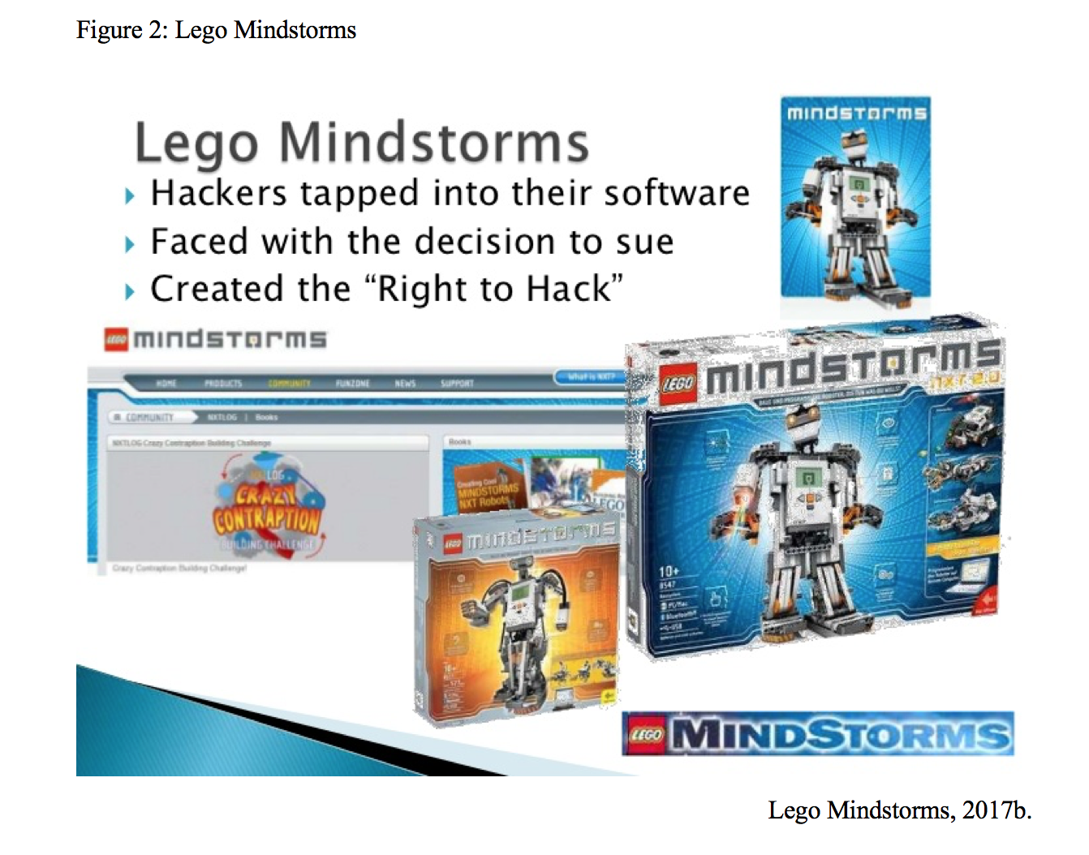

In the creative Prosumption, there are many challenges that businesses must navigate and manage carefully. Prosumers is company led, companies have to create a platform for consumers to co-create. The prosumers must be up-to-date on product development. Furthermore, for Prosumption to work, they must be offered reward. Again, prosumers are treated as co-creators therefore there is loss of control over innovation processes (e.g. Hacking), and products potential can be jeopardized because everything depends on what customers do with it (Tapscott & Williams, 2006b).
Nonetheless, businesses benefit from Prosumption, as it provides highly valuable information. Companies such as Google, Facebook and Amazon.com are provided with highly valuable information by the internet (Anderson, 2009). More so, businesses get free labour from prosumers because some are not actually paying prosumers for the information provided (Appendix-1). Digital businesses do not need to hire traditional market researchers to collect and compile all of these data (Gritzer, 2012).
In addition, consumers benefit from Prosumption by participating in the creation of a better product that satisfies them, better service and better information is at their figure tip, and in a way, prosumer activity be can be regarded as altruistic because the product they help create, firstly, is to satisfy them and secondly to benefit other consumers.
In relation to the task of gathering information on companies that engaged in prosumers. This was a time consuming and difficult task. The obvious companies are the tech and game companies and finding all the required information was challenging but greatly satisfying. Furthermore, Universities like UWTSD and University of Glasgow (2013-2020) are using digital platforms such as Moodle as some forms of Prosumption, especially in reference to the personal learning environment.
In conclusion, prosumer activities can be filled with complications as alluded to above, nonetheless, it generates benefits for both the businesses and consumers. Businesses must always remember that consumers have become co-creators, and equally must be treated the same. They need feedback and up-to-date information on the product or services development. This gives them satisfaction and a continuous willingness to collaborate. For the business, they are able to create a product with a ready-made market, they did not have to pay for market research, and in many cases, the consumers become the promoters for the product and customers generally trust other customers.

Part 2 Introduction

This paper will critically evaluate four files supplied that included File-1-Prosumer, File-2-Household Appliances, File-3-Swansea Business School and File-4-The Lampeter Farm. Several data tools for analysing and data modelling techniques will be utilised.
Evans (2014) argued that Business Analytics is the use of data, information technology, statistical analysis, quantitative methods, and mathematical or computer-based models to help managers gain improved insight about their business operations and make better, fact-based decisions. Therefore, in order to analyse the data provided, excel spreadsheet will be used. Excel is a spreadsheet application developed by Microsoft. Excel and makes it easy to visualise complex data and allows the ease of performing mathematical computations on segments of data easy as well. However, one of the shortcomings of excel is that it is a commercial software, its performance impacts on large datasets and cannot reproduce all types of graphs (Evans, 2014).
Edwards & Finley (1997) argued that when Excel spreadsheet is used as a modelling tool, it enables the summarisation of information from many sources in one place. It can present information in a format to help the decision-maker see the big picture of a given data. Furthermore, spreadsheet presents a specific view that is precise and well-structured. Edwards & Finley (1997) proposed further, that different types of data (figure 3) can be analysed in three different models:
- Logic Model
- Data Model
- Presentation Model

Evans (2014) described descriptive analytics as ‘using data to understand the past and current business performance in making informed decisions’. Evans (2014) further described predictive analytics as ‘predicting the future by examining historical data, and detecting patterns or relationships in these data, and then extrapolating these relationships forward in time’. Furthermore, Evans (2014) described prescriptive analytics as ‘identifying the best alternatives to minimizing or maximizing some objective’.
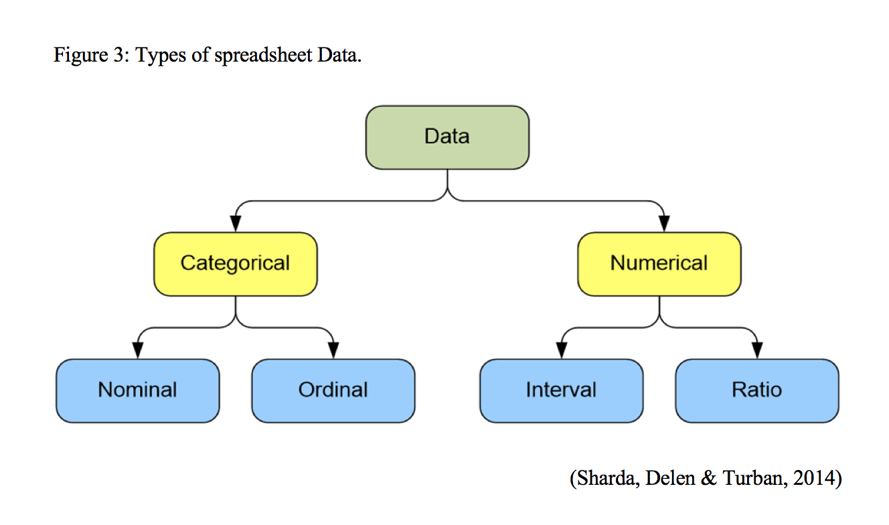
Furthermore, there are several data tools for analysing according to Evans (2014):
• List (database) queries and analysis
- Dashboards to report key performance measures
- Data visualization
- Statistical methods
- Spreadsheets and predictive models
- Scenario and “what-if” analyses
- Simulation
- Forecasting
- Data and text mining
- Optimization
• Social media, web, and text analytics

Benefits of Data Analysing

Authors such as Ragsdale (2001) and Evans (2014) agreed that data analysing helps organisations to reduce costs, manage risk better, make more informed and faster decisions, improve productivity and higher profitability and customer satisfaction. Nonetheless, Data Analysing faces few challenges such as lack of understanding of how to use analytics, competing business priorities, among others.
In analysing the giving task, firstly, data must be the cleansed, as cleansing will generate accurate data analysis, as this will allow the data to be accurate, countable, standardised; that is, consistent in format; Irrelevant or inappropriate data are eliminated and Non-redundant (see Appendix-2 for the rest; O'Beirne, 2008). Data cleansing is as important as issues like redundant data are removed. Furthermore, many authors including Ragsdale (2001) and Evans (2012) recommended modelling stages for staging the analytic process.
Model for Staging the Analytics Process
  - Recognizing a problem
  - Defining the problem
  - Structuring the problem
  - Analysing the problem
  - Interpreting results and making a decision
  - Implementing the solution

Recognising the Problem
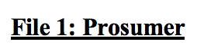
The focus here is determining companies’ sustainability statements by checking their websites.


After looking through the household appliance data, the resource consumption of these appliances is given top consideration.


The data presented reveals different usage at different time of the day for the time period.

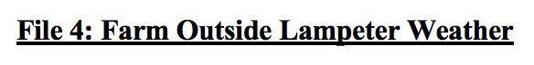
The recognisable pattern here is to determine the best weather forecast for the farm.

Defining the Problem

In defining the problem, the focus is on Sustainability. After examining the companies’ websites, attempts will be made to determine the evidence and analysis of common stated words and expressions used will be determined.

The focus is on usage Rating, total carbon emission (kg CO2) per year, percentage of Kg CO2 usage per Appliance/year, CO2 Rating.

The focus is to project when the peak and lowest energy kilowatt-hour (kWh) consumption periods are. What effect season or time has on consumption.

From the supplied data, an attempt will be made to determine the best time for growing grass, the best dry days, the snowing days, the most raining days and compare 2010 and 2018 data to determine the consistencies in the data.

Structuring the Problem

This stage involves cleaning the data to make a better sense of the data in all the files. Incomplete and missing data are removed or else the accuracy of the model may be affected. The first task conducted was to correct the errors and conduct general cleansing.

The objective is to determine
- Determine the common sustainable words used
- Sorted by how many businesses says ‘Yes’ to Evidence of Sustainability focus
- Sorted how many did not have evidence of sustainability
Data is cleansed, by
- Sorting in alphabetical order,
- Cleanings: converted all unfilled rows questions to assume 'No' and Cleanings: Deleted all unfilled questions (Appendix-3a,3d)
- All Duplicate Companies name in red high and red text
- All cell questions with no answer is assumed to be 'No'
- Cleanings: converted all 'Private' answer to the Question 'what type of Business Sector' to Assume 'Technology'
- sorted by how many businesses says yes to Evidence of Sustainability focus

The objective is to determine
- the top 2 products with worst CO2 usage and rating and find out the relationship between them
- relationship between kettle and tumble drier usage and cost
- Household health and hygiene appliances therefore:
- Deleted S9 and S18, converted word' Yes' to binary (1) and assume that unfilled date meant 'NO' which is converted to (0) (Appendix-3e,3f)
- By converting this, it will eliminate incorrect analysis and duplicating files

The objective is to determine
- Is there a link between seasons when students are on campus and the energy usage? To determine
- Total per day, average per pay, % usage per day, max usage, min usage. Then
- File number were rounded to 2 decimal places
- Date converted to text format
- Files were deleted (Appendix-3g)

The objective is to determine
- The best time to grow grass
- Best time for outdoor events such as cut and roll hay
- Filtering and sorting were used extensively

Analysing the Problem

56 businesses have evidence of sustainability and seven businesses did not have and Text Mining technique was used to show evidence of sustainability on some common themes that emerged is shown on Business processes (Figure-4).
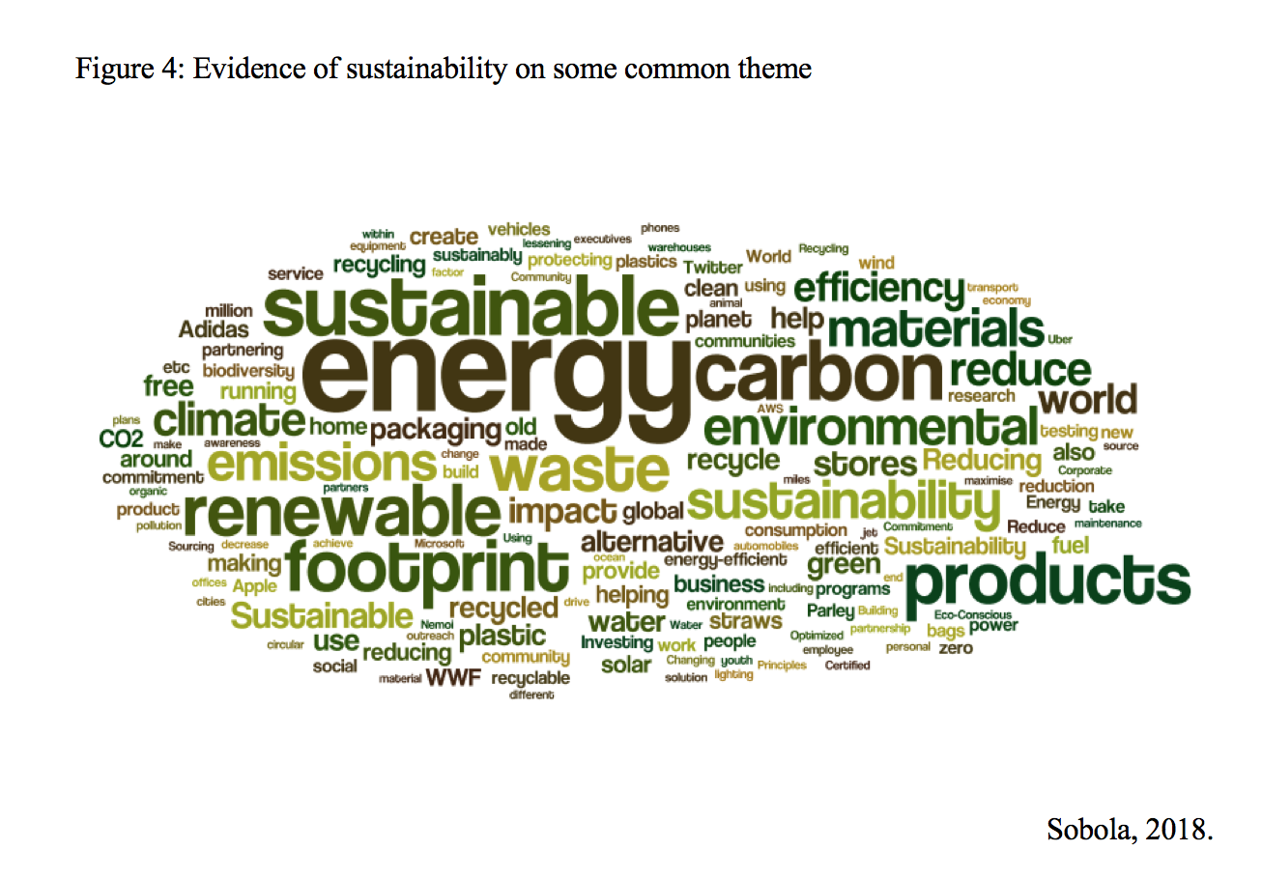

SUMIF (F2:X2,1) was used to determine Total Consumer. Formula Y2*96 was used to determine total usage=16896 (Appendix-4a). Although, Tumble driers have a 7% of usage after using the mathematical model (MM) Z4/$Z$18 (Appendix-4b). Total kg CO2 per year for Electric Tumble Dryer was 2067, the formula to get the % was AE4/$AE$18(Appendix-4c) =15%, it was classed level 4 in the CO2 Rating. The worst. while AE10/$AE$18 is the Electric Hob, producing Total kg CO2 per year 1548 and classed level 3 in the CO2 Rating (Appendix-4d). To class the appliances the mathematical model VLOOKUP(AF4, RATING_TABLE,2) was used (Appendix-4c).
The second objective was to determine the relationship between kettle and tumble drier usage and cost, Pivot table was used Tab Electric Dryer & Kettle (Appendix-4e). Sum of Total kg CO2 per year and Sum of Total Cost per year was used to compare the two appliances (Appendix-4f-4g).
The third objective was Household health and hygiene appliances Tab-Household-Appliances CO2 PivotChart (Appendix-4h) was used.

The objective is to determine if there is a link between seasons when students are on campus and the usage? (Appendix-5a,5h-5i) To determine
- Total per day is =SUM(B7:AW7)
- Average per day =AVERAGE(B5:AW5)
- % per day =AX5/$AX$912
- Maximum usage per day =MAX(B5:AW5)
- Minimum usage per day =MIN(B5:AW5)
- Total usage for specific hour maths model = SUM(AX5:AX910)
- Average usage for a specific hour =AVERAGE(AW5:AW910)
- Maximum usage was colour coded orange for each year
- Minimum usage was colour coded green for each year

- Sorting revealed that the highest rain fall was 40 for 2018 (Appendix-6a), 198 was the total January rainfall (Appendix-6b). The maths model =AVERAGE(B8:B38), SUM(E8:E38) etc (Appendix-6c). For average January temperature was 4.41, 7.18, 1.71, 6.39 and 2.47 for Temp, High, Low, Rain and Average Wind for January
- the Maximum and Minimum levels for ‘mean temp’, ‘high’,‘low’, and rainfall for January 2010 and January 2018, using inserted comment and colour coding to identify the in the excel file.
- Filter was used to extract the number of air night frosts record in January 2010 and January 2018, after Air Frost mathematical model IF(D8<=0,"Air Frost Night","No Air Frost Night") was used to sort the Air frost Night.
- Filter was used to extract the number of grass growing days record in January 2010 and January 2018, for the best time for growing grass, after Model was used IF(C10>=6,"Grass Growing","Not Growing"). Model =COUNTIF(H9:H34,"WNW") was used to determine the region with the most days for planting and model =IF(AND(K34="rain",J34="Grass Growing"),"priority location","") was used to determine the most suitable region to plant.
- Filter was used to extract the precipitation days for snow, dry and rain record in January 2010 and January 2018, after the precipitation model IF(D8<1,IF(E8>0,"Snow","Dry"),"Rain") was used. The most raining days and compare 2010 and 2018 data to determine the consistencies in the data.

Interpreting Results and Making A Decision

Visualisation:
Visualising the data using Graph, it has always been a best practice to Graphing data as it is always a common way to detect outliers, and data mining tools enables a good way to find patterns and breaks in patterns (O'Beirne, 2008; figure 5). It is not possible for all the Models on the Dashboard below to completely capture every possible analysis of various data supplied. Nonetheless, many summary models will still be analysed by graphs, tables, and placed in the Dashboard.
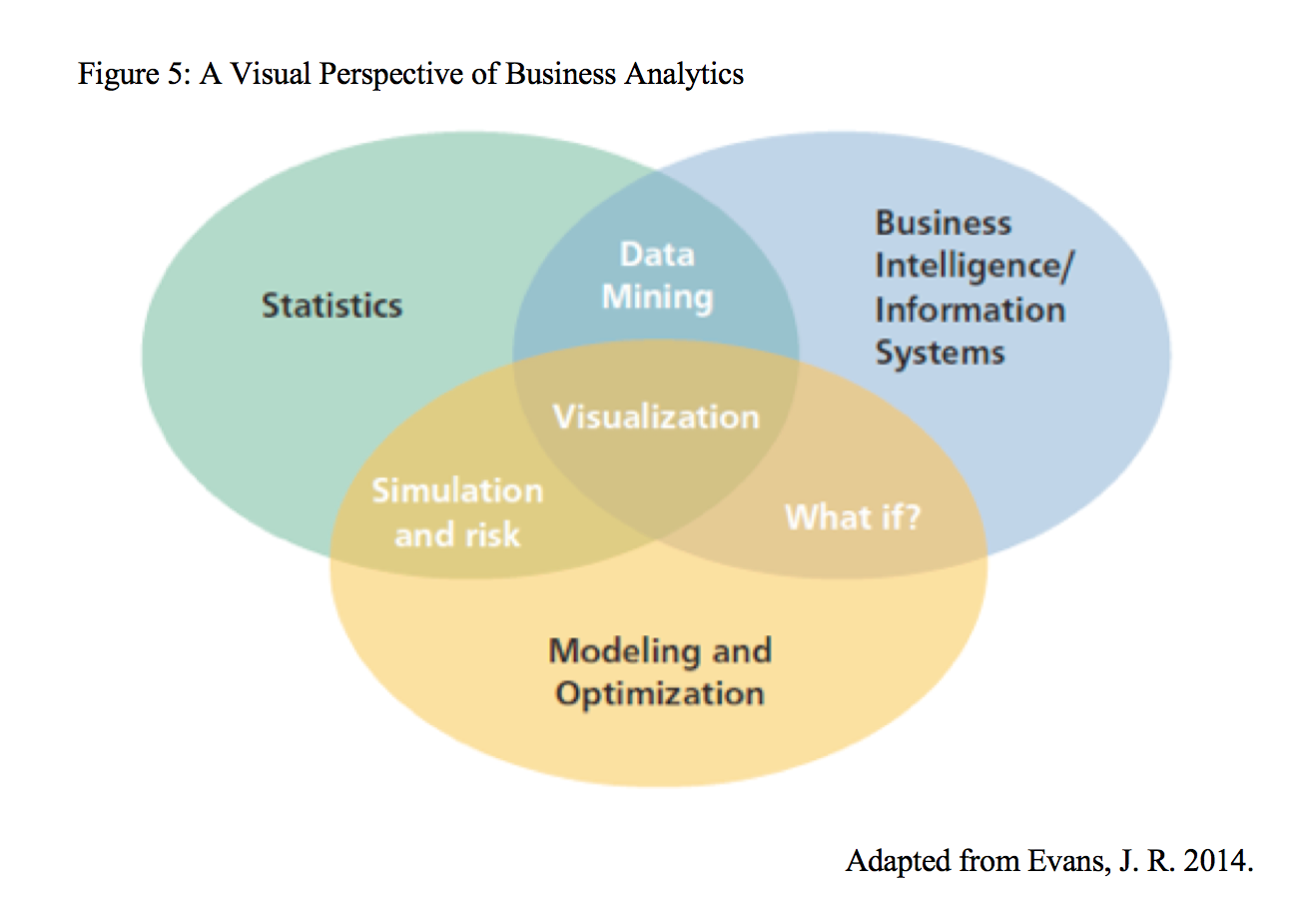
The wordie.net was used for text mining the evidence of sustainability (Figure-6a). Some common themes emerged such as sustainable, energy, carbon renewable etc. These themes proved that many businesses want stakeholders to see them as sustainable and are engaged in sustainable practices.
Furthermore, Pie Chart was used to visualise the evidence of Sustainability (Figure-6a), 56 businesses have evidence of sustainability and seven businesses do not show evidence of Sustainability 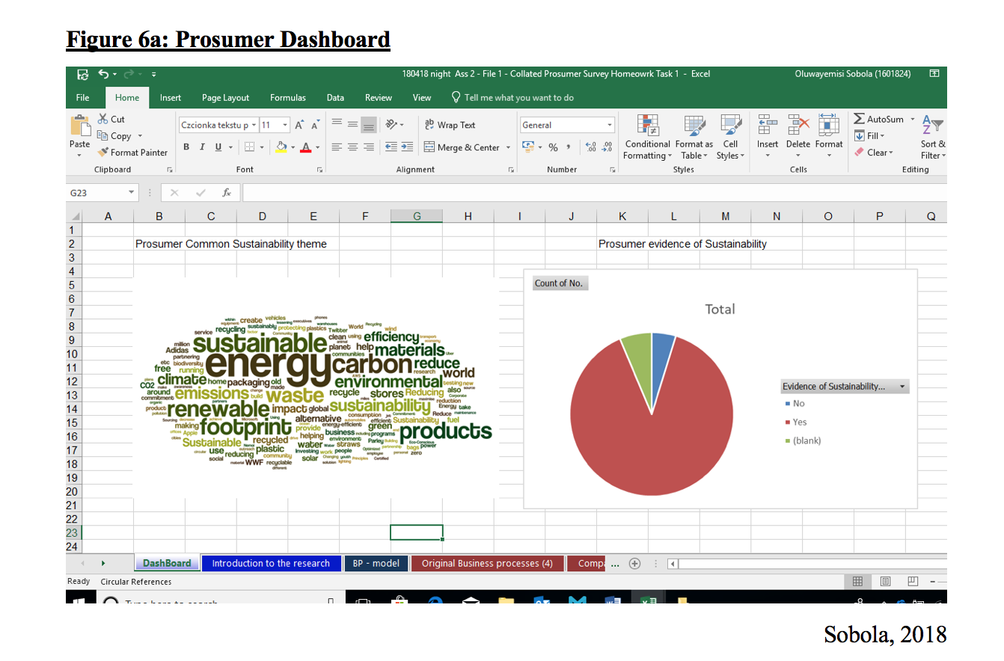
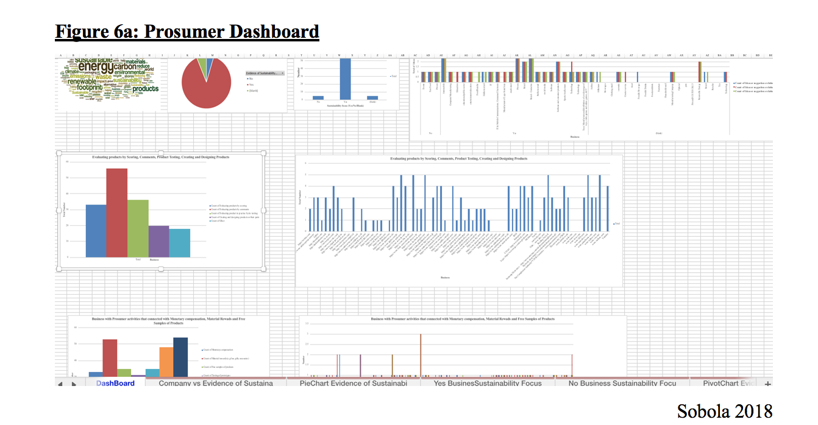
Figure 7a-7b, beneath revealed a perfect relationship between kettle and tumble drier usage, the total CO2 and total cost per year shows R2= 1 respectively. They are both costly appliances in terms of maintenance, the usage of kettle and tumble drier is very high understandably. The CO2, cost and Usage is linear, that is the more you use the more it costs you financially and the less you use the less it cost, and the CO2 discharged is correspondingly high.
Nonetheless, CO2 is bad for the environment. Again, when Household health and hygiene appliances (tumble dryer, gas hob, gas oven, kettle, microwave and washing mashing) were analysed (Appendix-4f-4h), although the % of usage was relative, the CO2 generated by tumble dryers was outliers, its use should be discouraged. Furthermore, microwave is used more than gas oven (Appendix-4e-4h). Therefore, this has implications for manufactures and food producers. Appliances were rated, the tumble drier was rated the worst generator of CO2 (Appendix-4a), it was rated class 4.
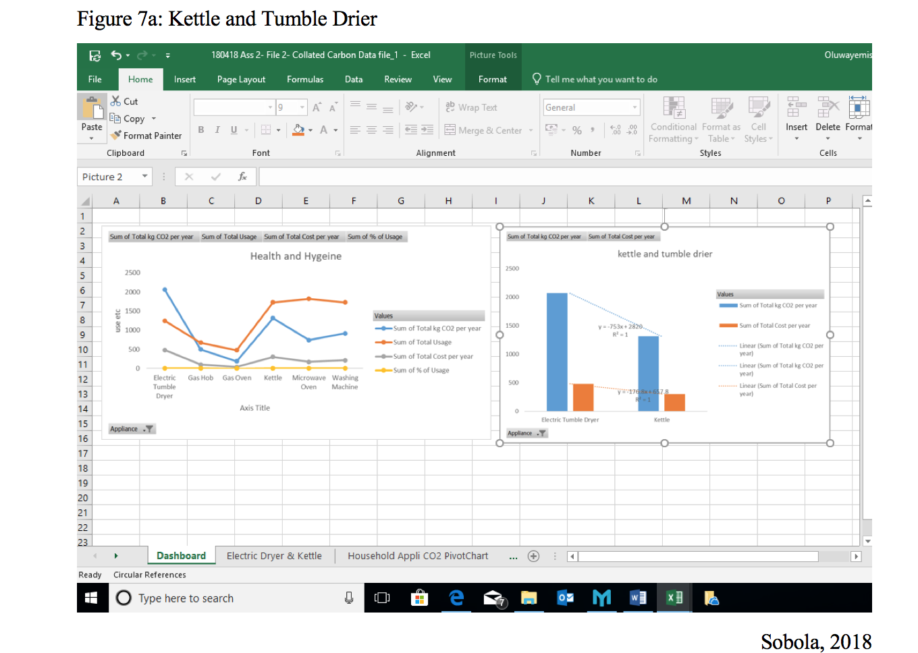
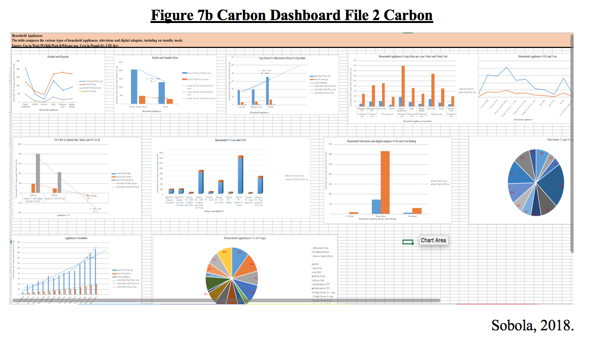

Figure 8 shows that the highest energy consumed day was 23/02/2015 with 1720.50kWh (Appendix-5a); the lowest energy consumption was consumption was on 13/08/2017 with 390.59kWh (Appendix-5b); total per day, average per pay, max usage 03/11/2015 was 69.11kWh (Appendix-5c,5h); min usage of £0.10 0n 21/11/2016 (Appendix-5d).
The date 29th April 2015 Between 21:30-06:00 on 30/04/2015 was an extremely high consumption date (Appendix-5e). This might be due to assignment submission being due or the start of examination. It was evident that the minimum energy consumption was between 9th -13th August (Appendix-5f), because University session was on holiday.

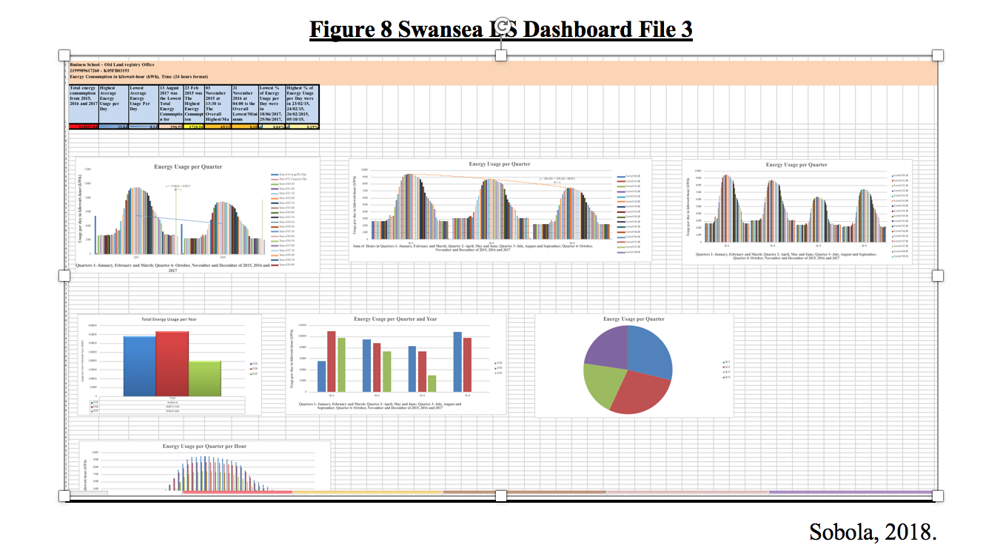
There was a perfect connection in energy consumption between both 1st quarter-January-February-March and 4th quarter-October-November-December of 2015-2016-2017, to show evidence of high usage during school times and days, that is y = -1160.8x + 6628.9, R² = 1 (Figure 9).
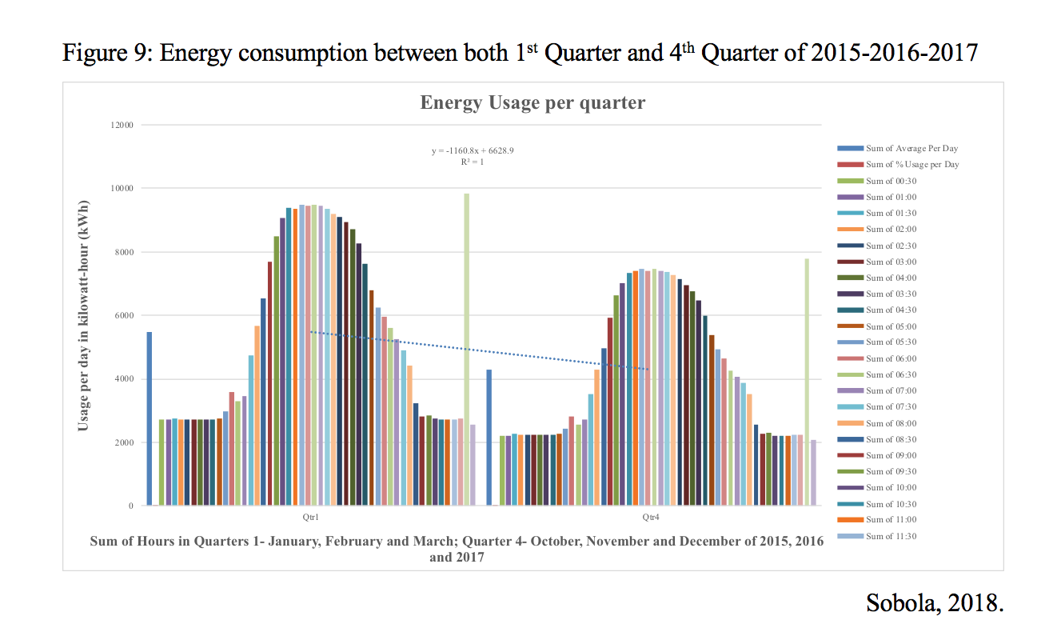
There is also evidence and a relationship between school time 1st Quarter-January-February-March; 2nd quarter-April-May-June; 4th quarter-October-November-December of 2015-2016-2017 (figure 10).
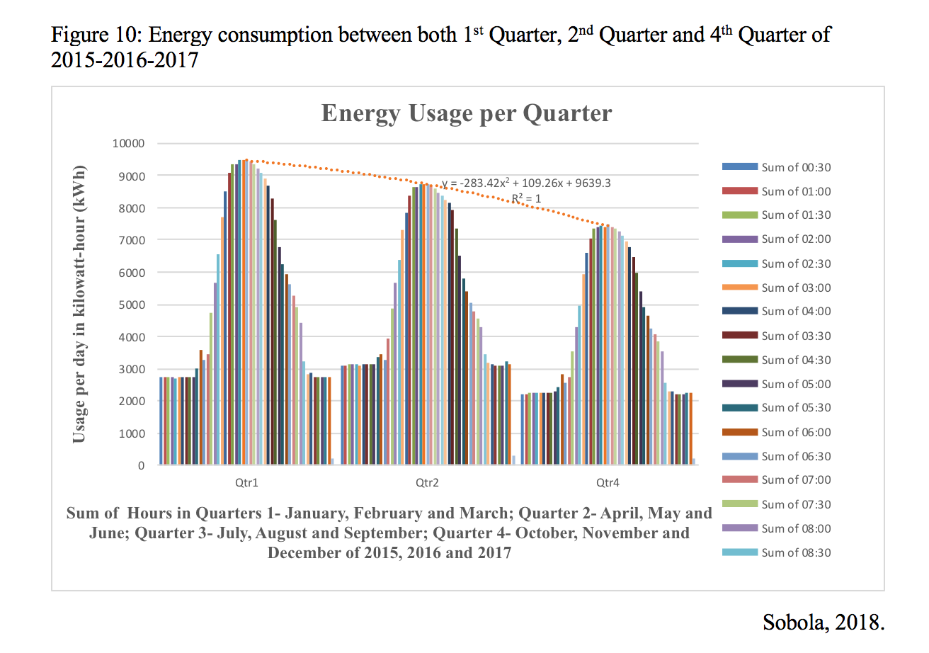
There is less consumption of energy in 3rd Quarter-July-August-September of 2015-2016-2017 which are school holidays (Appendix-5k-5l).

Figure 11a-11b for the Farm revealed that the highest rainfall for 2018 January was 40mm, 198mm was the total January rainfall (Appendix-6a). 2018 January average Mean Temperature, High, Low, Rain and Average Wind Speed was 4.41(°C), 7.18(°C), 1.71(°C), 6.39(mm) and 2.47(mph) (Appendix-6b).
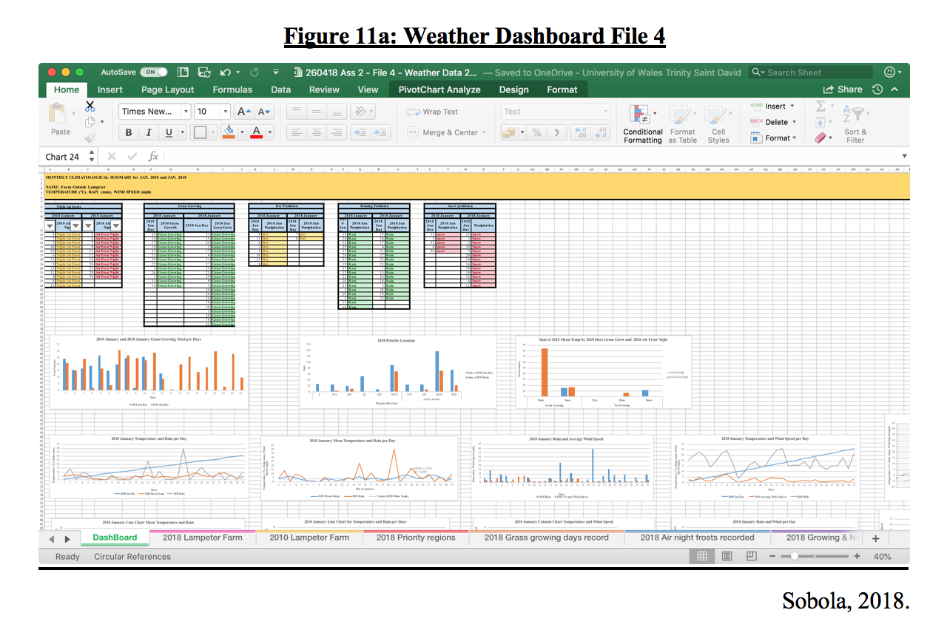
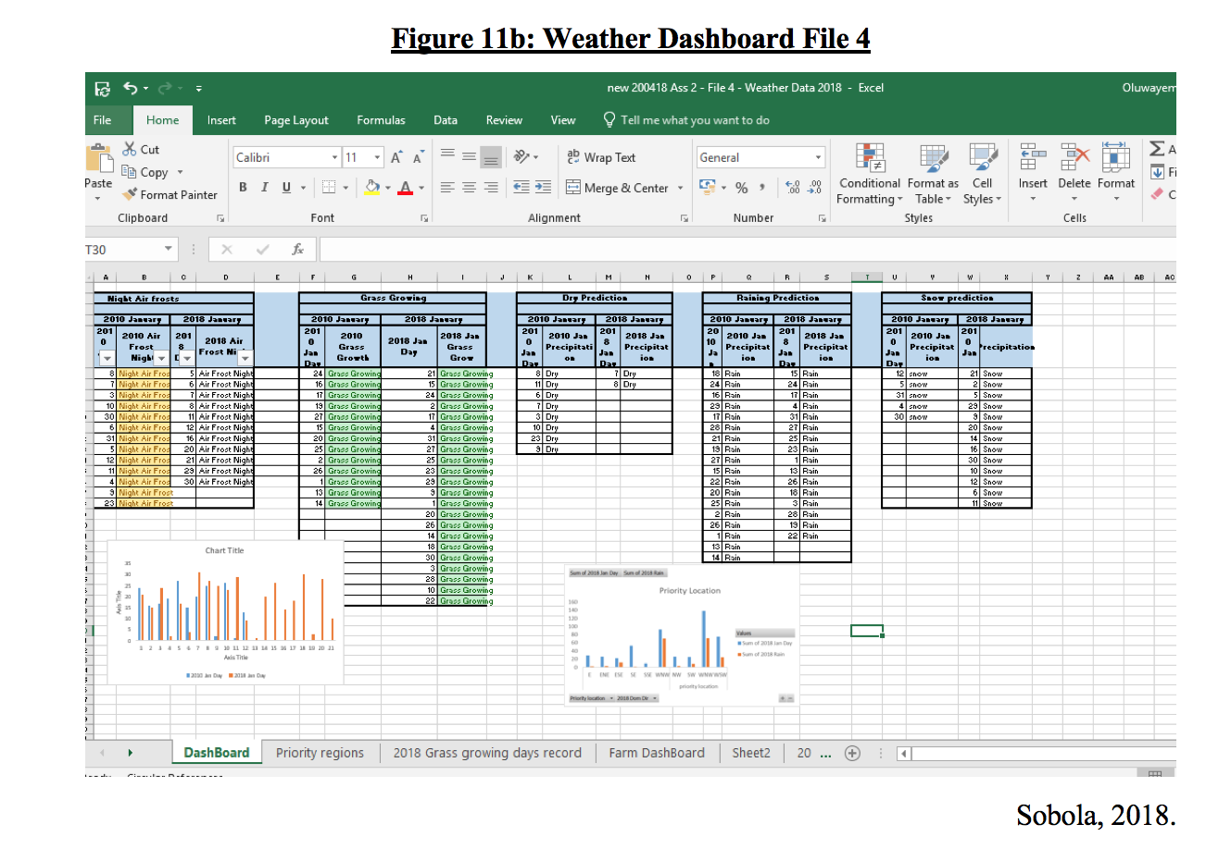
Furthermore, the number of air night frosts record in January 2010 and January 2018 were gathered and compared in the dashboard above were similar. However, when the number of grass growing days record in January 2010 and January 2018 were compared, there were 9 more favourable days in January 2018. Similarly, the number of raining days are comparable between the two years. Also, there were more dry days in 2010 compared to 2018.
When the level of snow was compared between 2010 and 2018, there will be more than double the amount of snow fall in 2018 compared to 2010. Again, Countif showed that there will be 13 days of snow in 2018.
In another development, WNW, regions have the highest numbers of days for planting and has the most conditions for planting whereby, there is rain, and grass Growing (Appendix-6c).

Recommendation
It is a welcome news that most businesses are committed to sustainable practices. This is in line with Future Well-being Wales Act 2015 (Welsh Government, 2015). Furthermore, businesses need to show more evidence of sustainability activity to encourage participation and collaboration on more prosumer activities. Since, customer knowledge is becoming an important asset for every business and government thereby creating new and innovative products, and services for consumers.

CO2 is bad for the environment, the public need to be made aware of using natural means to dry clothes and the velocity of boiling the kettle needs to be reduced. Instead of drinking lots of tea why not drink more water that is healthy.
Although the percentage (%) of usage was relative, the high cost and CO2 generated by the tumble dryer was an outlier, its use should be discouraged. Furthermore, electric oven/hub is more costly and used more, with a higher CO2 than the microwave, which is used more than the gas oven (Appendix-4f,4g,4h). Gas hob/oven should be encouraged to be used more because of its cost efficiency. Therefore, microwave manufactures can be assured of sustained business growth and the producers of readymade meals can be assured of a sustained growth in the demand for their products as less number of people are cooking.
Nonetheless, a new sustainable, innovative tumble drier and kettle are desperately needed in the market in order to reduce the environmental footprint.

Appendix-5j-5l shows that energy consumption has reduced from 2015 level. From the top 10 energy consumed days, 8 were in 2015, only 2 were in 2016, and none for 2017 in top 10 (Appendix-5g). More so, the highest energy consumed day was 23/02/2015 with 1720.50kWh. This needs to be investigated further to see if there was any special event that led to the high-energy consumption.
The date 29th April 2015 between 21:30-06:00 on 30/04/2015 was an extremely high consumption date (Appendix-5e). This could due to assignment being due or the start of examination, because this pattern might reoccur. Therefore, it is advised during budgeting that the university makes provision for a similar date close to the exams as potentially a costly period.
Also, there was a perfect connection in energy consumption in both the 1st quarter and 4th quarter and it could be utilised in future budgeting.

Since, the number of air night frosts record in January 2010 and January 2018 were gathered, where similar consequently lessons should be learnt from what happen in 2010 and what failed. However, when the number of grass growing days record in January 2010 and January 2018 were compared, there were 9 more favourable days in January 2018. More planting could be done, and the chances of success are high. Similarly, the number of raining days are comparable between the two years. More planting is possible but outdoor works may be affected by rain.
Also, there were more dry days in 2010 compared to 2018. Consequently, outdoor activities are possible in 2018, but the cutting and rolling of hay could be difficult which may affect hay for feeding the animals during winter. Therefore, arrangements may have to be made to get hay from other sources.
There was more than twice the level of snow in 2018 compared to 2010. This will impact greatly on the farm. Animals will spend less time outside, less work can be done outdoors, heating cost may increase, staff may not be able to get to work therefore, contingencies would have to be put in place for animal welfare.
In another development, ‘WNW’ regions have the highest numbers of days for planting and has the most conditions for planting whereby, there is rain, and grass growing. Furthermore, the WNW is a priority zone to plant, due to perfect planting conditions.

Conclusion

All businesses are committed to sustainable practices, and the Future Well-being Wales Act 2015 must be upheld. The companies must continue to engage in sustainable practices.

CO2 is bad for the environment, everyone need to be aware of this, and so could start utilising natural means to dry clothes instead of a tumble drier and the velocity of boiling the kettle needs to be reduced. Also, manufacturers need to find innovative and sustainable products to use for appliances production.

The energy consumption is reducing, still the reason behind high consumption during the exam could be investigated and seek a better sustainable method. During the winter period, there was perfect relationship between energy consumption in both the 1st quarter and 4th quarter and this could be utilised in future budgeting.

The Lampeter farm is advised to engage in more planting especially in the WNW area. The regions have the highest numbers of days for planting and has the most conditions for planting. They should also be aware that rain may affect outdoor works. The cutting and rolling of hay will be difficult which may affect the quantity of hay for feeding the animals during winter. Therefore, arrangements may have to be made to get hay from other sources. Plans have to be made as animals will spend less time outside, therefore heating cost may increase. Contingencies will need to be made, as staff may not be able to get to work during snow season.

Reference

Anderson, C. (2009). Free: The Future of a Radical Price. New York: Hyperion.
Andrejevic, M. (2003). Reality TV: The Work of Being Watched. Lanham, MD: Rowman & Littlefield.
boyd, d. (2006). ‘Friends, Friendsters, and MySpace Top 8: Writing Community into Being on Social Network Sites’. Retrieved from http://www.danah.org/papers/FriendsFriendsterTop8.pdf
boyd, d. (2008a). ‘Taken Out of Context: American Teen Sociality in Networked Publics’, unpublished PhD Dissertation, University of California, Berkeley, CA.
boyd, d. (2008b). ‘Why Youth (Heart) Social Network Sites: The Role of Networked Publics in Teenage Social Life’, in D. Buckingham (ed.) Youth, Identity, and Digital Media, pp. 119–42. Cambridge, MA: MIT Press. Retrieved from http://www.mitpressjournals.org/doi/pdf/10.1162/dmal.9780262524834.119
Edwards, J. S. and Finley, P. (1997). Decision Making with Computers: The Spreadsheet and Beyond. Prentice Hall.
Evans, J. R. (2014). Business Analytics: Methods, Models, and Decisions. Pearson Education.
Gritzer. (2012). Prosumption. Retrieved from https://georgeritzer.wordpress.com/category/prosumption/
Helft, M. (2007). ‘With Simple New Tools on Web, Amateurs Reshape Mapmaking’, New York Times, 27 July, pp. A1, A16.
Herman, A., Coombe, R.J. and Kaye, L. (2006). ‘Your Second Life: Goodwill and Performativity in Intellectual Property in Online Digital Gaming’, Cultural Studies 20: 184–210.
Konieczny, P. (2009). ‘Governance, Organization, and Democracy on the Internet: The Iron Law and the Evolution of Wikipedia’, Sociological Forum 24: 162–92.
Lego Mindstorms. (2017a). Retrieved from https://shop.lego.com/en-CA/LEGO-MINDSTORMS-NXT-2-0-8547
Lego Mindstorms. (2017b). [Image]. Retrieved from https://image.slidesharecdn.com/prosumer-120229175142-phpapp02/95/prosumers-10-728.jpg?cb=1330538419, https://shop.lego.com/en-CA/LEGO-MINDSTORMS-NXT-2-0-8547
Lessig, L. (2006). Code: Version 2.0. New York: Basic Books.
Mullins, R., and Dettmer, S., (2018). Consumers engagement in knowledge sharing with business organizations (enterprises) and public organizations (i.e. schools, public administration) [Collated Prosumer Survey Homework Task 1.xlsx], BMSP4004: Generating Business Data and Analysis. UWTSD Business and Management. 7 February 2018. Retrieved from https://moodle.uwtsd.ac.uk/mod/folder/view.php?id=107194
O'Beirne, P. (2008). European Spreadsheet Risks Interest Group (www.eusprig.org): Proceedings of EuSpRIG 2008 Conference "In Pursuit of Spreadsheet Excellence". Information and Data Quality in Spreadsheets. Retrieved from https://moodle.uwtsd.ac.uk/pluginfile.php/140477/mod_resource/content/1/Spreadsheet%20data%20quality.pdf
Ragsdale, C. T., 2001. Spreadsheet Modelling. s.l.:South-Western/Thomson Learning.
Ritzer, G. (2008[1993]) The McDonaldization of Society. Thousand Oaks, CA: Pine Forge Press.
Ritzer, G. And Jurgenson, N. (2015). Journal of Consumer Culture. Production, Consumption, Prosumption. The nature of capitalism in the age of the digital ‘prosumer’. University of Maryland, USA. Retrieved from http://www.facoltaspes.unimi.it/files/_ITA_/COM/Production_Consumption_Prosumption_-_COM.pdf
Sobola, O. (2018). ‘Final Data Analysis and Report-Excel File’, BMSP4004: Generating Business Data and Analysis. UWTSD Business and Management [Student]. Retrieved from
Stewart, D. (2005) ‘Social Status in an Open-source Community’, American Sociological Review 70: 823.
Tapscott, D. and Williams, A. (2006b). “Wikinomics”. Executive Book Summaries. Retrieved from http://cgis.hbg.psu.edu/articles/Wikinomics_Summary.pdf
Tapscott, D. and Williams, A. (2006a). “The Prosumer”. Wikinomics. Retrieved from http://hlt.media.mit.edu/dfe_readings/TapscottChapter5.pdf
University of Glasgow. (2013-2020). University of Glasgow E-Learning Strategy 2013 – 2020. Retrieved from https://www.gla.ac.uk/media/media_297622_en.pdf
Welsh Government. (2015). Well-being of Future Generations (Wales) Act 2015 The Essentials (2nd edn.). Retrieved from http://gov.wales/docs/dsjlg/publications/150623-guide-to-the-fg-act-en.pdf

Appendices

Appendix-1
  - working at the checkout counter at the supermarket by scanning one’s own food, bagging it, and paying for it by credit card;
  - using electronic kiosks to check into a hotel and at the airport, to purchase movie tickets, etc.;
  - co-creating a variety of experiences such as moving oneself through Disney World and its many attractions or serving as an ‘actor’ in the theatre ‘staged’ by Starbucks designed to create the image of an old-fashioned coffee house (Ritzer, 2008[1993]);
  - using do-it-yourself medical technologies (e.g. blood pressure monitors, blood glucose monitors, pregnancy tests) that allow patients to perform, without recompense, tasks formerly performed by paid medical professionals;
  - being a caller on a call-in radio show;
  - being part of Reality TV (Andrejevic, 2003);
  - Wikipedia, where users generate articles and continually edit, update, and comment on them (Konieczny, 2009).
  - Second Life, where users create the characters, communities, and the entire virtual environment (Herman et al, 2006).
  - The blogosphere, blogs (Web logs), microblogging (Twitter) and the comments on them produced by those who consume them.
  - eBay and craigslist, where consumers (along with retailers) create the market. (In recent years, eBay has moved away from user-generated auctions and toward those more dominated by traditional retailers and producers)
  - YouTube and Flickr, where mostly amateurs upload and download videos and photographs.
  - Current TV, where viewers create much of the programming, submit it via the internet, and decide which submissions are aired.
  - Linux, a free, collaboratively-built, open-source operating system, and other open-source software applications, such as Mozilla Firefox, that are created and maintained by those who use them (Lessig, 2006; Stewart, 2005).
  - Amazon.com, where consumers do all the work involved in ordering products and write the reviews. Also, the users’ buying habits and site navigation are documented to recommend products.
  - Yelp!, where users create an online city guide by ranking, reviewing and discussing various locations and activities in their area.
  - The GeoWeb, which consists of online maps where, increasingly, users are creating and augmenting content with Google, Microsoft, and Yahoo tools (Helft, 2007). Google Maps users, for example, can fix errors; add the locations of businesses; upload photos; link Wikipedia articles to, and blog about their experiences with, or reviews of, places on the map, thereby creating social communities.
  - Additionally, new ‘location awareness’ tools, often used in conjunction with ‘smart’ cell phones with GPS technology, allow users to track where they are at any given moment and upload this information to websites such as Facebook, Twitter or one’s blog. Some examples include Google Latitude, Yahoo’s Fire Eagle and the Loopt mobile phone application (Google Latitude: http://www.google.com/latitude/intro.html; Fire Eagle: http://fireeagle.yahoo.net/; Loopt: http://www.loopt.com/; Twitter has also announced that it will allow users to embed their location when posting content with their service (http://blog.twitter.com/2009/08/location-locationlocation.html).

Appendix-2
• Non-redundant - Not duplicated data
- all relevant data are input,
- data are input accurately,
- data are input for process at the correct time, and
- if data is passed from one file or worksheet to another, adequate controls are in place to ensure the completeness and accuracy of the transfer" (O'Beirne, 2008).

Appendix 3a File 1 Prosumer deleted data
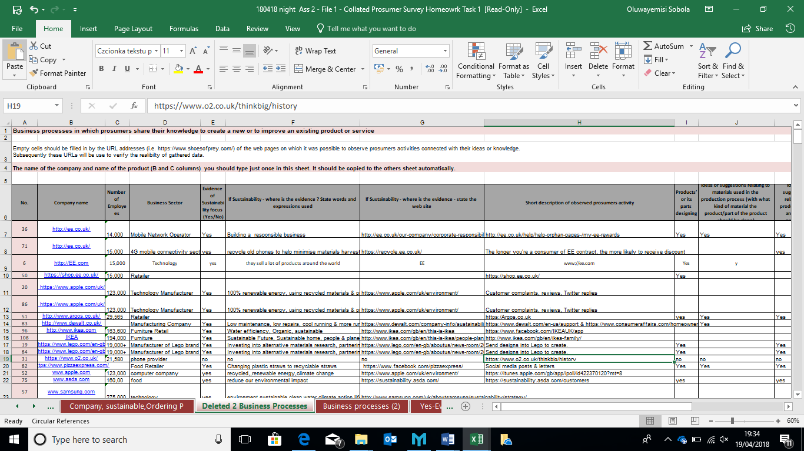

Appendix-3b File 3 Prosumer deleted data
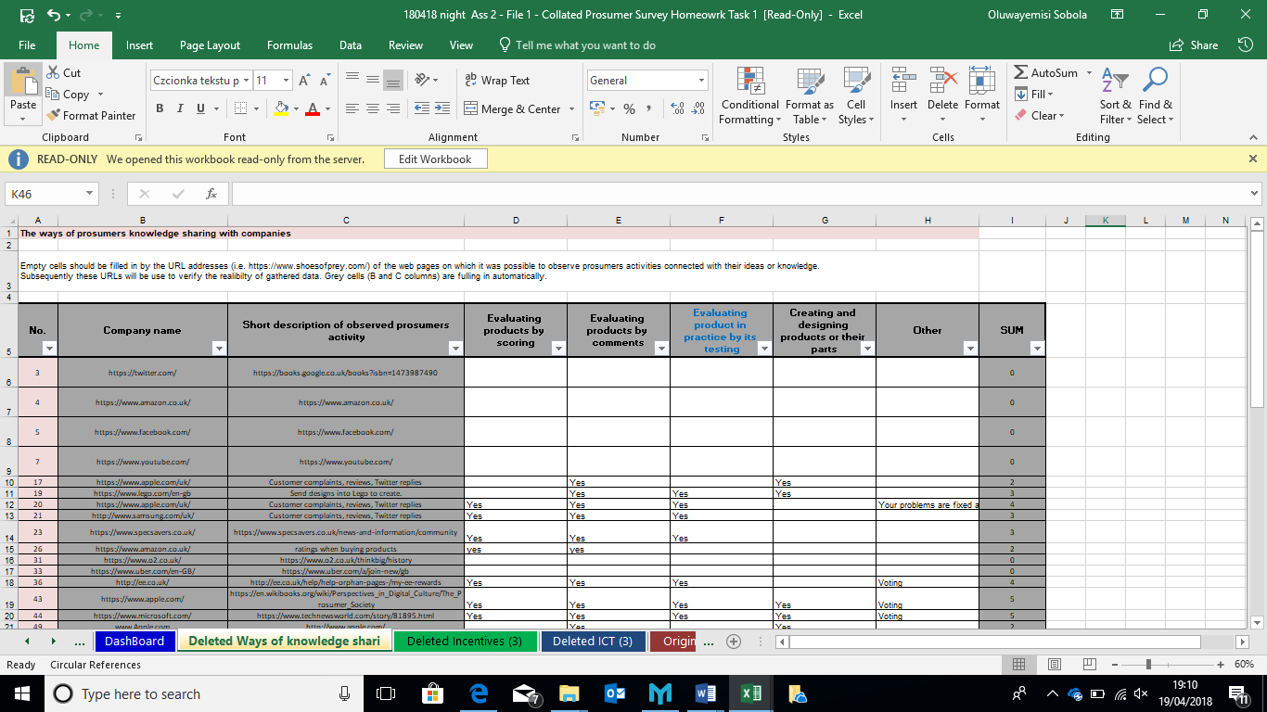

Appendix-3c File 3 Prosumer deleted data
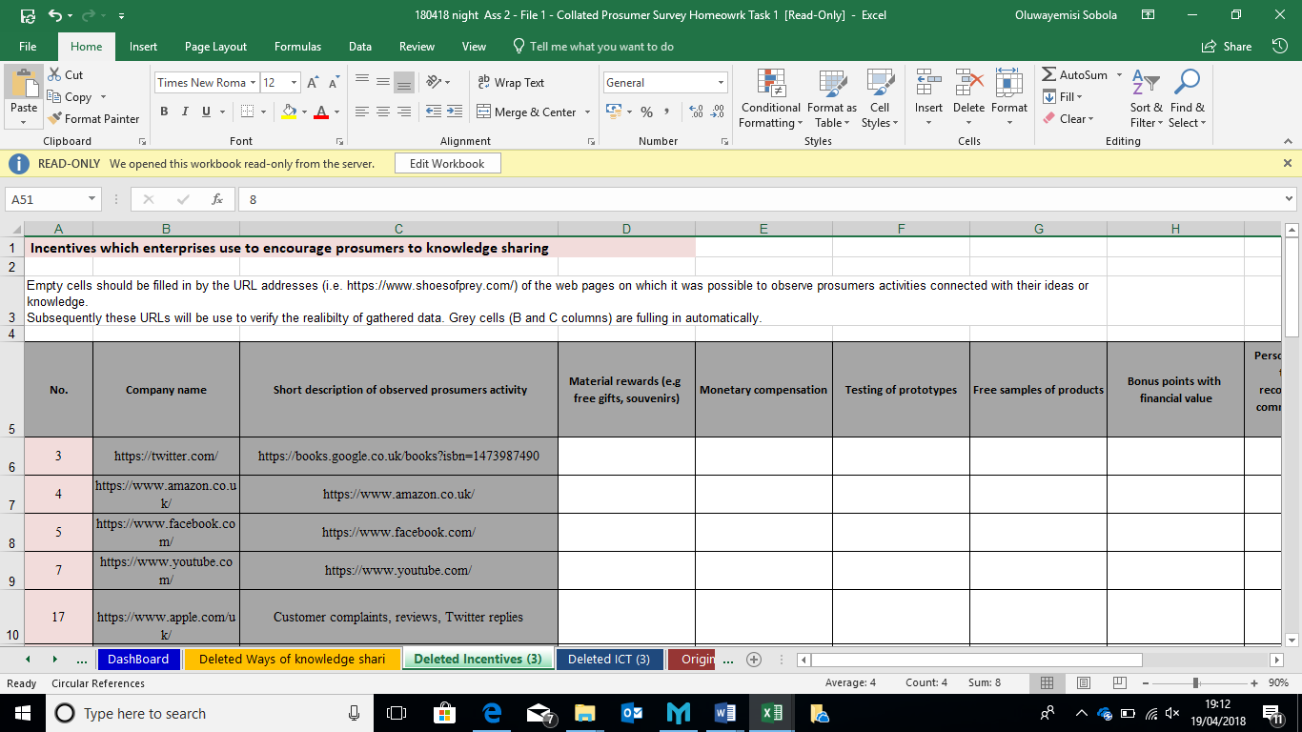

Appendix-3d File 3 Prosumer deleted data
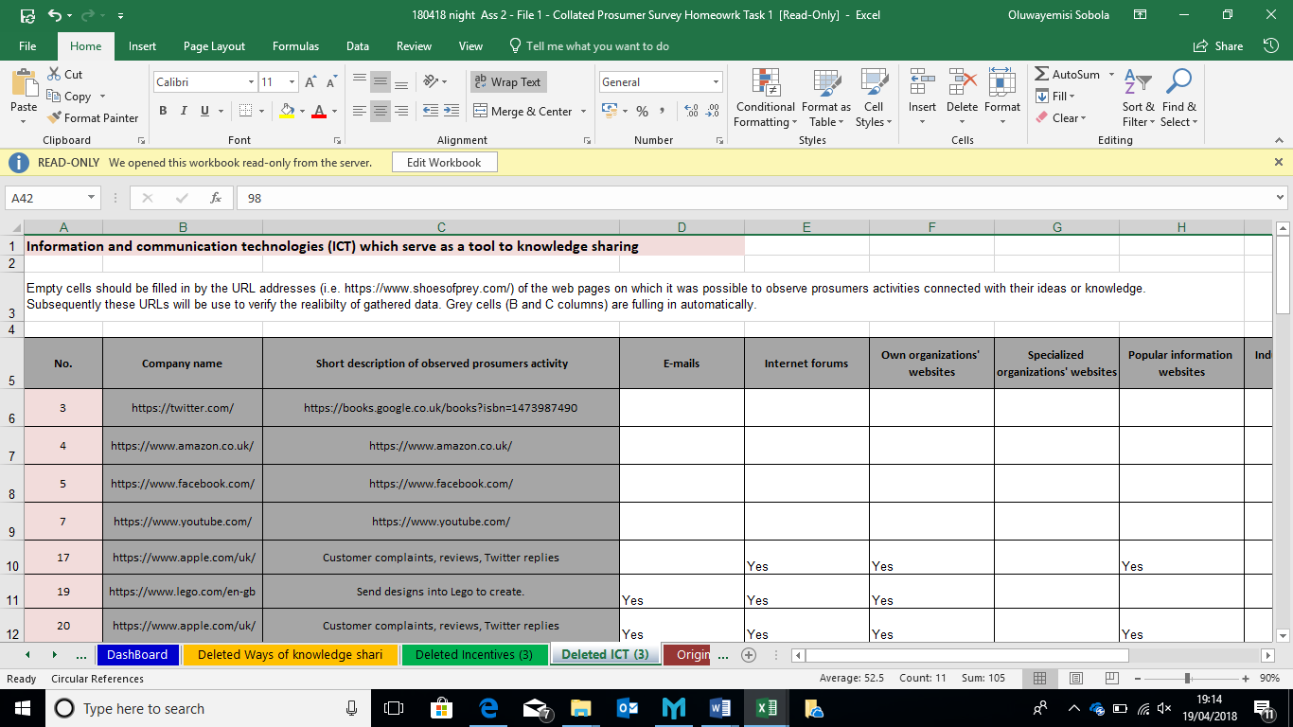

Appendix-3e File 2 Carbon deleted data
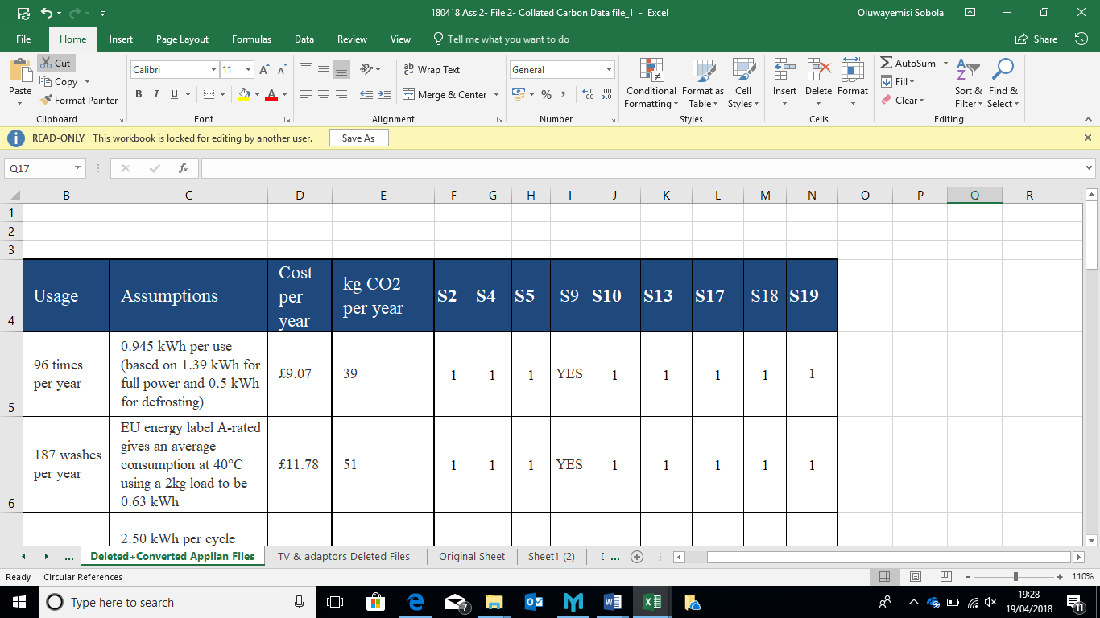

Appendix-3f File 2 Carbon deleted data
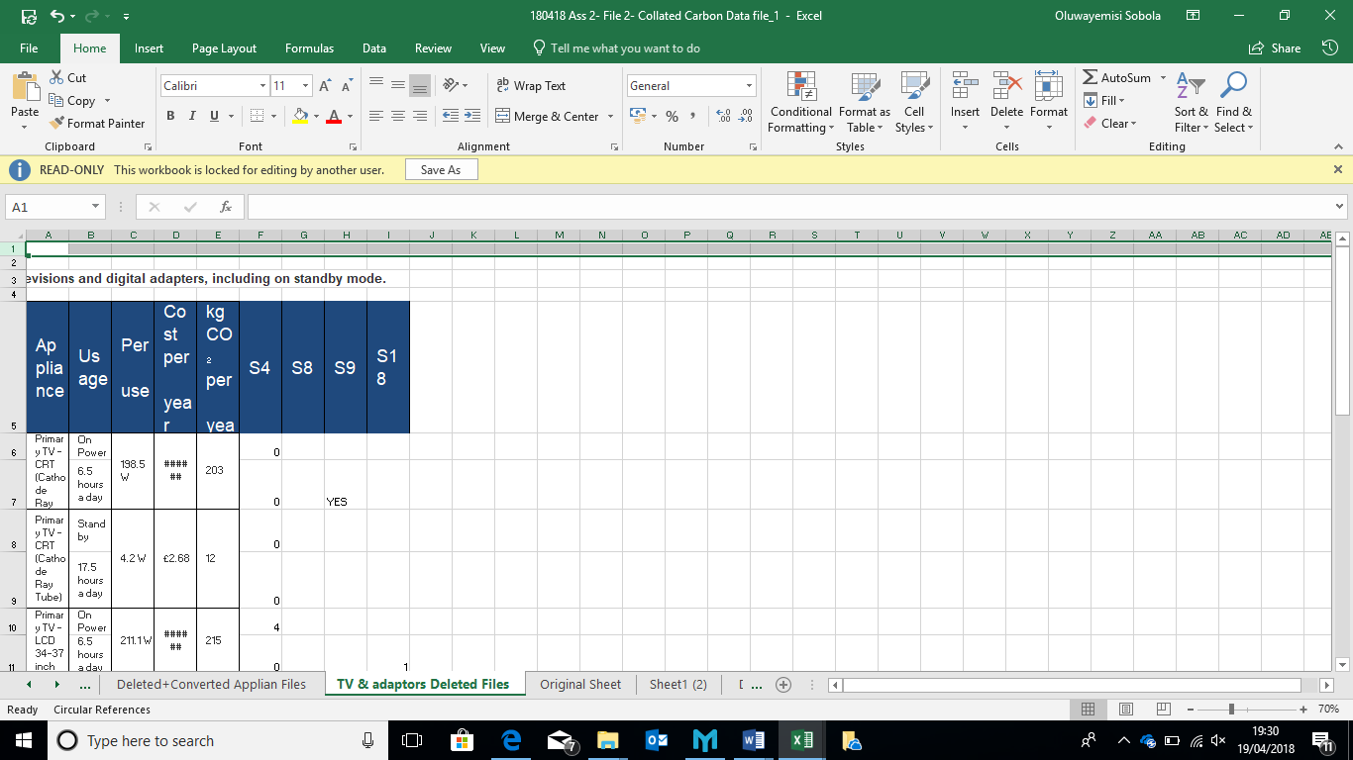

Appendix-3g File 3 Swansea BS deleted data
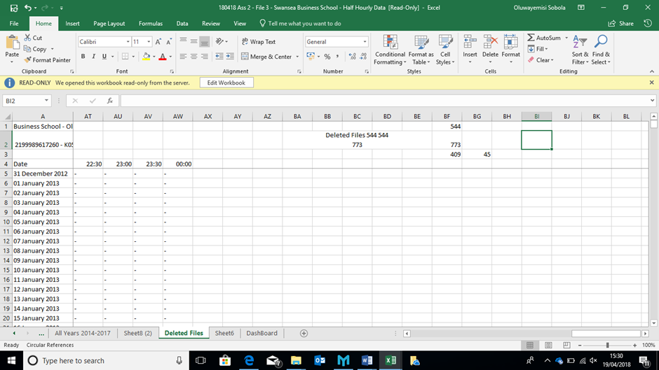

Appendix-4a File 2 Household Appliances
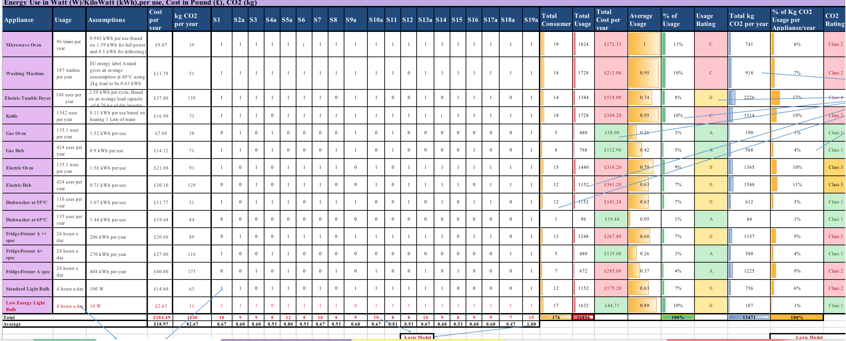

Appendix-4b File 2 CO2 Ratings
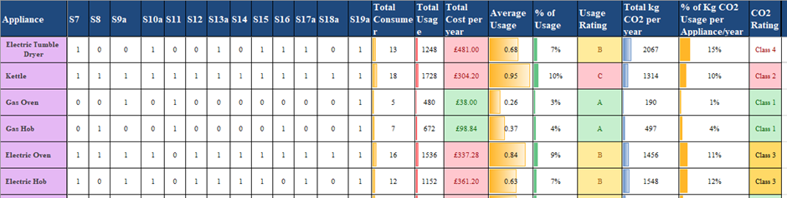

Appendix-4c File 2 Household Appliances
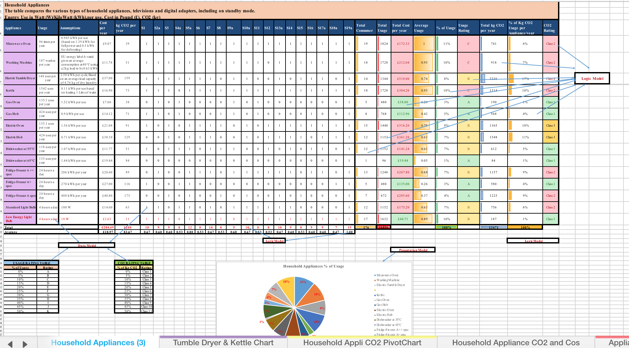
Appendix-4d File 2 Household Appliances
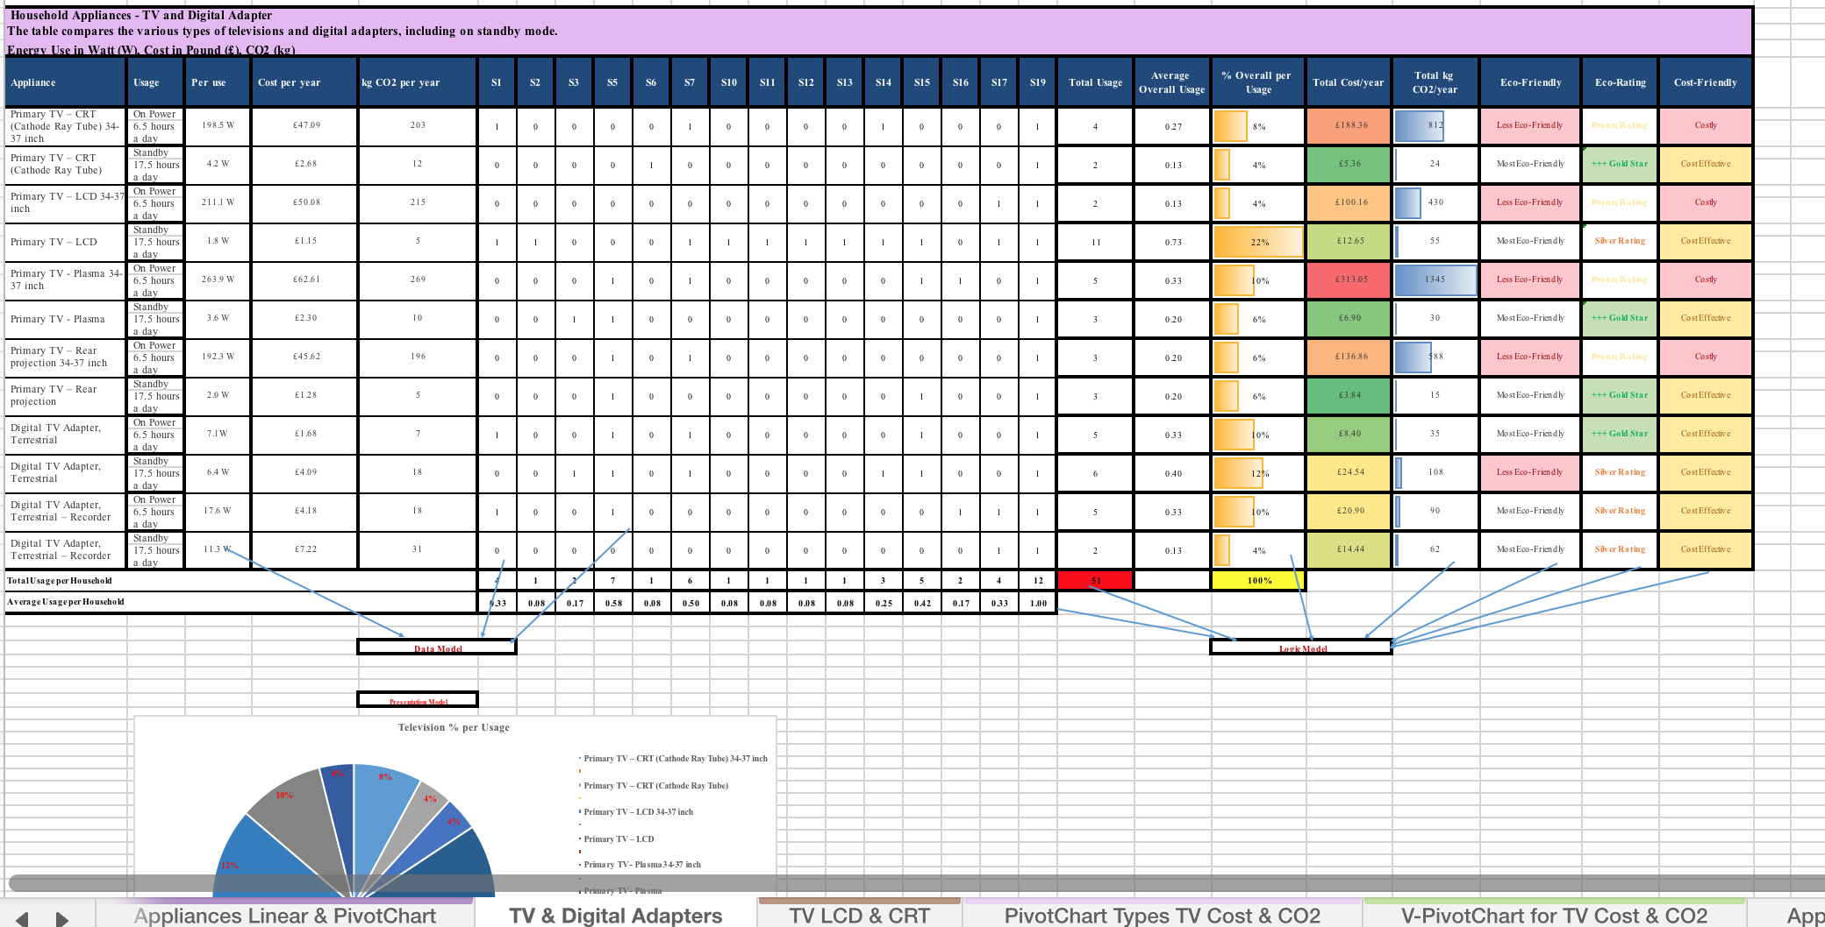

Appendix-4e File 2 Household Appliances

Appendix-4f File 2 Household Appliances

Appendix-4g File 2 Household Appliances
Appendix-4h File 2 Household Appliances
Appendix-5a Highest energy consumption day 23/02/2015
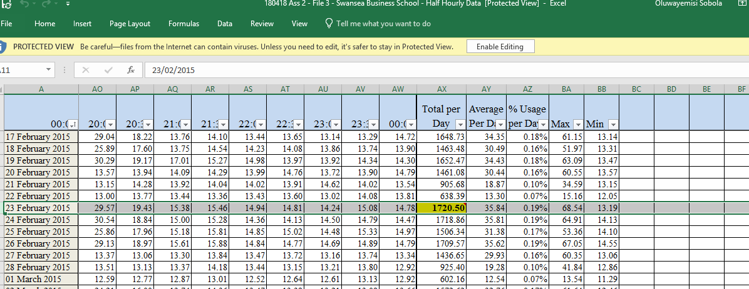

Appendix-5b the lowest energy consumption was on 13/08/2017
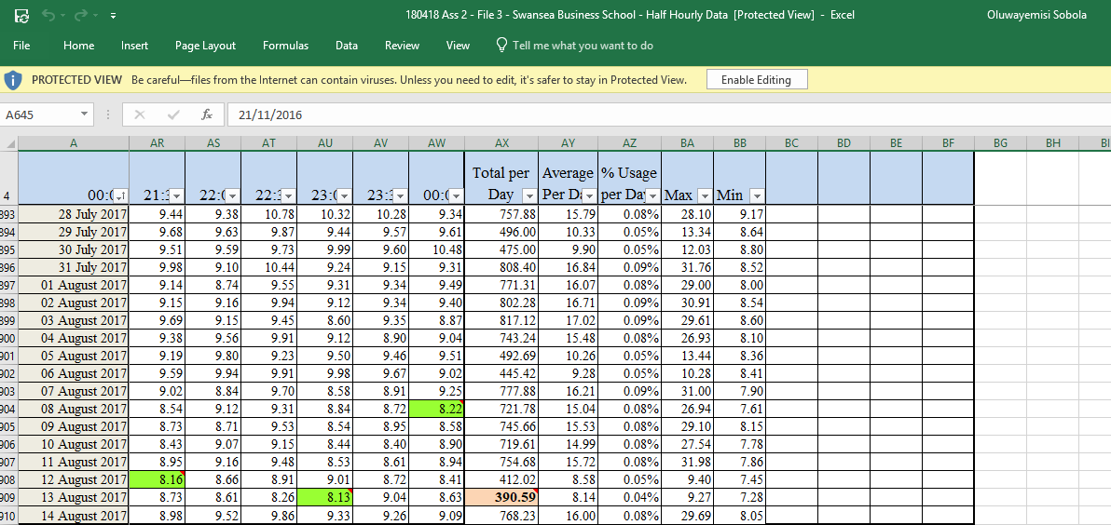

Appendix-5c maximum usage
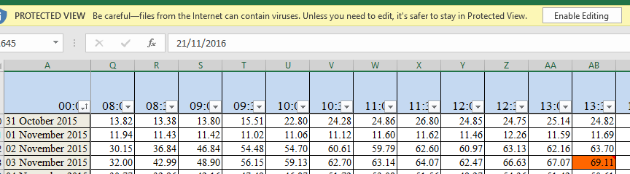

Appendix-5d, minimum usage of £0.10 0n 21/11/2016
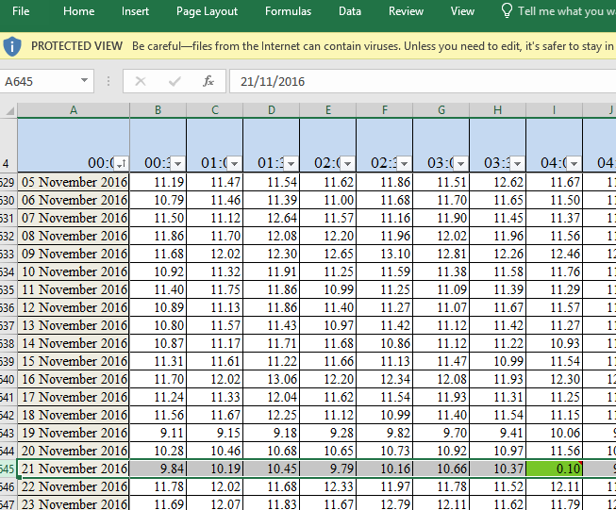

Appendix-5e April 29, 2015-April 30, 2015
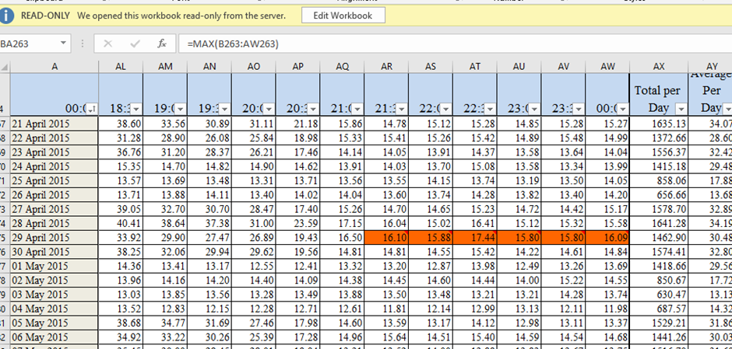

Appendix-5e April 29, 2015-April 30, 2015
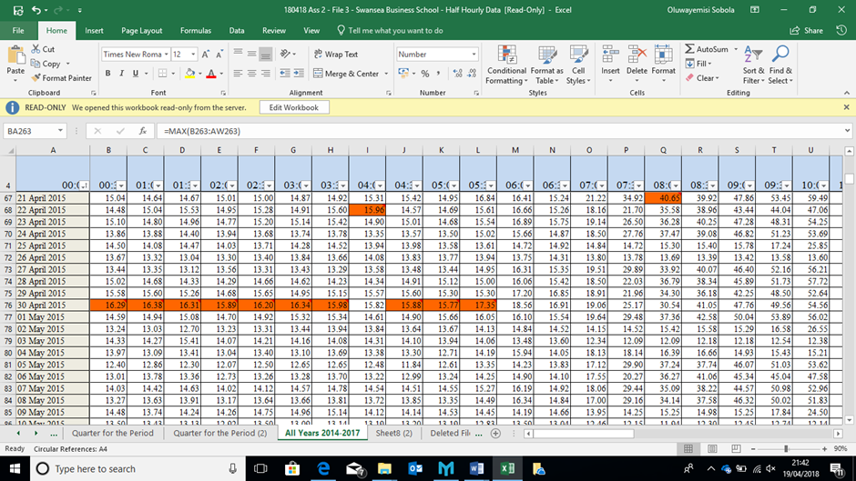

Appendix-5f minimum energy consumption period
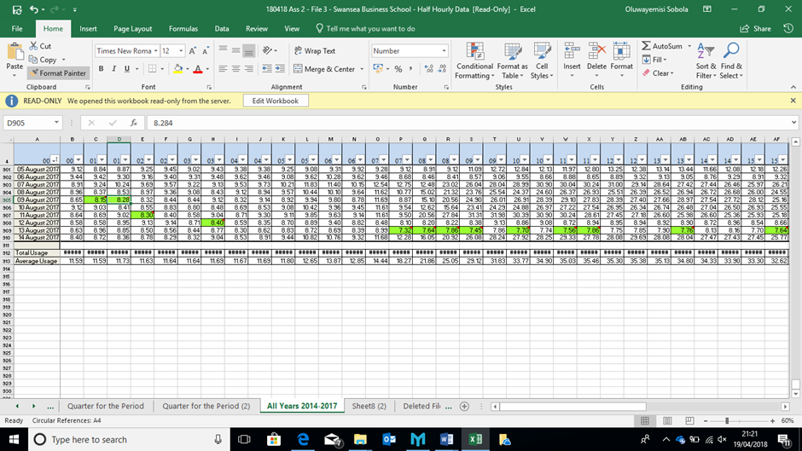

Appendix-5g top10 Energy consumption in the whole period
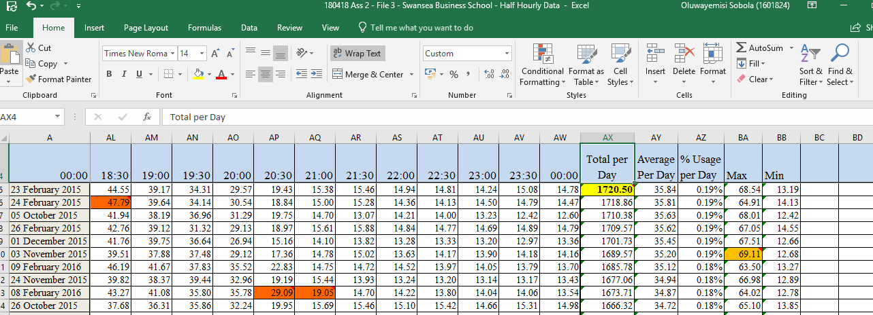

Appendix-5h File 3
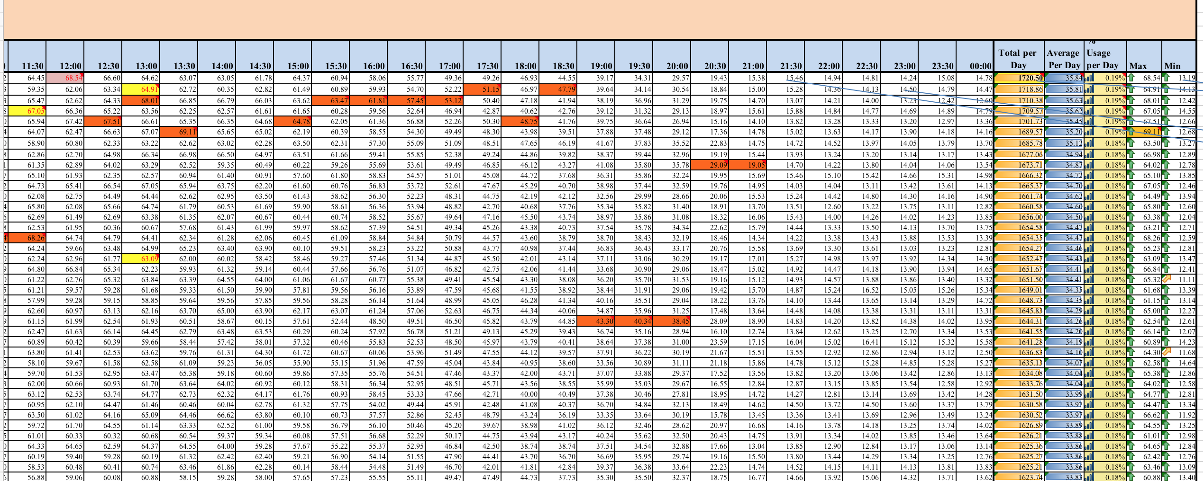

Appendix-5i File 3

Appendix-5j File 3

Appendix-5l File 3
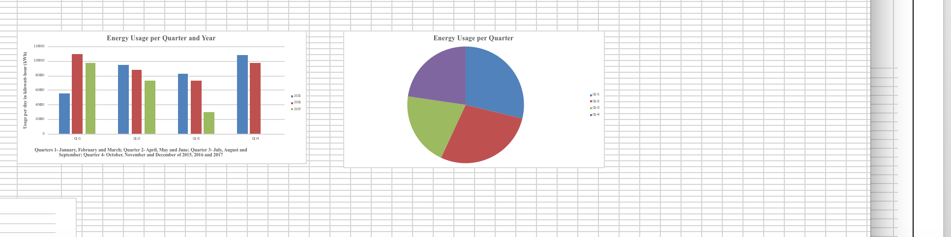

Appendix-6a File 4 Farm Outside Lampeter
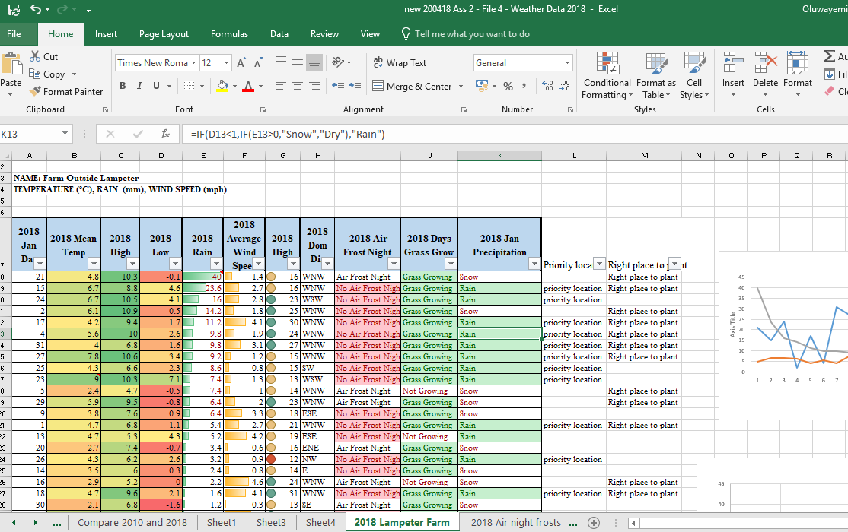

Appendix 6b the count if
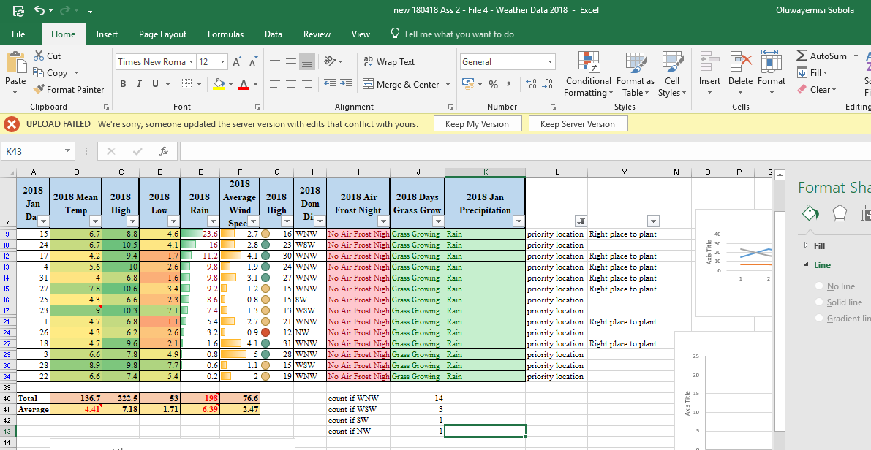

Appendix 6c Priority location


