Mock Interview Application Portfolio
Employability and Career Development

Curriculum Vitae
DAN CALIN
Aspiring Management Trainee
Birmingham
Mobile: +44 7407 464829
Email:
Profile
Aspiring Management Trainee seeking to build customer service skills, commercial awareness and practical business knowledge. Attracted to Enterprise Mobility’s structured training and mentoring, with a long-term goal of progressing towards team leadership. Willing to take on responsibilities, learn from them, accept feedback, and use it positively.
Education
CertHE Business Skills for the Workplace
University of Wales Trinity Saint David [May 2026]
Career Preparation
Selected Enterprise Mobility's Birmingham Graduate Management Trainee position as a future career goal. Preparation is based on the programme requirements and customer service, sales, financial control, operations and leadership.
Working Approach
Be customer-oriented: Listen carefully, clarify requests and communicate accurate information. Ask for advice when an enquiry is beyond my knowledge or authority.
Teamwork and organisation: Willing to follow procedures, agree on responsibilities and communicate progress. I am applying for feedback to improve my contribution to group goals.
Business results: Motivated to learn, through supervised practice, how customer relationships, sales and operational decisions impact business results.
Additional Information
Driving License: Full UK Manual
Availability: December 2026
Right to work in the UK: Indefinite Leave to Remain

Cover Letter
Dan Calin
Email: Info@mobility.com
Thelephone: 0800 800 227
19 October 2026
Hiring Manager
Enterprise Mobility
Birmingham
Re: Graduate Management Trainee - Birmingham

Dear Hiring Manager,
I am writing to apply for the Graduate Management Trainee position in Birmingham. I hold a Business Skills for the Workplace qualification and am interested in customer service and operations, which inspired me to pursue a career in management. I am really interested in your mix of practical responsibility and structured training and mentoring.
Employability and Career Development is part of my CertHE course and involves researching vacancies, developing personalised applications and preparing for interviews. As I prepare for this opportunity, I have been considering customer service, sales, financial control and operations that make a branch successful. I am eager to gain this knowledge through experience.
I would bring a learning mindset and a mindful approach to customer needs. I will listen attentively, understand what is being asked and give correct information, asking for advice as needed. These principles would be utilised when learning how to deal with reservations, reply to enquiries and maintain customer relationships.
I value teamwork, clear roles and responsibilities and keeping colleagues informed about progress. I would like to understand how costs, fleet availability and sales affect customer satisfaction and branch performance. I would appreciate input from my more experienced colleagues and incorporate that into my contribution.
Enterprise Mobility’s commitment to promoting from within matches my ambition to progress towards team leadership. I appreciate your consideration. I would welcome the opportunity to discuss my motivation and suitability in an interview.

Yours faithfully,
Dan Calin

Job Advertisement and Person Specification
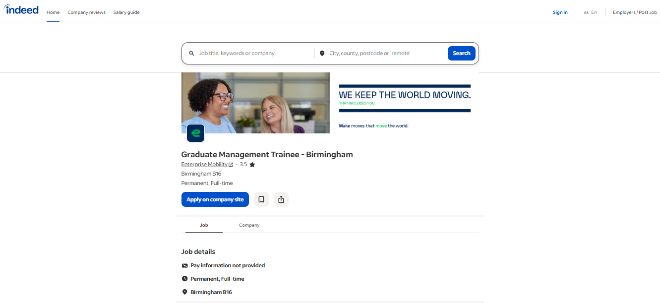
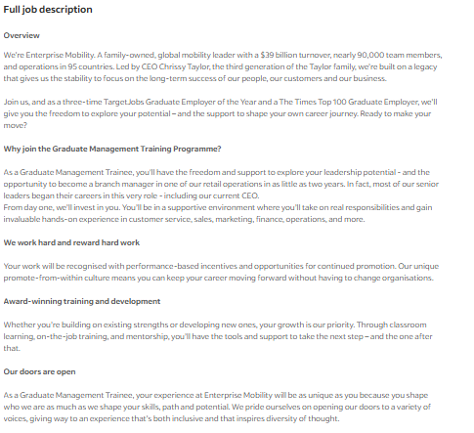

Responsibilities and Person Specification


