Mohmed Trissia (1921106)

The impact of strategic management on “Happy Beds” sustainable growth

Module: Strategic Management for SMEs (BMSW6104_LON)

Lecturer: Dr Mohamed Kalam

Table of contents:

Executive summary:……………………………………………………………………………………………………….3.
Introduction: ………………………………………………………………………………………………………………….3.
Happy Beds background:…………………………………………………………………………………………………4.
Happy Beds Strategic Management:………………………………………………………………………………..5
Strategic Analysis for Happy Beds:……………………………………………………………………………………..6.
- Internal Analysis:………………………………………………………………………………………………..7.
9M model of resource planning:…………………………………………………………………………7.
McKinsey’s 7s:…………………………………………………………………………………………………….9.
- External Analysis:……………………………………………………………………………………………...10
PESTEL Analysis:………………………………………………………………………………………………..11.
- Industry Analysis:………………………………………………………………………………………………12.
Porter’s five forces tool:…………………………………………………………………………………….13.
SWOT Analysis:………………………………………………………………………………………………….14.
Strategic options:…………………………………………………………………………………………………………..14.
Porter’s Generic Strategies:……………………………………………………………………………………14.
ANSOFF Matrix tool:……………………………………………………………………………………………..15.
Recommendation: ………………………………………………………………………………………………………..16.
Conclusion:……………………………………………………………………………………………………………………17.
References:…………………………………………………………………………………………………………………………………18.

Executive summary:
This executive summary provides an overview of an academic report on the importance of strategic management for small and medium-sized enterprises (SMEs). The report highlights the challenges that SMEs face in today's competitive business environment and explains how strategic management can help them achieve sustainable growth. The report begins by discussing the current state of SMEs in the global economy. SMEs account for a significant portion of economic activity in many countries and are a major source of employment and innovation (Horne, 2022). Taking “Happy Beds” as a case study, this paper introduces the concept of strategic management which involves developing and implementing strategic analysis to understand the internal, external, and industrial forces that may impact the company current and future performance. Various frameworks are used for this purpose including 9M of resource planning, McKinsey’s 7s, PESTEL, and Porter’s five forces. This report also offers strategic options analysis by implementing Porter’s Generic strategies and Ansoff model to recognize the strategic alternatives that “Happy Beds” may consider to improve its market share and profitability including several valuable recommendations such as strategic partnership and green strategy development.

Introduction:
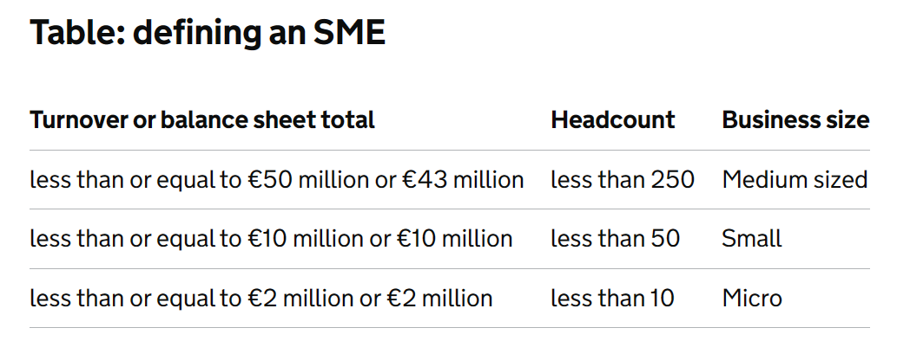
Small and Medium Enterprises (SMEs) are vital for economic growth and development in both developing and developed countries (Spence and Painter-Morland, 2011). Although the exact definition of SMEs can vary from one country to another, SMEs are generally considered as businesses that have a small number of employees and low volume of sales. In the European Union, for instance, businesses which have fewer than 250 employees and their annual turnover does not exceed 50m euros are considered as SMEs (Gov.uk, 2022) (Figure1). In its article of 2019, the International Labor organizations (ILO) mentioned that 90% of worldwide businesses are SMEs with large portion classified as micro businesses hiring less than 10 employees. The same source insisted that SMEs contribute more than 50% of GDP and 70% of employment worldwide.
Figure 1: source: Small to medium sized enterprise (SME) action plan - GOV.UK (www.gov.uk)
Consequently, SMEs are an essential part of the economy for various reasons. For example, they are the largest employers in many countries since they provide jobs and give opportunities to young people and entrepreneurs to enter the work force (Horne, 2022). Also, they are often the source of innovation as they quickly adapt to urgent circumstances and contribute to the diversity of the economy by providing a variety of goods and services. However, in today’s highly competitive marketplace, SMEs face different challenges which can hinder their growth and sustainability. Horne (2022) claimed that the rate of businesses that fail during the first year is about 20% and can reach up to 60% by the third year. He added that limited access to financial resources, lack of brand recognition, and poor management strategy are main factors of SMEs’ breakdown.
Therefore, to understand the link between strategic management and its impact of SME’s survival, this report aims to examine the key elements of strategic management process of “Happy Beds” company and identify the role of its emergent leadership in improving performance, sustaining competitive advantages, and add value to its market share.

Happy Beds’ background:

Figure 2: source: Who We Are | About Us | Happy Beds.
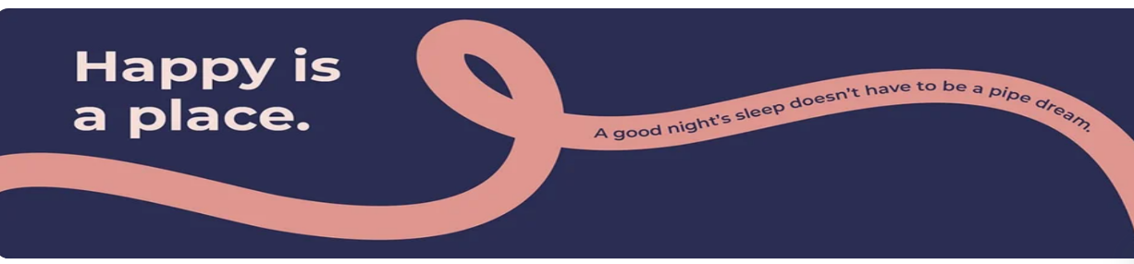

“Happy beds” is a UK-based online bed and mattress retailer. This small private limited company was founded in 2007 by Rex Isap with the aim of providing quality beds and mattresses at affordable prices (everybodywiki, 2022). Mr Isap started the business from home in London initially selling the products on different online platforms such as eBay and Amazon. As the business grew, the organization expanded its product range to include a variety of furniture items such as sofas, wardrobes, and bedroom sets. Overall information about the company is summarized in figure3.

Figure 3: source: Happy Beds Ltd | LinkedIn
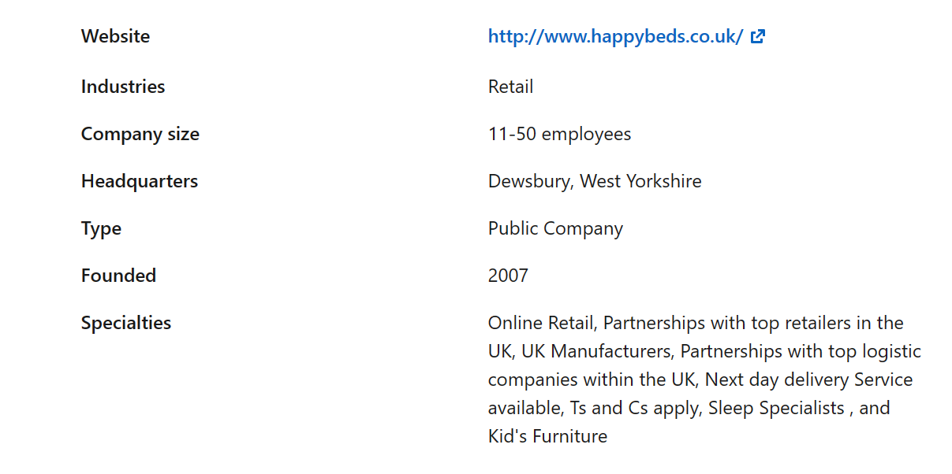
Based on the company’s mission statement, Happy beds’ main goal is to prioritize customer satisfaction and create a positive work environment where employees learn and develop their skills and capabilities. Additionally, the organization website highlights the commitment of the leadership in offering high quality products and services as well as a friendly and supportive team culture. The company also promotes transparency and accountability with clear policies for returns or refunds and a willingness to take into consideration customers’ complaints and feedback.
Consequently, these attributes have improved the company brand image and reputation leading to significant financial performance and an increase in customer satisfaction. For instance, Happy Beds financial 2021 reports indicated important sales growth contributing to total turnover of £3,429,631 Pomanda (2022). Also, the company’s feedback has reached a 4.8-star rate with over 40.000 customer reviews on all platforms including the company official website. Therefore, it is vital that “Happy Beds” find effective strategies to sustain its performance and develop a strong leadership that identify, manage, and execute those strategies.

Happy Beds strategic management process:
Strategy refers to a set of plans or actions designed to achieve specific goals or objectives (colin, 2004). The same author insisted that strategies involve making decisions about how to allocate resources, identifying opportunities, and mitigate risks to achieve a desired outcome. Yet more, in business context, strategy often refers to the overall approach that organizations take to achieve their short- and long-term goals to improve performance and sustain competitive advantages (colin, 2004). Therefore, it is paramount for organizations to have strong strategies to survive and create an effective process for managing, analyzing, assessing all necessities to meet their goals and objectives. This set of actions is called the strategic management process. Lynch (2018) argued that strategic management process refers to the process of defining an organization’s strategy and making decisions on allocations resources to develop and implement that strategy. The same author insisted that successful strategic management process requires three main analyses: strategic analysis, strategic options analysis, and strategic implementation and evaluation. Therefore, it is essential to conduct critical analysis on these three components to provide a key strategic recommendation for Happy Beds to overcome future challenges and achieve business goals. However, it is important to identify the company’s current strategic direction before giving more insight into the organization strategic management process.
In fact, Happy Beds’ vision is to create a happy place where people can enjoy their daily life and night sleep. This vision goes beyond selling furniture as leadership seeks to have a positive impact on people’s health by providing medical-friendly products. The company’s mission revolves around its approach on developing and designing products in accordance with the daily needs of consumers for the welfare of people at affordable prices. Also, the company has recently extended its mission to achieve positive environmental impact by helping consumers find the nearest recycling centers. In addition, Happe Beds core values include excellent customer service. The company focuses on continuous development of customer experience and purchase journeys to retain and attract customers. Cost consciousness, caring, honesty and fairness are also central values and significant components of Happy Beds’ business strategy which have important impact on achieving the company’s strategic goals such as excellence customer experience and green strategy improvement.

- Strategic analysis for Happy Beds:
This stage involves critical understanding and evaluation of internal and external business environments which can help leadership determine the organization strengths and weaknesses as well as external opportunities and threats (SWOT). The process of strategic analysis generally includes the following steps:
- Defining the organization’s mission and objectives: organizations start by defining their vision, mission, and goals which serve as a guide for the analysis.
- Conducting an internal analysis to identify the organization strengths and weaknesses. This involves different aspects such as financial resources, capabilities, leadership style, and culture.
- Conducting external analysis to identify their opportunities and threats. For instance, competition landscape, customer trends, economic conditions, and regulatory environment are among the factors that need to be examined in this analysis.
- Conducting SWOT analysis: After gathering all information from internal and external analysis, organizations can draw conclusion about the SWOT analysis.

Accordingly, Happy Beds strategic internal and external analysis involves the following:
- Internal analysis:
Several models and tools can be used to conduct SWOT analysis for an organization. For instance, to identify company’s internal strengths and weaknesses,9 M model of resource planning is an effective framework that can be used for this purpose. This model was introduced by Annmarie Hanon when writing her book “Digital Marketing: Strategic planning and integration” who insisted that 9 M factors need to be implemented by organization to ensure that right resources in place to meet its objectives (Comber, 2019). The 9 M model refers to:
1-Manpower: number of employees needed to carry work efficiently.
2-Materials: physical resources required to produce goods and services including raw materials and equipment.
3- Machinery: tools and machines needed to carry out the operations.
4-Methods: processes and procedures used to provide goods or services.
5- Money: financial resources needed such as capital and operating expenses.
6-Minutes: time needed to produce goods or services.
7-Measurements: tools and methods used to measure and evaluate employees, processes, and projects performance.
8-Management: senior leadership to achieve goals.
9-Mother nature: environmental factors that may impact the operations.

To understand the current state of Happy Beds resources and competencies, the 9M internal analysis includes the following:
1-Manpower: according to the latest confirmation statement submitted in April 2022 by the company accountant, Happy Beds Limited has 34 employees who are responsible of sales, marketing, and customer communications. This number does not include third party delivery partners who are in charge for picking and dropping all goods and services.
2-Materials: Happy Beds provide a wide range of products such as Mattresses, beds, bedroom furniture, and other home accessories. All these goods are made from wood, metal, and flexible polyurethane (foam).
3-Machinery: since the company is an online retailer, the sales and customer service agents use laptops to get in touch with all stakeholders. Also, the company’s warehouses have different machines to move the furniture around such as large trolleys, pallet tracks and stackers, and electric forklifts.

4-Methods: Happy beds have a user-friendly website for furniture lovers. The website provides all the newest products and home accessories for all sizes and materials. It is also for beds customization and seasonal sales discounts. Yet more, the company has other platforms where buyers can search and buy their products such as Amazon and eBay. For payment methods, customers can pay with their own credit/debit cards or use a third-party payment provider such as Klarna and PayPal which provide buy now and pay later finance without any commission. Mail brochures and sport sponsorship are other methods that the company use for band image and marketing strategies (figure4).
Figure 4: source: (26) Happy Beds Ltd: Overview | LinkedIn
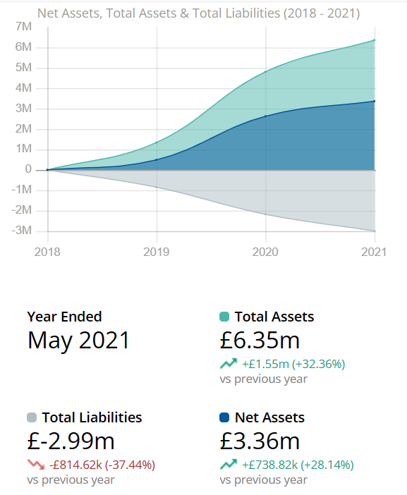
5-Money: according to Endole (2022), the company has increased its cash in bank amount by 11.43% in 2021 reaching £4.13M. The same article gives insight into the company financial performance between 2018-2021 which can be seen in figure 5.
Figure 5: source: Happy Beds Limited - Company Profile - Endole
6-Minutes: buying online requires not much time for the customer to complete the purchase. However, the delivery times can vary depending on various factors such as the location of the buyer and the availability of products. This can range from a few days to several weeks yet the buyers have the option to reduce the delivery time by paying additional charges (HappyBeds.co.uk, 2023).
7-Measurements: Happy beds use specific KPI (key performance indicators) systems to measure and evaluate their progress to align with the company’s strategy to achieve goals. For sales, marketing, and finance the company uses different fields to examine the overall business achievements such as revenue growth rate, website traffic, and cash flow. Also, customer service feedback metrics are vital for Happy Beds to recognize customer satisfaction, which is the core aspect of the company’s success.
8-management: according to the Dewsbury Reporter newspaper (2021), Rex Isap the founder of Happy Beds is the current CEO of the company. He is the one responsible for developing and executing the company s strategies, managing its finances, and building and leading a high-performing team.
9-Mother nature: Covid19 pandemic has been a key driver for Happy beds’ growth. Since the beginning of the pandemic, consumers have switched to online buying due to the stores’ closures and safety measures not to get infected. Also, organizations globally have introduced work-from-home style to perform office work effectively which necessitates extra furniture accessories such as desks and chairs.

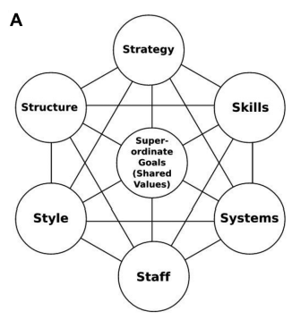
Another valuable tool that identifies Happy Beds internal analysis is the McKinsey 7’s framework. It was developed in the late of 1970s by Tom Peters and Robert Watern who were former consultants at McKinsey & Company (Batko and Szopa, 2016). The tool provides a holistic approach to organizational analysis and planning by considering 7 core aspects that need to be aligned to help organisation improve its effectiveness and performance. These elements are (figure 6):
Figure 6:source: 2 Challenges for a community of practice: recognising complexity with the mckinsey 7s framework - ProQuest
1-startegy: the direction and scope of the organization over long term.
2-structure: the way the organization is structed and how it operates.
3-systems: procedures, processes, and routines used to manage the organization.
4-shared value: core values, beliefs, and attitudes that shape the organization’s culture.
5-skills: capabilities and competencies that the organization possesses.
6-staff: workforce of the organization.
7-style: the leadership and management styles of the organization.

Applying this model on Happy beds gives further insight into the company strategic planning:
1-startegy: four main points constitute Happy Beds business strategy:
- Offering the lowest prices to attract and retain valuable customers.
- Adopting digital transformation features such as product customization to deliver memorable purchase experience.
- Providing simple checkout process with flexible payment methods.
- Using effective product recommendation algorithm such as “you might also like” or “consumers who bought this item also bought” to boost sales.
2-structure: Happy beds limited has a hierarchical organizational structure. The power and decision-making authority are coming from Mr Isap who sets rules and responsibilities to his subordinates who execute orders and carrying out tasks.
3-Systems: the company uses different methods to achieve goals and objectives. for instance, the leadership of the organization adopt different digital transformation features to enhance the customer purchase experience which can improve brand image and customer retention.
4-shared value: creating a comfortable and delightful place for everyone with the best quality and affordable prices is the core value of Happy Beds. Yet more, the company’s culture includes 4 key values: caring, honesty, fairness, and bringing happiness (Figure 7).
Figure 7: source: Who We Are | About Us | Happy Beds.
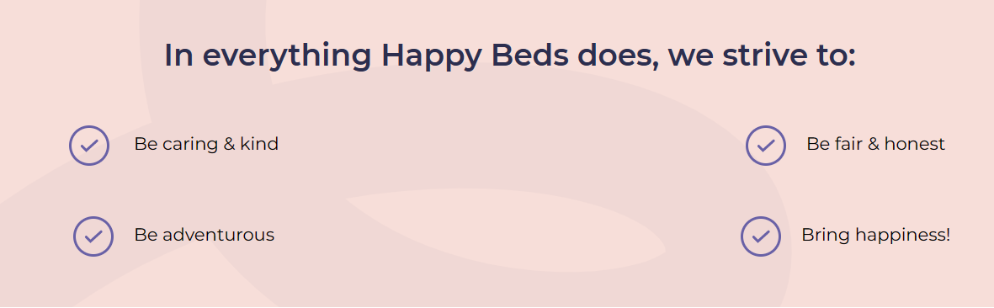

5-skills: innovation and customer service skills are key competencies that the company possesses. Creative leadership at Happy Beds is continuously Looking for new ways to develop existing products or upgrading the operating systems to create a pleasant purchase experience. additionally, the company promises to provide best customers service by hiring experienced individuals who have great knowledge of all products offered and can help with any issues when arise.
6-staff: as previously discussed in this report, Happy beds employ 33 people who carry all daily tasks and communicate with customers.
7-style: autocratic leadership style is the most dominant at Happy beds. The executive officer set rules when making business decisions and expect others to adhere to those rules.

- External Analysis:
According to Thakur (2021), the business environment is rapidly changing and creates opportunities and threats for organizations forcing them to transform their approach and implement strategic changes to improve competitive advantages and achieve business goals. Hence, conducting external analysis is vital for organizations’ survival since it provides valuable information about the macro environment in which they operate. The macro environment refers to the external factors that can influence organization operations and overall performance. These external forces can be summarized in what is known as PESTEL analysis. The acronym PESTEL stands for Political, Economic, Social, Technological, Environmental, and Legal factors.
Consequently, the following PESTEL analysis is important to identify the future opportunities an threats and develop effective strategy:
- Political: According to Low Pay Commission (2022), the government has decided to increase the national minimum wage by 97 pence on April 1st, 2023. Additionally, the main rate of corporation tax will rise from 19% to 25% for the companies with annual profits of £250.000 or more (HM Treasury, 2022). These factors can negatively impact Happy Beds financial performance. They can reduce the company profitability and limit the ability to invest in growth and expansion. However, the British government is now increasing the odds of rejoining the EU single market and customs union since the current prime minister is insisting that new deal with EU will hugely benefit UK businesses (Keegan, 2023). Hence, this pollical factor might improve Happy Beds’ profitability since the EU market enables free movement of products and services which leads to greater choice and low prices.
Figure 8: source: Rising cost of living in the UK - House of Commons Library (parliament.uk)
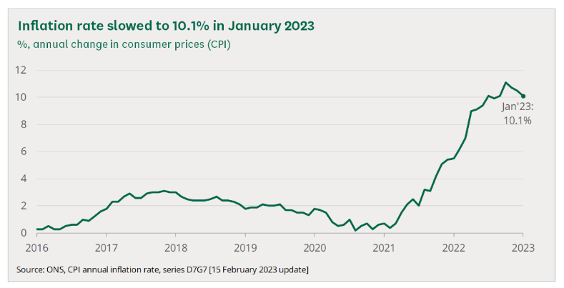
- Economic: The UK economy is in a slow recovery from the impact of covid19 pandemic. The employment rate has decreased slightly but remained higher than the pre-pandemic levels. Also, consumer goods and energy and food prices have been rising sharply due to great consumer demand and supply chain tailbacks leading to higher inflation rate (10.1 % in Jan 2023) (Figure 8). In addition, BRICS countries (Brazil, Russia, India, China, and South Africa) have formed a significant force in the world economy. These five emerging economies represent about a quarter of the global GDP reaching over 24 trillion US dollars in 2021 (O’Neill, 2023). BRICS countries are considering abandoning the US dollar as intermediary and conducting their massive trade and transactions directly with the Chinese yen. This development can add more uncertainty on the world economy and may aggravate financial volatility.
- Social: Happy beds need to take more initiatives to respond to social changes and demands. For instance, the UK population is predicted to increase by 2.1 million between 2020-2030 according to the Office of National Statistics (2023). This ongoing growth and living standards improvement will drive demand for space-efficient and reasonable pricing for home furniture. Moreover, lifestyle trends are continuously changing as the young generation prefer more modern, eco-friendly, and sustainable furniture than old traditional styles. Also, Social media influence can have significant impact on online furniture sales. Influencers and celebrities can promote certain furniture styles which can lead to increased demand for those products. Therefore, Happy Beds can take advantage of this trend by working with influencers or creating their own social media presence.
- Technological: today’s furniture industry requires companies to embrace technological advancement to remain competitive and meet customers’ needs. Among the technological factors that Happy Beds needs to consider are product digitalization, augmented reality, and smart home integration. Product digitalization is a simple process through which online buyers can showcase a furniture product in all colors, shapes, and styles. This can improve the firm’s marketing time and costs. The company also can use augmented reality to help buyers visualize how the furniture will fit their homes before purchase. Additionally, Happy Beds needs to consider their furniture products with smart home systems such as voice-activated assistants and lighting systems to add more value and improve brand image.
- Environmental: consumers are becoming increasingly aware of the impact of their purchasing decisions on the environment. According to YouGov (2022), 72% of British customers think about the environmental impact when buying. As a result, offering sustainable and eco-friendly products can be a significant selling point for Happy Beds. Also, switching to fully recyclable solutions will bring several environmental benefits such as reducing the amount of waste which damage landfills and cutting down greenhouse gas emissions to save energy.
- Legal: it is important for Happy Beds to constantly ensure that products comply with all applicable legal requirements enforced by the British authorities to avoid potential legal issues and liability. These requirements include product safety “GPSR 2005” which means forces organization to ensure that furniture is safe and free from any hazard or risks (Khiatani, 2022), fire safety “FFR 1988” which requires companies to ensure that upholstered furniture meet certain fire resistance standards (Khiatani, 2022), and Consumer Rights Act 2015 which sets different rules and regulations regarding consumer protection including accurate labeling, product description, and remedies for faulty products (Khiatani, 2022).

- Industry analysis:
The furniture industry is a significant contributor to the UK economy with a diverse range of products and services with countless SMEs operating in the furniture market. Therefore, it is paramount to conduct the furniture industry analysis in the UK to identify opportunities and threats, understand the competitive landscape, and develop strategic decision-making. For this purpose, Poter’s five forces model is used to recognize the key factors that may shape up Happy Beds current and future strategies. The framework considers assessing five forces to understand the competitive industry landscape:
- Threat of new entrants: the furniture industry in the UK is highly competitive with many SMEs operating in the market. The industry is also characterized by low barriers to entry including low capital investment and easy access to established distribution channels. Also, there are no regulatory or technological barriers. Therefore, the threat of new entrants is relatively high.
- Bargain powers of Suppliers: the furniture industry relies on a range of inputs including raw materials, components, and finished goods. The bargaining power of suppliers is low as there are many suppliers available and furniture manufacturers have various options for sourcing materials. Also, the industry is characterized by a high degree of fragmentation with many small suppliers operating in the market. Consequently, suppliers have limited bargaining powers in the UK furniture industry.
- Bargaining Power of Buyers: this force is relatively high. The consumers have many options for purchasing furniture including online retailers and brick-and-mortar stores. Additionally, consumers have access to a wide range of products and they can easily compare prices and quality across different retailers. Therefore, furniture sellers must compete with price, quality, and design to attract and retail customers.
- Threat of Substitutes: Although there have been innovations in furniture products, the need for beds, pillows, and duvets still exists. Therefore, there is no close substitute for furniture products which reduces the threat of substitutes for the furniture industry.
- Intensity of Competitive Rivalry: the number of large companies and SMEs in the UK furniture industry is uncountable. Although large companies such as IKEA have strong presence in the market, small and medium businesses are intensifying the competition as they can provide high quality furniture products at cost-effective prices which creates difficulties for large companies to manage their pricing and overhead expenses of running such large businesses. Therefore, the intensity of competitive rivalry is very high.

Conducting this critical analysis of internal and external environment leads us to conclude the following SWOT analysis:

Strengths | Weaknesses | Opportunities. | Threats.
Excellent customer satisfaction.  Affordable price.  Highly motivated workforce.  Innovative digital transformation systems. | Not enough brand recognition.  Not enough resources to expand.  Weak marketing strategies. | Population growth.  More hybrid jobs.  Increase virtual buying trend.  UK Re-joining to EU single market. | Aggressive competitors.  New taxation rules.  Increase In workers’ pay.

- Strategic Options analysis:
Strategic options analysis is a process used by organizations to evaluate various alternatives available to them and determine the most suitable strategy to achieve their goals (Lynch, 2018). The process involves analyzing the organization’s current situation, identifying possible strategies, assessing the feasibility and impact of each strategy, then selecting the most appropriate one. Therefore, Porter’s Generic strategies is a valuable model that organizations can use for this purpose. Developed by Michael Porter in 1985, this model identifies three strategies for achieving competitive edge:
- Cost leadership strategy: this strategy focuses on increasing profits by reducing operation costs and charging lower prices. Dr Porter insists that the successful implementation of this strategy requires continuous investments in technology, the ability to develop efficient logistics, and keeping labor, materials, and facilities low.
- Differentiation strategy: it focuses on making products and services attractive and unique to customers in comparison with those of competitors. For instance, specializing in unique features or services, being known for excellent customer service, or having a highly valued brand image are examples of differentiation strategies. It is critical that organizations need to be creative, innovative, and can provide high quality products or services to achieve business goals whilst using this strategy.
- Focus strategy: it concentrates on developing products or services for niche market. Using this strategy requires a deep understanding of customers’ needs. The aim of this approach is to meet customers’ demands by providing that special extra product or service that cannot be obtained from competitors. Yet more, Michael Porter claimed that organizations need to adopt either cost leadership or differentiation strategy along with focus strategy. He argued that organizations cannot win a significant market share by using the focus strategy alone.

Looking at Happy Beds current strategic orientation, it is evident that the company’s leadership focuses on implementing both cost leadership and focus strategies. Happy Beds’ main goal is to achieve a competitive advantage by offering furniture products at lower prices than its competitors while maintaining high quality and meeting customers’ needs. Also, the company’s generic focus strategy is to provide extra services such as product customization, paying by installment with zero commission, and more discounts when buying or exchanging furniture from the same brand.

Ansoff Matrix:
Known also as the Product-Market Growth Matrix, the Ansoff matrix is strategic tool used to analyse and guide business growth strategies. it was introduced by the Russian American Igor Ansoff in his book “Corporate Strategy” in 1965 (Kipley et al,. 2012). Ansoff suggested four strategies can be key drivers for organizational growth (figure9):

Figure 9: source: The Ansoff Model [Marketing strategy matrix] | Smart Insights
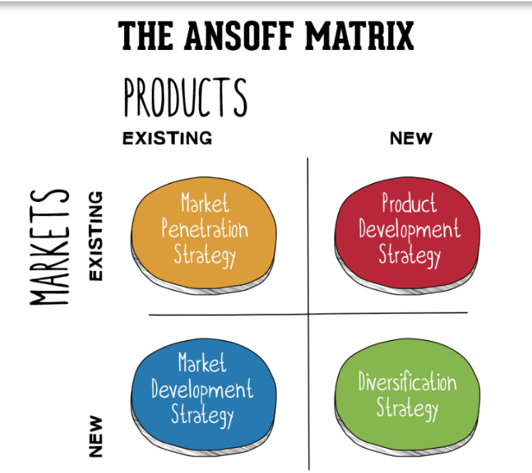

1: Market penetration strategy: it involves increasing sales of existing products in the existing market. Therefore, Happy Beds can try to enhance its market share in the furniture industry by finding more methods that can help selling goods to existing customers and attracting new furniture consumers through aggressive distribution, advertising, and price promotion.
2: Product development strategy: it involves creating new products to sell in the existing market. the success of this strategy depends on Happy Beds’ ability to effectively conduct research and insight into its customers and market needs as well as its internal capabilities and competencies to drive innovation. For instance, by evaluating the customer customization processes and designs, the company may consider refine or create new products to increase profitability.
3: Market development strategy: this option involves taking existing products into new market. Happy Beds can consider selling their products in different European countries since the UK is likely to rejoin the EU single market. However, this can be risky for Happy Beds growth since it is very difficult to understand and analyze the complexities and challenges of the EU market and competition with other European furniture giants can negatively affect the company’s financial performance.
4: Diversification strategy: it involves creating new products to sell to new markets. Moving to an unfamiliar market can be catastrophic for Happy Beds since creating entirely new products demands big investment and involves high risks. However, the company may consider other business arrangements which can help the company grow and expand in new industries or markets such as joint ventures, strategic alliance, or franchise. Effectively adopting these methods allows Happy Beds to achieve their strategic goals by sharing its resources and rewards with other companies.

Recommendation:
After conducting critical analysis of the micro and macro environment of Happy Beds, as well as the furniture industry, several recommendations could be beneficial for the company to take into consideration to develop new strategies which can help improve its market share and financial performance. For instance, “Happy beds” needs to continuously provide excellent customer service by ensuring the customers receive prompt and attentive assistance throughout their purchasing journey. This includes offering flexible payments options like the ones already available on the business website, flexible delivery time slots, and a free return policy.
Moreover, since most consumers prefer nowadays to shop online, it is essential for Happy Beds to change its current marketing strategy by investing more in social media platforms and leveraging third-party marketplaces. Also, improving CRM (customer relationship management) can be a powerful marketing tool. Encouraging customers to leave feedback on the company’s official website and social media and responding to these reviews show that “Happy Beds” values the buyers’ opinions and committed to improving their buying experience. This can help the company develop its brand image, which is considered one of its weaknesses. Additionally, the company needs to continuously find ways to develop its existing products and reduce its prices by investing more in product research. Embedding the Japanese Kaizen strategy of “Continuous Improvement” in the company’s culture is essential for this purpose. It can help leadership improve productivity and effectiveness by continuously finding efficient methods to cut costs and provide quality products. Happy Beds can implement the differentiation strategy by focusing more on the green strategy. Collaborating with other complimentary businesses such recycling companies and green strategy experts to help the company accelerate transition towards delivering environmental-friendly sustainability. For instance, happy beds can provide customers free pick up and disposal of used products in their recycling partners to improve the environment protection.

Conclusion:
Small and medium-sized enterprises are an important driver of economic growth and job creation. Unlike larger companies, SMEs have limited financial and human resources making it challenging to gain significant competitive advantage over larger firms. Therefore, continuous strategic development and implementation are crucial for SMEs to achieve sustainable growth. effective strategy management brings countless benefits to organizations. It helps identifying and leveraging competitive landscape, managing risks, and building a strong brand and reputation.
Happy Beds operates in highly competitive industry. The organization need to invest time and resources into developing and implementing strategic plans which align with its goals and values by continuously conducting internal and external analysis to take advantage of emerging opportunities and adapt its strategies accordingly to changing market conditions.

References:
Batko, R. Szopa, A. 2016. An Imagination of Organizations in the Future: Rethinking McKinsey’s 7s model. Strategic Imperatives and Core Competencies in the Era of Robotics and Artificial Intelligence. IGI Global. Available [online]: An Imagination of Organizations in the Future: Rethinking McKinsey's 7S Model - University of Wales Trinity Saint David (uwtsd.ac.uk).
Colin, W. 2004. Strategic Management. 1st ed. McMillan Education UK. London. Available [online]: Strategic Management - University of Wales Trinity Saint David (uwtsd.ac.uk).
Comber, L. 2019. Have you heard of 9Ms of resource planning framework? Available [online]: Have you heard of the 9Ms of Resource Planning Framework? – Go Marketing Guru (wordpress.com).
Dewsbury Report. 2021. Seventeen new staff in record year at Batley-based Happy Beds. Available [online]: Seventeen new staff in record year at Batley-based Happy Beds | Dewsbury Reporter.
EverybodyWiki.com. 2022. Happy Beds. Available [online]: Happy Beds - EverybodyWiki Bios & Wiki.
Endole. 2022. Happy Beds Limited. Available [online]: Happy Beds Limited - Company Profile - Endole.
Gov.uk. 2022. Small to medium sized enterprise (SME) action plan. Available [online]: Small to medium sized enterprise (SME) action plan - GOV.UK (www.gov.uk).
Happybeds.co.uk. 2023. Delivery information. Available [online]: Delivery Information | Happy Beds.
Happybeds.co.uk. 2023. Who we are. Who We Are | About Us | Happy Beds.
HM Treasury. 2022. Government update on Corporation tax. Available [online]: Government update on Corporation Tax - GOV.UK (www.gov.uk).
Horne. B. 2022. How Many Businesses Fail in the First Year in the UK?. Available [online]: How Many Businesses Fail in The First Year In the UK?- NerdWallet UK.
ILO. 2019. The power of small: Unlocking the potential of SMEs. Available [online]: The power of small: Unlocking the potential of SMEs - InfoStories (ilo.org).
Keegan, W. 2023. Even Sunak seems to like the single market: So why doesn’t labour?. Available [online]: Even Sunak seems to like the single market. So why doesn’t Labour? | William Keegan | The Guardian.
Khiatani, J.V. 2022. Furniture Regulations and Standards in the United Kingdom. Available [online]: Furniture Regulations and Standards in the United Kingdom (compliancegate.com).
Kipley, D., Lewis, A. O., & Jeng, J.-L. (2012). Extending Ansoff’s Strategic Diagnosis Model: Defining the Optimal Strategic Performance Positioning Matrix. SAGE Open, 2(1). https://doi-org.ezproxy.uwtsd.ac.uk/10.1177/2158244011435135.
LinkedIn. 2023. Happy Beds LTD. Available [online]: (26) Happy Beds Ltd: Overview | LinkedIn.
Low Commission Pay. 2022. Large minimum wage increases help protect low-paid workers’ living standards. Available [online]: Large minimum wage increases help protect low-paid workers’ living standards - GOV.UK (www.gov.uk).
Lynch, R.L. 2018. Strategic Management. 8th edition. Harlow, England. Pearson.
O’Neill, A. 2023. Gross domestic product (GDP) of the BRICS countries from 2000 to 2027. Available [online]: BRICS: GDP per country 2027 | Statista.
Pomanda.com. 2022. Happy Beds Limited Company information. Available [online]: Happy Beds Limited - Company Profile - Pomanda.
Spence, L. Painter-Morland, M. 2011. Ethics in small and medium sized enterprises: a global commentary. 1ed. Springer Netherlands. Available [online]: Ethics in Small and Medium Sized Enterprises A Global Commentary - University of Wales Trinity Saint David (uwtsd.ac.uk).
Thakur, V. 2021. Framework for PESTEL dimensions of sustainable healthcare waste management: Learnings from COVID19 outbreak. Journal of cleaner Production. Vol 287. P.125562-125562. Available [online]: Framework for PESTEL dimensions of sustainable healthcare waste management: Learnings from COVID-19 outbreak - ScienceDirect (uwtsd.ac.uk).
The Office of National Statistics. 2023. Population projection. Available [online]: Population projections - Office for National Statistics.
YouGov. 2022. Shoppers prefer sustainable products, while retailers think it’s the brand name. Available [online]: Shoppers prefer sustainable products, while retailers think it’s the brand name | YouGov.

