Children young people and family
Student: Karon Mcqueen
Number:1809080
Tutor:Dr Mark Gallagher-Read
BMHP 5004

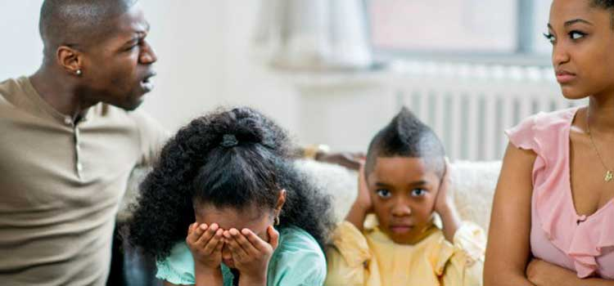

CONTENT PAGE
Introduction…………………………………………………………..pg 3
Position of vulnerability……………………………………………..pg 4
Risk factors………………………………………………………….pg 5-6
Subject of assessment………………………………………………pg 7
Conclusion…………………………………………………………….pg 8
Acknowledgement…………………………………………………….pg 8
References…………………………………………………………….pg 9

INTRODUCTION

In summary, this is a case study of a child, young person and family, demonstrates the way in which the family was in a vulnerable position, The multi-disciplinary service working together in collaboration to help the family to move forward to be more independent which they also provide current policy and actions to help support the family.
Here, the mothers son is with an intense emotional state of offending behaviour and in a difficult position to settle because of non-resident status ,which might have posed a particular challenge to the mother who herself had lack of parenting skills and have made wrong decisions for her family she also had problems with accommodation, rent arrears, employment status of the mothers partner, general wellbeing within the family and school issues of bulling

Position of vulnerability

According to the case study it appears that the child and young person and family are in a vulnerable position. This is because they are in poverty, they had frequently family relocations. It also appears that the family have continuous rent arrears, there appears to be concerns regarding school related issues of bulling, antisocial activities within the household, also a broad-spectrum of health issues, work related issues of the mother’s partner , also the young boy was in resident care of the experts.
The mother has had a lack of parental guidance and could not take care of the children ,although she clearly care for them, these are negative outcomes within the family.

RISK FACTORS
The young adolescent boy was living in care of the local authority while the rest of the siblings and parents where moving around in changed accommodations in an extremely time this cause them to have rent arears they also struggle with education which one of the children had a problem in school following an impending exclusion and needed to retain a place in school also they had issue of bulling and needed to tackle that problem as well.
The young adolescent boy had behavioural problems and he was a non- resident ,which was caused by Lack of parenting skills of the mother. The mother had made some poor decision for her family but wants to develop in a positive way by engaging in parenting sessions although she was reluctant to become involved at first
They had general well being of the family which can cause a strain on the house hold, they also have finical problem because the mothers partner had no employment and could not help in this situation ,this can increase stress, limited enjoyable time and cause a strain in the home, this family is facing difficulties in different areas which is affecting their well being

Below there are agencies and policy that are involved in this case such as
The probation services - Children Act 2004 -
Metropolitan police -Children Act 2004
Education services
The youth in need team
Neighbourhood services
Temporary accommodation
CAMHS -NHS service that treats Mental Health and Emotional Health, Mental health Act 1983
Kinara Family Resource Centre
Parenting Support Group
Homeless Person Unit - Birmingham City Council
Anti-Social Behaviour Team
Connexions and job centre plus
Social services -Anti Social Behavioural Team-Safe Guarding Children Act1989/2004
The child, young person and family became a issue of valuation by health and communal societies because one of the young adolescent boy who had behavioural problems and he has a non-resident status and was in the care of local authority. The family also had parenting problems, also in a short period of time they had to move houses several times because of homelessness which caused them to have rent arrears.
There are several key agencies involved in this case but there are specific agencies that take action towards the child, young person and family to help them overcome most of their issues such as The CAMHS , anti-social behavioural team helps the young adolescent boy with his behavioural problems, Parenting support group which helps the mom to improve in a confident manner towards opportunity for the family, Educational services helps the children to further their education and also help the children to retain a place in school ,Probation helps reduce the likelihood of reoffending within the family, Police helps to prevent further crime being committed, The youth in need team is to safeguard the well being and vulnerability of the family, Kinara family resource centre helps to provide services, develop programs for the family to identify their needs, Homeless person unit helps to support the family with their homeless situation, Neighbourhood service helps to get accommodation, Temporary accommodation provides place for the family to live, Connexions helps with a session for one of the older children and for the older child to live separately, Social services sign post agencies to keep the family together.
Job centre did nothing to help the family.

SUBJECT OF ASSESSMENT BY SOCIAL CARE AGENCIES.

Multidisciplinary services meet the diverse needs and vulnerabilities of the child young person and family by implementing action plans for the family by ensuring that they were re-housed and that they continue to engaged in their new tenancy due to historical difficulties they also helps one of the children to retain a place in school following an impending exclusion, involving the children in activities and connexion support for the older children, mother arranged to attend parenting classes but fail multiple lessons although she develop a positive attitude to the future, all these give the family hopes that the non- resident son would be able to reintegrated into the family

As Powell (2011) state, the core skills aptitudes for protecting incorporates the capacity to survey needs to work in association with kids, families and multi-disciplinary group so as to advance physical and enthusiastic prosperity and their security and their safety.
These agencies should provide more support on a longer timescale until the family is fully out of the situation they are in , they should consider these elements and take into account all the factors that are affecting the family and ensure all plans they have put in place is fulfilled , helping the mother with her parenting ,counselling or one to one sessions and also to help the mothers partner to get a job which could be helpful within the family to help take care of the house hold which the job centre was not helpful in this situation .

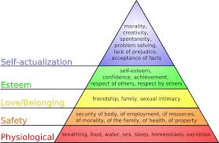

Maslow hierarchy (2020)

Conclusion

The child young person and family is facing difficulties in many areas which is affecting their wellbeing within the family negatively, these factors can influence their self-confidence they can develop mental health issues cause by stress and depression, this family is not developing at a normal rate they need social adjustment, self-esteem also physical, intellectual, emotional and social needs.

Acknowledgement
Working in a group to do this assignment about vulnerable family in this case study, has helped me to understand more in details what the assignment was about and the different legislation also what the family has gone through with the different agencies thanks to Sophia Angus-Walcott, Joan McDonald and Luthfa Khanam for working and co-ordinating with me so that we could finish this assignment.

References

Children Act(2004) Available at: www.legislation.gov.uk/ukpga/2004/31/contents(Accessed 3 March(2020).
Mental Health Act (1983) Available at: https://www.legislation.gov.uk/ukpga /1983/20/contents (Accessed 3 March 2020).
Birmingham City Council (2020)Available at : https://www.homeless.org.uk/homeless-england/service/birmingham-city-council-housing...(Accessed 1 March 2020)
GOV.UK. 2020. Department For Education. [online] Available at: <https://www.gov.uk/government/organisations/department-for-education> [Accessed 18 March 2020]. Markedbyteachers.com. 2020.
CPD Online College. 2020. Safeguarding Children | Legislations And Policies Surrounding Safeguarding. [online] Available at: <https://cpdonline.co.uk/knowledge-base/safeguarding/legislation-safeguarding-children/> [Accessed 18 March 2020
Play.google.com. 2020. [online] Available at: <https://play.google.com/store/books/details/Safeguarding_and_Child_Protection_5th_Edition_Link?id=RO GOV.UK. 2020.
Youth Offending Teams. [online] Available at: <https://www.gov.uk/youth-offending-team> [Accessed 18 March 2020].

