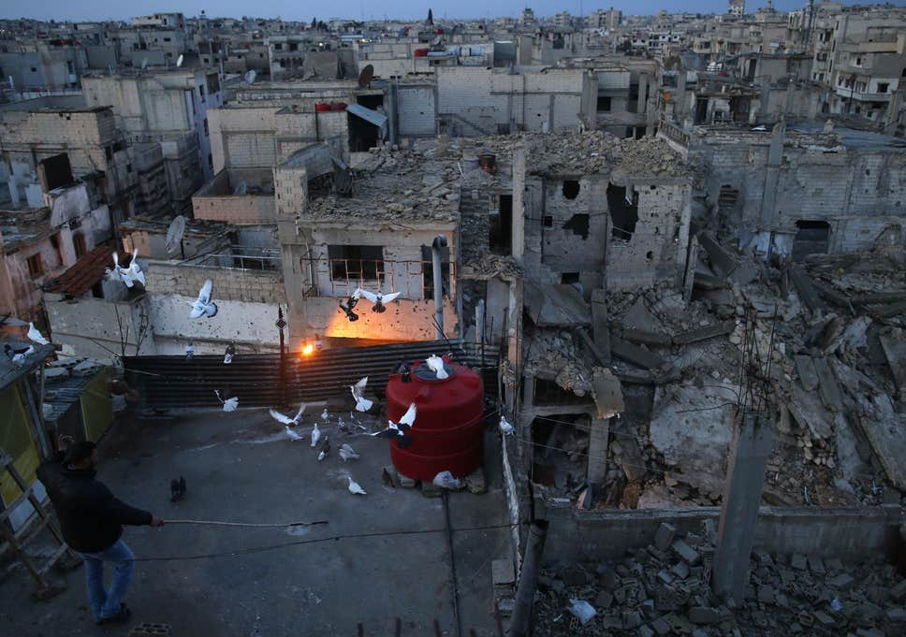

The Treasures of Homs

In a defiant pool of light
we are dazzling flares
against the ragged void.
A bright scrap of life,
we soar above
the scarred, blinded face
of our beautiful city.

We fly among others
whose own masters
launched the missiles
that ripped and ruined.
We do not judge,
for like fingers,
each winged treasure
is different.

But like fingers,
all belong to
the same hand.

I did read this at first and decided to think about it a bit before replying – I have to read carefully first.
I read about this man (and there was a cat man as well feeding dozens of abandoned cats in Aleppo). Both had trouble with IS who wanted to ban pets - and the Syrians love birds in particular.
I love the idea of this but it’s still too close to the surface.
Think about perception who is speaking and who is seeing. you want to present the way they look against the sky (maybe against the ruins?) but you then switch to the pigeon’s point of view which would be looking down.
because you aren’t clear about this, there isn’t a firm visual element there’s not a real sense of Homs as a place which has lost so many of its treasures.
what is the space around the pigeons like – for pigeons who stay wedded to home and their man even as it is disintegrating, as smells different, sounds different, looks different
what do the pigeons sound like as they fly? their wings, as they come to roost? their settling sound how do they appear to those who look at them? to those who welcome them back? where do they fly to when the fruit trees, the gardens and the parks are all burned and the fountains smashed?
Maybe look at some pictures of Homs before it was destroyed (heartbreaking)
do a bit of research into pigeons to understand them as treasures. if you want it to be visual I think it might be better to aim for a kaleidoscope of fragments, like a faceted jewel
the saying is brilliant. maybe you could split it to cup the poem by opening and closing, using italics and different indentation to indicate the statuis of the sections?

