CONSTRUCTION PROJECT MANAGEMENT
Option 2 build two dwellings
Paul Hamilton
P143032

TABLE OF CONTENTS
1. Introduction/Drawing of dwelling
2. Area and volume to be excavated
3. Site clearance and earthworks
4. Raft foundation
5. Floor slabs Pre-cast concrete
6. Timber Frame Work
7. External Skin 100mm Face Brick
8. Roof structure
9. Activity schedule
10. Programme Gantt chat
11. Site layout
11.1 Perimeter of Site
12. Conclusion
13. Bibliography

CONSTRUCTION PROJECT MANAGEMENT CASE STUDY
Executive Summary:
We plan to build a dwelling of two symmetrical houses in Swansea SA1.
The soil we are building on is a mix of gravel, sand and clay. Therefore the foundation of our choice is Raft foundation.
Front and rear of dwelling:
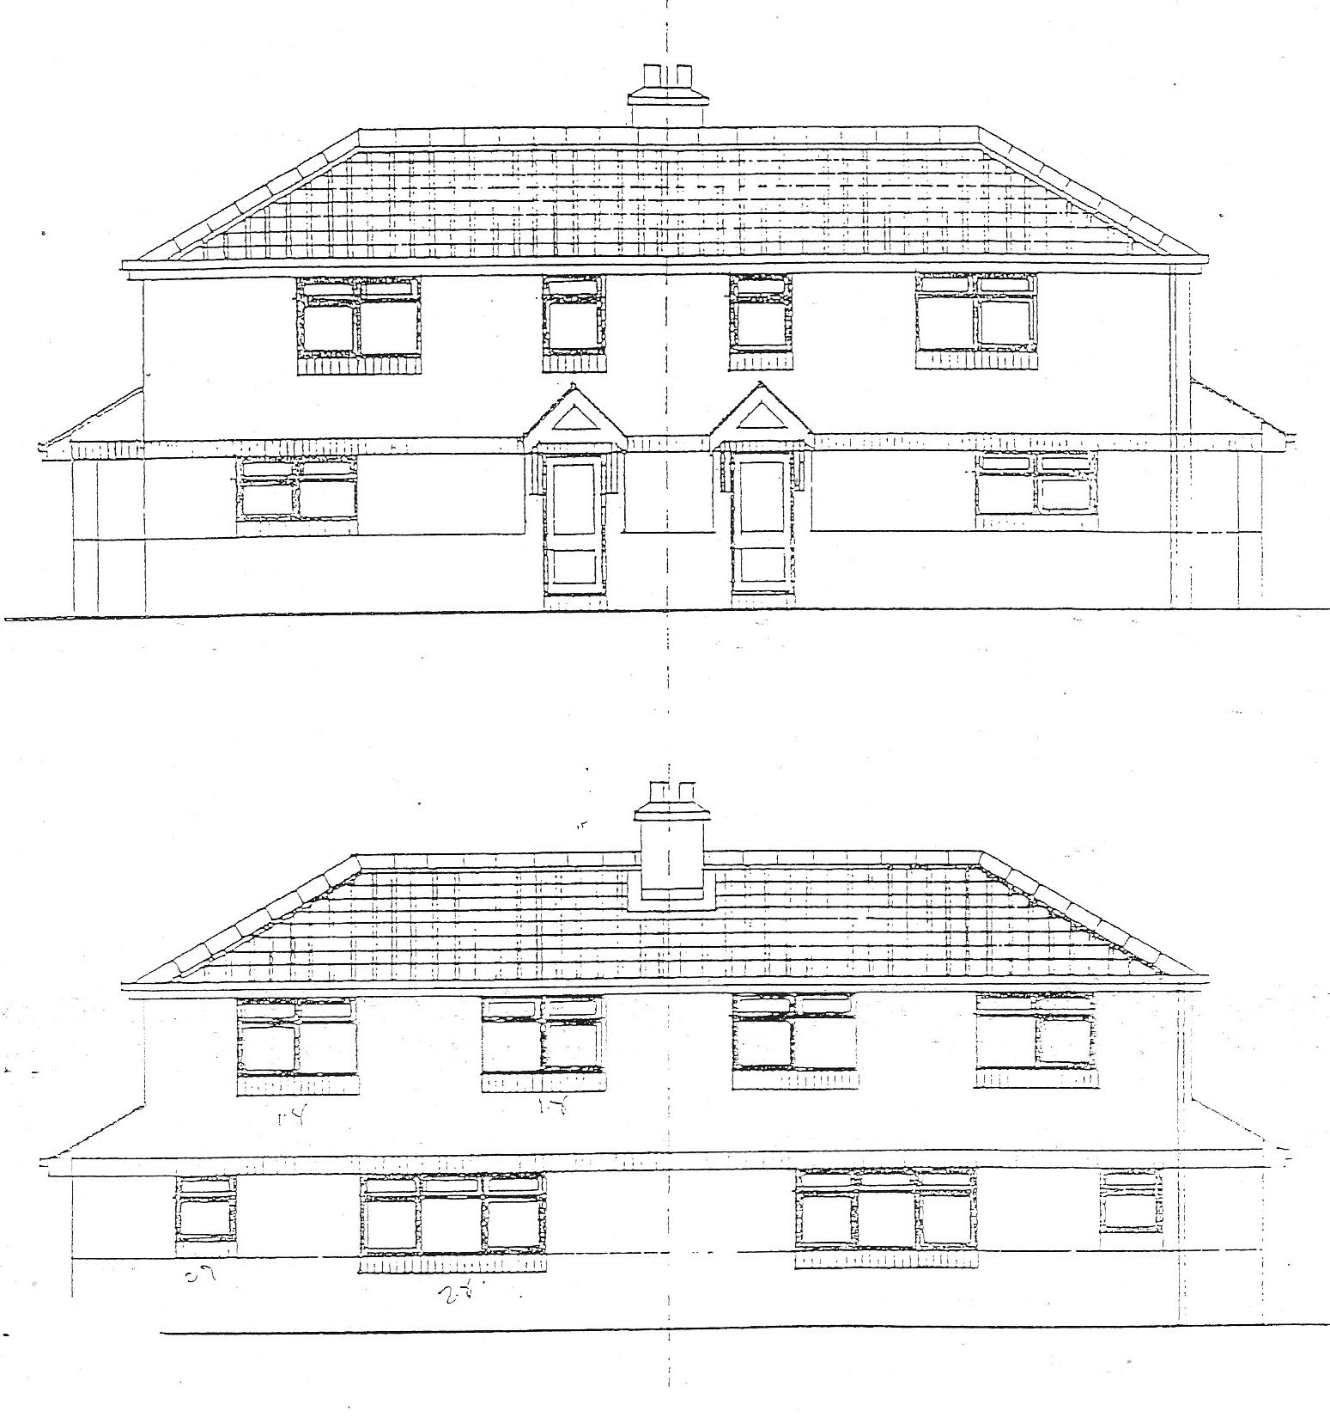

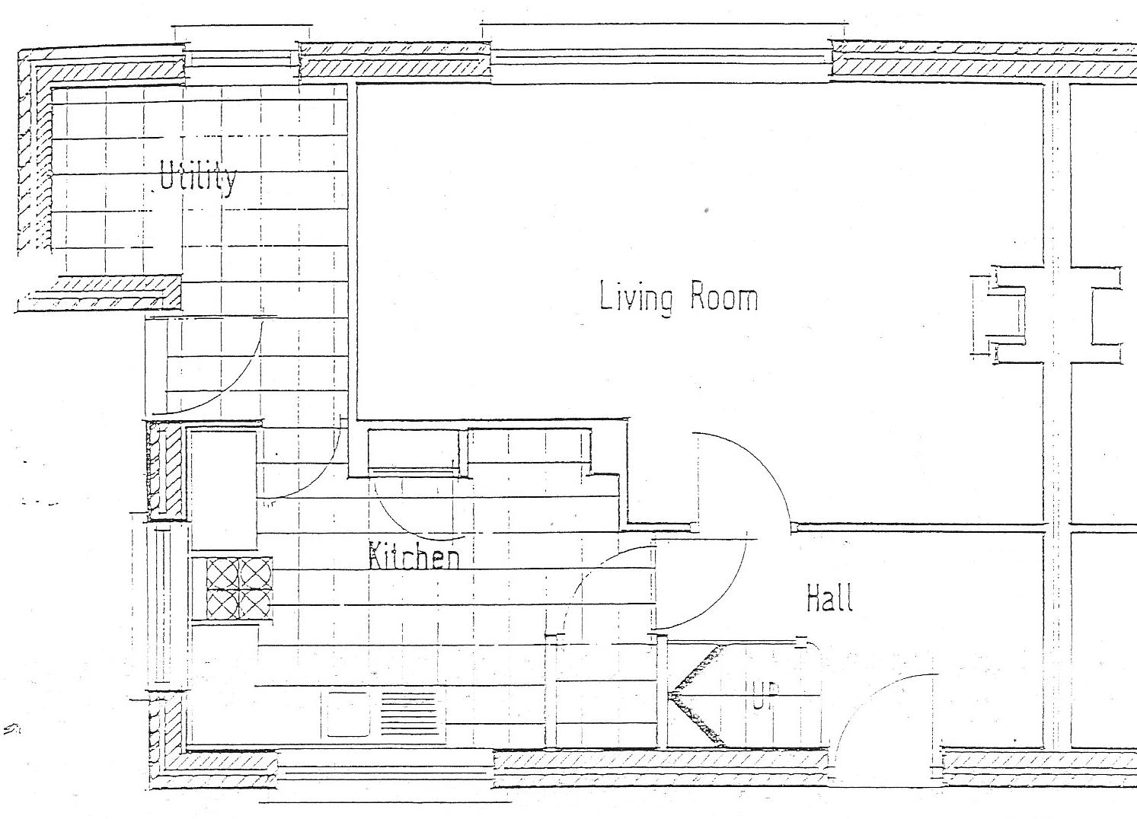
First floor:

Ground floor:
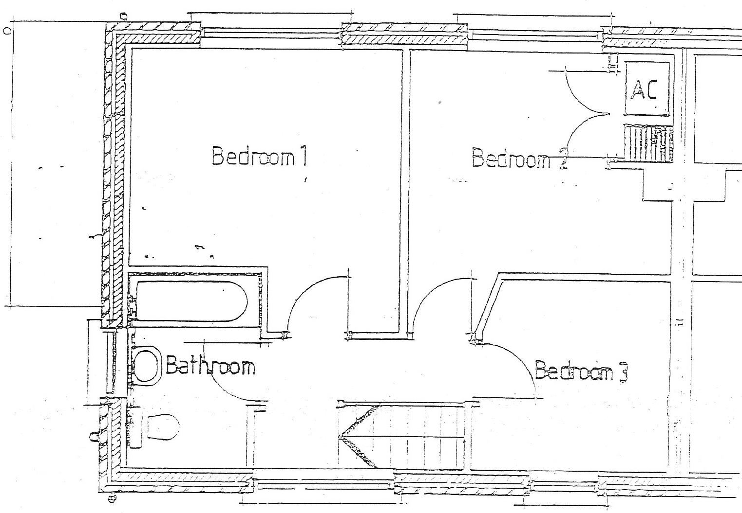

1. INTRODUCTION
This case study as described in the executive summary will show the appropriate systems and establish the different activities needed to construct these dwellings in sequence.
Duration of each activity and a programme in a bar chat shall be produced as a result. A line of balance diagram shall be included and recommendations to reduce construction time shall be made. A clear, detailed and viable site layout plan shall also be included in this exercise.
2. SITE CLEARANCE AND EARTHWORKS SYSTEM / ACTIVITIES
Using an excavator, we will level our construction area by moving parts of the earth’s surface including unformed rock. We will backfill where needed and some of the earth will be moved to another location for use in final levels.
DURATION = 1 week
3. AREA AND VOLUME TO BE EXCAVATED USING SPON’S
AREA TO BE EXCAVATED - 200m2
(SPONS) Plant 200m2 cost £22000
Excavation, removal and concrete 600mm-17mx33mx0.6m=336.6m3
Volume for 2 longest walls = 16.5 x 2 = 19.8m3
8.5m x 16.5m x 0.6m = 9.9 x 2sides
Volume =168.3m3 +168.3m3
=336.6m3
4. RAFT FOUNDATION SYSTEM / ACTIVITIES
- 1m deep excavation
- Blind concrete 100mm
- Steel reinforcement
- Pouring concrete into form-work
1 digger operative, 56 concrete wagons at 6m3 per wagon 1 pump operative and 3 gangs to level the concrete shall be required for completing our raft foundation.
DURATION= 1week
5. FLOOR SLAB – PRE-CAST CONCRETE SYSTEMS/ ACTIVITIES
Pre-cast concrete flooring will be delivered on site ready to be installed and ready for usage without delays for curing which are very costly.
Precast concrete floors using pre-stressed planks supported by our foundation will be our choice of floor slabs. Pre-cast flooring minimizes waste on site and reduces costs. The slab floor lifting system does requires “bar” individual floor beams being lifted into final position with chains or beam clamps. Two gangs will be required to hook our floor planks from the ground where a crane will lift into the accurate position we require and to other gangs will be ready to guide plank into accurate position and crane unhooks at that point. (1 crane operative, banks man, 2 gangs).
DURATION FOR PRE CAST CONCRETE FLOORING
At 20 panels a day: 1.2m per panel along 16.5m walls = 16.5/1.2 = 13.75 panels
13.75 panels x 2 floors = 27.5
27.5 x 0.20 panels per day 5.5 days
DURATION = 1.5 weeks

(Langdon, 2005)
6. Timber Frame Work System/ Activities
Build Route one = All work is carried out by a main contractor.
This is the ideal build route for self-builders who want a professional team to take all the responsibility and weight off your mind.

PROS
The main contractor oversees the entire construction project. You have one main point of contact.
The main contractor is responsible for managing and coordinating all construction procedures on site. You can essentially relax, watch it all happen, and be handed the keys once the project is completed.
If you choose this route, we recommend that you follow a rigorous tendering process, to find the right contractor for the job. If you hire the right team, you’ll get great results.

CONS
If you hire the wrong company, the results can be disastrous.
Since all responsibility is passed on to one contractor, you can expect to pay more.
COST FOR TIMBER FRAME ALONE
8.5 x16.5 = 140.25m2
Standard specification per m2 =£269
140.25m2 x £269 = £37,660
(Langdon, 2005)

CALCULATING ERECTION COST ESTIMATES
A budget of around £30-45m² will give you a ballpark for the erection costs to get your project to the wind and watertight stage. (SPONS)
COST FOR ERECTION
140.25M2 X 45M2 = £6,311.25
1 CRANE DRIVER, 2 GANGS AND A BANKS MAN WILL BE NEEDED TO COMPLETE THIS ACTIVITY. (5 gangs)
DURATION 1 WEEK
7. External skin system/activities
External wall will be made up of face brick average bricklayer will lay between 300-600 bricks per day equivalent to between 10m2-20m2. There, will be 1 gang of two bricklayers, and 1 labourer equivalent to possibly 1200 bricks being laid per day.
60 BRICKS PER M2 (Paul Hamilton)
140.25m2 x 60 = 8,415 BRICKS NEEDED IN TOTAL
8,415/1200=7.012 DAYS
Duration 1.5 weeks

ELEMENT | INSTALLED RATE | TWO STOREY HOUSE (100m2)
External wall | Price per m2 | Quantity
A 100mm brickwork outer skin | £50 | 240
B 100mm cavity wall insulation (full fill) | £10 | 240
C 100mm lightweight thermal block | £20 | 24
(Langdon, 2005)
Total cost per square meter of 100mm face brick external skin
140.25m2 x £50 = £7,012.51
8. ROOF STRUCTURE/ COVERING/ACTIVITIES
Pre-manufactured roof trusses come in a wide variety of styles. They are designed by the manufacturer for each specific building.
Timber trusses also are built in a variety of styles using wood or metal joints. Heavy timber rafters typically spaced 8 feet (2.4 m) to 12 feet (3.7 m) apart are called principal rafters. Principal rafters may be mixed with common rafter.
(HOMES, 1986)

(Spons) States that per dwelling it would take 10 days labour and £6900 per unit to cover and become water tight.
2 x £6900 = £13,800 Total cost for two dwellings.
2 x 10 = 20 days total duration.
9. Activity Schedule
NUMBER | ACTIVITY | DURATION
1 | SITE CLEARANCE | 1 week
2 | EXCAVATION | 1 week
3 | RAFT FOUNDATION | 1 week
4 | FLOOR SLAB | 1.5 weeks
5 | TIMBER FRAME WORK | 1 week
6 | BRICK WORK | 1.5 week
7 | ROOF STRUCTURE | 1 week

10. Gantt Chart

11. SITE LAYOUT
For the site layout the following shall be considered:
Transport, Storage, Welfare facilities, signage, waste, access, security of premises, car park, delivery vehicles and services. Site layout plan shall be developed at the point when contract is finalised. The contractor is to design this.
11.1. PERIMETER FENCING AND SECURITY
The site shall be fenced off using hares fencing along the perimeter which shall be made stable in the ground with help of heavy rubber feet. It is essential to keep thieves and any unauthorised personal from entering the site, the site will have clear signage: Construction site-keep out, Do not enter, No unauthorised personnel. Installation of CCTV cameras is highly recommended as it will be easy to prove any trespassing, vandalism or theft on site.

12. CONCLUSION
This case study has shown that it is very important to plan our activities and duration before starting on a project. Number of labourers can be changed as the project progresses and introducing more equipment to shorten our programme is a possibility or can be used for different activities. Our Gantt chart is useful to keep progress as different parts of the project unfold. A well thought out, site lay out can avoid accidents on site. A well labelled site with pedestrian routes clearly marked can avoid accidents. Provision of welfare facilities, and car park means that there is a health and safety measure for the workers and visitors on site.

13.

Bibliography

Education Ltd.Smith, N. (2000) Engineering Project Management, Oxford, Blackwell Science Ltd.
HOMES, ￼. (1986). TIMBER FRAME SELF-BUILD. Retrieved February 25th, 2018, from https://www.fleminghomes.co.uk
Illston, J. M. (1994) Construction Materials: Their Nature and Behaviour, England, Clays Ltd.
Langdon, D. (2005). Spon's Architects' and Builders' Price, Book 2005. London & New York: Spon Press Taylor & Francis Group.
Nicholas, J. (2004) Project Management for Business and Engineering: Principals and Practice, 2nd ed. Oxford, Elsevier Butterworth-Heinemann.
Millward, D. et al. (1995) GNVQ Construction and the Built Environment: Advanced, Essex, Longman Group Ltd.
Tomlison, M. (1996) Foundation Design & Construction. 6th ed. Essex, Addison Wesley Longman Ltd.

