Data handling and business intelligence – LCBB5000
Assessment 2- Coursework (written report)
Anita Petreus 2024822

Crime is one of the most serious issues faced by countries, and it has a negative impact on both society and the economy. Numerous investigations have been conducted to determine the root causes of London's high crime rate. The crime rate in London has steadily risen over the years, with the high increase occurring in 2016 and continuing through 2017. This study looks into the factors that contribute to the city of London's high crime rate. Unemployment, homelessness, and low-wage workers are all factors that contribute to crime in the London area, according to this study. (kaggle.com) and other publicly available sources were used to gather the data (data.gov). Pre-processing of these datasets was carried out manually in Excel, and then in Jupyter using Python. Different analytics tools such as R and Tableau use various machine learning and data mining models like Pearson's correlation coefficient, multiple linear regression analysis, and k-means clustering for visualization.
Analysis showed a strong negative association between crime and low income, but a strong and positive association between homelessness and that same measure. Unemployment has a positive association with crime, but it's not as strong as that of homelessness. The F-statistic and P-values from multiple linear regression analyses also show a strong connection between these variables.
The FBI's Uniform Crime Report collects data and statistics from participating law enforcement agencies across the country. There is agency, incident, and county-level data dating back to 1960 available for download. Police agencies are analysed using agency-level data. The National Incident Based Reporting System (NIBRS) collects incident and arrest data at the incident level. Only crimes and arrests are included in county-level data. For this guide, we're looking at crime data at the county level. Actual and cleared crime statistics are included in this report.
The crime rate is the ratio between the number of felonies and crime recorded by the police and detectives and the population.
How Determine the crime rate
Since counties with populations under 100,000 have a disproportionately high tax burden compared to those with populations of 100,000 or more, this guide does not include rates for counties with populations under 100,000.
You should add a new column called "crime rate." Arkansas counties' aggravated assault rates will be the focus of our research. If we divide the number of aggravated assaults per 100,000 people, then multiply that number by a factor of 1,000,000. Here's what it'd look like in a prison cell:
=(C7/D7)*1000000.

Doing a double-click on the cell's lower right corner will populate the rest of the column with the new violent crime rate Right-click on the new rate, select Format Cell, and round to two decimal points. The aggravated assault rate per 100,0000 residents in the county is 3252.70.

Plotting data in Pivot Tables in Microsoft Excel is one of the most powerful capabilities of the program.
Analysis of up to a million rows in Excel can be accomplished with a few mouse clicks, and the results are displayed in an easy-to-read table. You can "pivot" the report layout by dragging fields around, highlight important information for management, and include Charts and Slicers for your monthly presentations using the Pivot Table.
We've put together an interactive guide to the 50 different ways you can utilize a Pivot Table in Excel. Click here to see it in action.
Using Excel's tables can provide a host of advantages, and when done correctly, they can be quite powerful. Because of their numerous benefits, you should begin utilizing them as soon as feasible, regardless of how vast your data set is to begin with.
• Many different built-in Table Styles with color formatting; \s• Use of a Total Row which uses built-in functions to calculate the contents of a particular column;
• Dropdown lists that allow you to Sort & Filter;

• When you scroll down from the Table, its Headers replace the Column Letters in the worksheet;

• Remove Duplicate Rows automatically;

• Summarize the Table with a Pivot Table;

• Supports calculated Columns so you can create dynamic formulas outside the Table;
Transformation For improving the crime
Understanding and obtaining the best features from unemployment, homelessness, and low-wage workers by location and race attributes is essential to removing multicollinearity from the model. • Pearson Correlation Coefficients are used in a number of crime studies to examine the linear relationship between various factors and crime occurrences, but the data considered in this work does have a linear relationship. • • Excel features like pivot tables were employed. For the purposes of preparing the dataset for analysis, IF and lookup functions were used. Methods for descriptive analysis and data discovery were employed to thoroughly examine the datasets for the presence of any values that were omitted.
First step picking a cell in the table
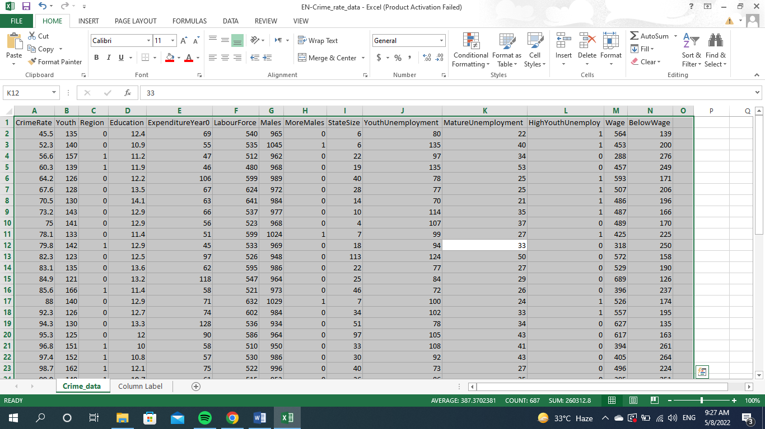

STEP 2: Let us insert our table! To do that press Ctrl + T or go to Insert > Table:

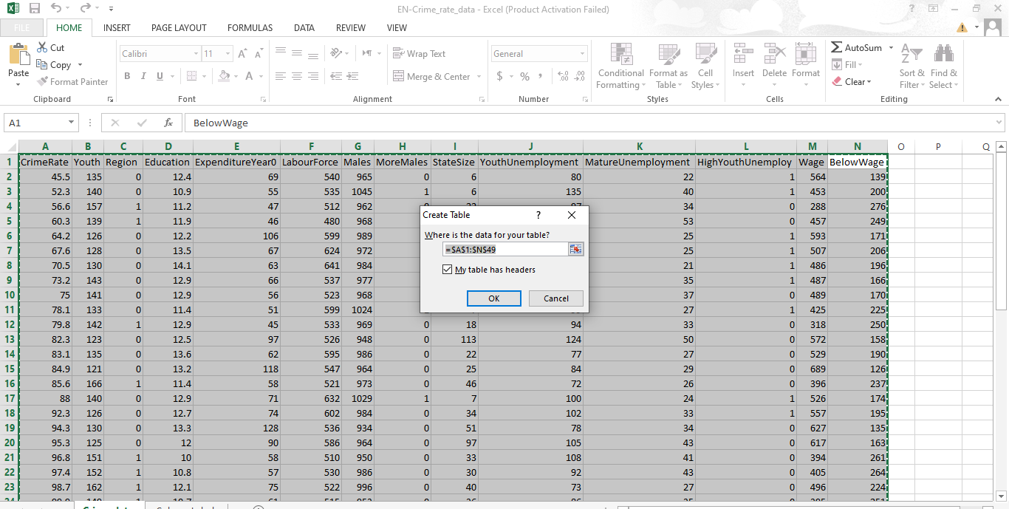
Step 3: Click OK
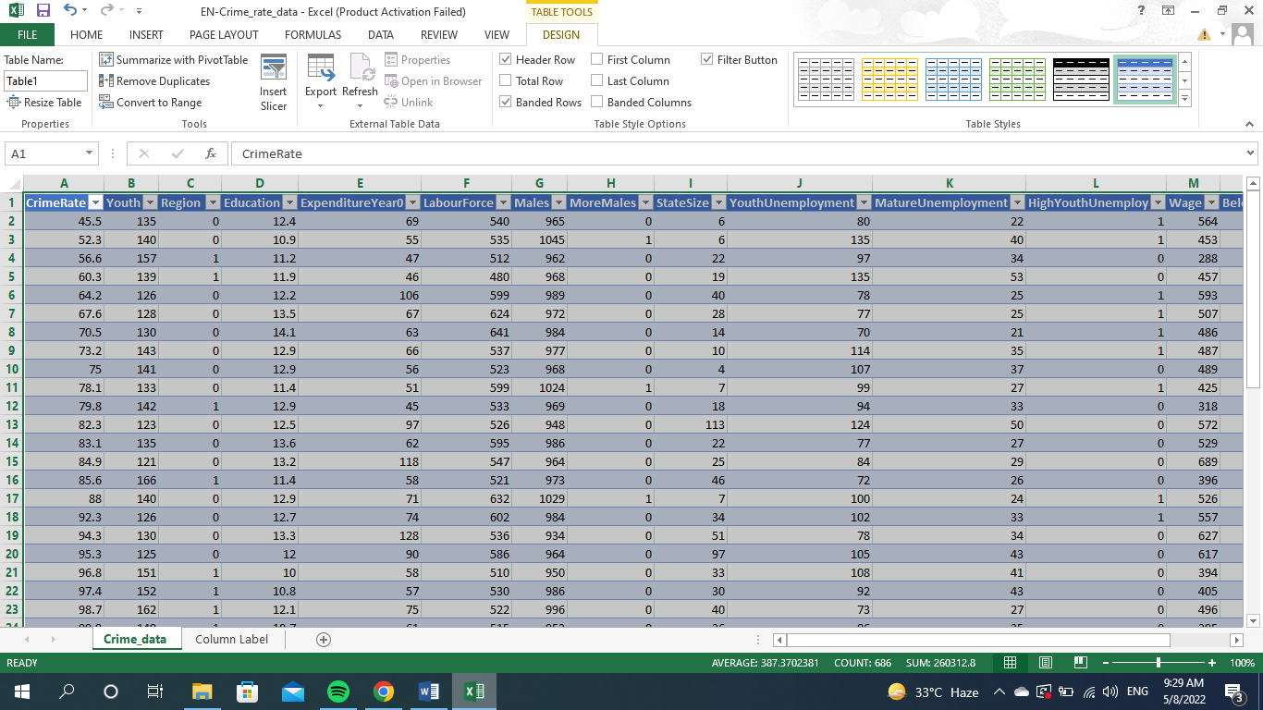

Excel's Pivot Tables let you quickly and easily examine tens of thousands of rows of data with just a few clicks of your mouse. Creating one is a breeze, and I'll show you how to do it in just a few minutes.
As an analyst, you should always use a Pivot Table whenever possible, as it will help you make better decisions and save you a lot of time in the long run.
STEP 1: Click in your dataset.
STEP 2: Go to Insert > Pivot Table
STEP 3: Place the Pivot Table in a New or Existing Worksheet
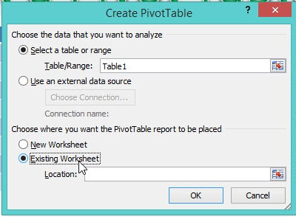
STEP 4 Drop the fields
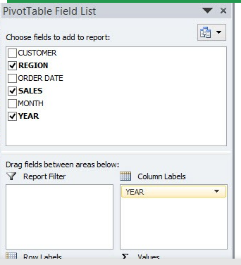

Calculation Techniques of Pivot
A pivot point (P) is defined as the sum of the previous high, previous low, and
previous close values divided by the current value. P x 2 = S1 – Previous high.
from the previous high and the previous low to get the second value.
R1 = (P x 2) – (P – 2) – Previous Low.
P + (Previous High – Previous Low) = R2 5.

In order to determine which counties have the highest aggravated assault rate per 100,000 residents, we can sort our data by highest to lowest rates. On the right side of the home tab, select Sort and Filter from the drop-down menu under the violent crime rate column. Sort the results in ascending size order. Make sure to expand the selection so that your data does not become mixed up when you are prompted to do so.

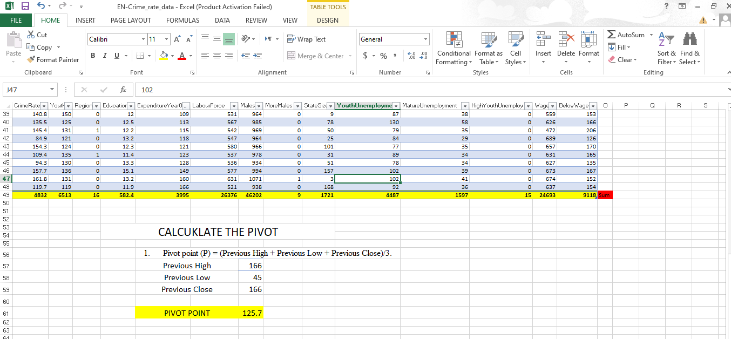
We now see the inequality between the number of crimes reported and the overall crime rate in each of Arkansas's reporting counties. Excel's Geography function will come in useful for this. So that the geography function can locate our data, we will need State and County. Select the column headings that you want to use by clicking on them. Click Geography on the Data tab. To indicate that we are ready to create a map with our data, question marks will appear next to the headings. In the Insert menu, select Maps and then Filled Map from the drop-down menu.

A look at the correlation analysis's findings reveals some crucial information. As long as we don't look for anything else, correlation analysis provides us with a wealth of information about the data. An example of a Pearson's Correlation chart can be seen in the image below. Low wages have a negative correlation with crime based on the Pearson Correlation model below, while unemployment and homelessness both have a positive correlation (0.74). We can infer from the data that crime rises in tandem with falling wages and rising levels of homelessness and unemployment.

Each dataset was subjected to a variety of analyses, the results of which can be seen in the following graphs. The graph above shows that the number of crimes in London decreased in 2014, before rising sharply the following year. An increasing number of people are becoming homeless in London, according to this graph. Since 2012, it has been steadily rising, but in 2016 it began to decline. Despite the fact that the graph below clearly shows that homelessness and crime appear to be unrelated, we'll see in the next section how homelessness impacts London's crime rate.

IF function
If the logical test returns True, then the IF function returns True; otherwise, the IF function returns False. Using the example of passing scores above 70: =IF(A1>70,"Pass,"Fail"). IF functions can be nested to test more than one condition at a time. The IF function can be used in conjunction with other logical functions, such as AND and OR.

The TRUE or FALSE values you enter

=IF (logical_test, [value_if_true], [value_if_false])
Arguments
The term "logical test" is used to describe a value or logical expression that can be evaluated as TRUE or FALSE.
When true, the value if true option can be used to provide additional information. When logical test returns TRUE, this value is returned.
value if false - Optional When logical test returns FALSE, this is the value to return.
"HIGHEST","LOWEST") =IF(G57>=166

A "nested" IF function is possible. Nesting one IF function inside another allows for a formula to test for additional conditions and return a wider range of outcomes. To ensure that the logic is correct, each IF statement must be carefully "nested" within the next.
When you are constructing a test with IF you will find :
- equal to (A1=B1)
- greater than (A1>B1)
- greater or equal ( A1 >= B1)
- less than (A1<B1)
- less than or equal ( A1<= B1)
- not equal (A1<>B1)

If the high crime rate in London is linked to unemployment, homelessness, and salaries that are below the living wage in London's capital city, we wanted to know more about that relationship. In this work, statistical methods such as correlation, multiple linear regression (MLR), and clustering were employed. While there appears to be a high association between crime and homelessness, there is a positive but smaller correlation between unemployment and crime. According to multiple linear regression analysis, there is a statistically significant relationship between the predictors and the outcomes. Using the p-values of variables, we can rule out the null hypothesis and assert a substantial relationship between crime, unemployment, low-wage work, and homelessness. We may divide the city of London into three distinct groups based on wage, homelessness, unemployment, and crime, as determined by K–means clustering analysis (Figure 1). According to the conclusions of this analysis into the crime rate in London, the London Metropolitan Police and other government officials may be able to use the information.

Part 2

K-Means Clustering is a simple but powerful algorithm in data science. There are numerous real-world applications for K-Means Clustering. Even in the most diverse industries, the method of categorizing or segmenting works. This is why the idea of clustering in data science is so important.
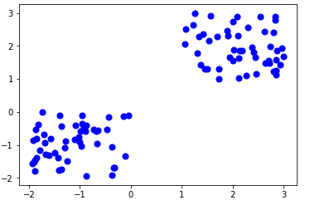
Here is the code for finding the center of the clusters:
Kmean.cluster_centers_

[0, 0, 0, 0, 0, 0, 0, 0, 0, 0, 0, 0, 0, 0, 0, 0, 0, 0, 0, 0, 0, 0,
0, 0, 0, 0, 0, 0, 0, 0, 0, 0, 0, 0, 0, 0, 0, 0, 0, 0, 0, 0, 0, 0,
0, 0, 0, 0, 0, 0, 1, 1, 1, 1, 1, 1, 1, 1, 1, 1, 1, 1, 1, 1, 1, 1,
1, 1, 1, 1, 1, 1, 1, 1, 1, 1, 1, 1, 1, 1, 1, 1, 1, 1, 1, 1, 1, 1,
1, 1, 1, 1, 1, 1, 1, 1, 1, 1, 1, 1]

Data mining
If you're considering a career in data science, continue reading to learn more about these data mining approaches and how they can lead to success in a variety of industries.
• Clustering • Association • Data Cleaning • Data Visualization • Classification • Machine Learning • Predictive Analytics

Clustering
Data visualisation techniques such as graphs that show buying trends or demographics for a particular product can be improved by using clustering.
Data Mining Clustering: What Is It?
Data points are clustered into groups according to their similarities and differences, and this process is called clustering. A more precise picture of a broad demographic (such as consumers or users) and their habits can be gained by segmenting the data in this way, which data scientists can do with ease.
How to use models: For each data cluster, a model is created that identifies the best data to fit that model.
Examples of Clustering in Business
Clustering is a useful tool for businesses to better manage their data. The use of clustering models can help retailers figure out who, when, and how often purchases specific products. This can assist businesses in marketing their goods and services to a specific group of people or geographic area.
Correlations between points in a data set can be found using association rules.
What Is a Data Mining Association?
An association is a technique used by data miners to find interesting or unique relationships between variables in databases. Marketing research and strategy are often aided by the use of associations.
It's important to look for multiple data points in a single data set when doing multi-dimensional association: For example, a retailer might want to know more information about a customer's age, method of payment (cash or credit card), or age.
Associations in Business: Some Real-World Examples
For example, retailers have noticed that parents who go shopping for childcare supplies are more likely to purchase specialty food or beverage items for themselves during the same trip, which is an example of association. Statistical correlation can be used to examine these purchases.3. Data Cleaning
Processing raw data before it can be mined is referred to as "data cleaning".
In Data Mining, what is the term "cleaning"?
Data cleaning is the process of arranging data, removing any duplicates or corrupted records, and filling in any blanks. Upon completion of this process, the most relevant data can be gathered for further analysis.
Various Approaches to Data Processing
Checking the accuracy of the information: Every single data point in a dataset must be formatted in the correct way (e.g, telephone numbers, social security numbers).
Examples of data cleansing in the workplace:
Poor data quality has a negative impact on 95% of businesses, according to Experian. It takes more time and resources to analyze incorrect data than it does to analyze correct data, and it often leads to incorrect analytics.
In the end, no matter how well-designed a model or algorithm is, if the data it uses is inaccurate, incomplete or corrupted, businesses will suffer.
Essentially, data visualisation is the act of transforming numerical data into an easily understandable visual representation that can be shared with important stakeholders inside an organisation.
What Is Data Mining Visualization and How Does It Work?
Information can be conveyed visually through the use of charts, graphs, maps, diagrams, and other visual representations of data. Data scientists use this method to present the outcomes of their research on a regular basis.
Methods for Visualization
There are an excess of options for visualising data. There are a few examples:
The following are examples of contrast graphs: Data can be displayed visually in the form of graphs and tables, for example, monthly product sales over a period of one year.
Visualisation of information about a given location can be accomplished through the use of maps and data visualisation. It is possible to display and compare population density and changes on maps; to compare populations of neighbouring states and counties; to determine how populations are distributed across geographic regions; and to compare features in one region to those in other regions.
Data Visualization in the Workplace: Case Studies
The ability to graphically explain data to executives, clients, and customers is a very valuable skill to possess. According to Markets and Markets, the global data visualisation tool market is predicted to nearly double (to $10.2 billion) by 2026 from its current level.

Nearly all fields of business can benefit from classification, which is a fundamental tool in data mining. It's a method for classifying large amounts of data based on the purposes for which they are put to use.
What Is Data Mining Classification?
Classes in data mining are considered to be forms of clustering because they help to extract comparable data points for comparing. As a business, you can use classification to identify broad groups within a demographic (e.g., a target audience or user base).
Examples of Business Classification
Customers are classified by financial institutions based on a variety of factors in order to market new loans or project the risks of credit card debt. Weather apps, on the other hand, categorize data to predict snowfall totals and other related statistics. As a result, supermarkets use classification to group products based on the demographics of their customers.

Computers may learn on their own through the use of algorithms, which is referred to as "machine learning." Machine learning, which is becoming an increasingly important aspect of modern technology, is the process of teaching computers how to do tasks based on the data they have collected, so making them smarter.
A more advanced approach, reinforcement learning, trains computers to make judgments based on data collected in a specific environment, which is more difficult to implement. For example, a computer may learn how to play chess by analysing the data from thousands of online games, such as those played on the internet.
Machine Learning in the Workplace
By utilising machine learning, businesses can use computers to quickly discover all kinds of data patterns (such as product usage or buying habits), and then create new business plans based on these findings. Many industries are beginning to recognise the importance of this skill set.

The advantages of using SPSS as a software package compared to other are:
When compared to other statistical software, SPSS has the following advantages: • SPSS is a comprehensive statistical software package.
A wide range of statistical tests,
from simple to complex,
Are already included.
Results are straightforward to decipher.
Displays data tables quickly and easily.
It's flexible enough to grow.
Limitations
Students may find it difficult to afford the licencing fees for SPSS.
Additional training is usually required to fully utilise all of the available features.
The graph features are not as simple as Excel's are.

Reference
Data mining : practical machine learning tools and techniques, Witten, I. H., Frank, Eibe.; Hall, Mark A., 3rd ed., Amsterdam 2011
Integration of data mining in business intelligence systems, Azevedo, Ana,; Santos, Manuel Filipe,, Hershey:, 2015
Database system: a practical approach to design, implementation, and management, Connolly, Thomas,, Beg, Carolyn E.,, Sixth edition, Global edition., Boston:, Pearson, 2015
www.myexcelonline.com
www.bootcamp.pe.gatech.edu
www.towardsdatasience.com
www.analyticsvidhya.com
Collica-Cox, Kimberly. “Crime & Society, 2e”,2020
www.encyclo.co.uk

