Developing a new landscape for customer care

Nalinda Super Centre (Pvt) Ltd.

Name: Waruna Galagedara
Student No.: 2206302
Program: MBA
Module: Strategic Management
Module code: BMMB7013
Submission Deadline: 16th December 2022

Contents

Page No.
- Executive Summary 4
- Introduction of Company, Strategies, and Tools 5
  - What is Strategy means? 7
  - What is Strategic Management? 8
  - Types of Strategy 9
  - Exploring strategy framework 10
  - Understanding the influence of the environment 11
    - Analysis of Micro Environment 12
    - Analysis of Macro Environment 13
  - Mintzberg’s Ps of Strategy 13
- Customer care
3.1 What is customer care 15
3.2 Customer expectation 15
- Evaluation of current customer care at NSC and future
global customer care experience 16
- Conclusion 29
- Recommendation 30
- References 31

List of Figures

Page No.
  - Strategies deliberate and emergent 10
  - Strategy framework 10
  - Layers of the business environment 12
  - Five P’s of strategies 14
  - Customer / Business Value matrix 17

List of Tables

Page No.
1. No. of calls and messages received during Sep.2022 16
2. No. of calls and messages division-wise 18

- Executive Summary
In 2021, the NSC (Pvt) Ltd recorded a turnover of £1,500,000, which is compared to a 10% decrease in 2020 due to the pandemic situation and the economic crisis in Sri Lanka. Due to problems with foreign exchange reserves, the country is facing fuel shortages and power shortages. This affected the distribution channel of "NSC" and it was not able to deliver its product on time. Since the lack of foreign currencies, the company has been unable to import spare parts to repair its product. Customers and consumers were not satisfied with the company's customer care services because they could not distribute products on time and had to wait weeks for warranty repairs.

NSC needs to better serve its customers and consumers to recover from its current sales drop position. In addition to this lack of foreign exchange reserves in banks, has severely limited the buying power it needs to buy products, the company needs to earn foreign currency for its imports. Because of these factors, the, company has to develop a new customer care strategy. According to the theories of Mintzberg and Michael Porter on strategic management, the appointed team created a plan and analyzed the macro and micro environment using SWOT and PESTEL. The team then compared the expected future global customer care service and NSC's current customer care position although this is useful for the future it has very little effect on the current situation.

Based on our strategic analysis, we recommended the company to use AI models and Chatbots to provide quality customer service. Furthermore, the team recommends the company to introduce the "Care one" method for an individual approach to customers. In addition, the team recommends starting an online store for foreign customers.

- Introduction of company, strategies and tools
Nalinda Super Centre (Pvt) Ltd. (hereinafter called “NSC”) is a Sri Lankan import and distribution company headquartered in Galle District Sri Lanka. The company mainly imports electrical appliances, garden tools, and power tools from China. It comprises of numerous affiliated businesses, most of them are united under the “Olik” brand and are one of the largest Home theatres sellers in the Southern and North-Western provinces of Sri Lanka in 2021 (Nalinda super centre, 2021).

“NSC” was founded by M.N.P. De Silva in 2001 as a trading company. Over the next eight years, the company diversified into areas including Leasing motorcycles, micro-financing, and retail selling of home appliances. The company has signed sole agent agreements with Chinese companies for power tools and electrical appliances such as “Sencan” and ”Semprox” brands (Buy olik.com, 2022).

The Company imported its first home appliances shipments of televisions, washing machines, refrigerators, and rice cookers in 2011. “NSC” has two own Showrooms in Galle and Habaraduwa in Sri Lanka. It has over 1000 dealers and over 1 million end users within Sri Lanka. The company provides six months to a one-year warranty for its products. The company has island-wide service centers and mobile repair vans to cover urgent repairs and installations. “NSC” has six major divisions; Marketing Division, Sales Division, Customer Care Division, IT Division, Finance Division, and HR Division. There are over 100 permanent staff working within the company.

The company has signed an agreement with “Daraz” to sell its products online and has launched a new company website called “Buyolik”. During the Covid-19 pandemic period the company used these two e-commerce businesses to survive in the market place. “NSC” expects to improve its online selling by using advertising and promotional campaigning. Due to power cuts in Sri Lanka, the company sold a considerable amount of generators in the first two quarters of 2021 by using online marketing. However, a shortage of fuel influences the sales of generators in the last two quarters.

The company faced a pricing issue on the imported products, due to high inflation and high freight cost as well as the volatility of foreign exchange rates. Its competitors use several illegal methods to maintain the price level to be unchanged such as transferring currencies illegally (Buying foreign currencies at inflated prices, since Sri Lankan banks do not have foreign reserves) and undervaluing imports to get lower customs duties. “NSC” is looking to do its sustainability model of business towards the People, Planet, and Profit. Training and Development of staff, introducing energy-efficient products, and maintaining better profitability throughout the year without considering the effects on price.

The company is looking for Door to Door sales strategies, and group sales strategies to develop its showroom sales in the future. In addition to that ‘NSC’ is looking for the development of after-sales service by implementing new service centers locally. Furthermore, the company needs to develop strategies to retain its supplier base.

  - What is Strategy means?
The strategy has existed for many years, but it only came to management's attention in modern times, which has been existence for about forty years. Well-developed strategies were used for winning battles throughout ancient history (Henry,2018, p.4).
According to Henry (2018, p.5), the role of strategies was to achieve the competitive advantage of organizations.

Let's look at the definitions of strategy created by leading strategy theorists,

"Establishing the long-term goals and objectives of the enterprise and adapting the procedures and allocation of resources necessary to realize these goals" Alfred D. Chandler. (Johnson et al. 2017, p. 4)

"Competitive strategy is about differentiation. It means deliberately choosing a different set of activities that provide a unique combination of value.” Michael Porter (Johnson et al. 2017, p. 4)

“A theory of the firm on how to gain a competitive advantage” Peter Drucker (Johnson et al. 2017, p.4).

“A pattern in a stream of decisions” Henry Mintzberg (Johnson et al. 2017, p.4).

Strategies are means to achieve goals. Strategy is a comprehensive plan that compares the opportunities and threats in the external environment with the firm's strengths and weaknesses in order to develop competitive advantages that achieve the organization's goals (Stead, J and Stead, W. 2017 p.22)

It can understand that according to above theorist’s strategy is a plan, set of activities, goals, and objectives to gain advantages against competitors.

  - What is Strategic Management?
“Strategic management can be described as the identification of the purpose of an organization and the plans and actions to achieve that purpose”
(Lynch, 2018 p.9).

The field of strategic management deals with the major intended and emerging initiatives that general managers take on behalf of owners, including the use of resources to enhance the performance of firms in their external environment (Lynch, 2018 p. 11).

Ginter et al. (2002) argue that strategic management is “a fundamental process for dealing with external change”, is the main management philosophy of all types of contemporary organizations, and is “an externally oriented management philosophy of an organization that combines strategic thinking and analysis. at an organizational event (Jasper, and Crossan, 2012. pp.838-846)

  - Types of Strategy
There are three basic forms of strategies in an organization.
- Corporate Strategy
- Competitive Strategy (Business Strategy)
- Functional Strategy
(Faulkner and Bowman, 1995, p.1-3)
Corporate strategy deals with mergers and acquisitions and the allocation of resources among an organization's strategic business units. Business strategy deals with the competition in industries or markets. It will look at competitive advantage against rivals as opposed to corporate strategy. A functional strategy is sometimes referred to as an operational strategy and deals with functional lines such as Marketing, Finance, and Research & Development. (Henry, 2018, p.16)

Henry Mintzberg describes the three strategy forms.
1. Intended strategy
2. Emergent strategy
3. Realized strategy.
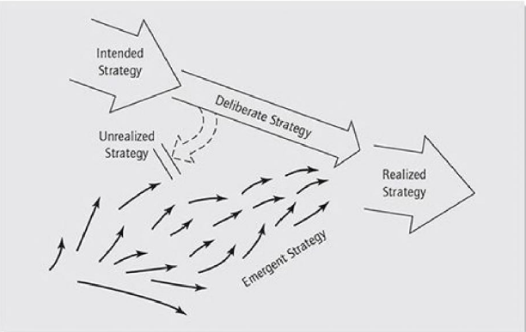
Figure 1.1 Strategies deliberate and emergent
(Mintzberg, et al 2020)
Henry Mintzberg emphasizes an “Emergent Strategy” approach.
“Strategies that are not deliberately planned and that may originate from lower levels of the organization are emergent strategies” (Haberberg and Rieple, 2008, p. 50).

  - Exploring Strategy framework
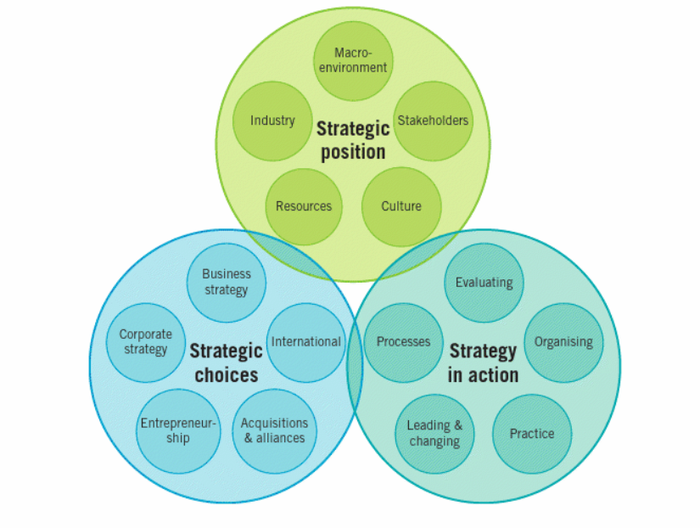
Figure 1.2 Strategy framework

There are three stages in the strategy-making process;
- Strategic Position
- Strategic Choices
- Strategy in action
(Johnson et al. 2017, p.12).

The strategic position deals with the impact on the strategy of the macro environment, the industrial environment, the resources and capabilities of the organization, the stakeholders, and the culture of the organization (Johnson et al. 2017, p. 12).

“Strategic choices include strategy options in terms of the directions the strategy could take and the methods by which the strategy could be implemented” (Johnson et al. 2017, p. 12).

“Strategy in action is about how strategies are formed and how they are implemented” (Johnson et al. 2017, p. 12).

  - Understanding the influence of the environment
The team needs to identify the strategic position of the organization before constructing a strategic plan. “Managers need to understand the environments in which they operate because these environments have a profound effect on what their organizations must do to survive and succeed” (Haberberg and Rieple, 2008, p. 21).

There are two environments in the organization, Macro-environment, and Micro-environment. Micro-environment is within the organization and the Macro environment is outside the organization. Strengths and Weaknesses are micro environment factors and Opportunities and Threats are Macro environment factors.
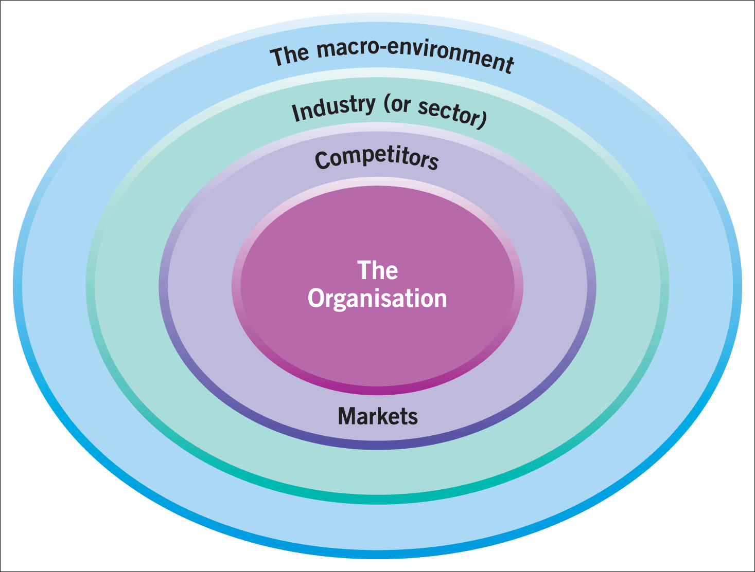
Figure 1.3 Layers of the business environment

Environmental influences can be thought of as layers around an organization, with the outer layer being the macro environment, the middle layer being the industry or sector, and the inner layer being strategic groups and market segments.
The macro-environment can be analyzed in terms of PESTEL factors, Industries and sectors can be analyzed in terms of Porter's five forces – barriers to entry, the threat of substitutes, customer bargaining power, supplier bargaining power, and rivalry.

2.5.1 Analysis of Micro Environment
The internal environment can be defined as a micro-environment. Suppliers, Customers, Partners, competitors, Trade unions, and local governments can be identified as micro environment. Porter’s five forces can be used to analyze it (Questus marketing knowledge, 2021).

2.5.2 Analysis of Macro Environment

The external environment consists of both the macro environment and the competitive environment. The competitive environment consists of the industries and markets in which organizations compete (Henry, 2018, p.36).

The state of the macro environment determines the general health and well-being of the company. The four most important factors in macro environment are the growth rate of the economy, the interest rate, exchange rates and inflation rates (Hill and Jones, 2001, p. 92).

Political, Economic, Social, Technological, Environment and Legal factors can be identified as analyzing tools of the macro environment.

2.6 Mintzberg 5 P’s of Strategy
Mintzberg has introduced the 5 P’s to develop a better strategy.
- Plan
- Ploy
- Pattern
- Position
- Perspective
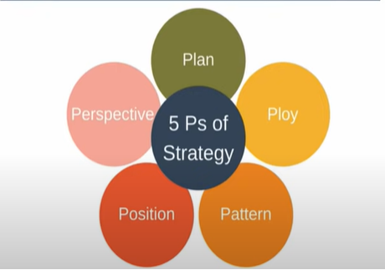
Figure 1.4 Five P’s of Strategy
According to Mintzberg, “a Plan is designed to achieve a particular long-term aim” (Mintzberg, 2007 p.3). Plans have two characteristics: they are created intentionally and in advance. Company can use SWOT and PESTEL to support the planning process (Expert Program Management, 2018).

The Ploy is a specific tactic to disrupt competitors. This tends to be a short-term tactic.

Pattern "in the stream of decisions. In other words, when a series of decisions related to some aspect of the organization shows some consistency over time, the strategy will be considered to have been formed” (Mintzberg, H, 1977, p. 28).

The Position shows where you sit on the field relative to the competitors.
The perspective looks internal and must be shared by all members of the organization. It focuses on shaping the personality and culture of the organization.
(Expert Program Management, 2018).
3. Customer care
3.1 What is customer care?
Help and advice provided by the company to those people who buy or use its products or services. Customer care is a simple idea. It means taking care of customers and satisfying their needs. In a world where most suppliers need to meet the needs of their customers, this experience is not a very happy one (Stone and Young, 1988, p. 1).
Acquiring customers is much more expensive than keeping them. In today's business world, we need to pay attention to customer care online as well. . It is important that the customers are contacted regularly and monitored for any problems with the service and to seek any new business.
Customer care must be rooted in the company culture and corporate beliefs. It cannot be grafted onto a business as an afterthought. It must be essential. It only exists if all employees want to believe it is vital and understand how achievable it is, they must all be able to understand it and explain it to others (Brown, 1989 p. 4). Regular training sessions are necessary to ensure customer service procedures are ahead and also to check the strategies are working and their effectiveness in regards profitability and efficiency.
3.2 Customer satisfaction
Satisfaction is a feeling. It is a short-term attitude that can easily change under a constellation of circumstances. It resides in the user's mind and differs from observable behaviors such as product selection, complaints and repurchases (Hom, 2000, p. 5).
“Satisfaction is the consumer's response to fulfillment. It is the judgment that a feature of a product or service or the service product itself has provided (or provides) a pleasant level of consumption-related fulfillment, including levels of under- or over-fulfillment (Oliver, 1997). That is a remarkable definition. First, the focus is on the consumer rather than the “customer” (Hom, 2000, p. 4).

- Evaluation of current customer care at NSC and future global customer care experience
NSC analyzes its customer complaints and customer feedback every day. The company monitors its consumer feedback as well on a daily basis. As explained in the introduction part of above the company gives a warranty for its products. NSC has a system to monitor the warranty period of the consumer. Sometimes consumers expect to repair the product after the warranty period. The dealers (the direct customer of NSC) are helping consumers to change the warranty date. The company does these repairs on the basis of keeping customers for the long term. Customers expect lower prices, product quality, and after-sales services from the company.

The company uses email, WhatsApp, company web pages, and phone calls for customer service. During the month of September 2022 company received 4,039 messages and calls from customers. That is every three minutes’ customers contacts the company.

The type of customer requirement is analyzed in the below table.
Type | No. of calls and Messages
Customer complaints | 85
Product Inquiries | 1412
Warranty Inquiries | 232
Price inquiries | 1381
Issues on products | 47
Others | 882
Total | 4039

Table 1 No. of calls and messages received on Sep 22.
Source: NSC Customer Service center

Example of Customer service strategy using a Value matrix
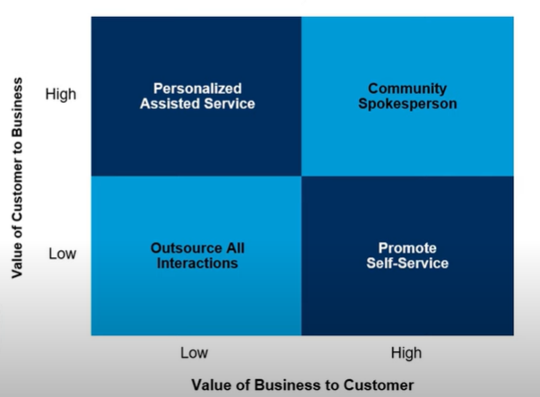
Figure 1.5 Customer / Business Value matrix
Source: Gartner / (Fredrik, B 2021).

According to the value matrix, NSC customer service needs personalized assisted service to its customers. However, when the value to the customer and the value to the business both are high then the customer is a community spokesperson for the company (Fredrik, B 2021).

NSC has analyzed its customer calls and messages division-wise. It shows the below results.;
Type | No. of calls and Messages
Sales | 207
Marketing | 367
Customer service | 2073
Finance | 412
IT | 968
HR | 12
Total | 4039

Table 2. No. of calls and messages division-wise
Source: NSC Customer Service center

This table shows that every employee should be responsible for better customer service in the company. In some American companies, the stall is trained in sales, and admin customer services making them more versatile in the company and therefore, have greater product knowledge. It also cut costs when employees are trained in multi-skill to be able to replace an employee who is on sick for a period of time,

Let's look at the functions of customer service in individual divisions of the company
Sales: After-sales service, lifelong customer management.
Marketing: Sales promotion activities
Customer Service: Product support services, delivery inquiries
Finance: Payment services, questions, and complaints
IT: Application and website support, customer account services
HR: Training employees to interact with customers.

Let's take a look at the company's SWOT analysis
The company has had a good relationship with its vendors since the company's inception. Some dealers have more than 100 showrooms themselves. Merchants are basically the company's primary customers. Every month, the company appoints around 20 new dealers across the country. The company has a good sales volume of sound systems in the southern and northwestern provinces of the country The expected number of users of electrical items in 2027 will be 6.3mn people. The average turnover to be expected is USD 118.6 in 2027 (Statista,2022). Most of the employees graduated from universities and worked long hours. There are no labor disputes in the company. Apart from the above strengths, a good strength for the company is the agreement between the Chinese companies and NSC to act as exclusive agents in Sri Lanka. The company sells products under its own brand name called “Olik” NSC not using Chinese brand names to sell products, since that reason if Chinese companies stop production no threat to the company.
Delays in the delivery of products and delays in the repair of warranty products are the main problems of the company's customers. The reason for these delays is the lack of spare parts and the distance to the main store. Due to high inflation and high fuel costs, the company cannot send smaller orders by lorry. Sales executives need some time to collect orders to cover a full load of a lorry. Further, lack of proper market information about the prices of substitute products, the company is unable to place the correct price of the product. Due to an improper debt recovery system operating cash circle is not functioning well. There are conflicts between the dealers and the company for the payments. High inflation and loss of jobs due to economic crisis results the disposable income of the people, which impact to spend on electrical devices.
Since the post-pandemic era, when people are used to shopping online, there are good opportunities to increase e-marketing. The company can place new repair centers in each district of the country and treat them as a separate business unit. There are many qualified technicians in the country to repair electrical equipment.

The Sri Lankan government is facing a shortage of foreign reserves. The government, therefore, banned the import of electrical equipment (govjob.lk, 2022). Banks are also restricted from issuing foreign currencies. Due to the high cost of fuel and electricity, consumers are not willing to buy electrical items. Customers have advanced knowledge about electrical equipment and the latest technology. Therefore, they are looking for product specifications, product quality, durability after-sales service, and so on. The trust in the company has decreased due to warranty issues. NSC is unable to import old spare parts due to currency issues. These problems will be a threat to the company.

SWOT analysis

NSC- Strengths | NSC- Weaknesses
.  - Strong Brand recognition.  ” Olik’  - Extensive dealer network throughout the country.  - High Market share in the country (for sounds equipment)  - Sole dealership with Chinese suppliers.  - High educational level of staff and lower staff turnover  - Strong financial ability of the company and good relationship with the banks.  - Having good ERP systems (sage and Microsoft Dynamics 365) | - Pressure on Margins due to stiff competition.  - Lower level of market information  - Delay in providing warranty repairs.  - Location of main stores.  - High delivery time.  - Bad image on customer service  - Lack of proper debt recovery system
NSC – Opportunities | NSC – Threats
- Exponential growth in the online business.  - Business growth through segmentation  - Knowledgeable technicians in the country to repair the products.  - Business partnership with the major online retailer - Daraz  - Relationship with International Markets. | - Strong Competitors.  - Import banned on electrical equipment in the country.  - High Fuel and electricity cost  - Lack of foreign currencies at banks  - Lack of spare parts availability in the country.  - Advanced customer knowledge

.
PESTEL analysis of the Sector

Sri Lanka has a political problem with the president and currently has an unstable government (Yeung, 2022). This will result business disruption and loss of businesses in the country. The government needs to increase the income because of that high tax rates may be imposed in the future (KPMG, 2022). This will affect the import and profit of the company. Good trade relationship between China and Sri Lanka is another key factor that has a direct impact to the company business.

High inflation rates and high-interest rates (Trading Economics, 2022) of the country affected to the company (Aljazeera, 2022). Since that issue entering new projects is difficult for every company. The impact of the volatility of exchange rates is leads to difficulties in pricing the product. Sri Lankan Government declared that they cannot pay foreign debt instalments due to lack of foreign currency reserves. Foreign International rating agencies downgrade Sri Lanka to default level, due to that reason and then Sri Lanka has lost the overseas market (Yeung, 2022).

Sri Lankan economy has transferred from an agriculture-based framework to Service related structure within past forty years (Sri Lanka Export Development Board, 2018). A significant amount of people is in their prime working age. The company can sell power tools and work-related tools by using demographic advantage. Sri Lankan social and cultural norms focus on caring for elderly relatives. This also has directly impacted to the people's purchasing power (Goonasekera, 2009).

Transforming Sri Lanka into a technology-based society is one of the country's key national policy objectives. People are used to the latest electronic devices in their daily and workplace activities (Narimatsu et al. 2021). The product life cycle has been changed due to technology. Suppliers have to be modified their products according to the demand. The marketing department has the challenge to introduce new products in a shorter period. Sri Lanka has made progress in establishing intellectual property protection mechanisms in line with international standards (Protecting Intellectual Property, 2021). The company can benefit from this by registering new patients and trademarks.

Electrical and electronic disposal is a threat to the environment and the government will impose new laws to protect the environment (Mallawarachchi, and Karunasena, 2012 pp.44-53). Natural disasters like flooding and slipping mountains are also issues for the company since some dealer shops affect by flooding and slipping. The Sri Lankan government is planning to go for a renewable energy development system, due to the fuel crisis and increase in electricity demand (Sri Lanka Export Development Board, 2018). Sri Lanka has a low carbon emission rate (Daily News, 2022). NSC needs to consider the import of re-energy products and low carbon emissions products.

Sri Lanka has not practiced privacy law in past. The government passed a new bill from parliament in February 2022 for personal data protection (New Comprehensive Data Privacy Law in Sri Lanka, 2022). The company is required to follow labour law, the law on consumer rights, and debt recovery laws. NSC must follow health safety laws and ISO standards on quality since the end users are working with electricity.

Political | Economic
- Government policy on imports of electrical appliances.  - Taxation policies on Sri Lankan Government.  - Political instability of the country. | - High inflation rate of the country.  - Volatility of exchange rates.  - High interest for borrowing.  - Bankruptcy of the country .
Social | Technological
- Demographics advantage in Sri Lanka  - People’s attitude toward Health and safety  - Educational level of the society  - Buying power of the people. | - Latest Technology based developments in the country.  - Intellectual property rights and patents protection
Environmental | Legal
- Extreme weather conditions in the country.  - Waste management policies | - Environmental Laws  - Import Laws  - Health and safety laws  - New tax laws  - Custom laws

Let’s look at how Porter’s five forces affect the NSC
- Extent of rivalry among competitors
There are four national-level competitors in the import and distribution market namely ‘Abans electronics’,’ Singer’, ‘Softlogic’, and ‘Damro’. In addition to them another competitor (DBL- Dean Brothers Limited) in the same province of the company. Price undercut and high advertising of competitors are major issues for the company (Competitive Rivalry: What Is It and Why Is It Important? 2021). The electrical equipment industry is growing every year in Sri Lanka. Since there is positive growth in the industry competitors will not capture each other’s market share. Further, the electrical equipment market is highly differentiated. NSC’s Products are unique to the company. It is difficult to win a customer from each other’s due this uniqueness.
- Threat of market entry
NSC has the advantage of sole dealerships with Chinese companies. The further brand image of “Olik” and the Island wide dealer network will help NSC from the threat of new entrants. The selling of electrical items needs high brand value and trust amongst the customers. It is difficult for to gain that experience for new players. NSC has done this business for the last two decades. Its products have a good brand name. There will be a high initial capital requirement to import products from China (CFI, 2022).
- Threat of substitutes
There are different brands of power tools and electrical equipment with different features in the market for lower prices. There is no high switching cost for customers to go for the different products. This will be a threat to the company (Garcia, C. 2022). However, the company targeted on middle-income level consumers, who are concerned about the quality of the product. So the threat can be minimized by doing market segmentation.

- Buyer power
NSC’s majority of sales doing for Business to Business, and no single consumer has a significant effect on the company’s revenue. There are only a few dealers who are buying more than 100 items per order. They are very concerned about the prices. If the buyer’s power is high, then the margin will drop. In the current digital world, customers have access to online websites and can match prices with similar brands. Therefore, the bargaining power of the customer is high.

- Supplier power
All Chinese suppliers are having the power of supplies. If production delays in China, that will lead to products becoming out of stock in Sri Lanka. The quality of the product is a vital part of the business. The company depends on the supplier for quality. The supplier is developing the products every year and stops the production of old products. However, the NSC needs old product spare parts for repair work. At this point, there is the power to the supplier, if they haven’t produced the old parts NSC is unable to do a repair,

Current issues at NSC as a summary

  - Non-availability of proper market details (Competitors’ prices, how many quantities are in the market?)
  - Consumer awareness about the product operations
  - Speedy Service center support for repairs and breakdowns
  - Delivery issues and customers’ payment issues

Future of Global Customer care with emerging technologies
- Artificial Intelligence
- Virtual customer assistants / Chatbot
- Omni channel customer engagement
- Real-time event-driven application
- Virtual personal assistant
(Fredrik, 2021).

How AI use in Customer care
- Augmenting messaging

- AI for sorting and routing support inquiries

- AI for enhanced phone support

- Back office work
Methods of serving customers
- White glove service

Service - Attention to detail, Speed, Convenience, Emotional
fulfillment, Tailor to unique needs.

Understand and
anticipate - Preventing issues, Solving problems before they’re
raised, Personalizing responses

- Hyper-personalized “Care of One”
Truly knowing the customers, reacting to customers before they even know they need it, and Integrating technologies across all channels. Implementing real-time agent tools and the superhuman agent (Fredrik, 2021).

  - Conclusion

NSC needs to plan three strategies for its customer service. According to the Mintzberg 5 P’s NSCs ‘position’ is good to implement a good customer strategy, since it has a good market share on sound system products and a good supplier base from China. There are weaknesses to cover in this strategy such as delays in orders and repairs and collection delays. There are strengths of Skilled staff and sage and Microsoft Dynamics 365 ERP systems to implement a new strategy. According to Porter’s five forces, the bargaining power of customers will be reduced since the new strategy looks for better customer service.

Basically, the company needs to collect and keep records of its customers and consumers’ data and market data. The company can use an ERP system to complete this task with its skilled workforce. The company needs to implement a proper user manual to educate customers on the correct use of products. It will help to reduce the repair time and repair cost of the company. NSC needs to monitor the delivery system and customer payment system. WhatsApp, Text, Voice, web reviews, and e-mail messages should be linked to one system and quickly respond to all messages.

Due to the import band and lack of foreign currencies company needs looks for an overseas online market. There is an opportunity to do it with the Daraz company and delivery can be made through Uber or ebay. The prosed customer care system can be implemented to online business as well.

  - Recommendations
The company can use the Artificial Intelligence model to assist in improving efficiency and using intelligence to make better decisions in the office work environment, especially for supplier payments and warranty claims and other important areas. AI can monitor consumer behaviors by using warranty details and also can help dealers to find the details about their orders. AI can get access to ERP and search order details for the customer. The company uses Chatbots and virtual customer assistants for product demonstration. In addition to that chatbots can help customers schedule appointments for their repairs.
NSC can create a virtual store on its website that will show product operating systems.
Most of People are watching YouTube videos to learn about product specifications and operating systems’ work. This will lead consumers to switch to other products. There may be the possibility of retaining customers from this virtual store. Doing research into your competitor has great advantages and helps to develop a working model that makes them successful. With the added use of AI these models can be analyzed and a new working model can be created to help the company to create a better and more efficient customer service.

We recommend moving to a “Care of One” model with AI and chatbots to create better customer service in the future. NSC can respond to customers before they know they need it and integrate technology across all channels using AI and chatbots. The company can inform the consumer of their next service or part replacements in advance.
The team strongly recommend doing this stage wise on a budget.
  - References

  - Aljazeera (2022) Inflation in Sri Lanka hits record 73.7 percent. Available at: https://www.aljazeera.com/economy/2022/10/21/inflation-in-sri-lanka-hits-record-73-7-percent (Accessed:01st December 2022).

  - Brown, A. (1989) Customer care management. Oxford: Heinemann Professional.

  - Buy olik.com (2022) Available at: https://buyolik.business.site (Accessed 15th November 2022).

  - CFI (2022) Threat of New Entrants -Threat posed by new competitors within an industry Available at:https://corporatefinanceinstitute.com/ resources/ management/threat-of-new-entrants/(Accessed: 28th November 2022).

  - Competitive Rivalry: What Is It and Why Is It Important? (2021) Indeed.com Available at: https://www.indeed.com/career-advice/career-development/competitive-rivalry (Accessed: 28th November 2022).

  - Daily News (2022) Sri Lanka’s measures to reduce carbon emissions commended. Available at: https://www.dailynews.lk/2022/11/09/local /290763/sri-lanka’s-measures-reduce-carbon-emissions-commended (accessed: 01st December 2022).

  - Dyer, J.H., Godfrey, P., Jensen, R. and Bryce, D., (2021). Strategic management. USA:John Wiley & Sons.
  - Exper Program Management (2018) 5 Ps of Strategy Mintzberg [Video]. Available at: https://www.youtube.com/watch?v=ZhM1JW2Bb8Q (Accessed: 24th November 2022).

  - Faulkner, D, Bowman, C. (1995) The essence of Competitive Strategy Hertfordshire: Prentice Hall International (UK) Limited.

  - Fredrik, B (2021) The future of customer service - how to create an innovative customer service strategy - with tech Available at: https://www.youtube.com/watch?v=X1XBzL2GSkc [Video]. (Accessed 25th November 2022).

  - Garcia, C. (2022) ‘Threat of Substitutes: Impacts, Factors, and Examples’ Konsyse Available at: https://www.konsyse.com/articles/threat-of-substitutes-explained-impacts-factors-examples//(Accessed: 28th November 2022).

  - Gartner (2022) The Customer Service Experience Top trends, channels and behaviors to watch in 2022 Available at:https://emtemp.gcom.cloud/ngw/global assets/en/salesservice/documents/trends/customer_service_experience_ebook.pdf (Accessed: 28th November 2022).

  - Goonasekera, S. (2009) ‘How Can Sri Lanka take Advantage of its Demographic Dividend?’ World bank Blogs [Blog] Available at: https://blogs.worldbank.org/endpovertyinsouthasia/how-can-Sri-Lanka-take-advantage-its-demographic-dividend (Accessed: 25th November 2022).

  - Govjob.lk (2022) Import Ban List Sri Lanka – Import Ban Gazette 2022 November Update Available at: https://www.govjob.lk/2022/11/news/import-ban-list-sri-lanka-import-ban-gazette-2022-november-update/ (accessed: 01st December 2022).

  - Haberberg, A, Rieple, A. (2008) Strategic Management theory and application Oxford: Oxford University Press.

  - Henry, E.A. (2018) Understanding Strategic Management. 3rd edn. Oxford: Oxford University Press.

  - Hill, C.W.L. Jones,G.R. (2001) Strategic Management an integrated approach. 5th edn.U.S.A.: Houghton Mifflin Company.

  - Hom, W. (2000) An Overview of Customer Satisfaction Models. Available at: https://files.eric.ed.gov/fulltext/ED463825.pdf (Accessed 25th November 2022).

  - Jasper, M. and Crossan, F., 2012. What is strategic management?. Journal of nursing management, 20(7), pp.838-846.

  - Johnson, G. et al. (2017) Exploring Strategy. 11th edn. Harlow: Pearson Education Limited.

  - KPMG (2022) Sri Lanka: Tax proposals in 2023 budget Available at: https:// home.kpmg/us/en/home/insights/2022/11/tnf-sri-lanka-tax-proposals-in-2023-budget.html 9accessed: 01st December 2022).

  - Lynch, R. (2018) Strategic Management. 8th edn. Harlow: Pearson Education, Limited.

  - Mallawarachchi, H. Karunasena, G. (2012) ‘Electronic and electrical waste management in Sri Lanka: Suggestions for national policy enhancements,Resources, Conservation and Recycling Journal Volume 68, Pages 44-53, (Accessed: 25th November 2022).

  - Mintzberg, H., (1977) Strategy formulation as a historical process. International Studies of Management & Organization

  - Mintzberg, H., (2007) Tracking strategies toward a general theory. Oxford: Oxford University Press.

  - Mintzberg, H., Ahlstrand, B. and Lampel, J.B., (2020) Strategy safari. UK: Pearson.

  - Nalinda super centre (2021) Available at: https://buyolik.business.site (Accessed 15th November 2022).

  - Narimatsu, J. Mendis, A. Seneviratna, J.Goonasekera, S. (2021) ‘Digitalization is the way forward for Sri Lanka’ World bank Blogs [Blog] Available at: https://blogs.worldbank.org/endpovertyinsouthasia/digitalization-way-forward-sri-lanka (Accessed: 25th November 2022).

  - New Comprehensive Data Privacy Law in Sri Lanka. (2022) CaseGuard Available at: https://caseguard.com/articles/new-comprehensive-data-privacy-law-in-sri-lanka/ (Accessed: 25th November 2022).

  - Olik Sri Lanka (2019) [Facebook] 16 May. Available at: https://www.facebook.com/bulk/?ref=page_internal (Accessed 15th November 2022).

  - Porter, M.E. (1985) Competitive advantage – Creating and sustaining superior performance. New York: The Free Press.

  - Protecting Intellectual Property (2021) International Trade administration [Blog] Available at: https://www.trade.gov/country-commercial-guides/sri-lanka-protecting-intellectual-property (Accessed: 25th November 2022).

  - Questus marketing knowledge (2021) What is the micro-environment of the organization [Video]. Available at:https://www.youtube.com/ watch?v= kHsgFxrdAUI (Accessed 25th November 2022).

  - Scribd (2019) MT - Abans Swot Analysis. Available at:https://www.scribd.com /document/427913579/Mt-Abans-Swot-Analysis (Accessed: 01st December 2022).

  - Sri Lanka economic crisis explained: What is happening in Sri Lanka? All you need to know | Rest of the World News (2022) Available at: republicworld.com (accessed: 22/11/2022).

  - Sri Lanka Export Development Board (2022) Renewable Energy Development in Sri Lanka. Available at:https://www.srilankabusiness.com/blog/renewable-energy-development-in-sri-lanka.html (accessed: 01st December 2022).

  - Statista (2022) Consumer electronics- Sri Lanka. Available at:https://www.statista.com/outlook/dmo/ecommerce/electronics/consumer-electronics /sri-lanka (Accessed: 01st December 2022).

  - Stead, Jean Garner, and W. Edward Stead. (2017) Sustainable Strategic Management. 2 edn. USA: Greenleaf Publishing Limited.

  - Stone, M, Young, L. (1992) Competitive customer care – A guide to keeping customers. Surrey: Croner Publications Ltd.

  - Trading economics (2022) Sri Lanka Interest rate. Available at:https:// tradingeconomics.com/sri-lanka/interest-rate (accessed : 01st December 2022).

  - Yeung, J.(2022) Sri Lanka is facing an economic and political crisis. Here's what you need to know. Available at: https://edition.cnn.com/ 2022/04/05/asia/sri-lanka-economic-crisis-explainer-intl-hnk/index.html (Accessed: 25th November 2022).

