Maddie Howes
BMPS5011
E-POrtfolio evidence of learning
[Changemakers: Creativity and Value Creation]

Contents

Mind map ……………………………………………………………………………………………………………………………………………page 1

Summary ……………………………………………………………………………………………………………………………………………. page 2

Elevator style pitch………………………………………………………………………………………………………………………page 3

Supporting flyer………………………………………………………………………………………………………………………………page 4

Conference poster ………………………………………………………………………………………………………………………page 5

References ………………………………………………………………………………………………………………………………………..page 6-7

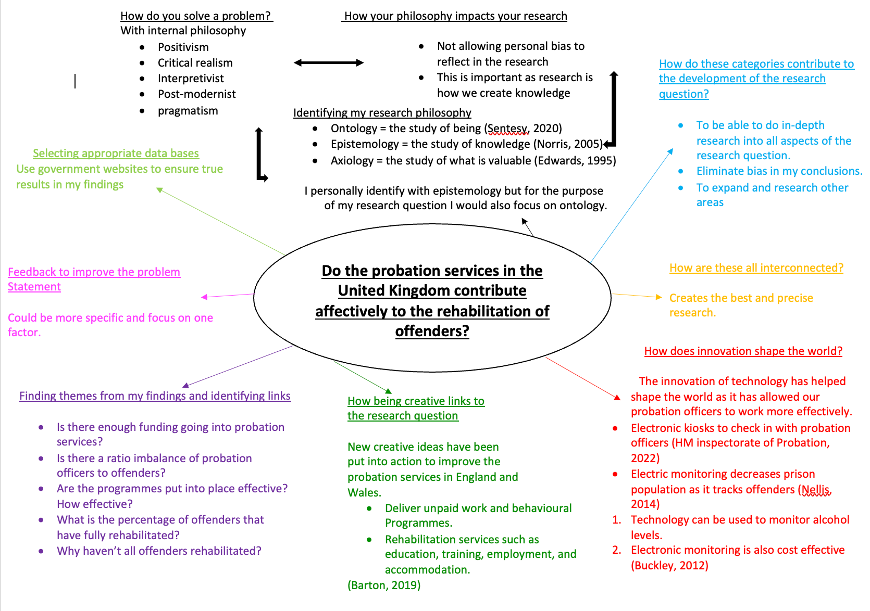
- Mind Map
2. Summary

https://1drv.ms/p/s!ApVj_i8lkNekg1jiMIrRs-pm2nDi

3. elevator pitch

https://1drv.ms/p/s!ApVj_i8lkNekg2TeXsoPzjsn5x-p

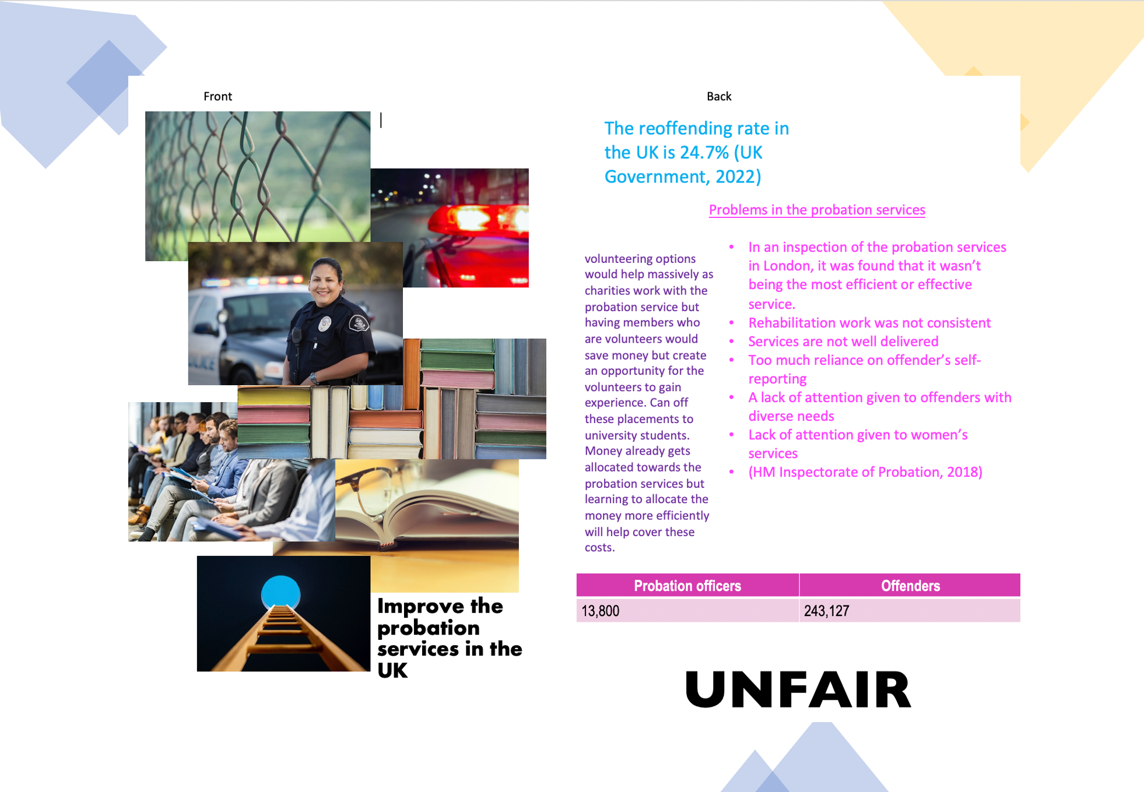
4. supporting Double sided A5 flyer
5. A3 Conference poster

https://1drv.ms/p/s!ApVj_i8lkNekg2yLzqqLaeu-vyZf

6.
References

Mind map

Barton, J. (2019) ‘“Strengthening Probation, Building Confidence”: The task of re-designing probation’, Probation journal, 66(1), pp. 131–137. Available at: https://doi.org/10.1177/0264550518825054. (Accessed: 15 November 2022)

Buckley, N. (2012) ‘The Management of Electronically Monitored Curfews’, Probation Journal, 59(4), pp. 416–418. Available at: https://doi.org/10.1177/0264550512467593a (Accessed: 15 November 2022)

Edwards, R.B. (1995) Formal Axiology and Its Critics. Edited by R.B. Edwards. Leiden;: BRILL.

HM Inspectorate of Probation (2022) More evidence needed to prove technology leads to better probation supervision. https://www.justiceinspectorates.gov.uk/hmiprobation/media/press-releases/2019/03/rabulletin2019-02/ (Accessed: 15 November 2022)

Nellis, M. (2014) ‘Understanding the electronic monitoring of offenders in Europe: expansion, regulation and prospects’, Crime, law, and social change, 62(4), pp. 489–510. Available at: https://doi.org/10.1007/s10611-014-9540-8 (Accessed: 15 November 2022)

Norris, C. (2005) Epistemology. London ;: Continuum.

Sentesy, M. (2020) Aristotle’s ontology of change. Evanston, Illinois: Northwestern University Press.

Summary

Mirza, N.A. et al. (2014) ‘A concept analysis of abductive reasoning’, Journal of advanced nursing. Mirza N.A., Akhtar-Danesh N., Noesgaard C., Martin L. & Staples E. (2014) A concept analysis of abductive reasoning. Journal of Advanced Nursing 70(9), 1980-1994. doi: 10.1111/jan.12379, 70(9), pp. 1980–1994. Available at: https://doi.org/10.1111/jan.12379 (Accessed: 15 November 2022)

Upmeier zu Belzen, A., Engelschalt, P. and Krüger, D. (2021) ‘Modeling as Scientific Reasoning—The Role of Abductive Reasoning for Modeling Competence’, Education sciences, 11(9), p. 495–. Available at: https://doi.org/10.3390/educsci11090495 (Accessed: 15 November 2022)

O'DAFFER, P.G. (1990) 'INDUCTIVE AND DEDUCTIVE REASONING', The Mathematics Teacher, 83(5), pp. 378-384

7.
Yilmaz, K. (2013) 'Comparison of Quantitative and Qualitative Research Traditions: epistemological, theoretical, and methodological differences', European Journal of Education, 48(2), pp. 311-325.
Bickman, L. and Rog, D.J. (2009) The SAGE handbook of applied social research methods. 2nd ed. Los Angeles ;: SAGE.

Chermahini, S.A. and Hommel, B. (2010) ‘The (b)link between creativity and dopamine: Spontaneous eye blink rates predict and dissociate divergent and convergent thinking’, Cognition, 115(3), pp. 458–465. Available at: https://doi.org/10.1016/j.cognition.2010.03.007. (Accessed: 15 November 2022)

UK Government (2022) Offender management statistics quarterly: April to June 2022. London: Ministry of Justice. Available at: https://www.gov.uk/government/collections/offender-management-statistics-quarterly. (Accessed: 15 November 2022)

Elevator style pitch

UK Government (2021) Bigger, better Probation Service to cut crime. London: Ministry of Justice. Available at: https://www.gov.uk/government/news/bigger-better-probation-service-to-cut-crime. (Accessed: 18 November 2022)

HM Inspectorate of Probation (2018) quality and impaction inspection: The effectiveness of probation work by the National probation service in London. London: National Probation service. Available at: https://www.justiceinspectorates.gov.uk/hmiprobation/wp-content/uploads/sites/5/2018/01/London-NPS-QI.pdf. (Accessed: 18 November 2022)

UK Government (2022) Proven reoffending statistics: January to March 2020. London: Ministry of Justice. Available at: https://www.gov.uk/government/statistics/proven-reoffending-statistics-january-to-march-2020/proven-reoffending-statistics-january-to-march-2020 . (Accessed: 18 November 2022)

Conference poster

House of Commons Justice Committee (2011) The role of the Probation Service ( Volume 1,2,3). London: House of Commons. Available: https://publications.parliament.uk/pa/cm201012/cmselect/cmjust/519/519i.pdf (Accessed: 19 November 2022)

Canton, R. (2013) 'The point of probation: On effectiveness, human rights and the virtues of obliquity', Criminology & Criminal Justice, 13(5), pp. 577-593. doi: 10.1177/1748895812462596. (Accessed: 19 November 2022)

UK Parliament (2022) Crime and rehabilitation: An overview. Available at: https://lordslibrary.parliament.uk/crime-and-rehabilitation-an-overview/. (Accessed: 19 November 2022)

