Foreign languages & cultural awareness (BMIH 5003)    ASSIGNMENT: CULTURAL AWARENESS | Executive Summary  The globalisation of society has resulted in a greater degree of intercultural communication. A hotel must respect its guests' cultural beliefs and values to provide excellent service. Hotels should tailor their services and experiences to cater to culturally diverse groups. As a result, guests will be more satisfied and loyal. Diverse and inclusive teams and ongoing training are essential to implementing cultural awareness effectively.  Mohammad Shahidul Islam Chowdhury, Student Id: 2026960  Lecturer: Rodrigo Aguilera

Table of Contents:

Introduction 2
Country Dubai (Located in a hotel) 2
Country United States (Guest's home country) 2
Country Analysis 3
Cultural Dimensions in Hofstede's Theory 4
Country-comparison…………………………………. 4
Hotel Handbook (do’s & don’ts) 5
Conclusion 6
Reference 8

Introduction:
Hotel guests from all over the world visit hotels every day, making it one of the most diverse industries in the world. Therefore, hotel employees must understand and be sensitive to the cultural needs and expectations of guests from diverse cultural backgrounds. Guests from different cultures come to hotels for various reasons, and cultural awareness involves understanding and respecting those reasons. A welcoming, inclusive environment should treat all guests equally. Hence, this essay discusses the importance of cultural awareness in the hotel industry and the various ways to improve guest satisfaction and loyalty through the development and implementation of cultural awareness.
Country Dubai (Located in a hotel):
Dubai is a multicultural city that attracts tourists from around the world. This city blends Arab traditions with Western influences. The result is that Dubai has developed a cultural awareness that welcomes people of all nationalities and backgrounds. Islam profoundly influences Dubai's culture, affecting dietary customs, dress codes, and social customs. Visitors should respect the cultural traditions of Dubai during their stay. Visitor customs and practices should be respected, such as dressing modestly in public places and avoiding drinking alcohol. A diverse population of expatriates and immigrants live in Dubai, a cosmopolitan city. Different cultures, including Indian, Pakistani, Filipino, and Western influences, have enriched Dubai's culture. Public places such as malls, restaurants, and markets require modest dress from guests. Sleeveless shirts and shorts should not be worn by women or by men. Sleeveless shirts and shorts should not be worn by women or by men. Respecting the local culture also means avoiding public displays of affection.

Country United States (Guest's home country):
Diversity of backgrounds, beliefs, and customs of ethnic, racial, and religious groups in the United States is part of cultural awareness. Promoting inclusivity, reducing discrimination, and fostering positive relationships in the U.S., a multicultural society, is essential. Sports, fast food, and technology are among the things Americans love to do, as well as their strong work ethic and dedication to their jobs. However, it is necessary to recognise that cultural awareness is an ongoing process that requires continuous education. A variety of cultures have influenced the United States, however. Americans are generally friendly and informal, and they value direct communication. Many social situations allow for open expression of opinion during small talk. A drink or an inquiry about their interests may be appreciated if offer an American a drink. When customers' expectations still need to be met, they may provide feedback.
Country Analysis:
Dubai and the United States welcome visitors worldwide regardless of their cultures and values. Islam heavily influences Dubai's culture; visitors should respect and understand local customs. Among its hospitality industry highlights are high service standards and attention to detail. A warm welcome and friendly service are hallmarks of American culture, characterised by diversity and individualism. There is a reputation for excellent hospitality and service in Dubai and the United States, both in terms of cultural awareness. Despite their differences in culture and values, Dubai and the United States strive to create welcoming and memorable experiences for their visitors. Visitors to each country should consider cultural sensitivities within each country.
Hotels in Dubai must be aware of the customers and expectations of guests from the United States. In addition, to provide a positive experience to guests, good communication, punctuality, and excellent customer service are also essential.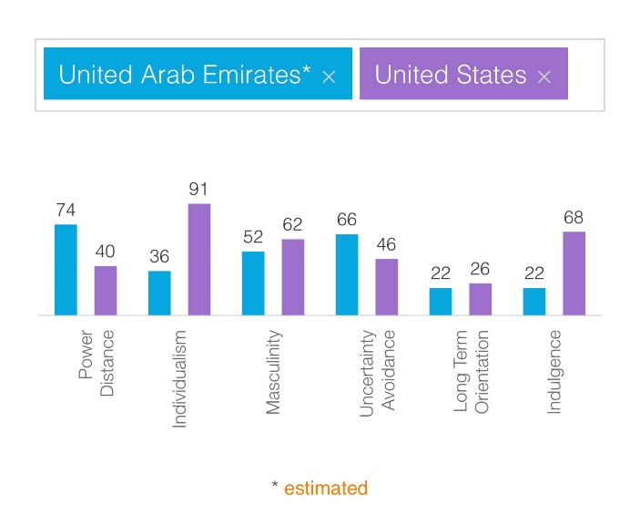
Cultural Dimensions in Hofstede's Theory:
Based on the work of Dutch psychologist Geert Hofstede, a group's culture determines its identity and what behaviours are acceptable. Culture shapes who we are and what behaviour is acceptable and unacceptable. According to him, there were four cultural dimensions. Still, in later studies, two more were added.
- Power and authority distinctions,
- Avoidance of uncertainty and individualism,
- Uncertainty avoidance
- Masculinity and femininity,
- Long-term versus short-term orientations (added in 1985), and
- Indulgence versus restraints (added in 2010).
Country-comparison:
Hofstede's Theory | United-Arab-Emirates | United-States
Power distance | A country's power imbalance reflects how much power institutions and organisations have and whether or not people accept it. | An institution or organisation within a country with less power tends to expect and accept unequal power distribution.
Uncertainty avoidance | In Uncertainty Avoidance, we assess whether a culture has created beliefs and institutions to deal with ambiguous and unknown situations. | Uncertainty Avoidance involves society's approach to the unknown future: Should we plan for it or just let it happen?
Individualism and collectivism | The degree of interdependence among society's members is the fundamental issue addressed by this dimension. | A society's degree of interdependence among its members is an essential aspect of individualism, which this dimension addresses.
Masculinity and femininity | In this case, masculinity refers to whether people want to be the best or like what they do (feminine). | Men or women are masculine depending on how they perceive themselves, whether they seek excellence for themselves (males) or like what they do (females). Showing one's success is more motivating than being successful per se in American society.
Long vs short-term orientations | As societies face present and future challenges, Long-term orientation emphasises maintaining ties to the past. Both existential goals, however, are prioritised differently by organisations. | Organisations prioritise their two existential goals differently to cope with present and future challenges. Nevertheless, as societies deal with current and future challenges, they must maintain some ties to the past.
Indulgence vs restraints | According to our upbringing, indulgence measures how much we try to control our desires and impulses. Generally, excess leads to a sense of luxury, while restraint leads to understanding the condition. | Individuals' tendency to control their impulses and desires depends on their upbringing.

Hotel Handbook (do’s & don’ts):
Do’s | Don’ts
Please make sure you research before they arrive. | Don't dismiss guest concerns or complaints.
Please make sure to maintain a clean and well-maintained property. | Don't encroach on guests' privacy.
Provide prompt and professional responses to complaints from guests. | Exaggerating hotel amenities is not a good idea.
Please get to know their culture. | Joke inappropriately.
All guests should be treated with respect and courtesy. | Stereotypes based on nationality.
Ensure that guests are greeted with a warm welcome and a smile. | Ask questions impatiently.
Inform guests about the hotel's amenities and services clearly and accurately. | Offensive hand gestures.
Slow down and be deliberate when you speak. | Disregard others' feelings.

Conclusion:
The world we live in today is increasingly interconnected, which makes having a grasp of foreign languages and cultural awareness essential. In addition, people from different cultures should understand and respect each other's values, beliefs, customs, and practices. To provide cultural awareness training to hotel staff, they must learn about different cultures, customs, traditions, and taboos. The team can avoid cultural misunderstandings by anticipating and preventing them, such as serving guests food that is offensive to their religious beliefs. Also, by practising active listening and showing empathy towards guests of diverse backgrounds, they can become more sensitive to cultural differences. Hotel decor, cuisine, and activities can also incorporate cultural elements to give guests an authentic and unique experience. Providing cultural activities like dance performances and translations of language and cultural guides can be one way to share local art, music, and cuisine. The result is that a person's horizons will be widened, their communication skills will be enhanced, and they will have greater chances to grow professionally and personally.

Reference:
Anon, (2022). American Culture: Language, Traditions, People, Customs & Etiquettes - Leap Scholar. [online] Available at: https://leapscholar.com/blog/culture-in-us-language-traditions-people-customs-etiquettes/#:~:text=Job%20in%20USA

Anon, (n.d.). Differences Between Arab and American Culture | Difference Between. [online] Available at: http://www.differencebetween.net/miscellaneous/culture-miscellaneous/differences-between-arab-and-american-culture/#:~:text=People%20in%20the%20Arab%20nations

Bartenders (2020). The Importance of Diversity in Hospitality. [online] Overproof. Available at: https://overproof.com/2020/06/15/the-importance-of-diversity-in-the-hospitality-industry/

Çakir, I. (n.d.). Developing Cultural Awareness In Foreign Language Teaching. [online] Available at: https://files.eric.ed.gov/fulltext/ED494346.pdf

Check front. (2019). 15 Tour Guide Do’s and Don’ts for Cultural Sensitivity. [online] Available at: https://www.checkfront.com/blog/importance-cultural-sensitivity-communication/

Complete Hospitality Training. (n.d.). Understanding Cultural Awareness in Hospitality. [online] Available at: https://cht.edu.au/news/understanding-cultural-awareness-in-hospitality#:~:text=Cultural%20awareness%20is%20the%20sensitivity

Drobot, I.-A. (2021). Multilingualism and Awareness of Cultural Differences in Communication. [online] www.intechopen.com. Intech Open. Available at: https://www.intechopen.com/chapters/77761

Evason, N. (2021). American Culture. [online] Cultural Atlas. Available at: https://culturalatlas.sbs.com.au/american-culture/american-culture-core-concepts

Flip Flop Wanderers (2017). Cultural Differences in Dubai You Need to Know About. [online] Flip Flop Wanderers. Available at: https://www.flipflopwanderers.com/cultural-differences-dubai/

Free Essays. (n.d.). Consumer Behaviour in the U.S. and UAE - 1418 Words | Report Example. [online] Available at: https://ivypanda.com/essays/consumer-behaviour-in-the-us-and-uae/
Hofstede Insights (2022). Country Comparison. [online] Hofstede Insights. Available at: https://www.hofstede-insights.com/country-comparison/the-united-arab-emirates
Icfai Business School (2019). What is culture, and how can culture be understood through Hofstede’s cultural framework? [online] Ibsindia.org. Available at: https://ebooks.ibsindia.org/ob/chapter/what-is-culture-and-how-can-culture-be-understood-through-hofstedes-cultural-framework/
Iguchi, Y. (2018). Understanding cultural differences in hospitality - Insights. [online] Insights. Available at: https://insights.ehotelier.com/insights/2017/03/17/understanding-cultural-differences-hospitality/

Mind Tools Content Team (2022). MindTools | Home. [online] www.mindtools.com. Available at: https://www.mindtools.com/a1ecvyx/hofstedes-cultural-dimensions

The Ultimate Guide to Cross-Cultural Communication | Grammarly Business. (2021). The Ultimate Guide to Cross-Cultural Communication at Work. [online] Available at: https://www.grammarly.com/business/learn/cross-cultural-communication/
www.mmclearningsolutions.com. (n.d.). MMC - Mediterranean Management Centre. [online] Available at: http://www.mmclearningsolutions.com/Project_Card.aspx?ProjectID=1521#:~:text=Cultural%20awareness%20communication%20and%20social

