MY REPORT ON DEVLOPING WORKPLACE CRITICAL THINKING

“How do organisational beliefs, attitudes, and value systems affect workplace behaviour? Also, how will tailoring workplace changes for the post-COVID mindset tackle the challenges we face now, and create more resilient businesses in the future?”

Teletha Duberry
Student I.D - 1917189
Developing Workplace Critical Thinking
Term 1 Assignment
Lecturer: Yajesh Kumar

TABLE OF CONTENTS

1. |  | Executive Summary | Pg.3
2. |  | Introduction | Pg.4
3. |  | Egg Free Cake Box | Pg.5
 | 3.1 | Covid-19 | Pg.5
 | 3.2 | The Importance of Beliefs, Attitudes and Values in the Workplace | Pg.7
 | 3.3 | Critical Thinking | Pg.9
 | 3.4 | Egg Free Cake Box – Response to Covid-19 | Pg.9
 | 3.5 | The R.E.D Model | Pg.10
 | 3.6 | Gainsharing Plans | Pg.12
4. |  | Conclusion and Recommendations | Pg.14
 |  | References | Pg.15
 |  | Appendices | Pg.16

Executive Summary

Are UK Businesses prepared for the change in dynamics to come in the events of Covid-19? How will the effects of the Pandemic influence shifts in workplace behaviour?
These are some of the concerns many organisations are currently undergoing during such uncertain times. However, they can most certainly start acknowledging the ‘new normal’ and start to apply critical thinking to the health and safety of their employees and work environments in order to maintain efficient and effective. In this report we looked at how Egg Free Cake Box has managed to maintain their business in the Food Industry. As they anticipate the changes in employees’ beliefs, attitudes and values, this report highlights how this organisation has taken action to ensure employees are supported as well as the hygiene safety of their products and customers. And how the R.E.D Model can assist them in further critical thinking methods. So how will the maintain production and service throughout the event of Covid 19? We identify how the ‘Scanlon Plan Theory’ is an effective management plan for Egg Free Cake Box to sustain their business and continue to grow as they become more resilient towards the impacts of the Pandemic.

Introduction

The sudden approach of Covid-19 caused non-essential organisations to close for business, this instilled fear into employees, who were now worried about working alongside colleagues, travelling to work and most of all the impact these factors could have on their health.
It was now under extensive circumstances that critical thinking was applied within the workplace, forcing employees to consider all the internal factors that could have a heavy effect on the organisation. Under the Food Safety Act 1990, the well-being of staff in the workplace had to be reassessed under the new Health and Hygiene Guidelines.
The Franchises (branches/Kiosks) also, was at risk of losses, based on the fact that they were not considered essential. This would’ve affected owners in various ways such as; ownership liabilities (rent and utilities,) personal finances and change in circumstances causing potential debt and loss in investments. Shareholders were also at risk of losing shares in the organisation, if a new structure wasn’t applied immediately.

The purpose of this report is to analyse how introducing changes that are in accordance with the new Government guidelines for Covid-19, will create solution for the external factors that are currently creating challenges for organisations internally. It is important that these solutions for change create a positive impact on both employees and employers, preparing them for any future economic changes.
This study could benefit all types of businesses, as all industries in the working sector have had to adjust during this time. The negative impact on organisations including, employees not wanting to wear PPE or just simply being exempt from PPE, not wanting to get tested and follow self-isolation procedures, has resulted in many employers losing their staff due to becoming sick, bereavements, other staff wanting to protect their family at home, working parents who have had to stop working due to no childcare because schools and nurseries have closed etc.
The various beliefs, values and attitudes within the workplace have been disturbed amongst employers and employees, heavily impacting on the organisation’s ethos.

In the first section of this report, we will be looking at a Public Limited Company and Franchisee by the name of Egg Free Cake Box (Cake Box holdings PLC) and their history. Also, an in-depth critical analysation on the impact of Covid-19 on individuals’ day-to-day lives, health and well-being as well as returning to the workplace. We gathered some information on Egg Free Cake Box in regard to the rapid changes that they have taken into consideration, via the Health and Safety Manager’s COVID-19 Update video. This gives us an insight on the workplace changes and how this will impact on workplace behaviour.

It would be intriguing to determine this organisations strategic planning for the next annual period… so the second section of this report is where we will look at the importance of critical thinking as a Leader of an organisation and why using the ‘R.E.D Model’ can assist in Egg Free Cake box’s future performance, especially with sustaining the impact of Covid-19.

Further to these findings, in the third section I will discuss how the ‘Scanlon Plan Theory’ is suitably connected to the organizations structure and supports the critical thinking strategy I would deem logical for this particular workplace behaviour. In this report it is our aim to finalize ideas that maybe beneficial to this organisation, in order to maintain their brand and develop sustainability in the market.

Egg Free Cake Box

Egg Free Cake Box (Cake Box holdings PLC) is a Public Limited Company and a Franchise in the UK. This brand began on their journey in 2008 when they opened their first small store, now currently having 174+ branches in 2020, they’ve continued to open more branches to this date.
ECB is family orientated ran business, who believe that holding on to family values results in the success of Egg Free Cake Box. They take great pride in ensuring that their customers’ benefit from these values by baking and decorating cakes with love, and delivering exceptional customer service knowing that they are being allowed into a person’s family, when making a cake for their special occasion.
All of their products are 100% egg free and cater to a strict lacto vegetarian diet, making it a safe option for anyone with egg allergies at parties. (Egg Free Cake Box, 2020)

Operational Highlights

- 133 franchise stores in operation as at 31 March 2020
- 20 new franchise stores added in the period (2019: 27 new franchise stores)
- As part of a trial 12 kiosk stores opened in the year in various shopping centre locations
- Successful launch of new product ranges including salted caramel and red velvet cakes
- Recruitment of four regional area managers to help support further growth
- New Bradford warehouse and distribution facility in operation (Egg Free Cake Box, 2020)

Franchise Model

Our franchise model has underpinned our success as a business to date, as we have grown to 133 franchise stores operated by 70 franchisees since opening our first shop in 2008. We believe that the focus we have on our people and our franchisees who, as owner occupiers, are driven to increase sales and offer exceptional customer service with the support of Head Office, will allow us to continue delivering resilient sales growth. (Egg Free Cake Box, 2020)

3.1 Covid-19

In less than three months, COVID-19 has radically redefined how we relate to space and to each other. Compare today to March of this year: face masks are now an everyday accessory. We wait to enter grocery stores in six-foot-spaced queues without a second thought. And we cross the street to avoid people not as a snub, but to protect our health and others’. Sustained periods of hardship are known to change human psychology and behaviour, sometimes permanently. Pandemic mitigation itself requires mass, coordinated behavioural change to succeed. As people return to offices in the coming months, we should expect those who have adapted to social distance and working from home to bring a set of new concerns, expectations and even unconscious reactions to situations that previously seemed harmless and normal. The importance of business continuity through the pandemic makes it incumbent upon employers to reshape the workplace to make workers feel comfortable, supported and able to do their jobs effectively.
The challenge is clear. Workplaces must adapt. Yet, how do we design a workplace that responds not just to fear and anxiety, or the invisible threat of germs, but the full range of learned behaviours and attitudes that have evolved through the COVID-19 crisis?
In the last decade, employers have increasingly prioritized employee wellness, including mental health, understanding that happiness and productivity go hand in hand. Many employers are initiating workplace assessments to identify where physical changes can help mitigate germs. If they go one step further to examine the problem holistically from the user perspective, taking into account COVID-19-related attitude and behavioural shifts, they will succeed in creating a powerful support tool for worker morale, public health and business continuity.
We’ve narrowed down a list of five behaviour and attitude shifts we predict will have the heaviest impact on the corporate workplace along with recommendations for meeting these challenges. (Cerutti & Grodoski, 2020)

- Individuals will now have an intense awareness to public spaces, surfaces and other individuals.
- Individuals are now conscious and consistently concerned about their personal safety.
- An increase in need of support for Individuals’ mental health and well-being.
- Social Distancing will build a stronger community
- Individuals will now deem work flexibility a compulsory requirement rather than just an advantage.

Egg Free Cake Box – Covid-19

The COVID-19 pandemic has been unprecedented in scale and impact, and we have taken swift and decisive action to protect our customers, colleagues, franchisees, and the communities in which we operate, by implementing the necessary steps to safeguard our business through the crisis, in line with UK Government guidelines. Whilst we remain in an uncertain and difficult situation for the country, Cake Box’s values have ensured that we do things in the right way. I am very grateful and proud of the efforts of all our staff in Enfield and franchisees across our store estate, who have been supporting the effort in their local communities by sending thousands of our cakes to front line workers, especially the NHS. There remains much uncertainty about the virus and how long it will continue to impact our business, our customers, and the wider public and economy, but I am confident that we have the financial and operational resilience to withstand the various challenges, emerge from the crisis and return to serving our loyal customer base whilst continuing to pursue our growth plans. (Egg Free Cake Box, 2020)

Covid-19 Update

Our Food Safety Management System ensures that we pay careful attention to personal and environmental hygiene, especially where our cakes are baked and prepared. We believe that food should always be safe for consumption. With COVID-19, we have increased operational levels to include social distancing, (as far as is reasonably practicable) provided a range of PPE, and stepped-up surveillance of both hand and personal hygiene measures to ensure that there are no margins for error or cross contamination. All staff have been trained by various internal media of our new strategies, and we will continue to put safety at the forefront of our business. Our people will continue to work safely and carefully whilst they bake and create celebration cakes to be consumed safely by our customers. (Egg Free Cake Box, 2020)

According to Health and Safety Manager Nevita Irish (Irish, 2020), it is important that the organisation continues to produce delicious cakes as well as cakes that are safe to eat. In alignment with the Government, NHS and Food Safety Industry Guidelines, they have implemented new measures to minimize risks to staff and customers as they re-open their branches.

Some of the measures include:
- Social Distancing
- New PPE for everyday use
- Extra cleaning and Sanitizing
- Educating staff on new safety measures and guidelines
- Required sign posts around workplaces and branches
- External Cleaning and sanitizing areas for warehouse equipment
- External Handwashing sink
- Protected desk screens in office areas (Irish, 2020)

3.2 The Importance of Beliefs, Values and Attitudes in the Workplace

Appendix A

As mentioned Earlier in this report, ECB take great pride in working as a team with family-like values. It is important that as a CEO your beliefs are very transparent to employees, as this is the behaviour that sets the president for the environment and overall success of the brand.
Just like ‘Family Values’ workplace values will define your brand as a whole. Therefore, it is important that everyone in the workplace’s values is in alignment, as this encourages great working relationships, excellent communication and understanding which helps focus on the main purpose of the organisation.
If these values are not shared amongst the workplace, it is highly likely that the overall performance of the organisation will be affected, due to lack of efficiency in job roles, variated views and opinions and different targets/goals, which will most possibly lead to the organisations main goal not being achieved.
So, ECB working as a team in a family like manner has so far played a huge part in their success this far, allowing them to maintain great quality products and consistency in customer service.

When employees share the same beliefs as their employer, their work performance is deemed efficient. To maintain such efficiency employers usually encourage employees to complete Personal Development Plans to help them set goals/targets that can be reviewed after an appropriate period of time. These types of methods help both employees and employers to track work performance, build value and maintain efficiency. As well as these types of methods, employees need to be clear on how their job position contributes to the organisational performance. It is also important that as a leader of an organisation your customers/clients see both you and your teams’ passion and belief in the brand and its ethos, because if you don’t value your own brand, who will?

What is Attitude?
An attitude is a psychological state of mind. It is the way a person thinks about situations, and it ultimately determines a person's behaviour. In the workplace, employees can have either a positive or negative attitude about specific work tasks, products or services, co-workers or management, or the company as a whole.
Bad attitudes result in apathy to daily tasks. Employees are easily agitated by minor problems. Tasks are completed at substandard levels.

Positive attitudes among employees make workdays more enjoyable. Tasks are performed to a higher standard and without complaint. An example of a positive employee attitude occurs when an employee views a negative customer service call as an opportunity to change the narrative for the customer from a bad experience to a good one.

What is Behaviour?
Behaviour is defined by the actions of a person based on specific stimuli. At work, employee behaviour is triggered by actions such as greeting customers, talking to co-workers and interacting with management. Managers note employee reactions to deadlines, difficult work tasks and problems. An example of a negative employee behaviour occurs when an employee tells an upset customer to "take their business somewhere else" if the customer isn't happy. (Leonard, 2019)

As a leader of your organisation, it is your responsibility to scope for like-minded individuals who can maintain a healthy lifestyle balance, which includes personal and at work. As well as beliefs and values contributing to employees’ workplace attitudes and behaviours, it is also a known fact the personal circumstances and issues outside of the workplace can have an impact on an employees’ job role. Some of these circumstance and issues could be:

- Childcare
- Being a Carer for Elderly Family Member
- Housing Issues
- Health – Temporary Disabilities, Minor Disabilities etc.
- Maternity

This means, that the organisation should have support in place for these employees as by law, they are not within in their rights to fire them under these circumstances. These are problems that may not always be visible when undergoing the recruitment process, but developed over time or during employment, certain laws and regulations have been put in place by the government to guide organisations on how they need to support their employees, such as the Equality Act 2010 – Discrimination against Disability, Discrimination against working mums, flexible working and more.

Employers can attempt to prevent negative attitudes and behaviours in the workplace by focusing on the things they CAN control in terms of how employees are feeling IN the workplace.
As you may already be aware, some employers have a thorough recruitment process that helps them to scope for individuals who already carry similar workplace beliefs and values, as this often determines the type of attitude and behaviour, they will have towards their job role. Some interview techniques consist of:

- Customer Focused Interview Questions
- Workplace Scenario Questions
- Assessment based Interview
- Group Interviews

3.3 Critical Thinking

Appendix B

Critical thinking is important in an organisation as this is the process applied to make healthy decisions in the workplace that will benefit organisational performance. Some individuals are natural critical thinkers and are also considered Empaths, often pre-assessing individuals’ state of minds, emotions and intentions. These are the type of individuals often find solutions to most issues whether they are directly involved or not. However, not all individuals have this natural ability therefore, it becomes a skill that has to be indoctrinated in the workplace and applied within the workplace culture.

According to NCTE Ambassador Lindsay Schneider (Schneider, 2020), empathy is the highest level of critical thinking. Leaders often spend a lot of time undergoing research and creating plans to help individuals develop critical thinking. However, the highest and most imperative reasoning we can study is ‘empathy.’ In order to analyse and understand individuals’ behaviour via environmental settings, intellect etc. we need to first implement a critical analysis and expose ourselves to the feelings and life experiences of others.

Through critical thinking, writing, reading, and re-reading, we analyse texts and authors’ craft in order to both gain empathy for lives we have not lived and for experiences we have not had, all while meeting a new character whom we come to care for deeply. (Schneider, 2020)

3.4 Egg Free Cake Box

Response to COVID-19

Like other businesses across the UK and around the world, managing the impact of COVID-19 has been a primary focus for the Group since the outbreak of the pandemic. Our first priority has remained the health, safety and wellbeing of our customers, colleagues, franchisees and their staff and the communities in which we operate across the country.
Following updated UK Government advice on 23 March 2020, we closed all of our franchise stores as we looked to protect our staff, franchisees and customers and also to help relieve any further pressure on our NHS.
We looked at all possible routes to support franchisees amidst the crisis, in particular, assisting them in applying for the Government's Retail, Hospitality and Leisure Grant which has and will continue to provide a significant level of support. We have also been providing franchisees with advice and assistance relating to the furloughing of staff, whilst providing flexibility in certain payment terms where appropriate. In addition, we welcomed the UK Government’s announcement that our franchisees will not have to pay business rates for 12 months.
At Group level, we applied to the Government's Job Retention Scheme in relation to Head Office, Warehouse and Bakery staff in order to protect the jobs of the workforce due to the closure during the current crisis. We also took all other appropriate cost saving measures, including cutting discretionary marketing spend.
As a result of the above, noting that our franchise stores have relatively low levels of rent and overheads, we are very confident that our franchisees will be able to navigate this unprecedented period.
As the COVID-19 situation and Government guidance has evolved since the end of March, we have made careful steps to gradually re-introduce a limited service to customers, through our Click & Collect service. As announced on 11 May 2020, having reviewed our operations, consulted with our franchisees and listened to their employees and customers, we finalised new ways of working that allowed franchisees to begin to open their stores, whilst ensuring the safety of our franchisees and their employees by putting into place social distancing measures and issuing appropriate personal protective equipment (PPE) to all franchisees for their staff.
Accordingly, as at 1 June 2020, we had 131 of our 133 franchise stores open, offering a limited menu of products. Initial demand from customers has been encouraging, with 75% of stores trading at pre COVID-19 levels.
Production has now resumed across all sites, where we have also implemented new health and safety procedures and are operating with reduced staffing levels to maintain the appropriate distancing.
We will continue to keep all measures under review, prioritising the safety of all of our stakeholders. (Egg Free Cake Box, 2020)

3.5 The RED Model

Watson-Glaser Development 1926-2013

The Watson-Glaser has a distinguished history, dating back to its initial development in the 1920s and regular revisions and enhancements have ensured that the test still remains a leading critical thinking appraisal tool today. It has been used in thousands of private and public sector organisations worldwide as a selection and development tool and in academic settings. It is widely used throughout the law sector to help organisations recruit new employees. (TalentLens, 2013)

Critical thinking can be organised into a "RED Model," an organising framework to facilitate learning:

Recognise Assumptions

During Covid-19, ECB have a clear understanding that as a Food Business, it is important that their staff are practicing exceptional hygiene, health and safety, in both the warehouse and store branches.
According to the Government Guidelines, extra health and safety measures must be implemented in the workplace due to Covid-19, to help minimize risks of Coronavirus spreading amongst staff and the public.
Since implementing the new guidelines as outlined in Egg Free Cake Box – Covid-19 by the Health and Safety Manager, ECB will need to ensure that all staff are briefed on factual information and new workplace practices/procedures. This can be done via team meetings, with a follow up of emails/letters sent out with meeting minutes, which will include direct website links to the Government and NHS guidelines, and be kept up to date as and when required.
Although as an organisation it is their responsibility to follow Government guidelines, there are loop holes in factual information given, that may push employees’ workplace beliefs, values, attitudes and behaviour to differ.
The key shareholders have analysed the current circumstances and are in no question as to whether there is still a demand for ECB’s products in the market. They proceed on to follow the appropriate guidelines, ensuring that all staff are supported and safe, so that the business can stay producing products for their customers.

Evaluate Arguments

Over the last year, living through a Pandemic has changed many individuals, in terms of their mind set, beliefs and morals. Some issues may rise with those staff whose beliefs may vary from the majority due to difference in culture, religion etc. as they are viewing Covid-19 as a ‘Conspiracy’ and do not believe in wearing PPE, social distancing or taking the vaccine.
Such as the fact that although guidelines are being followed amongst the public, outside, in homes and in workplaces, people are still being tested positive for Covid-19, some losing their loved ones as well as their own lives, even those who have been vaccinated. The difference in views will heavily affect attitude and behaviour in the workplace.
Whilst the Government has issued appropriate exemption badges, there is no strict eligibility or definitive guidelines for who can wear one in public. For example, a simple exemption sign can be shown via a mobile phone or applied for free of charge via the TFL website.
It is therefore important that ECB create a strict policy where necessary, ensuring that a GP’s certificate is received by Human Resources to confirm their exemption from wearing PPE.
Before implementing any new polices, the responsibility falls on the Health and Safety Manager and HR Team to have a meeting with Managers and Directors on how they are going to handle these issues in the best possible way.
Any new procedures/policies will have to be made prominent as the staff return to work in a staggered form. This means a meeting every time someone else returns, with follow up emails.

Draw Conclusions

ECB can continue to provide great standards of service to customers, as long as they ensure that all staff are working safely and taking the new Government and NHS guidelines seriously moving forward.

Here are the main things they need to have in place to be prepared for future changes throughout the Pandemic:

- Employee Health and Food Safety Checklist for Human and Animal Food Operations During the Covid-19 Pandemic
- Covid-19 Workplace Checklist
- Health and Safety Risk Assessment
- Information on personal and surfaced hygiene
- Information on Ventilation in the workplace
- Vulnerable Employee Guidance and Support
- Furlough Employee Guidance and Support
- Guidance and Support for Employees working from home
- Clear and informative annual reports and updates for Investors and Shareholders

Appendix C

Appendix D

3.6 Gainsharing Plans

Appendix E

One of the systems implemented in most organisations, is a ‘Profit Sharing Plan,’ where the system automatically pays employees once overall target performance goals have been met (making profit over an annual period. This plan however, differs to ‘Gainsharing Plans,’ where systems are implemented in the workplace for employees to grasp the concept of ‘work and reward’ amongst themselves and their colleagues. In order to reach the organisations overall key targets, the incentive of receiving bonus pay outs as a reward every month, is motivated by regular review of employee/team performance and feedback to encourage motivation, growth and efficiency, which reflects o the overall organisations performance.

Various Gainsharing Plans:
- Scanlon Plan
- Improshare
- Rucker Plan
- Custom Plan

The Scanlon Plan

The Scanlon Plan (SP) is a systematic approach to enhancing organizational effectiveness through a formal participation program and a financial bonus. It has met with varying degrees of success. The present study is an investigation of factors that account for this variation in success. SP success was found to be positively related to the average level of participation in decision making reported by employees, to the number of years a company had had an SP, managerial attitudes, chief executive officer's attitudes, and expected level of SP success; but not related to company size. (White, 1979)

Advantage

- Profit Increase
- Profit Sharing
- Motivated Employees
- Work and Reward
- Financial Growth
- Increased Productivity
- Increased Efficiency
Disadvantage

- Installation of the plan – Time Consuming
- Requirement of Vital Data Sharing - Finances

Though information on whether ECB currently uses a Profit Sharing or Gainsharing Plan, for the nature of the business, it’s fair to assume that as a PLC and Franchisee, they would most probably use a Profit Sharing Plan, as it involves less risks and encourages Investors to buy into shares and employees/public interests to buy into a franchise.
However, a Gainsharing Plan such as the Scanlon Plan, will also be very beneficial to ECB in this current time, especially as individuals are vastly becoming demotivated by the impact of Covid-19.

As time moves forward, the uncertainty of where things are heading at this moment are unclear, and unfortunately many businesses have had to suffer the worst end this Pandemic already. Therefore, it is important that organisations who have managed to survive this far, now look at how they can prepare for future changes in the market and the economy.
ECB have the advantage of being a part of the Food Industry, which stays in high demand. This doesn’t mean however, that business can’t become at risk in the near future.
The core employees of this organisation are those who are situated in the ECB warehouse where their delicious cakes are baked and distributed to store branches. With the Covid-19 restrictions now in place, as well as individuals highly concerned about their health and well-being, financial stability is an additional worry for employees now more than ever, so sustaining a job during this time is very important.

So how can ECB ensure that they create a win-win management plan for the sustainability of their business?
Implementing the Scanlon Plan would consist of a Management Team meeting (Managers, Directors, Human Resources) to first apply critical thinking to the well-being of employees and the sustainability of the organisation. Then to propose and discuss the plan and bring everyone board, as this is going to be a time-consuming process and will require sharing of vital data, that the organisation has to be willing to share to ensure full implementation of the Scanlon system.
Once agreed that this plan will contribute to the organisation sustainability, Employees are entitled to a team meeting, where this gainsharing plan will be discussed including what is expected of them to increase their opportunity of being rewarded, their actions will also be a contribution to the overall organisation performance and profits. These actions can include team meetings, that allow employees to initiate and share ideas that can facilitate organisational performance and growth. With the consistency of these actions, employees will start to see the benefits of working as a team and this will lead to increased productivity, increased profits, and receiving rewards on a monthly basis. This will impact on the ECB’s annual performance, and help the to sustain a healthy business moving forward in the midst of the Pandemic.

4. Conclusion and Recommendations
Based on the information gathered in this report, Egg Free Cake Box has proven to be a thriving organisation who has the potential to sustain a great business, even with the impact of Covid-19 in the initial stages. The future of their business looks remarkably promising.
During this current climate, workplace beliefs, values and attitudes will be more of a challenge for managers than before, however with careful due diligence, suggesting they use the R.E.D Model, most organisations including ECB, can indubitably create a safe and harmonious work environment for all employees and reduce as much levels of work-stress possible. Although this will still be challenging with the external issues having a major impact, ECB can only attempt to grasp stability of the internal issues, likewise other businesses. As discussed in 3.6 Gainsharing Plans the Scanlon Plan would be an effective plan for management and employees moving forward.

Future businesses aiming to be a part of the Food industry can definitely use the findings and suggestions in this report for future reference, to get a head start at gaining a prosperous business venture in the long-term that can create a healthy workplace culture and sustainability.

References
Cerutti, K. & Grodoski, L., 2020. Work Design. [Online]
Available at: https://www.workdesign.com/2020/06/five-post-covid-behaviors-and-attitudes-that-will-reshape-the-workplace/
[Accessed 7 August 2021].
Egg Free Cake Box, 2020. Covid-19 Safety Measures. [Online]
Available at: https://www.eggfreecake.co.uk/covid19-saftey-measures
[Accessed 10 August 2021].
Egg Free Cake Box, 2020. Egg Free Cake - About Us. [Online]
Available at: https://www.eggfreecake.co.uk/about
[Accessed 7 August 2021].
Egg Free Cake Box, 2020. Full Year Results for the twelve months ended 31 March 2020, London: Egg Free Cake Box.
Invest Northern Ireland, 2020. Safe Workplace Checklist. [Online]
Available at: https://www.investni.com/sites/default/files/2020-06/Safe%20Workplace%20Checklist.pdf
[Accessed 30 August 2021].
Irish, N., 2020. Covid 19 Update. London: Egg Free Cake Box.
Leonard, K., 2019. Behaviour Vs. Attitudes in Employees. [Online]
Available at: https://smallbusiness.chron.com/behavior-vs-attitude-employees-37187.html
[Accessed 12 August 2021].
MindTools, 2017. Six Thinking Hats. [Online]
Available at: https://www.mindtools.com/pages/article/newTED_07.htm
[Accessed 13 August 2021].
OSHA, 2020. Employee Health and Food Safety Checklist for Human and Animal Food Operations During the COVID-19 Pandemic. [Online]
Available at: https://www.fda.gov/media/141141/download
[Accessed 30 August 2021].
Schneider, L., 2020. Empathy Is the Highest Level of Critical Thinking. [Online]
Available at: https://ncte.org/blog/2020/01/empathy-highest-level-critical-thinking/
[Accessed 12 August 2021].
TalentLens, 2013. Tips on Critical thinking. [Online]
Available at: https://admissions.apu.ac.jp/resource/load/documents/Tips_on_Critical_Thinking.pdf
[Accessed 12 August 2021].
White, J., 1979. The Scanlon Plan:Causes and Correlates of Success, 22(No.2), p. 292.

Appendices

Appendix A

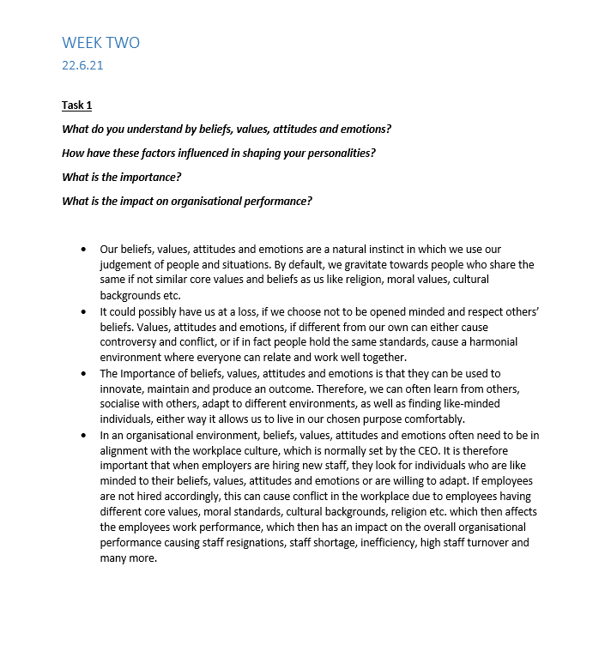
(Notes from Lecture Week 2 22.6.21)

Appendix B

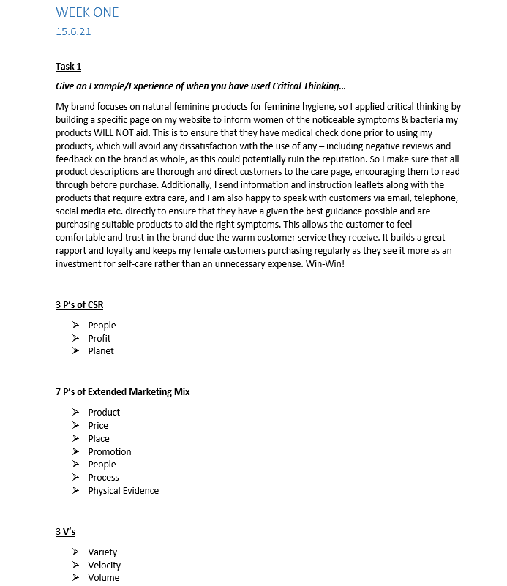
(Notes from Lecture Week 1 15.6.21)

Appendix C

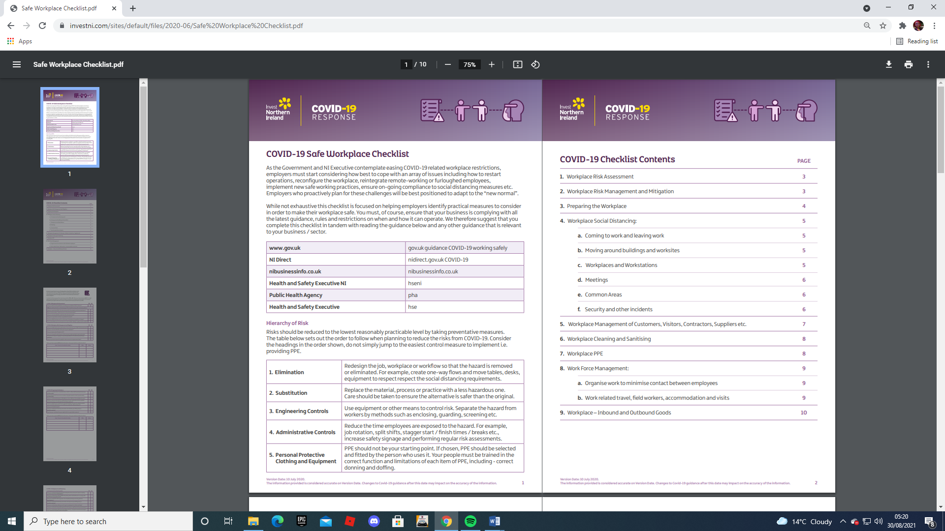

(Invest Northern Ireland, 2020)

Appendix C continued…

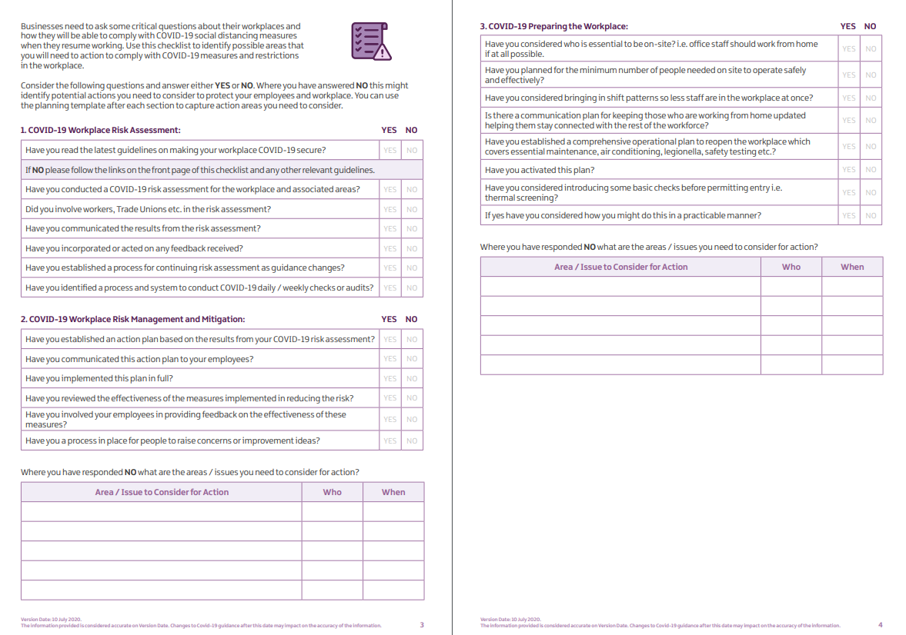
(Invest Northern Ireland, 2020)

Appendix C continued…

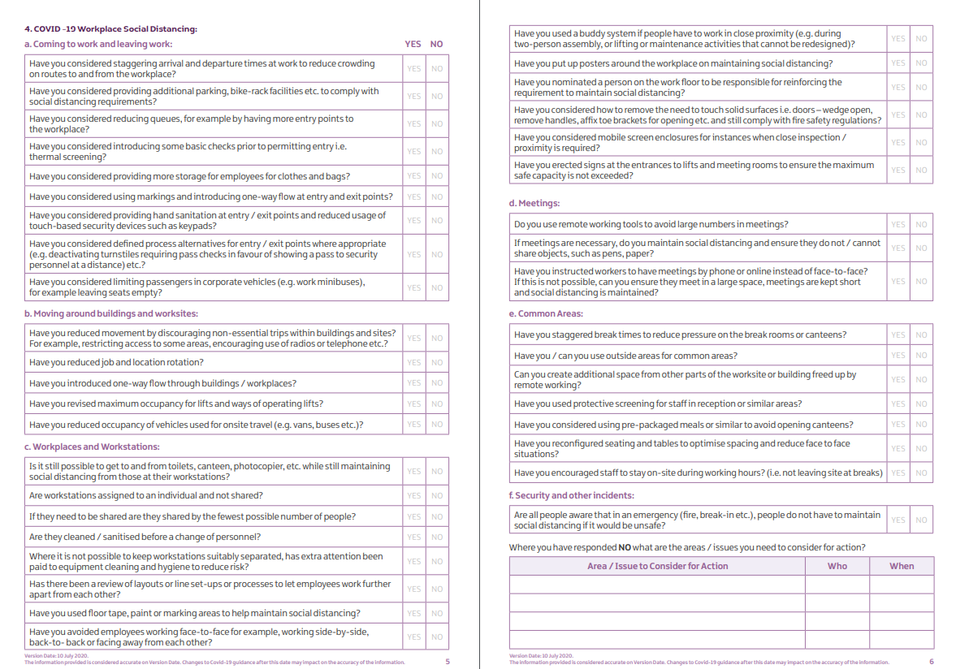
(Invest Northern Ireland, 2020)

Appendix C continued…

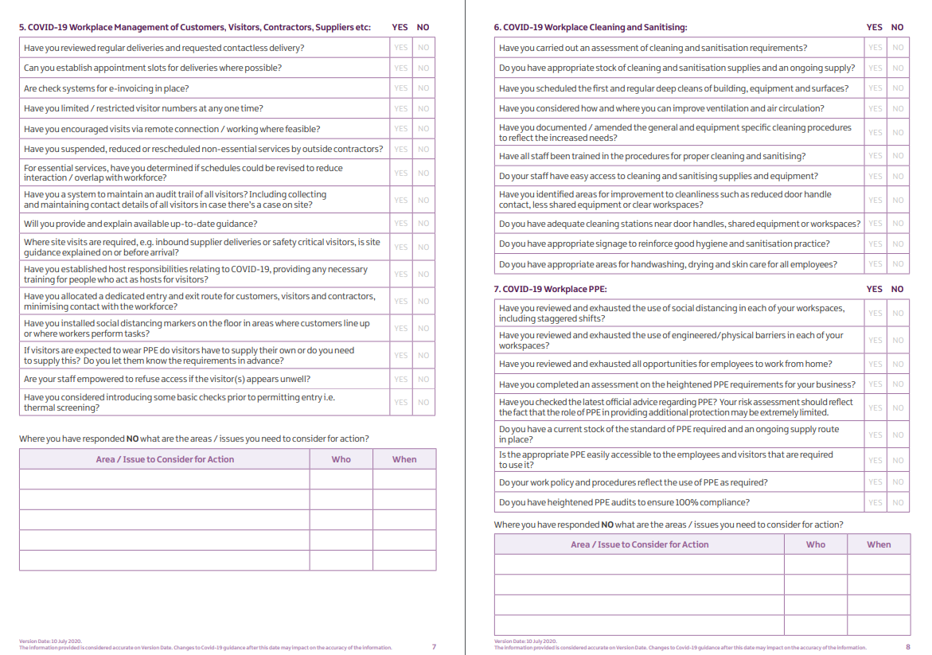
(Invest Northern Ireland, 2020)

Appendix C continued…

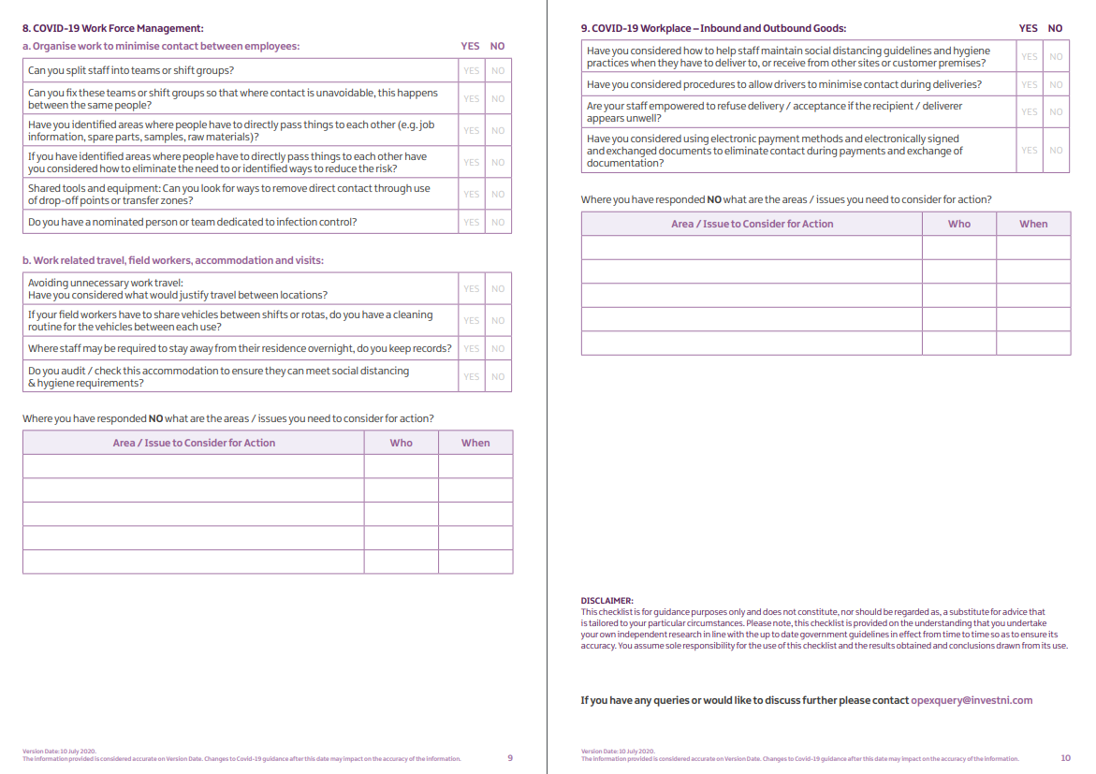
(Invest Northern Ireland, 2020)

Appendix D

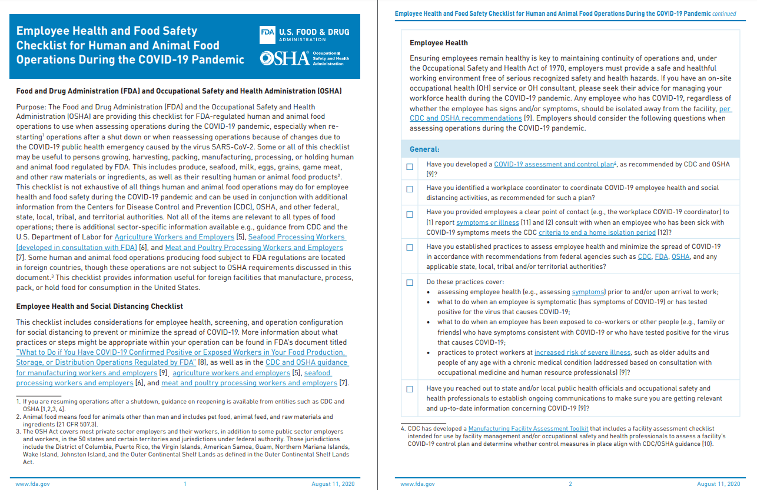
(OSHA, 2020)

Appendix D continued…

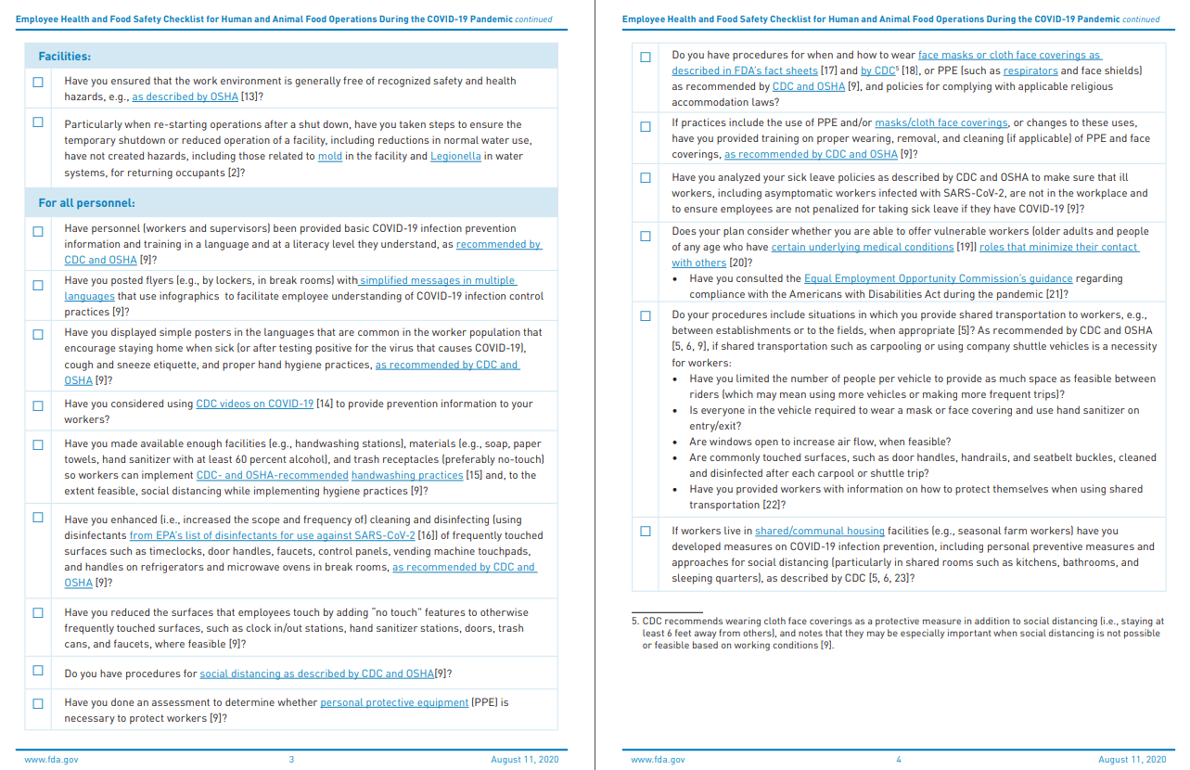
(OSHA, 2020)

Appendix D continued…

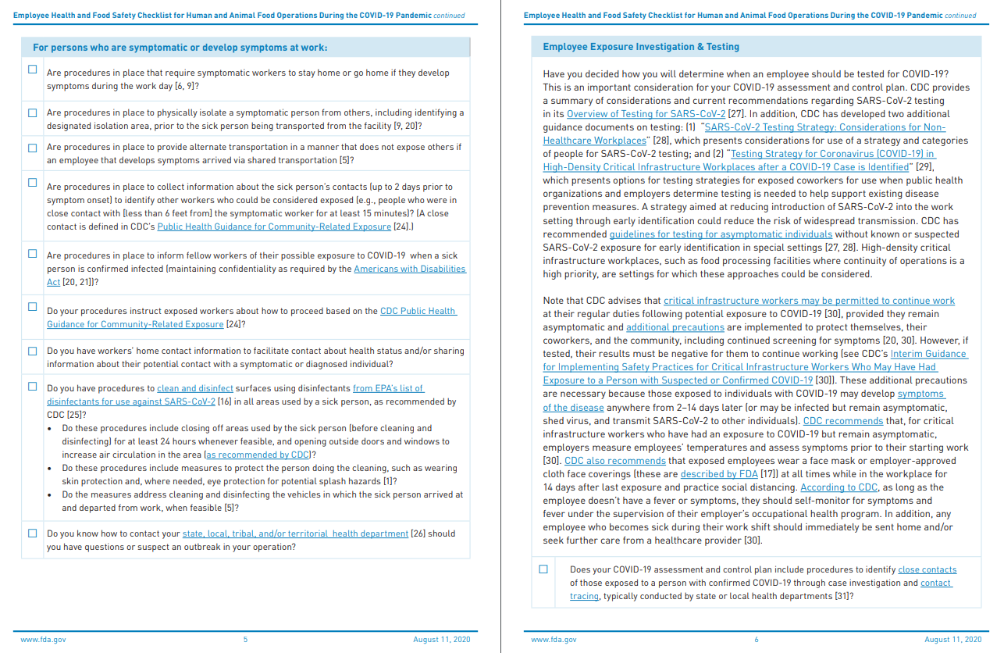
(OSHA, 2020)

Appendix D continued…

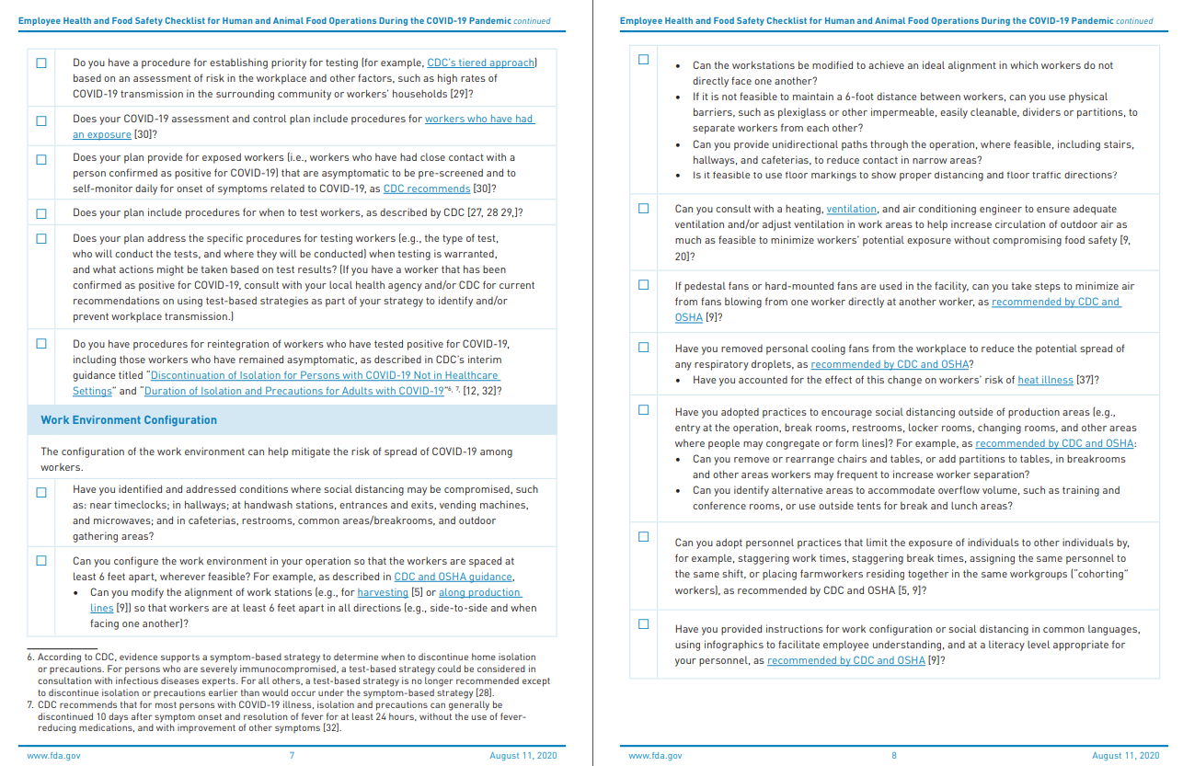
(OSHA, 2020)

Appendix D continued…

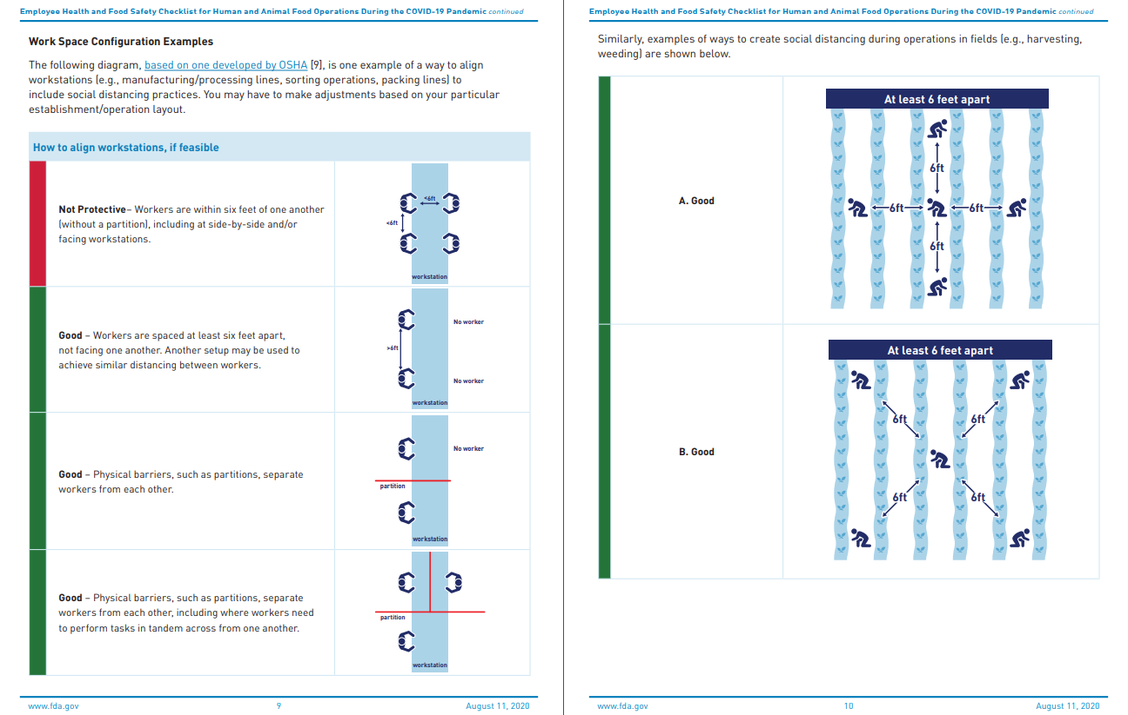
(OSHA, 2020)

Appendix D continued…

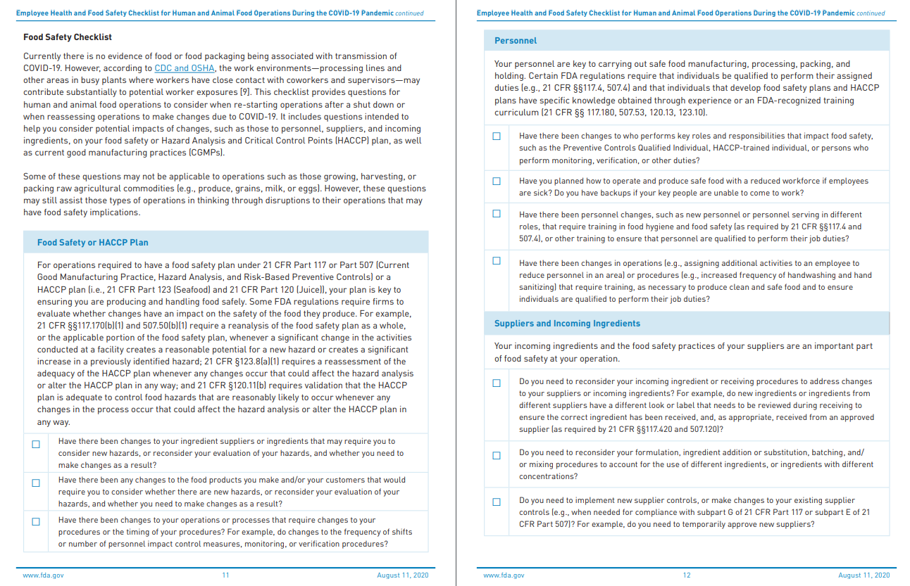
(OSHA, 2020)

Appendix D continued…

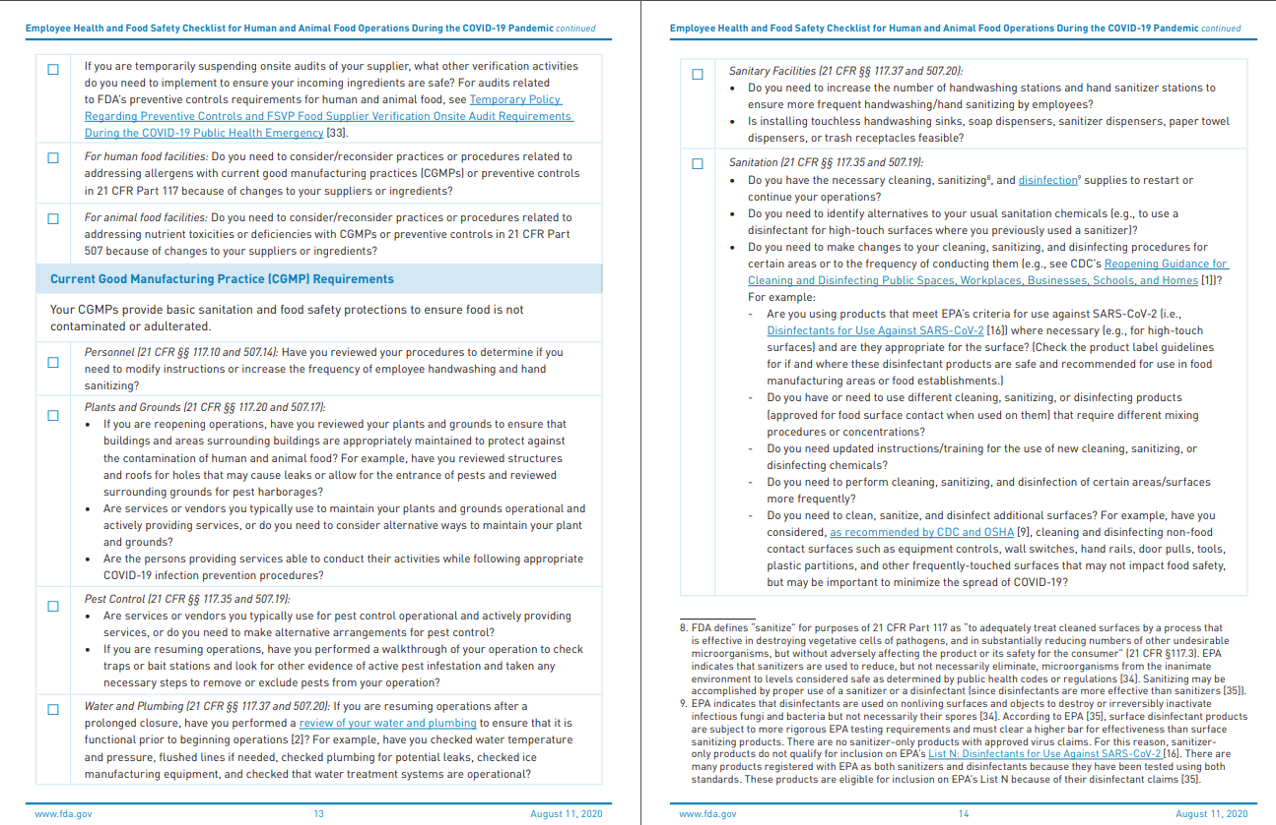
(OSHA, 2020)

Appendix D continued…

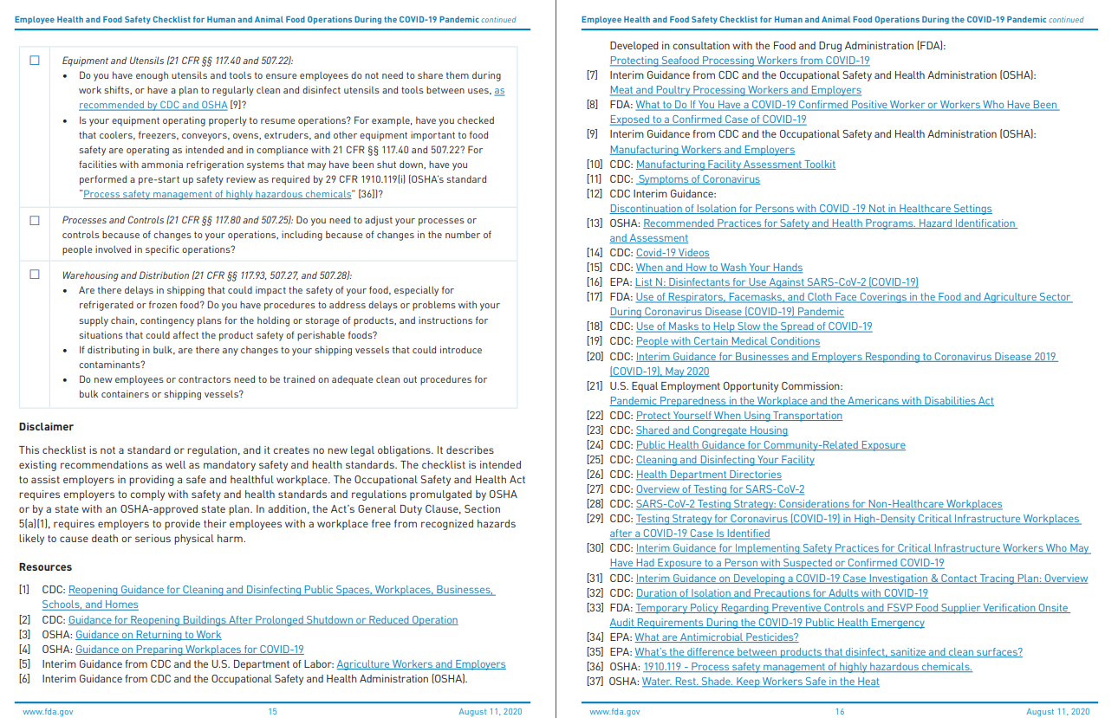
(OSHA, 2020)

Appendix E

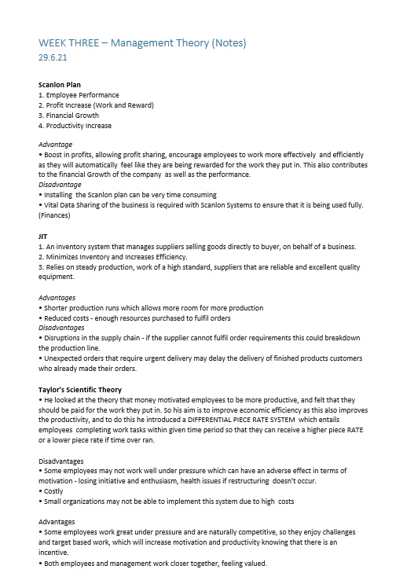
(Notes from Lecture Week 3 29.6.21)

