

Student name: Tita Panio Catapang
Student ID: 2431420

Module name: Introduction to Physiology
Module code: BMHP5023_ LON
Lecturer name: Mr Soban Sadiq

Assessment: 1

April 9, 2026

Introduction
Even though the medical community has the necessary skills and medications to treat asthma, the condition is frequently under-identified and inadequately managed. For healthcare providers to successfully treat patients-especially those dealing with sinus or nasal inflammation-they must have a solid grasp of how asthma functions (Mims, 2025).

What is asthma? And risk factors.
The complicated genetic condition known as asthma is influenced by the environment. Our society is increasingly burdened by it in terms of healthcare expenses, morbidity, and quality of life. Even with extensive attempts, only a small number of asthma genetics basis of asthma is extremely complicated. Also, asthma is a result of a malfunctioning relationship between our genes and the environment they are exposed to, particularly during pregnancy and the first few months of life. The rising incidence of asthma across all age groups suggests that our immune system and living conditions are out of balance, causing airway inflammation in response to environmental exposures and frequently harmless proteins like allergens, which are responsible for the current asthma and allergy epidemic. Due to the intimate connection between asthma and chronic rhinosinusitis, otolaryngologist must be well-versed in asthma, the disease’s etiologic causes, and its assessment and treatment.
Numerous environmental risk factors, including exposure to tobacco smoke and air pollution, as well as occupational risk factors have been found to raise the chance of acquiring asthma. Furthermore, in people who are predisposed to asthma, atopy, stress, and obesity can all raise the risk (Toskala, 2015).

Respiratory outcome | EP | MLP | FT | p-value*
Parent-reported formal diagnosis of asthma up to and including adolescence  (n = 276) | 8/73 (11%) | 5/124 (4%) | 3/79 (4%) | 0.064
Parent-reported asthma or asthma-like symptoms up to and including adolescence  (n = 266) | 10/69 (14%) | 17/120 (14%) | 5/77 (7%) | 0.196
Asthma medication in the 12 months before the study visit  (n = 31) | 6/10 (60%) | 5/16 (31%) | 3/5 (60%) | 0.697
Negative effects of asthma on daily functioning  (n = 28) | 4/10 (40%) | 1/11 (9%) | 2/5 (40%) | 0.728
Ever experienced wheezing symptoms  (n = 273) | 18/70 (26%) | 23/123 (19%) | 7/80 (9%) | 0.006
Experienced wheezing in the year before the study  (n = 46) | 2/18 (11%) | 4/21 (19%) | 3/7 (43%) | 0.097

Respiratory outcomes in adolescence.
*
p-value of chi-square test for trends.

The table above discusses research findings on the prevalence of asthma and respiratory issues among teenagers,

Table 1
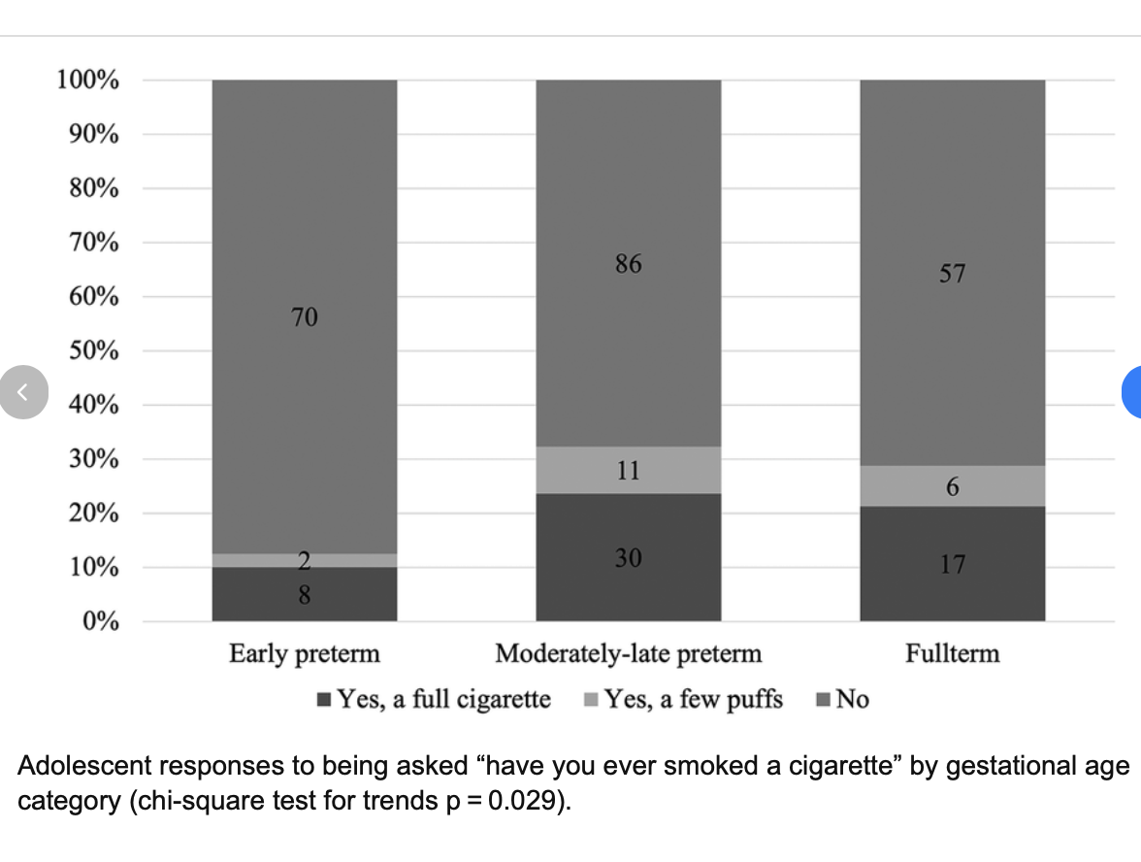
(van Dokkum, N. H. et al, 2025)

Figure 1

Structure of the respiratory system

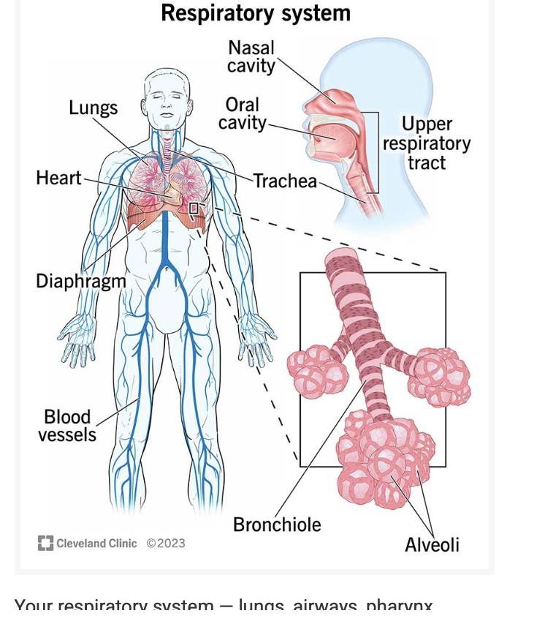
(Cleveland clinic, 2024)
Your respiratory system- lungs, airways, pharynx, larynx, nose and mouth-brings in oxygen and gets rid of carbon dioxide.

The organs and tissues in your body that are called your respiratory system. It consists of the tube-like structures (airways) that connect your mouth, nose, and lungs. Your respiratory system is supported by blood vessels and muscles, and it is shielded by your ribs. Together, these components allow your body to absorb oxygen during inhalation and expel carbon dioxide during exhalation
Your respiratory systems primary job is to remove carbon dioxide, a waste product, and draw in oxygen for your body’s cells. This is accomplished by breathing in and out as well as by gas exchange between the surrounding blood vessels and the tiny air sacs in your lungs, known as alveoli
Your respiratory system also:
- Warms and adds moisture to the air you breathe in
- Protects your body from particles you breathe in
- Allows you to talk
- Helps you smell
- Balances level of acidity (Cleveland clinic, 2024)

Figure 2

Gas exchange in lungs

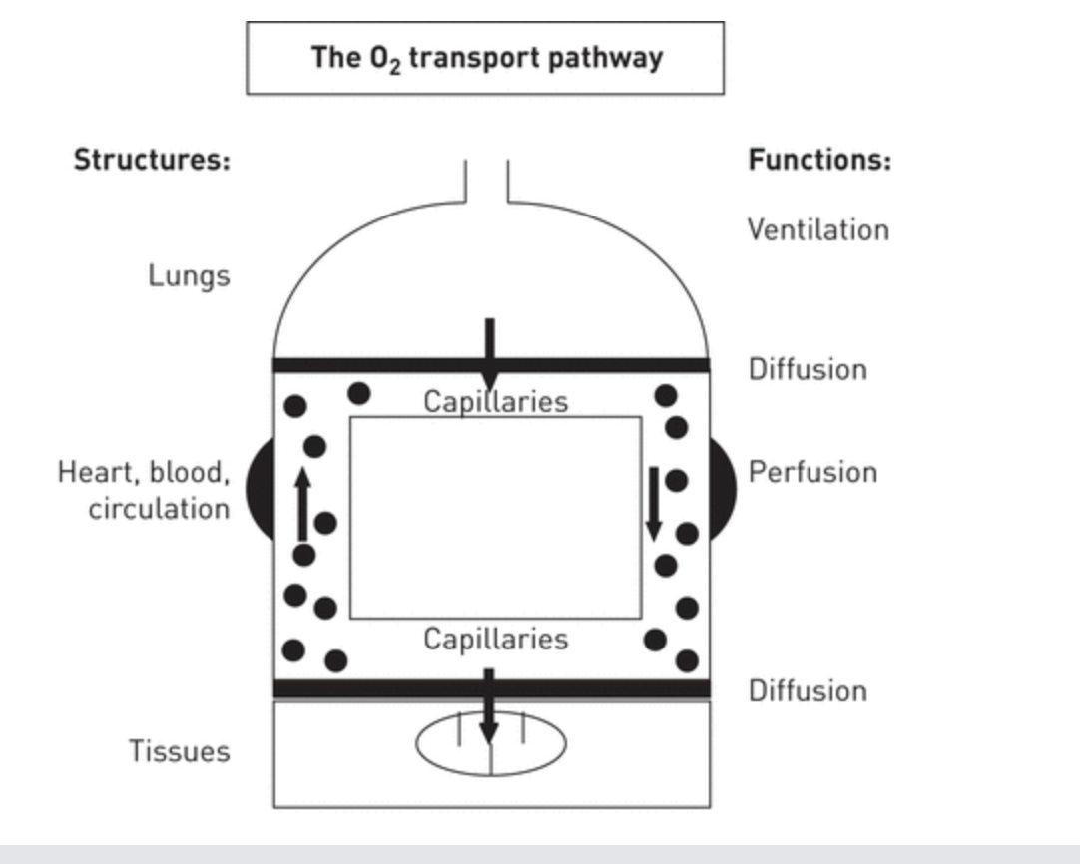
Diagram illustrating the main components and physiological roles of the O2 transport route. Like O2, CO2 is transported from the tissues to the lungs via the same mechanism (Wagner, 2014)
From the above, it can be concluded that pulmonary gas exchange is a continuous process that includes: 1) ventilation; 2) diffusion (including physical diffusion across the pulmonary blood gas barrier and subsequent chemical reactions (between O2 and haemoglobin (Hb) and for CO2 conversion to bicarbonate); and 3) perfusion. Conservation of mass is the underlying idea that quantitatively unifies these three distinct physical processes. It simply implies that all the oxygen molecules that are breathed but not expelled in the lungs diffuse from the alveolar gas to the blood and end up in the blood (Wagner, 2014)
The Mechanism of Lung Tissue Swelling
Toxic gases, smoke, and fine particulate matter are examples of irritants that can cause direct chemical or membrane damage when ingested in high concentrations. The body releases signalling molecules such cytokines and histamines because of this injury, which immediately causes an inflammatory reaction.
These mediators make the capillaries more permeable or leaky. As a result, inflammatory cells and protein-rich fluid leak out of the blood vessels into the interstitial space, which is the tissue that surrounds the air sacs, and eventually into the alveoli. The physical swelling of the lung tissue is caused by this accumulation of fluid, also referred to as pulmonary oedema (Ghadiali, 2008)
Impact on Respiration
Gas exchange is directly harmed by the transformation from elastic, healthy tissue to bloated fluid-filled tissue.
- Increased Diffusion Distance: The blood-air barrier is incredibly thin in a healthy lung. This barrier is thickened by swelling, which makes it necessary for oxygen to pass through a layer of fluid to reach the red blood cells. This slows down the intake of oxygen.
- Reduced Lung Compliance: Stiff lungs result from swelling, Dyspnoea, or shortness of breath, results from the respiratory muscles having to work significantly harder to inflate the lungs during inhalation due to this loss of suppleness.
- Ventilation-Perfusion (V/Q) Mismatch: Even though blood is till flowing to the alveoli, they are unable to engage in gas exchange when they fill with fluid. This results in “shunting,” in which the heart receives deoxygenated blood without receiving new oxygen (Ghadiali, 2008).

Recording and tracking respiratory functions

A fundamental aspect of contemporary clinical practice is the monitoring of respiratory function. It offers a real-time insight into the ventilation, acid-base balance, and oxygenation of patient (Dougherty, 2015).
An essential component of preventive asthma care is peak flow monitoring. It offers an objective assessment of lung function, frequently identifying airway narrowing prior to the onset of physical symptoms like coughing or wheezing (Bateman, 2008)
What is Peak Flow?
The greatest speed at which an individual may expel air from their lungs following a deep inhale is known as the Peak Expiratory Flow Rate (PEFR), and it is measured by a peak flow meter (Bateman, 2008)
Importance of Tracking respiratory Functions
For several reasons, monitoring metrics including peak expiratory flow (PEF), oxygen saturation (SpO2), and respiratory rate (RR) is essential.
- Early deterioration detection: The most sensitive measure of physiological discomfort is frequently the respiratory rate. Changes in RR often occur several hours before changes in blood pressure or heart rate (Dougherty, 2015).
- Assessment of treatment efficacy:
Clinicians can determine whether treatments like bronchodilators or extra oxygen are indeed effective by using recording features.
- Managing Chronic conditions:
Regular recording aids in the identification of “baseline” triggers and helps patients with COPD or asthma avoid acute exacerbations.
- Identifying systematic issues:
Not all respiratory abnormalities are related to the lungs; they might also indicate neurological deterioration, infection, or metabolic acidosis (Rolfe, 2019).
What happen if we do not record these functions?
Neglecting respiratory monitoring might have quiet but potentially disastrous effects.

Consequence Description

Failure to Rescue A slow increase in effort may go unrecognised until the patient experiences a respiratory arrest if there is no documented trend.
Hypoxemia & Organ
Damage Low oxygen levels that go unnoticed might cause irreversible harm to the heart and brain (Dougherty, 2015)
Diagnostic errors It is challenging to distinguish between a primary lung problem and a cardiac problem when there is missing data.
Delayed discharge Patients may stay in the hospital longer than necessary
Without documented evidence of stability, which raises risk of secondary infections.

Recommendations

Comprehensive asthma management: Evidence-based strategies
SABA monotherapy is no longer advised in evidence-based treatment recommendations for asthma, which now prioritise ICS. For adults and adolescents in GINA treatment as well as for patients prescribed ICS-formoterol maintenance therapy, the 2019 and more recently, the 2020 Global Initiative for Asthma (GINA) strategy recommends ICS and LABA with a quick onset of action-as the preferred as needed reliever. For moderate asthma, budesonide-formoterol is now recommended as needed based on results from further supported by open-label pragmatic clinical trials as a safe and effective way to reduce severe exacerbations when compared to maintenance budesonide plus as-needed SABA , GINA recommends low-dose ICS anytime SABA is administered, emphasising the use of ICS even in young patients (McIvor, 2020).
The integrated reliever strategy (AIR) therapy. This replaces the traditional SABA-only rescue method with a combination of an inhaled Corticosteroid (ICS) and formoterol.
Mechanism: Formoterol provides rapid relief (like a SABA) but also lasts longer. When combined with ICS (like Budesonide or Beclometasone), the patient receives a burst of anti-inflammatory medicine exactly when their symptoms are flaring.
The MART Approach for Persistent Asthma: for patients with moderate to-severe asthma, the review highlights Maintenance and Reliever Therapy (MART).
The strategy: Instead of using one inhaler for daily prevention and a different one for emergencies, the patient uses the same ICS- formoterol inhaler for both.
Clinical Benefit: This creates a flexible dosing schedule. If a patients environment triggers an attack, their increased use of the reliever naturally scales up their maintenance protection simultaneously, preventing a minor flare-up from becoming a hospitalisation (Papi, 2020).
Lifestyle changes that could manage the asthma?
(Papi, 2020) argue that asthma is a dynamic disease. Lifestyle factors often act as the “triggers” that make this underlying inflammation flare up.
Exercise: using ICS-formoterol combination before physical activity. This is evidence-based because it treats the immediate narrowing of the airways while simultaneously providing a protective dose of steroid to prevent the late-phase inflammatory response that often follows exercise.
Weight and Inflammation: the Author emphasise that asthma is an inflammatory condition, they indirectly support weight loss. Obesity creates a “pro-inflammatory” state in the body that can make the ICS (inhaled Corticosteroid) they advocate for less effective.
Smoking: smokers have different “asthma phenotypes.” Smoking causes structural changes in the lungs that can resist the very anti-inflammatory treatments are trying to optimise.
Summary of lifestyle interventions:
Focus area Actionable step

Indoor air Use HEPA filters and avoid wood-burning stoves.

Diet Consume a diet rich in antioxidants (fruits and vegetables).

Monitoring Keep an asthma diary to track symptoms and peak flow readings.

Vaccination Stay up to date with flu and pneumonia vaccines to prevent
Respiratory infections.

6. Conclusion
In summary, the effective management of transitioned from a purely reactive model to a proactive, “whole person” approach. Evidence suggests that combining pharmacological care with structured self-management and lifestyle modifications is essential for achieving long-term control (Stoodley, 2019). While inhaled corticosteroids remain the clinical foundation, integrating regular physical activity- such as exceeding 7,000 steps daily- has been shown to significantly enhance respiratory function and reduce the frequency of rescue medication use (MDPI, 2025).
Furthermore, lifestyle factors such as weight management and dietary improvements play a critical role in reducing the systemic inflammation that often exacerbates airway sensitivity (Nyenhuis, 2018). For patients with obesity-related asthma, even a modest weight loss of 5-10% can lead to clinically meaningful improvements in quality of life (Stoodley, 2019). Health promotion strategies that empower patients through education and personalised action plans facilitate better adherence and fewer emergency interventions (MDPI, 2025).
By addressing these modifiable risk factors alongside medical therapy, individuals can transition from merely managing symptoms to optimising their overall physiological and psychological wellbeing.

References
- Bateman, E.D. et al. (2008) ‘Global strategy for asthma management and prevention’: GINA executive summary, The European Respiratory Journal: Official Journal of the European Society for Clinical Respiratory Physiology, 31(1), pp. 143-178. Available at: https://doi.org/10.1183/09031936.00138707
- Cleveland Clinic (2024) Respiratory System
https://my.clevelandclinic.org/health/body/21205-respiratory-system
https://www.bbc.co.uk/bitesize/guides/zd6fy9q/revision/3

- Ghadiali, S. N. and Gaver, D.P. (2008) ‘Biomechanics of liquid- epithelium interactions in pulmonary airways’. Respiratory Physiology and Neurobiology Volume 163, Issue 1-3, pp. 232-243 Available at: https://doi.org/10.1016/j.resp.2008.04.008
- McIvor, A, and Kaplan, A. (2020) ‘A call to action for improving clinical outcomes in patients with asthma’, NPJ Primary care respiratory Medicine, 30(1) p 54, Available at: https://doi.org/10.1038/s41533-020-00211-x.
- MDPI, (2025) ‘Impact of physical exercise on adult asthma control’: A randomised clinical trial. Healthcare, 13(20), 2634. Available at: https://doi.org/10.3390/healthcare13202634
- Mims, J.W. (2015) ‘Asthma: definitions and pathophysiology’ International Forum of Allergy and Rhinology, Volume 5, Issue 51, pp. 52-56. Available at: https://doi.org/10.1002/alr.21609
- Nyenhuis, S. M., Dixon, A. E., and Ma, J. (2018) ‘Impact of lifestyle interventions targeting healthy diet, physical activity, and weight loss on asthma in adults’: What is the evidence? The Journal of Allergy and Clinical Immunology: In Practice, 6(3), 751-763. Available at: https://link.springer.com/article/10.1186/s13223-020-00472-8
- Papi, A. et al. (2020) ‘Treatment strategies for asthma’: reshaping the concept of asthma management, Allergy, Asthma, and Clinical Immunology, 16(1), p. 75. Available at: https://doi.og/10.1186/s13223-020-00472-8.
- Stoodley, I. et al. (2019). ‘Evidence for lifestyle interventions in asthma’. Breathe, 15(2), e50-e61. Available at: https://doi.org/10.1183/20734735.0019-2019
- Toskala, E., and Kennedy, D. W., (2015) ‘Asthma risk factors’. International Forum of Allergy and Rhinology. Volume 5, Issue S1 pp. s11-s16. Available at: https://doi.org/10.1002/alr.21557
- Van Dokkum, N. H. et al. (2025) ‘Prevalence and early-life risk factors of asthma in preterm adolescents’: a cohort study, Frontiers in Paediatrics, 13(1720645), p. 1720645. Available at: https://doi.org/10.3389/fped.2025.1720645.
- Wagner, P. D. (2014) ‘The physiological basis of pulmonary gas exchange’: implications for clinical interpretation of arterial blood gases. European Respiratory Journal. 45(1): 227-243; Available at: DOI: https://doi.org/10.1183/09031936.00039214

