Qualification: CIPD Diploma in Applied Human Resources
Module Name: Developing Professional Practice in Human Resources
Activity 2 – CIPD Profession Map

Word Count: 1113

Student Name: David Harris
Student Number: 1907534
CIPD Membership Number: 55479883

By signing below, I confirm that the work/evidence presented is my own, unaided work. I understand the regulations pertaining to candidate malpractice and the action that may be taken as a result.

Signed: 
Date:

Introduction
Being professional is a key factor of being a HR practitioner and provides the evidence and legitimacy to be truly effective. This is demonstrated by the high quality of work that an HR Professional delivers (Johns T, Perkins G).
To assist HR professionals in their career, the Chartered Institute of Personnel and Development (CIPD HR Profession Map, 2019) (CIPD) developed a Profession Map (known within the report as the Map) in 2009. This report sets out to explain the Map’s purpose, along with how it can be used to benefit HR Professionals in their continued HR journey.

Report
The Map is divided into several sections – a) eight behaviours b) ten professional areas and c) four bands of professional competence. These identify the different skills and behaviour traits that any HR Professional should demonstrate to be truly effective in their role. The Map allows HR Practitioners to benchmark their ability within their HR career, as well as identifying actions needed for progression within their role. This is done via a self-assessment against each of the professional areas and behaviours, referring these to the competence band that relates to the relevant role. To this end, the Map acts as a life-long career tool, fitting with the view of (Woodhams C et al, ) where Continual Professional Development (CPD) is seen as just that, a continual life-long commitment to maintain and develop knowledge.

The CIPD (CIPD HR Profession Map, 2019) has purposefully designed the Map to drive HR practitioners to be the best that they can be and has identified the behaviours and skills of the very best HR professionals. An image of the Map can be seen below:
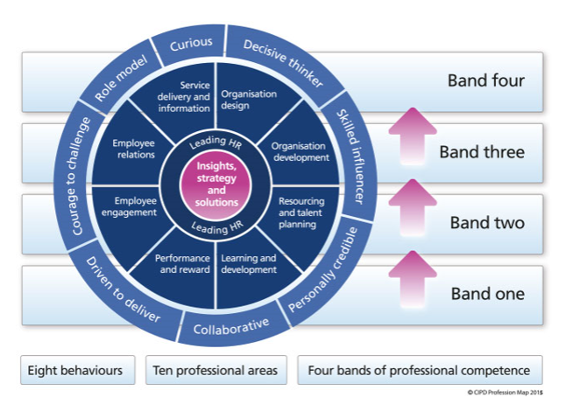
Figure 1 CIPD Profession Map 2015

The Map separates the things that HR professionals need to do to be fully effective, as well as how these must be done. These are divided into ten professional areas (what they must do) and eight behaviour (how they must do them). The two areas found at the centre of the map show the two traits that are applicable to all areas of HR and are the responsibility of all HR practitioners. The remaining eight professional areas are more suited to HR specialists and specialisms. The behaviours identify how HR practitioners should act if they wish to be successful within their roles. These are seen as vital traits and something that is supported by organisations in the way they deliver their HR provision. This can be seen in Tesco, who recently became the first organisation to attain the CIPD People Development Partner status. This demonstrates their collaboration with the CIPD to develop their HR provision (CIPD launches status for organisations excelling at HR's own development, 2019). In addition, public service organisations, particularly policing, have shifted their recruitment processes to place greater emphasis on the values of their employees rather than purely on their ability. This demonstrates organisational belief in the values displayed within the Map (Introducing a new competency and values framework for policing, 2017).
The final section of the Map consists of four bands of professional competence. These bands identify the differing levels within an HR professional’s career; starting at band one being a tactical day to day HR practitioner, to band four - a strategic HR professional responsible for leading an organisation. Whatever the band, the Map identifies the characteristics and behaviours that individuals display and engage in at each level.

Figure 2. Profession Map Behaviour Areas

“It is becoming increasingly important for HR Professionals to be ‘thinking performers”. (Woodhams C, Perkins G, ??) describe the nature of the HR Professionals role having changed dramatically from one that was seen to be administrative to one that is a more influencial role, adding value to an organisation. Thinking performers are individuals who both carry out tasks but also those who consider the wider impact of their decisions and how these fit with the organisational strategy and purpose.
HR Professionals need to be taken seriously in their organisation and this can only be achieved by demonstrating the behaviours identified within the Map. The CIPD term this as being ‘business savvy’ (Johns T & Perkins, G, ??) and state that this consists of 4 elements, which fit with the Map’s behaviour areas. These are:
- Understanding the business model in depth
- Generating insight through evidence and data
- Connecting with curiosity, purpose and impact
- Leading with integrity, consideration and challenge

The HR professional that is able to display the above areas in their work is someone who is able to be fully effective and to provide the most impact for their organisation. This role requires an individual to being able to display many different qualities, including the ability to ask questions of their organisation and processes, whilst ensuring that their organisation’s business model is fully understood. This is vital in ensuring that organisational strategy is considered when decisions are being reached.
In addition, being a skilled influencer is vital in enabling change and ensuring that all parties are engaged. To be a truly skilled influencer, this requires developed communication skills. Often managers revert to instructing people to do things, however the results for this are limited. By being a fully effective communicator and by basing your communication success on the response it gets from your audience, this provides the best possible chance of positive results (Yemm, 2008).
Finally, the need to be a role model for the organisation, as well as being personally credible is key in ensuring that the HR Professional’s role is one that both continually evolves, but also develops fellow colleagues in their roles. These individuals display high levels of integrity and act in a consistent manner. They offer guidance and advice to colleagues and do so in a manner that is supportive and fosters an organisation environment where shared knowledge and learning is both supported and promoted.

Conclusion
In conclusion, the CIPD Profession Map is a vital tool for all HR professionals, irrelevant of their role within HR, or their length of service. It provides a well-structured and intuitive model for benchmarking any HR practitioner’s current abilities, while providing tangible and realistic objectives to allow for further progression, either within their role or to allow progression to a higher role in HR. The elements within it are the basis for the development of sound HR practice and are the necessary behaviours and values which all HR Professionals must demonstrate.

Recommendations
- All HR Professionals should undertake a self-assessment against key areas of the Map, identifying objectives to develop in their role.

- HR Professionals should ensure that they are fully aware of their organisation’s strategic objectives and vision, to allow this to be considered when carrying out HR work.

Bibliography
Carol Woodhams, G. P. (n.d.). Developing the Knowledge and Skill of the HR Professional. In Studying Human Resource Management (pp. 109-126). London: Chartered Institute of Personnel and Development.
CIPD HR Profession Map. (2019, Dec 10th). Retrieved from CIPD: https://www.cipd.co.uk/learn/profession-map/2013-profession-map
CIPD launches status for organisations excelling at HR's own development. (2019, December 30th). Retrieved from HR Magazine: http://www.hrmagazine.co.uk/article-details/cipd-launches-status-for-organisations-excelling-at-hrs-own-development
Introducing a new competency and values framework for policing. (2017). Retrieved from College of Policing: https://www.college.police.uk/What-we-do/Development/competency-and-values-framework/Pages/Competency-and-Values-framework.aspx
Perkins, T. J. (n.d.). Developing Professional Practice. In Studying Human Resource Management (pp. 68-87). London: Chartered Institute of Personnel and Development .
Yemm, G. (2008). Influencing Others - a key skill for all.

Qualification: CIPD Diploma in Applied Human Resources
Module Name: Developing Professional Practice

Team Dynamics and Internal Politics

Word Count: 1241

Student Name: David Harris
Student Number: 1907534
CIPD Membership Number:55479883

By signing below, I confirm that the work/evidence presented is my own, unaided work. I understand the regulations pertaining to candidate malpractice and the action that may be taken as a result.

Signed:
Date:

Report
Teams exist in all walks of life, both personal and professional. They play a vital part in achieving the goals set for them as long as they are effective and are managed well. The difference between a team and a group of individuals relates to their shared goals and shared accountability to achieve these goals (Smith, 1992). Smith quotes “A team is a small number of people with complementary skills who are committed to a common purpose, performance goals, and approach for which they hold themselves mutually accountable”, therefore differentiating a team from a simple group of individuals.
HR professional often work in teams, either with other HR professionals or in wider teams within their organisation, such as with trade unions, employees or line managers. Huczynski and Buchanan (2017) describe teams fitting into one of four categories; Action, Advice, Project or Production, with organisations using teams more frequently to undertake specific team tasks (Lacarenza et al, 2018). What is necessary for all teams is a need for a mix of skills and for these to be complementary to each other and provide a mix of abilities. There is also a need for these to be managed effectively.

There are several models which explain the ‘team’ process and what impacts on its effectiveness. (Smith, 1992) explains that individuals often find it difficult to work beyond being an ‘individual’ and shy away from taking responsibility for others and allowing others to take responsibility for their performance. This is overcome when people focus less on becoming a team and more on the fundamental characteristics of being effective. Smith describes this as a triangle identifying three separate areas; Skills, Accountability and Commitment, and suggest that these are the three areas needed for an effective team. This is not dissimilar to Belbin’s model, where individual characteristics are categorised into one of nine roles covered within ‘Thinking’, ‘Action’ and ‘People’. This, and Smith’s triangle model are shown below:

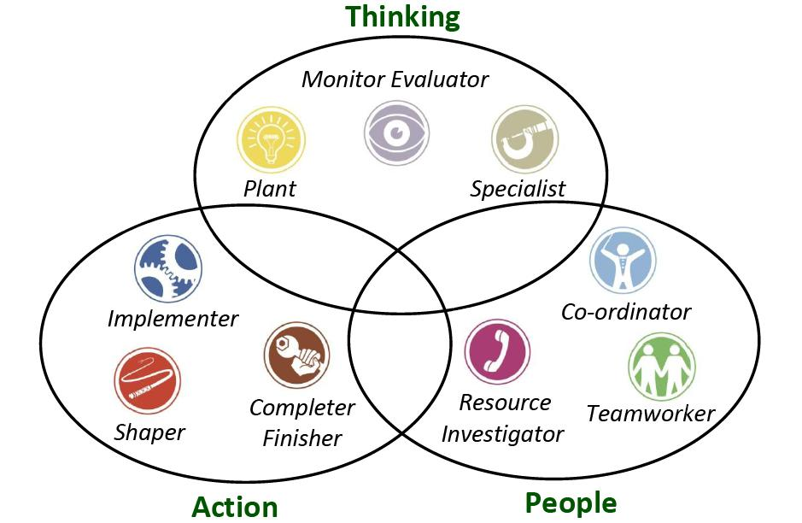
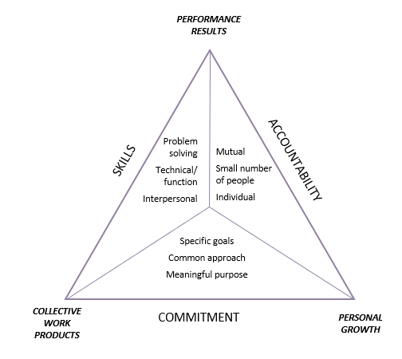

Fig 1. Katzenbach and Smith
Fig 2. Belbin

Belbin’s model identifies character traits and categorises these as one of the above nine team roles. It is vital for supervisors and team leaders to understand their team’s strengths and weaknesses in order that these can be managed effectively and that individuals can be tasked accordingly. This can can assist in achieving team goals. (Why Use Belbin?, 2019).
To understand Belbin’s model there are a number of questionnaires available, aimed at identifying the skills of team members and identifying which of the Belbin roles each person naturally leans towards. Whilst most individuals tend to have a predominance towards one, it is possible for some people to portray traits of more than one.
Whilst the above models focus on the characteristics of individuals within a team, Tuckman’s theory of team development focuses on how teams develop and the different stages teams go through from their initial forming. Tuckman describes this as a four-stage process as shown in fig 3 below.

Fig 3. Tuckman’s Model

The model (initially created in 1965) refers to the path which teams follow as they develop. It describes the four separate stages teams move through from initial forming, through to the stage that they are fully functioning and high performing. It is a vital tool for team leaders to be aware of as it not only maps the way team members act, but also the importance of how team leaders must act at each stage, and how team goals can be negatively affected if the process is managed ineffectively (Miller, 2014).
The model describes that teams often begin polite and positive about their goals and tend not to question processes of procedures. They have high expectations of each other and of the team’s chance of achieving its goals. The Forming stage requires team leaders to be more directive to ensure that goals are set for the team. As they move into the Storming stage the team start to question each other and the negative character traits of individuals start to appear. It is vital for team leaders to be able to manage their teams at this stage and to help them identify each other’s skills.
As teams start to work closely together and recognise each other’s abilities, they begin to work in harmony and begin performing better. At this stage of the process a team leader starts to become more of a facilitator and is able to allow the team to manage their own performance, whilst continuing to support and develop team members. If this continues well, the final stage of the process is the Performing stage, where the team take on more responsibility and become more positive about their ability in achieving their goals and objectives.
What is vital during this process is that line managers are both aware and equipped with the necessary skills to understand how and why their team is acting in a certain way. Understanding this model allows line managers to predict patters of behaviours, as well as assisting their team progress through the stages as smoothly as possible.
Whilst the above models are key to understand how individuals team members act as well as how teams develop, this is not always enough to ensure that objectives are achieved. This is evident in change management processes, where it is demonstrated that informal coalitions exist and play a key part in organisation’s ability to effectively manage such a process (Rodgers, 2006). The Business Dictionary define organisational politics as ”the pursuit of individual agendas and self-interest in an organisation without regard to their effect on the organisations efforts to achieve its goals”, which can make this seem negative. Rodgers, however suggests that internal politics are both necessary and inevitable.

Whatever management’s view is of change, teams of individuals in an organisation will inevitably speak about what they want to and will decide for themselves how the change process will work. Rodgers describes the normal change process as below, identifying the three different management styles:
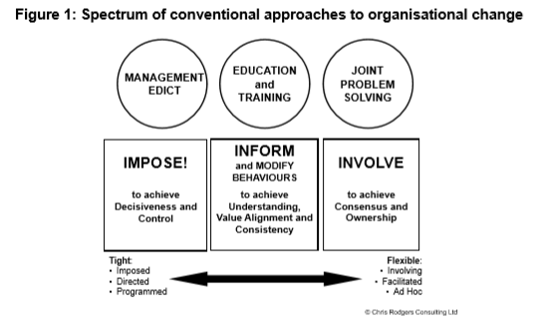
This suggests a clear difference from ‘tight’ to ‘flexible’ management styles, however what is important to understand and accept is that whatever management style is adopted, managers cannot stop their teams discussing matters however they see fit. This is where the informal coalitions are made. This is an important viewpoint to understand, as this recognises how powerful conversations, discussion and internal politics can be.
Rodgers suggests that internal politics are a necessary and unavoidable step in any process, particularly when change impacts on team’s resources or workload. Whilst politics can be seen as a negative issue, this is the reality and to try and avoid it will delay any process being completed. Team leaders and managers should embrace organisational politics at play and engage with their teams to work through these processes rather than trying to fight against them.

Conclusion
To conclude, it is important for team leaders to be aware of how their teams are made up and the differing skills and abilities of each of their team members. Additionally, it is also key to understand the processes that teams move through and how these can be managed to assist in achieving team goals. Lastly, whilst the above allows managers to be better equipped to manage their team, they must also be aware of how internal politics in their organisation play out and how these can assist in achieving their objectives.

Recommendations
- All team leaders should seek to assess their team’s abilities by using a Belbin style questionnaire.

Bibliography
Christina Lacarenza, S. M. (2018). Team Development Interventions: Evidence-Based Approaches for Improving Teamwork. American Psychologist, 73(4), 517-531.
Miller, T. (2014, May). Engaging Leadership. Training Journal, 22-27.
Rodgers, C. (2006). Informal Coalitions. Organisations and People.
Smith, J. K. (1992). The Wisdom of Teams: Creating the High-Performance Organisation. Harvard Business Press.
Why Use Belbin? (2019, November 29). Retrieved from Belbin.com: https://www.belbin.com/about/why-use-belbin/

