Creativity is inherently difficult to define due its individualistic nature. There are many definitions as to what creativity means to the individual, however NACCCE have described creativity as “imaginative activity, fashioned so as to produce outcomes that are original and of value (NACCCE, 1999, p.29). This principle is agreed by Woods and Jeffrey (1996), Craft (2001), and Harland et al (1998) who stress the importance creativity has on education. The key findings from the synthesis of their work found that creative learning benefits from merging experience with innovation, giving control over activities and ownership of learning (NACCCE, 1999, as cited in Craft, 2008). Woods (1990) suggests teaching creatively uses imaginary approaches that make learning more engaging and therefore more successful. Craft and Jeffrey (2008) state that teaching for creativity aims to develop children’s thinking or behaviour. Robinson (2005); Torrance (1988); Amabile (1996); Gardner (1992) agree, suggesting creativity requires original ideas that have value for the individual. Despite these definitions aiming to develop peoples understandings of creativity, they are often broad and open to discussion, suggesting creativity is difficult to define. Kaufman and Beghetto (2013) suggest most definitions look to the appropriate components of these ‘creative outcomes’ as seen above and agreed by Amabile (1996); Kaufman and Beghetto (2009); Sternberg and Lubart (1996). Going forward I will be using the NACCCE (1999) definition which emphasises both the originality of ideas and the appropriate outcomes of peoples creativity. However, I must also treat the topic of creativity as fluid, acknowledging the various definitions that exist. Ryhammer and Brolin (1999) believe development of original ideas is a particular human characteristic, therefore the individual nature of the requirements of appropriate outcomes should be accounted for. There is importance for educators to allow children the opportunity to express themselves, especially through creative ideas. Feldhusen (1995) suggests creative thinking is a process of modifying ideas from existing knowledge, along with the ability to create new ideas. Callaghan (1976) suggests students leaving school are not equipped with the skills needed to succeed in industry and believes that schools should be providing these skills, thereby enabling children to thrive in and contribute to society. This ties in with the key objective of the UK government regarding the economy and education in helping to secure a skilled workforce, able to act in an enterprising way (Department of Trade and industry (2000, 2001). It is therefore important for teachers to develop these enterprise skills. Jones and Iredale (2010) further suggest education should produce more people with higher level general skills, better able to operate in an enterprising way, taking advantage of opportunities emerging from the new flexible market which would change the way people are taught as well as what they learn (Jonesand Iredale, 2010). This pedagogy is not subject specific but can be introduced and applied across the curriculum (Iredale 1993; 2002; Ofsted 2004). In this essay, I will be critically evaluating my own approaches to teaching creativity and enterprise skills, utilising the EntreComp framework and assessing how they might be used to develop children’s skills and ability to succeed in the future.
McLeod (2007); Arieti (1976) believe creativity has different applications as well as primary biological foundations. This humanist approach looks at the involvement of higher thinking processes added to primary biological motivations to learn, as asserted by Geary (2000) and the psychoanalytic approach. However, Mednick (1963) believes the creative process is created by forming associated elements which then create new combinations. Anderson, Krathwohl et al (2001) suggest two of the most important educational goals are to promote retention and transfer, which indicates meaningful learning. It is important to understand retention enables students to remember previous learning, whereas transfer requires students to remember but also to make sense of and use previous knowledge to link information. Therefore higher order thinking processes become heavily involved in the process of learning. As seen in Fig 7. and Fig 8 I demonstrated to my class how to make a clock, and they then copied my actions. The class teacher then further instructed on how to space the numbers in order for the clocks to be neat. While this instruction is necessary, the problem lies with the amount of input the class had in producing these clocks. In order to develop this I could have used Bloom’s Taxonomy (1956) where I could question the class using higher order thinking skills. I could have further challenged them by thinking of ideas and materials we could use to create a clock, ensuring class discussion and the development of idea generation. Koestler (1964) proposes that creativity involves a ‘bisociative process’, meaning it requires a large and diverse range of connections between knowledge and being able to recall and link these connections. Massaro et al (2012) agrees, stating that creativity has a multi-dimensional nature. This shows that I am currently working at a level 3 within the Entrecomp Framework for area of ideas and opportunities (Fig 10.). In order to improve I need to look to create more opportunities for learners to create value at level 4. I can start to do this by looking at creating real-world contexts to engage the class, changing the expected forms for certain subjects. This is agreed by Sainsbury and Clarkson (2008); Estyn (2016), showing the importance of creating engaging contexts which develop the learning environment, providing greater motivation for learning. However, I must be careful that I develop a good knowledge base with the class in order to apply these skills to differing contexts. I will therefore use Blooms Taxonomy (Bloom, 1956) to ensure the development of higher order thinking skills. I developed my own skills within this area during this module; during the escape room learning experience my fellow students and I were able to apply previous knowledge on functional fixedness, divergent thinking and using themes from the Scamper model such as modification (Eberle, 1996) in order to find clues and complete the task.
Watson (2001) has shown that technological advances have changed the way people now access knowledge with the internet a gateway to information. Aspinall (2014) agrees with this and asks the question: what knowledge do we need in the 21st century? The World Economic Forum (Soffel, 2016; WeForum, 2020) has suggested a number of possible key 21st century competencies such as critical thinking, problem solving, creativity, communication and collaboration, whilst also suggesting key character qualities including curiosity, initiative, persistence, grit and adaptability are required. Donaldson (2015) emphasises the importance of these skills within ‘Successful Futures’, with skills such as persistence and collaboration key. One of the four key aims is enterprising, creative contributors who are ready to play a full part in life and work. The main aim of education is providing children with the knowledge and skills to do this. The World Economic Forum (Soffel, 2016) suggests we are now entering a fourth industrial revolution, citing developments in technology such as artificial intelligence, robotics, nanotechnology and 3D printing. The World Economic Forum (Soffel, 2016) further suggests that there will be changes in the typical jobs people will have with the enhancement of technology, requiring children to have a new skillset to prepare for the changing world economy. Donaldson (2015); Payton and Hague (2010) further explain technology can help children through engagement and the extensive opportunities for online learning. However, as Aspinall (2014) argues, technology needs to be used correctly as there is a danger that teachers are overusing it needlessly. Puentadura’s (2010) SAMR Model looks to explain how technology can be used successfully by teachers and learners, allowing teachers the ability to facilitate individualised learning.
Scottish executive (2001) see the need for children to be equipped with creativity and adaptability to thrive in an ever-changing world, agreed by Ofsted (2004). Enterprising qualities are also viewed as essential in relieving the stress of the social issues that have emerged from rapid changes in society (Hytti and O’gorman, 2004); Rae and Carswell (2001). Enterprise education aims to provide children with the key skills required by industry, as seen in the Entrecomp Framework (Bacigalupo et al 2016). However, I must be careful when using an Enterprise education pedagogy as it can be confused for work related and entrepreneurial skills. Researchers agree, suggesting that enterprise education can be blurred with other ‘work related learning’. Dwrryhouse (2001); Jones-Evans et al (2000). This may cause confusion to practitioners, therefore not allowing them to use the full potential of enterprise and creative education strategies. Enterprise education aims to create opportunities for the development of key skills, behaviours and attributes. Jones and Iredale (2010) suggest developing children’s enterprise skills provides students with an attitude towards learning which rewards and supports innovation, change and development. The skills allow the opportunity for children to develop change, while Gibb (1993) suggests this can help develop individuals ability of exploration of new ideas and developments. Gibb further asserts that enterprise education proposes increased opportunities for children to develop these skills, which can help develop their creative processes. Creativity and enterprise skills are often linked; creative processes that are created in order to set up businesses and create products of use for the general public exemplify this idea. Agreeing with this, Gibb (1993); DeTienne and Chandler (2004) assert that creative thinking is a core enterprising skill. DeTienne and Chandler (2004) have further shown the effectiveness of the links between creativity and enterprise skills. In order to improve my ability to develop these skills in the classroom, helping children develop these skills is crucial. It is therefore important for me to understand what I can do to develop children’s thinking and learning skills using enterprise education to further their creativity and innovation. Jones and Iredale (2010); Gibb (1993) suggest enterprise education looks to improve children’s opportunities to develop key skills, behaviours and attributes, developing learners ability to improve their learning. Gregorc (1985) asserts the need for pedagogic approaches that support both left-brain and right-brain capacity. He suggests this can be seen in pedagogies such as experiential learning (Kolb, 1984; Vvgotsky, 1997) and active learning approaches (Johnson and Johnson, 2008), where knowledge can be created cooperatively between the teacher and learner. Mitchelmore and Rowley (2010) suggest this framework has many applications. They also suggest frameworks attempting to outline numerous applications can be difficult to ensure progression due to confusion. Spencer and Spencer (1993) and Lackeus (2013) also believe frameworks may miss the point of developing learning and providing feedback to improve learning as they are typically driven by goals to achieve business performance. The Entrecomp Framework (Bacigalupo et al, 2016) does not show how to develop these competencies, only the next step, meaning it can be difficult to assess and provide steps for learners to improve. As seen in Fig 1. and Fig 6. my lesson looked to improve children’s thinking and developing their ideas on how they would improve a piece of work by using a class discussion and linking back to the success criteria.
The Entrecomp Framework (Bacigalupo et al, 2016) aims to provide a common definition for entrepreneurship, whilst establishing a clear link between education and the workplace. This framework can be used to help develop the key competencies based on enterprise education and creativity ideals, with key skills such as metacognition, resilience and creative thinking heavily influencing this idea of enterprise education. Bacigalupo et al (2016) suggests these key skills have importance in developing children’s learning. This progression model will help me understand as a practitioner where my competencies for creativity and enterprise lie due to the comprehensive nature of the framework. The learning outcomes stated in this framework helps the learner and practitioner understand at what stage they are in their learning. These statements can be seen following Donaldson’s (2015) recommendations, where children will follow a line of progression at their own pace of learning. Proitz (2010) believes these statements can be adapted to the learners need. In this case I will be assessing my own teaching ability and how key creativity and enterprise skills can develop my practice and help develop children’s creativity and enterprise skills by utilising key skills throughout the Entrecomp Framework (Bacigalupo et al, 2016). However, Bacigalupo et al (2016) suggest that this framework does not provide a linear sequence every person can follow. It is important this framework sets out the necessary skills needed in order to improve learning and key creative skills. It is also important that these skills are not created the same way for each learner due to the many differences in which individuals learn. Strommen and Lincoln (1992) look at the effective use of technology, suggesting we now live in an age where technology can be used to gain instant facts. This is what they believe relegates technology to a supplementary role which fails to capitalise on the potential benefits technology can have on learning. Children are now using sites such as YouTube in order to learn specific skills, such as learning the guitar or how to code. Learners must be able to internalise information from their working-memory and have the ability to store that information in their long-term memory. It is important children are able to link new information which is then readily available for use. This is agreed by Garvey (1977); Herron & Sutton-Smith (1971) who suggest children assimilate new information within pre-existing ideas, and modify their understanding in light of new data. Brookhart (2010) suggests due to the development of higher order thinking skills, it is important when teaching creativity to develop my own key competencies in order to get the best and use better practices for the children I am teaching. To develop this I could use divergent thinking which develops and broadens thinking processes; thinking divergently entails generating various ideas and solutions from one specific problem or idea. The purpose of divergent thinking is to ignore constraints and to entertain different possibilities. Haylock (1987) believes that teachers improved creativity within problem solving by getting rid of obsessions. Ediger (2001); Rodgers (2002) suggest reflective thinking allows people to carry their experience into meaning formation and developing connections to create deeper meanings and help reach their goal. In order to do this, Barak et al (2006) suggests teachers need to be open minded to develop creativity.
In order to improve my teaching and development of children’s learning during my teaching as seen in Fig 7. I need to improve children’s thinking and idea making. Working at level 3, in order to improve I can help children develop their divergent thinking. Russ’s (1993) model of affect and creativity identified a number of cognitive processes involved in creativity, where Russ (2013) believes children should be allowed the opportunity to transform toys and objects within different contexts and create possible role play opportunities. Runco (1993) agrees, suggesting that idea generation is crucial to developing creativity. It is also important to develop convergent thinking; where Guilford (1966) explains the requirement for children to understand the rules and knowledge in order for the creative product to be useful, divergent thinking allows this product to be unique. The process of developing these two thinking styles can be seen by Land and Jarman (1992) who developed a measurement tool which would demonstrate the ingenuity and practical skills that were required during the aborted Apollo 13 mission. Robinson (2005) suggests that schools are more focussed on results and preparation for exams compared to the development of creativity and key enterprise skills. Williams (2018) suggests the current curriculum restricts opportunities to teach the skills society now demands, often restricting children’s motivation with the use of old fashioned pedagogy based on building memory. It is therefore difficult to fit creativity within the school day in the build-up to examinations, however as suggested by Williams (2018), I could create a day of the week designed to improve children’s key skills in creativity and enterprise education. It is therefore important to take this risk in order to improve children’s mindsets, allowing them to become ambitious, capable learners (Donaldson, 2015), agreed by Williams (2018).
As seen in Fig 4. And Fig 5. I have tried to improve creativity using motivation using both the local area and a story about a wanted wolf who the class needed to help catch using a wanted poster. These lessons are aimed at improving the class’ motivation to learn. I think this is a crucial aspect for developing creativity and enterprise skills as, as Geary (2000) suggests, motivations are crucial for the ability for children to learn. I could improve my teaching by using techniques such as De bono’s thinking hats (2017), helping with idea generation. Another technique I could develop within my practice is habits of mind (Costa and Kallick, 2000) which develops children’s abilities for specific creative skills. Dweck’s (2015) idea of a growth mindset suggests that students enjoy learning when they are intrinsically motivated. Claxton (2003) would agree, suggesting that teachers should build learning power within their classrooms by creating habits and attitudes of curious, confident independent learners. Behaviourists such as Skinner (McLeod, 2015) believe learning is created by habits and learned behaviour. Motivation must be developed by children’s own interests rather than menial tasks aimed at improving short-term memory capacity. I could use my own interests and children’s interests in order to improve motivation such as using the popular game Minecraft to develop learning. Walton (1976); Eisner (1984); Furlong et al (2000) suggest teachers and children should use their own interests when learning and creating their understanding. Aspinall (2014) would agree, suggesting the use of Minecraft and coding can spark children’s interests in menial tasks and subjects. Rheinberg (2008) agrees, stating that motivation provides children’s learning the ability to create positive reasons for putting effort into producing knowledge. To try and create the motivation to learn long-term I will need to develop children’s metacognition and self-efficacy so that they can create their own motivation. Ashman (2016) and Didau (2015) suggest these processes require a solid foundation of knowledge before children can start developing and linking ideas in order to create unique and useful products. Creativity is grounded in ordinary mental processes (Boden, 1998; Ward, Smith and Finke, 1999). Passey (1999) analysed the curriculum in the UK, comparing it to Blooms taxonomy and found that there are far fewer objectives aimed at developing children’s higher order thinking skills. This is further agreed by Ofsted (2001) who stated that pupils location of information is often an end in itself, with information often presented unprocessed suggesting creativity teaching requires basic skills to be taught alongside specific learning in order to make connections. I could use the principles behind Reform-Based Mathematics (Baxter, Woodward and Olsen, 2005); (National Council of Teachers of Mathematics, 1989). This pedagogy asserts the view of children learning by discovery using techniques like desirable difficulties (Bjork and Bjork, 2011). Scruggs and Mastropieri (1996) believe this form of learning allows the teacher to accommodate to learners individual needs. This is agreed by what Bransford, Brown and Cocking (2000) call a ‘community of learners approach’ where learning environments are designed around how children learn, providing a learner-centred, assessment-centred and knowledge-centred community. An example of this approach can be seen in Alberta education which McEwan (1995) and Bosetti (2001) believe provides students with the accountability of their own learning, where the teacher can focus on the needs of individuals providing focused feedback when required to push the learning on.
Fig11. shows an art lesson looking at creating stained glass windows, where links to the Tudors helped the class to create new ideas. This suggests I am working towards level 3 for creativity (Fig 9.) (Bacigalupo et al, 2016). During the lesson, a learner created a window with symbols using characters from Pokemon, showing original thought where they had developed the ideas seen in examples of Tudor stained glass windows and created something with their own unique spin, in turn creating meaning. This is linked with Eberle’s (1996) Scamper model, showing signs of adaption to adjust their product in order to make it unique. To improve the class’ ability to use these techniques more often I could use de Bono’s thinking hats (2017) and LEGO serious play (James, 2013). Using these techniques I would be more able to help develop children’s thinking skills through discovery and play based learning. I could also, based on this example, develop children’s ability to overcome Dunker’s functional fixedness (1945), which he suggests is where previous experience or knowledge could lead to a block in learning. This may prevent individuals from producing creative solutions. It is therefore hard to conceive that creative behaviour is somehow knowledge free (Woodman, Sawyer and Griffin, 1993). It is therefore important that I am able to develop children’s ability to overcome functional fixedness using structure creative thinking processes. Craft (2001) and Van Oech (1990) suggest this allows children to challenge previous learned assumptions. This shows evidence of level 3 within creativity (Fig 9.).
As seen in Fig 2, the class were writing a story about a roman soldier, linking to their knowledge from previous history lessons. From Fig 2. I would suggest that I am working at level 3 in the creativity (Fig 9.) where the class developed their creative ideas, this also suggests that I am working at level 3 in the area of ideas and opportunities (Fig 10) (Bacigalupo et al 2016). Fig 7. further shows that I am able to develop resources in order to create something at level 3 for creativity, however in order to improve I need to be able to develop how I could use different solutions, where the class could use their own ideas using materials in different ways. This could in turn help me to improve children’s ‘functional fixedness’, which Dunker (1945) believes is where they can only see the use of the object their previous learning has taught them, rather than the ability to perceive an object in another way, a skill crucial to problem solving. German and Defeyter (2000); Adamson (1952) suggest younger learners show lower levels of functional fixedness due to their inexperience, and so are able to use objects in different ways coming to useful solutions. Reimers-Hild (2013) and Llewellyn et al (2016) show this within the marshmallow challenge, which challenges the learners ability to use their creative abstract thinking as well as known facts as they investigate how to keep a structure up. Land and Jarman (1992) Torrence (1988) Dunker (1945) have created tests in order to test creativity and allow children to develop their creative skills and ideas. However, I would suggest this can be difficult as a teacher; assessing creativity is very difficult due to people’s differences in what they believe to be useful outcomes. I would use these methods in order to develop creative thinking skills and improve the learning by providing feedback during and after the process. Sadler (2013) agrees, suggesting that feedback has a number of different functions whereby it is there to help students to improve their learning. The main importance of this is allowing students the ability to appreciate high quality work in order to assess themselves. This can be seen in Kolb’s learning cycle (2007) which looks at the process where the learner is able to experience learning and reflect on it in order to think of ways to improve and then experiment with new ideas. I believe this can help their ability to improve their own learning whilst also improving the creative process. This is agreed by Solomon (1994) who points out that students have shown positive performance in problem solving activities following being given opportunities with a certain structure and format.
The class also engaged in defining and overcoming potential problems; in Fig. 3, they were able to talk using different places in order to describe the roman soldier. We talked about accuracy and imaginative ideas to create some descriptive writing. Again, this shows I have been working at level 3 for creativity (Bacigalupo et al, 2016) and level 3 for creating ideas and opportunities (Bacigalupo et al, 2016). In order to improve I must be able to create opportunities to set up new ventures (Bacigalupo et al 2016), meaning I must be able to provide opportunities in order for children to develop their learning within real contexts to challenge the learners ability to use their knowledge. Hebb (1962); Orbach (1998); Brown and Milner (2003) look to Hebb theory (1962) of a framework of neural networks, suggesting that for learning to occur, neurons need to be able to fire together and create connections between previous learning and new learning in different contexts. Robinson (2005) talks about how in the past the pedagogies used by teachers have stifled a lot of creativity by essentially using what Robinson (2006) calls Model T Fordism, where the aim to produce learners for a workforce like a production system has overcome the need for different types of learning. On the other hand, Lofthouse, Leat and Towler (2010) have suggested that the future of education could look different with the increase of individualisation of learning. This has been helped with the improvement of technology and the user oriented nature of the internet. Dorninger and Schrack (2008) would further agree, suggesting ePortfolios which allow students to move along episodes of study at an individual time and process. Dorninger and Schrack (2008) and Ravet (2005) suggest this supports the idea of lifelong learning by helping children understand their own learning process and how they can positively affect their learning by using active learning pedagogies. Dorninger and Schrack (2008); Barrett (2001) suggest portfolios help learner’s self-organisation which support individual and collaborative learning processes. Donaldson (2015) would agree with the importance for children to be given the ability for lifelong learning. Estyn (2018) further agree that effective teaching requires the combination of effective use of pedagogical strategies with contextualising this learning using different subjects. Estyn (2018) also suggest the effective use of pedagogical improvement strategies. In order to improve my practice to develop learning with a view to the future of individualised learning, Donaldson’s (2015) pedagogical principles engender this practitioner improvement, engendering a culture of enquiry and engagement, using professional development days as strategic opportunities exploring further initiatives to make teaching and learning research informed decisions.
As seen in Fig 6. I have been developing children’s thinking and self-assessment by using a class discussion to critique learning and performance. I believe lateral thinking could be developed by using similar techniques in order to improve my teaching and learners thinking skills. Lateral thinking allows the ability to solve problems using an indirect creative approach, which is not immediately available with the use of reasoning. Penaluna and Penaluna (2009) suggests active learning pedagogies enable practitioners the ability to question processes and procedures, which may break down old predictable methods of explaining in which some learners may find it difficult to create their own meaning. As a teacher I could look at creating tasks promoting heuristic thinking, where the teacher does not provide clear and identifiable paths to solutions. Penaluna and Penaluna (2009) assert that this process requires flexible delivery strategies to enable the lecturer to respond to questions the students ask, developing their knowledge. These pedagogies encourage students to be critical of themselves and the work they provide. They will therefore become more aware of the speciﬁc relevance of their studies and develop specific learning goals. Amabile (1983) believes these tasks promote heutagogy and provide children with opportunities to develop their known content knowledge in an unknown area, stimulating the lateral thinking required to pair previous knowledge in order to reach a new goal. Eberle’s ‘SCAMPER’ model (1996) also looks at modification and changing the creative process in order to create a novel and useful one. The learner must be able to develop the ability to change the process when it does not seem to create novel and useful outcomes. Throughout teaching, I must be able to develop children’s thinking skills, allowing children the ability to use their previous knowledge, critically analyse and connect pieces of information, looking for new possibilities to use this information. However, there are inherent risks using this approach; children do not all have the same store of information for numerous reasons such as Geary’s (2000) views on biological knowledge, suggesting people are born with certain motivations which cannot be changed. Previous experience can cause ‘functional fixedness’, whereby children find it difficult to change their already learned concepts and ideas (Woodman, Sawyer and Griffin, 1993). However, Amabile (1983) suggests creativity can be facilitated by greater knowledge. It is important that the class teacher is aware of this and adequately introduces these techniques, such as modification, slowly. When children then follow these techniques and utilise them, a deeper understanding of knowledge should be evident.
The class teacher must look at the creation of knowledge with reference to individuals. An individualised learning perspective on education focuses attention on the ability of students to select modes of delivery and timing of course material (Vogel and Klassen, 2001). The teacher must ensure the learner is comfortable with the learning taking place and able to deal with the pace in class. A danger here lies in the cognitive ability of each child and the potential for cognitive overload, particularly among lower achieving children. Willingham (2007) suggests this is because some more advantaged children’s working memory has more capacity than other children’s. Dorninger and Schrack (2008) suggest assessment portfolios are providing alternative approaches to assessment to provide the flexibility demanded by new technology. However, this must take a form sustaining traditional credibility and accountability as learners are then more in control of their learning environment and able to ready themselves for the wider world and the economy. This is agreed by Ravet (2005) and Barrett (2001) who suggest e-portfolios allow teachers to provide flexible feedback and judgement for individual learning. Black and Wiliam (2009); Hattie (2012); Sadler (2013) agree, showing the importance of feedback in children’s improvement of their learning. Assessment portfolios allow the learner to develop at their own speed in order for the learning to be safely and well built within the memory. This prevents the possibility of a cognitive overload, where students struggle with large amounts of information within a classroom setting. This view provides an understanding that children learn at different speeds and have different capacities to learn (Willingham, 2007). Teachers will therefore be able to minimise this risk and work towards developing knowledge with an individual. In order to do this I must improve children’s metacognition and self-efficacy. The (QAA, 1997) supports the view of a programme of development based on independent and focused learning. Gibb (2005); Kirby (2006); Donaldson (2015) state the importance of students developing ownership for their learning process and lifelong learning.
In conclusion, I believe I have been able to assess my own creative and enterprise skills using the Entrecomp Framework (Bacigalupo et al, 2016), evaluating the approaches I have used and their strengths and weaknesses. Throughout the assignment I have judged myself to be working at level 3 within ideas and opportunities, and within creativity. I have suggested a number of different actions I can take in order to improve my teaching derived from developing different pedagogies within my class teaching, with the aim to develop learners creativity and enterprise education. Robinson (2005) suggests that schools do not provide opportunities within the curriculum to develop children’s creativity, where knowledge and memory creation take up much of teachers’ time. By utilising active learning pedagogies such as Reform-based mathematics (Baxter, Woodward and Olsen, 2005) and the ‘community of learners’ approach (Bransford, Brown and Cocking, 2000) children are offered the ability to improve basic self-regulation skills in order to become lifelong learners, while developing key skills which provide them with a readiness for jobs in the 21st century. Key skills must be developed to ready children for the requirements of technology and the economy. Robinson (2005); World Economic Forum (Soffel, 2016) suggest key skills associated with creativity and enterprise are crucial for economic readiness in the future. To improve my own practice I must therefore explore the ideas and key principles within active learning pedagogies. It is crucial that developing my own practice is based around improving children’s learning and work readiness. Craft and Jeffrey (2008) suggest that by utilising creativity, teachers can develop key thinking skills. To do this I will aim to teach key competencies such as thinking throughout the curriculum. I have seen through my own experience that teacher time is limited in helping develop creativity and enterprise skills, whilst also developing key curriculum areas within the day. However, I believe I will be better able to merge these together by teaching key skills, as seen in the Entrecomp Framework, throughout the curriculum. To improve children’s creativity, I could also use what Williams (2018) suggests as a creativity day, developing key competencies while allowing students time to develop ideas through experimentation and use of key skills developed throughout the curriculum.

References
Adamson, R.E., 1952. Functional fixedness as related to problem solving: A repetition of three experiments. Journal of experimental psychology, 44(4), p.288.
Amabile, T.M., 1983. The social psychology of creativity: A componential conceptualization. Journal of personality and social psychology, 45(2), p.357.
Amabile, T.M., 1996. Creativity and innovation in organizations.
Anderson, L. W. and Krathwohl, D. R., et al (Eds..) (2001) A Taxonomy for Learning, Teaching, and Assessing: A Revision of Bloom’s Taxonomy of Educational Objectives. Allyn & Bacon. Boston: Pearson Education Group.
Arieti, S., 1976. Creativity: The magic synthesis.
Ashman, G. (2016). Teaching Creativity. [Blog] Filling the pail. Available at: https://gregashman.wordpress.com/2016/02/10/teaching-creativity/ [Accessed 14 Dec. 2019].
Aspinall, B. (2014). Its Not About The Technology. [Blog] Brian Aspinall Teacher, Speaker, Coder, Maker. Available at: http://brianaspinall.com/its-not-about-the-technology/ [Accessed 2 Jan. 2020].
Bacigalupo, M., Kampylis, P., Punie, Y. and Van den Brande, G., (2016). EntreComp: The entrepreneurship competence framework. Luxembourg: Publication Office of the European Union, p.14.
Baker, J., & Zigmond, N. (1990). Are regular classrooms equipped to accommodate students with learning disabilities? Exceptional Children, 56(6), 515-526.
Barak, M., 2006. Teaching methods for systematic inventive problem‐solving: evaluation of a course for teachers. Research in Science & Technological Education, 24(2), pp.237-254.
Barrett, H. C. (2001). Electronic portfolios. Educational Technology; An Encyclopedia. ABC-CLIO
Baxter, J., Woodward, J., & Olson, D. (2005). Writing in mathematics: An alternative form of communication for academically low-achieving students. Learning Disabilities Research & Practice: A Publication of the Division for Learning Disabilities Council for Exceptional Children, 20(2), 119-135.
Bjork, E.L. and Bjork, R.A., 2011. Making things hard on yourself, but in a good way: Creating desirable difficulties to enhance learning. Psychology and the real world: Essays illustrating fundamental contributions to society, 2(59-68).
Black, P. and Wiliam, D., 2009. Developing the theory of formative assessment. Educational Assessment, Evaluation and Accountability (formerly: Journal of Personnel Evaluation in Education), 21(1), p.5.
Bloom, B.S., 1956. Taxonomy of educational objectives. Vol. 1: Cognitive domain. New York: McKay, pp.20-24.
Boden, M.A., 1998. Creativity and artificial intelligence. Artificial Intelligence, 103(1-2), pp.347-356.
Bosetti, L., 2001. The Alberta charter school experience. Can the market save our schools, pp.101-120.
Bosetti, L., 2001. The Alberta charter school experience. Can the market save our schools, pp.101-120.
Bransford, J. D., Brown, A. L., & Cocking, R. R. (2000). How People Learn: Brain, Mind, Experience, and School. Washington, D.C: National Academy Press.
Brookhart, S.M., 2010. How to assess higher-order thinking skills in your classroom. ASCD.
Brown, R.E. and Milner, P.M., 2003. The legacy of Donald O. Hebb: more than the Hebb synapse. Nature Reviews Neuroscience, 4(12), p.1013.
Callaghan, J. (1976), “Towards a national debate”, speech delivered at Ruskin College, Oxford, 18 October.259-273
Claxton, G., 2003. Building learning power. In Creative Thinking Conference.
Costa, A.L. and Kallick, B., 2000. Discovering and exploring habits of mind. Explorations in Teacher Education, p.36.
Craft, A. and Jeffrey, B., 2008. Creativity and performativity in teaching and learning: Tensions, dilemmas, constraints, accommodations and synthesis. British Educational Research Journal, 34(5), pp.577-584.
Craft, A., 2001. An analysis of research and literature on creativity in education. Qualifications and Curriculum Authority, 51(2), pp.1-37.
Craft, A., 2001. Little c creativity. Creativity in education, 45.
Craft, A.N.N.A., 2008. Creativity and early years settings. Developing reflective practice in the early years, pp.93-107.
De Bono, E., 2017. Six thinking hats. Penguin UK.
Department of Trade and Industry (2000), Excellence and Opportunity – A Science and Innovation Policy for the 21st Century, White Paper, Cm 4814, The Stationery Ofﬁce, London. Department of Trade and Industry (2001), Productivity in the UK: Enterprise and the Productivity Challenge, HMSO, London.
Department of Trade and Industry/Department for Education and Employment (2001), Opportunity for All in a World of Change: A White Paper on Enterprise, Skills and Innovation, Cm 5052, HMSO, London.
DeTienne, D.R. and Chandler, G.N., 2004. Opportunity identification and its role in the entrepreneurial classroom: A pedagogical approach and empirical test. Academy of management learning & education, 3(3), pp.242-257.
Didau, D. (2015). 20 psychological principles for teachers #8 Creativity. [Blog] Learning Spy. Available at: https://learningspy.co.uk/psychology/20-psychological-principles-for-teachers-8-creativity/ [Accessed 16 Dec. 2019].
Donaldson, G., 2015. Successful futures: Independent review of curriculum and assessment arrangements in Wales. Welsh Government.
Dorninger, C. and Schrack, C., 2008, June. Future learning strategy and ePortfolios in education. In EdMedia+ Innovate Learning (pp. 4063-4067). Association for the Advancement of Computing in Education (AACE).
Duncker, K. 1945. On problem solving. Translated by Lynn S. Lees from 1935 original. Psychological Monograph, 58(No. 270): 1–113.
Dweck, C., 2015. Carol Dweck revisits the growth mindset. Education Week, 35(5), pp.20-24.
Dwerryhouse, R., 2001. Real work in the 16-19 curriculum: AVCE business and young enterprise. Education+ Training, 43(3), pp.153-162.
Eberle, B., 1996. Scamper on: games for imagination development. Prufrock Press Inc.
Ediger, M., 2001. Assessing Teacher Attitudes in Teaching Science.
Eisner, E.W., 1984. The kind of schools we need. Interchange, 15(2), pp.1-12.
Estyn (2016). Creating an engaging learning environment. Cardiff: Estyn.
Estyn (2018). Improving Teaching. Cardiff: Estyn.
Executive, S., 2001. A smart, successful Scotland. The Scottish Executive Edinburgh.
Feldhusen, J.F., 1995. Creativity: A knowledge base, metacognitive skills, and personality factors. The Journal of creative behavior, 29(4), pp.255-268.
Furlong, J., Whitty, G., Whiting, C., Miles, S. and Barton, L., 2000. Teacher education in transition: Re-forming professionalism? (p. p143). Buckingham: Open University Press.
Gardner, H., 1992. Multiple intelligences (Vol. 5, p. 56). Minnesota Center for Arts Education.
Garvey, C. (1977). Play with language and speech. In C. Mitchell-Keman & S. Ervin (eds), Child Discourse (New York: Academic Press).
Geary, D.C., 2000. From infancy to adulthood: The development of numerical abilities. European child & adolescent psychiatry, 9(2), p.S11.
German, T.P. and Defeyter, M.A., 2000. Immunity to functional fixedness in young children. Psychonomic Bulletin & Review, 7(4), pp.707-712.
Gibb, A. (2005), “Towards the entrepreneurial university”, Policy Paper 003, National Council for Graduate Entrepreneurship – NCGE, Birmingham.
Gibb, A.A. (1993), “The enterprise culture and education”, International Small Business Journal, Vol. 11 No.3, pp. 11-34
Gregorc, A.F., 1985. Inside styles: beyond the basics: questions and answers on style. Gabriel Systems.
Guilford, J.P., 1966. Intelligence: 1965 model. American psychologist, 21(1), p.20.
Harland, J., Kinder, K., Lord, P., Stott, A., Schagen, I. & Haynes, J. (2000). Arts education in Secondary schools: effects and effectiveness. Slough: National Foundation for Educational Research.
Hattie, J., 2012. Visible learning for teachers: Maximizing impact on learning. Routledge.
Haylock, D.W., 1987. A framework for assessing mathematical creativity in school chilren. Educational studies in mathematics, 18(1), pp.59-74.
Hebb, D.O., 1962. The organization of behavior: a neuropsychological theory. Science Editions.
Hytti, U. and O’Gorman, C., 2004. What is “enterprise education”? An analysis of the objectives and methods of enterprise education programmes in four European countries. Education+ training, 46(1), pp.11-23.
Iredale, N. (1993), “Enterprise education in primary schools: a survey in two northern LEAs”, EducationþTraining, Vol. 35 No. 4, pp. 22-9.
Iredale, N. (2002), “Enterprise education: a brieﬁng paper”, available at: www.enterprise-impact. org.uk/pdf/EnterpriseEducation.pdf
James, A.R., 2013. Lego Serious Play: a three-dimensional approach to learning development. Journal of Learning Development in Higher Education, (6).
Jeffrey, B. and Woods, P., 1996. Feeling deprofessionalised: The social construction of emotions during an OFSTED inspection. Cambridge Journal of Education, 26(3), pp.325-343.
Johnson, R.T. and Johnson, D.W., 2008. Active learning: Cooperation in the classroom. The annual report of educational psychology in Japan, 47, pp.29-30.
Jones, B. and Iredale, N., 2010. Enterprise education as pedagogy. Education+ training, 52(1), pp.7-19.
Jones, B. and Iredale, N., 2010. Enterprise education as pedagogy. Education+ training, 52(1), pp.7-19.
Jones-Evans, D., Williams, W. and Deacon, J., 2000. Developing entrepreneurial graduates: an action-learning approach. Education+ training, 42(4/5), pp.282-288.
Kaufman, J.C. and Beghetto, R.A., 2009. Beyond big and little: The four c model of creativity. Review of general psychology, 13(1), pp.1-12.
Kaufman, J.C. and Beghetto, R.A., 2013. Do people recognize the four Cs? Examining layperson conceptions of creativity. Psychology of Aesthetics, Creativity, and the Arts, 7(3), p.229.
Kirby, D.A., 2006. Creating entrepreneurial universities in the UK: Applying entrepreneurship theory to practice. The Journal of Technology Transfer, 31(5), pp.599-603.
KOESTLER, A. (1964) The act of creation. New York: Macmillan.
Kolb, D.A., 2007. The Kolb learning style inventory. Boston, MA: Hay Resources Direct.
Lackeus, M., 2013. Developing Entrepreneurial Competencies-An Action-Based Approach and Classification in Education.
Land, G and Jarman, B. (1992), Breakpoint and Beyond: Mastering the Future Today.Harpercollins Publishers.
Llewellyn, R., Ronning, D., Clarke, M., Mayfield, A., Walker, S. and Ouzman, J., 2016. Impact of weeds in Australian grain production. Grains Research and Development Corporation, Canberra, ACT, Australia.
Lofthouse, R., Leat, D. and Towler, C., 2010. Coaching for teaching and learning: a practical guide for schools.
Massaro, M., Bardy, R. and Pitts, M., 2012, April. Can creativity be learned? The knowledge integration role of Management Control Systems during the creative process. In Proceedings of the 4rd European Conference on Intellectual Capital, Arcada University of Applied Sciences Helsinki (pp. 272-278).
McEwen, N., 1995. Educational accountability in Alberta. Canadian Journal of Education/Revue canadienne de l'éducation, pp.27-44.
McEwen, N., 1995. Educational accountability in Alberta. Canadian Journal of Education/Revue canadienne de l'éducation, pp.27-44.
McLeod, S., 2007. Maslow's hierarchy of needs. Simply psychology, 1.
McLeod, S., 2015. Skinner-operant conditioning. Retrieved from.
Mednick, M.T., 1963. Research creativity in psychology graduate students. Journal of Consulting Psychology, 27(3), p.265.
Mitchelmore, S. and Rowley, J., 2010. Entrepreneurial competencies: a literature review and development agenda. International journal of entrepreneurial Behavior & Research, 16(2), pp.92-111.
NACCCE 1999 All our futures: creativity, culture and education (London, DfEE)
National Council of Teachers of Mathematics (1989) Commission on Standards for School Mathematics. Curriculum and Evaluation Standards for School Mathematics. Reston, Va.: The Council.
OFSTED (2001) ICT in schools: the impact of government initiatives. An Interim Report April 2001. Ofﬁce for Standards in Education, London.
OFSTED (2003) Expecting the Unexpected can be downloaded from www.ofsted.gov.uk/publications/. London:Ofsted.
Ofsted (2004), Learning to Be Enterprising; An Evaluation of Enterprising Learning at Key Stage 4, HMI 2148, Report, 5 June, Ofsted, Manchester.
Orbach, J., 1998. The neuropsychological theories of Lashley and Hebb: Contemporary perspectives fifty years after Hebb's The Organization of Behavior: Vanuxem Lectures and selected theoretical papers of Lashley. University Press of America.
Passey, D., 1999. Strategic evaluation of the impacts on learning of educational technologies: Exploring some of the issues for evaluators and future evaluation audiences. Education and Information Technologies, 4(3), pp.221-248.
Payton, S. and Hague, C., 2010. Digital literacy in practice: case studies of primary and secondary classrooms. Futurelab.
Penaluna, A. and Penaluna, K., 2009. Creativity in business/business in creativity: transdisciplinary curricula as an enabling strategy in enterprise education. Industry and Higher Education, 23(3), pp.209-219.
Prøitz, T.S., 2010. Learning outcomes: What are they? Who defines them? When and where are they defined?. Educational assessment, evaluation and accountability, 22(2), pp.119-137.
Puentedura, R., 2010. SAMR and TPCK: Intro to advanced practice. Retrieved February, 12, p.2013.
QUALITY ASSURANCEAGENCY FOR HIGHER EDUCATION (1997) Subject Review Handbook: October 1998 to September 2000 (QAA 1/97) (London, Quality Assurance Agency for Higher Education).
Rae, D. and Carswell, M., 2001. Towards a conceptual understanding of entrepreneurial learning. Journal of small business and enterprise development, 8(2), pp.150-158.
RAVET, S., (2005) ePortfolio for a learning society, eLearning Conference, Brussels, May 19-20 2005.
Reimers-Hild, C.I., 2013. The Marshmallow Challenge.
Rheinberg, F., 2008. Intrinsic motivation and flow.
Robinson, K., 2005. How Creativity, EducationandtheArts Shape a Modern Economy.
Robinson, K., 2006. Ken Robinson says schools kill creativity. Talk.[Online]. TED-Talks. Retrieved on 21st Nov, 2019.
Rogers, M., 2002. Absent figures: A personal reflection on the value of art therapists own image-making. International Journal of Art Therapy: Inscape, 7(2), pp.59-71.
Runco, M.A. and Charles, R.E., 1993. Judgments of originality and appropriateness as predictors of creativity. Personality and individual differences, 15(5), pp.537-546.
Russ, S.W. and Wallace, C.E., 2013. Pretend Play and Creative Processes. American Journal of Play, 6(1), pp.136-148.
Russ, S.W., 2003. Play and creativity: Developmental issues. Scandinavian journal of educational research, 47(3), pp.291-303.
Ryhammar, L. & Brolin, C, (1999) ‘Creativity research: historical considerations and main lines of development’ in Scandinavian Journal of Educational Research, vol.43, no.3, 1999, pp
Sadler, D.R., 2013. Opening up feedback. Reconceptualising feedback in higher education: Developing dialogue with students, 1, pp.54-63.
Sainsbury, M. and Clarkson, R., 2008. Attitudes to reading at ages nine and eleven: Full report. Slough, UK: National Foundation for Educational Research.
Scruggs, T.E. and Mastropieri, M.A., 1996. Teacher perceptions of mainstreaming/inclusion, 1958–1995: A research synthesis. Exceptional children, 63(1), pp.59-74.
Soffel, J., 2016, March. What are the 21st-century skills every student needs. In World Economic Forum (Vol. 10).
Solomon, P., 1994. Problem-based learning: a direction for physical therapy education?. Physiotherapy Theory and Practice, 10(1), pp.45-52.
Spencer, L. M., & Spencer, S. M. (1993). Competence at work: Models for superior performance. New York: Wiley.
Sternberg, R.J. and Lubart, T.I., 1996. Investing in creativity. American psychologist, 51(7), p.677.
Strommen, E.F. and Lincoln, B., 1992. Constructivism, technology, and the future of classroom learning. Education and urban society, 24(4), pp.466-476.
Sutton-Smith, B., 1971. Child's Play [by] RE Herron [and] Brian Sutton-Smith. New York: Wiley.
Torrance,E.P.(1988).Thenatureofcreativityasmanifestinitstesting.InR.J.Sternberg(Ed.),Thenature of creativity (pp. 43-75). New York: Cambridge University Press.
Van Oech, R., 1990. Fostering Creativity: The Journey to Excellence.
Vogel, D. and Klassen, J., 2001. Technology‐supported learning: status, issues and trends. Journal of computer assisted learning, 17(1), pp.104-114.
Vygotsky, L.S., 1997. The collected works of LS Vygotsky: Problems of the theory and history of psychology (Vol. 3). Springer Science & Business Media.
Walton, R., 1976. The best interests of the child. The British Journal of Social Work, 6(3), pp.307-313.
Ward, T.B., Smith, S.M. and Finke, R.A., 1999. Creative cognition. Handbook of creativity, 189, p.212.
Watson, D.M., 2001. Pedagogy before technology: Re-thinking the relationship between ICT and teaching. Education and Information technologies, 6(4), pp.251-266.
Widgets.weforum.org. (2020). The 21st-century skills gap - New Vision for Education. [online] Available at: https://widgets.weforum.org/nve-2015/chapter2.html [Accessed 2 Jan. 2020].
Williams, C. (2018). EntreCompeEdu in Action: A teachers heartfelt call for more creativity in the classroom. [Blog] EntreCompEdu. Available at: http://entrecompedu.eu/blog-content.php?id=215 [Accessed 14 Dec. 2019].
Willingham, D.T., 2007. Cognition: The thinking animal. Englewood Cliffs, NJ: Pearson/Prentice Hall.
Woodman, R.W., Sawyer, J.E. and Griffin, R.W., 1993. Toward a theory of organizational creativity. Academy of management review, 18(2), pp.293-321.

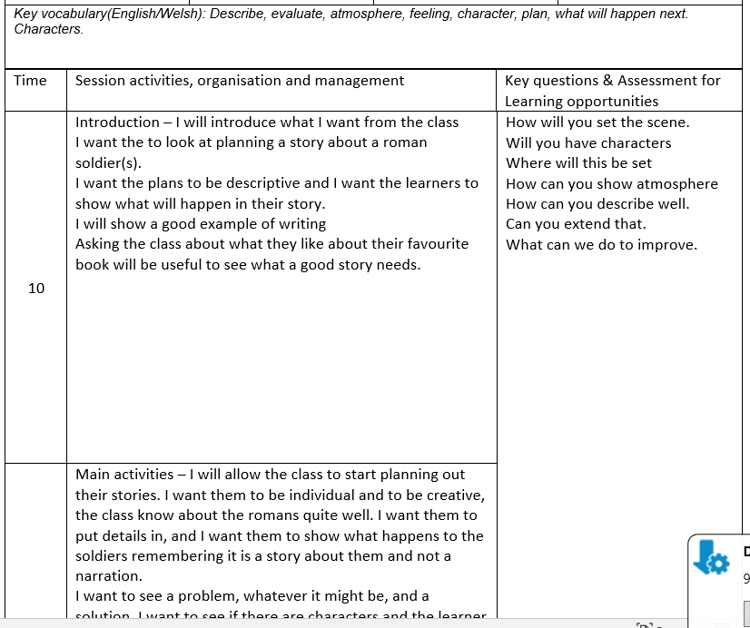
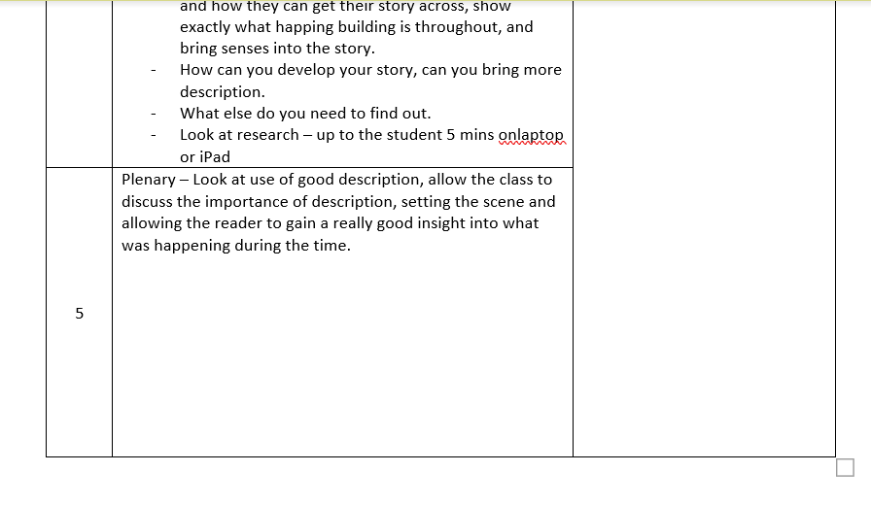
Appendix
Fig 2
Fig 1.
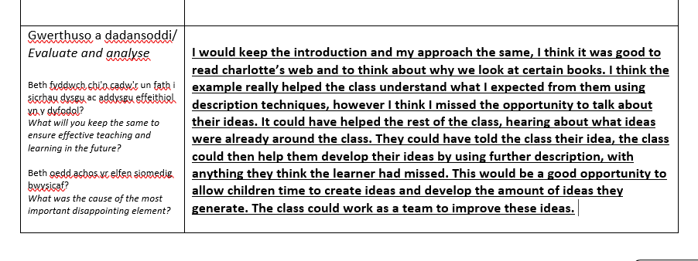
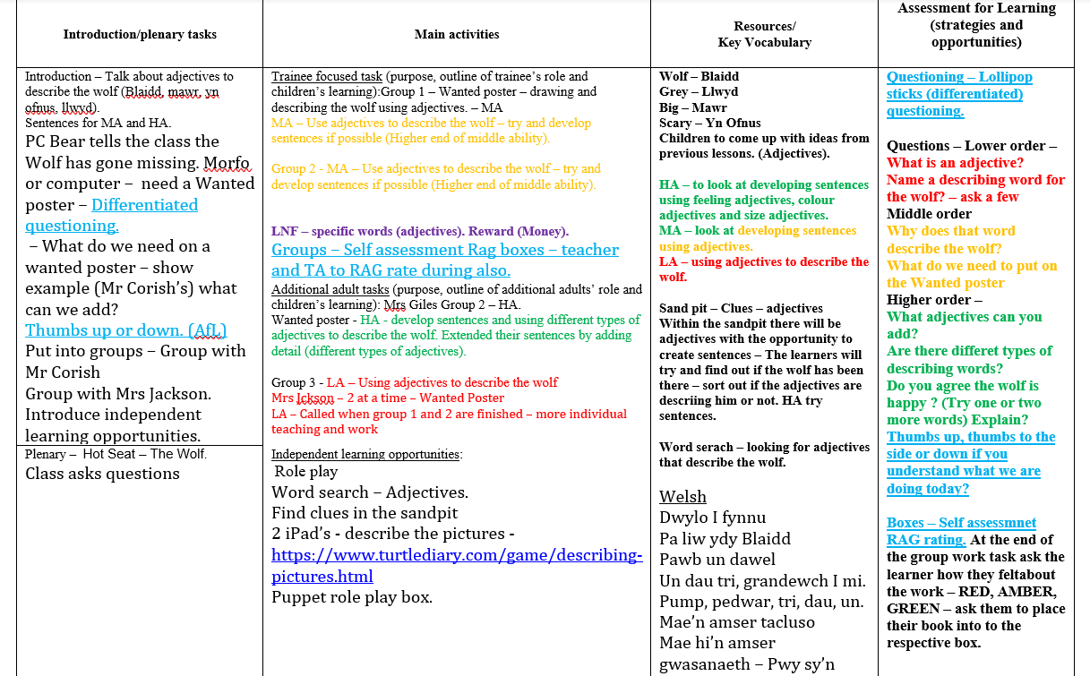

Fig 5.
Fig 4.
Fig 3.
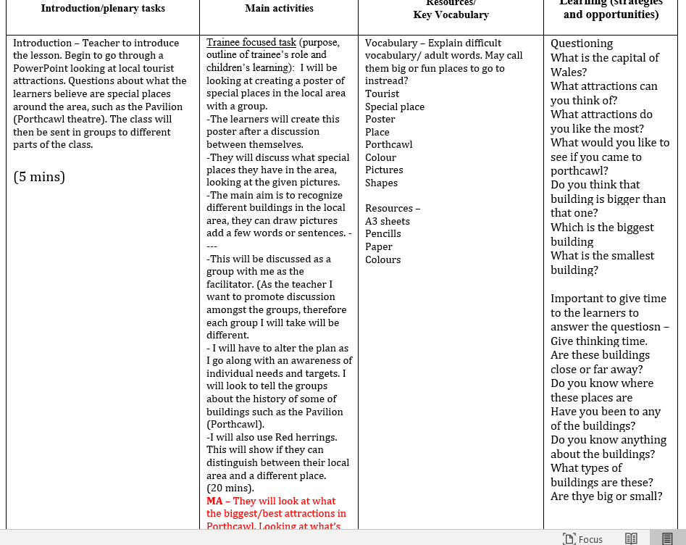

Fig 6.

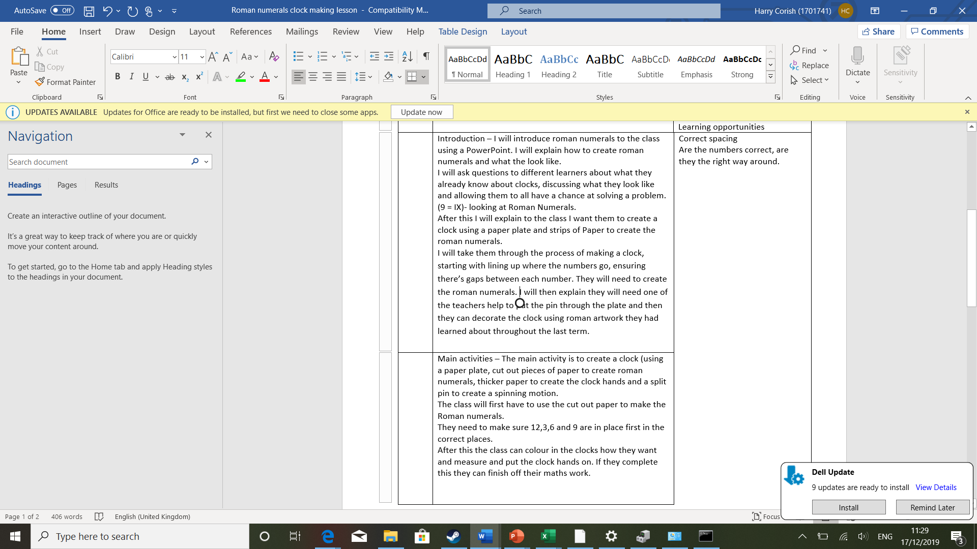

Fig 7.

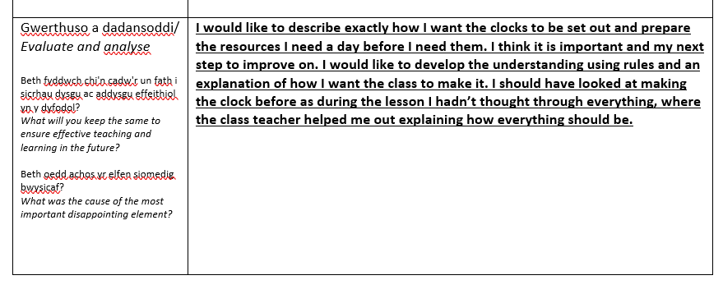
Fig 8.

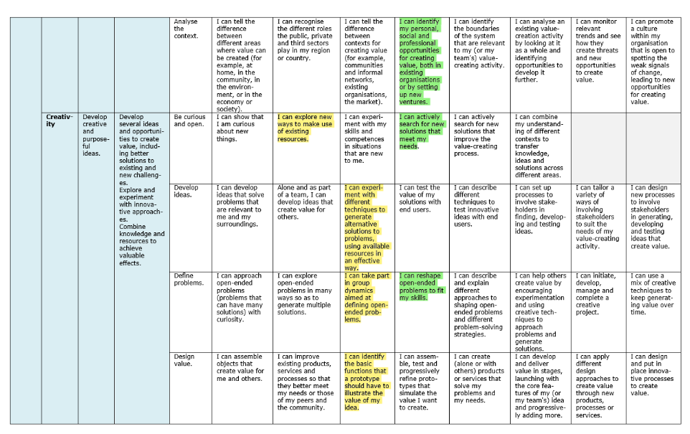

Fig 9. (Bacigalupo et al, 2016) creativity
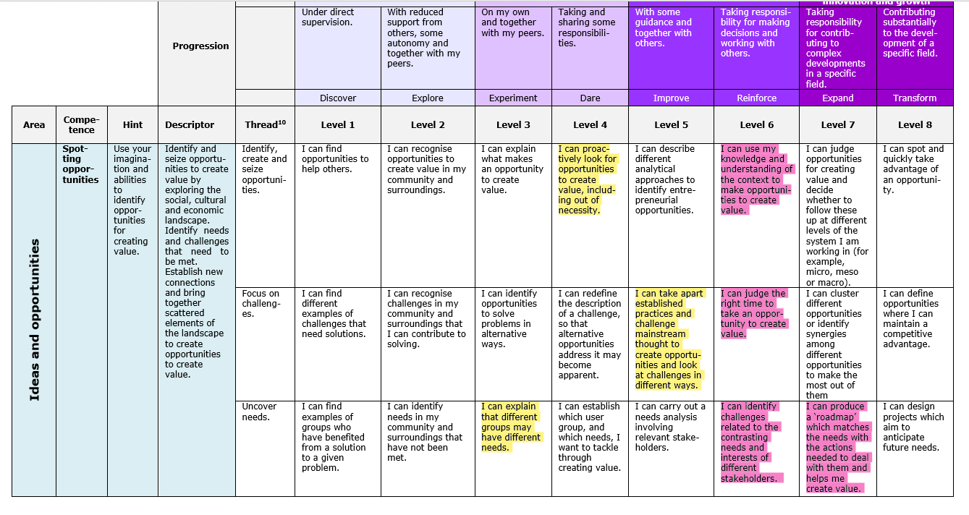
Fig 10. (Bacigalupo et al, 2016)
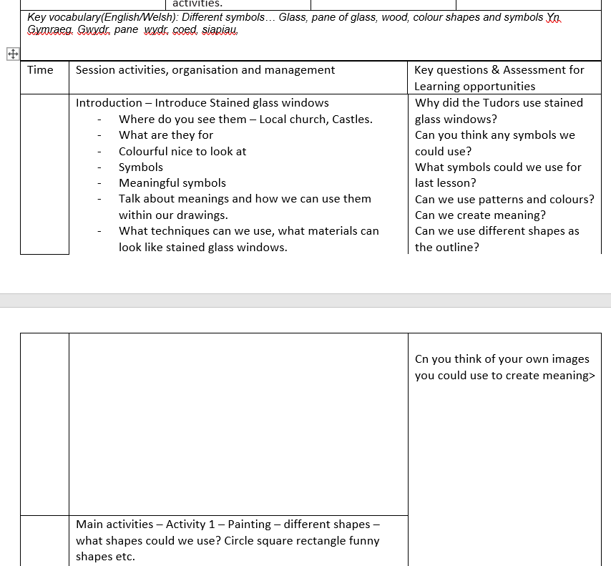
Fig. 11

