Rendering industry data comprehensible by utilising visualisations, an investigation.

by
Shane Clement

Supervisor: Jeanette Adams
Second Marker: Andrew Green

Project submitted as part of the requirements for the award of BSc (Hons) Applied Computing

June 2024

Table of Contents

1. Problem Statement 4
1.1 Introduction 4
1.2 Data Visualisations 4
1.2.1 Origins 4
1.2.2 DVs Through Business Motives 5
1.2.3 DV Techniques 5
1.2.4 Key Representatives 6
1.2.5 Platforms and Tools 7
1.3 Human Cognition 8
1.3.1 Perception of Visuals 8
1.3.2 Human-Computer Interaction (HCI) 8
1.3.2.1 Gestalt Psychology 9
1.4 Interpreting Inventory Data 10
1.4.1 Inventory Management Systems (IMS) 10
1.4.2 Utilising Visuals to Facilitate Decision-Making 10
1.4.3 Cynefin Framework 10
1.5 Safeguarding Data Privacy 11
1.5.1 Access Control Policies 11
1.5.2 GDPR 11
1.6 Conclusion 11
2. Aims and Objectives 12
2.1 Aim 12
2.1.1 Objectives 12
3. Deliverables 13
3.1 Scope 13
3.2 Application Type 13
3.3 Resources 13
3.3.1 Software Requirements 13
3.3.2 Development Techniques 13
3.3.3 Visualisations 13
4. Research Methodologies 14
4.1 Philosophy 14
4.2 Approach 14
4.3 Strategy 14
4.4 Choices 14
4.5 Time Horizon 14
4.6 Techniques and Procedures 15
4.6.1 Ethics and Legal 15
5. Project Plan 16
5.2 Work Breakdown Structure 16
5.2 Gantt Chart 17
6. Bibliography 18
‌5.1 Figures 20
7. Ethics Form 21

1. Problem Statement

1.1 Introduction
The project will investigate a Data Visualisation (DV) solution for a client who conducts inventory inspections. The client uses Capcon, a software package which outputs data in a Portable Document Format (PDF). Interpretation challenges emerge when the client conveys the data to their customers. It is proposed that integrating visualisations will enhance comprehension and support informed decisions. Capcon restricts usage to a single user and device, limiting accessibility for the client's coworker in a different location. Mitigating this obstacle should enhance the clients’ workflow significantly.
To support the investigation, research will be performed regarding the history and utilities of data visualisations, the cognition infrastructure supporting humans perceiving visualisations, the interpretation of inventory data, and concerning factors in data safeguarding.

1.2 Data Visualisations

1.2.1 Origins
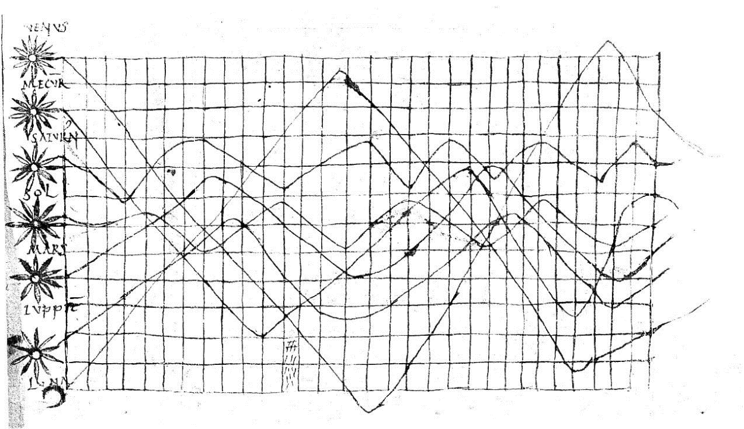
It is estimated that humans have been visualising data from the late 10th or early 11th century, with an example by Cicero (figure 1.1) consisting of the daily astronomy and physics being reviewed through time function collections of planetary orbits (1 p.1-3, 2 p.2426). The origin representation of statistical data was created in a graphical formation (figure 1.2) that portrayed the distance from Toledo, Spain to Rome, Italy - by Michael Florent van Langren in 1644 (3 p.1). Statistical graphics such as line graphs and bar and pie charts that are present today, were firstly the work of William Playfair (figure 1.3) (1, 4). His invention helped navigate the perception of how humans perceive Data Visualisations (DVs) as a universal language.
Figure 1.1 Approximately 10th or 11th-century time-series graph by Cicero

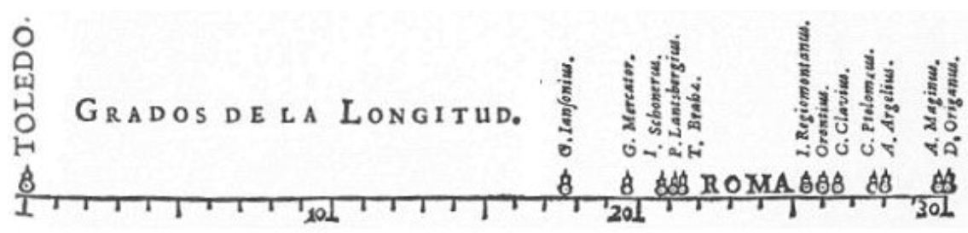
Figure 1.2 Toledo to Rome distance graph by Langren

Figure 1.3 Bar graph by Playfair (1976)

1.2.2 DVs Through Business Motives
The essence of DVs is imperative in modern organisations, aiding business processes through logical and graphical representations of intrinsic datasets. Non-technical personnel can simplistically decompose the data to gain insights and make data-driven decisions. DVs cover various aspects like market trends, Key Performance Indicators (KPI), and discrepancies (5 p.133).

1.2.3 DV Techniques
Srivastava (6 p.126) advocates for data analysts to choose efficient data representation techniques. Bar charts compare data categories, pie charts differentiate size proportions, and line graphs detect trends (6, 7). These techniques facilitate in conveying information across domains like inventory management, customer interactions, and competitor analysis. As data proliferates rapidly, integrating visualisation disciplines becomes crucial for firms to augment their economic moat (8 p.1).

1.2.4 Key Representatives
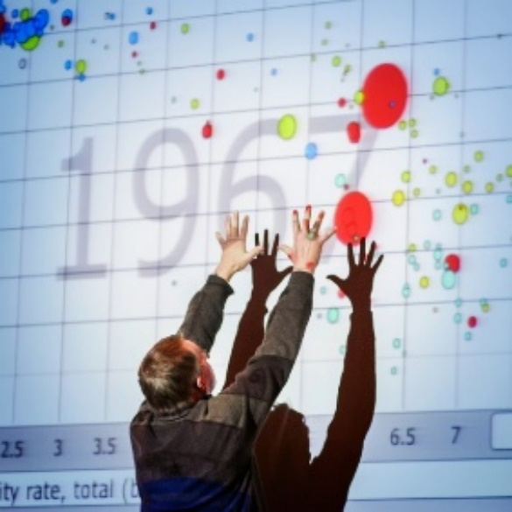
In his Ted Talk on human development trends, Hans Rosling utilised visualisations like charts and mapping techniques (Figure 2.1) to present sophisticated datasets (9). Using a bubble chart, he effectively decomposed a large volume of statistical data, allowing the audience to comprehend relationships between variables over time. This talk was pivotal in the data world, igniting an understanding of how to utilise and convey data complexities across a timescale (10).
Figure 2.1 Hans Rosling presents statistics through a bubble chart.

Edward Tufte, a DV expert, posited that the most simplistic graphics to comprehend are thoroughly well-designed in nature (11). Perceiving complex datasets through visualisations is an effective approach to analyse, summarise, and project quantitative information. A collection of miniature data graphics that are affiliated to a data set where the human eye can compare simultaneously, are known as ‘small multiples’ (Figure 2.2), a term popularised by Tufte (12 p.5).
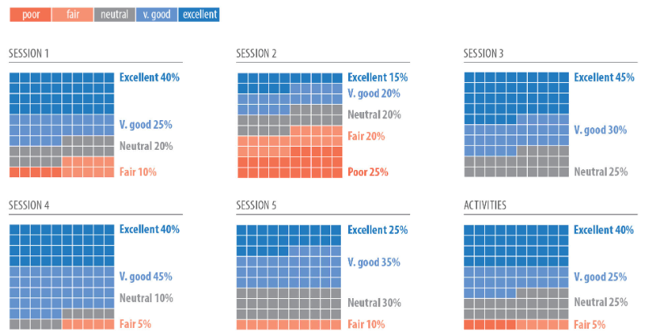
Figure 2.2 Small multiple waffle charts

1.2.5 Platforms and Tools
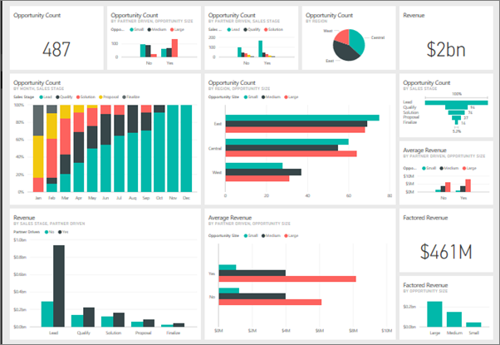
Off-the-shelf DV platforms like Microsoft's Power BI offer a collection of tools for organisations to integrate and visualise diverse operational data. Power BI transforms complex, structured data from sources like databases, spreadsheets and JSON files into user-friendly reports and dashboards (Figure 2.3). Users can select visualisations and apply filtration methods to transparently represent the data, although operating Power BI to its full potential requires a certain skill level (13).
Figure 2.3 PowerBI Dashboard

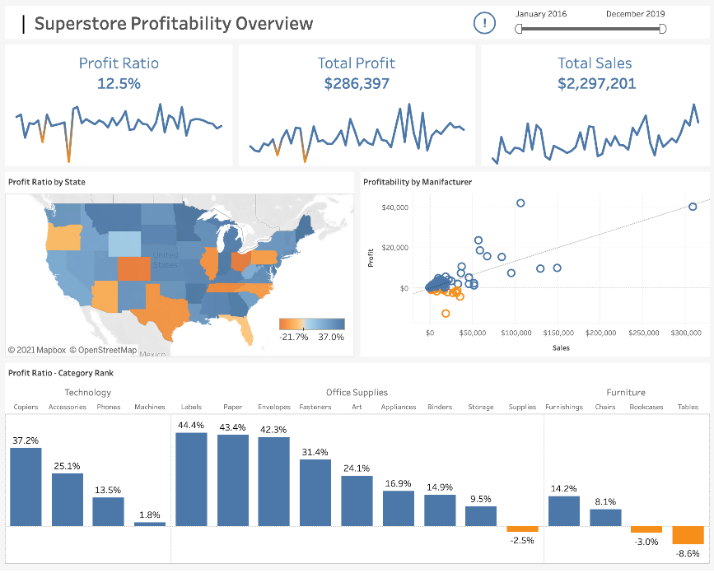
Tableau provides development and user-service environments. It is extensively utilised in the field of data analytics and provides many capabilities, such as infographics, geographic mapping, data cleansing, and data plotting (Figure 2.4) (14 p.318).
‌ Figure 2.4 Tableau Dashboard
Alternatively, businesses can develop bespoke DV applications that are customised for their specific processes. This approach provides streamlined methods that are tailored to a given dataset. Data security is magnified with bespoke as it is not shared with the vendor, unlike an off-the-shelf system (15).

1.3 Human Cognition

1.3.1 Perception of Visuals
Adopting data visualisations is crucial for communicating complex datasets effectively. However, selecting the appropriate techniques and elements to encapsulate the data’s meaning is paramount. Depending on user needs, interpreting how humans perceive visualisations is a cornerstone for the data to attain logical conveyance (16 p.9). How individuals process thought is largely attached to the human eye due to all bodily senses contributing to roughly 70% of vision. Moore (17 p.131) concurs, highlighting the cognitive tasks performed by the brain are based on visual input. Cognitive and perception processes work simultaneously, and depending on the visualisation, patterns will either make sense or be imperceptible (et al Ware) (18).

1.3.2 Human-Computer Interaction (HCI)
HCI first existed in the computer science field that involves the study of the interaction between humans and computers. Dix (19 p.3) asserts that HCI dates to the 1950s regarding a study by (Shackel et al) on the redesign of an analogue system’s control panel. This research incorporated principles of HCI, focusing on design, visuals, and prototyping. Carroll (20) states that HCI became more prevalent when personal computers were popularised in the late 1970s. Presently, it is used in multiple domains including user interfaces, visualisations, and system development (Figure 3.1). Huang (21 p.1) articulates that a system’s user interface is at the forefront of interaction. Designers and developers should maintain HCI principles that make computers usable to the user so that goals can be completed.
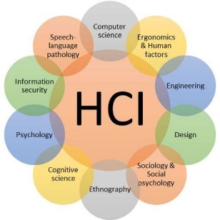

Figure 3.1 Holistic representation of HCI domains

1.3.2.1 Gestalt Psychology

Co-founded by Koffka and Kohler, Gestalt psychology delves into the sensations and perceptions of humans (22). It suggests that the human brain initially divides elements into parts to create a perception of the world as a complete and meaningful experience. The brain naturally organises information to form relevant and segregated wholes (23 p.139). For instance, objects viewed from a distance may be perceived differently up close, leading to the formation of shapes. The Cassiopeia constellation (Figure 3.2) in Gestalt represents a 'W' or 'M' shape in the sky, created by five stars perceived as closely intact, despite their actual immeasurable distance from each other (23).
Figure 3.2 Cassiopeia Constellation


The Kanizsa triangle (Figure 3.3) constructs an illusory contour where a series of visual stimuli and segmented lines are implied to perceive a connection. A triangular shape can be visualised, but the cognition system creates imaginary lines that connect two parallel and aligned edges (24 p.423-424).
Figure 3.3 Kanizsa Triangle

1.4 Interpreting Inventory Data

1.4.1 Inventory Management Systems (IMS)
Businesses leverage IMSs to centralise inventory monitoring, enabling stakeholders to forecast informed decisions. Verbeeke (25 p.16) indicates that resource availability is enhanced through an IMS (Chan et al.), and customer support measures can be achieved, (Reid et al). IMS objectives include enhancing overall costs by observing stock levels, ordering and shortages, minimising inventory expenditures, and facilitating cost-effective operations. Business Intelligence (BI) decisions can be executed with an IMS such as determining a product’s popularity (26 p.13). A study (27 p.567) suggests that IMS reduce human errors by eliminating manual processes. However, adopting a computerised system may pose challenges, with security risks identified, particularly in web-based systems where malicious hacking exists (28 p.104).

1.4.2 Utilising Visuals to Facilitate Decision-Making
Data-driven decision-making within organisations is essential to enhance the progression of business processes. Informed decisions are made throughout a variety of management levels: strategic, organisational, and tactical, using BI techniques such as DVs. Well-designed dashboards enhance human perceptions during decision-making, to facilitate the process of comparing and analysing KPIs to pinpoint data anomalies and inconsistencies (29 p.1903-1905, 30).

1.4.3 Cynefin Framework
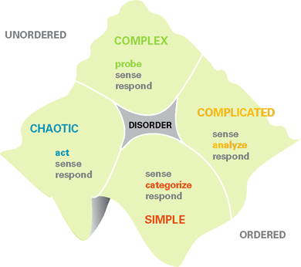
The Cynefin framework, developed by Welsh researcher and consultant Dave Snowden, conceptualises decision-making processes for solving complex problems. This systematic framework (Figure 4.1) comprises five contexts that leaders must navigate: complex, complicated, chaotic, and simple. In cases where the primary context is unclear, disorder is applied (31). Moore (17 p.130) articulates that unclarities arise when acknowledging the cause and effect of strategic decisions, and adopting the Cynefin framework helps address these business complexities.
Figure 4.1 The Cynefin Framework

1.5 Safeguarding Data Privacy

When managing data, ethical guidelines must be followed to address privacy concerns. Analytical tools are used for storing, retrieving, sharing, and visualising data, emphasising the need to enhance data safety (32). Data integrity is crucial for privacy, especially since organisational data is confidential (33). Inventory data, considered intellectual property, poses a risk if breached that could potentially benefit competitors. Therefore, safeguarding data is essential for protecting organisational interests.

1.5.1 Access Control Policies
Safeguarding data and resources from unauthorised disclosure and improper modifications, while ensuring availability to legitimate users, is a crucial requirement for any inventory management system. Enforcing protection involves controlling every system’s access to allow only authorised users (34 p.137, 35).

1.5.2 GDPR
The General Data Protection Regulation was enforced in 2018 which represents a shift in data protection laws that enforces more protection responsibilities on organisations. An article postulates that (36 p.1292-1294) these guidelines must be adhered to when processing information, if not, organisations may be susceptible to pay fines up to 20 million euros or 4% of their revenue.

1.6 Conclusion
Data visualisations are an integral tool to aid with decision-making procedures. Although they have existed from as early as between the 10th and 11th centuries, DVs have been popularised within business reporting since the 1960s. It is necessary to not only understand the benefits they obtain from harnessing business processes but also to grasp the inner workings of how humans perceive visual designs. HCI and Gestalt psychology are cornerstones within visualisations as they help to hypothesise the process of human cognition through the interpretation phases.
It is possible to conclude that amalgamating visualisations with inventory management systems allows data to be rendered into a meaningful context. This can identify future processes that may not have been detected. Safeguarding initiatives are essential to mitigate data privacy concerns such as access control policies and abiding by regulations like GDPR. Understanding and following the existing research will assist the investigation in accomplishing the intended solution.

2. Aims and Objectives

2.1 Aim
Evaluate the effectiveness of the client adopting visualisations when rendering inventory data, to facilitate decision-making.

2.1.1 Objectives

- Gather system requirements:
  - Meet with the client to discuss the solution to a given problem.
  - Discover what data visualisations represent holistically.
  - Explore the factors of how visuals are perceived through human cognition.
  - Research the importance of transforming inventory stock data into a meaningful context for business processes.
  - Investigate the significance of mitigating security initiatives for safeguarding data privacy.

- Design and develop the application:
  - Investigate Capcon’s software output.
  - Design the interface through mock-up drafts.
  - Formulise prototypes of code.
  - Develop the application through Visual Studio IDE in C# WinForm.NET.
  - Integrate iTextSharp for PDF extraction and manipulation.
  - Adopt testing procedures for bug or error detection – with revisions.
  - User acceptance testing.

- Reflect upon the effectiveness of the development model:
  - Achieving the solution.
  - Future application improvements.
  - Alternative approaches.

3. Deliverables

3.1 Scope
A desktop application will be created using Visual Studio's C# Windows Forms to save, process, and load data into various visualisations from a PDF file. The GUI architecture includes buttons, textboxes, and labels. iTextSharp library will be utilised to transform and manipulate the client's PDFs into a text file. This conversion enables the application to generate comprehensible data.

3.2 Application Type
A desktop application is ideal for the client's needs as it requires only offline access for loading data files. Desktop apps offer improved performance and speed by avoiding network interruptions. Security is enhanced through local data storage without an internet connection. Given the nature of depicting data, developing a mobile application would be impractical and challenging for users to perceive smaller-scale visualisations (37).

3.3 Resources

3.3.1 Software Requirements

- Windows 10/11
- Visual Studio 2022
- C# Language
- iTextSharp library
- Charting libraries (Nevron Chart, LiveChart)

3.3.2 Development Techniques
C# WinForms.NET is selected for development, providing pre-built templates for seamless integration. C# incorporates libraries like LiveCharts and iTextSharp for file conversion, enhancing the user experience (38). WinForms.NET, recognised for its user-friendly GUI capabilities, features an editor window for drag-and-drop GUI components and a main window for code development (39 p.11). Visual Studio IDE, chosen for its amalgamation with C#, offers essential features like debugging, testing, IntelliSense, and syntax highlighting (40 p.144-162, 41).

3.3.3 Visualisations
The researcher received an exemplified spreadsheet from the client, consisting of field names like products, stock, sales, and profits. Key fields to analyse include ‘Variance (£)’, ‘Total Gross Sales (£)’ and ‘General Profit (%)’. Bar charts will compare sales (£) across periods, line graphs for detecting trends over time, and pie charts will project percentage data proportions (6, 7).

4. Research Methodologies

4.1 Philosophy
The philosophical approach will be phenomenology, a qualitative research method that quantifies the study of human opinion (42 p.38). The research will capture stakeholders’ experiences whilst eradicating any external biases. Phenomenology allows the researcher to develop calculated observations from stakeholder feedback to determine the degree to which the proposed solution is effective (43). Phenomenology should assist in uncovering stakeholders’ requirements and motivations to develop an intuitive application.

4.2 Approach
An inductive approach facilitates the invention of theories and observations from research and stakeholder feedback. These initiatives are developed through observing and calculating an individual experiencing a specific event (44 p.172). Fostering a qualitative research method, this project will benefit from an inductive approach when collecting stakeholder feedback and experiences (45).

4.3 Strategy
Action Research, chosen for this investigation, involves conducting research as a live process to adapt to continuously changing data. This strategy systematically gathers stakeholder experiences, allowing for learning and reflection. The researcher and practitioner act as a single entity, simplifying improvements and knowledge attainment from stakeholders' experiences (46 p.684). Action research encompasses problem realisation, solution development and implementation, and evaluation and reflection processes, benefitting the investigation’s progress (47 p.38).

4.4 Choices
A mono-method process has been selected to gather qualitative primary data as the researcher is solely conducting interviews with the client. Benefits should materialise from this decision through the stakeholders openly conveying their perspectives and experiences of the phenomenon. From this, the researcher will thoroughly understand the strengths and weaknesses, such as flaws in the data visualisation designs (48).

4.5 Time Horizon
A cross-sectional research design, chosen for its analysis of the population at a specific time, allows for the gathering and evaluation of both primary and secondary research. This mechanism facilitates observations and permits the selection of a sample population based on specific criteria, proposing solutions to their current problem (49, 50). Cross-sectional should be advantageous as it grants the stakeholders’ experiences to be evaluated at the project’s conclusion.

4.6 Techniques and Procedures
Client interviews will use a semi-structured framework with open-ended questions to gather feedback (51). This approach allows diverse perspectives for recognising and addressing application requirements and concerns. Engagement with stakeholders' clients may be necessary for solution appropriateness, using Microsoft Forms for cost-effective and rapid questionnaire distribution (52). Coding and data analysis will enhance data quality, summarising responses into themes (53 p.259). A hybrid qualitative approach, combining pre-identified and emergent themes, will be employed (54). Self-directed questions will guide data utilisation and address research objectives.

4.6.1 Ethics and Legal
Ethical considerations are integral to harnessing valid and accurate data, certifying the research's integrity. As the project involves managing clients' data, qualitative research will incorporate data-safeguarding initiatives, with the researcher being accountable for adherence (55 p. 320-323). Avoiding plagiarism is vital for maintaining research integrity and avoiding copyright issues. A Vancouver referencing style will be consistently applied during secondary research in the study.

5. Project Plan

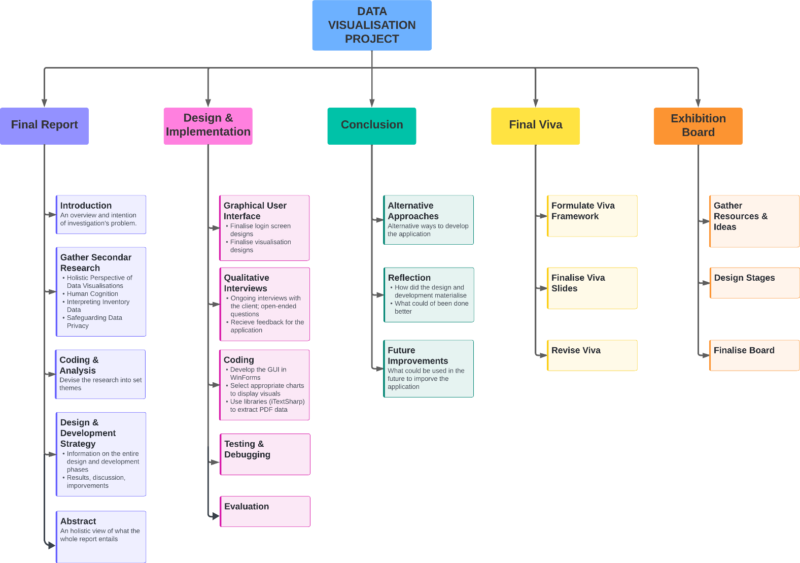
5.2 Work Breakdown Structure

5.2 Gantt Chart
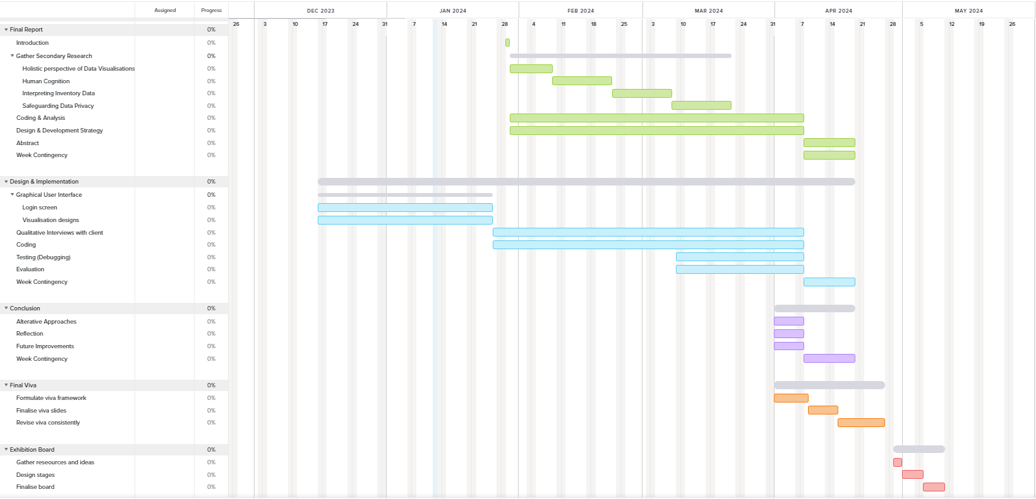

6. Bibliography

- Wood B, Bolch C. Seeing and Understanding Data. Statistics and Probability [Internet]. 1.10.2018 [Accessed on 18.11.2023]; Available from: https://digitalcommons.ursinus.edu/triumphs_statistics/2/?utm_source=digitalcommons.ursinus.edu%2Ftriumphs_statistics%2F2&utm_medium=PDF&utm_campaign=PDFCoverPages
- Spence I. William Playfair and the Psychology of Graphs. JSM: Proceedings of the American Statistical Association. 2006. Available from: https://www.researchgate.net/publication/228091928_William_Playfair_and_the_Psychology_of_Graphs
- Friendly M, Valero-Mora P, Ibáñez Ulargui J. The First (Known) Statistical Graph: Michael Florent van Langren and the “Secret” of Longitude. The American Statistician [Internet]. 2010 May;64(2):174–84. Available from: https://www.datavis.ca/papers/langren-TAS09154.pdf
- Callejon M. Masters series: William Playfair, the father of statistical graphics [Internet]. Flourish. 2023 [Accessed on 18.11.2023]. Available from: https://flourish.studio/blog/masters-william-playfair-father-of-statistical-graphics/
- Almobark B. A Quantitative Approach for Data Visualization in Human Resource Management. International Journal of Computer Science and Network Security. 2023;23(2). Available from: https://www.researchgate.net/publication/368882391_A_Quantitative_Approach_for_Data_Visualization_in_Human_Resource_Management
- Srivastava D. An Introduction to Data Visualization Tools and Techniques in Various Domains. International Journal of Computer Trends and Technology [Internet]. 2023 Apr 30;71(4). Available from: https://ijcttjournal.org/2023/Volume-71%20Issue-4/IJCTT-V71I4P116.pdf
- Siirtola H. The Cost of Pie Charts [Internet]. IEEE Xplore. 2019. Available from: https://ieeexplore.ieee.org/abstract/document/8812005
- ‌Chy MKH, Buadi ON. Role of Data Visualization in Finance. American Journal of Industrial and Business Management. 2023 Aug 7;13(8). Available from: https://www.scirp.org/journal/paperinformation.aspx?paperid=127201
- ‌‌Rosling H. The best stats you’ve ever seen. 2006 [Accessed on 25/11/2023]. Available from: https://www.ted.com/talks/hans_rosling_the_best_stats_you_ve_ever_seen?autoplay=true&muted=true&language=en
- Kempler P, Kazar K, Éva Kuruczleki. Seeing Dynamic Data Visualizations in Action: Gapminder Tools. Springer eBooks. 2022 Jan 1;179–98. Available from: https://link.springer.com/chapter/10.1007/978-3-031-20748-8_8#Sec3
- Tufte ER. The Visual Display of Quantitative Information. 2nd ed. Graphics Press; 2007.
- Few S. Data Visualization: Past, Present, and Future. 2007. Available from: https://www.perceptualedge.com/articles/Whitepapers/Data_Visualization.pdf
- Kosara R, Mackinlay J. Storytelling: The Next Step for Visualization. 2013 May;46(5):44–50. DOI: 10.1109/MC.2013.36Raszler A. How Power BI can be Built to Analyze Player and Team Statistics in the NBA. Theses/Capstones/Creative Projects [Internet]. 2020 May 1 [cited 2023 Nov 25]; Available from: https://digitalcommons.unomaha.edu/university_honors_program/98/?utm_source=digitalcommons.unomaha.edu%2Funiversity_honors_program%2F98&utm_medium=PDF&utm_campaign=PDFCoverPages
- Batt S, Grealis T, Harmon O, Tomolonis P. Learning Tableau: A data visualization tool. The Journal of Economic Education. 2020 Aug 20;5. DOI: 10.1080/00220485.2020.1804503
- Halwai S. Comparison Bespoke Software And Off-The-Shelf Software | [Internet]. Sigma Data Systems. 2021 [Accessed on 25/11/2023]. Available from: https://www.sigmadatasys.com/how-bespoke-software-is-nothing-like-off-the-shelf-software/
- Kelleher C. VISUALIZING THE UNIVERSAL DATA CUBE A Dissertation Presented [Internet]. 2014 [cited 2023 Nov 27]. Available from: https://curran.github.io/phd/dissertation/dissertation.pdf
- Moore J. Data Visualization in Support of Executive Decision Making. Interdisciplinary Journal of Information, Knowledge, and Management. 2017;12.
- Few S. Information Dashboard Design: The Effective Visual Communication of Data. O’Reilly. 2006. Available from: http://public.magendanz.com/Temp/Information%20Dashboard%20Design.pdf
- Dix A. Human–computer interaction, foundations and new paradigms. Journal of Visual Languages & Computing. 2017 Oct;42: https://doi.org/10.1016/j.jvlc.2016.04.001
- Carroll JM. Human Computer Interaction - Brief Intro [Internet]. The Interaction Design Foundation. UX Courses; 2012 [Accessed on 2/12/2023]. Available from: https://www.interaction-design.org/literature/book/the-encyclopedia-of-human-computer-interaction-2nd-ed/human-computer-interaction-brief-intro
- Huang K. Challenges in Human-Computer Interaction Design for Mobile Devices. 2009;1. Available from: https://iaeng.org/publication/WCECS2009/WCECS2009_pp236-241.pdf
- Paul Main. Gestalt Psychology [Internet]. 2023 [Accessed on 24/11/2023]. Available from: https://www.structural-learning.com/post/gestalt-psychology
- Wolfgang Köhler. Gestalt psychology: an introduction to new concepts in modern psychology. New York: Liveright; 1992.
- Lehar S. Directional Harmonic Theory: A Computational Gestalt Model to Account for Illusory Contour and Vertex Formation. Perception. 2003 Apr;32(4). DOI:10.1068/p5011
- Verbeeke N. Data-driven Inventory Management. 2021 [Accessed on 2/12/2023]. Available from: https://essay.utwente.nl/87631/1/Verbeeke_BA_EEMCS.pdf
- Chin C, Ramiah S, Razali NF. Inventory Management Systems (IMS). Journal of Applied Tech ology and Innovation. 2023;7(3). Available from: https://www.researchgate.net/publication/372653862_Inventory_Management_Systems_IMS
- Atieh AM, Kaylani H, Al-abdallat Y, Qaderi A, Ghoul L, Jaradat L, et al. Performance improvement of inventory management system processes by an automated warehouse management system. Procedia CIRP. 2016;41(1). Available from: https://www.sciencedirect.com/science/article/pii/S2212827115012019
- Jorge Mamani Idme, Valenzuela L, Morales H, Laberiano Andrade–Arenas. The Implementation of Information Security for the Inventory System in a Municipality of Lima-Perú. International Journal on Advanced Science, Engineering and Information Technology. 2022 Jan 26;12(1). DOI:10.18517/ijaseit.12.1.13914
- Abu-AlSondos IA. The impact of business intelligence system (BIS) on quality of strategic decision-making. International Journal of Data and Network Science. 2023;7(4). DOI: 10.5267/j.ijdns.2023.7.003
- Zhang T, Wang X, Li ZZ, Guo F, Ma Y, Chen W. A survey of network anomaly visualization. 2017 Apr 24;60(12). DOI: 10.1007/s11432-016-0428-2
- ‌Snowden D, Boone M. A Leader’s Framework for Decision Making. Harvard Business Review. 2007 [Accessed on 2/12/2023]. Available from: https://hbr.org/2007/11/a-leaders-framework-for-decision-making
- Gahi Y, Guennoun M, Mouftah HT. Big Data Analytics: Security and privacy challenges. IEEE Xplore. 2016. DOI: 10.1109/ISCC.2016.7543859
- ‌Yadav C, Wang S, Kumar M. Algorithm and approaches to handle large Data – A Survey. International Journal of Computer Science and Network. 2013;2(3). Available from: https://arxiv.org/ftp/arxiv/papers/1307/1307.5437.pdf
- Samarati P, Capitani de Vimercati. Access Control: Policies, Models, and Mechanisms. Foundations of Security Analysis and Design. International School on Foundations of Security, Analysis and Design. 2001. Available from: https://link.springer.com/content/pdf/10.1007/3-540-45608-2_3.pdf
- Dr. Ingle DR. Literature Review of Data Security Measures and Access Control Mechanisms of Information Security. 2022. Available from: https://www.researchgate.net/publication/362541370_Literature_Review_of_Data_Security_Measures_and_Access_Control_Mechanisms_of_Information_Security_Head_of_Department
- Labadie C, Legner C. Understanding Data Protection Regulations from a Data Management Perspective: A Capability-Based Approach to EU-GDPR. 2019. Available from: https://serval.unil.ch/resource/serval:BIB_65AAB323C49C.P001/REF.pdf
- Patel S. Exploring Desktop Application Development: Benefits, Types, and Process. 2023 [Accessed on 9/12/2023]. Available from: https://www.cmarix.com/blog/desktop-application-development/#:~:text=There%20are%20numerous%20benefits%20to,network%20latency%20or%20bandwidth%20issues.
- Jamil IA, Abedin MI, Sarker DK, Islam J. Vibration Data Acquisition and Visualization System using MEMS Accelerometer. International Conference on Electrical Engineering and Information & Communication Technology. 2014. DOI: 10.1109/ICEEICT.2014.6919090
- Almeida F. Visual C#.NET: Console Applications and Windows Forms. ISSUU Publishing; 2018.
- Price MJ. C# 10 and .NET 6 - Modern Cross-Platform Development - Sixth Edition Build Apps, Websites, and Services with ASP. NET Core 6, Blazor, and EF Core 6 Using Visual Studio 2022 and Visual Studio Code. Birmingham: Packt Publishing, Limited; 2021.
- Tan J, Chen Y, Jiao S. Visual Studio Code in Introductory Computer Science Course: An Experience Report. 2023 Mar 10. DOI: 10.48550/arXiv.2303.10174
- Mwadulo MW, Odoyo CO. Phenomenology Approach Applicability in Information Systems and Technology Field. Computer Science and Information Technology. 2020;8(2). Available from: https://www.researchgate.net/publication/341828080_Phenomenology_Approach_Applicability_in_Information_Systems_and_Technology_Field
- Smith, D W. Phenomenology, The Stanford Encyclopedia of Philosophy (Summer 2018 Edition). 2013 [Accessed on 22.09.2023]. Available from: https://plato.stanford.edu/archives/sum2018/entries/phenomenology/
- Malhotra G. Strategies in Research. International Journal Of Advance Research And Development. 2017;2(5). https://www.ijarnd.com/manuscripts/v2i5/V2I5-1220.pdf
- Creswell. JW. Research Design. Qualitative, Quantitative and Mixed Methods Approaches. 3rd ed. Sage Publications. 2009.
- Romeo G. Computers and the primary curriculum: an action research case study. IFIP World Conference on Computers in Education. Springer eBooks. 1995. Available from: https://link.springer.com/chapter/10.1007/978-0-387-34844-5_64
- Kotsias J, Ahmad A, Scheepers R. Adopting and Integrating Cyber-Threat Intelligence in a Commercial Organisation. European Journal of Information Systems [Internet]. 2022 Jul 11;1–17. Available from: https://www.tandfonline.com/doi/full/10.1080/0960085X.2022.2088414
- ‌Nyanchoka L, Tudur-Smith C, Porcher R, Hren D. Key stakeholders’ perspectives and experiences with defining, identifying and displaying gaps in health research: a qualitative study protocol. BMJ Open. 2019 Aug;9(8). DOI: 10.1136/bmjopen-2018-027926
- Setia MS. Methodology Series Module 3: Cross-sectional Studies. Indian Journal of Dermatology [Internet]. 2016;61(3):261–4. Available from: https://www.ncbi.nlm.nih.gov/pmc/articles/PMC4885177/
- Mukherjee D, Roy S. Cross-sectional study. Elsevier eBooks. 2023 Jan 1;237–41. DOI: https://doi.org/10.1016/B978-0-323-88423-5.00101-1
- Jamshed S. Qualitative research method-interviewing and observation. Journal of Basic and Clinical Pharmacy [Internet]. 2014;5(4):87–8. Available from: https://www.ncbi.nlm.nih.gov/pmc/articles/PMC4194943/
- ‌Mcleod S. Questionnaire: Definition, examples, design and types [Internet]. Simply Psychology. 2023 [Accessed on 24/11/2023]. Available from: https://www.simplypsychology.org/questionnaires.html
- Skjott Linneberg M, Korsgaard S. Coding qualitative data: a synthesis guiding the novice. Qualitative Research Journal. 2019;19(3). DOI 10.1108/QRJ-12-2018-0012
- ‌Xu W, Zammit K. Applying Thematic Analysis to Education: A Hybrid Approach to Interpreting Data in Practitioner Research. International Journal of Qualitative Methods. 2020;19. DOI: doi.org/10.1177/1609406920918810
- Finlay L. ‘Rigour’, ‘Ethical Integrity’ or ‘Artistry’? Reflexively Reviewing Criteria for Evaluating Qualitative Research. British Journal of Occupational Therapy; 2006. Available from: https://citeseerx.ist.psu.edu/document?repid=rep1&type=pdf&doi=a6913a4e7c6c59a421feda190264a127348be92e

‌5.1 Figures
1.1, 1.2, 1.3 Wood B, Bolch C. Seeing and Understanding Data. Statistics and Probability [Internet]. 1.10.2018 [Accessed on 18.11.2023]; Available from: https://digitalcommons.ursinus.edu/triumphs_statistics/2/?utm_source=digitalcommons.ursinus.edu%2Ftriumphs_statistics%2F2&utm_medium=PDF&utm_campaign=PDFCoverPages
2.1 The best Hans Rosling talks you’ve ever seen [Internet]. ted.com. [Accessed on 2/12/2023]. Available from: https://www.ted.com/playlists/474/the_best_hans_rosling_talks_yo
2.2 Pirrone A. Comparing Survey Responses Over Two Time Points. Same Data, Displayed 6 Different Ways. 2021 [Accessed on 9/12/2023]. Available from: https://www.alanapirrone.com.au/blog/tag/small+multiple
2.3 Microsoft. Introduction to dashboards for Power BI Designers. 2023 [Accessed on 9/12/2023]. Available from: https://learn.microsoft.com/en-us/power-bi/create-reports/service-dashboards

2.4 Stuff by Yuki. Tableau Dashboard – Superstore. 2021 [Accessed on 9/12/2023]. Available from: https://stuffbyyuki.com/tableau-dashboard-superstore/
3.1 Design Methodologies in Human Computer Interaction. 2022 [Accessed on 2.12.2023]. Available from: https://www.linkedin.com/pulse/design-methodologies-human-computer-interaction-suresh/
3.2 Cassiopeia Constellation - Features And Facts: The Planets. 2023 [Accessed on 2/12/2023] Available from: https://theplanets.org/constellations/cassiopeia-constellation/
3.3 Nieder A. Seeing more than meets the eye: processing of illusory contours in animals. Journal of Comparative Physiology A. 2002 Apr 9;188(4):249–60.
‌4.1 Snowden D, Boone M. A Leader’s Framework for Decision Making. Harvard Business Review. 2007 [Accessed on 2/12/2023]. Available from: https://hbr.org/2007/11/a-leaders-framework-for-decision-making‌

7. Ethics Form
Name: | Shane Clement
Project/Research Title: | Rendering industry data comprehensible by utilising visualisations, an investigation.
Name of Supervisor: | Jeannette Adams
School/Dept. | NPTC
Faculty: | Computing
Proposed Start Date: | 27/10/2023 | End Date: | June 2024

1. Summary of planned research (please indicate below the purpose of your planned project/research, together with your aims, main research questions and research design – you should continue onto a separate sheet if necessary)
This research project aims to investigate the effectiveness of stakeholders utilising a data visualisation application to render inventory data more comprehensible – facilitating decision-making.
Aim
Evaluate the effectiveness of the client adopting visualisations when rendering inventory data, to facilitate decision-making.
Objectives
- Gather system requirements:
  - Meet with the client to discuss the solution to a given problem.
  - Discover what data visualisations represent holistically.
  - Explore the factors of how visuals are perceived through human cognition.
  - Research the importance of transforming inventory stock data into a meaningful context for business processes.
  - Investigate the significance of mitigating security initiatives for safeguarding data privacy.
- Design and develop the application:
  - Investigating Capcon’s software output.
  - Design interface through mock-up drafts.
  - Formulise prototypes of code.
  - Develop the application through Visual Studio IDE in C# WinForm.NET.
  - Integrate iTextSharp for PDF extraction and manipulation.
  - Adopt testing procedures for bug or error detection – with revisions.
  - User acceptance testing.
- Reflect upon the effectiveness of the development model:
  - Achieving the solution.
  - Future application improvements.
  - Alternative approaches.

2. Methodology (You need to be clear about the methodology you intend to use in your study; this could include any number of methods, so either tick those shown below (where appropriate) or put the details in the box marked *)

x | Interviews | x | Participant Observation |  | Use of personal data
 | Focus groups |  | Questionnaire | x | Literature Review
 | Performance |  | Presentation |  | Other (state below)*

3. Participants - Does your proposed project/research involve human participants?

x | 1. Yes, as a primary source* |  | 2. Yes, as a secondary source* |  | No- go to section 4

*If you have ticked yes, it is likely you will need an Advanced CRB check before undertaking your study

If yes, indicate who your participants are:

 | Early years/Pre-School children | x | Adults - give details below
 | School age children |  | Vulnerable people - give details below
 | Young People aged 17-18 | I will be using a stock taker and their assistant as my main participants.
 | Unknown at this stage

4. Ethical issues - you should tick all that apply

 | Administration of drugs incl. alcohol |  | Deprivation
 | Unpleasant stimuli in any manner or form |  | Active deception or withholding information
 | Collection of highly personal information |  | Payment

5. Are there any ethical concerns other than those listed above? (Continue onto a separate sheet if necessary)

6. If there are any ethical concerns, please state how you intend to minimise any risk of harm or distress that could be caused (continue onto a separate sheet if necessary)

You should enclose any materials (e.g. questionnaire, interview schedule), plus the Consent Form, and the Debriefing Sheet when submitting the Ethics Approval Form to your supervisor.

Student Signature: S. Clement Date: 27/10/2018

**********************************************************************************
 | Advanced CRB check required |  | CRB confirmation received - Date:_______________
 | Recommendation of approval given at Faculty Level
 | Approval not given at Faculty level – forwarded for discussion at the next meeting of the University Ethics Committee
Comments:

Signature: (Assistant Dean/Head of School) _______________ ____________ Date: ________________

Faculty recommendation endorsed by the Ethics Committee | Chair’s Initials |  | Date

