

To Identify vulnerabilities of the local network by pen testing and mitigating the vulnerabilities by enhancing the security

by
Thomas Barnett

Supervisor: Nitheesh Kaliyamurthy

Project submitted as part of the requirements for the award of
BSc (Hons) Computing (stream)
BEng (Hons) Electrical and Electronics Engineering
etc (change course name as applicable)

July 2022

Table of Contents
Abstract 2
Introduction 3
First Project Failing 6
Communication Plan 6
Report’s Flow 7
Aims and Objectives 8
Literature Review 9
Academic Literature 9
Recent Cyber Attacks 13
Reducing Cyber-Attacks: 14
Oracle VM VirtualBox: 16
Kali Linux 18
Metasploit Framework 21
Metasploit With Kali Linux: 23
Nmap 24
Research Methodology 25
Why the use of a simulating in this project? 26
Experiment and implementation: 26
Virtual Machine Setup and IP allocation: 26
Oracle VM VirtualBox DHCP script: 27
Expected Outcomes: 30
Vulnerability Analysis: 31
Exploits 40
Evaluation 53
Conclusion 54
Reflection 54
References 55

Abstract
This paper has the involvement of an experiment conducting penetration tests on proven vulnerabilities to find mitigations for said vulnerabilities. These penetration tests are done through a multitude of software working with each other. Software’s such as Kali Linux, Metasploit Framework, Metasploitable 2, Nessus and Nmap. Each software is used to conduct said pen test within experiment section of paper. Within this paper there is information on said software’s above and academic literature on proven techniques of penetration tests using software’s talked about above.

Keywords: Penetration Testing, Kali Linux, Metasploit Framework, Metasploitable 2, Nessus, Nmap

Introduction
1.0 Introduction
To Identify vulnerabilities of the local network by pen testing and mitigating the vulnerabilities by enhancing the security there will need to be a structure to the research and the experiment of this paper. Before conducting the experiment there will need to be research done on software’s used, past literature based of this paper and cyber-attacks. These tasks being done will allow for a successful experiment.
  - Software’s
    - Oracle Virtual Box
Oracle VM VirtualBox will be the virtual machine the local area network will be created and ran on. Oracle Virtual Box has many features such as the portability, hardware compatibility and many more. The use of this software in this experiment is being used because of the research of past academic utilizes that utilises this software.
    - Metasploit Framework

Metasploit is a ruby-based framework. This software allows a user to perform penetration test. Metasploit is suited with tools that the user can use to conduct these penetration tools to test security vulnerability, emulate networks, execute attacks, and evade detection. Advantages of using Metasploit would be simplifies complex tasks, range of capabilities orders in systematic manner and industry accepted tools.

    - Kali Linux

Kalia Linux is used for penetration testing. Its main purpose and design are to execute penetration testing and forensics. There are many tools available within Kali to use during penetration tests. Kali and Metasploit work hand in hand. Metasploit will come with Kali pre-installed. This allows for a smooth process.

    - Nmap

Network Mapper (Nmap) is used for network discovery. Nmap can also be used for related things. Such as networks inventory, managing service upgrade schedules and monitoring host or service uptime. Nmap will be used in the experiment as its flexible, powerful, portable, free and easy to use.

    - Metasploitable 2
Metasploitable 2 is a purposely vulnerable Ubuntu Linux virtual machine platform. Used to conduct penetration tests.

    - Nessus
Nessus is used to scan for vulnerability scanning. Each vulnerability will have a low medium or high-risk factor associated with them. It is up to the pen tester to choose which test they believe is the possible biggest vulnerability according to the scan’s outcome. Once this is done, they can start to penetration test said outcomes.

  - Local Area Network
    - Threats

Local area networks can be under threat from many aspects of cyber security. The main threats would be criminal gangs. These organised criminal gangs will attack a specific LAN or company at once to gain access to certain material within that network. These attacks often cause major damage to the user or business that uses said network. The next threat could be singular criminals using different methods to gain access to a network. Such as emails. These emails can gain information on the LAN’s users. With this information they can gain passwords and usernames to gain access to the LAN. There are many threats a LAN can face therefore having the correct security measures in place is important to keep material inside of the LAN safe.

    - Importance of Security

Without security protecting the material inside of a local area network or LAN, it makes it a prime network to be taken advantage of. This can also be said with the importance of keeping security new and fast. Having old methods of security that is outdated can cause higher chances of security breaches in a LAN

  - Security
    - Physical Security
Physical security can be used to keep a local area network secure. This form of security is often used with businesses that have a large amount of income and who can afford to spend revenue on enhancing the security to the perimeter fencing, door access controls, biometrics, etc, in order to prevent access to unauthorised personnel into the data rooms that contain the key local area networks. There are different forms of physical security such as locks for door, bigger/more secure doors or even staff that patrol around the building where the local area network is. These security features can be useful but are very expensive.

    - Secure Software

Using software that is secure and new is important for the security of the LAN. This also falls into making sure that all software is applied and installed with the latest version. Complying with this will not only keep the LAN more secure but faster as the latest software will help with the performance of applications made available to users. This paper is using many different software. Each of these software is secure and rated highly amongst other users.

    - Firewalls
Using physical and software-based firewalls will help protect and control who can access the applications/services. Using Threat prevention will also protect the network from attacks. These methods often reduce the successfulness of a cyber-attack drastically. This will depend on the type of anti-virus a user will be using (free or purchased). Often but not guaranteed the more the anti-virus costs the more secure the security within the firewall is. Therefore, researching and finding the best fitting anti-virus for a said network will be needed to get the best security methods for the network.

  - Cyber-Attacks

Cyber-attacks are major problems when conducting a network for users to fluctuate through. Having attacks happen can cause network to often loss sensitive information within them. This not only causes problems for said network but users within the network. Often sensitive information being leaked will later be sold online in bulk. This information will have bank details, house address and full names of each user. If this was to leak it would be an uncontrollable problem for a network. Therefore, keeping these situations from unfolding will be the focus of a network.

  - Vulnerabilities Pen Tested

- Samba MS-RPC
- PHP CGI Argument Injection
- Vstfpd Backdoored
- Java RMI Server Code Execution
- UnrealIRCD Backdoored
- VNC Server “password”

First Project Failing
When first starting research on penetration testing the plan was to test Private Cloud security features. I was going to create a private cloud within AWS services and run multiple Kali Linux penetration testing tools through it. Later, within this research I had to gain permission to run penetration tools through a personal private cloud within AWS services. After getting in contact with AWS to seek their permission unfortunately I never received a response. This didn’t allow me to run a test’s therefore having a major problem in this project. This meant I had to fall back on to my backup plan.

Communication Plan
Throughout this project there will be frequent meetings with the supervisor talking about the projects path. Within these meetings the supervisor will give feedback on work being done and work needing to be done throughout the project. These meetings will happen each week leading up to the ending date.

Report’s Flow
Flow of the project:

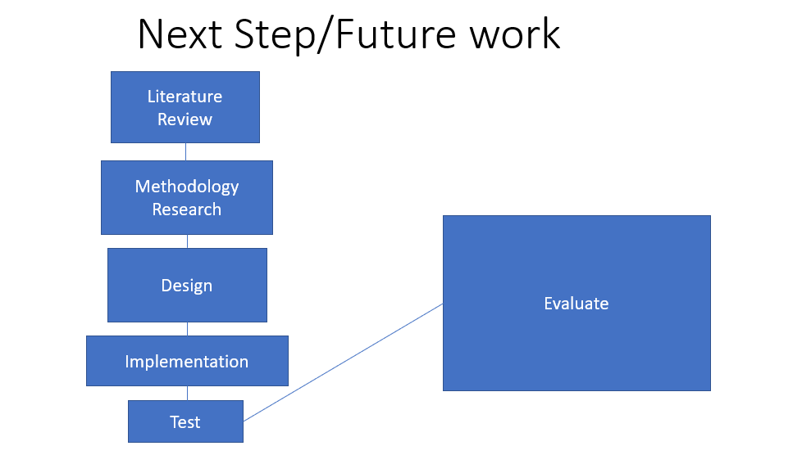

Literature Review
Literature review is the gathering of information for the private virtual environment used during this project. And the penetration tools being used during this project. This information gathered will be from sources which are credible and reliable. This literature review will give knowledge on the different virtual environments that emulate cyber-attacks. And the tools that can be used to emulate these attacks on the simulated environment.

Methodology Research
The methodology of the project will be made, and it will show how to experiment will be structed within the project.

Design
This section of the project will be the design of the emulated virtual environment.

Implementation
This is where the tools will be implemented into the virtual environment revealing security flaws within the private environment. Using this private environment means there are no legal issues.

Test
This is where the penetration tests will be run on the emulated system. This will see if the hypothesis is correct.

- Testing each tool.
- How to fix the security flaw issue.
- Document the outcomes of each test.
- Compare and contrast to other tests done in a virtual environment.

Evaluate
This is where the evaluation of the project will be broken down.

Aims and Objectives

Aim:
Identify vulnerabilities in a LAN
Objective:
Review literature on academic papers based on title of paper. Find proven techniques to find vulnerabilities.

Aim:
Penetration testing vulnerabilities found
Objective:
Conduct penetration tests on found vulnerabilities.

Aim:
Mitigate the identified vulnerabilities
Objective:
Review literatures on mitigations for vulnerabilities found. This can be done through the academic paper that involves the proven techniques or other academic literatures.

Literature Review

Academic Literature

Exploiting Vulnerabilities of a Linux Based Machine: Penetration Testing Report and Incident Response Procedure

Scope:
This literatures scope is the involvement of penetration testing of the Metasploit machine. This includes all services included with Metasploitable. Within this report they conduct a multitude of penetration tests. These tests present a source of proven techniques to identify vulnerabilities. Within this paper they also given credible sources for mitigations for each test being conducted. [1]

Software used:
- Kali Linux
- Metasploit Framework
- Metasploitable 2
- Nessus
- Nmap

Vulnerabilities Found in Paper:

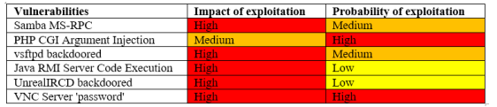 [1]

Nessus Scan:
Nessus scanner is used to find vulnerabilities. This is configured against the Metasploitable machine. There was a total of seventy-two vulnerabilities found. The only those that had impact exploiting the Metasploitable machine are focused on. The results of Nessus scan, arranged by the following security level.
[1]

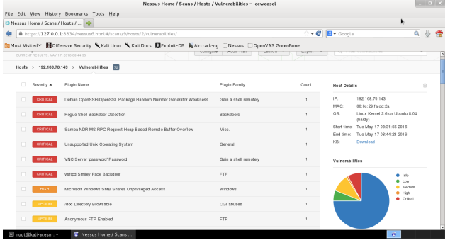 [1]

Attacks Conducted:

Samba MS-RPC

The MS-RPC functionality in smdb in Samba versions 3.0.0 through 3.0.25rc3 permits remote attackers to execute commands via a shell session and characters. It was revealed that Samba did not properly escape input parameters for external scripts defined in smb.conf. Remote attackers could send specially created MS-RPC requests and execute arbitrary shell commands.
CVE details 2007-2447 reported this vulnerability with a base score of 6.

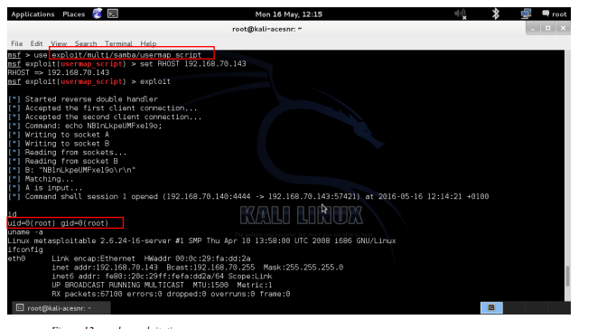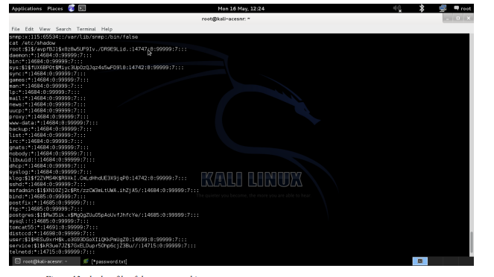
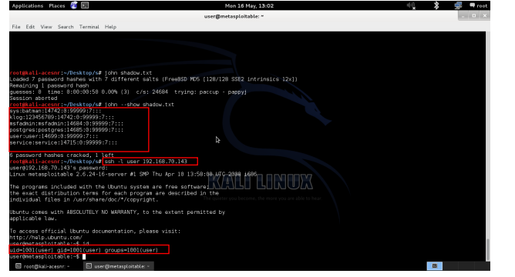

PHP CGI Argument Injection

This particular flaw affects the Apache server because a CGI script specifies the PHP version. The service gets variables, some of which have user-managed attributes. As a result, the services used them to initiate library calls. An attacker can add extra codes to the query string if these parameters are provided incorrectly. An injection attack can be launched against PHP versions 5.3.12 and 5.4.2 when CGI is running. Code execution is accomplished by using the -d flag in the php.ini configuration file. It affects user privilege settings, DOS attacks, and granting an attacker access to private information.
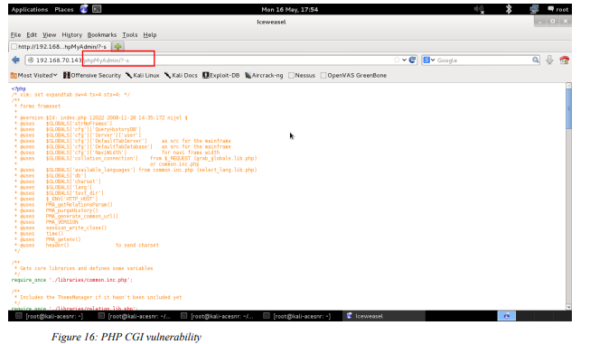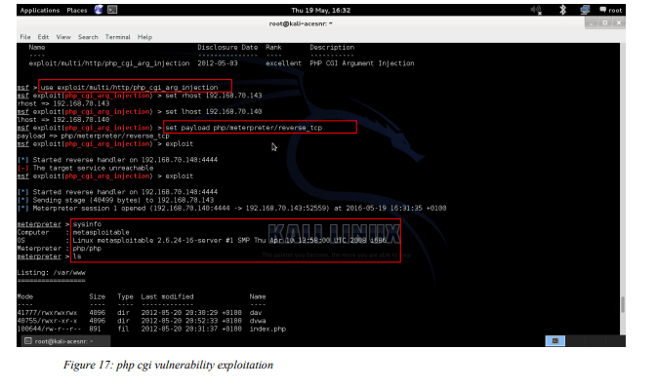
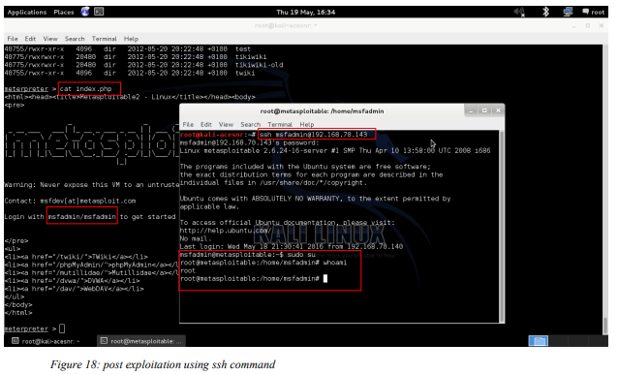

Vstfpd Backdoored

A variety of Linux operating systems include the FTP web server VSFTPD. Except for a major incident that happened in July 2011, when someone updated the default version 2.3.4 with a newly produced version that contained malicious code with a backdoor, VSFTPD is secure. Due to this vulnerability, remote attackers are able to log into the vulnerable version of the VSFTPD protocol while paying attention to port 6200 and obtain remote administrative access by using the smiley ":)" as the username and any password. Additionally, CVE-2011-2523 observed a situation similar to this where a java SE 15 vulnerability also allows an attacker from another place to execute instructions using a malware backdoor.

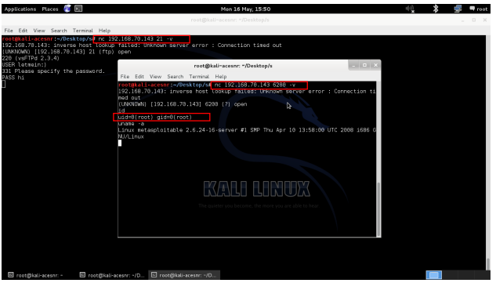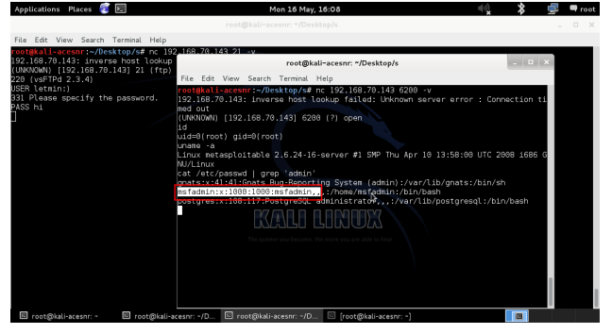

Java RMI Server Code Execution

Due to an insecure registry configuration and the activation service, the Java Remote Method Invocation (RMI) server permits remote code execution with high privilege user authorization. There is no need for any kind of authentication or validation when using the Java RMI method to execute a call. This is feasible because Java RMI allows its classes to be loaded through a remote protocol. By sending malicious packets to the affected version while the packet is being processed, an attacker can take advantage of this flaw and potentially infect the susceptible system.
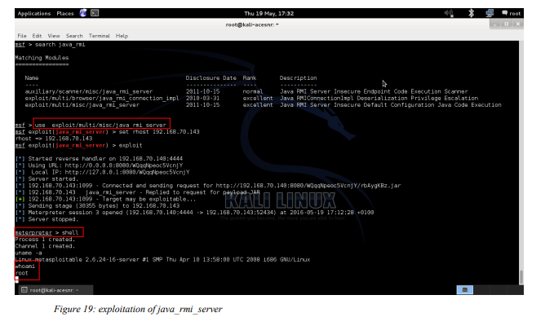

UnrealIRCD Backdoored

The unrealRCD contains an unreal3.2.8.1 file, which has been claimed to have been overwritten or heavily changed by the backdoor. This Trojan horse in the DEBUG3 DOLOG SYSTEM macro allows the remote attacker to run commands as freely as any other user using ircd. This major issue happened in November 2009 as a result of the original.tar file being replaced by the backdoor. (UnRealircd 2010, CVE_Mitre 2010).

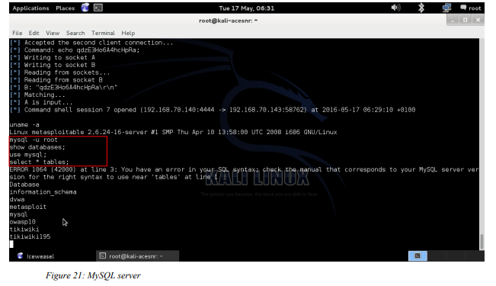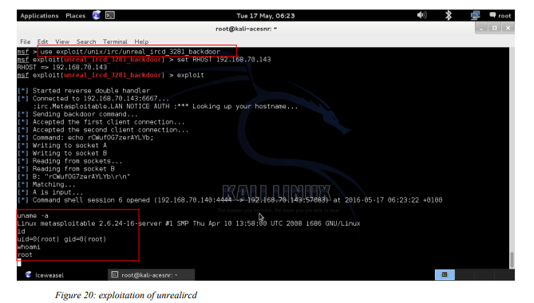

VNC Server “password”

The Nessus scan revealed in the previous portion of the finding that the VNC server is protected by a very weak password that may be readily guessed or brute force attacked. Using the disclosed password, an attacker can exploit this vulnerability to acquire remote shell access using a VNC viewer. Nessus also indicates that this vulnerability is a significant concern since VNC is utilised to gain shell access.

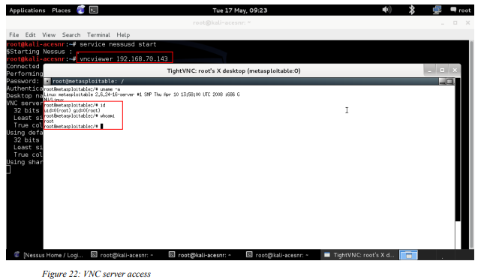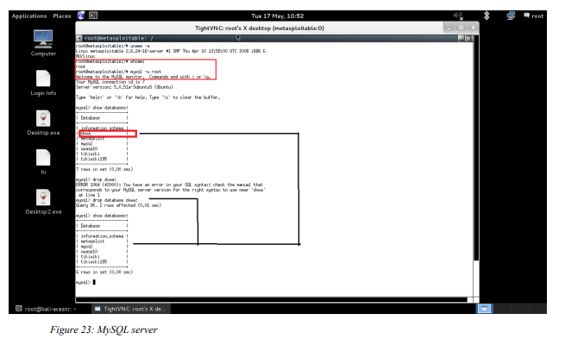

Design methodology:

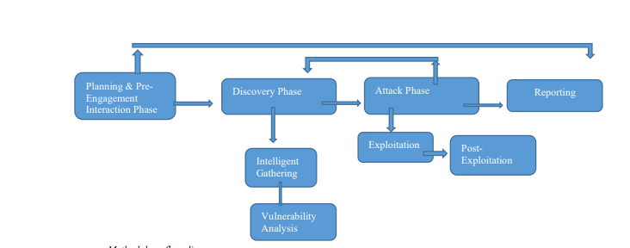 [1]

Within in this academic literature they followed a structure that allowed them to conduct each penetration tests successfully. Here is the conducted structure of the following academic literature.

- Planning and Pre-Engagement Interactions

  - Discover Phase

  - Intelligence Gathering

Footprinting:
Scanning:
Enumerating:

- Vulnerability Detection

- Attack Phase

  - Exploitation
  - Post Exploitation
  - Reporting [1]

This structure allowed me as a reader to understand the methods used and the reasons for each method being used. This allowed for an ease of read. This paper was structured very well. It had no confusing areas of confusion.

For each attack being conducted it followed with a description of the vulnerability, an explanation of the exploit and then the mitigation for said vulnerability. They also used CVE as an indicator for the exploitation level of the vulnerabilities. Whether it was a low, medium, or high impact of exploit.

The end of this paper had steps on how to deal with an incident of a breach. They went into a lot of detail on how to cope with each different step. Here are these steps.

Incident Response Procedure:

Step 1: Incident Preparation Plan
Step 2: Incident Identification Plan
Step 3: Incident Containment Plan
Step 4: Incident Eradication Plan
Step 5: Incident Recovery Plan
Step 6: Lessons learned and Follow-up Plan [1]

Recent Cyber Attacks
Lapsus$:
Recent attacks on Microsoft have been occurring. These attacks are from two young teenagers, they were aged 16 and 17. They were arrested because of an international police investigation. These hackers had managed to get into tech companies such as Microsoft. This Lapsus$ were under investigation and eventually caught on the 1^{st of} April 2022. Because of the boys ages being under 18 their identity’s have been kept secret from the public. Since the arrest of the two teenagers, city of London announced that they have arrested 7 more suspects between the ages of 16 and 21 within the UK. During this time within their telegram group (45,000 followers) they had been told some of the members of this group are on “vacation”. But after only a matter of a few days new material was posted within the telegram group on a software development company in Argentina. Meaning these people don’t care about the consequences of their actions. [2]

Oil tanking Deutschland GmbH & Co:
Fuel suppliers in Germany have been affected from cyberattacks. These cyberattacks disturbed the IT system that the fuel suppliers use. This caused major limited capacity problems for the company. Here is a quote from the company talking about their recent attack. "We are working to solve this issue according to our contingency plans, as well as to understand the full scope of the incident.". [3] But they wouldn’t give detail on the type of attack they had experienced. [3]

Gloucester Council Cyber Attack:
“Russian Hackers” have attacked the Gloucester council website. The council have been affected since 20th December last year. From then to now the online revenue and benefits have been affected. The National Crime Agency have been trying to work with the council to fix these problems and to understand why and how to stop it in the future. Here is a quote from BBC talking about the possible reason these attacks were possible. “According to the Local Democracy Reporting Service, the malware made its way into the local authority's system embedded in an email which had been sent to a council officer.” [4] Something as simple as an email can cause such major problems to s system security. Terry Pullen the labour group leader has said “There seems to be no indication as to when the IT systems will return to normal.” [4]. The council leader Richard Cook said they were doing everything can do to solve the situation is quick as possible. It is estimated the council will take up to six months to resolve the servers and systems affected. [4]

REvil Ransomware Gang Arrested:
REvil gang members have been charged according to the authorise in Russia. Following the ransomware attacks the United States have put a £7.3m reward on information about eh REvil members. Here is a quote from the Russian state news (Tass). “REvil developed malicious software and organised the theft of money from the bank accounts of foreign citizens.” [5]. The FSB have seized £4m (426m rubbles) and £440,000 of crypto currency. REvil is one of the most known ransomware groups. Therefore, the arrests of these individuals have been a major success in the Russian cybercrime world. This was also the first time in many years the United States and Russia came together on a cybercrime operation. This will scare many other cyber gangs as there is more of a presence on the capturing of them. [5]

Reducing Cyber-Attacks:
There are methods to reduce the risk of a cyber-attack in any organisation or personal system. These methods can be useful because of the many ways cyber-attacks can gain access into a system through its security flaws. Having these methods in place will reduce the number of attacks and educate the uneducated about the reasons of these methods being put in place. This will reduce the overall number of attacks successful. [6]

Reducing Exposure:
Here is a list of different methods to reduce exposure to a cyber-attack:
- Boundary firewalls and internet gateways
- Malware protection
- Patch management
- Allow listing and execution control
- Secure configuration
- Password policy
- User access control [6]

Boundary firewalls and internet gateways:
Having a network perimeter in place will detect executable downloads and will restrict access to malicious domains. Examples of network perimeter defences are web filtering; web proxy and firewall polices. [6]

Malware protection:
Maintaining malware defences will drastically decrease the chances of a cyber-attack gaining access to a system. These malware defences will recognise certain code that could be a cyber-attack and will stop this code from becoming destructive to a system. [6]

Patch management:
Having the correct patches to software will prevent attacks that exploit old software bugs. This exploitation can be small bugs therefore keeping software with its latest version is important to keep cyber-attacks at a low. [6]

Allow listing and execution control:
Having a system to stop a user from downloading an unknown software on a system will prevent cyber-attacks from occurring. This can also be with the use of USB’s and CD’s. Any of these methods can have cyber-attack threats within. [6]

Secure configuration:
Having restrictions on the use of a device is needed. If every user in a system had access to using their personal device within the system that would cause major security risks. As a user’s could have a cyber risk within their personal device. [6]

Password policy:
Having a policy in place to have a secure password’s is a good method to stop cyber-attacks. Having a policy where a user must have a certain amount of letter or numbers within their password with the needed use of a special character. This will give each user an acceptable password strength. Therefore, less cyber-attacks will be through passwords cracks of a user’s weak password. [6]

User access control:
Having a system where certain users can only access more important material will prevent less cyber-attacks. These users will be more dependable to keep these access controls to themselves. [6]

Oracle VM VirtualBox:
Oracle VirtualBox is a powerful product for enterprise tasks. It can be used for home use. Oracle Virtual Box is a x86 AMD64/Intel64 virtualization product. This VM is a good performance product with a lot of features. Oracle allows users to download this VM for free. Virtual Box runs on many operating systems such as Linux, Windows, and Apple. Solaris also allows for a big number of other guest operating systems. Such as XP, Windows 7, Windows 8, Windows 10, and Linux 2.4 to 4.0. Oracle Virtual Box is updated regularly with a “ever going list of features.” [7]

Features:
- Portability
- Guest Additions: Shared folders, Seamless windows, 3D virtualization
- Great hardware support#
- Guest Multiprocessing (SMP)
- USB Device Support
- Hardware Compatibility
- Full ACPI Support
- Multiscreen Resolutions
- Built-in iSCSI support
- PXE Network Boot
- Multigeneration branched snapshots
- VM groups
- Clean architecture and unprecedented modularity
- Remote machine display
- Extensible RDP authentication
- USB over RDP
[8]

Oracle Virtual Box Hosted Operating Systems:

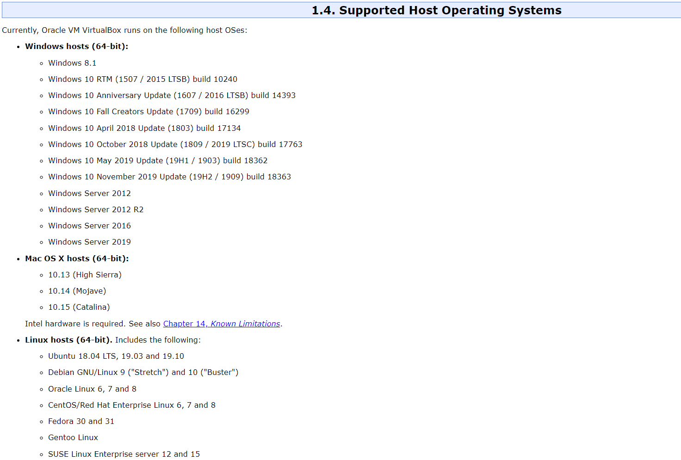 [9]

Why Virtualization is Useful:
There are many reasons using virtualization would be a good tool for a certain task. Here are some situations you would use a virtualization within this project. The testing and disaster recovery of this project. Within this project there is many tests within the virtual machine. These tests will be conducted using other tools such as Kali Linux and Metasploitable2. Using Oracle Virtual Box to run these tests will allow for those outcomes to be successful. But if the virtual box was to crash Oracle Virtual Box has a feature that allows a user to save a particular state of the virtual machine. This feature is called snapshots. This allows a user to run multiple tests over the same virtual machine while saving the machine at certain points to either record outcomes or use a later save and run different test. [10]

Oracle Virtual Box News Flash:

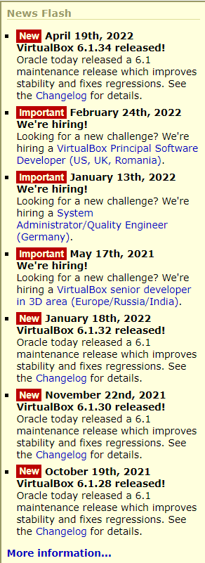
Oracle Virtual Box keeps a notification box on their main page for new updates they implement into their software. This allows for advanced users to look through this list and see what new features they could use on their own personal virtual machines.

Each of these updates are different. Some will be small updates while others might be huge updates. This can be stated by the “Important” and “New” red tabs next to each news flash update. [7]

If a user wanted to know more about past updates that are not listed within this news flash box, they can simply press “More information…” at the bottom of this box and they will be cited to a new page where they will see updates from as long as October 15th, 2013.

[7]

Kali Linux
Kali Linux is a software aimed for penetration testing. It can also be used for Security Auditing. Kali Linux formally known as Backtrack Linux is an open-source Debian-based Linux distribution. Within the Kali Linux software there are hundreds of tools for a wide range of penetration testing and vulnerability testing. There are also tools for security research, computer forensics and reverse engineering. Kali Linux is free software for use in a wide range of virtual machine hosted on platforms such as Oracle Virtual Box. Kali Linux was created on 13th March 2013. [11]

Features:
- 600 penetration testing tools
- Free (always will be)
- Open-source Git tree
- FHS compliant
- Wide-ranging wireless device support
- Custom Kernel
- Developed in a secure environment
- GPG signed packages and repositories
- Multi-Language support
- Completely customizable
- ARMEL and ARMHF support [11]

Kali Linux Bug Tracker:
Kali Linux users have a designated place within their website where a user can see every bug that has been happening recently or in the past. Each of these bugs are given an ID, category, severity, status, updated and summary. This allows for user who might be in counting a bug to either solve the problem or post the bug onto the page. This page is easy to use as it has a filter section where the user can filter for certain sections of the software or bug.

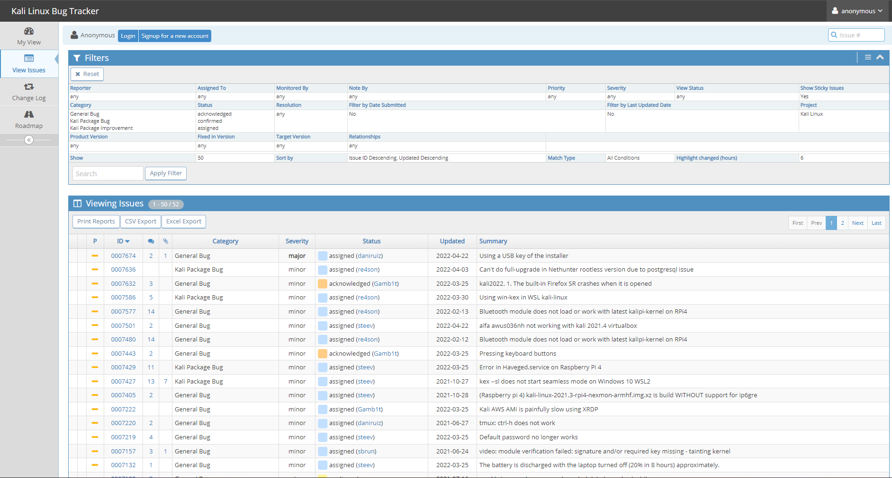 [12]

Kali Linux Platforms:
Kali Linux uses many platforms to operate from. For this project Kali Linux will be used has a virtual machine. Within the get-kali page on their website there is a list of the many platforms which are available to use. Here are some platforms. Bare Metal, Virtual Machines, ARM, Mobile, Cloud, Containers, Live Boot and WSL. There are many options for hosting Kali Linux. [13]

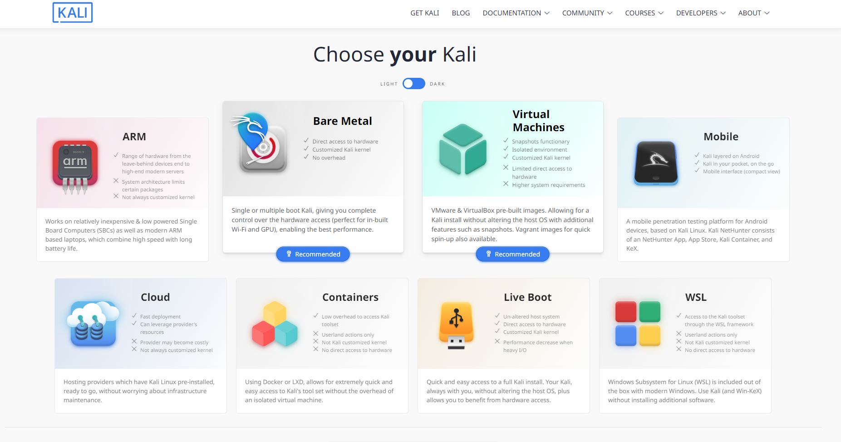 [13]

Nessus:
Nessus is a vulnerability scanner used to scan systems for security flaws that could possibly be taken advantage of during a cyber-attack. This scanner will look for any flaws within the system and inform the user after the scan was successful. These flaws may be within the system because of outdated software. Therefore, Nessus will inform the user about the vulnerability and how to fix it. This will be similar with other vulnerability’s Nessus finds within a scan of a system. [14]

Here is a quote from tenable (Nessus creators) talking about why Nessus is the “No.1” vulnerability assessment tool.

“From the beginning, we've worked together with the security community. We continuously optimize Nessus based on community feedback to make it the most accurate and comprehensive vulnerability assessment solution in the market. 20 years later and we're still laser focused on community collaboration and product innovation to provide the most accurate and complete vulnerability data” [14]

Deploy On Any Platform:
Nessus can be used on different platforms. Such as Windows, Mac, and Raspberry Pi. Nessus is also available to use anywhere are user feels like. This can be a large advantage when a user has a system, they want to scan for vulnerabilities but said system is not in proximity. [15]

Efficiency and Accuracy:
Plugins within Nessus are dynamically compiled. This increased the performance and efficiency of the scan on the system. This allows for a smooth and efficient scan when finding vulnerabilities. [15]

Pre-Built Policies and Templates:
Nessus has 450 configured templates users can use. These 450 pre-configured templates help the user find where the vulnerability is quickly. [15]

Customizable Reporting and Troubleshooting:
Customizable reports can be changed to a specific need. This can be useful for a suited security process. [15]

Live Results:
The user can run an offline vulnerability assessment with all plugin updates. [15]

Ease of Use:
Nessus design is easy to use. It doesn’t involve a complex system where the user will study before using Nessus. There is also a resource centre for the user to have guidance if they don’t understand something. [15]

Grouped View:
Issues that can be like each other will be grouped together and showed as one group. This will incrassate amount of time it takes to find the solution to the vulnerability. [15]

Metasploit Framework
Metasploit Framework:
The Metasploit Framework is a Ruby-based, modular penetration testing platform that enables you to write, test, and execute exploit code. The Metasploit Framework contains a suite of tools that you can use to test security vulnerabilities, enumerate networks, execute attacks, and evade detection. At its core, the Metasploit Framework is a collection of commonly used tools that provide a complete environment for penetration testing and exploit development. [16]

Metasploit Advantages:
- Industry accepted tool for testing on vulnerabilities and exploits.
- Simplifies complex tasks.
- Range of capabilities ordered in a systematic manner.
- Consistent updates
- Contains many different types of modules. [16]

Basic Terminologies:
Payload:
A payload is the action that a threat performs, apart from its main behaviour. Payloads can range from stealing personal information to deleting the contents of a hard drive.

Exploit:
A computer exploit, or exploit, is an attack on a computer system, especially one that takes advantage of a particular Vulnerability the system offers to intruders. Used as a verb, exploit refers to the act of successfully making such an attack

Exploit Ranking Values:

Excellent Ranking | The exploit will never crash the service. This is the case for SQL injection, CMD execution, RFI, LFI, etc. No typical memory corruption exploits should be given this ranking unless there are extraordinary circumstances (WMF Escape())
Great Ranking | The exploit has a default target AND either auto-detects the appropriate target or uses an application- specific return address AFTER a version check.
Good Ranking | The exploit has a default target, and it is the "common case" for this type of software (English Windows 7 for a desktop app, 2012 for server, etc).
Normal Ranking | The exploit is otherwise reliable but depends on a specific version and can't (or doesn't) reliably autodetect.
Average Ranking | The exploit is generally unreliable or difficult to exploit.
Low Ranking | The exploit is nearly impossible to exploit (or under 50% success rate) for common platforms.
Manual Ranking | The exploit is unstable or difficult to exploit and is basically a DoS. This ranking is also used when the module has no use unless specifically configured by the user (e.g.: exploit/unix/webapp/php.eval).

Shellcode:
Shellcodes are instructions in a set to be used as a payload. This occurs when exploitation happening. Shellcode is written in a language called assembly typically. A Meter Peter shell or a command shell will be used after the series of instructions in most cases. [17]

Module:
Module is a software used within the Metasploit Framework. Users will use this exploit module to start an attack. This is part of the software. Another module would be auxiliary module. This module will be used for scanning a system or system enumeration. Modules such as the above are the reasons the Metaploitable Framework is strong. [17]

Listener:
The Listener is used for finding a waiting for an incoming connection. Here is an example. A user conducts an exploit on a machine. Once this machine has been exploited it will call the attacking machine. This is where the listener comes In and completes the connection. Waiting for the attacking machine to connect to the system that was exploited. [17]

Metasploit With Kali Linux:
Kali Linux is a penetration testing tool software. Designed for the use of forensic and penetration testing. Kali Linux has a multitude choice of tool to use. Kali Linux comes with Metasploit Framework pre-installed. Metasploit offers different interfaces this includes console, command line, and graphical interfaces. Below are the following interfaces that are useable. [17]

MSFconsole:
MSFconsole is the most used part within Metasploit Framework. This is because it is flexible, feature rich, and supported with tools in the framework. It is an all-in-one interface to almost every point in the Metasploit Framework. Therefore, MSFconsole is used to do mostly everything a client needs. Here are some examples of what a client can do when using MSFconcole. A client can launch an exploit, loading auxiliary, enumeration performing and running mass exploitation through a whole network. [17]

MSFcli:
MSFcli runs from a command line that allows the client to change and redirect an output from different tools. This is into the MSFcli and direct MSFcli output. Like MSFconsole MSFcli also supports the use of doing exploits and auxiliary modules. This is useful when testing modules for the Framework. [17]

Armitage:
Armitage is a graphical user interface. This was created by Raphael Mudge. This graphical interface is full of features and is completely free. To use Armitage the client will enter armitage in the CLI of Kali Linux terminal. [17]

Metasploitable 2
Metasploitable 2 is a purposely vulnerable test environment which can be hosted has a virtual machine. This platform will be used in conjunction with Kali Linux and Metasploit
v
Nmap:
Nmap also known as Network Mapper is an open-source utility for network discovery. It is also useful for network inventory, managing service upgrade schedules, and monitoring host or service uptime. IP packets are used in Nmap to determine the hosts that are available. Here are some reasons Nmap is sufficient. [18]

Flexible:
Nmap supports a multitude of different techniques for mapping out networks. This is full of IP filter, firewalls, and routers. With many more. Also, port scanning mechanisms TCP and UDP, OS detection, ping sweeps, and more. [18]

Powerful:
Nmap is a powerful tool used to scan large networks or large amount machines. (Hundreds of thousands of machines). [18]

Portable:
Nmap allows the user of many operating systems. Systems such as Microsoft, Linux, FreeBSD, OpenBSD, Solaris, IRIX, Mac OS X, HP-UX, NetBSD, Sun OS, Amiga, and many more. [18]

Easy to Use:
Nmap is easy to use to the non-informed user. But Nmap is also has many advanced features for users who have the knowledge on the features of Nmap. [18]

Free:
Nmap is free to all users. This makes it a good choice for a first-time user, projects, and a non-organisation test. [18]

Well Documented:
Nmap is well documented within their website. They have many pages on how to install Nmap, the many features, and more. This is perfect for a user who is new to Nmap as they don’t have to rely on an unreliable site to understand the way Nmap works. These pages are always up to date too. [18]

Popular:
Nmap is a popular choice. Thousands of people download Nmap each day. This may be because of the many operating systems Nmap allows. Here is a quote on the Nmap website talking about Nmap’s popularity. “It is among the top ten (out of 30,000) programs at the Freshmeat.Net repository. This is important because it lends Nmap its vibrant development and user support communities.” [18]

Research Methodology

Research Onion:
Using the research onion to conduct the research methodology. Using this technique allows for a reader to understand the physiological, approach and strategies of this paper.

Philological:
Positivism:
Positivism is used under the philological heading. This is because of the conducting of the penetration test within this paper and its experiment. Proposing the solution of the mitigations allows this to fall under positivism. These mitigations will show how said vulnerabilities can be more secure/fixed.

Approach
Deductive:
The deductive approach has been chosen because of the objective of this paper. “To Identify vulnerabilities of the local network by pen testing and mitigating the vulnerabilities by enhancing the security.” This is our objective within this paper. This objective will be conducted through the penetration tests where the proven techniques of attacks will be found through the academic literature review findings. There will then be mitigations to solve these vulnerabilities.

Strategies
Experiment:
Experiment is related to both the deductive approach and the philological positivism. This is because of the experiment being conducted through this paper. There is a certain problem in the paper. This being the security of a LAN. Testing said security through finding proven vulnerabilities found through literature review then conducting penetration tests on the vulnerabilities creating an answer to be solved allows for an experiment to be conducted. Therefore, being under the strategies of experiment in the research onion.

Time Horizons:
Longitudinal:
Collecting data in different parts of time is making this paper fall under the longitudinal time horizon.

Why the use of a simulating in this project?
This use of a simulation within this project allows for the testing of security in a virtual machine. This simulation testing allows for me to record outcomes and analyse the outcomes within these simulated tests with the academic literature researched.

Reasons for simulation:
- Doesn’t involve legal issues when penetration testing a simulated system.
- Able to save certain points of the simulation. If there was a crash or mistake.
- Being able to use Kali Linux.
- Fast and efficient testing.
- Others can replicate these tests on a personal virtual environment.

Experiment and implementation:
Using Oracle Virtual Box to host Kali and Metasploit2 for penetration testing lab.

Tools Download targets:
- Oracle VM Virtual Box version 6.1.32-149290 for Windows 64-bit from [19]
- Kali Linux version 2022.1 for VirtualBox 64-bit from [20]
- Metasploitable 2 from [21]

Virtual Machine Setup and IP allocation:
To host Kali Linux and Metasploitable2 virtual machines, they each require an IP address on the same network, and that the said network is isolated from access to the internet. To achieve this, Oracle VM VirtualBox is configured to act as a DHCP server and allocate IP addresses when requested from VM’s that are configured to use a specific network setting within VirtualBox. Within the settings of each VM, Network Adaptor 1 is configured to attach to an Internal Network and a specific Name, is this case “TomsLab”.

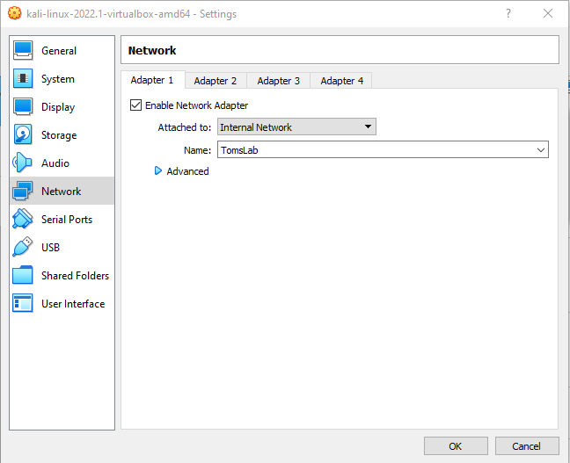

Oracle VM VirtualBox DHCP script:
Check the status of DHCP servers:
C:\Program Files\Oracle\VirtualBox>VBoxManage list dhcpservers

Apply DHCP Server:
C:\Program Files\Oracle\VirtualBox>VBoxManage dhcpserver add --network=TomsLab --server-ip=192.168.3.1 --netmask=255.255.255.0 --Lower-ip=192.168.3.2 --upper-ip=192.168.3.254 –Enable

A 192.168.3.X IP address is allocated to each VM configured to use the “TomsLab” network.

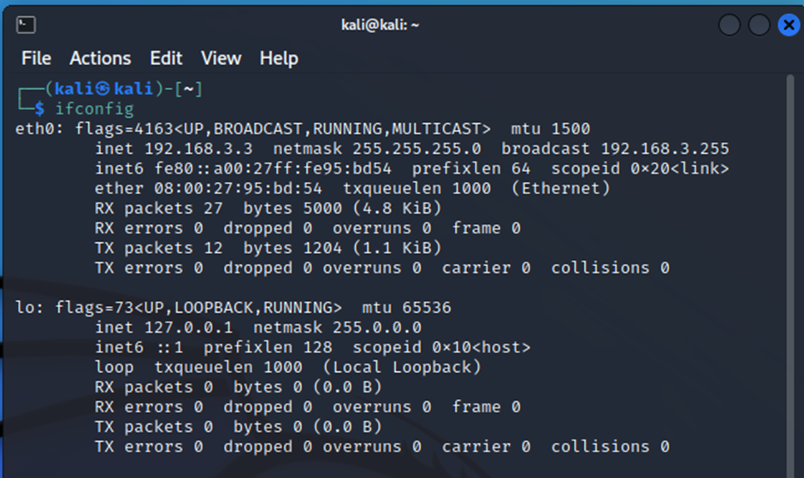

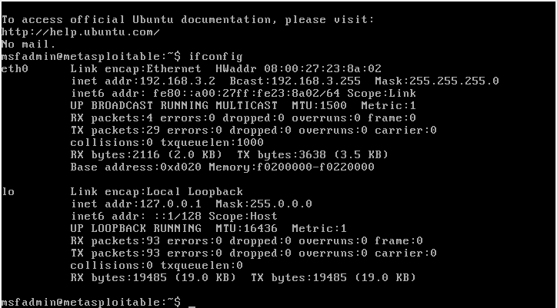

Because the VMs are configured to attach to Internal Network, this isolates them and prohibits them from contacting the internet. I can be confident that I am only running tests within my own isolated penetration testing lab.

Kali Linux confirmation that it cannot contact the internet

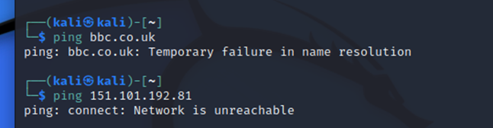

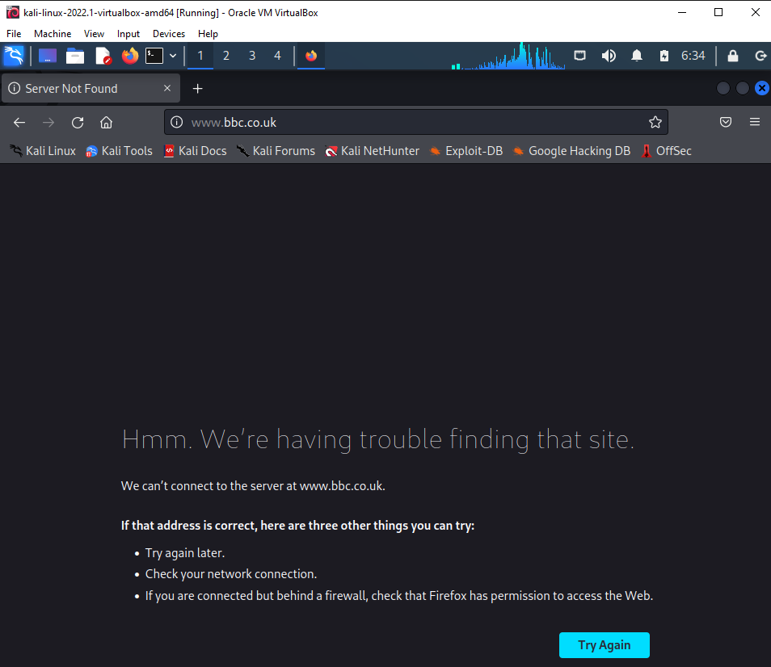

Metasploitable2 confirmation that it cannot contact the internet
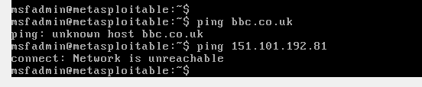

I need to ensure that both Kali Linux and Meatsploitable2 can ping each other, this will allow us to continue with the penetration testing capabilities.
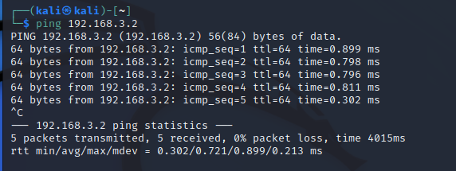

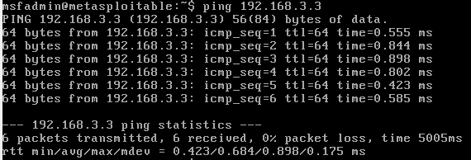

Pen testing Phases:
Reconnaissance (Information Gathering) ==> Vulnerability Analysis ==> Exploitations ==> Post Exploitation ==> Reporting

Expected Outcomes:
Samba MS-RPC:
The Metasploit framework usermap_script is utilised to exploit command execution vulnerability in samba when utilizing non-default “username map script” configuration as shown in figure 1 below. This automatically gives us a root shell without authentication because the configuration option is utilized to map usernames preceding system verification.
vsftpd port 21:
Demonstrates how the Netcat regulate is utilized to discover the variation of VSFTD and whether it's a backdoor and then utilized a smiley “letmein:)” as username. On additional smaller terminal window terminal, while the first terminal is still running, the Netcat command is utilsed to acquire shell and root access using port 6200 instead of 21.

PHP CGI Argument Injection:
Below demonstrates that passing -s characters on the URL makes PhpMyAdmin of the hosted Metasploitable vulnerable. Figure 6 illustrates an exploit utilising the Metasploit exploit/multi/http/php cgi arg injection module and a PHP interpreter payload with the necessary entities.

Java RMI Server Code Execution:
Below demonstrates the use of exploitation exploit/multi/misc/java_rmi_server module of Metasploit framework to obtain shell access as a high-privilege user.

UnreallRCD backdoored:
The Metasploit framework module exploit/Unix/irc/unreal ircd 3281 backdoor is used to exploit the unrealRCD vulnerability, which also grants root access

VNC Server Password:
depicts access to the VNC server using the disclosed 'password' as a password.” And further below paragraph “To learn more about the attack, a vnc shell is used to connect to the MySQL server and then dump one of the databases

Each test followed the correct expected outcomes listed above.

Reconnaissance (Information Gathering):
The discovery process used to find information about the network, users, and target. This could include scans of the network to find out which IP addresses respond, and further scans to see what ports on the devices at these IP addresses are open. Scans can be passive or active. A passive scan is researching information about the target’s public records, social media sites, and other technical information, such as DNS, whois, SSL certificates, etc. Active scans use tools called scanners i.e., Nessus, NMAP, NeXpose, WebInspect.

Vulnerability Analysis:
Nessus:
Installing and using Nessus Essentials onto Kali Linus to scan for vulnerabilities on Metasploit 2:
Nessus does not come pre-installed on Kali Linux by default. The following paragraphs explain the download, installation, and application use procedures for Nessus Essential onto Kali Linux. Nessus Essentials is the free version of the software and is ideal to use for this project.

Note: To install Nessus Essentials onto Kali Linux internet access is required, therefore, the Kali Linux VM is shut down and the network settings are changed to a Bridge Adapter to allow Kali Linux internet access. The necessary installation files downloaded, installed, registered and plugin. Both Kali Linux and Metasploitable 2 had to be kept on the bridge adapter network to have internet access whilst Nessus continued to download and update plugins. Once the scan had been completed both Kali Linux and Metasploitable 2 were be shut down and the Internal Network set back to use the TomsLab group to stop internet and isolate to only communicate with the lab network.

The Nessus Essentials vendor, Tenable, also advises that the Kali Linux is up to date, this can be performed by executing the following command:

Kali Linux will download updates and automatically install them, you can monitor the terminal window whilst this is being performed,
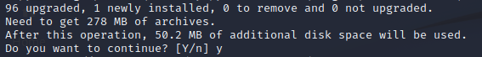

From Kali open a web browser and navigate to https://www.tenable.com/downloads/. You must register to use download Nessus Essentials and for an activation code to be emailed to you. Scroll down the webpage and select Nessus-8.15.4-debian6_amd64.deb for Debian 9, 10 / Kali Linus 1, 2017.3, 2018, 2019, 2020 AMD64 to download, this is the 64bit architecture which is the version of Kali Linux operating on the VirtualBox.

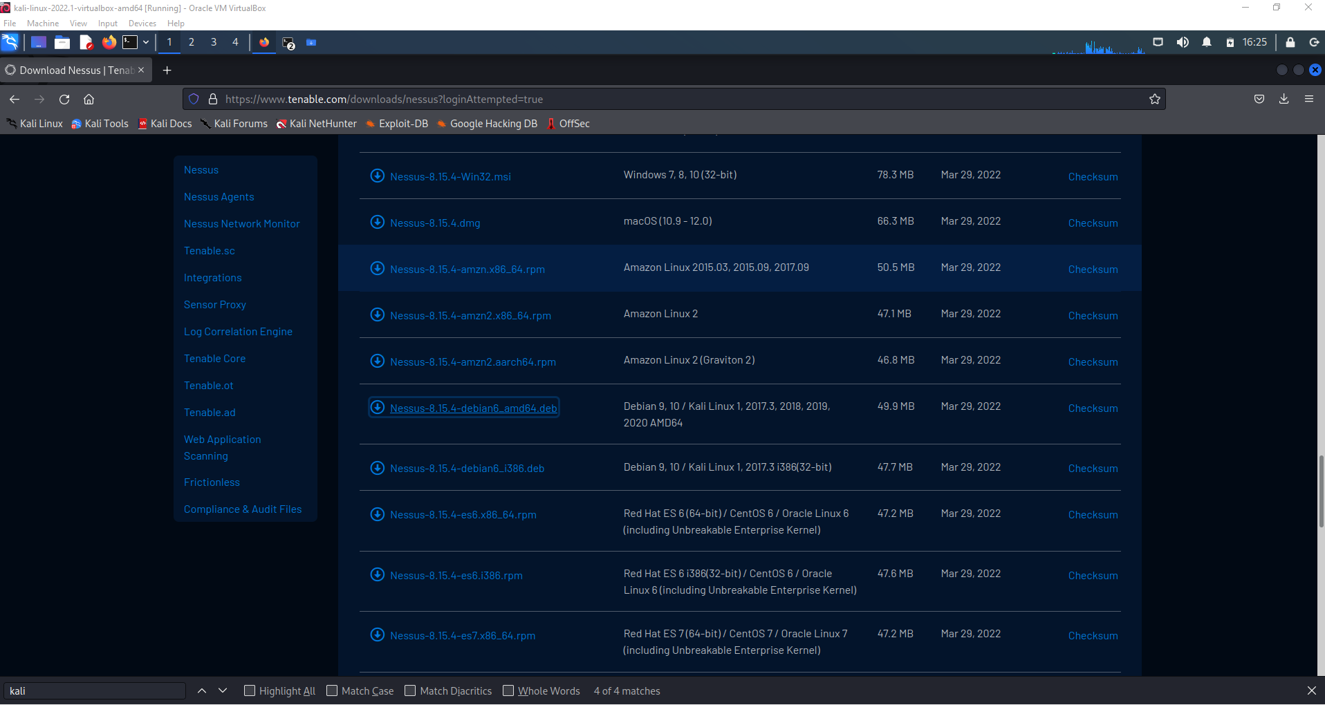
Change the permissions to check the Program box which allow this file to run as a program. Open the download folder, right click on the Nesus-8.15.4-debian6_amd64.deb file and select properties. Select Permission and click the Program box, now click close.

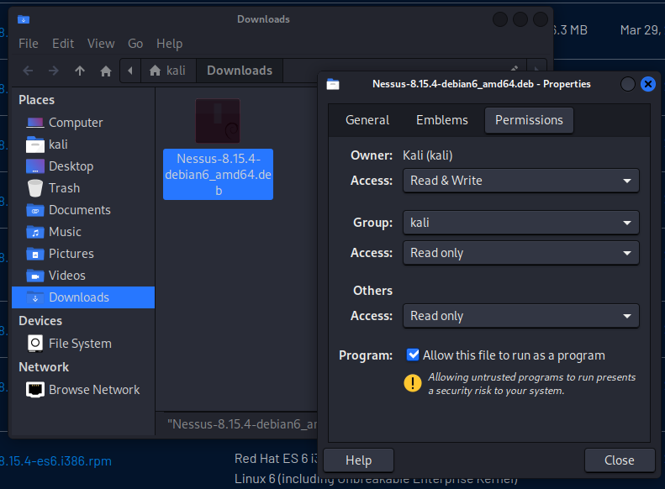

Back at the Download folder, right click and select Open Terminal Here.
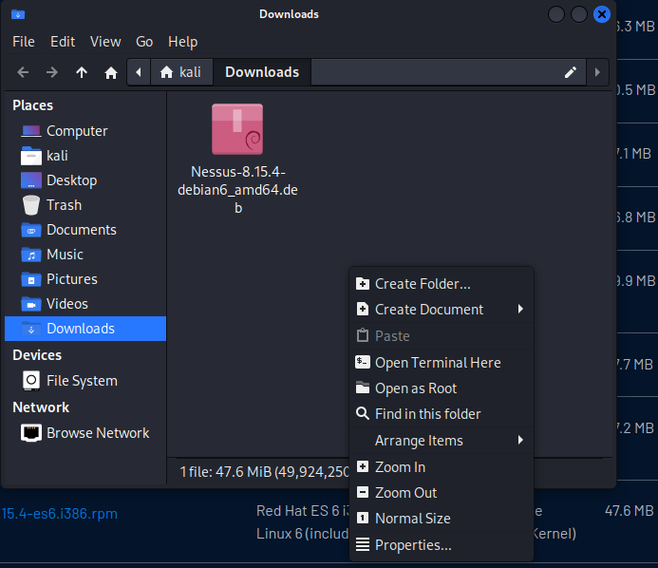
Nessus will now be installed by performing the following commands. Once the installation is complete the Nessus service needs to be started by the following command /bin/systemctl start nessusd.service.

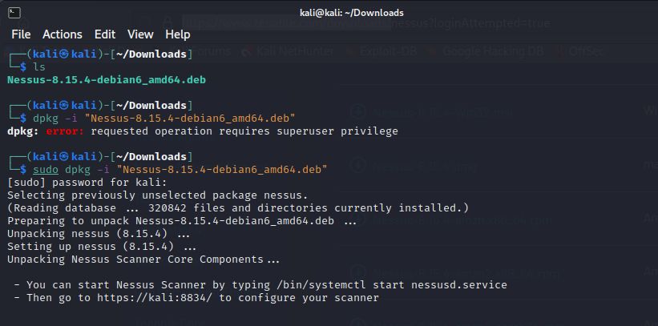

To scan the target, the configuration of the Nessus Essentials scanner is completed via browsing to https://kali:8834/ . There will be an SSL certificate warning, this can be continued past since we are only setting this one on for a demonstration purpose and not a Production environment. Click on Advanced and select “Accept the Risk and Continue.”

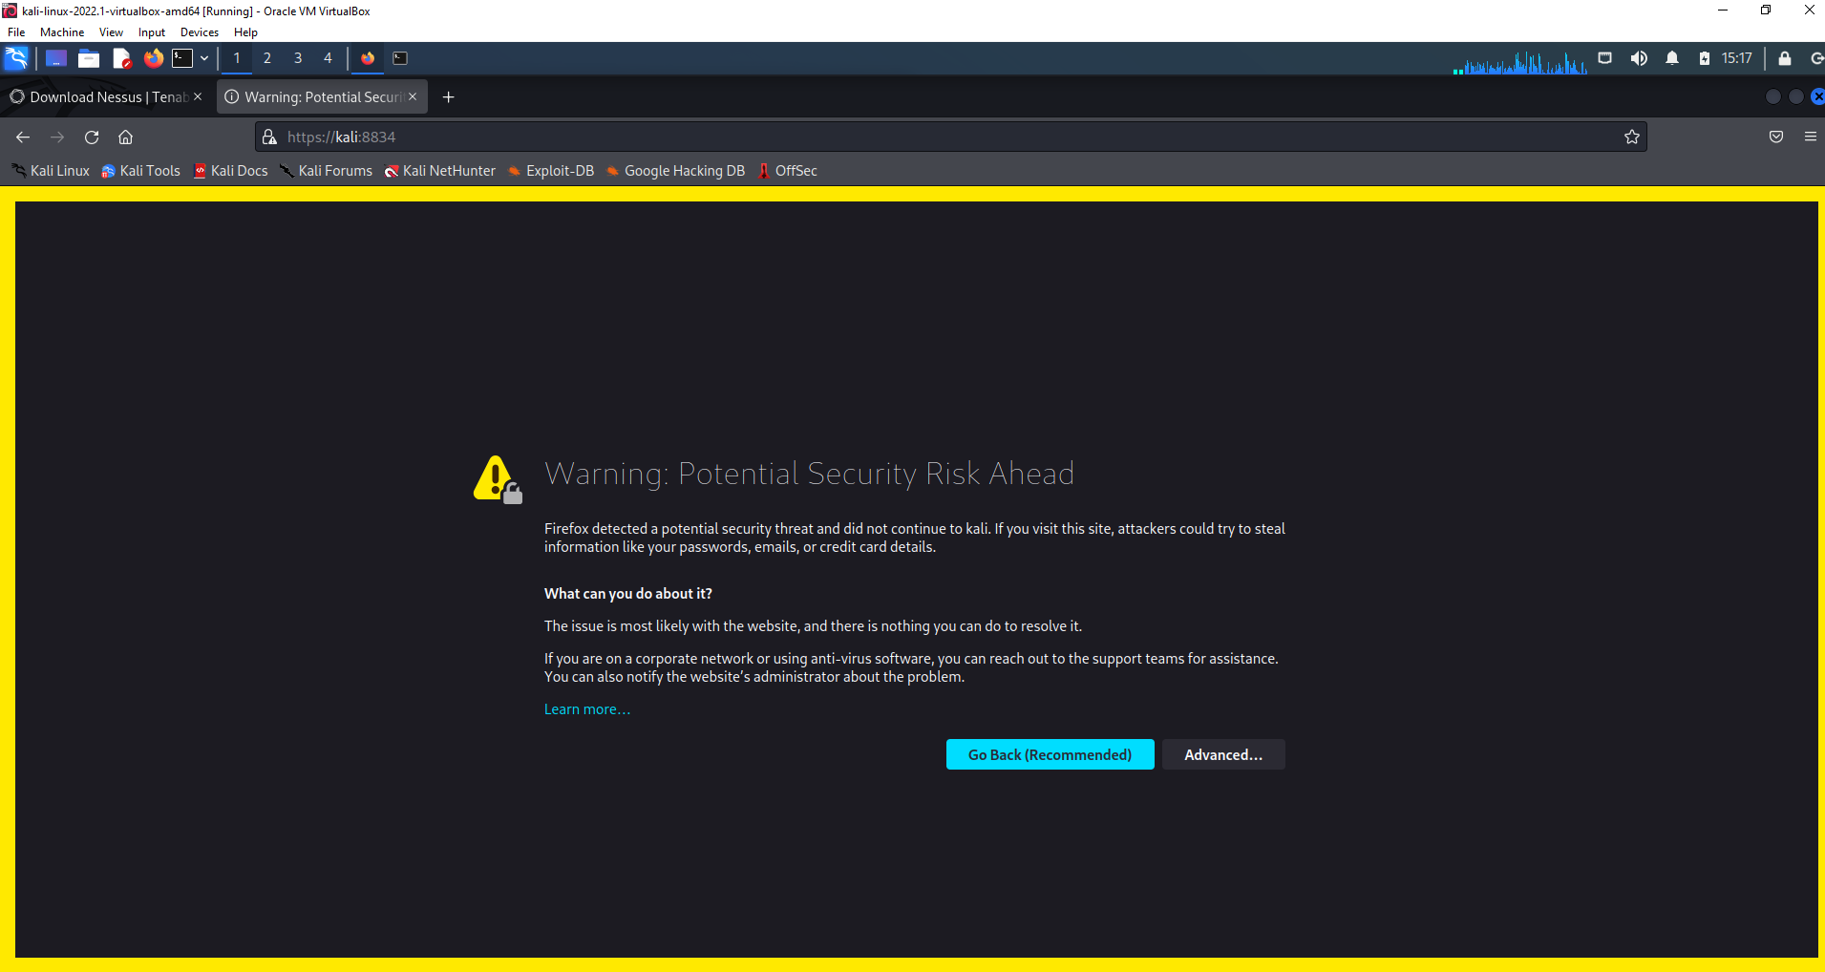

Once the activation code has been entered along with a username and password, Nessus will start downloading and compiling its plugins.

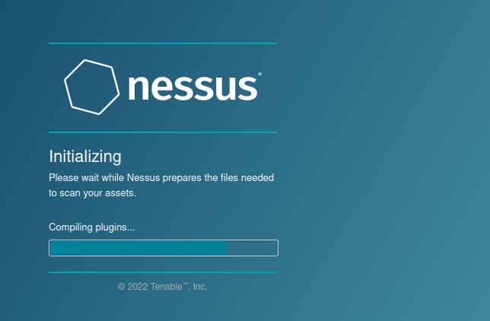

When Nessus Essentials has completed the plugins download and installation a logon screen will be presented, the username and password used at the Nessus Essentials registration page are the credentials to be used.
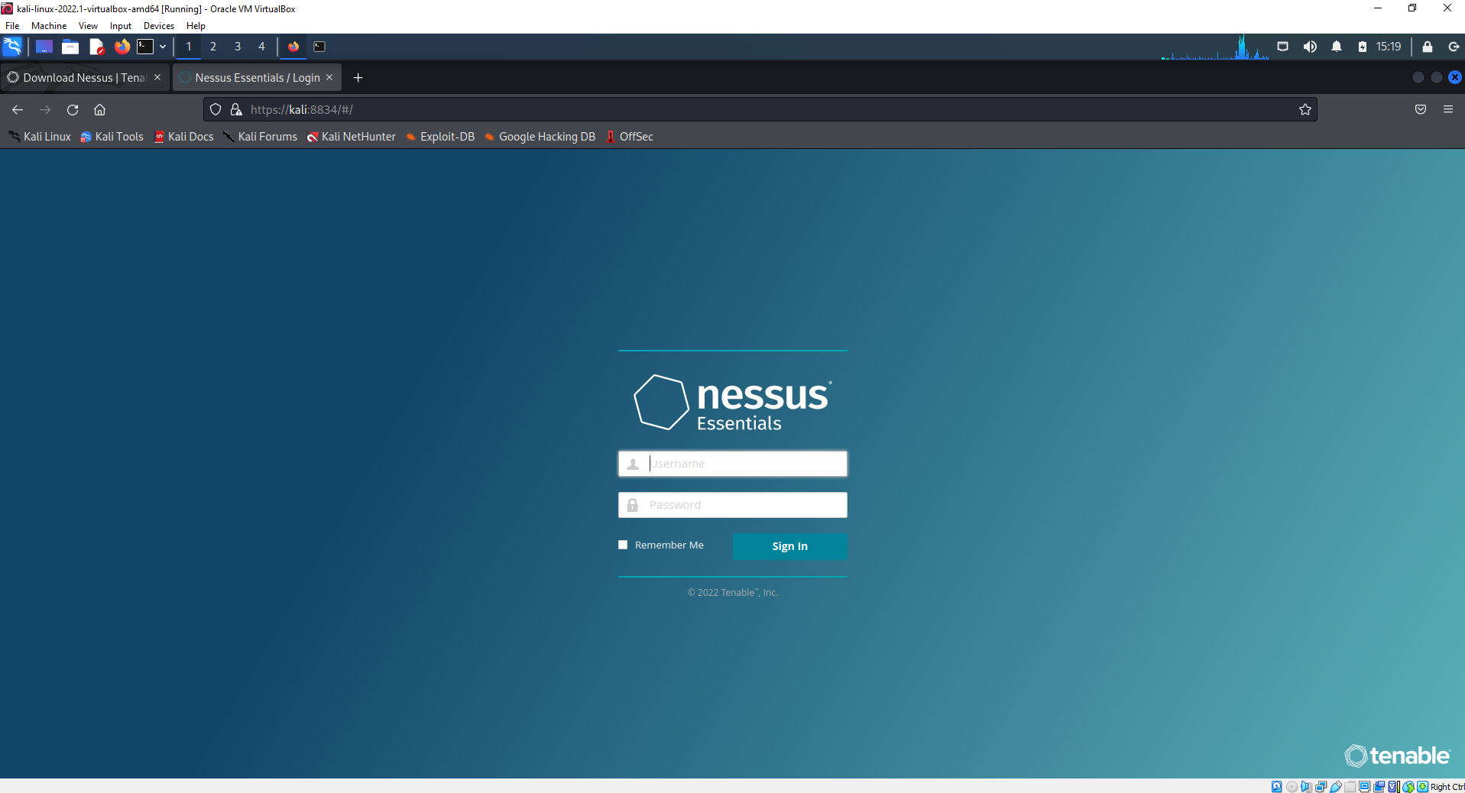

A basic scan is configured using the target IP address (192.168.200.20) of the Metasploit 2 host. This was executed and left to run for a period to discover and list vulnerabilities.
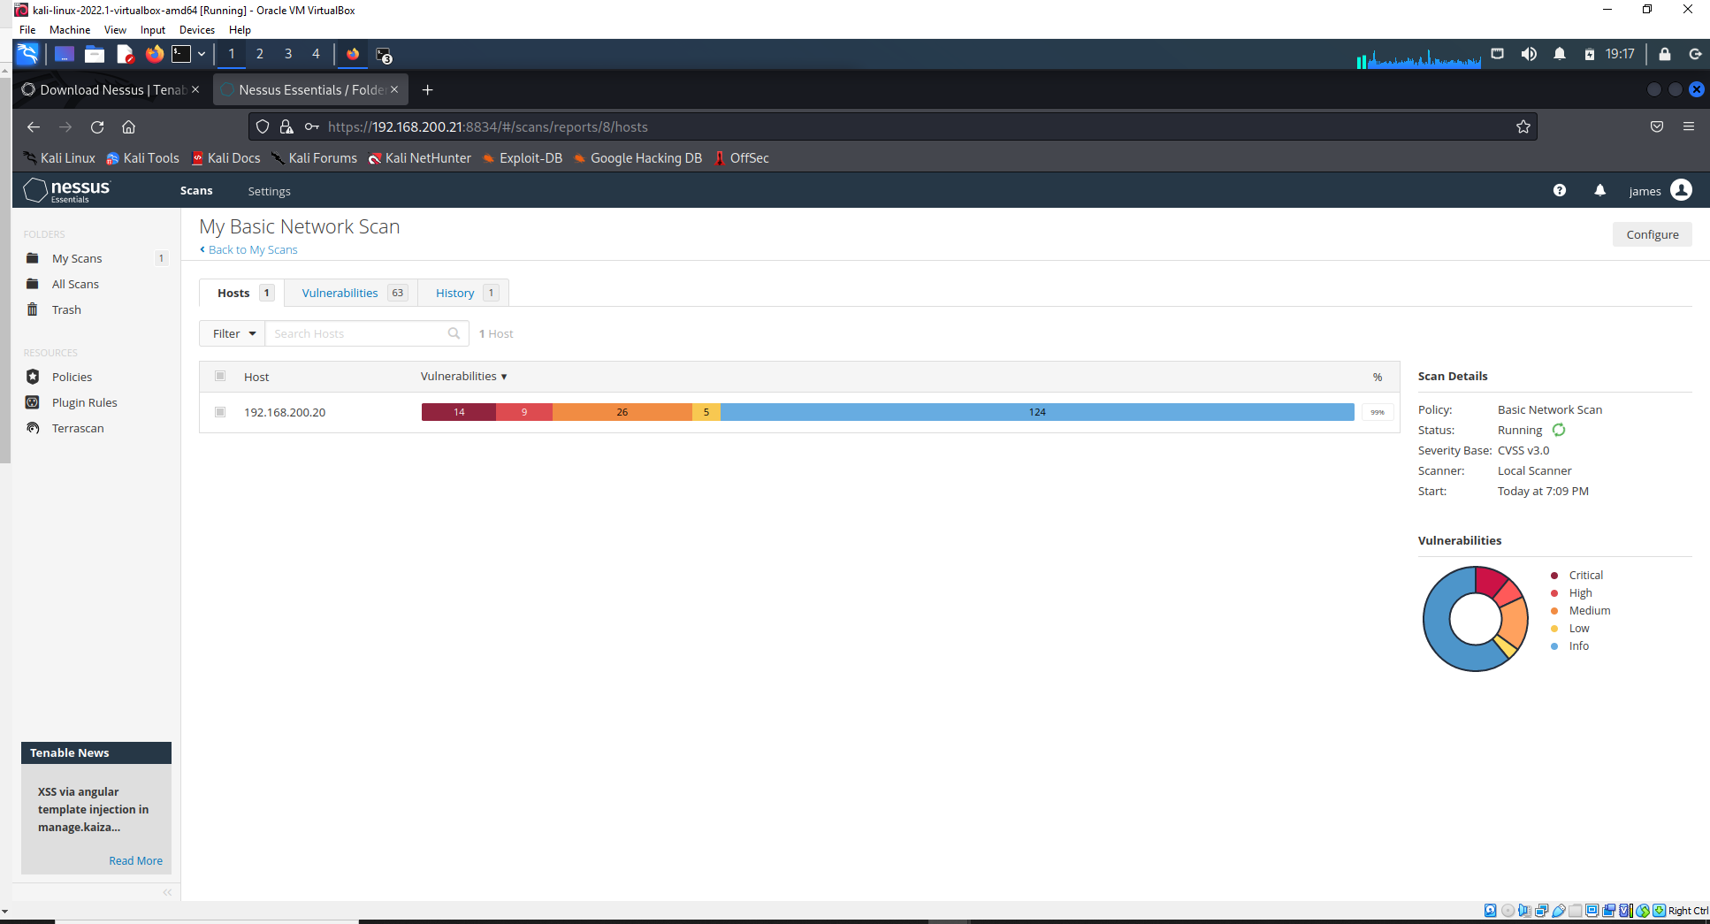

The scan presented back 72 vulnerabilities ranging from Critical, High, Medium, Low, Mixed, and Informational, each with their relevant Common Vulnerability Scoring System (CVSS) base scores. From this scan, and by combing the results from Nmap, it was easy to see just how vulnerable Metasploitable 2 is and how it provided a good platform to exploit a number of these issues for this project.
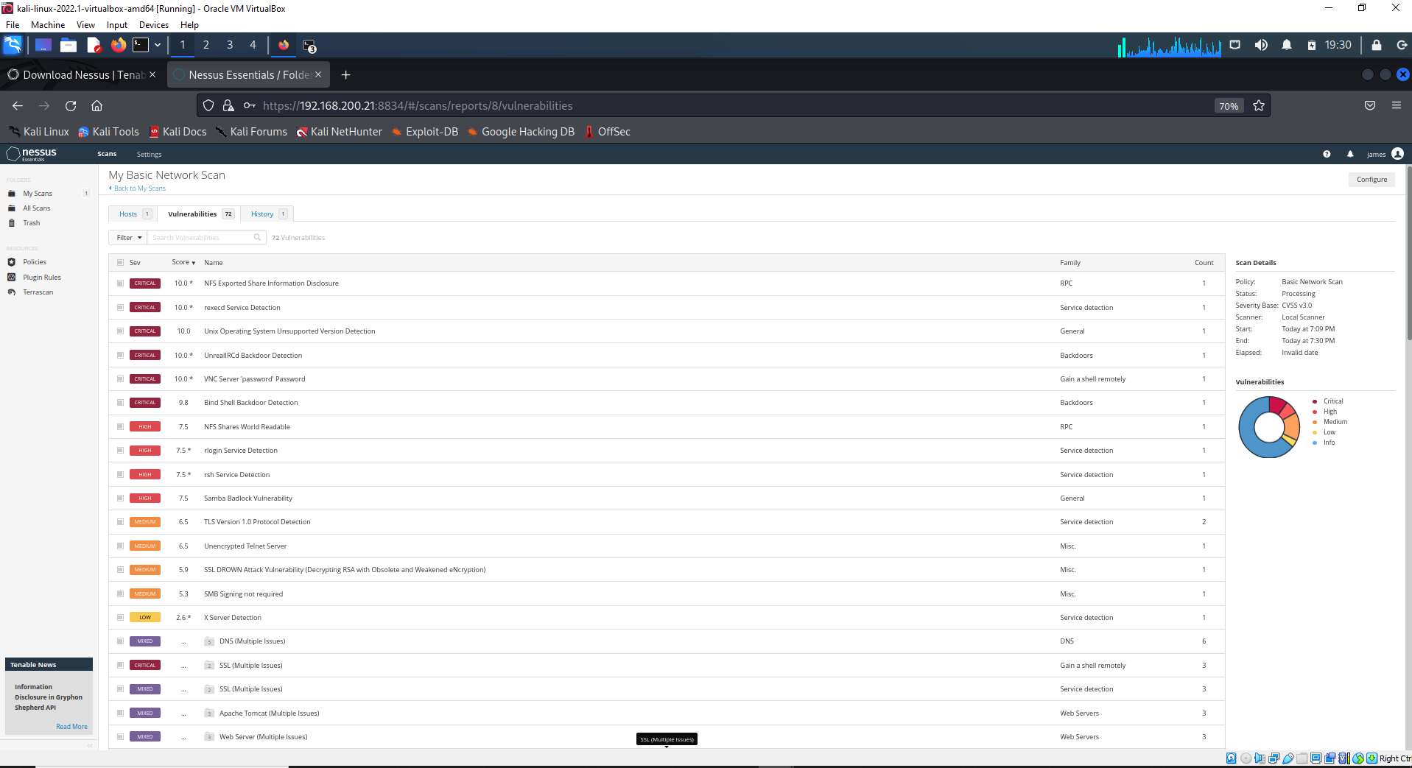
Further detail could be obtained by drilling down on each vulnerability, as you can see for SSH which had multiple issues.
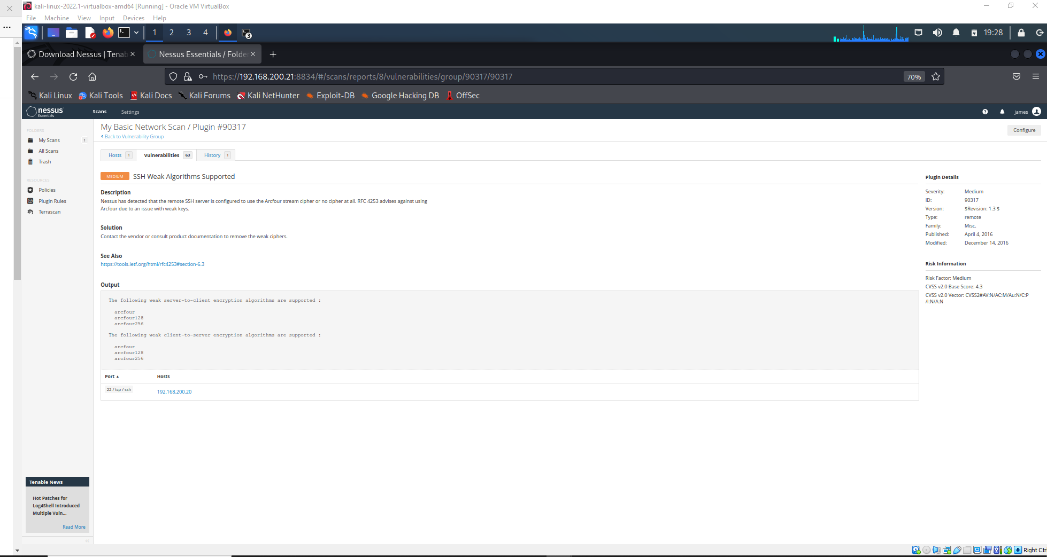

With Nessus it can also scan Host Discovery against the target for opened ports, this again can be combined against the output from Nmap in order to cross reference against each scans reported opened ports.
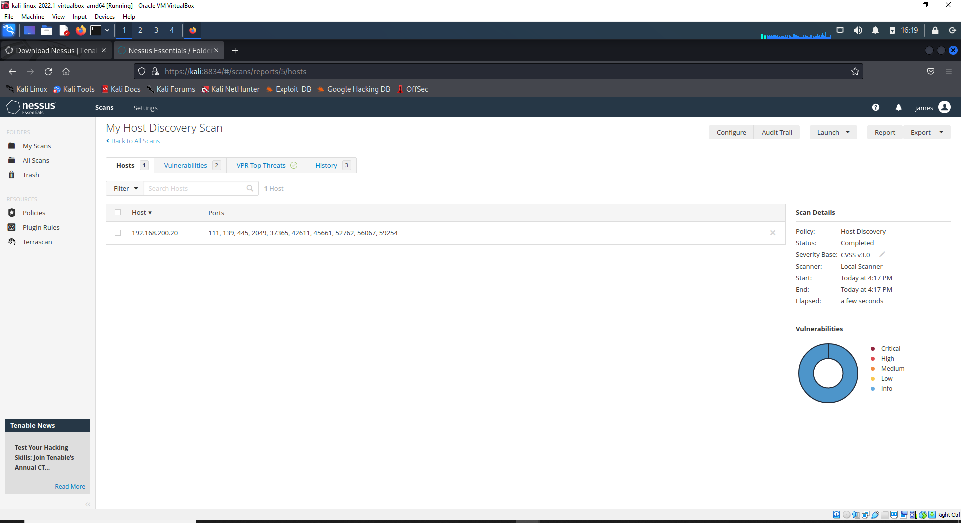

The Nessus product from Tenable is one of the market leaders for vulnerability tools used in both the private and public working sectors. It is a tool which can be setup to run daily reports against areas within Enterprise Environment’s such as Compute, Storage and Network. Thus, providing an invaluable resource of detecting vulnerabilities and exploits in quick succession so they can be assessed and remediated before being exploited.

Using Nmap to discover the Metasploitable2 host, the services running on the host and its operating system.
Using the command –sV –O 192.168.3.2 will scan the Metasploitable2 host.

Options:
-sV – will provide the version of network processes.
-O – will provide the operating system.

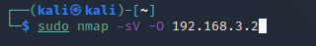

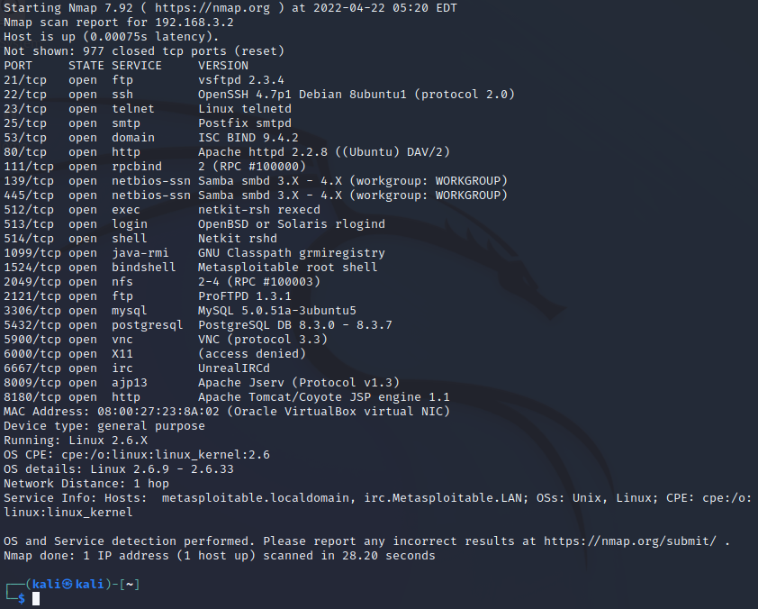
The above image provides details on the current ports opened on the Metasploitable2 VM which Nmap has discovered.

Foot printing
  - fping
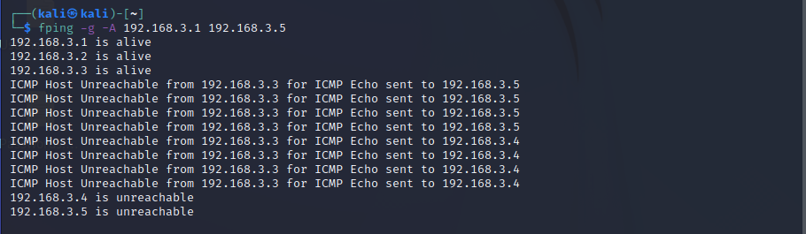
The above figure provides IP host information from the fping scan between a set number of IP addresses within the IP subnet that Kali is configured with. The first IP, 192.168.3.1, can be quickly and possibly identified has the gateway for the 192.168.3.0/24 subnet. The same can also be said for the IP address of Kali since we have control and by checking its IP information can be identified has 192.168.3.3. This leaves the 192.168.3.2 host which in this case can be identified has the Metasploitable2 host.

- Scanning
  - Netcat
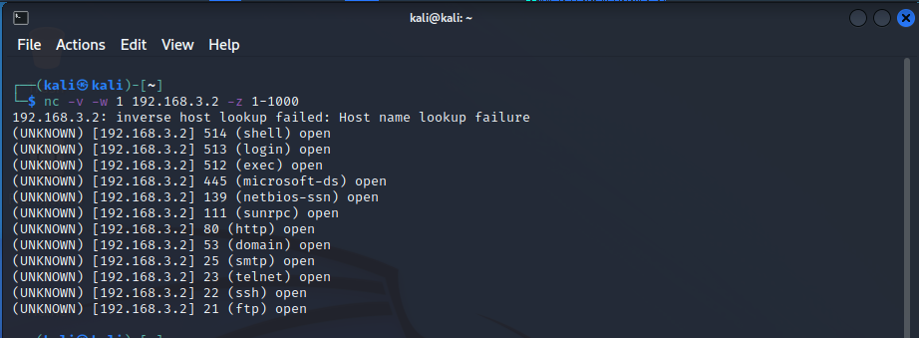
The above figure is the Netcat tool used to identify the targets open ports

- Enumerating
  - Nbtscan
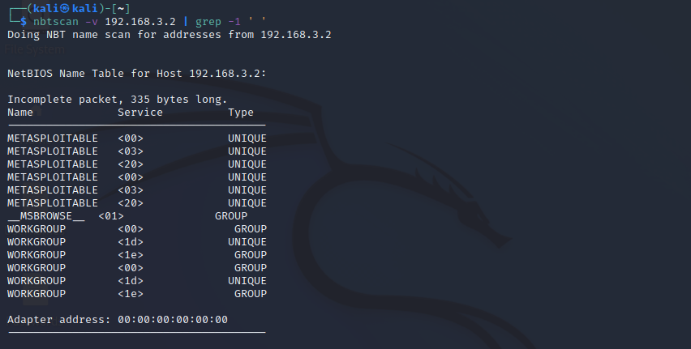
The above figure is the nbtscan tool used to retrieve the target’s NetBIOS name and MAC address.

  - SMB scan - this scan provides detail of the SMB and Operating System version
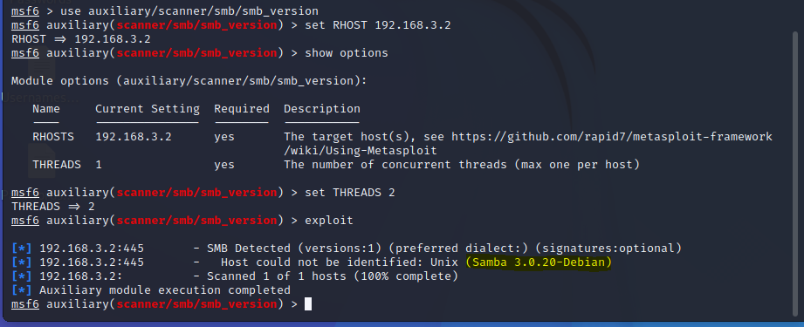

  - HTTP enumeration - this can provides details of the SMB folder structure.
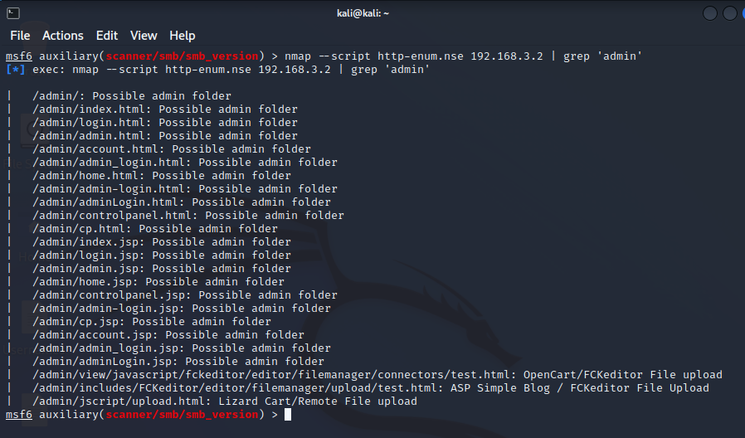

Exploits

- Vulnerability 1 - Samba MS-RPC

Description:
The MS-RPC functionality in smdb in Samba versions 3.0.0 through 3.0.25rc3 permits remote attackers to execute commands via a shell session and characters. It was revealed that Samba did not properly escape input parameters for external scripts defined in smb.conf. Remote attackers could send specially created MS-RPC requests and execute arbitrary shell commands.
CVE details 2007-2447 reported this vulnerability with a base score of 6.

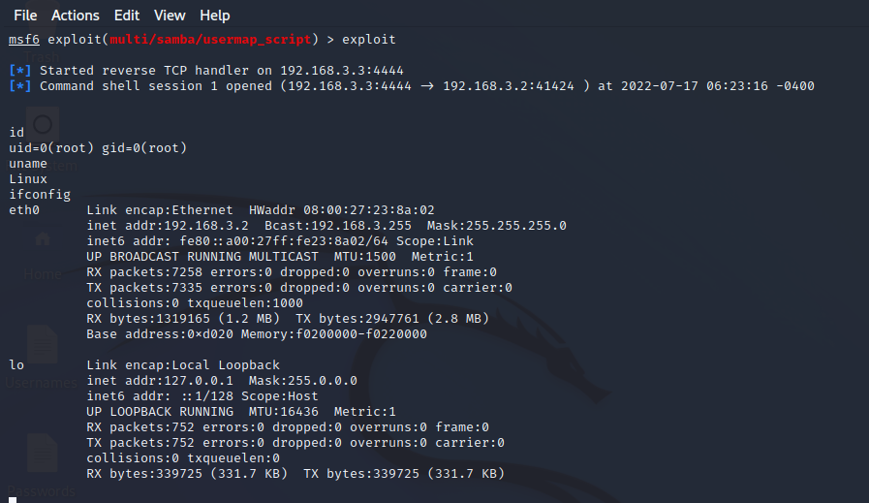

Figure 1

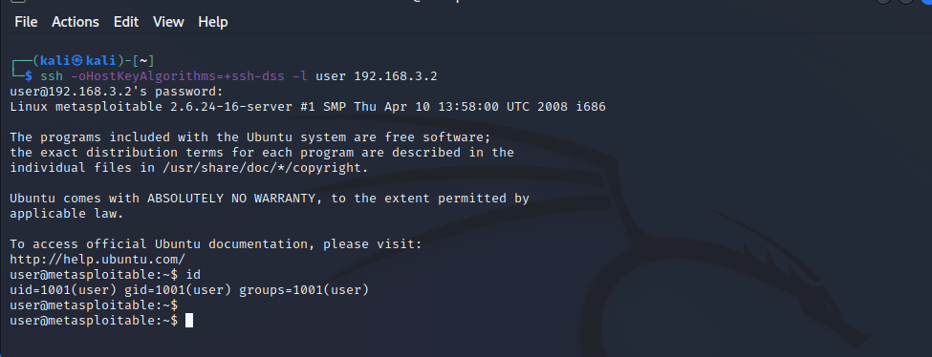
Figure 2

Mitigation
To remediate this issue, patches are available from samba.org website for vulnerable samba versions.
By removing all external script invocations from the samba setup, such as the username map and printer commands, this deformity can be minimised. Running the most recent stable version of Samba can lower the risk because it is merged with the definitions to fix earlier problems.

- Vulnerability 2 – vsftpd port 21, version 2.3.4 backdoored

Description
A variety of Linux operating systems include the FTP web server VSFTPD. Except for a major incident that happened in July 2011, when someone updated the default version 2.3.4 with a newly produced version that contained malicious code with a backdoor, VSFTPD is secure. Due to this vulnerability, remote attackers can log into the vulnerable version of the VSFTPD protocol while paying attention to port 6200 and obtain remote administrative access by using the smiley ":)" as the username and any password. Additionally, CVE-2011-2523 observed a situation similar to this where a java SE 15 vulnerability also allows an attacker from another place to execute instructions using a malware backdoor.

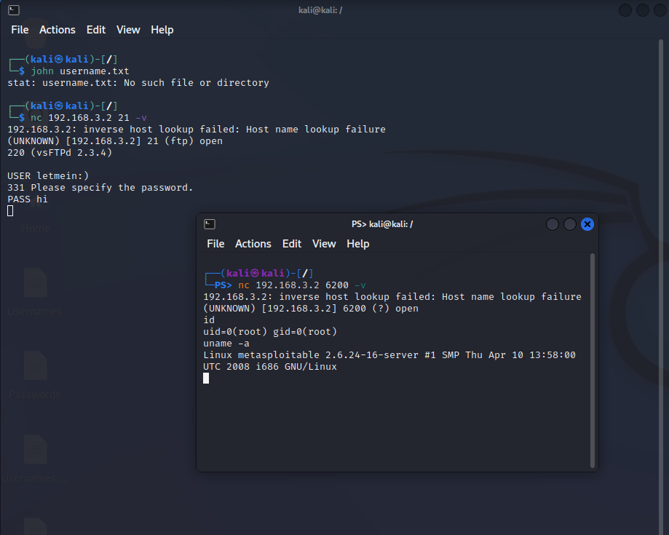

Figure 3: Exploitation of vstpd
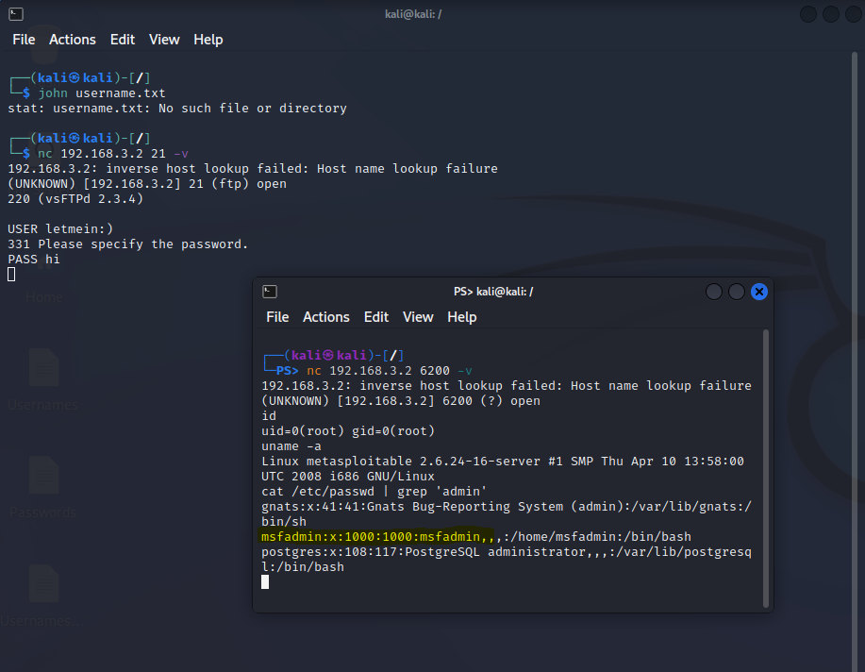
Figure 4: admin details

Mitigation
With the subsequently published version 2.3.5-3 and high priority, the reported CVE-2011-2523 problem connected with VSTFD version 2.3.4 has been resolved. The updates that eliminated the backdoor feature were implemented into the versions. The updated version may be downloaded from https://security.appspot.com/vsftpd.html.
- Vulnerability 3 – PHP CGI Argument Injection

Description
This particular flaw affects the Apache server because a CGI script specifies the PHP version. The service gets variables, some of which have user-managed attributes. As a result, the services used them to initiate library calls. An attacker can add extra codes to the query string if these parameters are provided incorrectly. An injection attack can be launched against PHP versions 5.3.12 and 5.4.2 when CGI is running. Code execution is accomplished by using the -d flag in the php.ini configuration file. It affects user privilege settings, DOS attacks, and granting an attacker access to private information. CVE 2012-1823

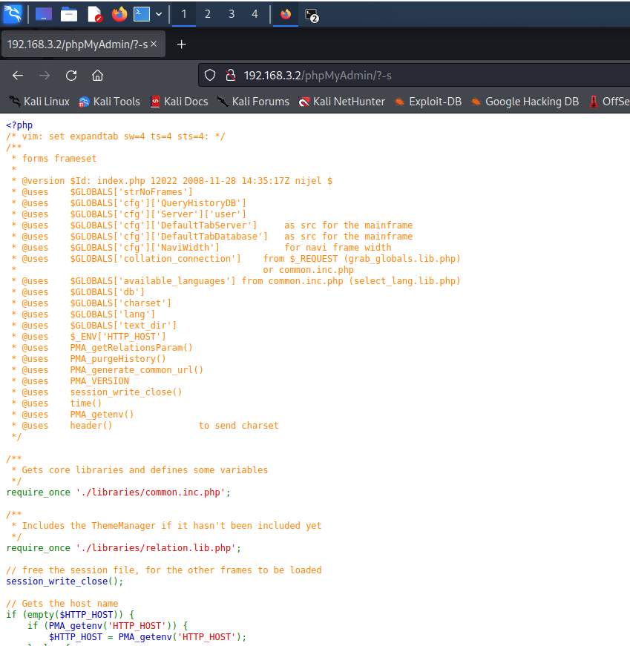

Figure 5: PHP CGI vulnerability
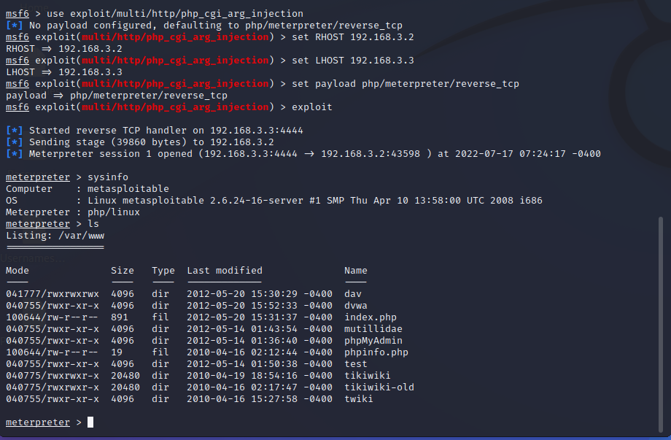
Figure 6: php cgi vulnerability exploitation

Escalation of privilege
Figure 7 below displays the SSH post-exploitation with the login and password from index.php exposed.
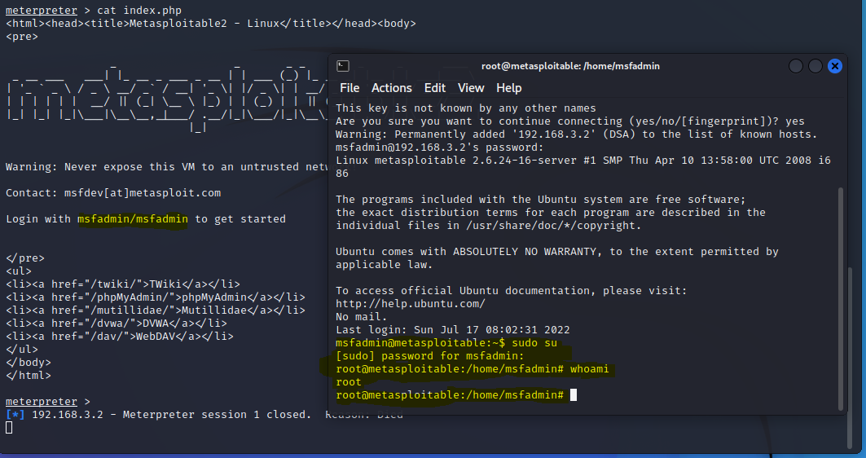
Figure 7 post exploitation using ssh command

Mitigation
Use of the most recent definitions is strongly advised. Alternatively, you can utilise pre-written scripts that you can obtain from http://kb.sp.parallels.com/Attachments/20000/Attachments/cve-2012-1823-wa_pp.tgz
These optional parameters can be protected from filtering by using the .htaccees rule, writing to a file, and saving it in the directory for Apache. NCSA developed the .htaccess technology which Apache has adopted.
You can also:
- Disable use of CGI mode for PHP, or
- Implement a WAF (Web Application Firewall).
- Update your PHP version to latest.

- Vulnerability 4 – Java RMI Server on port 1009 Java Code Execution

Description
Due to an insecure registry configuration and the activation service, the Java Remote Method Invocation (RMI) server permits remote code execution with high privilege user authorization. There is no need for any kind of authentication or validation when using the Java RMI method to execute a call. This is feasible because Java RMI allows its classes to be loaded through a remote protocol. By sending malicious packets to the affected version while the packet is being processed, an attacker can take advantage of this flaw and potentially infect the susceptible system. CVE-2011-3556

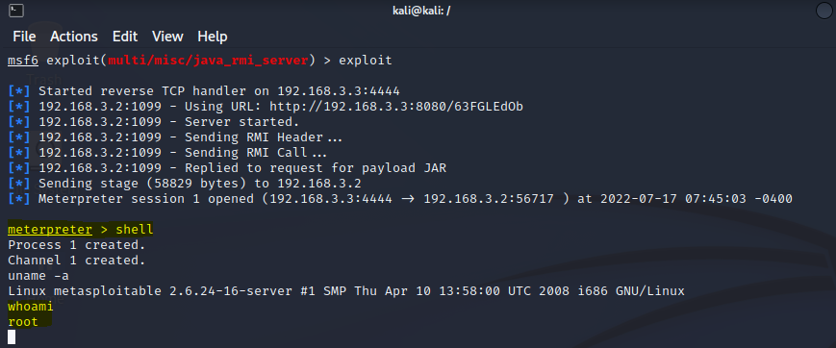
Figure 8 exploitation of java_rmi_server

Mitigation
The Java RMI class loader exploit has been fixed in Java 7.21, where the RMI property java.rmi.server.useCodebaseOnly now defaults to true. This change is also applicable to JDK 6 Update 45 and JDK 5 Update 45 releases.
Upgrade OpenEdge's current Java version to a later supported version update. Also see Articles.
- The following Java version is packed with the OpenEdge 11.4, 11.5, 11.6 installation media:
- JDK 1.7.0_45: Windows (32-bit and 64-bit), Solaris (64-bit), Linux (32-bit and 64-bit)
- OpenEdge 11.6, is still shipped with Java 1.7, however Java 8 Runtime is supported on all OpenEdge 11.6 supported.
- Java 8 is certified for and is the shipped version since OpenEdge 11.7.x and therefore no update is required.

A workaround is to disable class-loading thus prevent the attack, open DLC/properties/AdminServerPlugins.properties file and modify the 'jvmargs' line" under the following section to prevent 'hacking' the main AdminServer process (default port 20931)
[PluginPolicy.Progress.AdminServer]
jvmargs=....... -Djava.rmi.server.useCodebaseOnly=true
For NameServer, WebSpeed, AppServer modify the jvmargs line under their respective sections in DLC/properties/AdminServerPlugins.properties:
[Plugin.NameServer]
[Plugin.WebSpeed]
[Plugin.AppServer]
Then restart the AdminServer.
Additional security can be added using a host-based firewall to restrict access to the affected service(s).
The OEM / OEE Console can further be secured by using SSL, disabling HTTP, and switching to use HTTPS with a valid certificate. For further information refer to Article:

- Vulnerability 5 – UnreallRDC 3.2.8.1 backdoor Command Execution –

Description
The unrealRCD contains an unreal3.2.8.1 file, which has been claimed to have been overwritten or heavily changed by the backdoor. This Trojan horse in the DEBUG3 DOLOG SYSTEM macro allows the remote attacker to run commands as freely as any other user using ircd. This major issue happened in November 2009 as a result of the original.tar file being replaced by the backdoor. (UnRealircd 2010, CVE_Mitre 2010). CVE 2010-2075

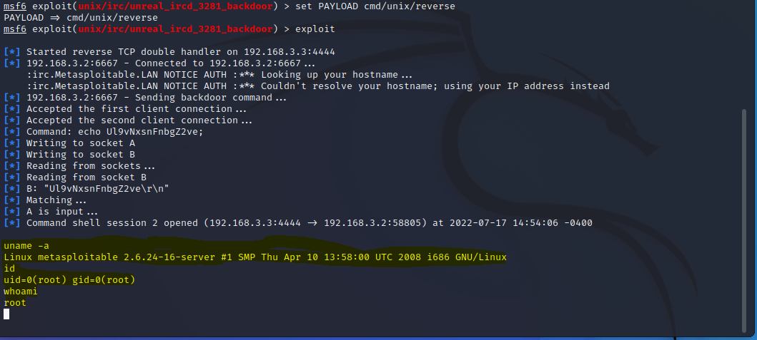
Figure 9 exploitation of unrealircd

The figure 10 below depicts the use of the shell to get access to the MySQL server in order to further investigate the assault.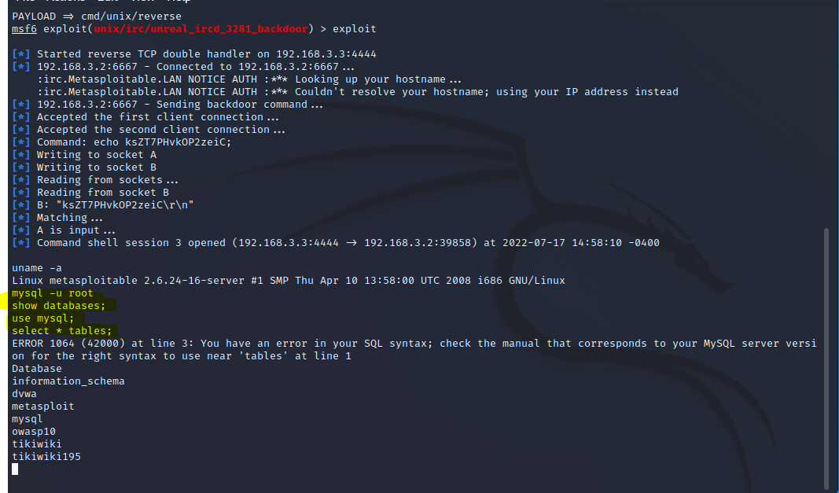
Figure 10 MySQL server

Mitigation
The solution has been patched into the latest versions. Re-downloading and constructing the precise version that has been mitigated is another option.
Verify MD5 checksums. Recompile and restart UnrealIRCd
- Vulnerability 6 – VNC Server weak ‘password’ Password on port 5900
Description
The Nessus scan revealed in the previous portion of the finding that the VNC server is protected by a very weak password that may be readily guessed or brute force attacked. Using the disclosed password, an attacker can exploit this vulnerability to acquire remote shell access using a VNC viewer. Nessus also indicates that this vulnerability is a significant concern since VNC is utilised to gain shell access.

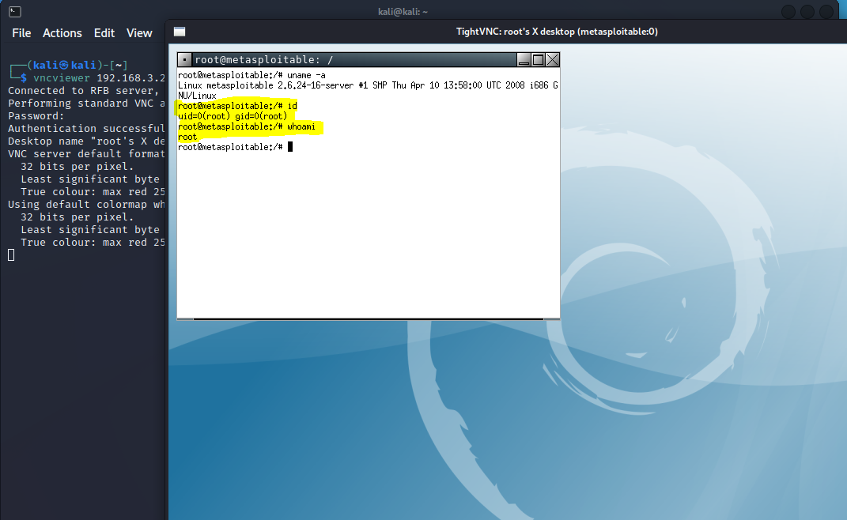
Figure 11 VNC server access

To learn more about the attack, a vnc shell is used to connect to the MySQL server and then dump one of the databases, as seen in figure 12 below.
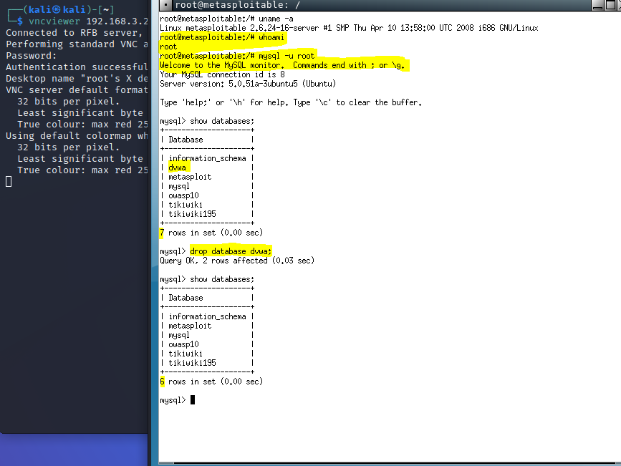
Figure 12 MySQL server

Mitigation
- Strong secure password creation with the following rules:
- The password should not RESEMBLE the username, nor vice versa.
- Every password must contain at least one letter, one number, and one special character, and there must be a mix of upper- and lower-case letters.
- The password should be long enough.

-

Evaluation
What conclusions can be drawn from data?
Conclusions can be drawn that each exploit was successful and recorded within the project. The expected outcomes were correct as followed through when completing the exploits. Literature review allowed for good research of specific software used to complete this projects exploits. Overall, it showed having a system that detected flaws within cyber security and test them will make a better and more secure home network, organisation etc.

Were the objectives met?
Aims were met with each objective. First aim was to identify vulnerabilities within a local area network. This was completed through research of the academic literature. This was completed by finding proven techniques within said academic literature. Second aim was completed through the exploitation of these vulnerabilities found within the first aim. Last aim was to mitigate these vulnerabilities/exploits. This was done using academic literature to find mitigation solutions for each scenario/exploit.

Are the outcomes what you would expect?
Each outcome was successful and mitigated. Therefore, the outcomes were successful, and the LAN conducted a successful penetration test. Making the security of said LAN more secure from possible attacks within the future.

If you were to do It again, what would you do differently?
I was to redo this project. I would first research more on other virtual machines, penetration testing tools, and vulnerable systems. Do exploits on both ones used and others. Then compare on both results that came from using different software’s for each outcome. I believe this will give a more in-depth knowledge on the title of this page “to Identify vulnerabilities of the local network by pen testing and mitigating the vulnerabilities by enhancing the security”

Conclusion
Within this project there was an experiment testing the security of an LAN. This was through the Metasploit Framework. Using Oracle VM Virtual Box to run the simulation and Kali Linux to run penetration tests on the experimental system. Within this project there were multiple tests run. This project is different to others as there were multiple exploitations done on different ports within the Metasploit framework. These tests were all different therefore creating a more diverse experiment compared to others. Also giving the needed mitigations to fix these vulnerabilities.

Reflection
When starting this project, I had a vison of penetration testing. My first vison was the penetration test a private cloud. This would have been done through AWS services. But I was unable to have permission from Amazon to perform these tests. Therefore, I had to recreate my project. I still wanted to do penetration testing and had to find other ways this could be done. This is when I found academic literature on said experiment above. This environment would have the capabilities to run penetration tests within in it. If I was to change the outcome of this project and make the project better. I first would have created what I have done thus far. That being using Oracle VM Virtual Box, Kali Linux, and Metasploit Framework. Then created another private virtual environment using different software’s. I would run the same exploits on each environment. Then record said results of both virtual environments and compare each test done to see if the software being used changes to outcomes drastically or not.
I believe this would give me more in-depth knowledge on other software’s that could have been used for penetration testing of a LAN, and why certain exploits might not work for certain software’s. This would overall make my project more knowledgeable and gives the reader of this project a better understand of the outcomes of the experiment.

References

[1] | I. A. Yari, "Exploiting Vulnerabilities of a Linux Based Machine: Penetration Testing Report and Incident Response Procedure," September 2016. [Online]. Available: file:///C:/Users/TJB/Downloads/ExploitingVulnerabilitiesofaLinuxBasedMachinePenetrationTestingReportandIncidentResponseProcedure.pdf. [Accessed 12 July 2022].
[2] | "BBC Lapsus$: Two UK teenagers charged with hacking for gang," BBC , 1 April 2022. [Online]. Available: https://www.bbc.co.uk/news/technology-60953527. [Accessed 5 April 2022].
[3] | J. Tidy, "BBC Cyber-attack strikes German fuel supplies," BBC, 1 February 2022. [Online]. Available: https://www.bbc.co.uk/news/technology-60215252. [Accessed 5 April 2022].
[4] | BBC, "Gloucester Council cyber attack linked to Russian hackers," BBC, 18 Jan 2022. [Online]. Available: https://www.bbc.co.uk/news/uk-england-gloucestershire-60045060. [Accessed 5 April 2022].
[5] | BBC, "REvil ransomware gang arrested in Russia," BBC, 14 Jan 2022. [Online]. Available: https://www.bbc.co.uk/news/technology-59998925. [Accessed 5 April 2022].
[6] | N. C. S. Centre, "Reducing your exposure to cyber attack," National Cyber Security Centre, 13 October 2015. [Online]. Available: https://www.ncsc.gov.uk/information/reducing-your-exposure-to-cyber-attack. [Accessed 5 April 2022].
[7] | O. V. Box, "Welcome to VirtualBox.org!," Oracle Virtaul Box, [Online]. Available: https://www.virtualbox.org/. [Accessed 5 April 2022].
[8] | O. V. Box, "1.3. Features Overview," Oracle Virtaul Box, [Online]. Available: https://www.virtualbox.org/manual/ch01.html#features-overview. [Accessed 5 April 2022].
[9] | O. V. Box, "1.4 Supported Host Operating Systems," Oracle Virtual Box, [Online]. Available: https://www.virtualbox.org/manual/ch01.html#hostossupport. [Accessed 5 April 2022].
[10] | O. V. Box, "1.1 Why is Virtualization Useful?," Oracle Virtual Box, [Online]. Available: https://www.virtualbox.org/manual/ch01.html. [Accessed 5 April 2022].
[11] | K. Linux, "What is Kali Linux?," Kali Linux, [Online]. Available: https://www.kali.org/docs/introduction/what-is-kali-linux/. [Accessed 5 April 2022].
[12] | K. Linux, "Kali Linux Bug Tracker," Kali Linux, [Online]. Available: https://bugs.kali.org/view_all_bug_page.php?filter=62655222af475. [Accessed 5 April 2022].
[13] | K. Linux, "Choose your kali," Kali Linux, [Online]. Available: https://www.kali.org/get-kali/#kali-platforms. [Accessed 5 April 2022].
[14] | Tenable, "Nessus," Tenable, [Online]. Available: https://www.tenable.com/products/nessus. [Accessed 5 April 2022].
[15] | Tenable, "BUILT FOR PRACTITIONERS, BY PRACTITIONERS," Tenable, [Online]. Available: https://www.tenable.com/products/nessus. [Accessed 7 April 2022].
[16] | R. 1. Metasploit, "Metasploit Framewrok," RAPID 1 Metasploit, [Online]. Available: https://www.metasploit.com/?msclkid=710cfb3ec3d111ec91447aede374475b. [Accessed 5 April 2022].
[17] | U. Timalsina, "Use of Metasploit Framework in Kali Linux," April 2015. [Online]. Available: https://www.researchgate.net/publication/316874535_Use_of_Metasploit_Framework_in_Kali_Linux. [Accessed 6 April 2022].
[18] | Nmap, "Nmap: Discover your network," Nmap, [Online]. Available: https://nmap.org/. [Accessed 8 April 2022].
[19] | O. V. V. Box, "Oracle VM Vitural Box Download," Oracle VM Vitural Box, [Online]. Available: https://www.oracle.com/virtualization/technologies/vm/downloads/virtualbox-downloads.html?msclkid=3be20580c0de11ecbfa07434df01ef24. [Accessed 23 March 2022].
[20] | K. Linux, "Kali Linux Download," Kali Linux, [Online]. Available: https://www.kali.org/get-kali/?msclkid=c8a660cdc0de11eca63d71f32ae28f2a#kali-virtual-machines. [Accessed 23 March 2022].
[21] | R. 1, "Metasploitable - Virtual Machine to Test Metasploit," RAPID 1, [Online]. Available: https://information.rapid7.com/download-metasploitable-2017.html. [Accessed 23 March 2022].
[22] | Rapid7, "SMB Version Detection," Rapid7, [Online]. Available: https://www.rapid7.com/db/modules/auxiliary/scanner/smb/smb_version/?msclkid=93074e79c5a911ec8e5915e1f9d2b219. [Accessed 6 April 2022].
[23] | Rapid7, "Samba "username map script" Command Execution," Rapid7, [Online]. Available: https://www.rapid7.com/db/modules/exploit/multi/samba/usermap_script/?msclkid=f5a63fa2c5a911ecac9de2b2717c5002. [Accessed 6 April 2022].
[24] | Rapid1, "HTTP Version Detection," Rapid1, [Online]. Available: https://www.rapid7.com/db/modules/auxiliary/scanner/http/http_version/?msclkid=43f593fdc5ab11ec833950c00dce2bc4. [Accessed 6 April 2022].
[25] | Rapid1, "HTTP Directory Scanner," Rapid1, [Online]. Available: https://www.rapid7.com/db/modules/auxiliary/scanner/http/dir_scanner/?msclkid=eba815c1c5aa11ec8433ca927b2bc9a3. [Accessed 6 April 2022].
[26] | O. Security, "Scanner HTTP Auxilary Modules," Offensive Security, [Online]. Available: https://www.offensive-security.com/metasploit-unleashed/scanner-http-auxiliary-modules/?msclkid=b0b086c1c5aa11ecb7831e3a9420b966. [Accessed 6 April 2022].
[27] | O. Security, "Scanner SSH Auxiliary Modules," Offensive Security, [Online]. Available: https://www.offensive-security.com/metasploit-unleashed/scanner-ssh-auxiliary-modules/?msclkid=67d19ddec5a511ec9e12796b4b476e86. [Accessed 6 April 2022].
[28] | InfosecMatter, "SSH Login Check Scanner - Metasploit," InfosecMatter, [Online]. Available: https://www.infosecmatter.com/metasploit-module-library/?mm=auxiliary%2fscanner%2fssh%2fssh_login&msclkid=67d14d53c5a511ec87f842358ccefed0. [Accessed 6 April 2022].
[29] | C. Metasploit, "Class: Metasploit::Framework::LoginScanner::Telnet," Class, [Online]. Available: https://docs.metasploit.com/api/Metasploit/Framework/LoginScanner/Telnet.html?msclkid=2f9f0b6ec5a611ecbd91ebeb0caf2f6c. [Accessed 6 April 2022].
[30] | Rapid7, "VSFTPD v2.3.4 Backdoor Command Execution," Rapid7, [Online]. Available: https://www.rapid7.com/db/modules/exploit/unix/ftp/vsftpd_234_backdoor/?msclkid=c53651c9c5a611ec840d631bec1fd39c. [Accessed 6 April 2022].
[31] | Rapid7, "SMTP User Enumeration Utility," Rapid7, [Online]. Available: https://www.rapid7.com/db/modules/auxiliary/scanner/smtp/smtp_enum/?msclkid=ad54532dc5a711eca12cd0d0649d2a1a. [Accessed 6 April 2022].

