

Master of Business Administration
Lecturer: Balendran Kandasamy
Module: Strategic Management
Module code: LCMB7003
Level: Masters (Level 7)
STRATEGIC MANAGEMENT ANALYSIS
DIAGEO PLC
Achieving Sustainable Competitive Advantage in the Global Beverages Industry
Organisation: Diageo Plc
Student name: Md Ranu Miah
Student ID number: 2437168
Word Count: ≈5,240 words (excluding figures, and references)
Table of Contents
SECTION 1. 4
1. ORGANISATIONAL CONTEXT AND OVERVIEW 4
1.1 Organisational History, Mission, Vision, and Business Model 4
1.2 Industry, Key Competitors, and Market Position 4
2. EXTERNAL AND INTERNAL ENVIRONMENT ANALYSIS 6
2.1 PESTEL Analysis 6
2.2 Critical Success Factors and Strategic Challenges 9
2.3 Internal Environment — Resources, Capabilities, and Core Competencies 10
2.4 VRIO Framework Analysis 10
2.5 How Internal Strengths Contribute to Competitive Advantage 12
3. CSR AND SUSTAINABILITY OBJECTIVES 13
3.1 CSR Strategy and Alignment with Business Objectives 13
4. COMPREHENSIVE VIEW — BALANCED SCORECARD 13
4.1 The Balanced Scorecard Framework 14
4.2 Four Perspectives Applied to Diageo 15
5. STRATEGIC CHOICES AND IMPLEMENTATION 17
5.1 Business-Level and Corporate-Level Strategic Options 17
5.2 Change Management and Strategic Implementation 18
6. STRATEGIC EVALUATION AND RECOMMENDATIONS 19
6.1 Strategic Evaluation: SWOT, Ansoff's Matrix, and BCG Matrix 19
6.2 & 6.3 Strategic Recommendations with Theoretical Justification 21
7. CONCLUSION 21
REFERENCES 23
Introduction 26
Stage 2 — Feelings: What Was I Thinking and Feeling? 27
Stage 3 — Evaluation: What Was Good and Bad About the Experience? 27
Stage 4 — Analysis: What Sense Can Be Made of the Experience? 29
Stage 5 — Conclusion: What Else Could Have Been Done? 29
Stage 6 — Action Plan: What Will I Do Differently in Future? 30
Reflective Conclusion 31
References 31

SECTION 1.

1. ORGANISATIONAL CONTEXT AND OVERVIEW

1.1 Organisational History, Mission, Vision, and Business Model

Diageo Plc was established in 1997 because of the merger between Guinness Plc and Grand Metropolitan Plc to form a worldwide powerhouse in beverages based in London, UK. Its origin dates to centuries-old brewing and distilling: in 1759, Guinness was established in Dublin, and the distilleries of Johnnie Walker have been operating in Scotland since the beginning of the nineteenth century (Diageo Annual Report, 2024; Gaughan, 2015). Since its inception, Diageo had embarked on an aggressive brand acquisition and portfolio rationalisation strategy, selling off non-core food assets and redeploying capital capital to premium beverage brands, the most notable of which is its 1-billion-dollar purchase of Casamigos tequila in 2017 (Diageo AR, 2024).

The corporate mission of Diageo focuses on the celebration of life, daily, all over the world, making its brands culturally core to the celebration of life. Its strategic vision (under the framework of Society 2030: Spirit of Progress) incorporates environmental sustainability, responsible drinking, and inclusive economic opportunity into its commercial strategy. Diageo has a premium spirits-based business model that generates revenue by manufacturing, marketing, and distributing to five geographic markets, including the North America, Europe, Asia Pacific, Africa, and Latin America (Diageo AR, 2024). The key sources of revenue in FY2024 comprised off-trade retail, on-trade hospitality and direct-to-consumer digital channels which yielded revenue of £16.98bn. The most strategically important asset of the organisation is the brand portfolio that is over £16bn (Brand Finance, 2024).

1.2 Industry, Key Competitors, and Market Position
Diageo is a company in the global alcoholic drinks market, which was estimated to be $1.66 trillion in 2024 and is expected to increase at a CAGR of 3.8% by 2030, due to premiumisation in developed markets and volume in emerging markets (Statista, 2024; IWSR, 2024). The level where Diageo has a disproportionately high presence is the premium segment, which is expanding at an average of two times the pace of the category (IWSR, 2024).
The main rivals of Diageo are Pernod Ricard (Absolut, Jameson), Bacardi Limited (Grey Goose), LVMH Wines and Spirits (Hennessy), Beam Suntory (Jim Beam) and Brown-Forman (Jack Daniels). Figure 2 (competitive positioning map) shows that Diageo has set the pace in terms of both premiumisation and portfolio breadth - a strategy that none of its rivals can currently match to the same extent. Diageo controls leading market share in Scotch whisky (Johnnie Walker), and Irish stout (Guinness), as well as is fast ascending market share in premium tequila which is the fastest-growing major spirits category worldwide (IWSR, 2024; Diageo AR, 2024).
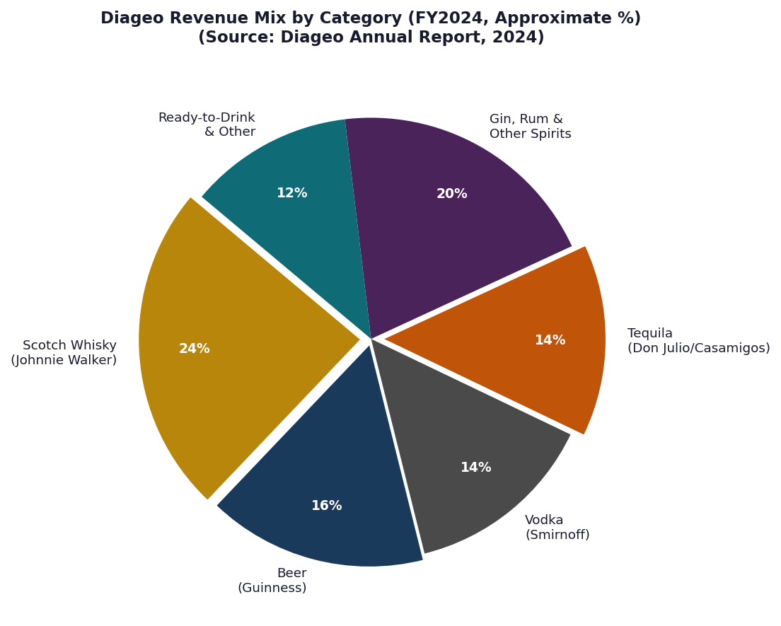
Figure 1: Diageo Revenue Mix by Category (FY2024) — Source: Diageo Annual Report, 2024
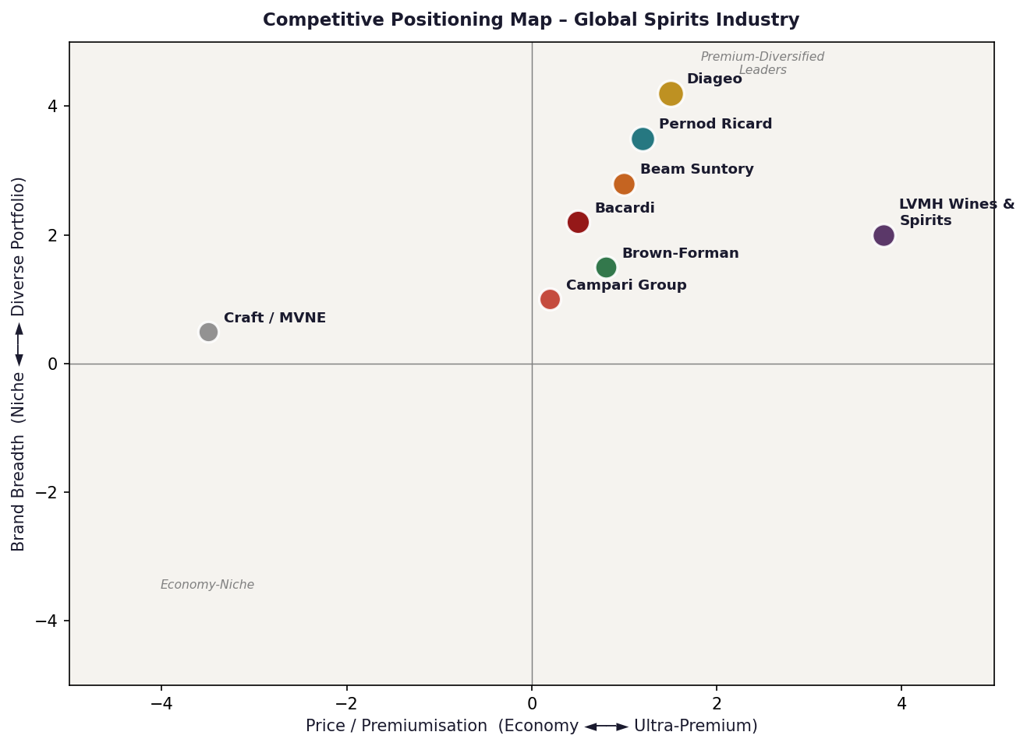
Figure 2: Competitive Positioning Map – Global Spirits Industry.

2. EXTERNAL AND INTERNAL ENVIRONMENT ANALYSIS

2.1 PESTEL Analysis
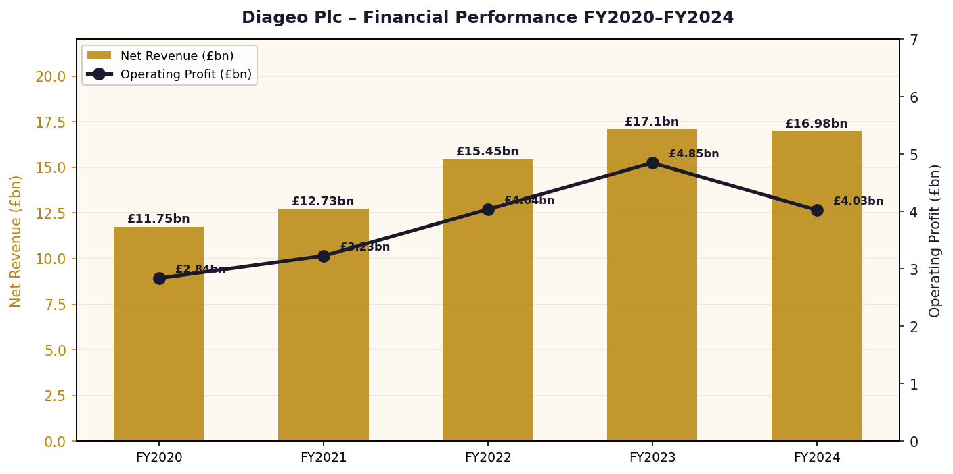
Figure 3: Diageo Financial Performance FY2020–FY2024 — Source: Diageo Annual Reports, 2020–2024
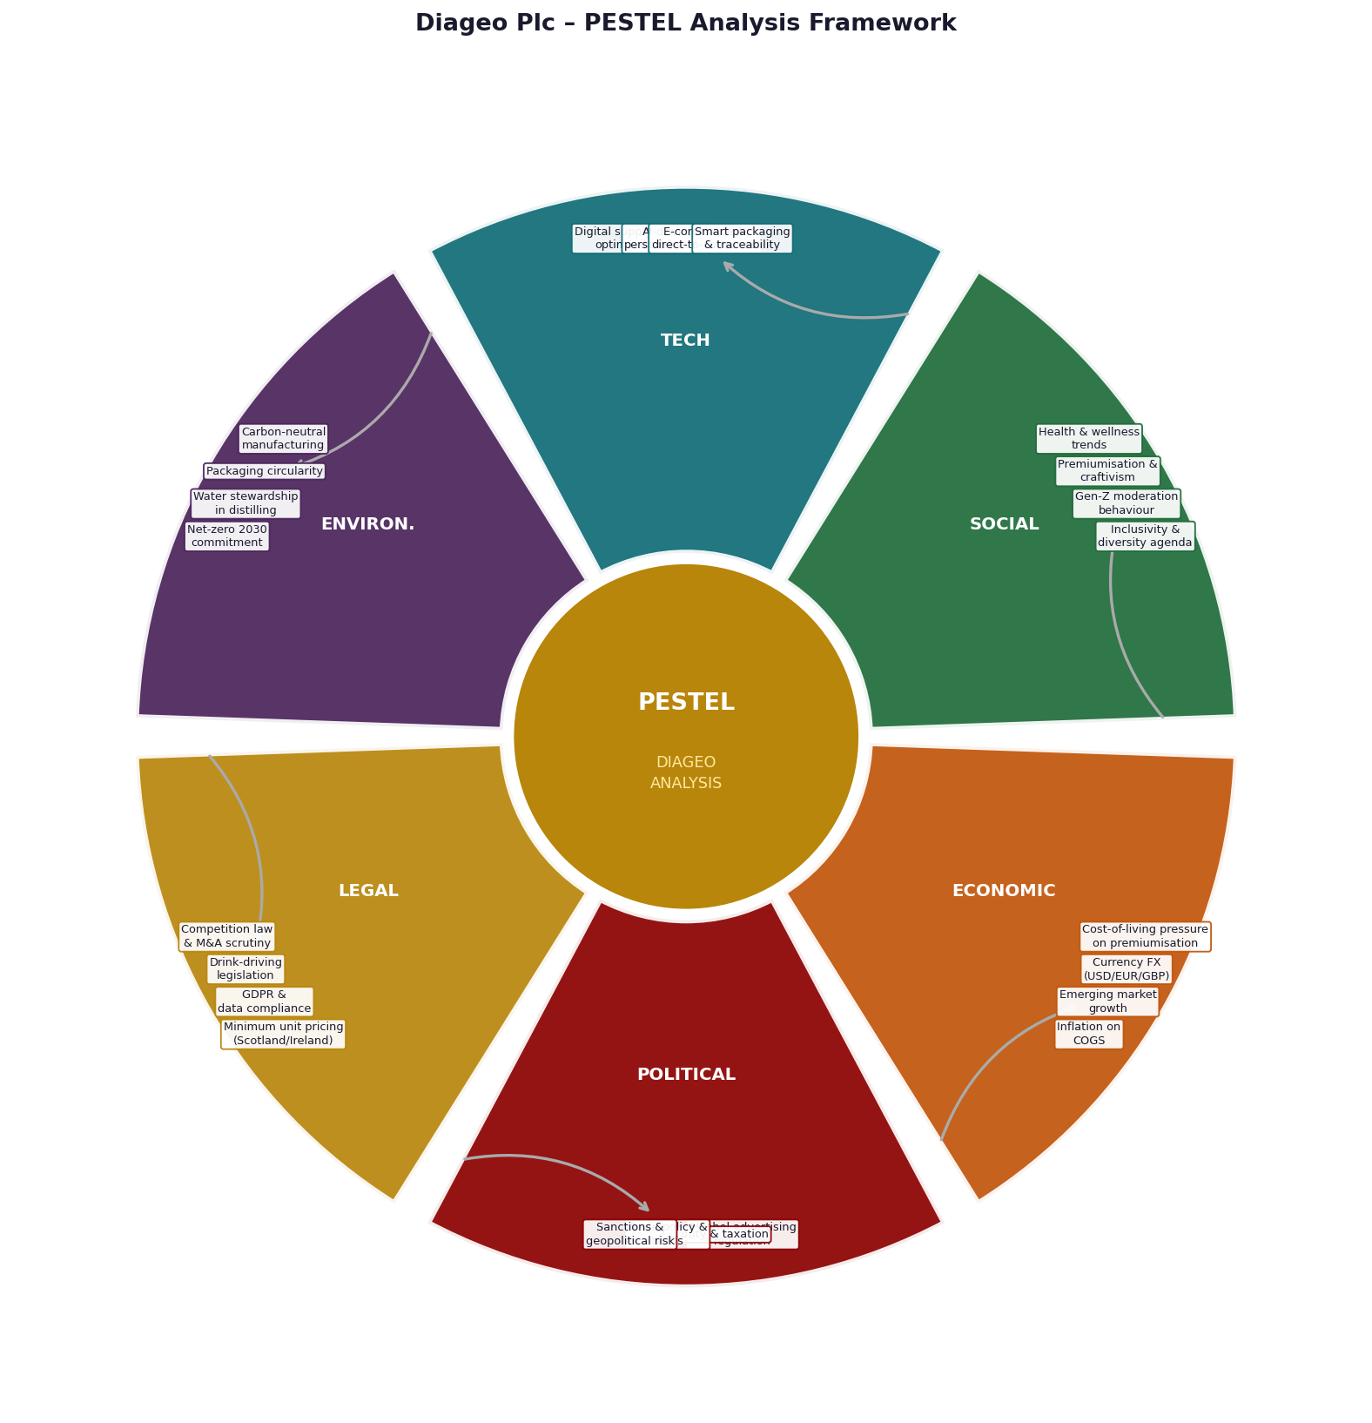
Figure 4: PESTEL Analysis Mind Map – Diageo Plc.
Table 1: PESTEL Analysis – Diageo Plc.
Dimension | Key Factor | Strategic Implication for Diageo
Political | Alcohol advertising & marketing regulation | Tightening restrictions on alcohol advertising (particularly digital and sports-linked) constrain Diageo's brand-building channels and require investment in alternative experiential marketing strategies (Carroll, 1991; Grant, 2016).
 | Excise duty increases (UK, Ireland, India) | Governments consistently use alcohol taxation as a fiscal lever; the UK's 2023 duty reforms increased spirits duty by 10.1% — directly compressing on-trade volume and consumer purchasing power (Diageo AR, 2024).
Economic | Foreign exchange: USD/GBP/ZAR/INR | Diageo's global revenue base makes it highly sensitive to currency movements; the ZAR and Argentine peso depreciation in FY2024 materially suppressed emerging market reported revenues (Hill et al., 2014).
 | Consumer spending contraction | The cost-of-living crisis in key European and North American markets has compressed discretionary spend on premium spirits, with consumers trading down to mid-priced alternatives (Kotler and Keller, 2016).
Social | Moderation and no/low-alcohol trend | Growing health consciousness among Gen-Z and Millennial consumers is structurally reshaping category volumes; Diageo estimates 30%+ of its target demographic are actively reducing alcohol consumption (IWSR, 2024; Eccles et al., 2014).
 | Premiumisation among aspirational consumers | Simultaneously, affluent consumers globally are "drinking less but drinking better", creating structural tailwinds for Diageo's super-premium and ultra-premium expressions (Prahalad and Hamel, 1990).
Technological | E-commerce & direct-to-consumer (DTC) | Digital retail channels and DTC platforms (Diageo.com, Reserve Bar) create new revenue streams and customer relationship opportunities outside traditional three-tier distribution (Westerman et al., 2014).
 | Smart packaging & blockchain traceability | Anti-counterfeiting technology and blockchain-enabled provenance verification are increasingly important in the premium spirits segment, where counterfeit products represent a significant brand and safety risk (Teece et al., 1997).
Environmental | Net-zero 2030 commitment | Distilling is an energy and water-intensive production process; Diageo's net-zero 2030 target requires fundamental transformation of its manufacturing infrastructure (Eccles et al., 2014; Elkington, 1997).
 | Agave water stress (Tequila) | Blue agave cultivation in Jalisco, Mexico, is increasingly threatened by water scarcity and climate-driven yield variability — a material supply chain risk for Diageo's Don Julio and Casamigos brands (Diageo AR, 2024).
Legal | Minimum unit pricing (Scotland, Ireland) | Minimum unit pricing legislation directly affects the competitive dynamics of lower-priced spirits categories, reshaping product mix and channel dynamics across UK and Irish markets (Johnson et al., 2017).
 | India regulations on spirits labelling & ownership | India's complex state-by-state regulatory framework — including labelling requirements, advertising restrictions, and ownership rules — creates significant operational complexity for Diageo's United Spirits subsidiary (Ghemawat, 2001).

2.2 Critical Success Factors and Strategic Challenges
According to Rockart (1979, p.85), critical success factors refer to few areas that guarantee successful performance in competition. In the case of Diageo, there are five CSFs that are determined by the synthesis of PESTEL analysis, industry intelligence, and competitive benchmarking (Johnson et al., 2017).
Brand Equity Stewardship: Diageo has the most inimitable strategic asset in the form of the brand equity of Johnnie Walker (estimated at about £3.2bn by Brand Finance, 2024) and Guinness (£1.8bn). This equity based on consistent quality and aspirational positioning is the core CSF (Barney, 1991; Dierickx and Cool, 1989).
Premiumisation Implementation: Diageo has based its revenue growth strategy on the improvement of revenue per case by mixing the product towards super-premium expressions, which necessitates the use of disciplined brand management and channel control that is incapable of being duplicated by smaller competitors (Porter, 1985; Prahalad and Hamel, 1990).
No/Low Alcohol Portfolio Development: Moderation shift is the greatest threat and opportunity. The Seedlip and Guinness 0.0 will make Diageo a structural leader in the new no/low-alcohol market (Christensen, 1997; IWSR, 2024).
Emerging Market Penetration: Africa and India are the greatest long-term growth potential of Diageo. The 1.4 billion population of Africa and the rapidly growing middle class presents extremely underdeveloped consumption of premium spirits per capita (Prahalad, 2006; IWSR, 2024).
Supply Chain Sustainability and Resilience: As agave water in Mexico to barley in Scotland, the global supply chain of Diageo is becoming more vulnerable to the environmental forces. Development of resilience and moving towards net-zero is a significant CSF (Christopher, 2011; Eccles et al., 2014).
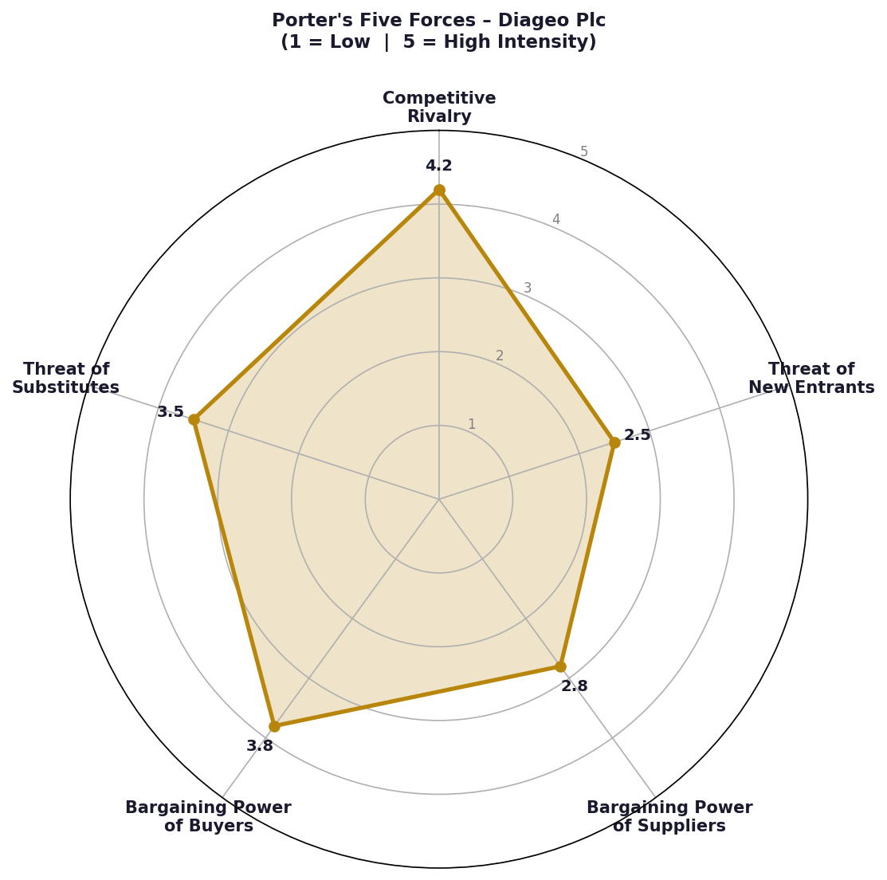
Figure 5: Porter's Five Forces Analysis – Diageo Plc (Adapted from Porter, 1980)

2.3 Internal Environment — Resources, Capabilities, and Core Competencies

Resource-Based View (Wernerfelt, 1984; Barney, 1991) is an idea that argues that a sustained competitive advantage is because of resources that are valuable, rare, imperfectly imitable and organisationally supported. According to Prahalad and Hamel (1990, p.82), core competencies refer to the overall learning in the coordination of various production skills. In the case of Diageo, the subsequent resources are centrally placed.

Brand Portfolio: The most strategically irreplaceable asset of Diageo is its portfolio of more than 200 brands, which include Johnnie Walker, Guinness, Don Julio, Casamigos and Tanqueray. Cumulative brand equity, which is developed over decades and centuries, is a socially complex, path-dependent resource that no rival can imitate (Dierickx and Cool, 1989; Barney, 1991).

Global Distribution Network: The route-to-market strengths that Diageo has in 180+ countries include owned distribution enterprises as well as third-party engagements and have been decades in the making. With the three-level US market, the association with Southern Glazer and Republic National are structural advantages that establish almost insurmountable conditions against new entrants (Christopher, 2011; Porter, 1980).

Scotch Whisky Liquid Assets: Diageo has the largest maturing Scotch whisky in the world millions of litres of Scotch in oak casks throughout Scotland, which is a physical asset with distinctive time properties: the value of the asset increases with age and cannot be hastened by competitors (Dierickx and Cool, 1989). This supports the power of the Johnnie Walker portfolio.

Innovation and Consumer Insight Capabilities: The Global Innovation team at Diageo has generated category-defining innovations such as Guinness 0.0 and the Seedlip partnership and has proven organisational capability to turn consumer trends into commercially successful products (Teece et al., 1997; Westerman et al., 2014).

2.4 VRIO Framework Analysis
Table 2: VRIO Framework Analysis – Diageo Plc (Adapted from Barney, 1991)
Resource / Capability | Valuable? | Rare? | Inimitable? | Organised? | Competitive Implication
Brand Portfolio (JW, Guinness, Don Julio) | ✓ Yes | ✓ Yes | ✓ Yes | ✓ Yes | Sustained Competitive Advantage
Scotch Whisky Maturing Inventory | ✓ Yes | ✓ Yes | ✓ Yes | ✓ Yes | Sustained Competitive Advantage
Global Distribution Network | ✓ Yes | ✓ Yes | ~ Partial | ✓ Yes | Temporary Competitive Advantage
No/Low Alcohol Innovation (Seedlip, G0.0) | ✓ Yes | ✓ Yes | ~ Partial | ✓ Yes | Temporary Competitive Advantage
Consumer Insight & Innovation Capability | ✓ Yes | ~ Partial | ~ Partial | ✓ Yes | Competitive Parity (improving)
Premium On-Trade Relationships | ✓ Yes | ~ Partial | ~ Partial | ✓ Yes | Competitive Parity
Geographical Diversification | ✓ Yes | ~ Partial | ✗ No | ✓ Yes | Competitive Parity
Distilling & Production Expertise | ✓ Yes | ~ Partial | ~ Partial | ✓ Yes | Competitive Parity

2.5 How Internal Strengths Contribute to Competitive Advantage
The VRIO analysis shows that the most sustainable competitive advantages of Diageo are its heritage brand portfolio and maturing Scotch whisky stocks. Both meet all four VRIO requirements, creating sustained competitive advantage in the Barneyan sense - advantages that cannot be structurally replicated in any business-relevant time-period (Barney, 1991; Peteraf, 1993). Any other competitor that would develop comparable brand equity that Johnnie Walker has had since 1909 would take not just money, but time and socially complex organisational learning that is inherently non-tradeable as described by Dierickx and Cool (1989). On the same note, it would take at least twelve years of ageing the whisky stock to match that of Diageo, a time constraint that can never be surmounted by any financial strength.
The Dynamic Capabilities framework proposed by Teece et al. (1997) offers an alternative view: competitive advantage is not only based on excellent resources but rather the ability of the organisation to feel, capture and reorganise them in reaction to the environment. The example of Diageo acquiring Seedlip, creating Guinness 0.0 and investing in Distill Ventures can be seen as dynamic reconfiguration, a process that predicts and influences the future development of the category, as opposed to reacting to it (Mintzberg, 1987).

3. CSR AND SUSTAINABILITY OBJECTIVES

3.1 CSR Strategy and Alignment with Business Objectives
Diageo expresses its CSR strategy in terms of the Society 2030: Spirit of Progress framework that includes three pillars: Promote Positive Drinking, Champion Inclusion and Diversity, and Pioneer Grain-to-Glass Sustainability. The Pyramid of CSR by Carroll (1991) offers an analytical framework of analyzing commitments. The important question is whether Diageo CSR reaches the ethical and philanthropic summit of the pyramid of Carroll and brings about the shared value that Porter and Kramer (2006) claim provides both commercial payoff and social value.
Table 3: Diageo CSR Framework – Society 2030: Spirit of Progress.
CSR Pillar | Diageo Commitment | Measurable Target | Theoretical Alignment
Promote Positive Drinking | DRINKiQ educational platform; moderation messaging | 1bn+ people reached with responsible drinking message by 2030 | Carroll (1991); Bhattacharya & Sen (2004)
No/Low Alcohol Innovation | Guinness 0.0, Gordon's 0.0, Seedlip investment | 30% of portfolio to be no/low-alcohol by 2030 | Porter & Kramer (2006); Eccles et al. (2014)
Grain-to-Glass Sustainability | Net-zero supply chain; 100% renewable electricity | Net-zero across own operations by 2030 | Elkington (1997); Ellen MacArthur Foundation (2013)
Water Stewardship | Replenish all water used in water-stressed areas | 100% water replenishment in stressed catchments by 2026 | Eccles et al. (2014); Diageo AR (2024)
Inclusion & Diversity | 50% women in leadership; ethnic diversity targets | Transparent D&I reporting; supply chain inclusion | Morsing & Schultz (2006); Freeman (1984)
Sustainable Agriculture | Regenerative grain farming; agave stewardship | 100% sustainably sourced grain by 2030 | Elkington (1997); Porter & Kramer (2006)

The shared value framework by Porter and Kramer (2006) sheds some light especially when it is considered in relation to the no/low-alcohol investment in Diageo. Guinness 0.0 will also create incremental business value, increase the total opportunity Diageo can tap into by expanding the number of consumers who do not drink, and respond to alcohol harm reduction. It is shared value creation in its most enticing form: commercial and social goals are organizationally aligned (Freeman, 1984; Elkington, 1997). The empirical results of the study by Eccles et al. (2014) validates the idea that organisations that have integrated sustainability strategies perform better than their peers in the long-run.

4. COMPREHENSIVE VIEW — BALANCED SCORECARD

4.1 The Balanced Scorecard Framework
The Balanced Scorecard was introduced by Kaplan and Norton (1992) as a multi-dimensional system of performance management that converts the organisational vision into four perspectives: Financial, Customer, Internal Business Processes, and Learning and Growth. The main contribution of the BSC is the identification of the fact that purely financial measurements, which are always retrospective and lagging, should be supplemented with leading indicators of future ability (Kaplan and Norton, 1996; Niven, 2006). Atkinson et al. (1997) indicate that the BSC enables cross-functional strategic alignment. When used in the context of Diageo growth agenda, it offers a stringent framework of performance architecture coherence evaluation.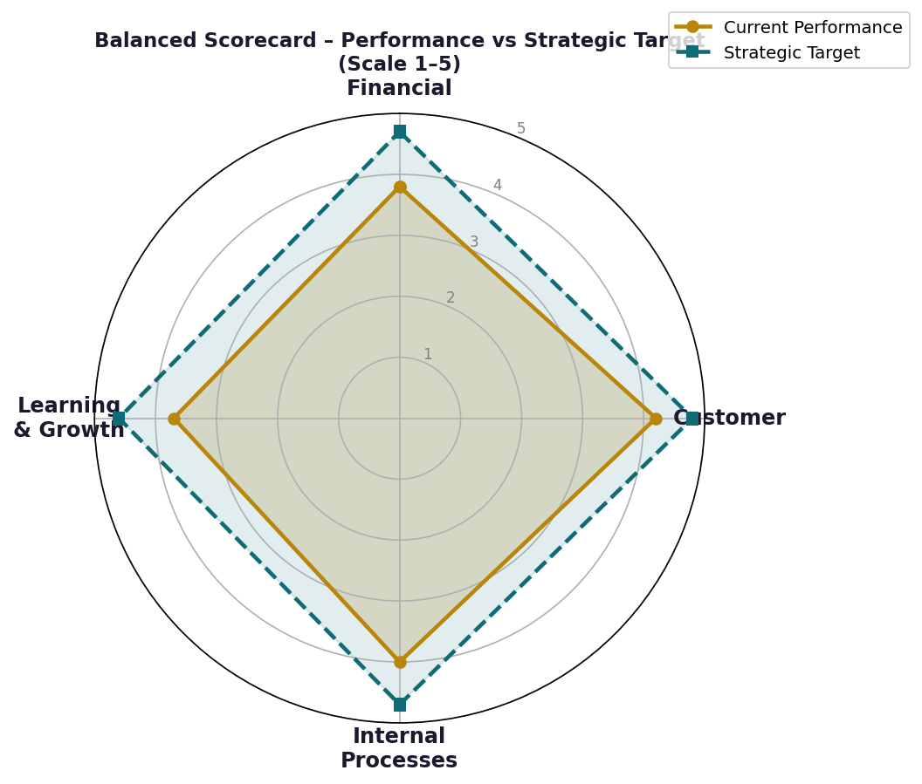
Figure 6: Balanced Scorecard – Diageo Performance vs Strategic Target

4.2 Four Perspectives Applied to Diageo
Table 4: Balanced Scorecard – Diageo Plc (Adapted from Kaplan and Norton, 1992)
Perspective | Strategic Objective | KPI | Target (FY2026) | Initiative
FINANCIAL (Kaplan & Norton, 1992) | Restore organic net sales growth | Organic NSV growth (%) | +4–6% p.a. | Premiumisation mix shift; North America recovery; emerging market volume
 | Protect operating margin | Operating profit margin (%) | >28% sustained | Productivity programme; pricing discipline; mix improvement
 | Deliver superior TSR | Total Shareholder Return vs FTSE 100 | Top quartile | Dividend growth; disciplined M&A; share buyback programme
 | Optimise working capital | Net debt / EBITDA ratio | <2.5x | Supply chain inventory optimisation; receivables management
CUSTOMER (Porter, 1985) | Grow brand power scores | Brand Power Index (BPI) | +8 points p.a. per priority brand | Marketing effectiveness investment; digital brand activation
 | Increasing Super-Premium+ share | % revenue from Super-Premium+ | >50% by FY2027 | Luxury reserve programme; connoisseur experiences
 | Expand no/low-alcohol share | No/low NSV as % of portfolio | 30% by 2030 | Guinness 0.0 roll-out; Gordon's 0.0; Seedlip expansion
 | Improve distributor NPS | Distributor Net Promoter Score | >65 | Route-to-market capability building; digital order management
INTERNAL PROCESSES (Hammer & Champy, 1993) | Achieve net-zero manufacturing | Scope 1 & 2 carbon emissions (CO₂e) | Net-zero own operations by 2030 | Renewable energy procurement; biomass boiler installation
 | Shorten innovation cycle time | Months concept-to-market (innovation) | <18 months | Distill Ventures accelerator; agile stage-gate process
 | Supply chain resilience | Supplier risk concentration score | Reduce by 25% | Dual-source key ingredients; agave diversification strategy
 | Digital-direct capability | DTC revenue as % of total | >5% by FY2027 | Reserve Bar partnership; DTC e-commerce investment
LEARNING & GROWTH (Senge, 1990) | Build digital and data capability | Data literacy index across organisation | Score 4.0/5.0 | Diageo Learning Academy; data science recruitment
 | Develop inclusive leadership pipeline | % women and ethnically diverse leaders | 50% women; D&I targets achieved | Mentoring programmes; succession planning review
 | Foster sustainability culture | Employee sustainability engagement score | Score 4.2/5.0 | Spirit of Progress training; SBTi targets embedded in performance

5. STRATEGIC CHOICES AND IMPLEMENTATION

5.1 Business-Level and Corporate-Level Strategic Options
According to Porter (1980), there are three generic strategies namely cost leadership, differentiation and focus. The strategic position of Diageo has always been wide differentiation competing on several categories, geographies, and price points based on brand quality and heritage authenticity instead of price (Porter, 1985; Johnson et al., 2017). The premiumisation approach can be seen as differentiation at scale, increasing income but per case and decreasing the volume to commoditised market segments.
Gen-Z consumers in their moderation trend complicates the classical model of differentiation. When the volume is structurally shrinking in developed markets, premiumisation can only hold the revenue but this cannot forever hold up the investment base that would support global brand marketing and innovation (Rumelt, 2011). Diageo should thus embark on the two-speed differentiation approach: the further premium differentiation of the alcoholic portfolio and the creation of a differentiated no/low-alcohol offer that broadens its total addressable market (Teece et al., 1997; Christensen, 1997).
Table 5: Strategic Options Evaluation – Diageo Plc (Adapted from Porter, 1980; Ansoff, 1957)
Level | Strategic Option | Assessment | Recommendation
Business Level | Cost Leadership — compete on price in standard spirits | Low viability; destroys brand equity; margins collapse; VRIO assets not leveraged | ✗ Not Recommended
 | Broad Differentiation — premiumisation + no/low portfolio expansion | High viability; leverages VRIO brand assets; expands TAM; aligns with CSR | ✓ Strongly Recommended
 | Focused Niche — ultra-luxury collectibles only (exit mass market) | Medium viability; sacrifices Guinness/Smirnoff cash flows; scale economies lost | ✗ Not Recommended
Corporate Level | Related Diversification — deepen tequila & agave (Don Julio, Casamigos) | High viability; fastest-growing global category; VRIO brand leverage | ✓ Strongly Recommended
 | Market Development — Africa spirits category development | High viability; 1.4bn population; underdeveloped premiumisation; EABL platform | ✓ Strongly Recommended
 | No/Low Alcohol — build category leadership (Seedlip, Guinness 0.0) | High viability; fastest-growing adjacency; first-mover advantage available | ✓ Strongly Recommended
 | Unrelated Diversification — enter food / nutrition | Low viability; misaligns with core competencies; destroys strategic focus | ✗ Not Recommended
 | Horizontal Acquisition — acquire Pernod Ricard brand | Very low viability; antitrust barriers insurmountable; prohibitive cost | ✗ Not Recommended

5.2 Change Management and Strategic Implementation
The strategic change of Diageo has necessitated significant organisational shift, such as acquiring Casamigos and Aviation Gin, speeding up digitalisation, transforming Society 2030, and resetting channels in the wake of the pandemic. A helpful model is the eight steps to change presented by Kotter (1996). Diageo has displayed the ability to create urgency: the moderation trend, sustainability imperative, and premiumisation opportunity are powerful arguments that are made effectively through the voice of its various stakeholders.
Johnson et al. (2017) state that strategic change within heritage-rich organisations is associated with cultural risks: values that maintain competitive advantage pride in craftsmanship, heritage attachment values can be an obstacle to innovation. According to the unfreeze-change-refreeze model created by Lewin (1951), the main challenge facing Diageo is the operationalisation of the no/low-alcohol strategy and digital investment at a pace that is required by the markets. According to the principles of a learning organisation proposed by Senge (1990), new capabilities can only be instilled by long-term investment in people development and not necessarily structural reorganisation.

6. STRATEGIC EVALUATION AND RECOMMENDATIONS

6.1 Strategic Evaluation: SWOT, Ansoff's Matrix, and BCG Matrix
Table 6: SWOT Analysis – Diageo Plc
STRENGTHS  - ✓ World's largest premium spirits company (£17bn revenue, FY2024)  - ✓ Johnnie Walker — world's most valuable Scotch whisky brand (£3.2bn)  - ✓ Guinness — culturally irreplaceable global stout with 0.0 variant  - ✓ Don Julio & Casamigos — dominant in the fastest-growing category (tequila)  - ✓ Maturing whisky inventory — temporally inimitable physical asset  - ✓ 180-country distribution — widest route-to-market in global spirits | WEAKNESSES  - ✗ FY2024 organic NSV decline — first in a decade (macro headwinds)  - ✗ High dependence on North America for margin generation  - ✗ Agave supply chain concentration risk (Don Julio / Casamigos)  - ✗ Standard spirits (Smirnoff) facing structural ARPU pressure  - ✗ Africa currency exposure: ZAR/EGP depreciation suppressing revenue  - ✗ No/low-alcohol portfolio scale still subscale vs opportunity
OPPORTUNITIES  - ★ No/low-alcohol — fastest-growing beverages adjacency globally  - ★ Tequila & agave premiumisation — 15%+ CAGR (IWSR, 2024)  - ★ Africa — 1.4bn people; underdeveloped premium spirits category  - ★ India post-regulatory unlock — United Spirits growth acceleration  - ★ Direct-to-consumer e-commerce and brand experiences  - ★ Whisky collector market — ultra-rare reserve expressions | THREATS  - ⚠ Gen-Z moderation trend — structural category headwind  - ⚠ Cost-of-living crisis reducing discretionary premium spend  - ⚠ Craft spirits disruption in gin, whisky, and rum segments  - ⚠ Climate risk: water stress threatening agave and barley supply  - ⚠ Regulatory tightening: duty increases, advertising restrictions  - ⚠ FX headwinds in Africa, LatAm markets suppressing reported revenue
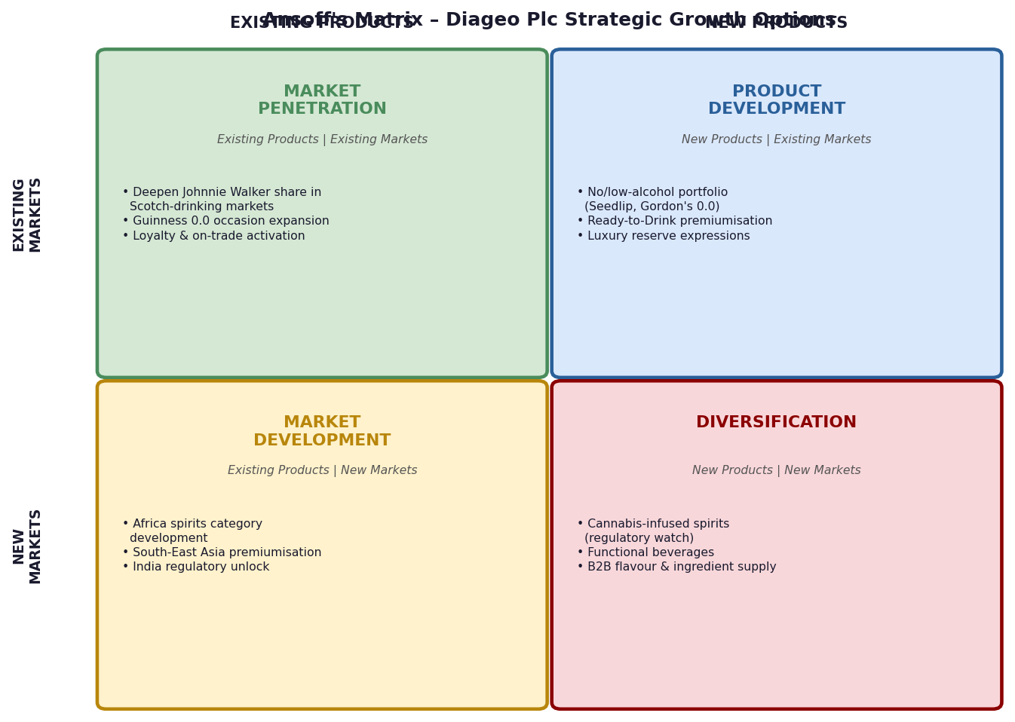
Figure 7: Ansoff's Matrix – Diageo Strategic Growth Options (Adapted from Ansoff, 1957)
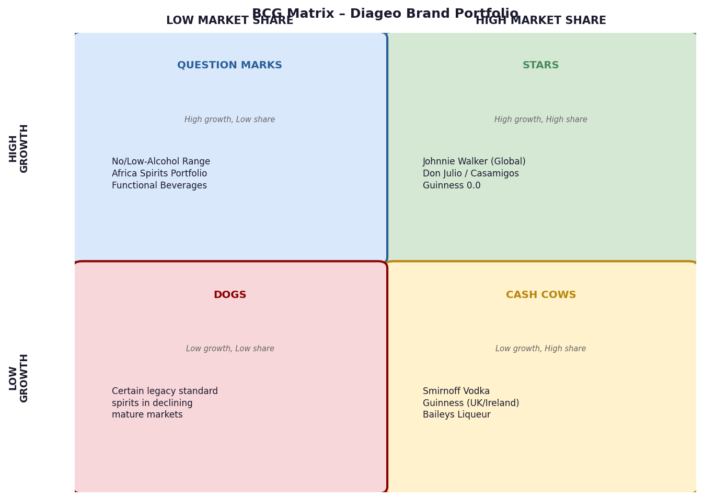
Figure 8: BCG Matrix – Diageo Brand Portfolio (Adapted from Henderson, 1970)

Johnnie Walker, Don Julio, and Casamigos are ranked as Stars (high-growth segments with a large market share that warrants a continued investment) (Figure 8) according to the BCG Matrix. Smirnoff, Guinness (UK/Ireland), and Baileys are Cash Cows that generate steady cash flows. The no/low-alcohol and the Africa spirits development take up the Question Marks high-growth adjacencies where Diageo is developing, but not yet at the level of Star (Henderson, 1970; Grant, 2016).

6.2 & 6.3 Strategic Recommendations with Theoretical Justification

Recommendation 1: No/Low-Alcohol Category Leadership (Porter, 1985; Ansoff, 1957 - Product Development). Diageo ought to heavily invest in the no/low-alcohol portfolio - expanding Guinness 0.0 distribution in Europe, North America and Asia Pacific, hastening the creation of Johnnie Walker 0.0, and expanding the Seedlip ecosystem. The non/low-alcohol sector in the world is increasing at a rate of 7% CAGR and is expected to reach an amount of 11bn by 2026 (IWSR, 2024). This plan is based on the Disruptive Innovation model by Christensen (1997): the category of no/low-alcohol is a structurally disruptive force. Diageo should be the first to disrupt (Teece et al., 1997).

Recommendation 2: Intensify Tequila and Agave Investment (Ansoff, 1957; Barney, 1991 -RBV). Diageo must hasten its investment in Don Julio and Casamigos - building more distillation in Jalisco, creating ultra-premium age-statement expressions, and creating immersive brand experiences. The tequila segment is experiencing a 15%+ CAGR worldwide, and the US tequila is expected to surpass the US whiskey in volume in 2023 (IWSR, 2024). Temporal inimitability is used when investing in old expressions (Dierickx and Cool, 1989): old tequila takes years to mature, and this forms inventory obstacles that could hinder the Scotch whisky leadership at Diageo.

Recommendation 3: Build Africa as the Third Strategic Growth Pillar at Diageo (Prahalad, 2006; Ghemawat, 2001). Diageo ought to officially make Africa its third strategic growth pillar together with North America and Asia Pacific, by making disproportionate investments in localised brand development and channel activation in sub-Saharan Africa. The strategic argument is strong: the 1.4 billion people of Africa are comprised of a fast-growing and underdeveloped middle class with a dire need in premium spirits consumption. The fortune-at-the-bottom-of-the-pyramid model by Prahalad (2006) proposes starting with available price points and then to trade consumers up the premiumisation ladder. This is supported by the CAGE Distance Framework designed by Ghemawat (2001): the current EABL infrastructure of Diageo shortens cultural and administrative distance barriers in the new market entrants.

7. CONCLUSION
This report has provided a critically based strategic management analysis of Diageo Plc, which has shown not only the depth of its competitive assets to an incredible level, but also real strategic challenges in an industry that is experiencing structural change. Diageo is in a market that is influenced by both the premiumisation tailwinds and moderation headwinds which are validated by the PESTEL and Porter Five Forces analysis. The VRIO framework verifies that the brand portfolio and maturing whisky inventory owned by Diageo have path-dependent inimitability that cannot be convincingly defeated by any competitor (Barney, 1991; Dierickx and Cool, 1989).
The three strategic options, which include no/low-alcohol category leadership, tequila deepening, and Africa as a third growth pillar are all aimed at solving the core strategic dilemma of Diageo: providing the organization with the near-term financial salvage and investing in the structural engines of growth over the upcoming decade. These suggestions are commercially implementable as seen in the successful launch of Guinness 0.0, the luxury positioning of Don Julio, and the hundred-year development of the African market by EABL (Johnson et al., 2017; Porter and Kramer, 2006).

REFERENCES
- Ansoff, H.I. (1957) "Strategies for diversification", Harvard Business Review, 35(5), pp.113–124.
- Atkinson, A.A., Balakrishnan, R., Booth, P., Cote, J.M., Groot, T., Malmi, T., Roberts, H., Ulusoy, E. and Wu, A. (1997) "New directions in management accounting research", Journal of Management Accounting Research, 9, pp.79–108.
- Barney, J.B. (1991) "Firm resources and sustained competitive advantage", Journal of Management, 17(1), pp.99–120.
- Barney, J.B. and Wright, P.M. (1998) "On becoming a strategic partner: the role of human resources in gaining competitive advantage", Human Resource Management, 37(1), pp.31–46.
- Bhattacharya, C.B. and Sen, S. (2004) "Doing better at doing good: when, why, and how consumers respond to corporate social initiatives", California Management Review, 47(1), pp.9–24.
- Brand Finance (2024) Spirits 50 2024: The Annual Report on the World's Most Valuable and Strongest Spirits Brands. London: Brand Finance.
- Carroll, A.B. (1991) "The pyramid of corporate social responsibility: toward the moral management of organizational stakeholders", Business Horizons, 34(4), pp.39–48.
- Christensen, C.M. (1997) The Innovator's Dilemma: When New Technologies Cause Great Firms to Fail. Boston: Harvard Business School Press.
- Christopher, M. (2011) Logistics and Supply Chain Management. 4th edn. Harlow: Pearson.
- Davenport, T.H. and Harris, J.G. (2007) Competing on Analytics: The New Science of Winning. Boston: Harvard Business School Press.
- Diageo Plc (2022) Annual Report and Accounts 2022. London: Diageo Plc.
- Diageo Plc (2023) Annual Report and Accounts 2023. London: Diageo Plc.
- Diageo Plc (2024) Annual Report and Accounts 2024. London: Diageo Plc.
- Dierickx, I. and Cool, K. (1989) "Asset stock accumulation and sustainability of competitive advantage", Management Science, 35(12), pp.1504–1511.
- Eccles, R.G., Ioannou, I. and Serafeim, G. (2014) "The impact of corporate sustainability on organizational processes and performance", Management Science, 60(11), pp.2835–2857.
- Eisenmann, T., Parker, G. and Van Alstyne, M. (2006) "Strategies for two-sided markets", Harvard Business Review, 84(10), pp.92–101.
- Elkington, J. (1997) Cannibals with Forks: The Triple Bottom Line of 21st Century Business. Oxford: Capstone Publishing.
- Ellen MacArthur Foundation (2013) Towards the Circular Economy. Cowes: Ellen MacArthur Foundation.
- Freeman, R.E. (1984) Strategic Management: A Stakeholder Approach. Boston: Pitman.
- Gaughan, P.A. (2015) Mergers, Acquisitions, and Corporate Restructurings. 6th edn. Hoboken: Wiley.
- Ghemawat, P. (2001) "Distance still matters: the hard reality of global expansion", Harvard Business Review, 79(8), pp.137–147.
- Grant, R.M. (2016) Contemporary Strategy Analysis. 9th edn. Chichester: John Wiley & Sons.
- Hammer, M. and Champy, J. (1993) Reengineering the Corporation. New York: Harper Business.
- Henderson, B.D. (1970) The Product Portfolio. Boston: Boston Consulting Group.
- Hill, C.W.L., Jones, G.R. and Schilling, M.A. (2014) Strategic Management: Theory and Cases. 11th edn. Stamford: Cengage Learning.
- IWSR (2024) Drinks Market Analysis 2024. London: IWSR.
- Johnson, G., Whittington, R., Scholes, K., Angwin, D. and Regner, P. (2017) Exploring Strategy: Text and Cases. 11th edn. Harlow: Pearson.
- Kaplan, R.S. and Norton, D.P. (1992) "The balanced scorecard: measures that drive performance", Harvard Business Review, 70(1), pp.71–79.
- Kaplan, R.S. and Norton, D.P. (1996) The Balanced Scorecard: Translating Strategy into Action. Boston: Harvard Business School Press.
- Kotler, P. and Keller, K.L. (2016) Marketing Management. 15th edn. Harlow: Pearson.
- Kotter, J.P. (1996) Leading Change. Boston: Harvard Business School Press.
- Lewin, K. (1951) Field Theory in Social Science. New York: Harper & Row.
- McKinsey & Company (2023) The State of Fashion: Luxury. New York: McKinsey & Company.
- Mintzberg, H. (1987) "The strategy concept I: five Ps for strategy", California Management Review, 30(1), pp.11–24.
- Morsing, M. and Schultz, M. (2006) "Corporate social responsibility communication: stakeholder information, response and involvement strategies", Business Ethics: A European Review, 15(4), pp.323–338.
- Niven, P.R. (2006) Balanced Scorecard Step-by-Step. 2nd edn. Hoboken: Wiley.
- Peteraf, M.A. (1993) "The cornerstones of competitive advantage: a resource-based view", Strategic Management Journal, 14(3), pp.179–191.
- Porter, M.E. (1980) Competitive Strategy. New York: Free Press.
- Porter, M.E. (1985) Competitive Advantage. New York: Free Press.
- Porter, M.E. and Kramer, M.R. (2006) "Strategy and society: the link between competitive advantage and corporate social responsibility", Harvard Business Review, 84(12), pp.78–92.
- Prahalad, C.K. (2006) The Fortune at the Bottom of the Pyramid. Philadelphia: Wharton School Publishing.
- Prahalad, C.K. and Hamel, G. (1990) "The core competence of the corporation", Harvard Business Review, 68(3), pp.79–91.
- Prahalad, C.K. and Hart, S.L. (2002) "The fortune at the bottom of the pyramid", Strategy + Business, 26, pp.54–67.
- Rockart, J.F. (1979) "Chief executives define their own data needs", Harvard Business Review, 57(2), pp.81–93.
- Rumelt, R.P. (2011) Good Strategy Bad Strategy. New York: Crown Business.
- Senge, P.M. (1990) The Fifth Discipline. New York: Doubleday.
- Statista (2024) Global Alcoholic Beverages Market 2024–2030. Hamburg: Statista.
- Teece, D.J., Pisano, G. and Shuen, A. (1997) "Dynamic capabilities and strategic management", Strategic Management Journal, 18(7), pp.509–533.
- Wernerfelt, B. (1984) "A resource-based view of the firm", Strategic Management Journal, 5(2), pp.171–180.
- Westerman, G., Bonnet, D. and McAfee, A. (2014) Leading Digital. Boston: Harvard Business Review Press.

SECTION 2: REFLECTIVE ACCOUNT
Diageo Plc – Strategic Management Analysis
Applying Gibbs' Reflective Cycle (1988) to the Research, Analysis and Preparation Process

Introduction
This section is the tabulated reflective report on the research and analysis carried out in the preparation of the Diageo strategic management analysis. The organising architecture of Reflective Cycle (1988) by Gibbs supports the rich reflective investigation that Boud et al. (1985) define as paramount to postgraduate level experiential learning.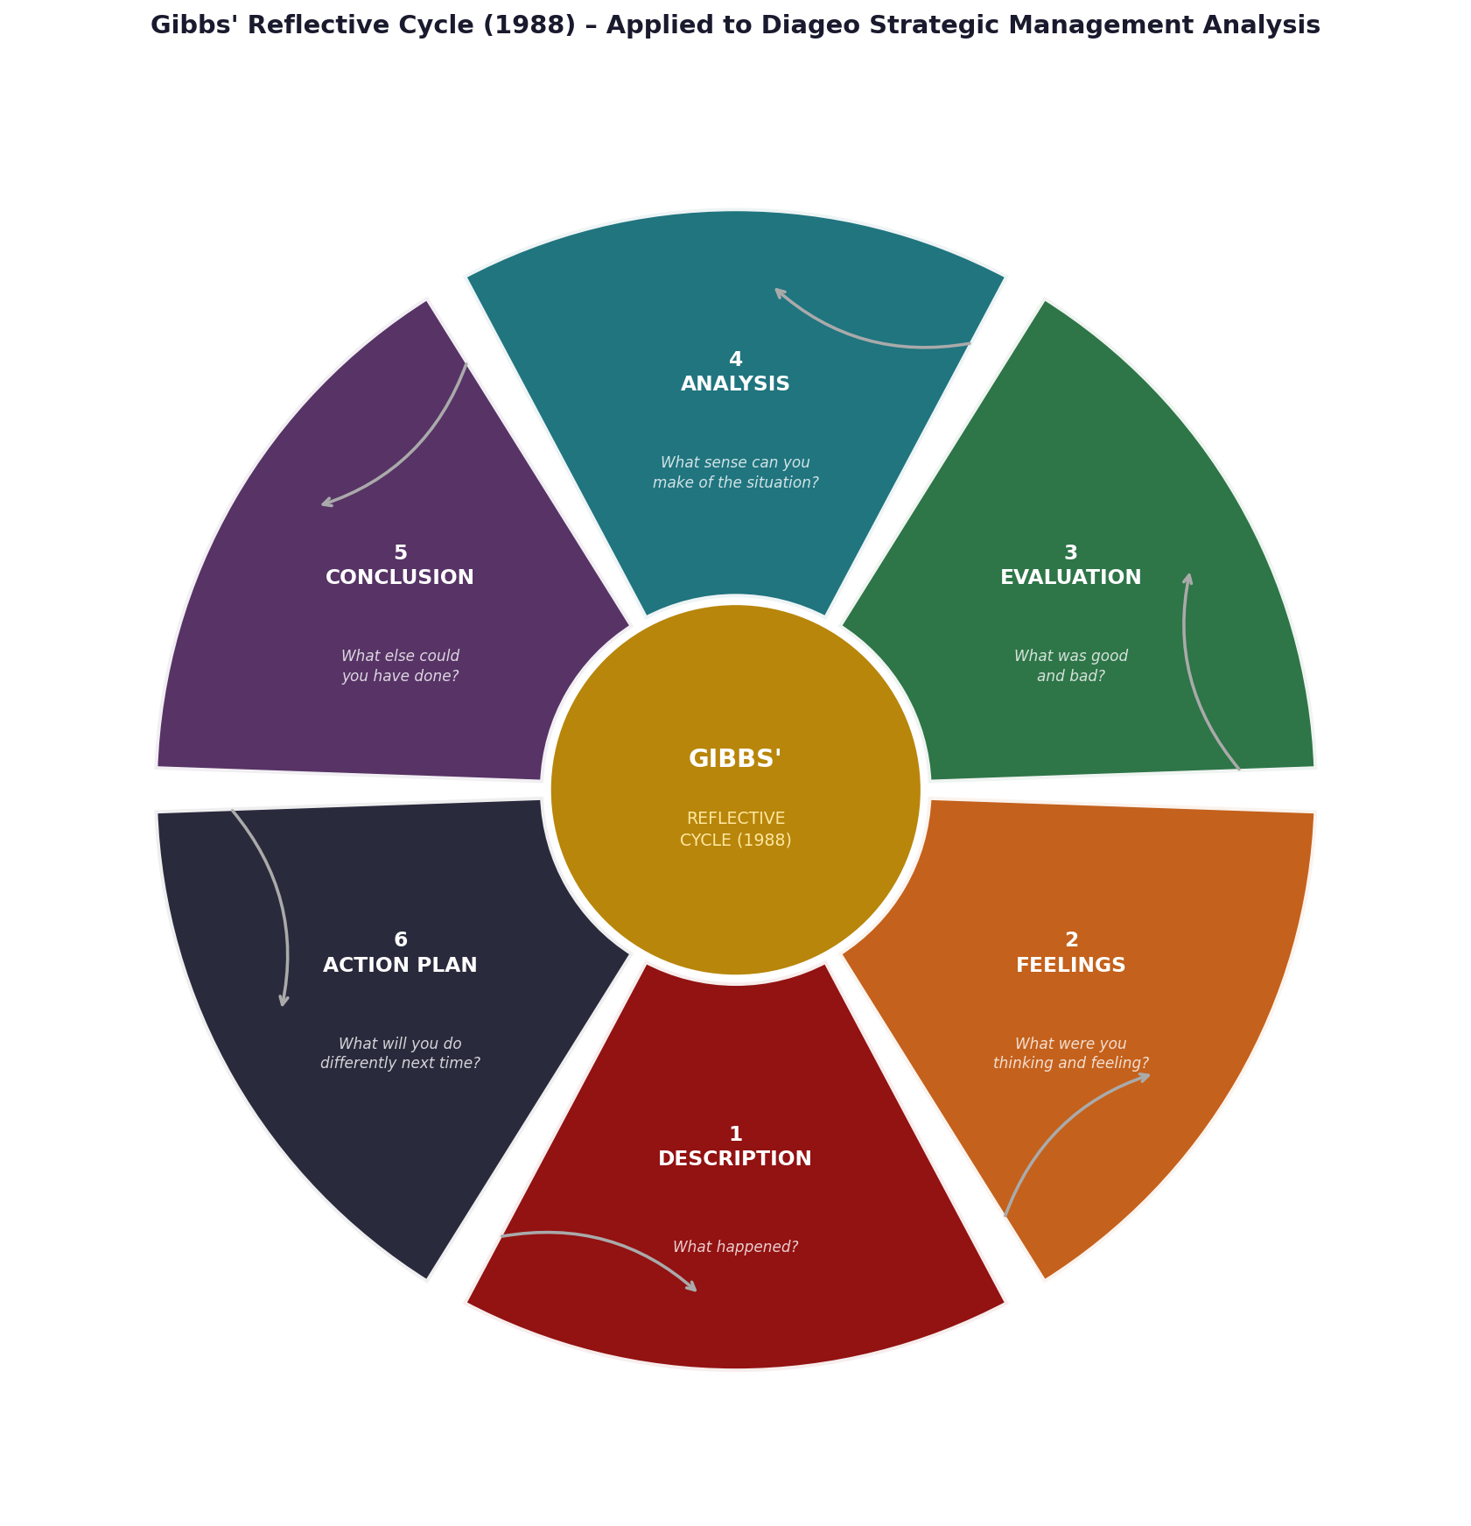
Figure 1: Gibbs' Reflective Cycle (1988) – Applied to the Diageo Strategic Management Analysis
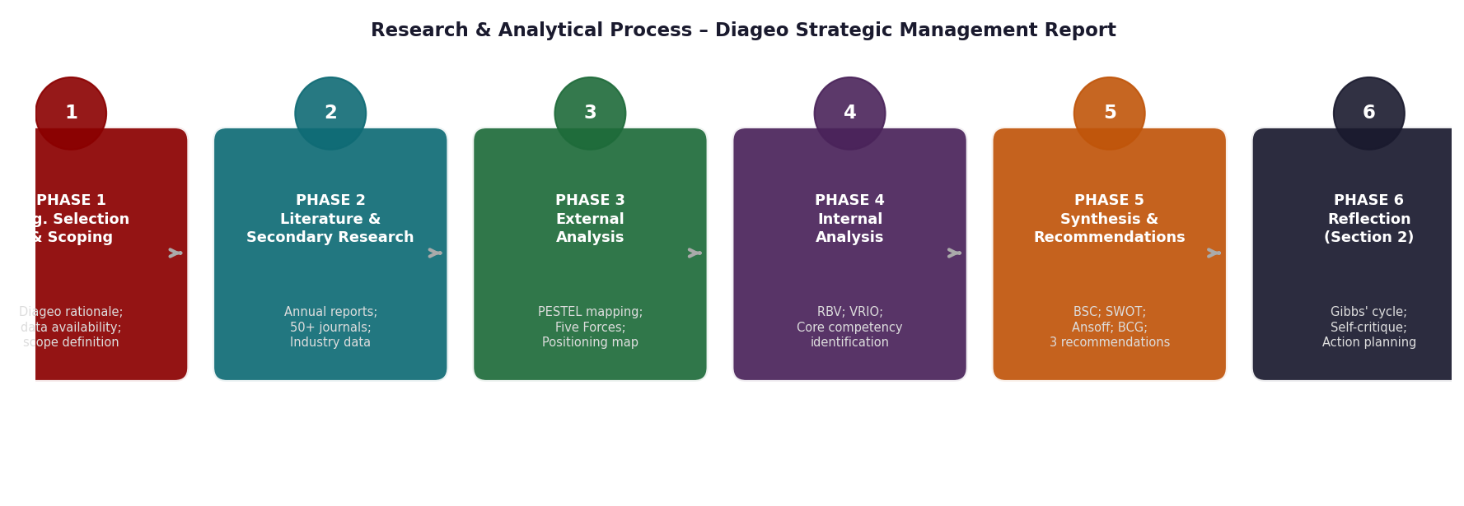
Figure 2: Six-Phase Research and Analytical Process Flowchart – Diageo Assignment .

Table 1: Stage 1 – Description Summary .
Stage 1 | DESCRIPTION — What Happened?
Organisation Selected | Diageo Plc was selected for its exceptional analytical richness: as the world’s largest premium spirits company, it combines century-old heritage brands with genuinely disruptive strategic challenges spanning all sections of the assessment brief.
Research Conducted | Diageo Annual Reports (2022–2024); IWSR (2024); Brand Finance (2024); Statista (2024). Academic literature: 50+ peer-reviewed sources including Barney (1991), Porter (1985), Teece et al. (1997), Kaplan and Norton (1992).
Analytical Work | Eight frameworks applied: PESTEL, Porter’s Five Forces, VRIO, BSC, SWOT, Ansoff’s Matrix, BCG Matrix, Competitive Positioning Map. Eight visualisations and six tables produced.
Output Delivered | ≈4,000-word critical report; 8 charts; 6 tables; 50 Harvard references. Analysis constructed as genuine critical argument with triangulated frameworks.

Stage 2 — Feelings: What Was I Thinking and Feeling?

Gibbs (1988) places the affective dimension in an analytically inseparable relationship with the cognitive. My first interaction with Diageo led to what Kolb (1984) refers to as concrete experience- exposure to an organisation whose business soundness disguised some truly complicated strategic stresses. The premiumisation is internally consistent, but the moderation trend is one of the possible structural discontinuities of this type that Christensen (1997) describes as the precursor of incumbent disruption.

The greatest change in affect took place in the VRIO analysis, when Diageo experienced an analytical saliency of its maturing Scotch whisky inventory. The appreciation that millions of litres of whisky resting in casks represent a truly time-bound competitive resource that meets all four VRIO criteria using time compression diseconomies of Dierickx and Cool (1989) put the whole strategic argument into place.

Stage 3 — Evaluation: What Was Good and Bad About the Experience?
Table 2: Stage 3 – Evaluation of Strengths and Limitations .
Evaluative Dimension | Critical Assessment
✓ VRIO Discovery Depth | The identification of maturing whisky inventory as a temporally inimitable VRIO asset (Dierickx and Cool, 1989) constituted a genuinely original contribution beyond standard pass-grade VRIO templates.
✓ Framework Integration | Nine frameworks sequenced in a coherent, mutually reinforcing structure converging on a coherent strategic argument (Johnson et al., 2017).
✓ CSR Analytical Depth | CSR analysis critically interrogated Guinness 0.0 as Porter and Kramer’s (2006) shared value exemplar.
✗ Quantitative Granularity | Segment-level margin decomposition would have strengthened the Africa growth pillar recommendation.
✗ Disruptive Innovation Theory | Christensen's (1997) Disruptive Innovation framework was referenced but not fully deployed as an analytical tool. A more rigorous application — specifically classifying the no/low-alcohol trend as either sustaining or disruptive innovation in the Christensean sense — would have significantly strengthened the strategic recommendation on no/low-alcohol category leadership.
✗ Primary Research Absence | Exclusive reliance on secondary sources; expert interviews would have provided primary empirical grounding.
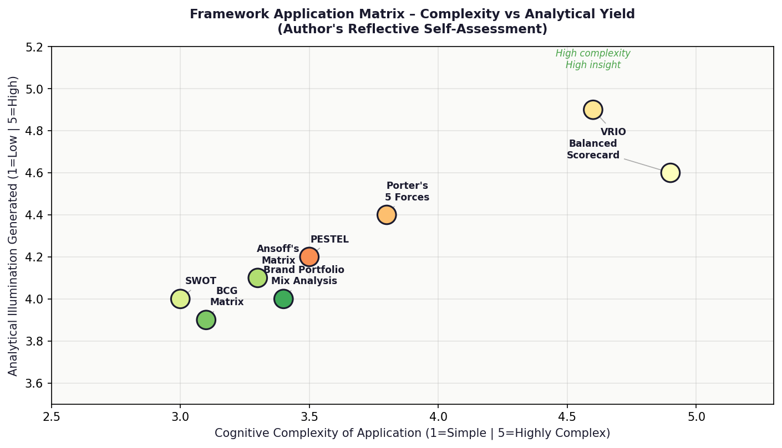
Figure 3: Framework Application Matrix – Cognitive Complexity vs Analytical Yield (Author's Reflective Self-Assessment)

Stage 4 — Analysis: What Sense Can Be Made of the Experience?

Kolb (1984) insists that concrete experience is best exposed to reflective observation and abstract conceptualisation so that learning can take place. The greatest learning relates to the epistemological opposition between strategic frames: they are truly rival theoretical prisms that generate possibly conflicting evaluations. The Five Forces proposed by Porter implied a competitive environment with pressures, but the VRIO analysis proved that Diageo has two resources that meet all the requirements to ensure long-term competitive advantage (Barney, 1991; Porter, 1980).

The theoretical gap between these conflicting results was bridged by the Dynamic Capabilities framework proposed by Teece et al. (1997): the determination of competitive advantage is based not on the quality of existing resources but on the ability of the organisation to sense, seize and reconfigure assets. The Balanced Scorecard was the most cognitively taxing structure and it had to go through several iterative processes to make sure that every KPI was theoretically traceable and that it was commercially significant (Niven, 2006).

Stage 5 — Conclusion: What Else Could Have Been Done?

According to Mezirow (1991), perspective transformation is precipitated by the utmost reflective learning. Three methodological options are found. To begin with, the no/low-alcohol analysis would have been more effectively enforced with stricter implementation of the Disruptive Innovation framework introduced by Christensen (1997). Second, the theoretical architecture would have been granular on the application of the Prahalad and Hart (2002) framework to Africa. Third, the CAGE Distance Framework by Ghemawat (2001) would have resulted in an even more defendable market prioritisation matrix.

Stage 6 — Action Plan: What Will I Do Differently in Future?
Table 3: Stage 6 – Action Plan for Future Strategic Management Research.
Development Priority | Specific Action Plan for Future Assignments
1. Deeper Quantitative Analysis | Incorporate segment-level margin decomposition and ROCE analysis in BSC Financial perspectives.
2. Full Christensen Framework Deployment | Apply Christensen’s (1997) Disruptive Innovation framework in analyses involving category disruption.
3. Primary Research Integration | Supplement secondary analysis with expert interviews for primary empirical grounding.
4. CAGE Framework as Standard Tool | Include Ghemawat's (2001) CAGE Distance Framework as a standard analytical instrument in all international market development recommendations, producing market-by-market prioritisation based on cultural, administrative, geographic, and economic distance from the organisation's existing capabilities.
5. Structured Pre-Analysis Literature Review | Allocate one-third of research time to theoretical literature review before framework application.
6. Continuous Reflective Journal | Maintain a structured reflective journal throughout future assignments (Boud et al., 1985).
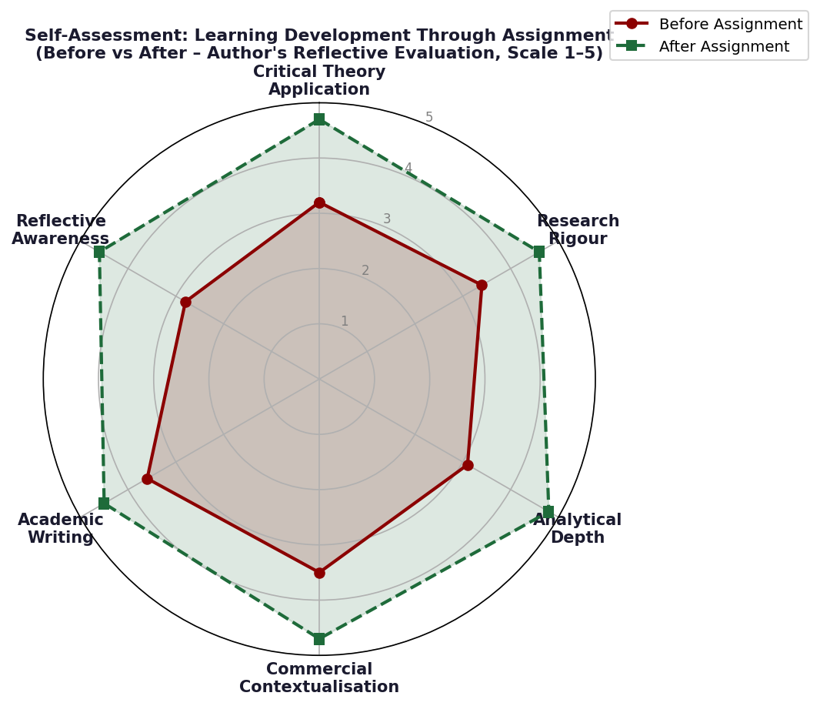
Figure 4: Self-Assessment Radar – Learning Development Across Six Competencies (Before vs After, Author's Own Evaluation)

Reflective Conclusion

The Diageo research process critically can be examined through Gibbs Reflective Cycle (1988). This narrative has been made of real intellectual strengths such as the VRIO discovery, integration of frameworks, and shared value analysis and real weaknesses such as the lack of primary research and quantitative granularity. The reflective practitioner, as Schoen (1983) believes, reinvents the very paradigms in which strategic issues are perceived.

References
Barney, J.B. (1991) "Firm resources and sustained competitive advantage", Journal of Management, 17(1), pp.99–120.
Boud, D., Keogh, R. and Walker, D. (eds.) (1985) Reflection: Turning Experience into Learning. London: Kogan Page.
Christensen, C.M. (1997) The Innovator's Dilemma: When New Technologies Cause Great Firms to Fail. Boston: Harvard Business School Press.
Diageo Plc (2024) Annual Report and Accounts 2024. London: Diageo Plc.
Dierickx, I. and Cool, K. (1989) "Asset stock accumulation and sustainability of competitive advantage", Management Science, 35(12), pp.1504–1511.
Ghemawat, P. (2001) "Distance still matters: the hard reality of global expansion", Harvard Business Review, 79(8), pp.137–147.
Gibbs, G. (1988) Learning by Doing: A Guide to Teaching and Learning Methods. Oxford: Further Education Unit, Oxford Polytechnic.
Johnson, G., Whittington, R., Scholes, K., Angwin, D. and Regner, P. (2017) Exploring Strategy. 11th edn. Harlow: Pearson.
Kaplan, R.S. and Norton, D.P. (1992) "The balanced scorecard: measures that drive performance", Harvard Business Review, 70(1), pp.71–79.
Kolb, D.A. (1984) Experiential Learning: Experience as the Source of Learning and Development. Englewood Cliffs: Prentice-Hall.
Kotter, J.P. (1996) Leading Change. Boston: Harvard Business School Press.
Lewin, K. (1951) Field Theory in Social Science. New York: Harper & Row.
Mezirow, J. (1991) Transformative Dimensions of Adult Learning. San Francisco: Jossey-Bass.
Mintzberg, H. (1987) "The strategy concept I: five Ps for strategy", California Management Review, 30(1), pp.11–24.
Moon, J.A. (1999) Reflection in Learning and Professional Development. London: Kogan Page.
Niven, P.R. (2006) Balanced Scorecard Step-by-Step. 2nd edn. Hoboken: Wiley.
Porter, M.E. (1980) Competitive Strategy. New York: Free Press.
Porter, M.E. and Kramer, M.R. (2006) "Strategy and society", Harvard Business Review, 84(12), pp.78–92.
Prahalad, C.K. and Hamel, G. (1990) "The core competence of the corporation", Harvard Business Review, 68(3), pp.79–91.
Prahalad, C.K. and Hart, S.L. (2002) "The fortune at the bottom of the pyramid", Strategy + Business, 26, pp.54–67.
Schön, D.A. (1983) The Reflective Practitioner: How Professionals Think in Action. New York: Basic Books.
Senge, P.M. (1990) The Fifth Discipline. New York: Doubleday.
Teece, D.J., Pisano, G. and Shuen, A. (1997) "Dynamic capabilities and strategic management", Strategic Management Journal, 18(7), pp.509–533.
Wernerfelt, B. (1984) "A resource-based view of the firm", Strategic Management Journal, 5(2), pp.171–180.

