
Maryna Lypova 2618218
Assessment 1 – Reading Task Template
PART 1: Upload your photo of your A3 in-class notes here:
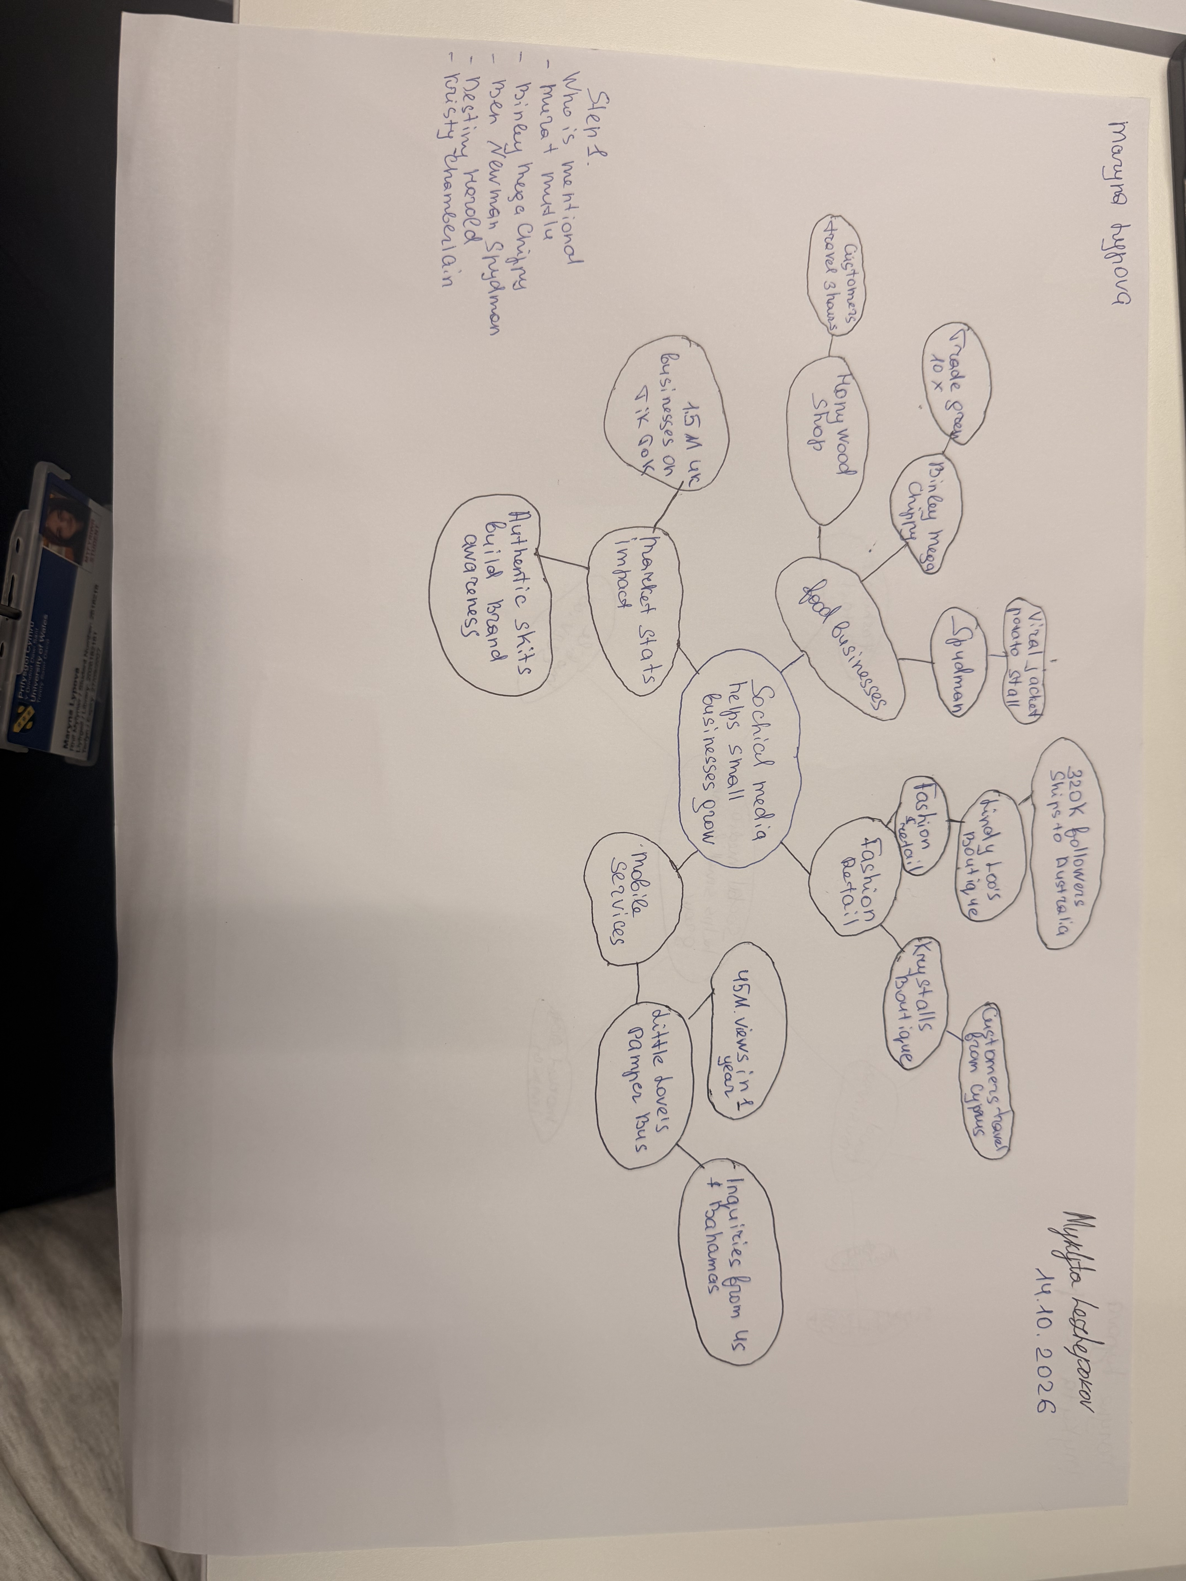

PART 2:
- Answer every question below in 1-3 full sentences.
- Use your own words. Do not use generative AI to answer these questions.
- Include a specific detail from the text when asked.
REMINDER
- The main idea is the overall message of the whole text.
- A key point helps to explain the main idea.
- A specific detail or example from the text shows that the key point is true.

- What is the main idea of the whole text?
The main idea of the text is that social media like tik tok and Instagram helps small buisinesses get popular and make more money.When a video goes viral online many new custumers come to the shop in real life

- What is one key point that supports the main idea, and which specific example from the text shows this?
One key point is that going viral on social media can quickly increase a shops sales.For example Binley Mega Chippy got ten times more business after people started posting videos about it online

- What is a different key point that supports the main idea, and which specific example from the text shows this?
Another key point is that social media makes custumers travel a long way just to visit a shop for example teenagers travel to Krystalls Boutique at the way from Cyprus after seeing their funny videos on tik tok

- Which part of the text do you think is most important, and why?
I think the most important part is where it says that people buybfrom people.This is important because it shows that simple and real videos work better than normal boring ads

Reflection:
- What did you find difficult in this task (including in-class components), and why was it difficult?
It was a bit hard for me to choose only one example for each point because there were many business stories in the text.Also it was hard to write everything in my own words and not just copy frome the article.

- What helped you with this difficulty, and how did it help you?
Making notes in class helped me a lot.Looking at my mind map made is easier to understand the main ideas and write simple sentences by myself.

