Assessment

Lab Submission Requirments:
- Document Nessus report & mitigation steps

- Document Nikto report & mitigation steps

Tools:
- Nessus (Windows)
- Nessus (Kali)
- Nikto (Kali)

Task 1 – Use Nessus tool in Windows to scan for network vulnerabilities

Policy creation
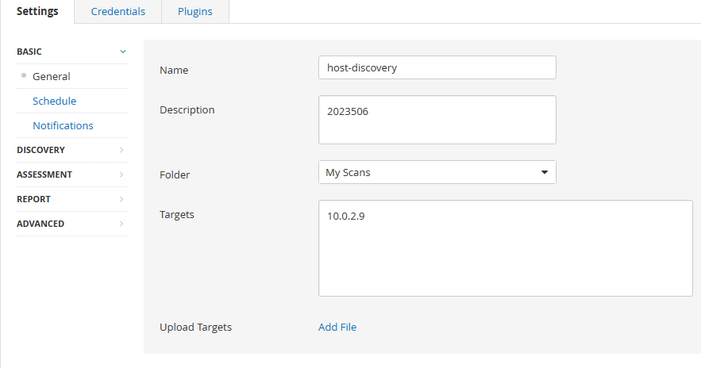
Ping remote host
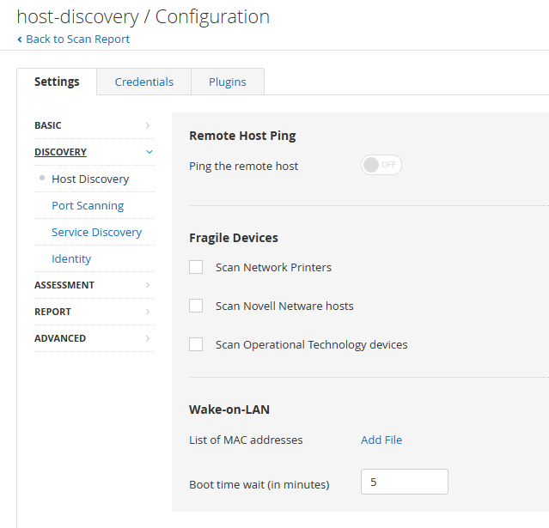

Very open TCP ports
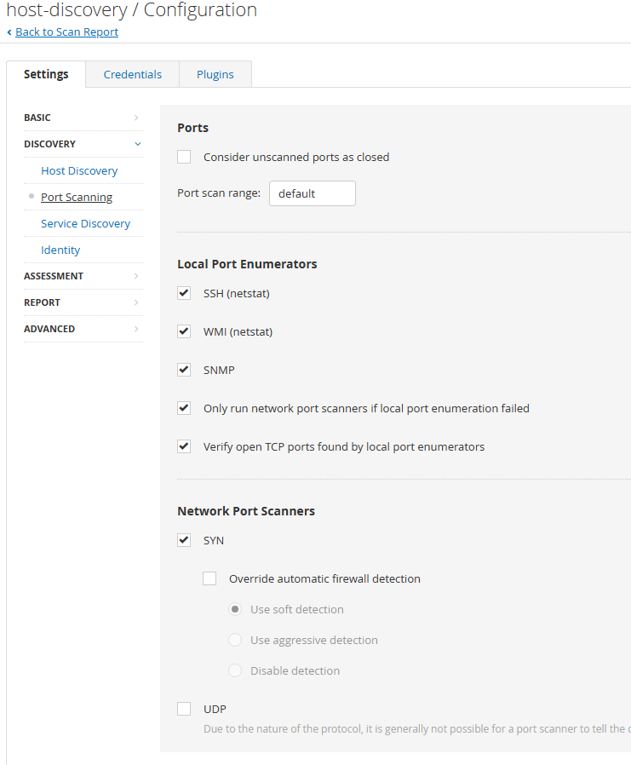

Why would we turn off ping the remote host option?

There are several reasons that would encourage us to turn off the "Ping remote host" option.
Stealth
- Nessus will use ping by default to discover hosts. Disabling the option stops Nessus from using this as default. Can make scanning less obvious and reduce likelihood of detection.
Filter / Firewall bypassing
- Traffic might be filtered or configure in such a way to block ICMP. Disabling the option can help bypass these restrictions.
Precision
- Allows Nessus to utilise a broader range of methods for detecting hosts which may be more reliable than an isolate ICMP.
Custom networks
- ICMP is not always reliable in terms of determining status of hosts. As previously touched upon configuration may be intention in this regard.

Why would we set them too unlimited?
Setting "TCP sessions per host" to unlimited improves Nessus in several key areas. Firstly, scanning efficiency. By allowing multiple connections we can detect vulnerabilities at a quicker rate. Furthermore, by allowing unlimited connections we can optimize resource utilization Nessus will efficiently manage system resources such as bandwidth and processing power to achieve its objectives. Lastly, it allows us to be agile in response to complex network environments such large number of open ports or custom network configurations.

Nessus report and mitigation (Windows)
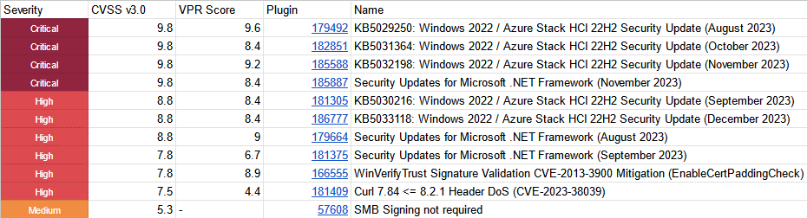

Vulnerability:
SMB Signing not required. [1][2]
Overview:
The vulnerability associated with the disabled SMB signing feature permits adversaries to circumvent the integrity verification of Server Message Block (SMB) communications, thereby facilitating the unauthorized manipulation of transmitted data [3]. Exploitation of this vulnerability empowers attackers to compromise the confidentiality and integrity of sensitive information, potentially leading to unauthorized access and malicious activities. The absence of SMB signing enables interception of communications, allowing attackers to execute man-in-the-middle or relay attacks. [4].

Mitigation Plan:
Mitigation for the outlined vulnerability can be achieved in several ways depending on the context of the environment in question and the relative security requirments. Some possible mitigations steps include.
- Enable SMB signing. [5] [6]
  - Ensure SMB signing is enabled on both the server and the client. Configure via Group Policy [7]
- Update and patch systems [2]
  - Installation of the latest windows updates and security rollups is always advisable.
- Implement Access Control
  - Enforce access controls and permissions to limit unauthorized access. i.e., file sharing permissions
- Employ NLA
  - Enable network level authentication to enhance overall security.
However, these are subject to environmental constrictions and requirments and should be implemented with consideration to disruption to workflow or systems.

Task 2 – Nessus report (Kali)

Nessus report and mitigation (Kali).
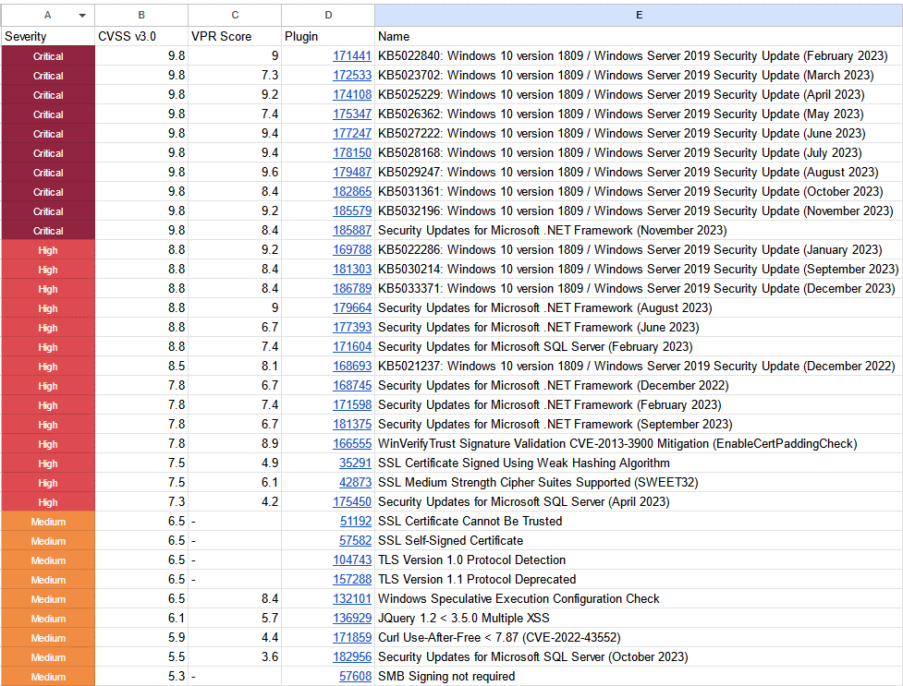

Vulnerability:
JQuery 1.2 < 3.5 Multiple XSS [8] [9]
Overview:
Cross-site scripting vulnerabilities enable malicious actors to inject and execute unauthorized scripts in the context of a user's web browser, potentially leading to various security risks such as unauthorized access, data manipulation, or other malicious activities [10].

Mitigation Plan:
- Upgrade to the latest version
  - Upgrading brings in the latest security fixes. Latest version is always recommended. Rescan to ensure accuracy. [11][12]
- WAF
  - Utilising a WAF can provide an additional layer of security. WAF can detect malicious traffic such as XSS attempts before they reach any applications. [13]
- Security Monitoring
  - Monitor the network via logs and traffic for signs of suspicious activity.
- Apply windows updates.
  - Security rollups cover a lot of bases and the first port of call when mitigating any issues.

Task 3 – Nikto report (Kali)

Target Overview:
Host: 10.0.2.9
Type: Web Server
OS: Linux
Services: Apache 2.4.27

Vulnerabilities:
- Apache default file found.
  - Can be used to retrieve sensitive server information [14] .
- Directory indexing found.
  - Unintended directors may to disclosed to the user containing sensitive information [15]
- PHP EOL - Vulnerable to XST.
  - XStream is a simple library to serialize objects to XML and back again. In affected versions s vulnerability may allow a remote attacker to load and execute arbitrary code from a remote host only by manipulating the processed input stream [16]
- Apache out of date
  - Out of date software provides many attack vectors that can be exploited.

Observations:
Scanned targets current security posture if very poor. Not only are there vulnerabilities present, but they are easily exploited vulnerabilities with a wealth of online documentation outlining the methods and techniques required to do so. Target system should not be used in a production environment without serious risk of breach.
Mitigation:
Suggestions would be to immediately implement mitigation measures to alleviate the documented weaknesses. Some methods that should be employed prior to being utilised in a production environment should be:

- Update to the latest versions
  - Apache, PHP [17]
- Utilise online documentation to restrict access to default files [18]

Task 4: Discuss with your classmates/ team about Nmap Scripting Engine (NSE). Address what NSE is? How to effectively use Nmap as a lightweight vulnerability scanner?
NSE is a powerful and flexible component of Nmap security scanner.
It allows the writing and execution of scripts to perform various tasks beyond the standard port scanning function.
Scripts are written in "Lua" and can accomplish such functions as

- Version detection
- Vulnerability scanning
- Information gathering

Scripts are categorized into default, discovery, exploitation, external, intrusive, safe.

Scripts can take arguments which aids customizability.

To use Nmap as vulnerability scanner you need to interact with the previously discussed NSE.

A basic command for a vulnerability scan for example:

Nmap -sV --script nmap-vulners/ <target>

You can also specify ports if that suits the objective better.

Nmap -sV --script nmap-vulners/ <target> -p80,223

Further to broad vulnerability scans you can also get more focused and use specific scripts to target certain vulnerabilities.

CSRF Vulnerabilities:

Nmap -sV --script http-csrf <target>
Sherlock:

http-sherlock: Intends to exploit the “shellshock” vulnerability in web applications.

Http internal Ip disclosure:

Nmap -sV --script http-internal-ip-disclosure <target>

Alternate Tool

Original tool: Nessus

Alternate tool: Greenbone Vulnerability Management (OpenVAS)

What is OpenVAS?
OpenVAS (Open Vulnerability Assessment System) is an open-source vulnerability scanning and management tool designed for discovering and assessing security vulnerabilities in computer systems. It provides a comprehensive and continually updated vulnerability database, offering both network and web application vulnerability scanning. OpenVAS identifies potential security issues, misconfigurations, and weaknesses in systems, helping organizations and security professionals to proactively address and remediate vulnerabilities. It is widely used for security assessments, penetration testing, and ensuring the overall security posture of networks and web applications. OpenVAS is part of many Linux distributions, including Kali Linux, making it accessible to a broad user base.

Demonstration

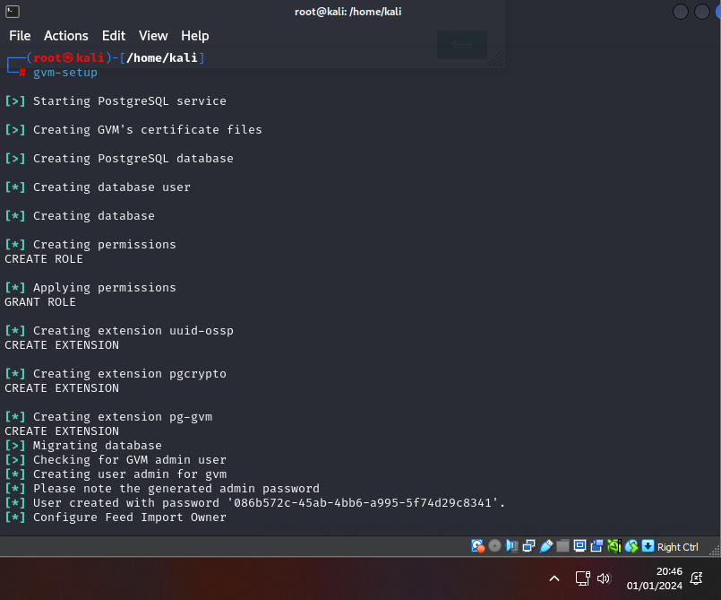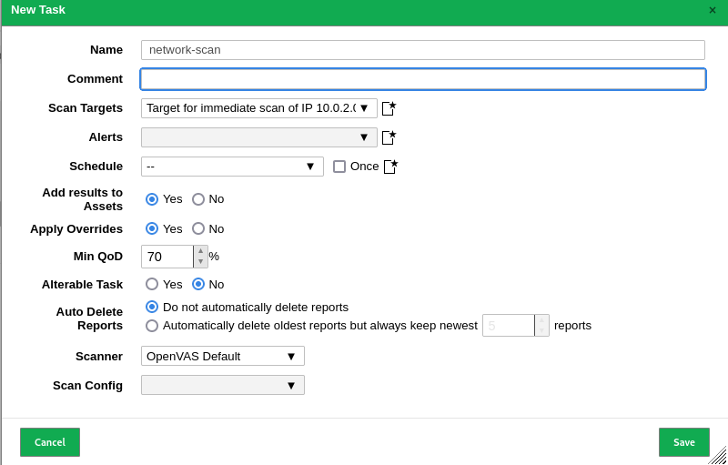
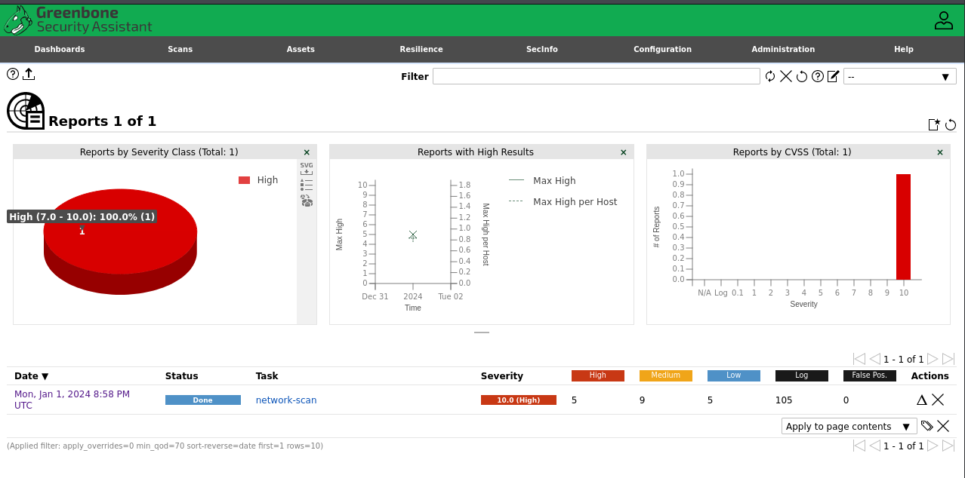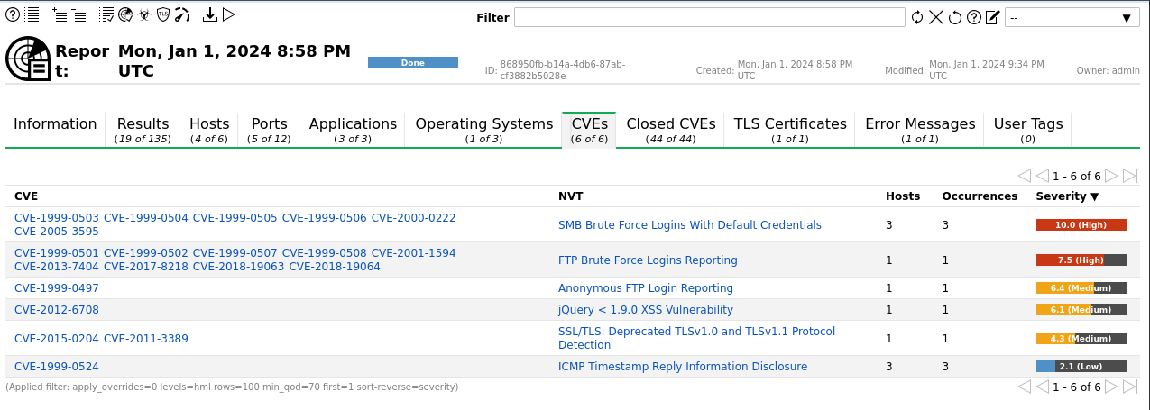
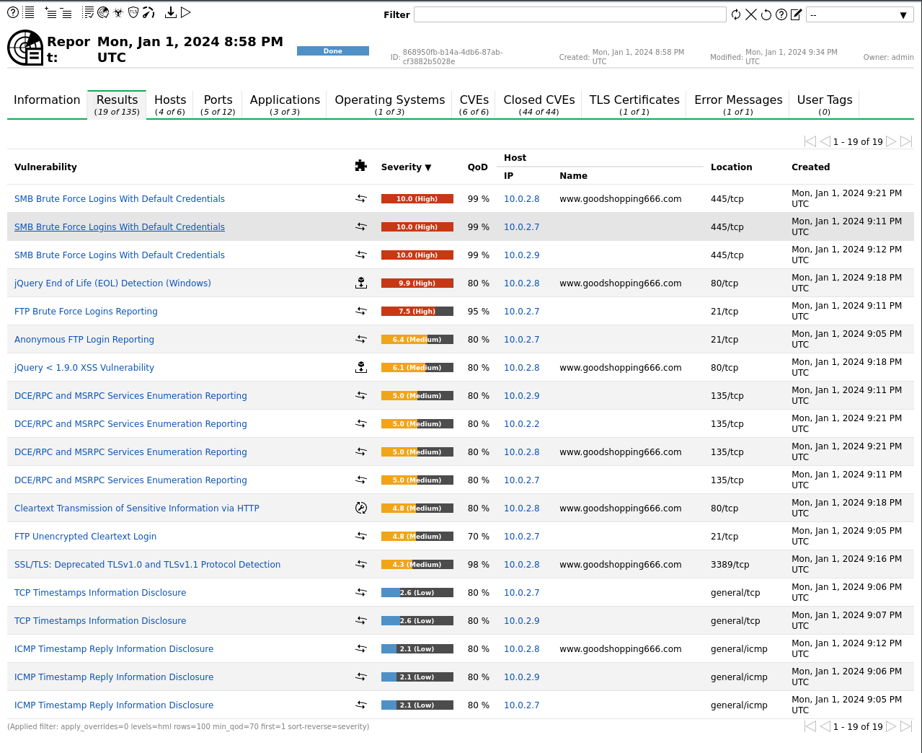
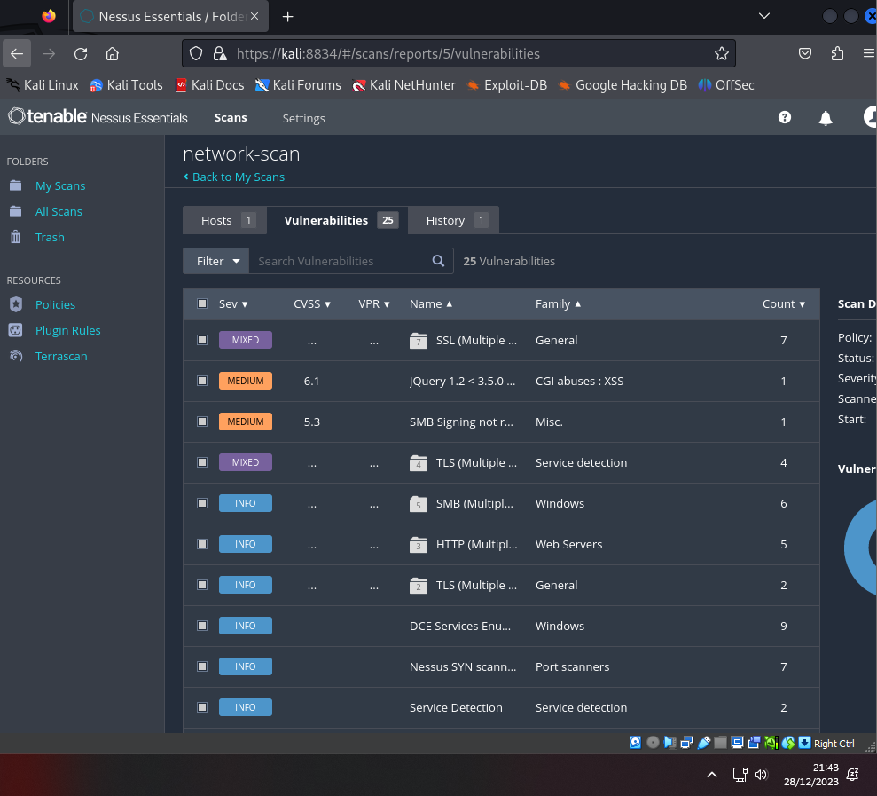

Comparison
Greenbone vulnerability management and Nessus both provide a suitable functionality for enumerating vulnerabilities on a target host or subnet. Both scanners were able to enumerate similar vulnerabilities however, they present these very differently. I think this is where there is a large distinction between the two.
Greenbone provides you with extensive information of not only the vulnerability but exploitable vectors within such vulnerability. Utilising these provides you with a clear understanding of the likelihood of attack without additional research needed. Nessus on the other hand, provide you with more of a summation, its list all the same details in terms of statistics such as CVE, Severity. However, it does not lend the same information regarding exploits.
Furthermore, another distinction between the two can be made in reference to their interface. Nessus, being a paid product greatly benefits from a modern GUI. Greenbone on the other hand, suffers from a lack of modernisation lending to some interaction issues.

Conclusion
Overall, I found both to excel at their purpose, which is vulnerability enumeration. However, I find greenbone to be more the overall useful. The addition of CVE information and exploitable vectors is a welcome addition and should be also introduced in the Nessus framework.
In summary, both scanners are interchangeable. However, it will likely come down to user preference which is the more utilised.

References
[1] NVD. "CVE-2016-2115." [Online]. Available: https://nvd.nist.gov/vuln/detail/CVE-2016-2115
[2] CVE. "CVE-2016-2115." [Online]. Available: https://cve.mitre.org/cgi-bin/cvename.cgi?name=CVE-2016-2115
[3] RedFoxSec. "How to Find and Fix SMB Signing Disabled Vulnerability." [Online]. Available: redfoxsec.com/blog/how-to-find-and-fix-smb-signing-disabled-vulnerability/.
[4] Tenable. "Nessus Plugin ID 57608." [Online]. Available: tenable.com/plugins/nessus/57608.
[5] NetApp. "Enabling SMB Signing." [Online]. Available: netapp.com.
[6] Microsoft Learn. "Require SMB Security Signatures." [Online]. Available: learn.microsoft.com/en-us/windows/security/threat-protection/security-policy-settings/microsoft-network-client-digitally-sign-communications-always.
[7] Microsoft. "Microsoft Network Client Digitally Sign Communications (Always)." [Online]. Available: learn.microsoft.com/en-us/windows/security/threat-protection/security-policy-settings/microsoft-network-client-digitally-sign-communications-always.
[8] CVE. "CVE-2020-11022." [Online]. Available: https://cve.mitre.org/cgi-bin/cvename.cgi?name=CVE-2020-11022
[9] NVD. "CVE-2020-11022." [Online]. Available: https://nvd.nist.gov/vuln/detail/CVE-2020-11022
[10] OWASP Foundation. "Cross Site Scripting (XSS)." [Online]. Available: Cross Site Scripting (XSS) | OWASP Foundation
[11] Micro Focus. "JQuery 1.2 < 3.5.0 Multiple XSS Vulnerability found in Network Automation (NA) i 2019.05." [Online]. Available: https://portal.microfocus.com/s/article/KM000024471?language=en_US
[12] Micro Focus. "Patch PH_196702." [Online]. Available: https://kmviewer.saas.microfocus.com/#/PH_196702
[13] OWASP. "Cross Site Scripting Prevention - OWASP Cheat Sheet Series." [Online]. Available: https://cheatsheetseries.owasp.org/cheatsheets/Cross_Site_Scripting_Prevention_Cheat_Sheet.html
[14] FortiGuard. "Intrusion Prevention." [Online]. Available: Intrusion Prevention | FortiGuard
[15] IBM Documentation. "Directory Indexing Attacks." [Online]. Available: https://www.ibm.com/docs/en/snips/4.6.0?topic=categories-directory-indexing-attacks
[16] NVD. "CVE-2021-39141." [Online]. Available: https://nvd.nist.gov/vuln/detail/CVE-2021-39141
[17] The Apache HTTP Server Project. "Apache HTTP Server 2.4 Vulnerabilities." [Online]. Available: https://httpd.apache.org/security/vulnerabilities_24.html
[18] VNT Web. "Apache Restricting Access to Icons/Readme." [Online]. Available: vntweb.co.uk/apache-restricting-access-to-iconsreadme/.

