Module Code: BMSW4004
Module Name: Problem Solving and Decision Making
Task – 2: Report
Lecturer: Laila Maazouz
Student name: Dimitrichka Dimitrova
Student ID: 2123033
Introduction 3
Forever 21 3
Employee Turnover and its Importance 3
Root Causes Analysis (RCA) 4
Applying a Situational Analysis Model 5
Recommended Problem Resolution Strategies 6
Evaluation of Alternative Solutions 8
Implementation plan 9
Communication Plan with Stakeholders 11
Monitoring and Review Techniques 14
Conclusion 14
References 15

Introduction

Problem solving skills have a broad application across a wide range of different fields. Accordingly, they are also of importance in business (Van Aken and Berend, 2018).

The ability to identify, reflect on, analyse and develop a problem resolution strategy is key in the management of a company as it facilitates the overcoming of encountered setbacks and continuance of operations. Furthermore, the experience can contribute to the elucidation of an organization’s strengths and weaknesses. Given these implications, problem-solving skills can be acknowledged as facilitating the achievement of a successful and effective business performance (Adair, 2007).

Forever 21

Forever 21 is a US-based multinational fashion retailer that was founded in 1984 (MacCollum et al., 2011).

The organization was one of the leading fashion providers worldwide but has recently been suffering from a demand- and sales- declines which have engendered significant losses, led to the closure of multiple of rhe brand’s stores and eventually, the filing of bankruptcy of the company (McKinnon, 2021).

Nevertheless, although Forever 21 had limited its operations and primarily been focusing on its e-commerce channels during the last three years, it is reportedly now planning a business operations’ scope comeback (Barkho, 2022).

The current report will regard a problem that is of high relevance to all businesses and observe the case study of Forever 21 whereby the issue contributed to the development of a considerable business performance setback. In applying a range of problem-solution techniques, Forever 21’s situation will be analysed and a problem resolution strategy will be presented. The application of the proposed plan would aim to facilitate the successful comeback of the Forever 21 company.

Employee Turnover and its Importance

The problems in the workplace can be of various nature, given which one should be able to distinguish which ones of them are of the highest impact for the organization and thus, their resolution should be prioritized.

Staff turnover is a workplace issue that is encountered by various businesses all around the globe (Hom et al., 2017).

It can be recognised as a highly significant problem as it leads to the emergence of multiple negative effects, both of potential, as well as of actual character (Ongori, 2007).

The most significant adverse impact that is caused by high staff turnover is the one on the productivity of the business. When an employee decides to leave a company, the tasks that he/she has been fulfilling so far have to be reassigned to someone else. As a result of that, the work processes are impeded and their flow is disrupted (Iqbal, 2010).

A company also has to recruit new staff members to exchange the ones that have been lost due to employee turnover. That not only additionally disturbs the working processes but is also connected with expenses regarding the selection and training of these new employees. Moreover, oftentimes businesses have to hire temporary staff or increase the working hours of the current employees while the new employee recruitment processes are undergoing. This is connected with additional costs (Lee et al., 2017).

The experienced alterations in the work teams also have a negative influence on the company’s organizational culture and kead tk a diminishing of the workforce’s spirit, commitment and enjoyment (Ongori, 2007).

What is also to be accounted for, is the potential loss of valuable, highly skilled work cadres which choose to leave their current company and substitute it with a rival one (Morrell et al., 2011).

Root Causes Analysis (RCA)

To analyse the situation, the current paper will use a Fishbone diagram. The contents of the below presented diagram are based on a literature review of the most commonly identified causes of high staff turnover.

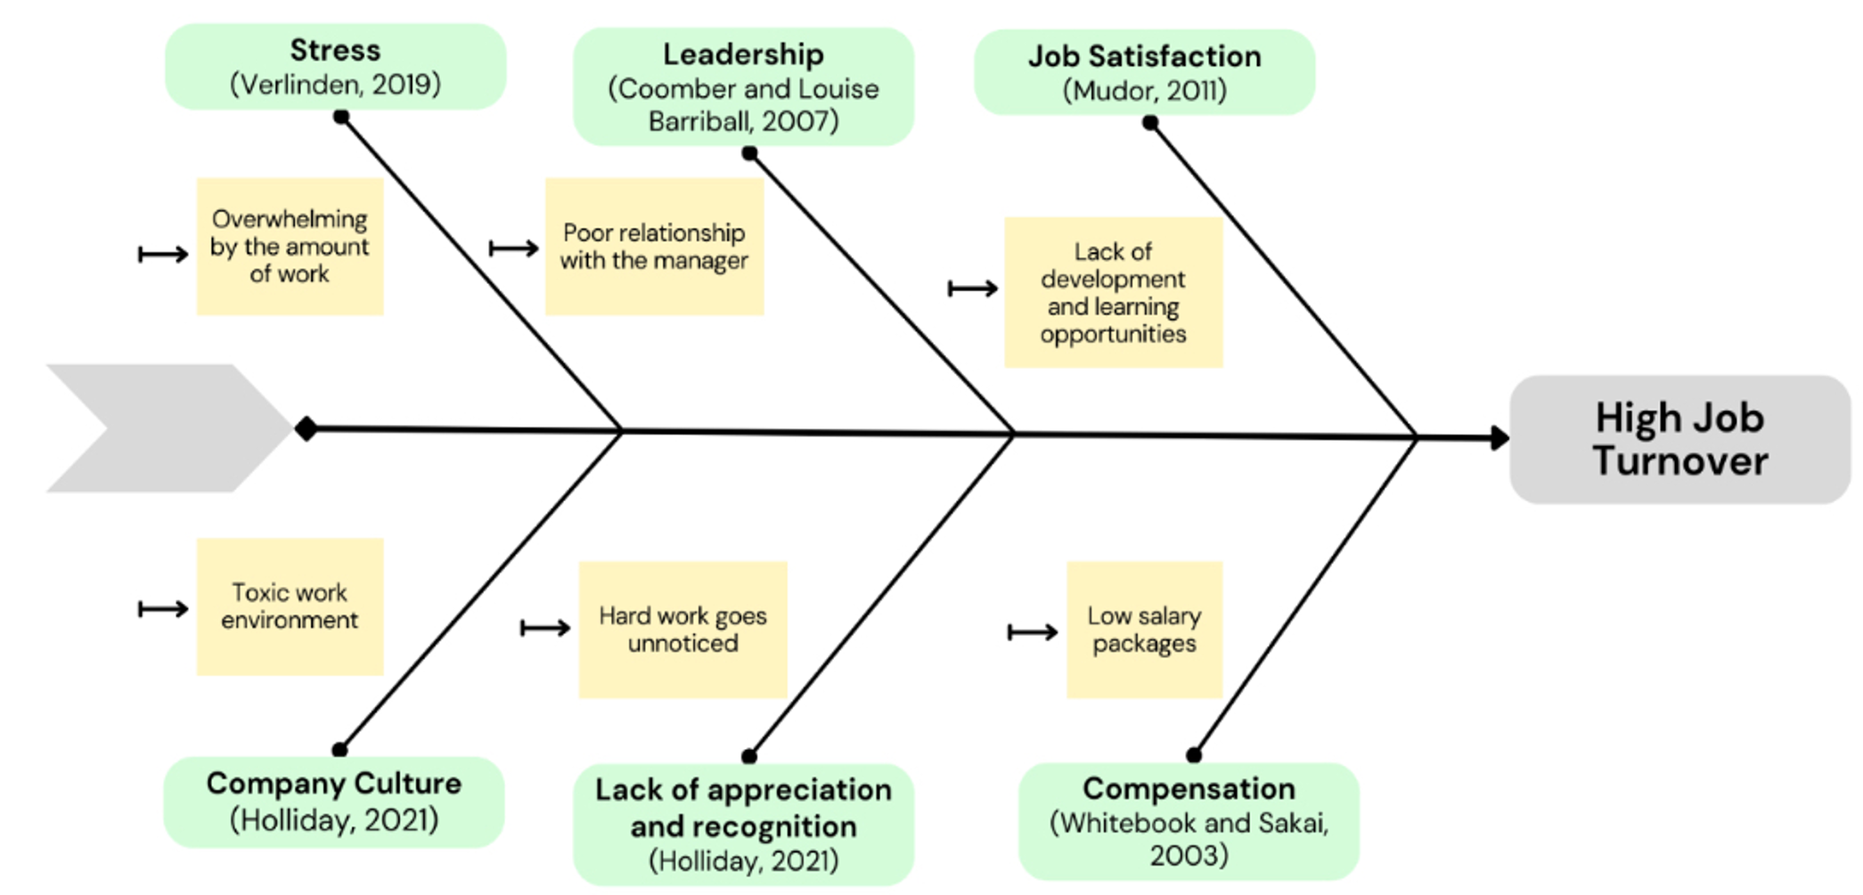

Figure 1. Fishbone diagram of high job turnover

In examining the diagram, it is to be extracted that a considerable amount of the identified reasons for high turnover are interrelated and concern the issue of low job satisfaction.

Furthermore, there is data that provides support for the fact that the high attrition rate at Forever 21 is to be attributed to the low satisfaction of its employees. For instance, the staff ratings regarding the satisfaction that they derive from working at the company amount for only 2.4 out of 5. This score is amongst the lowest ones of US-based companies (Indeed, 2022).

Currently, the staff at Forever 21 has been facing multiple negative work environment issues. In fact, there have been multiple lawsuits that have been filed against the company. The complaints of Forever 21’s workers are of various character: from such pertaining to the unfair treatment and labor exploitation, to violation of their civil rights, discrimination, humiliation and others (TRF, 2019)

Applying a Situational Analysis Model

In addition to the analysis done using the Fishbone diagram, a situational analysis via a SWOT model will be used. This analysis tool has been recognised as being highly useful to analyse a business’s current situation and facilitate the overcoming of business challenges and employment of changes (Helms and Nixon, 2010)

SWOT ANALYSIS OF FOREVER 21
Strengths (S)
- Huge operational scope
- Affordability to customers
- Wide variety of products
- Trendy designs
- Popularity amongst youth

Weaknesses (W)
- Diminishing customer demand
- Adverse associations with negative practices
- Negative press
- Targeting primary young customers
- High employee attrition rates

Opportunities (O)
- Increase the demand from its existing clients’ range
- Attract new customers
- New store openings and worldwide expansion
- Acquisition and/or partnership with other brands
- Achievement of an improved brand image by committing to positive changes
- Overcoming of its current challenges

Threats
- Competitive advantages of rival companies
- Further loss of customer demand
- Worsening of the brand’s image and customer perception
- Legal problems
- Inability to recover from its current crisis, possibly leading to the company’s complete collapse

In reviewing the SWOT analysis, it is to be extracted that the implementation of a problem-solution strategy that targets the resolution of the high staff turnover at Forever 21 is an essential factor for the state of the company.

Recommended Problem Resolution Strategies

Strategy 1: Fostering employees’ relationships

The first strategy to be suggested aims to improve the job satisfaction of Forever 21 and thus, contribute to the diminishing of the company’s high attrition rate by ameliorating the relations that workers have with the people that they interact with during their work days.

Although there have also been several cases whereby Forever 21’s workers have reported experiencing unpleasant work interactions with customers and colleagues, most complaints regard the treatment that they receive from their supervisors and managers. Employees disclose that they have been harassed, discriminated against their sexual orientation or race and accused of stealing from the store. This inevitably has contributed to the low job satisfaction rate at Forever 21.

Therefore, the strategy would emphasize on the stimulation of a better supervisor and management attitude towards lower standing in the organizational hierarchy individuals.

In addition, the plan would include the hosting of multiple events that urge the overall positive social environment in the company. For instance, colleagues and management would participate in different team building activities or gather at different locations.

Strategy 2: Encouragement of employee development

Another frequent contributor to the low satisfaction rates at Forever 21 appears to be the lack of development opportunities that the employees receive.

Data from Indeed (2022) reveals that the majority of the workers at the company evaluate that they do not acquire new competencies at work, nor have access to training options. Even more, 49% of the respondents disclosed that they strongly disagree with the statement that the management at the company cares about their career growth, whilst only a mere 8% said that they strongly agree.

Skills and career development are important for every person and are prerequisites for the achievement of a successful career. Accordingly, the Global Talent Monitor’s report on workforce activity in 2Q18 identifies the lack of skills advancement opportunities as a crucial factor in employee attrition (Gartner, 2018). Moreover, 31% of workers in Forever 21 report that they have decided to quit working for the company due to that reason (Indeed, 2022).

In recognition of these insights, the second strategy would encompass increases in job role and salary promotions, offering of more training and workshops and assistance in the pursuit of future career goals

Strategy 3: Enhancement of employee recognition

On a similar note to the positive treatment and encouragement of employees, it is also of importance for a company to show its appreciation of the work that its workforce does.

As discussed, at Forever 21 individuals at higher job positions frequently do not have the right attitude and respect towards lower standing staff members. This is reflected also in the poor recognition that they often receive.

A report by the analytical company Gallup (2022) highlights the essential role that adequate work recognition has on an organization’s workforce. According to it, employees that do not feel valued by the company that they work for are five times more likely to have a low job engagement rate and 27% more likely to experience issues in their work. What is more, they are 74% more likely to not see themselves as still working for their current companies in one year (Workhuman, 2022).

Further support comes from other research that outlines that 82% of respondents assess recognition to be a crucial factor for their work satisfaction and 63% of workers who feel appreciated do not have a high likelihood to seek to change their current job (SurveyMonkey, 2022).

In view of these data, the third strategy to be proposed focuses on the provision of greater employee recognition through various means such as performance rewards, acknowledgement of contributions and accomplishments and positive feedback.

Evaluation of Alternative Solutions

The previously outlined solutions are to be subjected to a Weighted decision making matrix tool. In doing so, their primary features will be analysed and evaluated which would enable the selection of the most optimal strategy.

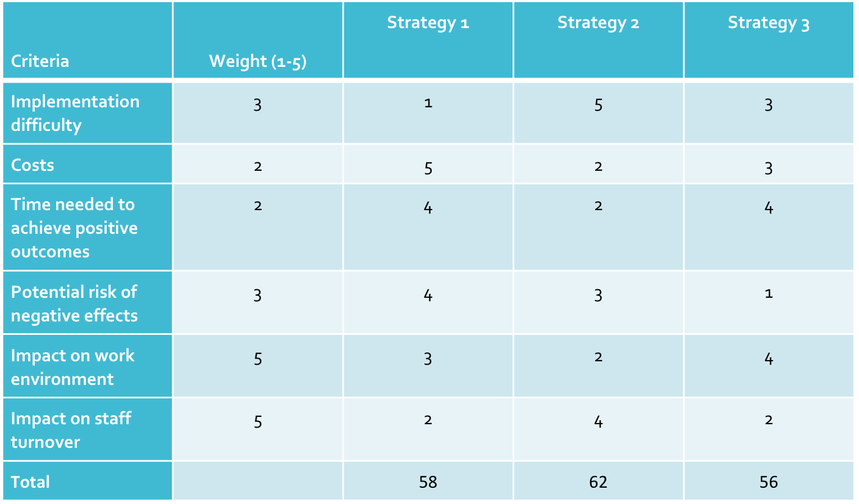

Different weights were attributed to different aspects of the outlined strategies. The most important factors were selected to be those related to the impact that the proposed strategic plans would have on the work environment and staff turnover at Forever 21, as they correspond to the main purposes of the strategies. The lowest weights were given on the costs and time needed for the implementation of the strategies, as it was considered that they would highly likely be worth the positive impacts that the strategies would bring about.

Based on the calculations made and the total scores of all strategies, it is to be evaluated that Strategy 2 would be most effective. Therefore, the paper would further examine the specific details about its implementation.

Implementation plan

The strategic plan would be constructed using the ADKAR model for change. This method is based on the conception that there are five outcomes that need to be achieved in order to successfully employ a change. They reflect the name of the model (Hiatt, 2006).

- Awareness
As per the ADKAR framework, a change should begin by the raising of awareness regarding the need for and the negatives of the current situation.

Therefore, it is to be recommended that Forever 21 commences its strategy implementation by explaining the adverse impacts of high staff turnover.

For instance, attention should be given to the negative impacts that these high rates have on the organization's financial resources and prosperity, as well as the overall organizational environment.

Moreover, it should be emphasized that frequent job changes also have a bad reflection on their job application profile which may hamper their career prospects and growth opportunities. In addition, new job finding is also to be outlined as a tedious and time-consuming process.

- Desire
After the employees have been made aware of the disadvantages of job turnover, both for them, as well as the company, they have to be explained how the changes brought about by implementation of the strategy would engender multiple positive effects. In doing this, the desire of the staff members and management to actively contribute to the employment of the strategy would be fostered.

For instance, the improved job retention would decrease various types of costs for Forever 21. As a result, the company would have a higher amount of funds that could be allocated to work environment improvements or/and workers’ salary raises.

Furthermore, considering that the strategy pertains to the fostering of employees’ personal development, they should be made aware of all the benefits that are associated with skills and career advancements.

- Knowledge
The ADKAR model acknowledges the need of people involved in a change process to possess the needed knowledge to embrace and contribute to the implementation of changes.

Given that, it should be ensured that the managers at Forever 21 have the necessary skills and expertise to lead and guide staff members in their career development process.

Moreover, workers should also be well-informed about how they would be involved in the process.

- Ability
After it is ensured that the necessary knowledge is possessed, the next step should be to provide for the ability of workers and management to incorporate the aimed at changes.

First, it is to be recommended that workshops are hosted to prepare both the management, as well as the workforce for the actions that would be undertaken.

Once the employees’ development program begins, each individual’s progress and success should be tracked and frequent feedback regarding what could be improved should be provided.

- Reinforcement
Considering that the strategy pertains to employees’ development, it is to be expected that they will appreciate and value the positive changes that they observe in themselves, their qualities and skills.

To further encourage their active participation, as well as provide for the management’s motivation to engage in the plan, reinforcements are to be used. They can be of various type: both in a monetary rewards form, as well as positive feedback and acknowledgment of contributions.

Communication Plan with Stakeholders

Every change in a company should be well-communicated to all of its stakeholders to ensure that they are aware of how it would impact the company and their interests. In doing so, an organization can prevent the occurrence of potential conflicts (Brugha and Varvasovszky, 2000).

Companies with a wide operational scope, like Forever 21 have multiple stakeholders.

A Power/ Interest matrix will be used to map out and classify them.

Meet their needs | Key players
Management | Employees  Company’s owners
Low priority | Keep informed
Banks and other lenders  Shareholders  Government and law authorities | Customers  Media  Product suppliers

Stakeholder Engagement Plan

Stakeholders | Power and Interest | Key Interest and Issues | Communication Vehicle | Frequency | Comments
Owners | High and High | The state of the company that they own will be significantly affected by the plan.  They might have concerns about the strategy’s effectiveness | Meetings, discussions, letters, reports | Upon the achievement of different milestones or requests | They should provide support for the plan’s implementation.
Employees | High and High | The plan aims to provide them with multiple benefits | Public discussions, private meetings, progress checks, anonymous inquiries | Constant feedback inquiries and active communication | They are the main party that would be impacted by the plan and the strategy’s success is to be evaluated via the outcomes that it has on them
Management | High and Low | They should be informed regarding the positive impacts that the strategy would bring about to them and the company, to stimulate their interest to actively participate in it.  They might have issues with the attitudinal changes that they have to commit to. | Face-to-face discussions, letters, reports, progress checks | Constant exchange of information | They are key factors for the successful implementation of the plan but may have reservations about it.
Banks and other lenders  Shareholders  Government and law authorities | Low and Low | Their interest and concerns regard the plan’s impact on the company’s commitments and accordance with legal policies. | Meetings, reports | Upon the completion of every stage of the plan | Inadequate communication with them can lead to the emergence of problems such as legal suits and penalties.
Customers  Product suppliers  Media | Low and High | They are interested in tracking the strategy’s implementation process and how it affects all stakeholders.  They are concerned that the plan may engender negative consequences. | Press releases, meetings, reports | When achieving different milestones and upon requests | Their perception may have a significant impact on the brand’s image and operations.

Monitoring and Review Techniques

Considering the complexity of the issue at hand and the importance of undertaking the most optimal approach to its solution, the proposed strategic plan would be frequently subjected to monitoring and reviewing. In doing that, Forever 21 would have the capacity to track the progress that is being made and potentially detect any setbacks that impede the effective employment of the strategy.

The setting of SMART goals would further enhance the project planning and progress monitoring.

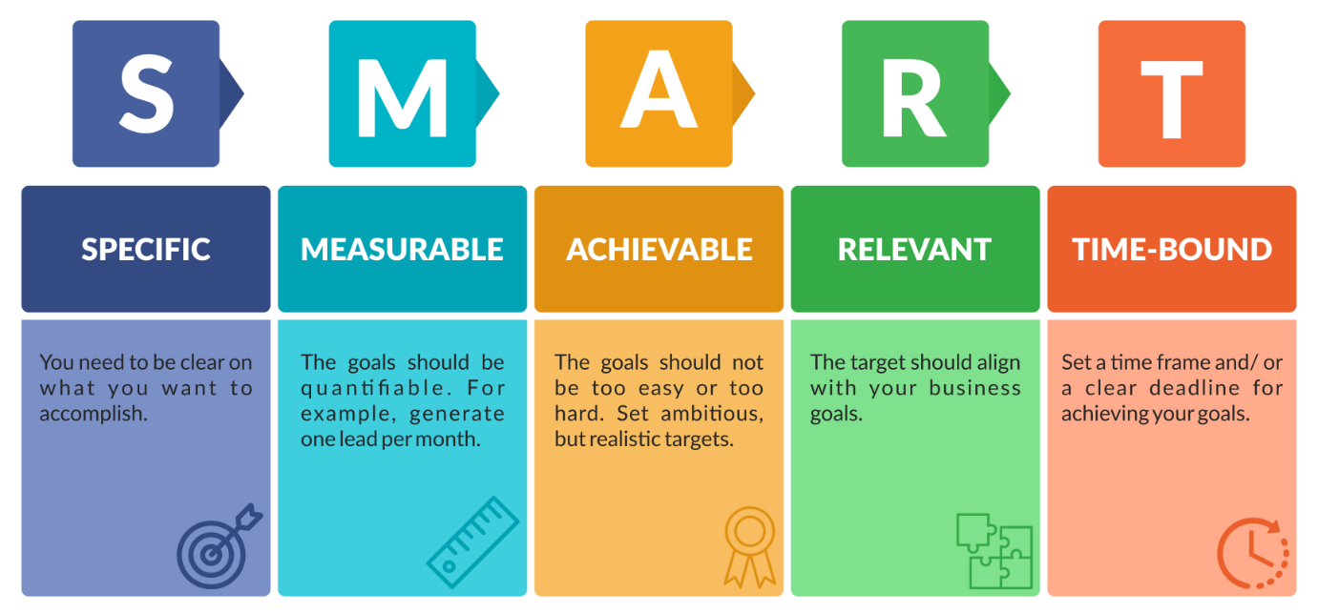
Figure 1. SMART goals (Source: LaunchSpace, n.d.)

Conclusion

High employee turnover has a detrimental effect on business. The current report examined the case study of Forever 21 to identify key factors that have a negative impact on a company’s employee retention rate and develop a plan that is to be used to resolve the problem with high attrition rate. Recommendations were provided to facilitate the proposed strategy’s implementation.

References
Adair, J. E. (2007) Decision making & problem solving strategies. Kogan Page Publishers.
Barkho, G. (2022) With plans to open 14 new stores, Forever 21 plots a comeback strategy, Modern Retail. Available at: https://www.modernretail.co/operations/with-plans-to-open-14-new-stores-forever-21-plots-a-comeback-strategy/.
Gartner (2018) Lack Of Career Development Drives Employee Attrition, Gartner. Available at: https://www.gartner.com/smarterwithgartner/lack-of-career-development-drives-employee-attrition.
Harvard Business Review (2019) Why You Should Stop Trying to Be Happy at Work. Available at: https://hbr.org/2019/07/why-you-should-stop-trying-to-be-happy-at-work.
Helms, M. M. and Nixon, J. (2010) 'Exploring SWOT analysis–where are we now? A review of academic research from the last decade', Journal of strategy and management.
Hiatt, J. (2006) ADKAR: a model for change in business, government, and our community.Prosci.
Hom, P. W., Lee, T. W., Shaw, J. D. and Hausknecht, J. P. (2017) 'One hundred years of employee turnover theory and research', Journal of applied psychology, 102(3), pp. 530.
Indeed (2022) Employees at Forever 21, Indeed.
Iqbal, A. (2010) 'Employee turnover: Causes, consequences and retention strategies in the Saudi organizations', The Business Review, Cambridge, 16(2), pp. 275-281.
Launch Space (no date) How to Create Meaningful SMART Goals, Launch Space. Available at: https://launchspace.net/blog/smart-goals/.
Lee, T. W., Hom, P. W., Eberly, M. B., Li, J. and Mitchell, T. R. (2017) 'On the next decade of research in voluntary employee turnover', Academy of management perspectives, 31(3), pp. 201-221.
MacCollum, C., Pape, H., Romley, N. and Witmer, O. 'FOREVER 21 CASE STORY'.
McKinnon, S. (2021) Forever 21: 4 Reasons it Failed & Filed for Bankruptcy, Indigo9 Digital Inc. Available at: https://www.indigo9digital.com/blog/forever21failureandbankruptcy.
Morrell, K., Loan‐Clarke, J. and Wilkinson, A. (2001) 'Unweaving leaving: the use of models in the management of employee turnover', International Journal of Management Reviews,3(3), pp. 219-244.
O'Connell, M. and Kung, M.-C. (2007) 'The Cost of Employee Turnover', Industrial Management, 49(1).

Office Vibe (2020) 12 Proven Strategies To Increase Job Satisfaction, Officevibe. Available at: https://officevibe.com/blog/how-to-improve-job-satisfaction.

Ongori, H. (2007) 'A review of the literature on employee turnover'.
Pink, D. (2009) 'The puzzle of motivation', TEDGlobal 2009.

SurveyMonkey (2022) Can employee recognition help you keep them longer?, SurveyMonkey. Available at: https://www.surveymonkey.com/curiosity/employee-recognition-and-retention/?zd_source=hrt&zd_campaign=5503&zd_term=chiradeepbasumallick.

TRF (2019) The many (law)suits of Forever 21, tfr.news. Available at: https://tfr.news/articles/2019/10/2/the-many-lawsuits-of-forever-21?format=amp (Accessed: 27 December 2022).
Van Aken, J. E. and Berends, H. (2018) Problem solving in organizations. Cambridge university press.
Workhuman (2022) Employee Recognition Statistics You Need to Know in 2022, www.workhuman.com. Available at: https://www.workhuman.com/blog/employee-recognition-statistics/.
Appendix


