

Name: Tamara Brylewicz
Student ID: 1915163
Module code: BMSW4004
Lecturer name: Suneth Fernando
Date: 11/08/2021

Table of content
0.1 Introduction…………………………………………………………
1.Problem definition…………………………………………………….
Explain the problem………………………………………………….
Tools and techniques used to identify the problem ……………...
2. identify the causes and effects (analyse the current situation)
Apply SWOT analysis (evaluate internal factors) ……………….
Apply PESTLE analysis (evaluate external factors) ……………
Apply Fishbone Analysis (evaluate the causes) ……………….
3. Identify solutions (identify at least two solutions or more)
and evaluate the best alternative solution for your problem …………
4. Produce a plan (how to implement the chosen alternative solution) …
5.implementation process of your alternative solution……………………
6.Review and monitor your solution……………………………………….
7. Conclusion…………………………………………………………………

Introduction
In this presentation I will be identifying a problem and show the tools and techniques I used to solve the problem I will also add SWOT analysis and add Pestle analysis and fishbone analysis and I will make a diagram to show you my working out, I will identify what happened and how we came to active our goals as a store we tend to be like family and we like everything clean and tidy , I will also identify solutions to all the problems , and evaluate an alternative solutions I will produce a plan on how to active the solutions , and write an implementation on how the process of our solutions are going and review all and monitor the solutions and write a full conclusion for my report.
Hope you enjoy.

1.Problem definition

What type of problem is best to define as a problem because there can be the smallest thing and it can effect a lot of people, well in my case I would like to identify a problem I have at my work place and it somewhat really becoming a bigger issue as me and my colleges from work have all said there needs to be a change because it is really bothering the workers and the customer.
The problem
- There are not enough tills for customers to be served by the workers (myself include).

Explain the problem
Our store is one of the popular places people come and by food essentials, I work at Aldi and with the amount of people that come everyday for shopping we as workers sometimes cannot manage in time, me and my colleges have all come together to go to our manager and make a suggestion about adding self service tills and that is how we started our plan to make a change, because we work after hours but don’t get paid the same amount as we would working our normal shifts, sometimes its even harder if they ask for you to come down to work on your day off,

I personally don’t have anything against working on my day off, but they should change it a little for someone that has a day off to have a £1.50 extra as they are suppose to have a day off instead we are working an extra day, and it is not completely fair, if we were to include salary and problems ,then most of this cases would have come fort a long time ago , but seeing that nobody is trying to change it , I think the time has come to confront the board and make a change.
As everyone else we all have families we need to support financially and look after, some of us leave our children to family members just so we go to work some of us are a single parent providing for our kids, and paying bills and taxes, so we do struggle it is not as easy as some have it.

Tools and techniques used to identify the problem
- Write a correspondence letter to the head of board – we wrote an email and added all the other staff so the head of board can see that this issue needs to change

- Suggest self-service – in the email we suggested that they should think about adding an additional service to the store, so the customers have less waiting time and due to the pandemic, we all need to restrict being close to one another.

- Recruiting more staff- so that we have more staff to work, and we don’t end up doing extra hours with same pay.

- Suggest extra pay - £1:50 to be added to hourly pay if they would call us to come to work on our day off.

The board then looked on it and they asked us on the email if there were more suggestions if so to write another email to them and they would look over the email and would write back their correspondence and review our email and let us know what is going to happen.

Identify the causes and effects (analyse the current situation)

The head of board wrote back to us saying they accept our suggestions and that they will start planning to manage it all, of course the process wasn’t going to happen overnight, so we were very thankful for their response, they did mark for us the following,

- The shifts would be changing – each employee would get the right hourly rate even if doing extra hours.
- Extra day (if called to work on day off) - £1 pound would be added if they would ask an employee to come work on a day off.
- Recruit more staff- they would start interviewing trained and experienced people to work so there are more staff working.
- Self-service checkouts – they accepted to rebuild the store from the inside to add self-service checkouts, so it is easier for the customers and the employees

Apply SWOT analysis (evaluate internal factors)

- Will lose customers if changes will not happen.
- Will lose profit
- Will lose employees
- Marketing trends,
- Self-checkout service(needed)
- New regulations.
- Recruit more staff
- Need more staff,
- Need to change times and shifts,
- Need to add extra money for extra hours.
- Great team
- good listeners
- manpower
- structure
- resources
- operational efficiency
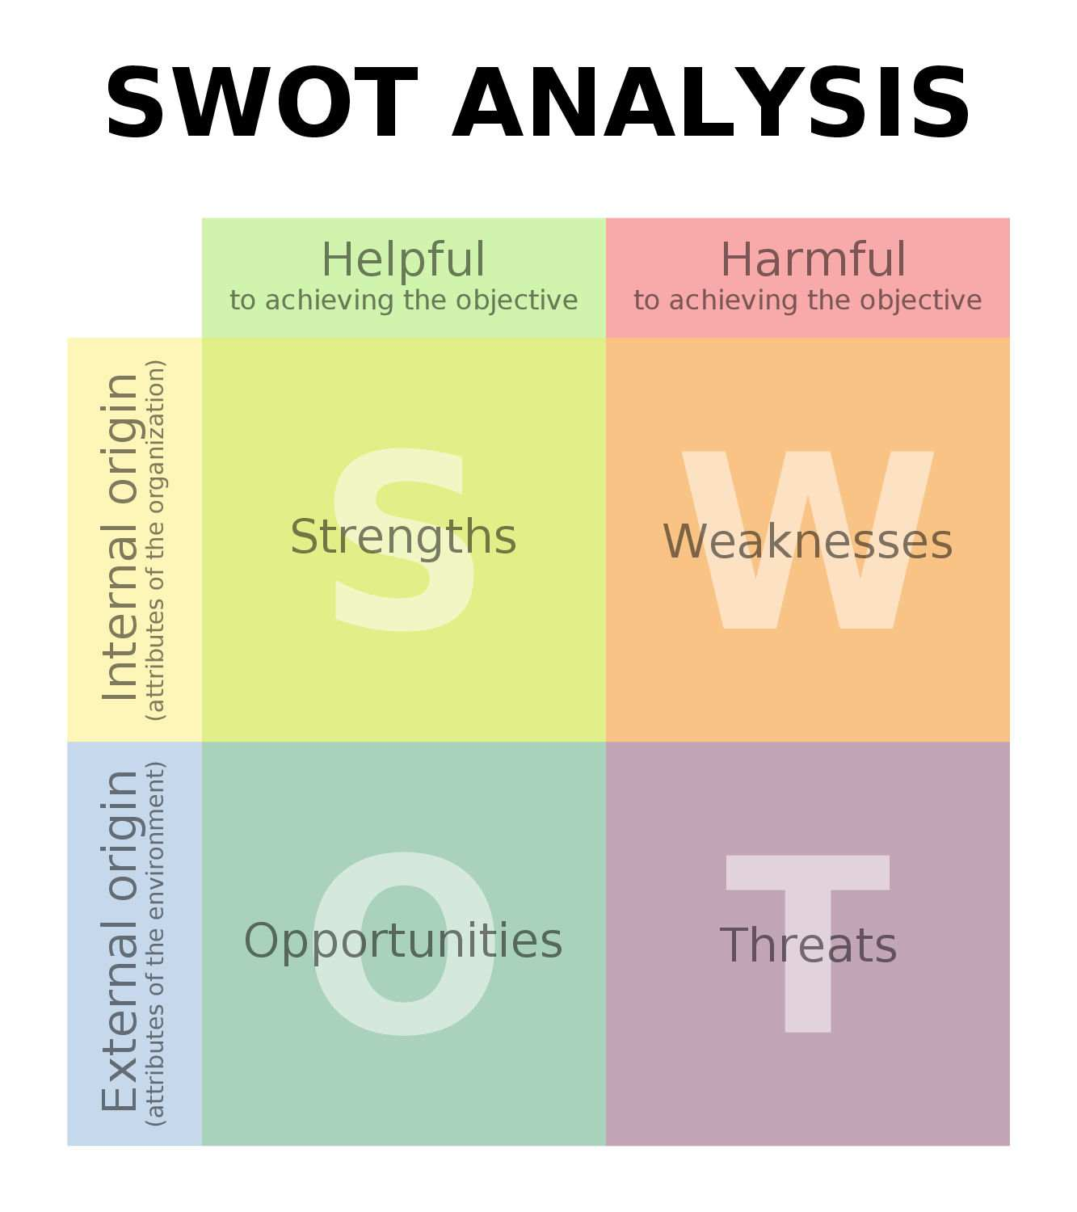
For the SWOT analysis I have written in the boxes what the internal factors are and the external factors but I will also do a PESTLE analysis for the external factors , to evaluate the internal factors for my SWOT analysis I can say that if the changes don’t happen and the extra money for extra hours or extra day are not fixed they will lose employees because everyone gets tired of doing double work for a simple pay rate.

Apply PESTLE analysis (evaluate external factors)
New regulation
Recruit more staff
Covid-19
Due to COVID-19 the shops are not aloud to be packed and added more self-services will help the store and make sure its not packed all the time and there are not a lot of people queuing up as you still need to do the 2-meter rule, and also due to Covid-19 a lot of employees are scared to go to work to not bring the virus back to their families.
Need to recruit more staff and start interviewing so that the ones working already don’t do overtime the leaders need to know that everyone has their own problems in their personal life.
The Headboard need to make new regulations, so the business doesn’t lose profit, not only for profit but also to keep their employees satisfied

Apply Fishbone Analysis (evaluate the causes)
-lack of leadership
- lack of communication
-lack of clear instructions

- Need adjustments to time shifts ,
- Need to be more flexible for employees with family members
- Need self-services
- Lack of safety
- Misunderstanding all strategies

Leadership

equipment
methods
- Lack of management
- Poor communication
- Need more staff
- Need 2- meter distance due to covid-19
- Lack of attention
- To many customers at once.
- To stressful
- To noisy
- Bad mood /tired
Environment
people
Management

Identify solutions (identify at least two solutions or more)
- Installing self-services – if the get self-services it would help a lot and the shop would be so packed of queuing.

- Paying a bit more for extra hours – we all work one shift for 7 hours so if we are told to stay longer pay a little extra, then at-least we wouldn’t get moody.

- Paying more on a day off and called to come to work – day off should be a day off but if you are calling me to work on my day off, I expect you to pay me more as it is supposed to be my day off.

- More communication- there is a lack of communicating between the employee and employer, we know we work for you, but our voices also matter so please listen and have a communication with us, maybe our mental wellbeing is becoming to interfere in our work life.

- More management / clear directions – clear directions, call my name don’t yell at the employee and expect us to just listen and you yelling from across the shop floor.

Best solution would be,
I cant pick one because I need at-least two of them to start first I would go with more communication between the employer and us their employees, if one understands one another and both are on the same page and both get along I don’t see any issue, but in this case it’s a bit different because there isn’t any communication involved, they just call to come in to work on our day off, and pay us, there are a lot of unsatisfied and unhappy employees working and for you to at least start baby steps first is first have a conversation some communication with your staff so they know what they say matters, no one is anybody’s dog here we are all humans with feelings and we all want to be heard, so please understand for me personally first one would be
- Communication
And the alternative solution would be,
- self-services for customers

As we all know how Friday, Saturday and Sunday is packed in food essential shops, because people go back to work on Monday they need to get their groceries for the whole week for that reasons the shops are always packed, and with self-services there wouldn’t be so much ques and because of the pandemic we still need to self-distance and there are no distancing in packed shops like that , and that also puts everyone and ourselves in harms way we could end up getting the virus and bring it home to an elderly or another of our family members and that is not fair to put them in harm’s way.

. Produce a plan (how to implement the chosen alternative solution)

less people in the shop -would lead to selfcare not being afraid of catching the virus. | Self-services – tills that a customer can go and check their items and pay making it less ques and less packet in the shop.
Self-distancing – holding the 2-meter distance safety for the customers and for staff. | More communication – talking to each staff so they know they are being cared for, talking to them making sure they understand everything perfectly.
More management -more experienced staff and more management over the staff in the store so that you know they are all doing the same amount of work, because some end up doing more and some end up doing not so much. | Extra wages for extra day or extra hour -giving your employees extra wages for extra days or extra hours makes them feel more comfortable for working makes their moods increase and makes them feel understood and satisfied.

What I did was write a correspondence to the head of board and told them what is going on and that we are really struggling in the shop to maintain distance and maintain our mental health state because we are asked to do extra hours and extra shifts and the wages are not really acceptable , that me and my team on our shifts are really tired of lack of communication and lack of monitoring the progress , the head of board wrote back to us on the email and said they will look into it and accepted our suggestions. The alternative solution is to re-build the floor inside the store extend it, just so there is more space for the self-customer services.

Implementation process of your alternative solution
The implementation process of my alternative solution is going very well the store has been extended and now installing the self-customer services, and the wages for extra hours and gone up by 18 percent and the wages for extra days have gone up £1 pound , so I am very happy and glad that now me and my colleges are being treated and valued the way we are suppose to be, like every human should be treated, now there are more interviews for more staff to be recruited and that I am also very happy and satisfied about now more employees are satisfied and more employees are happy to come into work every day.

Review and monitor your solution
Going over my solution and seeing how it was at the start of the problem and how it is now is bringing joy to my heart because not only do I feel safer at work but I also feel like I helped us all , the shop is earning more money we are earning the right wages and people are not packed in the ques, because of all the new solutions that came out to be a very good idea and best alternative solution , my head of board , my manager are my colleges are very glad of all of this, but I will continue to monitor my solution and make the sure the communication level don’t decrease but continue to increase.

Conclusion
Going through the process of trying to open the eyes of our managers for them to see what’s going on in the shop, how we are being treated asking us to come to work on a day off and being paid the same wages as a normal day, doing extra hours for the same wages, it is not fair on us the employees,
I have explained the problem and gave the tools and techniques on how to fix the problem I produced a plan I went through the SWOT analysis and the PESTLE analysis and Fishbone analysis diagram I have showed a clear view of what needs to be done and how to get to the set goal and how I started to engage with them and communicate , I hope this gives my readers a better view of how to start something you have a problem at work with .

