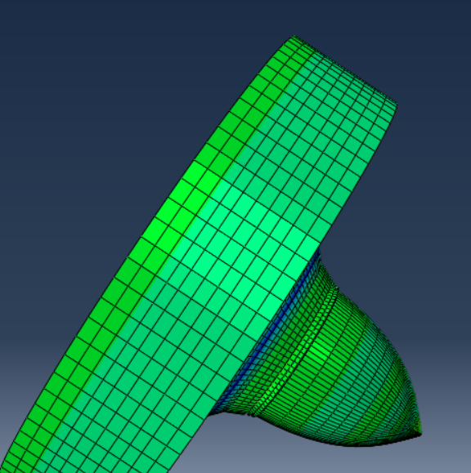
Cover Image 1: A still frame from the author's model

Comparative Modelling of A Tungsten Penetrator against Steel and Aluminium Plate
  - aBaQUS cae
Silas Blevins | OME Degree Apprenticeship | 15/05/2022

Contents
Table of Figures ii
Abstract 1
1.1 Introduction 2
2.1 Material Data 3
2.2 Alterations to the Template Model 5
2.3 Method and Simulation Overview 6
3.1 Results 7
3.2 Discussion 12
4.1 Conclusion 14
References 15

Table of Figures
Cover Image 1: A still frame from the author's model i

Figure 1: The model template used for this report 2
Figure 2: The Author's model set up with an Aluminium Plate 5
Figure 3: The Author’s model set up with a Steel Plate 5
Figure 4: Velocity against time for an entry at 200m/s 7
Figure 5: The penetrator passing through Aluminium at 200m/s - Max. Principal stress of 2.175GPa (Tensile) 8
Figure 6: The penetrator passing through Steel at 200m/s - Max. Principal stress of 8
Figure 7: Graph of velocity against time for entry at 500m/s 9
Figure 8: Graph of velocity against time for entry at 600m/s 10
Figure 9: Graph of velocity against time for entry at 800m/s 10
Figure 10: Stress on aluminium during penetration at 800m/s 11
Figure 11: Stress on Steel during penetration at 800m/s 11
Figure 12: example v₅₀ curve [7] 12
Figure 13: Mechanisms of Armour Penetration [6] 13

Table 1: The materials used in Figure 1 3
Table 2: J-C Parameters for the materials used 4
Table 3: J-C Damage Initiation values for the materials used 4
Table 4: A material key for Figures 2 and 3 6

Equation 1: The Johnson-Cook Strength Model 3
Equation 2: The Johnson-Cook Damage Initiation Criterion (As used in Abaqus) 3

Abstract
Computer modelling is an essential tool in the study of energetics and ballistics, as it allows approximations to be made of data such as material penetration or blast effect, and both reduces the need to carry out expensive or potentially hazardous trials, and informs the preparation of such trials when a need remains for practical validation – such as the use of novel materials.
This report will focus on the use of modelling in the context of ballistics, investigating the performance of two homogenous metal plates against a tungsten penetrator at a range of velocities. The metals chosen represent two of the most common materials for vehicle armour: Steel and Aluminium. Historically steel was used as armour on heavier vehicles such as tanks [1] whereas Aluminium is used to armour vehicles which require lighter weight, such as personnel carriers and armoured cars. Therefore it is to be expected that a Steel plate will offer better protection against high-velocity impacts than an Aluminium equivalent.
To measure the performance of the armour plates, data was collected on the velocity of the penetrator with respect to time as it passed though the plate, as well as the stresses within the plate. In all cases, the steel plate was more effective in slowing the penetrator, but this was clearest at higher velocities.

Introduction
This report is concerned with the performance of Steel 4340 and elemental Aluminium against a penetrator made of a generic tungsten alloy. The software used to produce all the models used herein is Abaqus CAE Student Edition from Dassault Systems Simlulia Corp. To inform the models, a range of material parameters were used, most significantly the Johnson-Cook parameters for both strength and failure where appropriate. Parameters for materials were informed by the material database Matweb [2], as well as a report by A. Bertarelli [3]. The data from these sources, combined with the parameters and materials included in the template model supplied by UWTSD enabled the materials in the author’s model to be represented as accurately as possible.
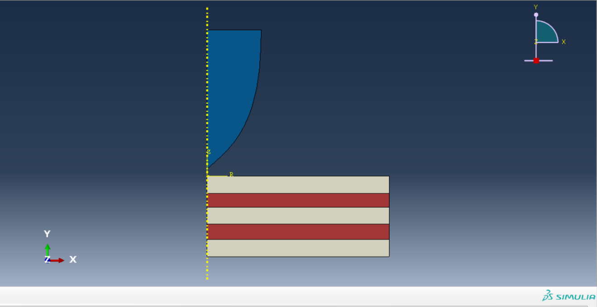
The author’s model was based directly on the model provided by the university, which presents a sheet of composite armour and a homogenous penetrator. This is seen in Fig.1 and Table 1 below.
Figure 1: The model template used for this report

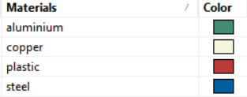
Table 1: The materials used in Figure 1

2.1 Material Data
For the purposes of this report, and the models associated with it, the Johnson-Cook equations were used to describe the strength of the materials used, and how they behave at the point of failure. These equations assign each material a number of parameters which the modelling software utilises to determine the behaviour of the materials. The Johnson-Cook equations were chosen as they represent the behaviour of materials experiencing the high strain rates expected in ballistics problems with suitably high accuracy. The equations are given below in Equation 1 [4] and Equation 2 [5]:
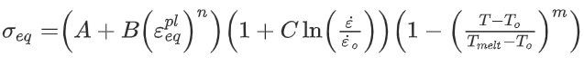
Equation 1: The Johnson-Cook Strength Model
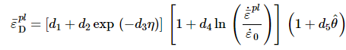
Equation 2: The Johnson-Cook Damage Initiation Criterion (As used in Abaqus)
Equation 1 describes how the material behaves under plastic strains, and Equation 2 describes the behaviour of the material at and around the point of failure. The tables overleaf give the material data used in the author’s model, and the source(s) from which that data was acquired.

Material | A | B | n | m | T_{melt}/K | T_{Transition}/K | Source
Tungsten Alloy | 1.506x10⁹ | 1.77x10⁸ | 0.12 | 1 | 1449 | 376 | [3] [2]
Aluminium | 1.67x10⁸ | 5.96x10⁸ | 0.551 | 0.859 | 619.85 | 226 | [3] [2]
Steel 4340 | 7.92x10⁸ | 5.01x10⁸ | 0.26 | 1.03 | 1516 | 273 | [3] [2]
Table 2: J-C Parameters for the materials used

Material | d1 | d2 | d3 | d4 | d5 | Ref.Strain | Source
Tungsten Alloy | 0 | 0.33 | -1.5 | 0 | 0 | 1 | [3] [2]
Aluminium | 0.0261 | 0.263 | -0.349 | 0.247 | 16.8 | 1 | [3] [2]
Steel 4340 | 0.05 | 3.44 | -2.12 | -0.002 | 0.61 | 1 | [3] [2]
Table 3: J-C Damage Initiation values for the materials used

2.2 Alterations to the Template Model
The author made no changes to the geometry of the model provided by the university, but changes were made to the material models used. The steel penetrator was substituted for the tungsten alloy, and the composite plate for Homogenous Aluminium or Steel, depending on the data being run at the time. The Materials in the model are shown in the figures below.
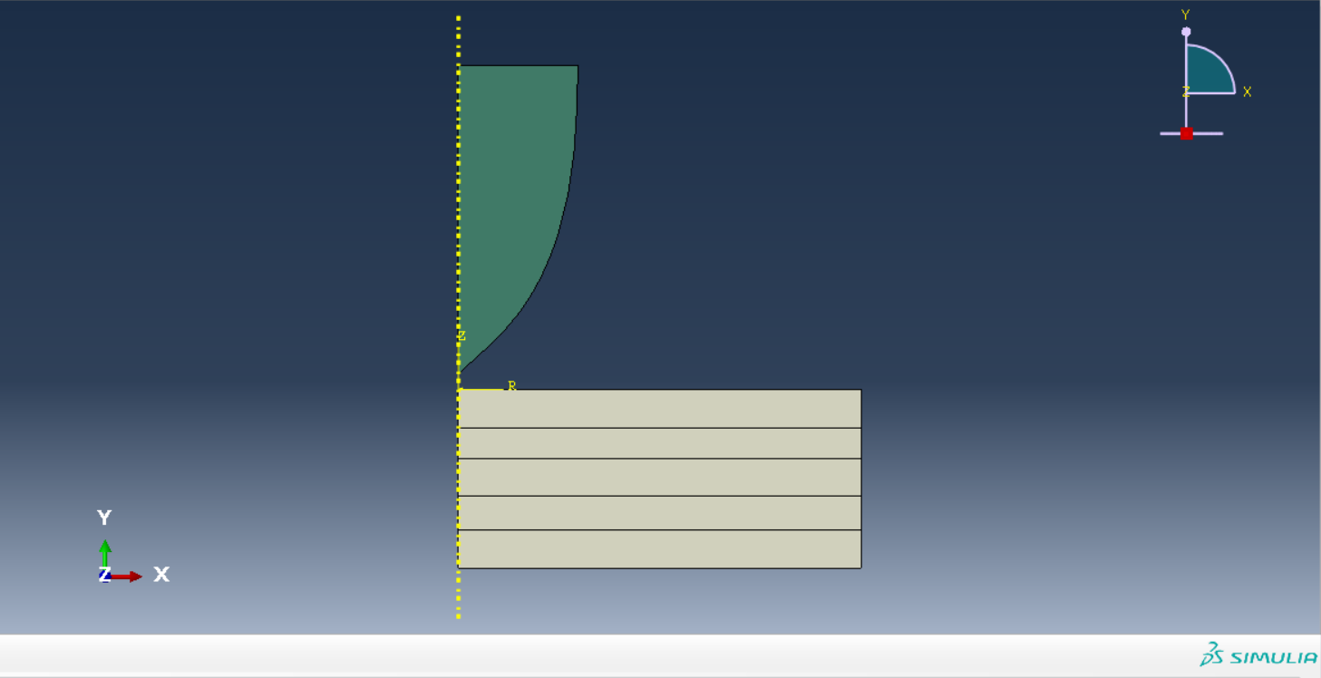
Figure 2: The Author's model set up with an Aluminium Plate
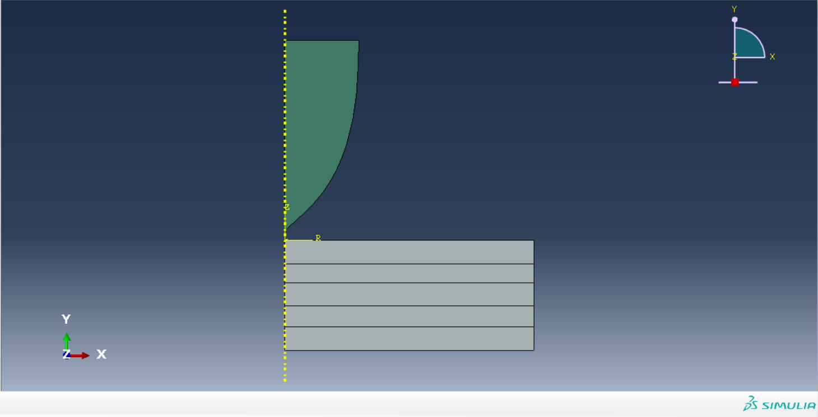
Figure 3: The Author’s model set up with a Steel Plate

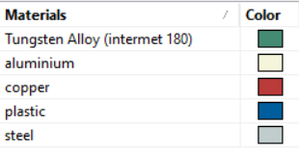
Table 4: A material key for Figures 2 and 3

2.3 Method and Simulation Overview
In order to keep the model relatively simple, and reduce the strain on student machines, the template used a 2-Dimensional Axisymmetric plot. In this form, the problem is solved only in two dimensions, but the geometric model can be swept about a predefined axis to provide some approximation of the problem in three dimensions. In this model, the axis chosen was the long axis of the penetrator (or the Y axis in Abaqus) as this resulted in the geometry being correctly formed when rotated. As a result of the template being based on layered armour, the homogenous approach meant all individual materials were replaced with the single material being investigated. Both materials were tested against the same penetrator at four separate velocities: 200m/s, 500m/s, 600m/s, and 800m/s. The velocity of the penetrator, as well as the [stress] On the material over time were measured to provide as scale for the performance of both materials against and identical threat.

3.1 Results
As the tungsten penetrator passes through the armour plate, it transfers its kinetic energy to the plate and as such the velocity decreases. If the armour is sufficiently thick, or the entry velocity sufficiently low, this velocity will reach zero and the armour will not be penetrated. Since the armour was kept the same thickness throughout this investigation, this effect was only seen when the velocity was low. Figure 4 below presents the velocity of the penetrator over time as it passes through both materials with an entry velocity of 200ms⁻¹

Figure 4: Velocity against time for an entry at 200m/s
From this graph, it can be seen that for an entry velocity of 200ms⁻¹, the two materials offer approximately equal protection against the penetrator. In both cases, when the simulation was run beyond the initial time limit, the round failed to penetrate the plate. This is illustrated in the figures overleaf, which show the penetrator passing through the plates, and the maximum stress on the materials.

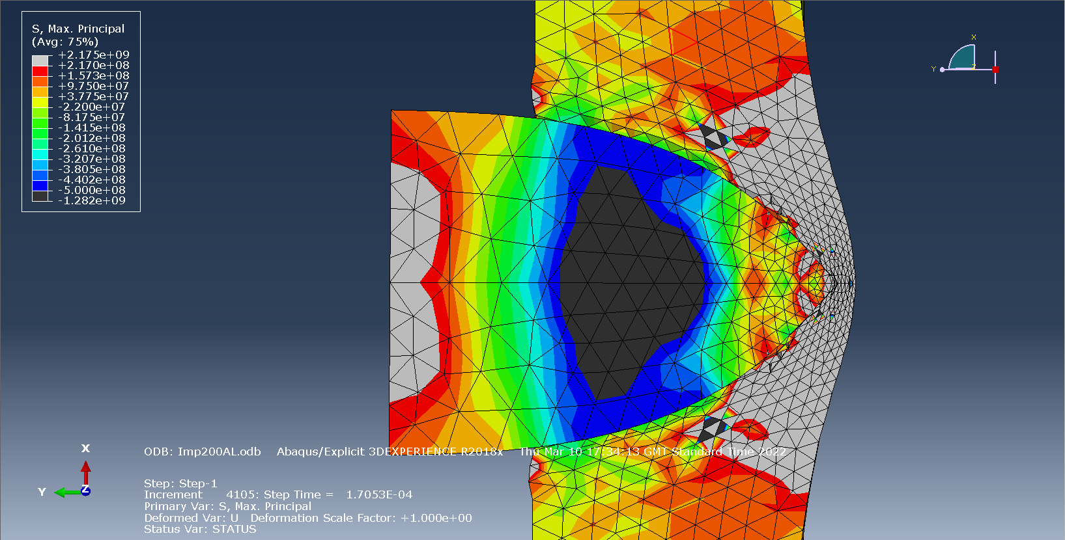
Figure 5: The penetrator passing through Aluminium at 200m/s - Max. Principal stress of 2.175GPa (Tensile)

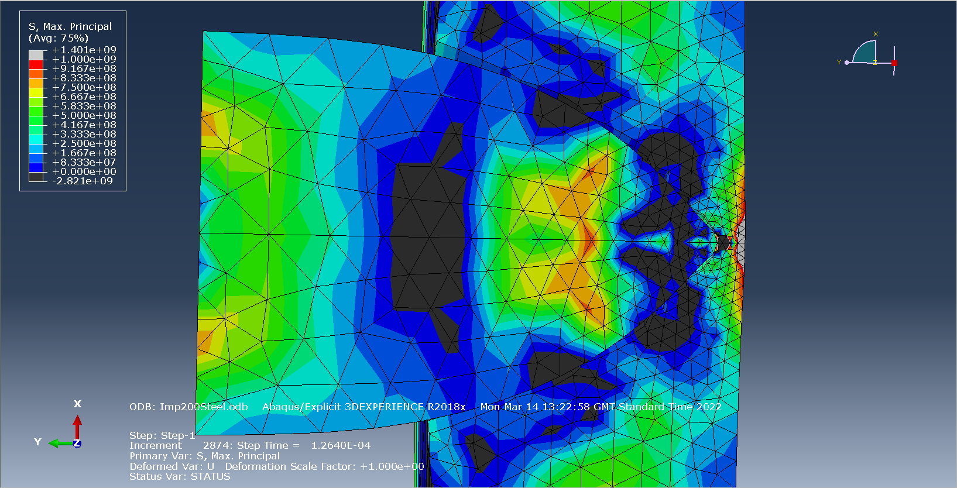
Figure 6: The penetrator passing through Steel at 200m/s - Max. Principal stress of
-2.821GPa (Compressive)

For intermediate velocities (500ms⁻¹ and 600ms⁻¹), the difference in protection provided by the two materials becomes more clear, with steel reducing the velocity significantly more than aluminium in a given time period. In practice this means that even in the event of successful penetration, the projectile carries less residual velocity, and so can do less damage to targets behind the armour. Figures 7&8 below illustrate the velocity over time for the intermediate velocities given above.

Figure 7: Graph of velocity against time for entry at 500m/s

Figure 8: Graph of velocity against time for entry at 600m/s

The figures above clearly illustrate the advantages of steel as an armour when compared to aluminium, but this is made most clear when the velocity is at the greatest tested, 800ms⁻¹. Figure 9 below presents this data.

Figure 9: Graph of velocity against time for entry at 800m/s

This disparity is also clear in the stresses on the materials during penetration. During the 800ms⁻¹ interaction, the aluminium experiences maximum principal stresses of up to 13.5GPa, whereas the steel experiences only 7.41GPa in the same direction. This is shown below in Figures 10&11
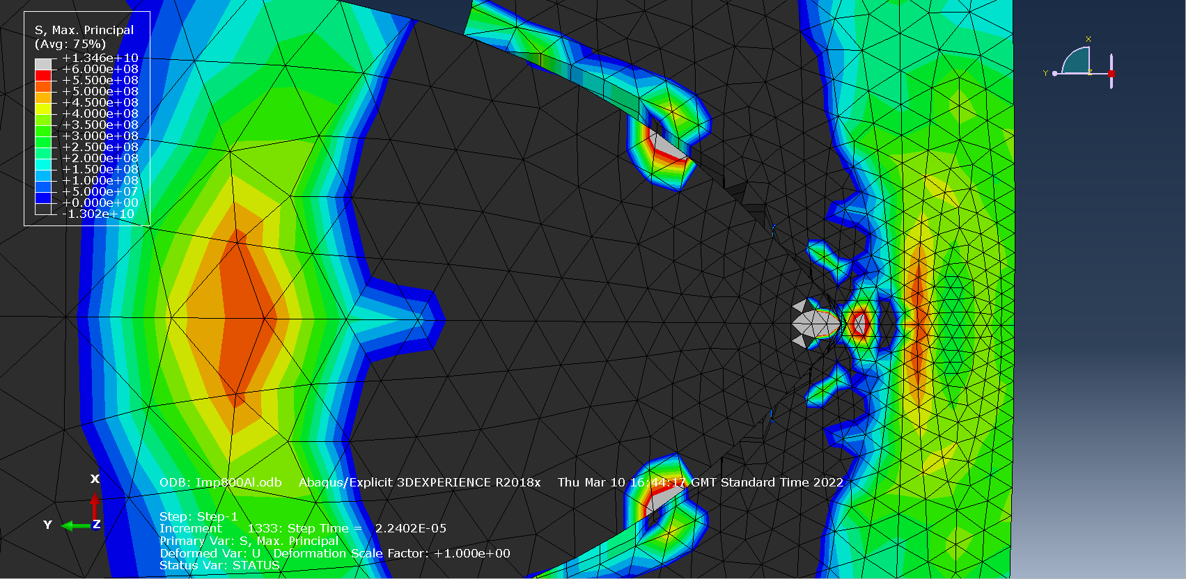
Figure 10: Stress on aluminium during penetration at 800m/s
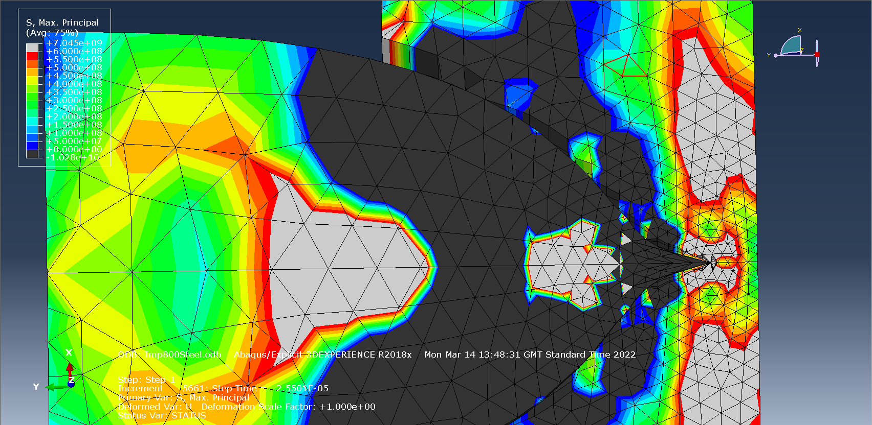
Figure 11: Stress on Steel during penetration at 800m/s

3.2 Discussion
The data presented in Section 3.1 clearly illustrates that Steel has better performance as an armour than Aluminium, which is consistent with findings by other models and empirical evidence. Despite this, it is necessary to discuss and address some shortcomings of the model used and the assumptions made in the results.
First among the concessions mentioned above is the fact that the nature of computer modelling requires a material being modelled to be treated as ‘perfect’ i.e., it has no chemical or physical deviations from the calculated properties. In a simulation therefore, a shot fired against an armour of given thickness will always penetrate, given it has sufficient velocity to do so. In practice, however, this is different. Owing to slight material differences between samples of armour and individual shots, the velocity required to penetrate is expressed as v₅₀, which is the velocity at which 50% of shots of a given kind will penetrate a specific armour. Figure 12 illustrates a typical v₅₀ curve.
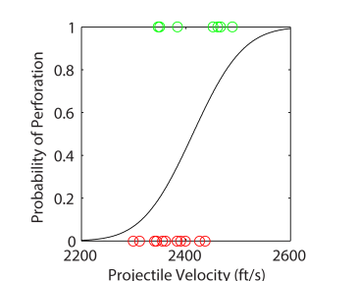
Figure 12: example v₅₀ curve [7]

The second concession to mention is the issue of fragmentation and spalling. In the results section of this report, the author referred to the reduced residual velocity of the penetrator resulting in reduced damage to targets behind the armour. Whilst this is true, it ignores the effects of the armour itself. When the material composing the armour and/or the penetrator fails, it can fragment, resulting in spalling behind the armour. The fragments formed here travel at high velocity and can damage targets themselves. This is the principle by which many early examples of Armour-Piercing Ammunition operated, and the use of armour spalling to damage the occupants of an AFV remains an important capability even in the age of shaped charges and long-rod penetrators. Figure 13 illustrates some common mechanisms of armour penetration, including the effects of fragmentation.
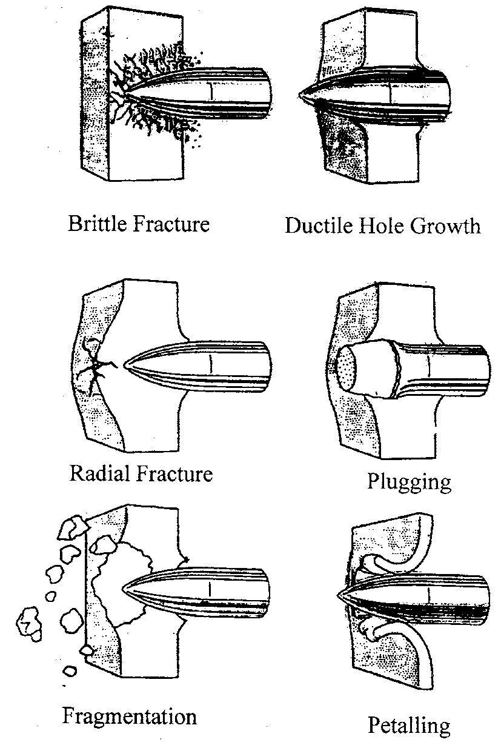
Figure 13: Mechanisms of Armour Penetration [6]
As a matter of practicality, although the mass of armour material was ignored in this model, it should be considered operationally. For example, on an aircraft, any armour should be as light as possible, whereas a bunker or hardened position allows more liberty in the materials used as mass is less of a concern.

4.1 Conclusion
In conclusion, this lab package has demonstrated that Steel is a more effective armour material than Aluminium at all velocities, but this is most apparent as velocity increases. From this, it can be extrapolated that the better a material is able to tolerate high stresses and high strain rates without failing, the higher its performance as armour. It is seen that as the penetrator passes through the aluminium, it experiences higher stress than the steel, pushing it to the point of failure and allowing the penetrator to pass through. To build on the points discussed in Section 3.2, when selecting a material for armour, it should also be resistant to cracking and shattering, and as such ductile materials are more desirable as armours than brittle ones.
Collating this gives the following statement: the ideal armour material can tolerate high strain rates, whilst also maintaining ductility. For applications where mass is of minimal concern, this is best fulfilled by thick sheets of steel or other metals, however when minimising mass is the priority, weaker metals like aluminium or novel composites and ceramics are the ideal solution.

References

[1] | K. Karthick, S. Malarvizhi and V. Balasubramanian, “Mechanical properties and microstructural characteristics of rotary friction welded dissimilar joints of rolled homogeneous armor steel and medium carbon steel,” Journal of the mechanical behaviour of materials, vol. 30, no. 1, pp. 171-178, 2021.
[2] | Matweb, “Matweb Material Property Data,” Matweb, 15 05 2022. [Online]. Available: https://www.matweb.com/. [Accessed 15 05 2022].
[3] | A. Bertarelli, “Beam-Induced Damage Mechanisms and their Calculation,” CERN, Geneva, 2016.
[4] | H. Nam, J. Kim, J. Han, J. Kim and Y. Kim, “Ductile fracture simulation for A106 Gr.B carbon steel under high strain rate loading condition,” in Recent Advances in Structural Integrity Analysis - Proceedings of the International Congress, Woodead Publishing, 2014.
[5] | Massachusets Institute of Technology, “Damage initiation for ductile metals,” MIT, 15 05 2022. [Online]. Available: https://abaqus-docs.mit.edu/2017/English/SIMACAEMATRefMap/simamat-c-damageinitductile.htm. [Accessed 15 05 2022].
[6] | C.-J. Hu, “Ballistic performance and microstructure of modified rolled homogeneous armor steel,” 2002.
[7] | T. H. Johnson, L. Freeman, J. Hester and J. L. Bell, “A Comparison of Ballistic Resistance Testing Techniques in the Department of Defense,” Institute for Defense Analyses, Alexandria, 2014.

Armoured Fighting Vehicle

