
Student Name: | Katie Marie Smith
Student Number: | 2307193
Module No:
Module Title:

Applied Leadership and Management in the Workplace
Module Assignment Submission

Table of Contents
Executive Summary 2
Introduction 3
What is a Learning Organisation? 3
Critical Assessment of Potential Organisational Benefits 6
Managing Individual Expectations in Personal Development 9
Critical Evaluation of Development Vehicles 11
Personal Development Plan (PDP) Table 13
Conclusion 15
Reference List 16
Appendices 1 18

Report - Development of a Trainee Dental Nurse to a Qualified Nurse
  - Applying Strategies for Performance Management and Career Development

Executive Summary
This report takes an in depth look at the professional development and organisational approaches involved in developing trainee dental nurses into fully qualified and registered professionals within a dental care setting. It calls to attention the organisation’s ongoing commitment and support to high-quality patient care, the professional growth of its staff, also the collaborative working environment. This, therefore, continues to show how a supportive learning environment including mentorship, and the access to development resources such as PDP SMART objectives, KPIS, training courses, e-learning, and feedback are fundamental to this process. Applying frameworks like Senge's fifth discipline, the report investigates the idea of the learning organisation and explores how organisational culture and structure affect trainee dental nurses' career advancement and job happiness weighing up the pros and cons of vehicles that help the organisation and individual. The three main learning phases survival, adaptive, and generative as well as benchmarking procedures discussed the difficulties of implementing beneficial recommendations are covered. The analysis concludes that encouraging an environment of continuous learning, reflective practice, and collaboration of the dental team is essential for the successful development of trainee dental nurses and the lasting care of quality provided by the dental care organisation.

Introduction
The report discusses how the organisation of a dental care setting focuses on the development of trainee dental nurses into qualified nurses. The business is committed to providing high quality dental care service to the community while encouraging the need for professional growth and development of its staff members. This will involve a personal supportive learning environment, where trainee dental nurses receive hands on experience and mentorship, while having access to various development tools and resources such as PDP SMART objectives, Training courses E learning, Work booklets, Feedback. The report will show how high-quality care is most important in developing the learning organisation. Overview of processes, tools and organisational culture is looked at in the report when contributing to the progression of a trainee dental nurse. Discussion and analysis of frameworks like Senge’s fifth discipline, organisational structures applied to the dental environment are shown to help aid the process of a learning organisation.

What is a Learning Organisation?
Learning organisation is a business that encourages an environment where employees can continuously acquire and share knowledge skills and insights to improve both individual and organisational performance. Foley et al. (2025) views on what a learning organisation stands for a mix of skills made up of creating, acquiring, and transferring knowledge, along with modifying its behaviour to reflect new knowledge and insights.
In the context of dental care, a learning organisation creates an environment where aspiring dental nurses feel competent and secure enough to acquire not only the technical skills required for their position but also the critical thinking, flexibility, organisation, along with teamwork skills. This type of culture acknowledges that personal development results in group improvement for the entire organisation and encourages mentoring, reflective practice, and open communication. Therefore, allowing progression in all these aspects will show dramatically to aid a successful business, e.g. targets achieved both NHS and private, low staff turnover, returning patients, high standard of quality care. Westgarth (2025) proposes that being led by cooperate dental practice can progress an individual career further rather than a business led by an individual as it has more of a sustained career while allowing development progress beyond dentistry into a commercial environment. A study by AlKatheri et al. (2025) Suggest that there are pros and cons within the NHS, as a qualified dental nurse many nurses are dissatisfied as the rise of costs just to be registered are increasing every year, dental nurses are not using their full skill mix capabilities since COVID 19 happened. Together, both perspectives outline that a supportive, development focused organisational structure is of importance for enhancing career satisfaction and professional growth among dental nurses.
Throughout a learning organisation there are many types of learning avenues from survival learning to adaptive learning which follows into generative learning. Through any organisation these learning avenues can occur. While in dentistry trainee dental nurses would begin their work life journey by survival mode in the first couple of weeks, for example being able to perform day to day tasks without any errors involved being mentored by a qualified nurse. Although the first stage can take time depending on who is mentoring the trainee nurse and how that individual learning needs are met. Williams et al. (2025) findings on mentorship suggest it can work successfully depending on who the mentor was, as the trainee dental nurse does not want to feel judged or inadequate. This could be a potential barrier in this particular learning stage. Leading on from this if the first potential barrier was overcome the trainee would grow in confidence which therefore continues on to adaptive learning. Undergoing more advance treatments such as surgical extractions or a complex situation regarding a patient’s medical history. This learning is gained through feedback and the online E learning modules the stage is about refining techniques used and lessons learnt from previous experience. The stage emphasises flexibility and the capability to adjust practices in response to evolving clinical demands.
The generative stage is about being a proactive dental nurse as the job role by this stage should acquire the trainee dental nurse now becoming a qualified dental nurse. Passing on their experience and expanding on their training, for example being a mentor to new trainee nurses, extending their duties while creating new knowledge and solutions that benefit both professional growth and the wider organisation. A dental nurse in training can not only carry out their duties but also promote innovation and advancement throughout their career by moving from survival to adaptive to generative learning.
Through these learning stages a tool of benchmarking can be applied to the trainee dental nurse. There are two primary benchmarking tools which are internal and external. Internal benchmarking would mostly suit the trainee dental nurse as it concentrates on the individual’s performance against their own comparison. The background of benchmarking in dental nursing would refer to professional standards, performance improvement and quality assurance in all duties a dental nurse presents. GDC (2025) states how out of the 9 principles a dental professional must follow, they have to maintain, develop and work withing their professional knowledge and skills. Benchmarking this by CPD cycles. Benchmarking therefore is a useful process in dental nursing which lets the whole team and organisations look at their work, find areas where they can improve, and work towards that goal by comparing themselves to recognised standards or best practices. Although if the benchmarking is only focused on comparison it can lead to lack of creativity as the practice by only aim to meet the standards rather than exceed them. For example, the dental nurse can pass to qualified nurse in theory but practically does the nurse fully exceed her role, such as thinking ahead of the tasks in question, giving that patient good quality care. However, guidelines and standards to achieve this can sometimes be blurred in dentistry. Anderson et al. (2025) comments on how clinical guidelines and standards are confusing when every patient is different no one is the same, so how can this be recorded and achieved within benchmarking.
The fifth discipline created by Peter Senge identifies five core principles, it is seen to be adaptable to any organisation. Although Akpan. (2025) disagrees as the systems thinking will eventually see reductionism in the process rather than interconnected systems. Whereas the fifth discipline applied to the setting of a trainee nurse can foster a continual learning and collaboration. The model can encourage an integrated approach to problem solving, while anticipating patient needs and adapting to changes in the clinical environment. Working more effectively within the role allows the team to integrate with one another. The trainee dental nurse can improve their own professional progress and help the dental care setting be more successful and adaptable by accepting personal mastery and a common vision. Please see table below on the diagram of the fifth discipline applied to a trainee dental nurse.

Discipline | Trainee dental nurse
- Personal mastery | Continuous improvement of skills e.g. infection control, CPD, Professional growth, confidence.
- Mental models | Reflection on assumptions such as only the dentist can decide. Replacing the way of thinking. To growth thinking
- Share vision | The dental team all have the same specific goals. Good quality care, professionalism, patient satisfaction.
- Team learning | Being active in discussions or problems that occur within the dental environment contributing ideas and suggestions. Developing a shared culture.
- Systems thinking | Understating how the whole role effects the dental environment from sterilisation to time keeping, stock, equipment.

Together, these disciplines show a rounded agenda. By having an effective trainee dental nurse who not only develops professionally but also contributes valuably to the wider dental team environment. The emphasis on high quality care trends throughout the process of the learning organisation. Alreshidi et al. (2025) indicates that effective collaboration in interpersonal relationships shows success rate of high-quality care allowing communication to be a main tool for the learning organisation.

Critical Assessment of Potential Organisational Benefits
Investing in the professional development of trainee dental nurse is very important for many reasons. Along with the advantages of improved patient care, reduced staff retention, succession planning and enhanced organisational reputation. There are many frameworks of organisational structures which can aid to highlighting the potential benefits, a well-defined structure helps clarify an individual role and responsibilities within the dental environment allowing effective communication, collaboration to develop successfully throughout the organisation.
Firstly, looking at the Hierarchical structure which is a clear chain of command, helps the trainee dental nurse have structure and support while preventing confusion on roles and responsibilities. Radevic et al. (2021) views on hierarchical structure in healthcare has a negative impact as the study shows the barriers it contains with organisational performance. The structure of this model leans into leadership rather than mentorship with the chain of order coming from the top e.g. owner, practice manager. Depending on the leadership style can have a positive or negative effect on the organisation. Olatoye et al. (2024) Views on hierarchical structure that the structure can obstruct a need for collaborative working environment and different leadership styles. The structure seems to be too traditional and lack of need for change and adjustments. Whereas the team-based structure consists of smaller teams interlinked encourages collaboration in the dental environment setting. See below a diagram of a team-based structure dental care setting.

Diagram 1 – Team based structure
Katie smith
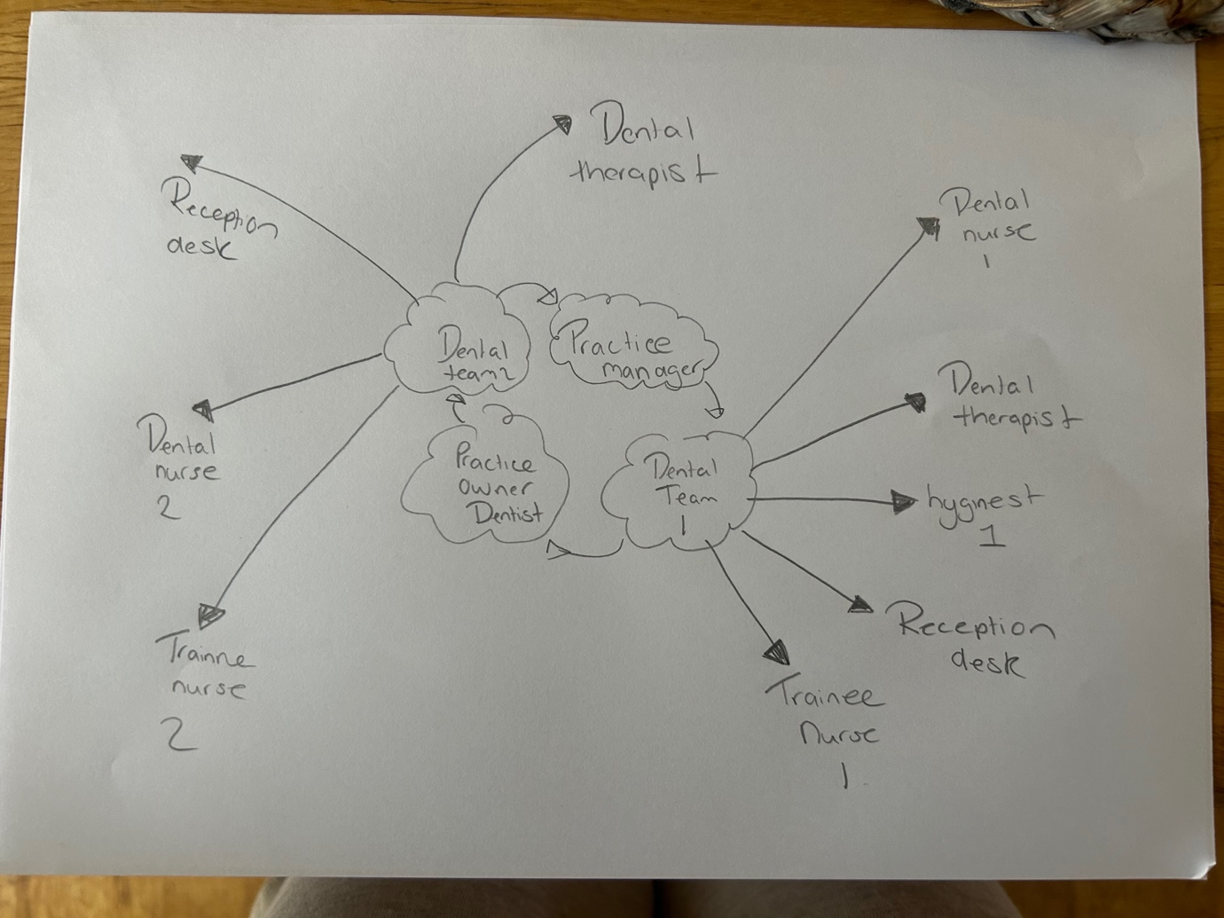

Furthermore, structures such as the functional and flat structure all have practicalities when applied to the dental organisation. The functional structure is used to group staff into their roles, which creates titles and progression in career opportunities for example a qualified nurse can have few or more titles such as lead decontamination, first aider, fire marshal, head nurse. These titles not only have benefit for the individual it also has potential benefit for the organisation as regulations would be up to date and followed allowing smooth workflow.
The flat structure is used mostly in small practices, run by individual not by a cooperate there are normally only two managers e.g. owner and practice manager. Direct communication is why the flat structure works best at small practices, allowing strong relationships to develop as everyone works closely together. Encouraging flexibility to work in other areas of the practice such as reception or leadership duties. By having a member of the team actively being involved in dual roles, will they eventually have burnout associated with this as pressure to preform and high workload would evolve. A study conducted by Knights et al. (2025) showed a sufficient percentage of the dental team suffering burnout trauma and depressive illness in regarding the dual roles played under the NHS. In conclusion, although the flat structure encourages flexibility and close collaboration, if role boundaries and workloads are not well managed, it may unintentionally raise the risk of employee burnout.

Managing Individual Expectations in Personal Development
Managing an in individual expectations in a personal development contains a mixture of clear communication and realistic goal setting with continuous support from the organisation. Building upon the importance of managing individual expectations in personal development, it is equally important to consider how performance management frameworks can strengthen and support the ongoing growth and effectiveness of trainee dental nurses within the organisation.
Performance management is a systematic process that involves every employee in helping their development by setting clear expectations and regular feedback. There are five elements involved with performance management they are planning, monitoring, developing, rating and rewarding. The framework has developed over time allowing effective performance management to be an important component in an individual development Rahmita et al. (2025) explains how the framework provides a structure for establishing precise performance standards, giving regular feedback, acknowledging accomplishments, and promoting staff growth (growth opportunities) through training and development. Within the dental team the trainee nurse would greatly benefit from this as by having clear performance standards the trainees can understand exactly what is expected of them in their roles. Elaborating on their regular feedback ensures the trainee that any areas for improvement can be identified quickly therefore allowing for more timely support and guidance. Please see appendix 1 detailed plan of performance management in a dental care setting.
Feedback, realistic goal setting using SMART will allow the cycle to continue. Not only it can be used for improvement the feedback depending on what type such as immediate feedback can help prevent a potential issue before it happens. Immediate feedback is highly valuable in dental setting as it is a continuous learning environment and not only impacts the individuals but everyone in the team including patients. Siriwatana and Pongpanich. (2025) States how patient safety is critical in a healthcare environment; how dental treatment needs customised reporting systems. Therefore, the organisation and the individual are more effectively equipped to uphold and practice high standards of care therefore achieve continuous improvement.

Mentorship training and development are essential part for the learning organisation and the individual. A mentor is a person who helps, guides, encourages and gives feedback. Adequate mentorship needs the organisational structure and leaders to support this, without the structure in place problems can occur. Hermansson et al. (2025) Findings on mentorship suggested the need for foundations to be put in place by the organisational structure first such as challenges in everyday work life routines. Mentorship in dentistry is seen to be a positive as it helps foster motivation teamwork and a positive working environment. Mentorship is increasingly recognised as a key part of dental nurse education, both pre and postqualification, as argued by Cuthbert et al (2021). It gives the opportunity for trainee to link their theoretical knowledge with on hands learning in the surgery.

Performance appraisal is a formal evaluation process conducted by the practice manager. It sets out a clear agenda by a structured meeting which both parties can prepare for. The individual will obtain a self-assessment form which is discussed in the meeting. Helping the trainees to identify their strengths, areas for improvement, and learning needs. Regular feedback from mentors, staff members and managers encourages open communication and supports confidence building. By setting SMART goals the appraisals help trainees stay focused and motivated, while also identifying training and development opportunities to co-inside with their personal career objectives and the governing body of the General Dental Council. GDC (2025) policy is that staff appraisal is implemented focusing on the individual wellbeing. Performance appraisals are shown to be a legal requirement to obtain by the organisation. However, they are sometimes shown to be negative Evans and Tourish (2025) explains how they are frequently criticised for being ineffective for both parties. Personal bias can be involved with the negative thinking due to the appraiser’s judgement or expectations. More points to consider is the lack of poor follow ups cancelled appraisals leading to distrust stress and anxiety of the individual. A balance of positive reinforcement needs to be considered along with constructive advice in order for the performance appraisal to be a success and an attribute for both individual and organisation.

Challenges and conflicts can occur in the organisation for many reasons due to bias people may have from ethics, values, emotions, perception, culture differences, skills, abilities and also conflict in management style these factors all group as personal reasons why conflict my occur. This therefore stops the progression of professional growth and performance, which is vital in a dental care seeing as you need communication and teamwork in order to provide quality care to your patients. Poor communication, misunderstandings, or differences in working styles may lead to tension among team members, which can undermine trust and collaboration the trainee nurse may retract from their job role, showing mistakes in their work. When conflict is not managed correctly, individuals may experience reduced confidence, hesitation in decision-making, and a reluctance to seek feedback or engage in further training. This not only makes it harder to learn and seek opportunities but can also affect the quality of patient care given and overall team performance. In line with the General Dental Council (GDC, 2023), maintaining effective communication and teamwork is essential to ensuring safe and professional practice. For that reason, conflict and challenges needs to be addressed promptly by, adapting the approach of a caring and supportive working environment through the aids of mentorship, open communication, and valuable feedback whether its 1-1 basis or 360 feedback is key to supporting the trainee dental nurses build confidence, strength, adaptability, and a positive willingness to learn and continue professional growth.

Critical Evaluation of Development Vehicles
When critically evaluating the development vehicles available to trainee dental nurses, it is key to assess the effectiveness, accessibility, and practical position of each method on professional growth and competence within the dental care setting.
Firstly, shadowing can allow individuals to learn by observation and gain real life experience into the dental nurse career, it can be highly effective for experiential learning type. Although negativity could develop by shadowing as it can lack structure and formal feedback also the quality of learning depending on who the mentor is and the engagement of the numerous treatments they observe. Woltenberg et al. (2019) Study showed how shadowing can develop appreciation for the professional in their job role. This therefore shows professional growth when shadowing another member of the team.

Coaching and mentorship can provide a structed guidance and ongoing support which develops into reflective practice, this can be beneficial for the trainee dental nurse as progression and confidence occurs. The organisation can help algin personal development with business goals. Setting objectives with a mentor and having a person to support the trainee will establish open communication. However, a mentor can be time consuming process the commitment that it requires the qualified nurse to do can be seen to put increasing pressure especially in a busy working environment. Outcomes of the trainee nurse can vary depending on who the mentor is.

E learning offers flexible and accessible training as based online it can be customised to the individual learning needs while meeting the organisation requirements. It is cost effective and can cover mostly all the topics the trainee dental nurse needs. It can be done in an individual own personal time, this is adaptable. Nevertheless, it may not suit everyone learning styles as it lacks the hands-on approach and then one to one interaction with a mentor and dentists in regarding feedback and encouragement. Work life balance could affect the learning progress, as if completed in personal time takes away from other opportunities an individual may want to peruse.

Formal qualifications these offer recognised, organised learning and make sure that everyone has a certain level of skill, which is useful for making sure that the organisation is doing things well. For the individual formal qualification can lead into career progression and professional recognition not only for oneself but from other team members. The main concern of a formal qualification is the time it takes and the financial occurrence it has on the organisation and the investment of that individual.

Short courses or workshops can help people learn specific skills they need, are often based on the most up to date best practices and can be personalised to fit the needs of the organisation. They may not always blend well with on-the-job requirements, though, and their brief duration may prevent deep learning or long-term behaviour modification. Although it allows continuous CPD cycle to be completed to uphold the GDC registration.
These numerous vehicles all have strengths when used in the workplace by mitigating their limitations is most effective in meeting the standards of both individual and organisational learning.

Personal Development Plan (PDP) Table
Development Objective | Action Steps | Success Criteria | Timeframe | Resources/Support | Review Method
Achieve competency in dental nursing core skills  - Examiantion  - Filling  - Root canal  - Open and dress  - Crown Prep  - Crown Fit  - XLA  - Dry socket  - Surgical extraction  - Impression mixing | Attend certified course; complete practical placements | Completion of required skills assessments | Within 12 months | Course materials, Dental nurse Levison’s book supervision, Dentist  Head Nurse  study day | Tutor feedback,  360 feedback formal assessment
Develop effective patient communication | Participate in mentorship sessions; observe experienced staff | Positive feedback from mentor and patients | 3-6 months | Mentorship, peer observation | Reflective log, mentor review
Understand health and safety procedures | Complete e-learning modules; attend staff training courses | Pass e-learning quiz; safe practice observed | 2 months | Online platform, access to workshops | Quiz results, Pass mark 80% supervisor observation
Prepare for formal qualification | Register and study for qualification exam | Exam pass | 12 months | Funding, study materials, exam leave | Exam results, progress meeting

The PDP plan serves as a planned-out roadmap to help aid the support of the trainee’s development by creating clear milestones, timelines, and measurable outcomes by applying the SMART framework. By breaking down the development into specific stages as shown in the table passing the e-learning quiz, demonstrating safe practice, and preparing for formal qualifications the plan enables both the trainee and their mentor to monitor progress in a straightforward layout.
Performance can be managed and evaluated through the use of Key Performance Indicators (KPIs), including quiz pass rates above 80%, tutor observations regarding different treatment, exam results, and progress meetings with practice manager, performance appraisals. These standards show evidence of success and help identification of areas for improvement. Regular personal development reviews such as 360 feedback or 1 to 1 will ensure that the trainee receives feedback in an orderly time frame, allowing them to reflect on their progress and adjust their approach when necessary. These reviews also give the individual an opportunity to celebrate their wins in their professional development and set new goals, allowing ongoing motivation and engagement.
The PDP shows potential problems occurring if the time scale is not met, the PDP develops contingency strategies for example access to additional tutoring for areas where the trainee may struggle, as well as wellbeing support to help manage stress or conflict in the dental environment, maintain a healthy work-life balance. Should the trainee experience difficulties in meeting the required standards, targeted actions like extra courses via E learning or tailored study plans concentrating on specific areas can be implemented. Furthermore, open communication challenges between the trainee and mentor will ensure that the areas of breakdown in communication are identified early, allowing for proactive problem-solving and support.
Altogether, this structured approach not only assists the trainee’s development but also promotes an environment of continuous improvement within the organisation. By combining the individual development to organisational objectives, the plan contributes to strengthened performance, job satisfaction, and retention, reinforcing the value of investing in staff development. Learning organisation is a fundamental element in any business and is an attribute to the business growth and success.

Conclusion
To conclude this report shows the importance of how a well-structured PDP helps guides the trainee progression within the dental environment; by using each stage of personal development the trainee shows ownership of their own learning. How investing in the learning organisation and using vehicles helps benefit not only the individual but the organisation too. Through the report it shows a clear pattern of how quality care is most important in the learning organisation the success on this depends on the whole dental team. How every vehicle identifies areas of positivity as well as negativity. Showing how the negative aspect of the vehicles can be overcome with clear communication, and collaborative working culture.

The mentorship is shown to thrive for a trainee as having that supportive learning along with continuous feedback allows the trainee to progress in their qualification.
Additionally, it is extremely important to recognise that the advantage of a PDP relies not only on its layout but also on constant engagement from both trainees and mentors involved with the organisation. The dental team can make the workplace a success by using reflective practice and open communication, the employees and employer can strengthen a workplace where continuous learning and adaptability are valued. In the future the organisation can use combined regular feedback and PDPs to meet the ever-changing world of dentistry this will further increase both individual growth and the overall quality of patient care given within the practice. This preventive approach ensures that both staff and the organisation remain resilient and responsive to the changing landscape of dental healthcare.

Reference List

91. https://www.tandfonline.com/doi/abs/10.1080/13561820.2019.1687430 OpenAI. (2025). Performance management in a dental practice [AI-generated diagram]. ChatGPT (GPT-5). https://chat.openai.com/

Akpan, B. (2025). Systems Thinking—Ludwig Von Bertalanffy, Peter Senge, Donella Meadows. In B. Akpan & T. J. Kennedy (Eds.), Science Education in Theory and Practice (Springer Texts in Education). Springer, Cham https://link.springer.com/chapter/10.1007/978-3-031-81351-1_24#citeas

AlKatheri, N., Niven, V., Sayers, M., & et al. (2025). A survey to explore the motivation, scope of practice, job satisfaction and timings of procedures undertaken by dental nurses with additional duties at one NHS trust. British Dental Journal. https://doi.org/10.1038/s41415-024-8272-0

Alreshidi, A. J., Alqarni, M. A. A., Alorayfej, I., Mobarki, N. A., Albaqami, M. S., Alenazi, F. H. E., ... & Alanazi, S. Z. (2025). Collaborative clinical practice across healthcare specialties: Insights from dental, nursing, laboratory, and medical records teams in Security Forces facilities. Gland Surgery, 10(1), 58–72. https://www.glandsurgery.net/index.php/GS/article/view/167

Anderson, R., Witton, R., & McColl, E. (2025). Clinical governance in primary care. In E. McColl & A. Alani (Eds.), Practical tips in clinical dentistry. BDJ Clinician’s Guides. Springer, Cham. https://link.springer.com/chapter/10.1007/978-3-031-90355-7_45#citeas

Cuthbert, J. C., Radford, D., & Louca, C. (2021). Should mentoring become routine practice in dental nurse education, pre and post registration? BDJ Team, 8, 10–11. https://doi.org/10.1038/s41407-021-0705-
x
Foley, T., & Horwitz, L. I. (2025). Learning health systems. Cambridge University Press. https://www.cambridge.org/core/elements/learning-health-systems/2FFC2BE5441728E3CD866643DB543242

GDC (2025) 7.3 You must update and develop your professional knowledge and skills throughout your working life. https://standards.gdc-uk.org/pages/principle7/principle7
GDC (2025) Standards for education pg. 8 https://www.gdc-uk.org/docs/default-source/about-us/gdc-standards-for-education-september-2025.pdf?sfvrsn=ecc2702b_1

Hermansson, S. K., Hilli, Y., Solbakken, R., Norström, F., & Bölenius, K. (2025). The need for organisational structure and leadership support: A qualitative study on nurse mentors' perspectives on the prerequisites for effective mentoring. https://doi.org/10.1111/jan.16948

Knights, J., Young, L., Humphris, G., Newton, T., & UK Dental Team Mental Health Research and Implementation Group. (2025). Burnout and depression in the UK dental workforce: Findings from a cross-sectional survey. British Dental Journal, 239, 189–196. https://www.nature.com/articles/s41415-025-8605-7

Olatoye, F. O., Elufioye, O. A., Okoye, C. C., & others. (2024). Leadership styles and their impact on healthcare management. Journal of Science. https://pdfs.semanticscholar.org/a2ae/87ee0b4292a1d5f2e6267ff040850b928d7d.pdf

OpenAI. (2025). Performance management in a dental practice [AI-generated diagram]. ChatGPT (GPT-5). https://chat.openai.com/

Rahmita, S., Fahmy, R., & Syahrul, L. (2025). The building blocks of an effective performance management system: A comprehensive review. Journal of Management and Digital Business, 5(1), 13–34. https://journal.nurscienceinstitute.id/index.php/jmdb/article/view/1512

Radević, I., Dimovski, V., Lojpur, A., & Colnar, S. (2021). Quality of Healthcare Services in Focus: The Role of Knowledge Transfer, Hierarchical Organizational Structure and Trust. Knowledge Management Research & Practice, 21(3), 525–536. https://doi.org/10.1080/14778238.2021.1932623

Siriwatana, K., & Pongpanich, S. (2025). Developing and evaluating a dental incident reporting system: A user-centred approach to risk management. BMC Oral Health, 25, 339. https://link.springer.com/article/10.1186/s12903-025-05729-5

Westgarth, D. (2025). What we're noticing is clinicians want a varied career – they don't want to be on the treadmill of being in the same practice, treating patients’ day after day. BDJ In Practice, 38, 250–251. https://doi.org/10.1038/s41404-025-3210-7

Williams, M., Cook, N., & Krysmann, M. (2025). Do dental nurses and trainee dental nurses suffer from job-related stress, and could mentorship help them to cope with that stress? British Dental Journal. https://doi.org/10.1038/s41415-024-8229-3

Woltenberg, L. N., Ballard, J. A., Gnonhossou, D. A., Norton, J. C., Burkhart, P. V., & Kuperstein, J. (2019). Interprofessional identity development within a brief shadowing experience: An exploratory case study. Journal of Interprofessional Care, 39(5), 782–7

Appendices 1
Figure 1. Performance Management in a Dental Practice.
Created by the author using ChatGPT (2025).

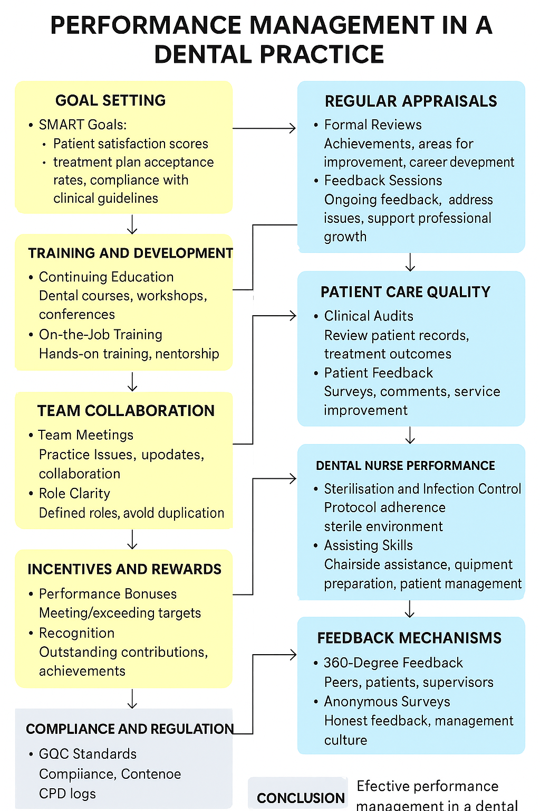

Bibliography

91. https://www.tandfonline.com/doi/abs/10.1080/13561820.2019.1687430 OpenAI. (2025). Performance management in a dental practice [AI-generated diagram]. ChatGPT (GPT-5). https://chat.openai.com/

Akpan, B. (2025). Systems Thinking—Ludwig Von Bertalanffy, Peter Senge, Donella Meadows. In B. Akpan & T. J. Kennedy (Eds.), Science Education in Theory and Practice (Springer Texts in Education). Springer, Cham https://link.springer.com/chapter/10.1007/978-3-031-81351-1_24#citeas

AlKatheri, N., Niven, V., Sayers, M., & et al. (2025). A survey to explore the motivation, scope of practice, job satisfaction and timings of procedures undertaken by dental nurses with additional duties at one NHS trust. British Dental Journal. https://doi.org/10.1038/s41415-024-8272-0

Alreshidi, A. J., Alqarni, M. A. A., Alorayfej, I., Mobarki, N. A., Albaqami, M. S., Alenazi, F. H. E., ... & Alanazi, S. Z. (2025). Collaborative clinical practice across healthcare specialties: Insights from dental, nursing, laboratory, and medical records teams in Security Forces facilities. Gland Surgery, 10(1), 58–72. https://www.glandsurgery.net/index.php/GS/article/view/167

Anderson, R., Witton, R., & McColl, E. (2025). Clinical governance in primary care. In E. McColl & A. Alani (Eds.), Practical tips in clinical dentistry. BDJ Clinician’s Guides. Springer, Cham. https://link.springer.com/chapter/10.1007/978-3-031-90355-7_45#citeas

Cuthbert, J. C., Radford, D., & Louca, C. (2021). Should mentoring become routine practice in dental nurse education, pre and post registration? BDJ Team, 8, 10–11. https://doi.org/10.1038/s41407-021-0705-
x
Foley, T., & Horwitz, L. I. (2025). Learning health systems. Cambridge University Press. https://www.cambridge.org/core/elements/learning-health-systems/2FFC2BE5441728E3CD866643DB543242

GDC (2025) 7.3 You must update and develop your professional knowledge and skills throughout your working life. https://standards.gdc-uk.org/pages/principle7/principle7
GDC (2025) Standards for education pg. 8 https://www.gdc-uk.org/docs/default-source/about-us/gdc-standards-for-education-september-2025.pdf?sfvrsn=ecc2702b_1

Hermansson, S. K., Hilli, Y., Solbakken, R., Norström, F., & Bölenius, K. (2025). The need for organisational structure and leadership support: A qualitative study on nurse mentors' perspectives on the prerequisites for effective mentoring. https://doi.org/10.1111/jan.16948

Knights, J., Young, L., Humphris, G., Newton, T., & UK Dental Team Mental Health Research and Implementation Group. (2025). Burnout and depression in the UK dental workforce: Findings from a cross-sectional survey. British Dental Journal, 239, 189–196. https://www.nature.com/articles/s41415-025-8605-7

Olatoye, F. O., Elufioye, O. A., Okoye, C. C., & others. (2024). Leadership styles and their impact on healthcare management. Journal of Science. https://pdfs.semanticscholar.org/a2ae/87ee0b4292a1d5f2e6267ff040850b928d7d.pdf

OpenAI. (2025). Performance management in a dental practice [AI-generated diagram]. ChatGPT (GPT-5). https://chat.openai.com/

Rahmita, S., Fahmy, R., & Syahrul, L. (2025). The building blocks of an effective performance management system: A comprehensive review. Journal of Management and Digital Business, 5(1), 13–34. https://journal.nurscienceinstitute.id/index.php/jmdb/article/view/1512

Radević, I., Dimovski, V., Lojpur, A., & Colnar, S. (2021). Quality of Healthcare Services in Focus: The Role of Knowledge Transfer, Hierarchical Organizational Structure and Trust. Knowledge Management Research & Practice, 21(3), 525–536. https://doi.org/10.1080/14778238.2021.1932623

Siriwatana, K., & Pongpanich, S. (2025). Developing and evaluating a dental incident reporting system: A user-centred approach to risk management. BMC Oral Health, 25, 339. https://link.springer.com/article/10.1186/s12903-025-05729-5

Westgarth, D. (2025). What we're noticing is clinicians want a varied career – they don't want to be on the treadmill of being in the same practice, treating patients’ day after day. BDJ In Practice, 38, 250–251. https://doi.org/10.1038/s41404-025-3210-7

Williams, M., Cook, N., & Krysmann, M. (2025). Do dental nurses and trainee dental nurses suffer from job-related stress, and could mentorship help them to cope with that stress? British Dental Journal. https://doi.org/10.1038/s41415-024-8229-3

Woltenberg, L. N., Ballard, J. A., Gnonhossou, D. A., Norton, J. C., Burkhart, P. V., & Kuperstein, J. (2019). Interprofessional identity development within a brief shadowing experience: An exploratory case study. Journal of Interprofessional Care, 39(5), 782–7

