Scott Burgess - 1350316
University of Wales Trinity Saint David
Introduction to web and database concepts
Assignment 2: Design and Implementation of a Relational Database System

Contents
1. Introduction 2
2. Scenario 2
3. Database Design 2
3.1 Entity Identification 2
3.2 Entity Relationship Diagram (ERD) 3
3.3 Normalisation 4
4. Database Implementation 5
4.1 Tables 5
4.2 Relationships 6
4.3 Validation Rules and Lookup Fields 7
4.4 Sample Data 9
5. Queries, Forms and Reports 10
5.1 Queries 10
5.2 Forms 12
5.3 Reports 13
6. Evaluation 14
7. References 16

Introduction
This report discusses a project which involved designing and implementing a relational database for the Eco_Ride electric bike rental scheme using Microsoft Access. The project began by analysing the scenario to identify the main entities, attributes and relationships required for the database. An Entity Relationship Diagram (ERD) was then created before developing the database structure and implementing the required tables, relationships and validation rules.
The database was populated with sample data and tested using a range of queries, forms and reports to demonstrate its functionality. It explains each stage of the project, from the initial design through to the completed database, before evaluating the final solution.

Scenario
At Eco_Ride, the current system relies on paper records and spreadsheets, making it difficult to manage customer details, bike availability, bookings and servicing efficiently.
To improve this, a database was developed in Microsoft Access to store and manage information on customers, bikes, stations, bookings, payments, servicing and staff. Relationships, validation rules and lookup fields were implemented to improve data accuracy and maintain data integrity.
The completed database also includes forms, queries and reports to help staff manage day-to-day operations and retrieve information quickly.

Database Design

3.1 Entity Identification
The first step was to identify the information that Eco_Ride needs to store in order to manage the bike rental service. From the scenario, seven main entities were identified: Customers, Bikes, Stations, Bookings, Payments, Servicing and Staff.
Each entity has a specific purpose within the database. The Customers table stores customer information, which will be required to make bookings. Customer information that will be taken will include first name, last name, date of birth, email and phone number.
The Bikes table records details about each bike, including its status, mileage, servicing dates and station location. This helps staff to quickly identify which bikes are available or rented, which bikes are due for servicing and where each bike is currently located.
The Bookings table records every bike rental transaction, which also links customers to the bikes they rent and records pickup and return information. This enables Eco_Ride to keep a record of which customers rented each bike, along with the collection and return locations and dates.
The Payments table stores payment details for each booking, where it will highlight which booking the payment correlates to, the amount of the payment, along with how and when the payment was made.
The Servicing table records maintenance carried out on bikes, including the service date, repair status and the staff member responsible. This helps ensure bikes are maintained regularly and provides a history of work carried out.
The Stations table stores information about each bike collection and return location. It allows bikes to be assigned to a station and helps track where bikes are currently located.
The Staff table stores employee details and links staff members to servicing records. This makes it possible to identify who carried out each service or repair.
The entities are linked using primary and foreign keys to create relationships between the tables. This reduces duplicate data and helps maintain data integrity throughout the database.

3.2 Entity Relationship Diagram (ERD)
Entity Relationship Diagrams (ERDs) are used during the database design stage to identify the entities within a system and the relationships between them. Creating an accurate ERD is important, as it provides the foundation for the structure and functionality of the final database [1].
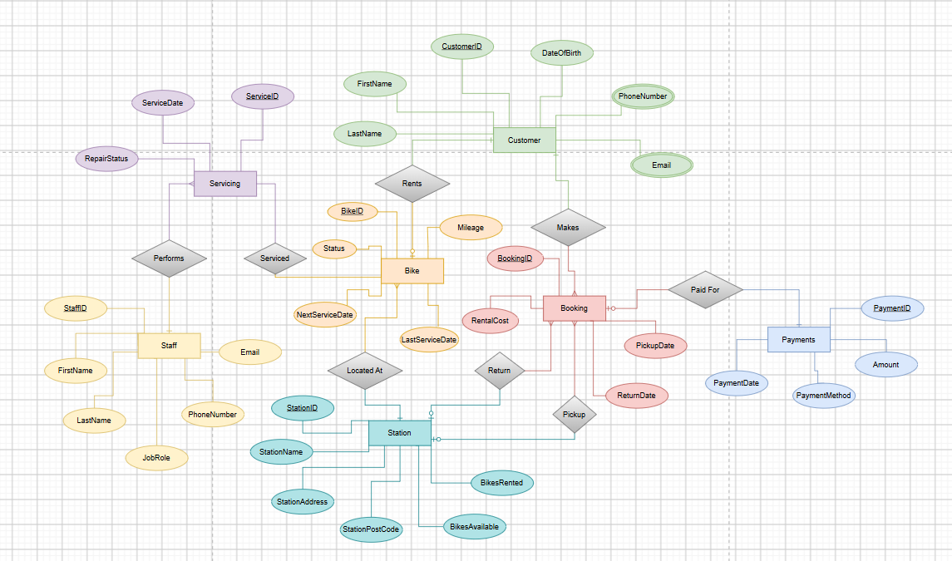
Figure 1 - Entity Relationship Diagram (ERD) for the EcoRide database.

Figure 1 illustrates the Entity Relationship Diagram (ERD) developed for the Eco_Ride database. The diagram, created using the draw.io application, identifies the seven main entities required to support the bike rental system: Customers, Bikes, Bookings, Payments, Stations, Servicing and Staff.
Relationships between these entities were established using primary and foreign keys, allowing the tables to be linked efficiently. One-to-many relationships were used where appropriate, such as between Customers and Bookings, and between Bikes and Servicing, while a one-to-one relationship was used between Bookings and Payments.

3.3 Normalisation
Normalisation is the process of organising data within a database to reduce duplication and improve consistency. Applying Third Normal Form (3NF) helps ensure that data is stored efficiently, reducing the risk of errors and improving the overall integrity of the database [2].
The database was designed to meet Third Normal Form (3NF). Each table stores information about a single entity, reducing duplicate data and ensuring attributes depend on the primary key. Separating information into related tables also improves data consistency and makes the database easier to maintain.

Database Implementation

4.1 Tables
Following the database design stage, the database was implemented in Microsoft Access. Seven tables were created based on the entities identified in the ERD, with each table representing a specific part of the Eco_Ride rental system. Appropriate field names, data types and primary keys were assigned to ensure data could be stored accurately and consistently.
Each table was assigned an AutoNumber primary key to uniquely identify every record. Appropriate data types were selected for each field depending on the information being stored. For example, customer names and email addresses were stored as Short Text fields, dates such as booking and service dates used the Date/Time data type, while rental costs and payment amounts were stored using the Currency data type.
The Bikes table stores information about each bike, including its status, mileage and servicing dates.
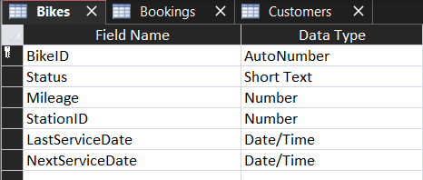
Figure 2 - Bikes table (Design View)
The Bookings table links customers and bikes together while recording the dates and cost of each rental.
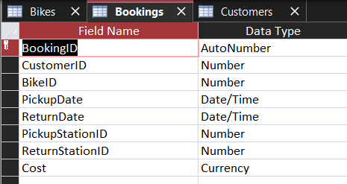
Figure 3 – Bookings table (Design View)
The Customers table stores personal information required to identify customers and create bookings.
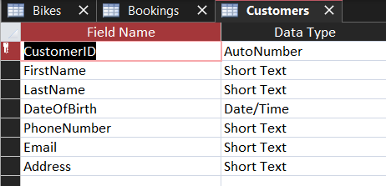
Figure 4– Customers table (Design View)
Figures 2–4 show examples of the table structures created in Microsoft Access. The remaining tables were implemented using the same design principles, ensuring the database structure accurately reflected the Entity Relationship Diagram developed during the design stage.

4.2 Relationships

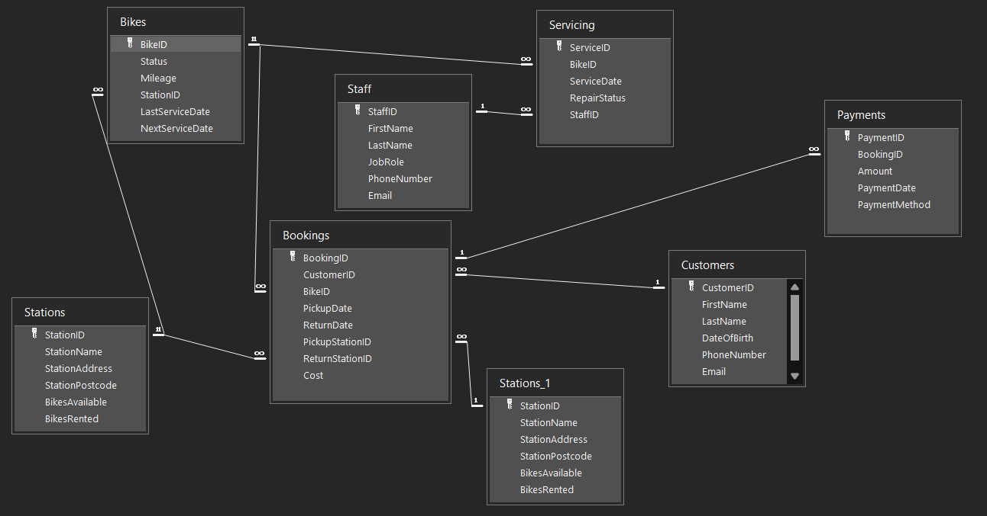
Figure 5– Relationships window showing table relationships
After the tables had been created, relationships were established using primary and foreign keys to link related information throughout the database. These relationships were based on the Entity Relationship Diagram (ERD) created during the design stage and ensured that data could be shared between tables without unnecessary duplication. Figure 5 shows the completed relationships within the Microsoft Access database.
One-to-many relationships were implemented where appropriate, including between Customers and Bookings, Bikes and Bookings, Stations and Bikes, Bikes and Servicing, and Staff and Servicing. A one-to-one relationship was also created between the Bookings and Payments tables to link each payment to its corresponding booking.

4.3 Validation Rules and Lookup Fields
Validation rules are used to help ensure that accurate data is entered into a database. They restrict the values that can be entered into a field based on predefined criteria, helping to reduce errors and maintain data consistency. If a validation rule is broken, Microsoft Access displays an error message to prevent invalid data from being saved [3].
Validation rules were used throughout the database to help ensure that accurate data was entered into each table. By restricting the values that users can enter, the risk of incorrect or invalid data being stored is reduced.
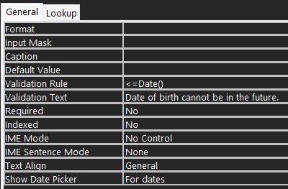
Figure 6 - Date of birth validation rule in Microsoft Access
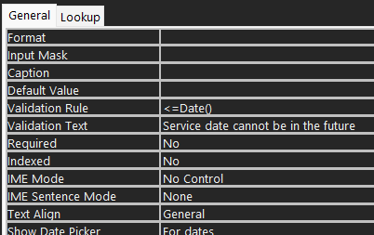
Figure 7 - Service date validation rule in Microsoft Access
Validation rules were applied to several fields within the database. For example, the Rental Cost and Mileage fields only accept values greater than or equal to zero, preventing negative values from being entered. The Date of Birth field also prevents users from entering a future date. Figures 6 and 7 show examples of some validation rules created in Microsoft Access.
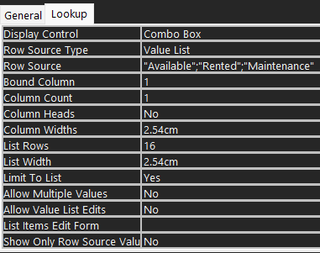
Figure 8 - Bike Status lookup field in Microsoft Access
Lookup fields were also used throughout the database to simplify data entry and improve consistency. Instead of manually typing information, users can select values from a predefined drop-down list. This helps to reduce input errors and ensures that data is entered in a consistent format. Figure 8 shows an example of this for the “Status” field within the “Bikes” table, ensuring the user can only select between available, rented or maintenance.
To confirm that the validation rules worked correctly, a number of test entries were made using invalid values. Microsoft Access prevented these records from being saved and displayed an appropriate validation message. Figures 9 and 10 show examples of the validation rules being applied.
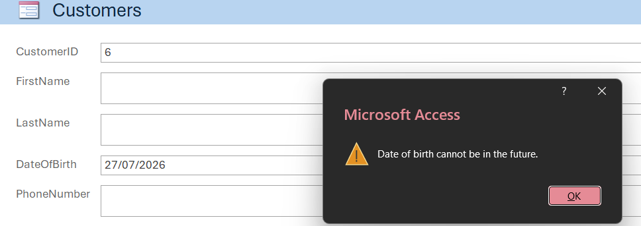
Figure 9 - Validation test for date of birth
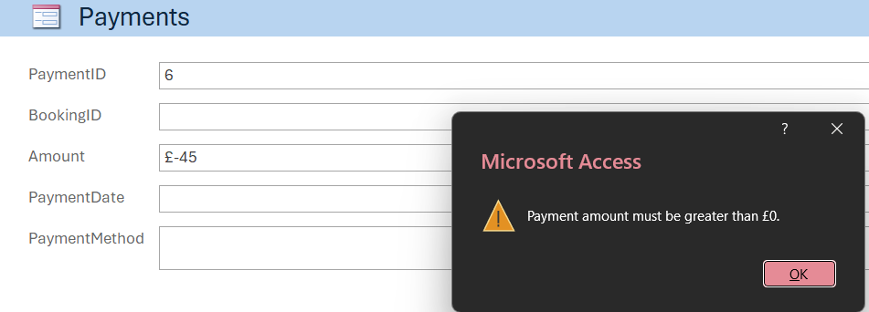
Figure 10 - Validation test for negative payment amount

4.4 Sample Data
Sample data was entered into each table to test that the database functioned correctly. Records were created for customers, bikes, bookings, payments, stations, servicing and staff to represent how the Eco_Ride rental system would be used in practice.
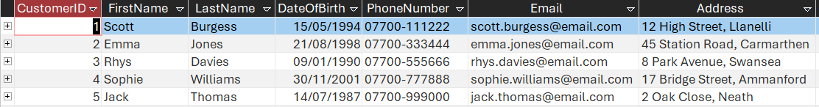
Figure 11 - Sample data in the Customers table
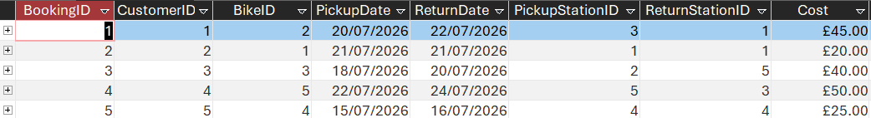
Figure 12 - Sample data in the Bookings table
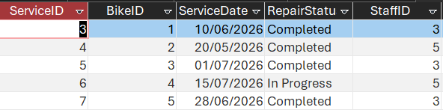
Figure 13 - Sample data in the Servicing table
Adding sample data also made it possible to test the relationships, queries, forms and reports, helping to identify and correct any issues before the database was completed. Figures 11–13 show examples of the sample data entered into the database.

Queries, Forms and Reports

5.1 Queries
Queries were created to retrieve and display specific information from the database. They make it easier to search, filter and organise data, allowing users to quickly access the information they need.
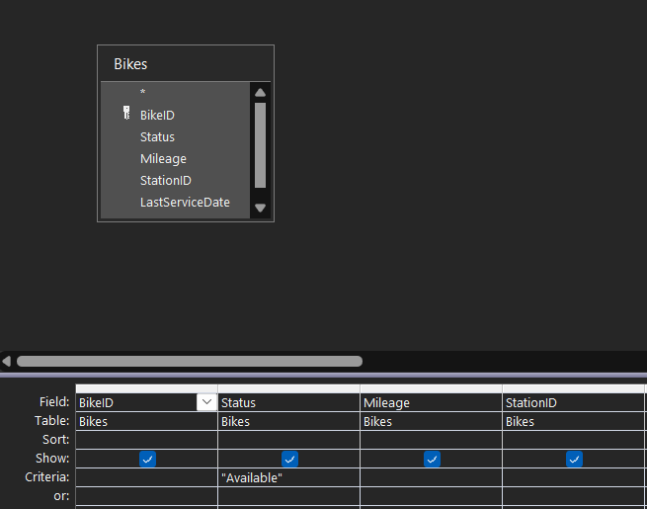
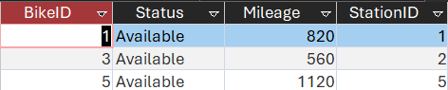
Figure 14 - Bikes Available query

Figure 14 shows an example of a query created in Microsoft Access, whereby the user can search for and display which bikes are currently available to be rented. The result of the query shows the BikeID, its availability, mileage and the station ID of where they are each located.

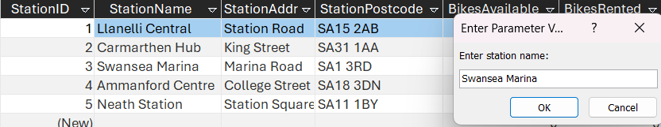
Figure 15 - Search bikes per station query
Figure 15 gives an example of where the user can search for which bikes are currently allocated to which station. In the example, the user can enter the station name, which will display the corresponding bike ID, along with its status and mileage.

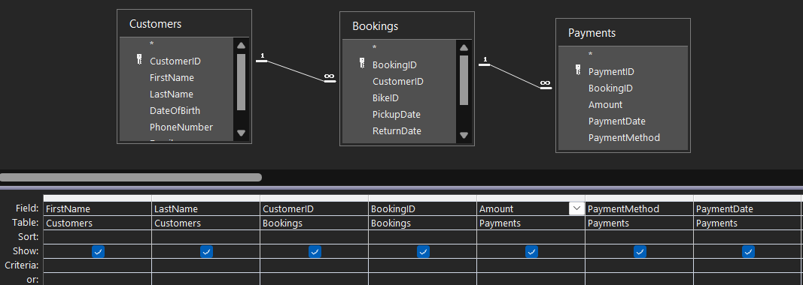
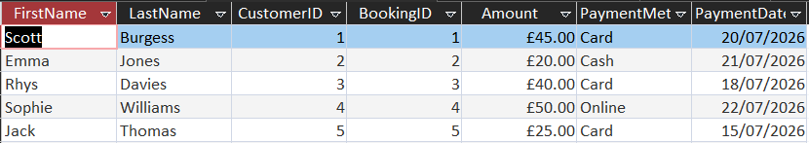
Figure 16 - Customer payments query
Figure 16 displays a query combining 3 of the tables from the database, which are Customers, Bookings and Payments. The first name, last name and customerID attributes are selected from the Customers table, the BookingsID attribute from the Bookings table, and the payment amount, payment method and payment date attributes from the Payments table. This allows the user to see which customers are related to which bookings, along with how much they have paid, how they made the payment and when they made the payment.

5.2 Forms
Forms were created to provide an easy way of entering, viewing and updating data within the database. They present information in a clear and organised layout, allowing users to access records without interacting directly with the tables.
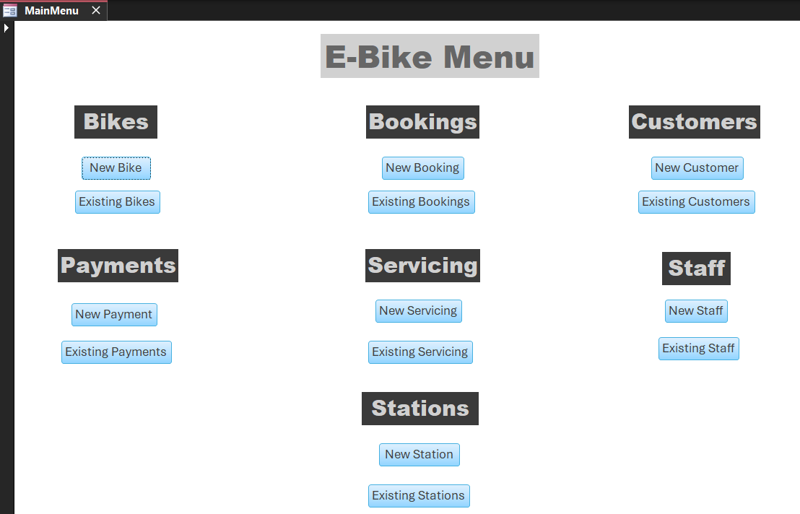
Figure 17 - Main Menu form
Figure 17 shows the main menu form, which was created to allow users to navigate the database quickly by providing buttons to create new records and view existing records within their corresponding tables.
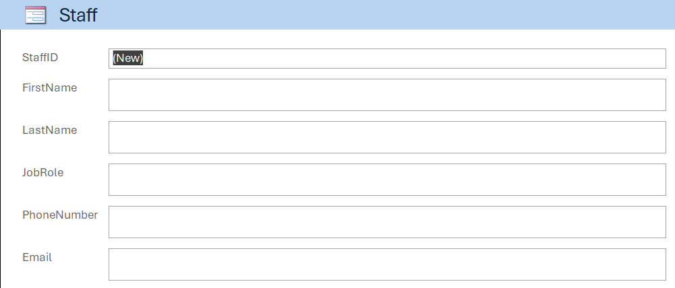
Figure 18 - New staff form
As an example of how the Main Menu form works, upon clicking the “New Staff” button, the user will be taken to a blank Staff form where they will be able to enter the relevant details for the new staff member. This is shown in figure 18 above.

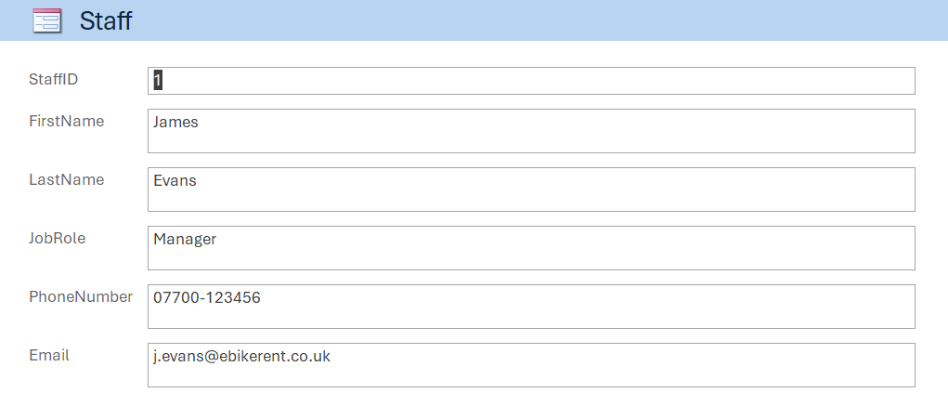
Figure 19 - Existing staff form
If the user were to click the “Existing Staff” button, they will be taken to page one of the Staff form which will display the existing data held for current staff members. The user can click through to view each existing staff member’s details and edit specific data where required. This is shown in figure 19 above.

5.3 Reports

Reports were created to present information from the database in a clear and organised format. They make it easier to view and print data, allowing users to review records and produce summaries.
Figure 20 below shows an example of a report created in Microsoft Access which displays customer booking information including the customer’s name, booking ID, pick up and return date of the bikes, along with the cost of the bookings and a total of all bookings.
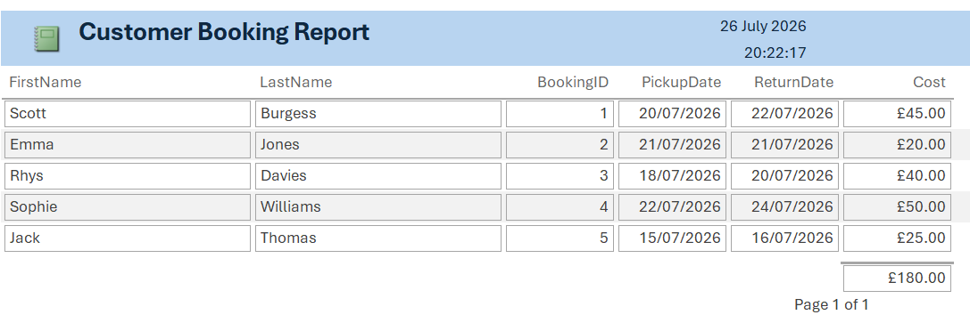
Figure 20 - Customer Booking Report
Figure 21 below shows a report of any bikes which are currently in for repairs. The report displays the bike ID, service date, repair status and the staff ID of who is responsible for the repairs.
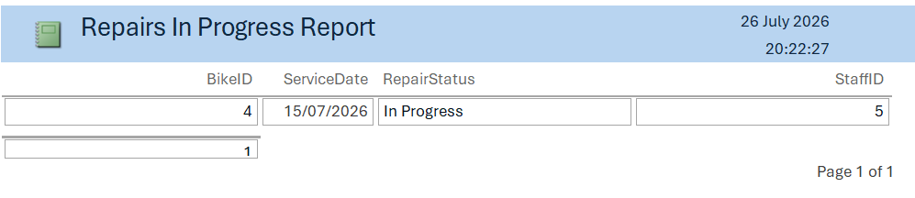
Figure 21 - Repairs in Progress Report

Evaluation
The completed database meets the requirements of the Eco_Ride rental system by providing an organised way of storing and managing information relating to customers, bikes, bookings, payments, stations, servicing and staff. The use of tables, relationships, validation rules, lookup fields, queries, forms and reports has resulted in a functional database that is easy to use and maintain.
One of the main strengths of the database is its relational structure, which helps to reduce duplicate data and improve consistency. Validation rules and lookup fields also help to minimise data entry errors, while forms provide a user-friendly interface for managing records. Queries and reports allow users to retrieve and present information quickly, improving the overall efficiency of the system.
Although the database meets the basic requirements, there are opportunities for further development. For example, additional queries and reports could be created to provide more detailed information, while features such as customer memberships, online bookings or automated maintenance reminders could be added to improve the functionality of the system.
Overall, there has been a demonstration of the successful design and implementation of a relational database in Microsoft Access. The finished database provides a practical solution for managing the day-to-day operations of the fictional Eco_Ride bike rental scheme while allowing for future expansion if required.

References
References
[1] C. R. Jaimez-González and J. Martínez-Samora, "DiagrammER: A Web Application to Support the Teaching-Learning Process of Database Courses Through the Creation of E-R Diagrams," vol. 15, no. 19, pp.4–21, October 5 2020, doi: 10.3991/ijet.v15i19.14745.
[2] D. Mendoza and N. Piedra, "TutNorBD: Assistant for teaching and learning process of relational database normalization up to 3NF from a universal table", inpp. 1–8. doi: 10.1109/LACLO50806.2020.9381184.
[3] A. Watkins and S. Kavanagh, "Keep your data clean-use validation rules to ensure accurate data entry," vol. 12, no. 5, pp.10, 2004,

