

Programme: BA Business Management
Module: Strategic Management and Sustainability
Module code: LCBB6004
Module Coordinator: Dr Jayalakshmi Gopalkrishnan
Assignment Title: Coursework: Written Report
Level 6 / group 1
Student Name: Valentina Ivanova
Student ID: 2023164

Table of Contents
Introduction 3
Business strategies of the company over the last five years 4
Resources and capabilities of VW supporting its strategy 6
Efforts to increase competitiveness, embedding sustainability in decision-making 9
Recommendations for future improvement 12
Conclusion 13
References 14
Appendix 16
SWOT 16
Porter’s five forces 17

Introduction
Volkswagen is one of the global leaders in car manufacturing and has a long history in this industry. This, however, did not save the company from facing full-scale consequences from the so called “Dieselgate” scandal which erupted back in 2015. At the time, the US Environmental Protection Agency charged the company for installing a specific software in its diesel vehicles that allowed them to cheat on tests and manipulate emissions results (Kell, 2022). It has been revealed that the real levels generated by Volkswagen cars have been 40 times higher than the allowed limit by law (Kell, 2022).
The scandal has had severe consequences for the company, including severe losses made from paying court settlements – approximately £193 million only during the year of the scandal – significant drop in customer base and trust, as well as many diverse problems with different stakeholders, ranging from investors to environmental organisations and regulators (BBC, 2022). Since the scandal occurred, the company already paid more than £30 billion in settlements with clients, who have been affected, as well as other parties which were suing the company (BBC, 2022). However, it can be assumed that Volkswagen learned its lesson. As discussed by Kell (2022), it has transformed from emission cheater to climate leader. The company transformed entirely its business model and strategy, emphasising on sustainability and protecting the environment and using these as main sources of competitive advantage. This shift in corporate behaviour addresses the newly evolving needs of customers and other stakeholder groups and is the main driver of Volkswagen’s reviving success during the last years.
This report aims to investigate these areas in greater depth, focusing on the new strategic management approaches of the company, the resources and capabilities supporting them, the ways through which it aims to increase competitiveness embedding sustainability in decision-making and many more. Recommendations for future improvement are also provided as an outcome of the analysis.

Business strategies of the company over the last five years
Corporate strategies reflect the tools and approaches used by business organisations to achieve their ultimate short- and long-term goals (Whittington et al., 2020). Corporate strategies have a direct impact on company performance and potential for future growth and development, which is why they have to be accurately defined. Strategic choice, as discussed by Barney (2019), is the based on detailed data insight and analytics. In order for managers to decide on the specific direction of the business, they first have to conduct analysis of the internal and external environment in which the entity operates. Two of the most commonly applied tools for this purpose, which are also illustrated in the appendix section, are SWOT analysis and Porter’s five forces. When the main strategic choice is made and decided on, strategies need to be implemented and thus, a competitive advantage over rivals is created (Lynch, 2018).
In general, according to academic theory, there are two main foundational sources of competitive advantage, illustrated by Porter’s generic strategies – cost leadership or differentiation (Tanwar,2013). The company can choose either of the two. In case the entity is operating in a niche market (narrow market scope), it is said to apply a segmentation strategy. As Volkswagen is targeting a broad market, this is not applicable in this case. Volkswagen has always built its competitive advantage on the basis of differentiation of products and services offered. Before the scandal, the brand was claiming that it produces some of the most innovative diesel engines in the industry that have some of the lowest emissions generated. After the scandal, however, the trust in the company’s statements and claims has been significantly dropped, which required it to take a large shift in strategic course.

Figure 1 – Porter's generic strategies model
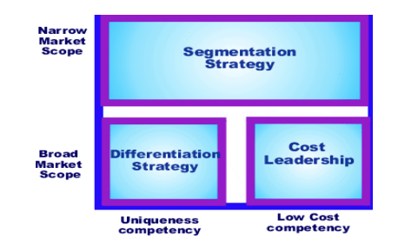
Source: Tanwar (2013)
The company has created a brand-new strategy that aims to both recover trust and image, as well as convince all stakeholders that Volkswagen is taking responsibility for its actions and puts efforts to make things right. The strategy is called ‘Transform 2025+’. It is based on realigning the product portfolio of the company with a clear focus and emphasis placed on e-vehicles (Volkswagen, 2023a). The strategy prioritises the shift towards zero-emission operation and aims to build a brand image of a company which is heavily concerned with climate change and the impact of the industry on environment (Volkswagen, 2023a). One of the goals of the entity is to increase the share of e-cars in Europe to comprising 70% of Volkswagen’s sales in Europe and 50% of sales in US and Chine by 2030 (Volkswagen, 2023a). Many critics believe that this is a strategy which only focuses on recovering the reputation of the company. However, the strategy of the brand shows that it has dedicated significant resources into innovation not only in terms of vehicle range, but also supporting digitalisation in the form of electrification, automation and digital products/services (Volkswagen, 2023a).
All this shows that the brand is using strategic management and sustainability not only to survive after the emissions scandal, but also as a foundation for a completely new business model. Considering its experience on the market, capabilities and the current industry trends, it can be assumed that it would turn out to be a successful choice.

Resources and capabilities of VW supporting its strategy
As already mentioned, strategic choice and development are based on assessing both internal and external environment. To be effective and successful, business strategies need to reflect organisational capabilities and resources, so that they are properly implemented. Resources represent all tangible and intangible possessions of a company that can be used for implementing its strategies or support its activities and operations (Barney, 2019). They are generally divided into financial, human and physical resources (Barney, 2019).
All of these can be investigated by referring to the company’s annual report and financial statements, as well as the information for labour provided. Information about corporate resources is provided on the extract of Volkswagen’s annual report shown below.

Figure 2 - Annual report extract
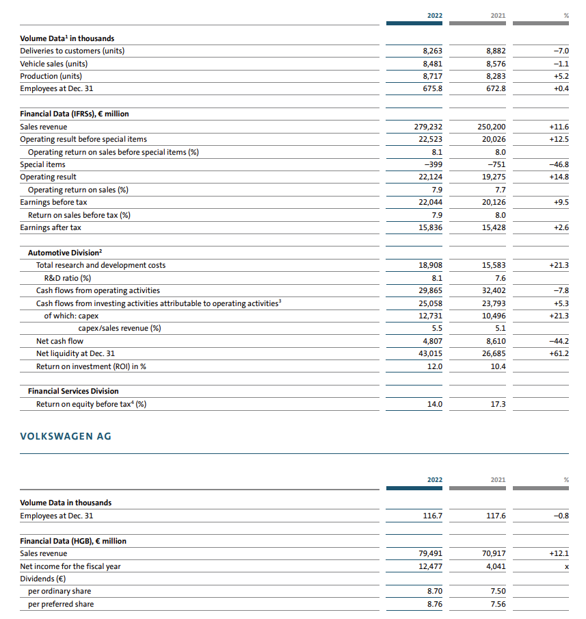
Source: Volkswagen (2023b)
As evident by the extract, the company’s sales revenue increased by 11.6% in 2022 compared to 2021, suggesting that there has been a larger financial inflow in the company, allowing the brand to implement its strategic plans (Volkswagen, 2023b). Earnings after tax also increased (by 2.6%) during the last year, suggesting that the strategy implemented by the company already starts improving its performance (Volkswagen, 2023b). Net income has also increased significantly in 2022. The company also has considerable human resources – more than 117,000 professionals with skills and experience who play a key role in being innovative and generating value for the organisation (Volkswagen, 2023b). All this suggests that the company has sufficient financial resources to back up strategic plans and actions.
When employees are considered, a more in-depth analysis should be conducted. As shown in the beginning of the extract, employees have increased in number in 2022, when they were 0.4% more than in 2021 (Volkswagen, 2023b). However, the notes of financial statements state that this figure include Chinese joint ventures. When these are isolated, it can be seen that the number of employees has decreased by 0.8%. Initially, this leads to the assumption that the resources and capabilities of the company have deteriorated. However, it may also be the case that, since the company invests heavily in digitalisation and automation of processes – a development leading to a reduced need for humans, while maintaining operational efficiency and capacity. This suggestion can be further supported by the fact that, in 2022, the score of employee satisfaction in Volkswagen has reached 82.4 which is higher than what has been recorded in 2021 (Volkswagen, 2023c). This leads to the assumption that labour turnover would be lower, and employees are motivated to work for the company, further suggesting that the commitment to digitalisation may be a valid reason for the decrease of labour.
In terms of tangible and intangible assets, the company can also be claimed to have sufficient resources in this regard too. Intangible assets increased in value 7.2% in 2022 compared to previous year (Volkswagen, 2023b). Property, plant and equipment, as well as lease assets also slightly increased in 2022. Current assets also increased, by approximately 12% (Volkswagen, 2023b).
Considering all this, it can be assumed that the company has required resources to implement desired strategies. It also has significant capabilities which further support their ambitious strategic goals. For example, the company is using a mechatronics platform which serves as its backbone for innovations and technological development (Volkswagen, 2023b). This, combined with Volkswagen’s Scalable Systems Platform (SSP) allows the company to develop last generation of fully electric, digital and highly scalable e-vehicles, engines and other products (Volkswagen, 2023b). The company also developed its own software – CARIAD, which allows it to develop data-based business models and take automated driving to higher levels (Volkswagen, 2023b). The high expertise of the company in producing battery and charging products for e-vehicles, as well as to provide energy services also comply with the currently selected and implemented strategic course of action (Volkswagen, 2023b).
Overall, it can be stated that the brand has sufficient resources and capabilities which support its aims, corporate objectives and long-term goals. The resources and capabilities are expected to support the development of a sustainable strategy and change in the foreseeable future.

Efforts to increase competitiveness, embedding sustainability in decision-making
Post-Dieselgate, the company has shifted efforts towards a more sustainable business model with higher emphasis placed on sustainability and the impact of operations on environment. As shown on the figure below, sustainability is embedded in Volkswagen’s operations, organisational structure, processes, tactics and strategies (Volkswagen, 2023c).
After the scandal, the company has established a cross-functional overall responsibility for sustainability which is spread and communicated across different units within the organisational structure of the company (Volkswagen, 2023c).
Figure 3 – Sustainability in Volkswagen's business model
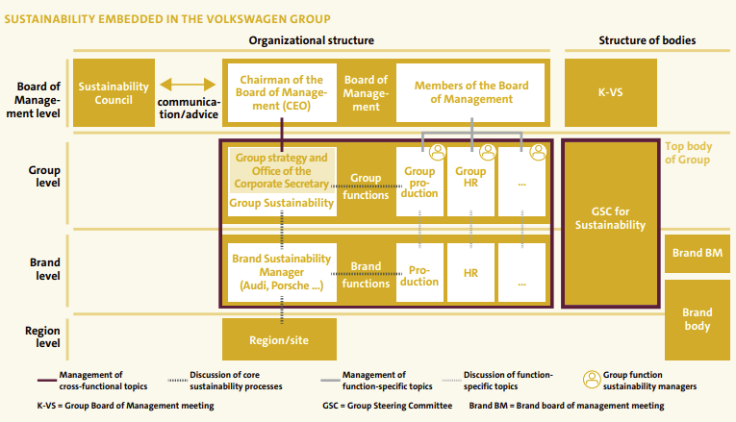
Source: Volkswagen (2023c)
In addition to that, as shown below, sustainability plays an important role in the policy of stakeholder management. Apart from considering the impact on environment and the needs and expectations of various stakeholder groups in this regard, the company has also created a sustainability council which supervises, and audits activities related to these areas. The council also serves as a mediator between internal and external stakeholders (Volkswagen, 2023c).
Figure 4 - Volkswagen stakeholder management
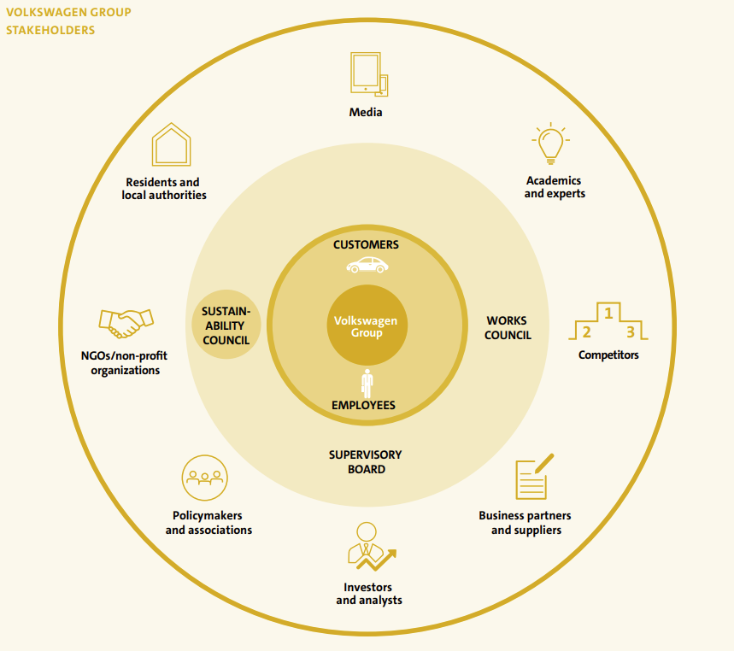
Source: Volkswagen (2023c)
Apart from all this, the company is planning to achieve a zero-impact factory production by 2050 (Volkswagen, 2023c). The progress until now and the planned development are shown below. As visible on the graph, the company succeeded to reduce its environmental impact of production by 25% in the period 2010-2018, and by 45% in the period 2010-2025 (Volkswagen, 2023c). In 2022, the company also succeeded to validate the aim of zero impact factory by it being approved by Production Group Committee. The goal is not only limited to eliminating factory footprint on environment, but also overall negative impact derived from operations, including energy consumption, emissions, water and waste (Volkswagen, 2023c).
The company has taken significant measures for improving performance in all these areas. According to its sustainability report, the Volkswagen has also made serious commitments to areas like biodiversity, protection of soil, avoiding operational disruptions, environmental compliance management, increasing resource efficiency and eliminating waste (Volkswagen, 2023c).
Figure 5 – Zero impact factory goal
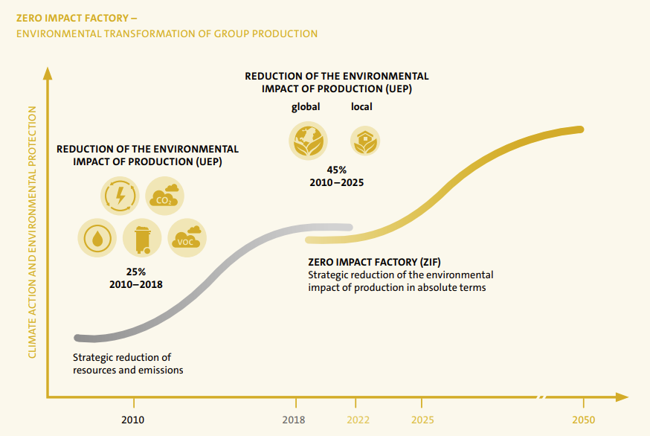
Source: Volkswagen (2023c)
To achieve all this, the company will also collect and analyse a greater variety of data, including 22 quantitative environmental indicators of performance and progress (Volkswagen, 2023c). Examples include CO2 emissions, solvent emissions, freshwater consumption, wastewater loads and many more) (Volkswagen, 2023c). Since the beginning of 2023, the company also uses a new checklist for continuous and consistent review of performance based on 143 pre-defined environmental criteria which include quantitative and qualitative indicators (Volkswagen, 2023c). From 2025 onwards, the zero-impact factory method is set and planned to replace the currently used KPI system, further illustrating the shift towards processes that will decrease environmental impact from operation.
All this supports the new corporate strategy and serves as a solid foundation for creating a competitive advantage against rivals. The strong dedication and commitment of the company to sustainability also supports the generic strategy of differentiation and allows the brand to rebuild its image, trust and credibility as perceived by different stakeholders. In the period after the Dieselgate scandal, Volkswagen has focused on improving problems related to unethical behaviour and negative impact on environment. Thus, the company has embedded new strategies and a business model to restore trustworthiness and recover in terms of financial and operational performance. When also considering the intense rivalry on the market and the sensitivity of consumers on sustainable topics, this increases even more in importance and significance.

Recommendations for future improvement
As evident from the discussion and critical assessment of information collected, it can be suggested that Volkswagen has made the right strategic choice of developing a strategy that both addresses industry trends and features (see Appendix section) and serves as a tool for recovering brand image, reputation and credibility as perceived by different stakeholders. However, due to the considerable consequences of the scandal which are still impacting business operations, such as ongoing court settlements, the company should not stop putting efforts to further improve operational and financial performance, while emphasising on sustainability even more. Some recommendations that can be considered by the brand include:
- Invest even more heavily in innovation, digitalisation and automation. This would further increase degree of differentiation while, at the same time, would be cost-effective and balance-off losses from court settlements to a certain extent.
- Invest even more in green solutions that would increase returns in the long run. Examples include green energy, waste management solutions and water conservation.
- Communicate more extensively sustainability strategy and plans of the company, as well as current achievements, progress made and efforts put, along with recognition from respected parties. This will support the recovery of the brand image and reputation of the company and would help it tackle with the consequences of the scandal.
- Use more extensively social media and other promotional channels to engage the public and other stakeholders, as this is expected to increase brand loyalty, as well as switching costs to other rivals, further supporting the differentiation generic strategy chosen by the company.
- Develop a wider-scale CSR strategy which also includes philanthropic activities along with other elements of corporate social responsibility.
The above-listed recommendations are just ideas for further development of the company’s strategy beyond initially set goals. They are considered to help it recover faster from the consequences of the scandal and improve its performance in all areas.

Conclusion
To sum up, the scandal of Volkswagen affected the company significantly and imposed a wide variety of challenges and pressures on it. However, the brand has succeeded to change its strategic course of action and address the problem by developing an entirely new business model and increasing the focus and emphasis on sustainability. It has been successful in implementing it so far, but the long-term impact would also depend on the industry development and external factors of influence.

References
Barney, J. (2019) Strategic Management and Competitive Advantage: Concepts and Cases. 6th global edition, Pearson
BBC (2022) Volkswagen Too Pay Out £193m In ‘Dieselgate’ Settlement, [online] Available: https://www.bbc.com/news/business-61581251 [Accessed: 1 August 2023]
Isabelle, D., Horak, K., McKinnon, S. and Palumbo, C. (2020) Is Porter’s Five Forces Framework Still Relevant? Technology Innovation Management Review, Vol. 10(6), pp. 28-41.
Kell, G. (2022) From Emissions Cheater to Climate Leader: VW’s Journey From Dieselgate to Embracing E-Mobility, [online] Available: https://www.forbes.com/sites/georgkell/2022/12/05/from-emissions-cheater-to-climate-leader-vws-journey-from-dieselgate-to-embracing-e-mobility/ [Accessed: 1 August 2023]
Lynch, R. (2018) Strategic Management. 8th edition, Pearson
Porter, M. (1979) How Competitive Forces Shape Strategy, Harvard Business Review, Vol. 57(2), pp. 137–145.
Tanwar, R. (2013) Porter’s Generic Competitive Strategies, IOSR Journal of Business and Management, Vol. 15(1), pp. 11-17.
Volkswagen (2023a) Strategy, [online] Available: https://www.volkswagen-newsroom.com/en/strategy-3912 [Accessed: 2 August 2023]
Volkswagen (2023b) Annual Report 2022, [online] Available: https://annualreport2022.volkswagenag.com/_assets/downloads/entire-vw-ar22.pdf [Accessed: 2 August 2023]
Volkswagen (2023c) Sustainability Report 2023, [online] Available: https://www.volkswagen-group.com/en/publications/more/group-sustainability-report-2022-1644 [Accessed: 2 August 2023]
Whittington, R., Regner, P., Angwin, D., Johnson, G., Scholes, K. (2020) Exploring Strategy: Text and Cases. 12th edition, Pearson

Appendix

SWOT
The SWOT analysis is acronym of strengths, weaknesses, opportunities and threats (Whittington et al., 2020). The strengths and weaknesses are internal and specific for Volkswagen. The research findings from the strategic report and other key insights from the annual report are used to identify the main strengths and weaknesses. The opportunities and threats are linked to the external environment and the industry; hence, they are outside of Volkswagen and cannot be affected by the actions of the company (Whittington et al., 2020). Nevertheless, opportunities and threats pose important directions for future strategic development and must be addressed accordingly by the company.
Strengths  - New business model  - New corporate strategy  - Zero impact production plan  - Greater commitment to sustainability  - Increasing resources  - Sufficient capabilities  - Market leader  - High brand awareness | Weaknesses  - Consequences of Dieselgate  - High investments would lower profits in short run.  - Court settlements increase costs.  - Reputation needs to be restored
Opportunities  - Strong growth of demand for e-vehicles and digital solutions  - Increased importance of sustainability  - High pace of technological development and digitalisation | Threats  - Intense rivalry  - Climate change issues and pressures  - Economic uncertainty  - Potential impacts from war in Ukraine  - Changing customer needs, expectations and preferences

Porter’s five forces
The Porter’s Five Forces is a model for industry analysis (Porter, 1979). By investigating five distinctive factors, it is possible to better understand the main factors affecting the level of profitability in every industry (Porter, 1979). As shown below, the factors can be affected by different factors; hence, they are explored in more detail as a part of the analysis of the automotive sector.
Figure 6 – Porter’s Five Forces model overview
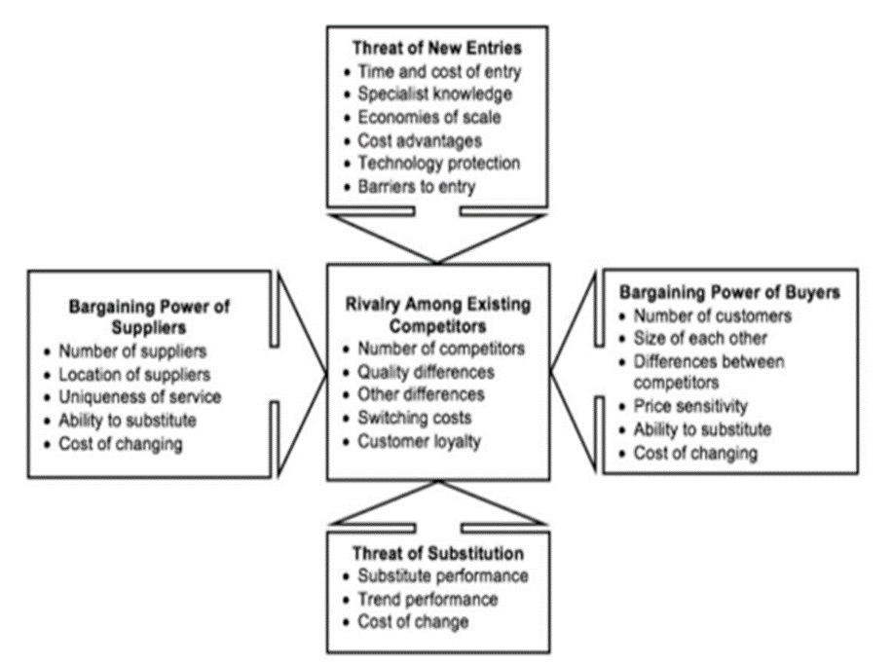
Source: Isabelle et al. (2020)
- Degree of rivalry: very high; rivals are both traditional manufacturers and entirely e-vehicles producers, such as Tesla. The mature automotive sector and low growth numbers also intensify competition.
- Bargaining power of buyers: relatively high due to high volumes of orders and low switching costs.
- Bargaining power of suppliers: relatively high as new modes require components that are provided by lower range of suppliers, such as critical raw materials and innovative digital solutions.
- Threat of new entrants: relatively low due to barriers to entry. There are solid capital requirements to develop production capacity, a global distribution network, economics of scale and others. These requirements discourage many new entrants.
- Threat of substitutes: relatively high due to the large variety of available vehicles and substitutes, including public transportation means.
Overall, the industry appears to be highly competitive with restricted profitability opportunities.

