
ACCB6017 Usability Engineering
User Requirements and Prototype
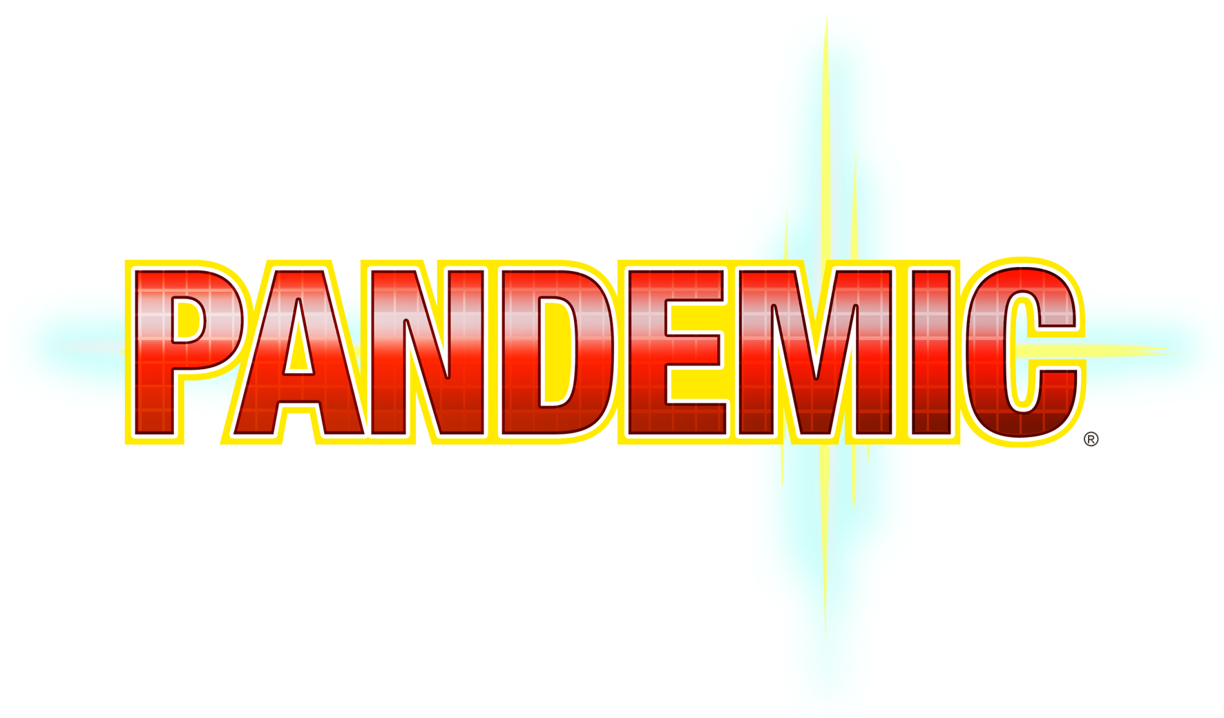
UWTSD Pandemic: Campus Outbreak Response

Student | Module | Assessment | Game Type
Abubarkar Dembele | ACCB6017 Usability Engineering | Component 1: User Requirements and Prototype | UWTSD version of Pandemic board game
Student ID | 2128085

Contents
Priority Work Plan 2
Executive Summary 2
1. Introduction 2
2. Game Concept 3
2.1 Prototype Type, Fidelity and Functionality 3
3. User Research Methodology 3
3.1 Research Aim 3
3.2 Participants 3
3.3 Data Collection Method 3
3.4 Questionnaire Questions 3
3.5 Summary of Expected Findings 4
4. Personas and Scenarios 4
4.1 🎒 Persona 1: Aisha Khan - Commuter undergraduate student 7
MoSCoW Requirements for Aisha Khan 7
4.2 🌍 Persona 2: Jean-Baptiste Traoré - International student 7
MoSCoW Requirements for Jean-Baptiste Traoré 8
4.3 🧠 Persona 3: Daniel Morgan - Mature / neurodivergent student 8
MoSCoW Requirements for Daniel Morgan 8
4.4 👩‍🏫 Persona 4: Dr Sarah Evans - Lecturer / academic staff 9
MoSCoW Requirements for Dr Sarah Evans 9
4.5 📱 Persona 5: Priya Patel - International postgraduate student 9
MoSCoW Requirements for Priya Patel 10
4.6 🛡️ Persona 6: Kwame Mensah - Professional services / campus support staff 10
MoSCoW Requirements for Kwame Mensah 10
5. User and Experience Requirements 11
5.1 Combined MoSCoW Summary 11
5.2 Flexible Participation and Shared Game State 11
6. Usability Design Considerations 11
6.1 Usability Quality Components 11
6.2 Learnability and Visibility 11
6.3 Cognitive Load 12
6.4 Accessibility and Inclusive Design 12
6.5 Navigation, Errors and Feedback 12
6.6 Mobile Interaction Design 12
6.7 Nielsen Heuristics Applied to the Storyboard 12
7. Wireframe Storyboard Design 12
8. Prototype Feedback 14
8.1 Planned Usability Tasks 14
8.2 Measures and Feedback Analysis 14
8.3 Planned Improvements 14
9. Peer Evaluation Plan 15
10. Conclusion 15
References 15
Appendices 17
Appendix A: Research Materials 17
A.1 Short Interview Prompts 17
A.2 Expanded Inclusive Questionnaire 18
A.3 Planned Analysis and Chart Formats 19
Appendix B: Full Persona Profiles 19
B.1 Aisha Khan - Commuter Undergraduate Student 20
B.2 Jean-Baptiste Traore - International Student 21
B.3 Daniel Morgan - Mature / Neurodivergent Student 22
B.4 Dr Sarah Evans - Lecturer / Academic Staff 23
B.5 Priya Patel - International Postgraduate Student 24
B.6 Kwame Mensah - Professional Services / Campus Support Staff 25
Appendix C: Extended Usability and Evaluation Evidence 25
C.1 Prototype Classification by Fidelity and Functionality 26
C.2 Nielsen's Five Usability Quality Components 27
C.3 Nielsen Heuristics Applied to the Storyboard 28
C.4 Detailed Usability-Test Questions 29
C.5 Five-Point Prototype Rating Statements 29
C.6 Data Visualisation Plan for Genuine Results 30
Appendix D: Wireframe Storyboards 30
Appendix E: Feedback Summary 42
Appendix E.1: Cognito Forms Questionnaire 42
Appendix E.2: Black-and-White Interactive HTML Prototype 45
Appendix F: Prototype Fidelity 46
F.1 Low-Fidelity Start Screen 47
F.2 Mid-Fidelity Start Screen 48
F.3 High-Fidelity Monochrome Preview 49

Figure 1 Persona coverage across user groups within the six-persona design set. 7
Figure 2 Accessibility and usability priorities derived from the persona requirements. 8
Figure 3 Storyboard navigation flow between the eleven mobile screens. 16
Figure 4 Start Screen wireframe. 33
Figure 5 Select Play Mode wireframe. 34
Figure 6 Create or Join Game wireframe. 35
Figure 7 Choose Campus wireframe. 36
Figure 8 Choose Role wireframe. 37
Figure 9 Campus Outbreak Map wireframe. 38
Figure 10 Outbreak Alert wireframe. 39
Figure 11 Player Action wireframe. 40
Figure 12 Cure Progress wireframe. 41
Figure 13 Team Status wireframe. 42
Figure 14 Mission Result wireframe. 43
Figure 15 Illustrative simulated participant summary showing task completion, errors, assistance required, emotional responses and participant comments. 52

Priority Work Plan
The first stage of the work focuses on the highest-value assessment areas: the wireframe storyboard prototype, the persona and data collection section, and the usability section supported by books and journal literature.
Priority | Assessment area | Weighting | Action
1 | Create the piece/design frame: mobile wireframe storyboard prototype | 30% | Create the main mobile screens and show how users move between them.
2 | Write about personas and how data was collected | 10% + part of research method | Use questionnaire/interview evidence to support persona development.
3 | Research for usability section | 20% | Use books and journal papers; compile references while writing.

Executive Summary
This report presents a user-centred black-and-white mobile prototype for UWTSD Pandemic: Campus Outbreak Response. Six personas represent varied study patterns, confidence and accessibility needs. Cognito Forms, interviews and card sorting support the requirements, while usability literature informs the interface. Eleven wireframes and a linked HTML prototype demonstrate the journey from launch to mission result. Colour and higher fidelity are reserved for Component 2.

1. Introduction
This report presents the user research and black-and-white mobile wireframe design for UWTSD Pandemic: Campus Outbreak Response. The concept transfers Pandemic's cooperative outbreak-and-cure structure to UWTSD campuses, where specialist university roles share information, control incidents and win or lose as a team [1].
The report links personas, MoSCoW priorities, usability literature, storyboard decisions and a planned evaluation process. Component 1 remains monochrome so users assess structure, terminology and navigation rather than final visual styling; colour concepts are retained for Component 2.

2. Game Concept
The game supports one to six players through solo, pass-and-play, asynchronous and live online modes. Players coordinate outbreaks and shared resources before the crisis reaches failure level. Asynchronous play supports different schedules [2], while pass-and-play enables local turns on one device [9].
Roles include Medic, Researcher, Security Officer, IT Support Officer, Librarian and Analyst. Each has one clear ability, while the interface keeps the map, current turn, available action and cure progress visible.

2.1 Prototype Type, Fidelity and Functionality
The artefact is a low-fidelity interactive structural prototype. Monochrome screens test layout, labels and workflow before major development [3], [4]. Links simulate navigation, but game algorithms, networking, AI and persistent data are not implemented.
Mid fidelity would refine spacing, typography and validation. High fidelity would add final visuals, live states and realistic behaviour. Appendix F summarises this progression; colour is reserved for Component 2.

3. User Research Methodology

3.1 Research Aim
The research examines navigation, accessibility, role clarity, emotional response and the information users need on a small mobile screen.

3.2 Participants
Participants should include undergraduate, mature and international students, casual and experienced gamers, and one staff-related user to avoid a narrow computing-only sample.

3.3 Data Collection Method
A Cognito Forms questionnaire, short interviews and card sorting will be used. The form records device, gaming, technical-confidence and accessibility preferences. Interviews explain reasons, while card sorting tests whether labels and screen groups match users' mental models [10]. Themes will refine personas and MoSCoW priorities [11]. The complete questionnaire and analysis plan are provided in Appendix A.

3.4 Questionnaire Questions
- What is your role at UWTSD or your relationship to university study?
- How often do you play digital games?
- What would make this type of strategy game easy to understand?

- Would you prefer icons, text instructions, or both?
- What accessibility features would help different users?

- What would make the game enjoyable enough to play again?

3.5 Summary of Expected Findings
Likely themes include clear navigation, short instructions, readable controls and reduced clutter. These remain hypotheses until the Cognito Forms responses, interviews and observed tasks are analysed.

4. Personas and Scenarios
The brief requires four personas; six are retained for broader coverage and must be checked against real participant evidence. Emojis are used within the cards to improve scanning while the content remains structured and academic. Full-length persona profiles are provided in Appendix B.
The following charts summarise the design coverage represented by the six personas. They describe the persona set only and are not presented as questionnaire findings.

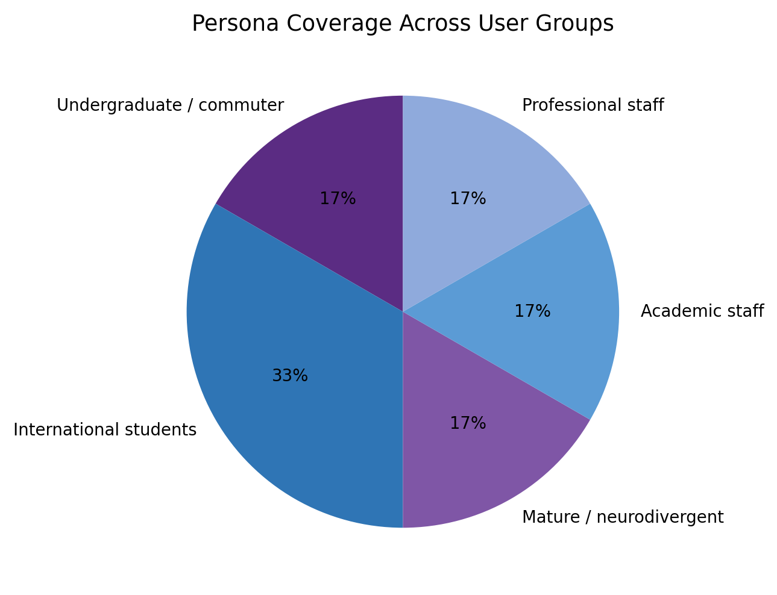
Figure 1 Persona coverage across user groups within the six-persona design set.

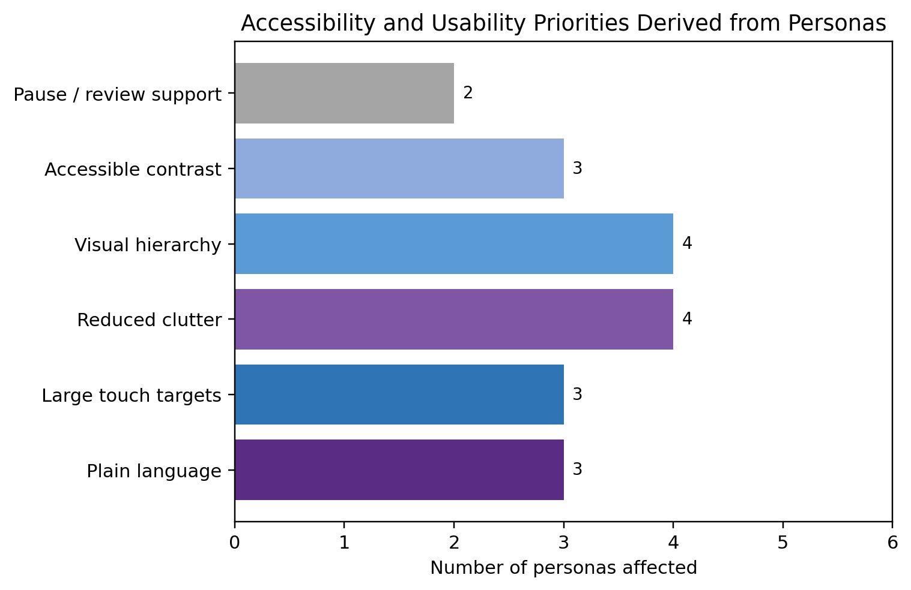
Figure 2 Accessibility and usability priorities derived from the persona requirements.

4.1 🎒 Persona 1: Aisha Khan - Commuter undergraduate student
🎒 Persona 1: Aisha Khan | Commuter undergraduate
🎂 Age | 24
🎓 Role | Commuter undergraduate
🌍 Background / cultural context | British Pakistani student travelling to Birmingham by bus.
📍 Campus | UWTSD Birmingham
💻 Technical confidence | Medium
♿ Accessibility / support needs | Large text, clear buttons and a simple mobile layout.
🎮 Gaming preferences | Casual player; prefers short sessions.
🎬 Scenario | Joins during a break and needs immediate role and action guidance.
✨ User and experience requirements | 1. Quick join  2. Clear role  3. Large buttons  4. Save/resume
🧭 Design focus | Fast joining and simple actions.

MoSCoW Requirements for Aisha Khan
Must Have | Should Have | Could Have | Won't Have
Quick join game | Short tutorial | Custom avatar | Long text-heavy tutorial
Clear role explanation | Save/resume | Difficulty levels | Complex advanced settings
Large readable buttons | Icons with labels | Quick chat feature | Full 3D design
Simple campus map | Progress indicator | Replay summary | Compulsory account creation

4.2 🌍 Persona 2: Jean-Baptiste Traoré - International student
🌍 Persona 2: Jean-Baptiste Traoré | International student
🎂 Age | 28
🎓 Role | International student
🌍 Background / cultural context | French/Malian computing student using English as an additional language.
📍 Campus | UWTSD Birmingham
💻 Technical confidence | Medium-high
♿ Accessibility / support needs | Plain English, labelled icons and visual examples.
🎮 Gaming preferences | Uses apps but avoids text-heavy games.
🎬 Scenario | Selects IT Support and needs each action explained before confirming.
✨ User and experience requirements | 1. Plain English  2. Labelled icons  3. Help  4. Action examples
🗣️ Design focus | Clear language and predictable controls.

MoSCoW Requirements for Jean-Baptiste Traoré
Must Have | Should Have | Could Have | Won't Have
Plain English instructions | Mini glossary | Language support later | Slang-heavy wording
Icons with labels | Tutorial examples | Audio explanation | Ambiguous icons
Help button | Consistent screen layout | Visual demo mode | Long rules document
Clear action descriptions | Error messages in simple language | Icon legend | Unexplained abbreviations

4.3 🧠 Persona 3: Daniel Morgan - Mature / neurodivergent student
🧠 Persona 3: Daniel Morgan | Mature / neurodivergent student
🎂 Age | 31
🎓 Role | Mature / neurodivergent student
🌍 Background / cultural context | Welsh mature student who can find busy screens stressful.
📍 Campus | UWTSD Swansea / Online
💻 Technical confidence | Medium
♿ Accessibility / support needs | Low clutter, clear priorities and pause/review support.
🎮 Gaming preferences | Enjoys strategy but dislikes too many choices.
🎬 Scenario | Needs the urgent zone and recommended action highlighted calmly.
✨ User and experience requirements | 1. Clean layout  2. Recommended action  3. Pause/review  4. Progress
🧘 Design focus | Calm alerts and visible priorities.

MoSCoW Requirements for Daniel Morgan
Must Have | Should Have | Could Have | Won't Have
Clean layout | Reduce pop-ups | Focus mode | Multiple flashing alerts
Recommended action prompt | Step-by-step tutorial | Optional reminders | Cluttered menus
Pause/review button | Priority indicators | Custom text size | Hidden critical information
Clear progress bar | Consistent navigation | Calm alert style | Unnecessary animations

4.4 👩‍🏫 Persona 4: Dr Sarah Evans - Lecturer / academic staff
👩‍🏫 Persona 4: Dr Sarah Evans | Lecturer / academic staff
🎂 Age | 45
🎓 Role | Lecturer / academic staff
🌍 Background / cultural context | Academic user interested in serious games and reflection.
📍 Campus | UWTSD Swansea
💻 Technical confidence | High
♿ Accessibility / support needs | Clear learning purpose, easy setup and useful results.
🎮 Gaming preferences | Limited gamer; confident with educational technology.
🎬 Scenario | Runs a class activity and discusses teamwork using the final summary.
✨ User and experience requirements | 1. Clear objective  2. Team progress  3. Results  4. Easy setup
📊 Design focus | Learning value and team feedback.

MoSCoW Requirements for Dr Sarah Evans
Must Have | Should Have | Could Have | Won't Have
Clear objective | Debrief screen | Export results | Entertainment-only design
Team status screen | Decision history | Classroom mode | Unclear scoring
Results summary | Teacher observation notes | Reflection questions | No feedback after gameplay
Role descriptions | Easy session setup | Group comparison | Overcomplicated setup

4.5 📱 Persona 5: Priya Patel - International postgraduate student
📱 Persona 5: Priya Patel | International postgraduate
🎂 Age | 27
🎓 Role | International postgraduate
🌍 Background / cultural context | Postgraduate studying across London and online contexts.
📍 Campus | UWTSD London / Online
💻 Technical confidence | Medium-high
♿ Accessibility / support needs | Simple language and consistent cross-device hierarchy.
🎮 Gaming preferences | Daily app user; prefers clean screens.
🎬 Scenario | Joins remotely and expects the same key information on phone or laptop.
✨ User and experience requirements | 1. Responsive layout  2. Simple labels  3. Predictable flow  4. Clear hierarchy
📱 Design focus | Consistent navigation across devices.

MoSCoW Requirements for Priya Patel
Must Have | Should Have | Could Have | Won't Have
Responsive mobile layout | Clear campus selection | Cross-campus lobby | Inconsistent layouts
Simple labels | Screen flow indicators | Profile preferences | Unlabelled controls
Consistent navigation | Accessible contrast | Optional notifications | Crowded dashboards
Visible current role | Confirmation before major actions | Keyboard shortcuts for desktop | Colour-only meaning

4.6 🛡️ Persona 6: Kwame Mensah - Professional services / campus support staff
🛡️ Persona 6: Kwame Mensah | Campus support staff
🎂 Age | 39
🎓 Role | Professional services / support staff
🌍 Background / cultural context | Ghanaian British worker familiar with campus incidents.
📍 Campus | UWTSD Birmingham
💻 Technical confidence | Medium
♿ Accessibility / support needs | Task-focused screens showing location and urgency.
🎮 Gaming preferences | Rare gamer; prefers practical workflows.
🎬 Scenario | Needs the incident, team state and next response immediately.
✨ User and experience requirements | 1. Visible location  2. Urgency  3. Action buttons  4. Team cues
🚨 Design focus | Practical incident coordination.

MoSCoW Requirements for Kwame Mensah
Must Have | Should Have | Could Have | Won't Have
Incident location visible | Clear notifications | Staff view mode | Excessive game jargon
Urgency level shown | Action confirmation | Incident log | Hidden team status
Task-focused action buttons | Simple resource count | Quick message templates | Small touch targets
Team status visible | Accessible button size | Priority filter | Purely decorative screens

5. User and Experience Requirements
Common requirements are quick setup, understandable roles, large touch targets, visible outbreak status, a simple campus map, consistent navigation and immediate feedback. These support effectiveness, efficiency and satisfaction [3].

5.1 Combined MoSCoW Summary
Must Have | Should Have | Could Have | Won't Have
Start screen and main menu | Short tutorial | Custom avatars | Full 3D graphics
Create/join game flow | Accessibility settings | Difficulty levels | Complex tutorials
Role selection | Icons with text labels | Chat/quick messages | Unlabelled icons
Campus outbreak map | Team status panel | Replay summary | Long rules-only screens
Player action screen | Cure progress screen | Classroom mode | Full colour final design in Component 1
Win/lose results screen | Confirmation for major actions | Export results | Complex account system

5.2 Flexible Participation and Shared Game State
The four modes access the same cooperative state. Solo supplies computer-controlled support; pass-and-play changes the active-player view; asynchronous play saves confirmed turns; and live play distributes updates immediately. Turn indicators, connection status and confirmation prevent conflicting board states [2], [9].

6. Usability Design Considerations

6.1 Usability Quality Components
Usability is evaluated through learnability, efficiency, memorability, errors and satisfaction rather than visual preference alone [4]. These qualities provide measurable questions for the storyboard.
Table 2. Usability qualities applied to UWTSD Pandemic.
Quality | Application
Learnability | Complete joining, role selection and a first action without lengthy help.
Efficiency | Reduce steps and time required to create or rejoin a game.
Memorability | Keep labels and control positions consistent across screens.
Errors | Prevent invalid actions and explain recovery in plain language.
Satisfaction | Measure confidence, stress, teamwork and willingness to replay.

6.2 Learnability and Visibility
The prototype shows the current role, outbreak level, available actions and team progress when needed. Visibility of system status, clear signifiers and consistent controls help first-time users predict outcomes [4], [5]. Game-usability research also supports clear goals and understandable status information [12], so major actions require confirmation.

6.3 Cognitive Load
Maps, roles, resources and team decisions can overload working memory. The wireframes use one dominant task per screen, short labels, grouped controls and progressive disclosure [6]. Completion time, wrong selections and a brief effort rating can identify avoidable cognitive demand [13].

6.4 Accessibility and Inclusive Design
Accessibility uses readable text, strong contrast, large touch targets, labelled icons, simple language and alternatives to colour-only meaning. Optional text resizing, audio guidance, captions and reduced motion should be tested [7]. Mobile guidance also supports consistent help and usable target sizes [14].

6.5 Navigation, Errors and Feedback
The storyboard follows a predictable sequence and gives feedback after important actions. Back and Cancel preserve user freedom, invalid room codes receive specific messages, and unavailable actions should be disabled. Consistency, error prevention and recognition rather than recall support recovery [4], [8].

6.6 Mobile Interaction Design
Important controls are large, separated and consistently positioned. The design prioritises the current player task over decoration. Mobile-game research recommends evaluating controls, feedback and interruptions in the device context [15], so asynchronous notifications should inform without distracting.

6.7 Nielsen Heuristics Applied to the Storyboard
Nielsen's heuristics appear through visible turn and cure status, familiar campus terminology, Back and Cancel controls, consistent buttons, room-code validation, labelled abilities, quick joining and accessible Help [4]. The full heuristic mapping and evaluation instruments are provided in Appendix C.

7. Wireframe Storyboard Design
Appendix D presents eleven individual black-and-white phone screens covering launch, modes, lobby, campus, role, map, alert, action, cure progress, team status and result. The HTML prototype provides clickable evidence for the first five stages.
Screen | Purpose | Main elements | Next action
1. Start Screen | Introduce the game | Title, Start Game, Join Game, Tutorial, Accessibility | Tap Start or Join
2. Main Menu | Select game mode | Create Game, Join Game, How to Play, Settings | Choose Create/Join
3. Create/Join Game | Start a session quickly | Room code, invite link, player list | Enter lobby
4. Choose Campus | Set game location | Birmingham, Swansea, London, Online campus map options | Select campus
5. Choose Role | Assign university roles | Role cards, ability summary, confirm button | Confirm role
6. Campus Outbreak Map | Main gameplay screen | Campus zones, outbreak markers, player icons, resources | Tap zone/action
7. Outbreak Alert | Show new crisis | Alert type, affected area, urgency, recommended response | Choose response
8. Player Action Screen | Let user act | Move, Treat Outbreak, Share Resource, Research Cure | Confirm action
9. Cure Progress | Show team progress | Progress bar, resources needed, completed cures | Return to map
10. Team Status | Show collaboration state | Player roles, turn order, health/resource status | Continue game
11. Win/Lose Result | End and reflect | Outcome, score, outbreak control, key decisions | Replay or exit

Suggested storyboard flow:

Start Screen – >
Main Menu – >
Create/Join Game – >
Choose Campus – >
Choose Role – >
Campus Outbreak Map – >
Outbreak Alert – >
Player Action Screen – >
Cure Progress – >
Team Status – >
Win/Lose Result.
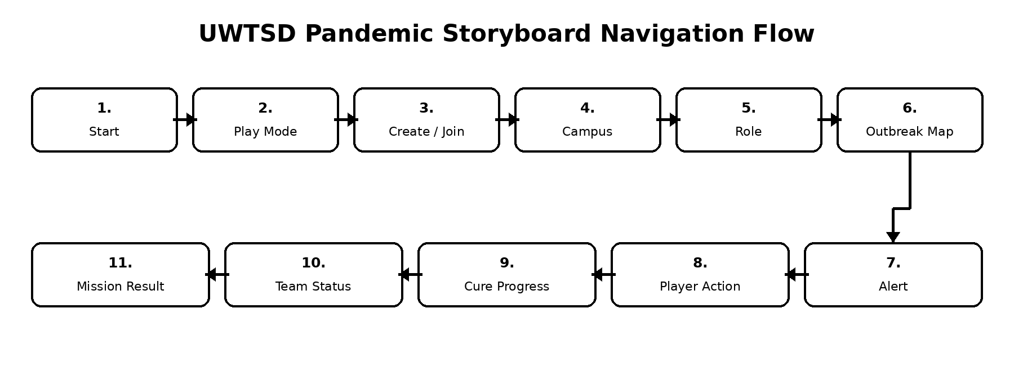
Figure 3 Storyboard navigation flow between the eleven mobile screens.

8. Prototype Feedback
Participants will complete realistic tasks before answering the Cognito form: start or join, distinguish the four modes, choose a campus and role, identify an urgent outbreak and locate accessibility support. Observation will record completion, hesitation, wrong taps, navigation reversals and requests for help. The detailed feedback instrument and Likert statements are reproduced in Appendix C.
Issue to check | Possible design response
Which screen was easiest to understand? | Identifies strong parts of the design.
Which screen was confusing? | Finds usability problems.
Were the buttons and labels clear? | Checks navigation and wording.
Did the game flow make sense? | Checks storyboard structure.
How did the design make you feel? | Checks emotional response and confidence.
What would you improve? | Provides design changes for the next version.

8.1 Planned Usability Tasks
- Start or join without researcher assistance.
- Explain the selected mode and specialist role.
- Identify the urgent outbreak and choose an action.
- Find Accessibility and recover from an invalid room code.

8.2 Measures and Feedback Analysis
- Objective measures: completion, time, wrong taps and help requests.
- Subjective measures: clarity, confidence, effort and emotional response.
- Open comments: easiest screen, confusing screen and preferred improvement.
- Only genuine repeated themes will be reported as findings.

8.3 Planned Improvements
- Add a short tutorial before the first game.
- Add clearer labels to action buttons.
- Improve the visual hierarchy of the outbreak map.
- Add accessibility settings for text size and contrast.
- Add a recommended action prompt for users who feel unsure.

9. Peer Evaluation Plan
Peer evaluation will check clarity, consistency, navigation, accessibility and emotional response. The table lists possible issues and responses; genuine feedback must confirm or replace them.
Issue to check | Possible design response
The role selection screen needs clearer descriptions. | Add short ability summaries under each role.
The outbreak map may be too busy. | Reduce clutter and highlight only urgent zones.
The game flow is understandable. | Keep the same overall screen order.
Accessibility options should be easier to find. | Add Accessibility button on Start Screen and Settings.

10. Conclusion
This report establishes a literature-informed usability direction for UWTSD Pandemic. Six personas and MoSCoW priorities guide the monochrome storyboard and linked prototype. Planned findings must later be replaced with genuine Cognito Forms, card-sorting, usability-test and peer-evaluation evidence.

References
[1] Z-Man Games, "Pandemic," official game page and rules, 2026.
[2] H. Saarenpää and H. Korhonen, "Asynchronous gameplay in pervasive multiplayer mobile games," in CHI Extended Abstracts, 2009, pp. 4213-4218.
[3] ISO 9241-11:2018, Ergonomics of Human-System Interaction - Part 11: Usability: Definitions and Concepts. Geneva: ISO, 2018.
[4] J. Nielsen, "Enhancing the explanatory power of usability heuristics," in Proc. CHI, 1994, pp. 152-158.
[5] D. A. Norman, The Design of Everyday Things, rev. ed. New York, NY, USA: Basic Books, 2013.
[6] J. Sweller, "Cognitive load during problem solving: Effects on learning," Cognitive Science, vol. 12, no. 2, pp. 257-285, 1988.
[7] W3C, Web Content Accessibility Guidelines (WCAG) 2.2, 2024.
[8] Y. Rogers, H. Sharp, and J. Preece, Interaction Design: Beyond Human-Computer Interaction, 6th ed. Hoboken, NJ, USA: Wiley, 2023.
[9] Microsoft, "Common multiplayer scenarios," Microsoft Game Development Kit Documentation, 2025.
[10] D. Spencer, Card Sorting: Designing Usable Categories. Brooklyn, NY, USA: Rosenfeld Media, 2009.
[11] J. Lazar, J. H. Feng, and H. Hochheiser, Research Methods in Human-Computer Interaction, 2nd ed. Cambridge, MA, USA: Morgan Kaufmann, 2017.
[12] D. Pinelle, N. Wong, and T. Stach, "Heuristic evaluation for games: Usability principles for video game design," in Proc. CHI, 2008, pp. 1453-1462.
[13] A. Darejeh, N. Marcusa, G. Mohammadi, and J. Sweller, "A critical analysis of cognitive load measurement methods for evaluating interfaces," Behaviour & Information Technology, 2024.
[14] W3C, "Guidance on applying WCAG 2.2 to mobile applications," World Wide Web Consortium, 2024.
[15] H. Korhonen and E. M. I. Koivisto, "Playability heuristics for mobile games," in Proc. MobileHCI, 2006, pp. 9-16.

[16] J. Rudd, K. Stern, and S. Isensee, "Low vs. high-fidelity prototyping debate," Interactions, vol. 3, no. 1, pp. 76-85, 1996.
[17] C. Snyder, Paper Prototyping: The Fast and Easy Way to Design and Refine User Interfaces. San Francisco, CA, USA: Morgan Kaufmann, 2003.
[18] International Organization for Standardization, ISO 9241-210:2019, Ergonomics of Human-System Interaction-Part 210: Human-Centred Design for Interactive Systems. Geneva, Switzerland: ISO, 2019.
[19] J. Nielsen, "Usability 101: Introduction to usability," Nielsen Norman Group, Jan. 3, 2012.
[20] A. Cooper, R. Reimann, D. Cronin, and C. Noessel, About Face: The Essentials of Interaction Design, 4th ed. Indianapolis, IN, USA: Wiley, 2014.
[21] J. Brooke, "SUS: A quick and dirty usability scale," in Usability Evaluation in Industry, P. W. Jordan et al., Eds. London, U.K.: Taylor & Francis, 1996, pp. 189-194.
[22] T. Tullis and B. Albert, Measuring the User Experience: Collecting, Analyzing, and Presenting Usability Metrics, 2nd ed. Waltham, MA, USA: Morgan Kaufmann, 2013.

Appendices

Appendix A: Research Materials

A.1 Short Interview Prompts
The short prompts below may be used during interviews after participants have reviewed the prototype. Participants may skip any question they do not wish to answer.
- What would make this game easy to understand?

- Would you prefer icons, text instructions, or both?
- What accessibility features would help different users?

- What would make the game enjoyable enough to play again?
- What would confuse you in a game with maps, roles and outbreaks?
- What information should remain visible on the main game screen?
- What should happen after an incorrect room code or accidental action?
- How should outbreak alerts show urgency without becoming overwhelming?

A.2 Expanded Inclusive Questionnaire
The expanded questionnaire covers background, experience, technical confidence, joining preference, play mode, navigation, accessibility, cognitive load, error recovery, emotional response, cooperation and return use. Participants may skip questions they do not wish to answer.
Question area | Questions
Background | What is your relationship to UWTSD? What age range are you in? Which device would you normally use?
Experience | How often do you play digital games or board games? Have you played Pandemic or another cooperative strategy game?
Technical confidence | How confident are you using an invitation link, QR code, room code, app settings and online multiplayer?
Joining preference | Which option would be easiest: guest join, room code, QR code, invitation link or account sign-in? Why?
Play mode | Which mode would you use: solo, pass-and-play, asynchronous online or live online?
Navigation | What information must stay visible on every screen? Which labels or icons are unclear?
Accessibility | Would text resizing, audio guidance, high contrast, subtitles, colour-safe symbols, reduced motion, extra time or simplified language help?
Cognitive load | How many choices should appear on one screen before it feels busy or stressful?
Error recovery | What should happen after a wrong room code, accidental action, missed turn or lost connection?
Emotional response | How should outbreak alerts communicate urgency without becoming overwhelming?
Cooperation | What team information, quick messages or turn reminders would help players coordinate?
Return use | What would make you play again, and which one feature would you remove or change?

A.3 Planned Analysis and Chart Formats
Closed questions will be summarised using counts or percentages, while open responses will be grouped into themes. Only genuine data will be reported. Every chart must include a clear title, labels, sample size and data source; bar charts are preferred when precise category comparison is important.
Chart | Recommended format | Required labelling
Participant profile by role | Horizontal bar chart | Role categories, count, n and data source.
Gaming frequency | Column chart | Never/occasionally/weekly/daily, count or percentage, n.
Preferred joining method | Bar chart | Room code, invite link, QR code, guest join; allow multiple responses if applicable.
Importance of usability features | Likert stacked bar chart | Statement, 1-5 scale definition, n and missing responses.
Accessibility support requested | Horizontal bar chart | Text size, contrast, audio guidance, captions, reduced motion, simplified language; note multiple selections.
Prototype task results | Table or clustered bar chart | Task completion, time, errors and satisfaction by task.

Appendix B: Full Persona Profiles
The concise persona cards in the main report support the word target. The complete profiles below preserve the fuller background, scenario, accessibility and experience information from the lecturer-reviewed working draft.

B.1 Aisha Khan - Commuter Undergraduate Student
🎒 Persona 1: Aisha Khan | Commuter undergraduate student
🎂 Age | 24
🎓 Role | Commuter undergraduate student
🌍 Background / cultural context | British Pakistani student who travels to campus by bus and uses her phone during short breaks.
📍 Campus | UWTSD Birmingham
💻 Technical confidence | Medium
♿ Accessibility / support needs | Needs clear text, large buttons and a simple layout because she often uses apps while travelling.
🎮 Gaming preferences | Occasional casual mobile gamer; prefers short sessions and quick understanding.
🎬 Scenario | Aisha receives an invite link from a classmate. She opens the game during a short break and wants to join quickly, understand her role and know what action to take without reading a long tutorial.
✨ User and experience requirements | 1. Quick join option  2. Clear role explanation  3. Large readable buttons  4. Short instructions  5. Save and resume option
🧭 Design focus | Fast joining, simple actions, clear mobile flow and confidence during short breaks.

B.2 Jean-Baptiste Traore - International Student
🌍 Persona 2: Jean-Baptiste Traoré | International student
🎂 Age | 28
🎓 Role | International student
🌍 Background / cultural context | French/Malian international computing student. English is not his first language, so he benefits from visual guidance and plain language.
📍 Campus | UWTSD Birmingham
💻 Technical confidence | Medium-high
♿ Accessibility / support needs | Needs simple English, labelled icons and visual reinforcement of instructions.
🎮 Gaming preferences | Enjoys mobile apps but avoids games with unclear rules or too much text.
🎬 Scenario | Jean-Baptiste joins a team game with classmates. He selects the IT Support role but needs clear guidance about what each action means, especially actions such as Move, Treat Outbreak, Share Resource and Research Cure.
✨ User and experience requirements | 1. Plain English labels  2. Icons with text support  3. Help button on each screen  4. Short examples of actions  5. Predictable interaction patterns
🗣️ Design focus | Plain English, labelled icons, visual guidance and no confusing slang.

B.3 Daniel Morgan - Mature / Neurodivergent Student
🧠 Persona 3: Daniel Morgan | Mature / neurodivergent student
🎂 Age | 31
🎓 Role | Mature / neurodivergent student
🌍 Background / cultural context | Welsh mature student with ADHD traits who sometimes finds busy interfaces stressful. He benefits from structure and clear priorities.
📍 Campus | UWTSD Swansea / Online
💻 Technical confidence | Medium
♿ Accessibility / support needs | Needs reduced clutter, clear focus, progress indicators and the ability to pause or review information.
🎮 Gaming preferences | Plays some strategy games but can feel overwhelmed by too many options at once.
🎬 Scenario | Daniel is playing during a usability test. When an outbreak alert appears, several actions are available. The interface highlights the most urgent campus area and shows a recommended next action so he can decide without feeling overloaded.
✨ User and experience requirements | 1. Reduced visual clutter  2. Recommended next action  3. Pause/review option  4. Clear progress bar  5. One main task visible at a time
🧘 Design focus | Low-clutter screens, calm alerts, recommended next action and pause/review support.

B.4 Dr Sarah Evans - Lecturer / Academic Staff
👩‍🏫 Persona 4: Dr Sarah Evans | Lecturer / academic staff
🎂 Age | 45
🎓 Role | Lecturer / academic staff
🌍 Background / cultural context | Welsh/English academic staff member interested in using serious games for collaboration and decision-making activities.
📍 Campus | UWTSD Swansea
💻 Technical confidence | High
♿ Accessibility / support needs | Needs clear learning purpose, classroom-friendly flow and a results summary that supports reflection.
🎮 Gaming preferences | Does not play many mobile games but is interested in educational digital tools.
🎬 Scenario | Dr Evans uses the game in a classroom activity. Students work together to control outbreaks across campus zones. After the game, the results screen shows team performance, outbreak control, cure progress and key decisions.
✨ User and experience requirements | 1. Clear learning purpose  2. Team progress screen  3. Results summary  4. Simple role explanations  5. Classroom-friendly layout
📊 Design focus | Clear learning purpose, team performance feedback and classroom discussion value.

B.5 Priya Patel - International Postgraduate Student
📱 Persona 5: Priya Patel | International postgraduate student
🎂 Age | 27
🎓 Role | International postgraduate student
🌍 Background / cultural context | British Indian / international postgraduate profile who studies across campus and remote learning contexts. She values clarity, simplicity and predictable interfaces.
📍 Campus | UWTSD London / Online
💻 Technical confidence | Medium-high
♿ Accessibility / support needs | Needs clear visual hierarchy, simple language and avoidance of confusing symbols.
🎮 Gaming preferences | Uses mobile apps daily and prefers clean interfaces with minimal distractions.
🎬 Scenario | Priya plays remotely with friends across campuses. Because she may join from a phone or laptop, she needs the game to work consistently and show the same key information across screens.
✨ User and experience requirements | 1. Consistent layout across devices  2. Clear simple language  3. Predictable screen flow  4. Strong visual hierarchy  5. Minimal distracting elements
📱 Design focus | Clean mobile layout, predictable navigation and strong visual hierarchy.

B.6 Kwame Mensah - Professional Services / Campus Support Staff
🛡️ Persona 6: Kwame Mensah | Professional services / campus support staff
🎂 Age | 39
🎓 Role | Professional services / campus support staff
🌍 Background / cultural context | Ghanaian-British professional services staff member who supports campus operations and understands real-world pressure during incidents.
📍 Campus | UWTSD Birmingham
💻 Technical confidence | Medium
♿ Accessibility / support needs | Needs practical, task-focused screens that make urgent actions easy to identify.
🎮 Gaming preferences | Rare gamer; prefers functional apps and clear workflows rather than entertainment-heavy design.
🎬 Scenario | Kwame tests the prototype from the viewpoint of campus support staff. He wants to understand what crisis is happening, where it is located, who is affected and which action the team should take next.
✨ User and experience requirements | 1. Clear incident location  2. Urgency indicators  3. Task-focused action buttons  4. Minimal game jargon  5. Useful team communication cues
🚨 Design focus | Urgency, incident location, task priority and practical team coordination.

Appendix C: Extended Usability and Evaluation Evidence
This appendix preserves the fuller prototype classification, usability matrices, testing questions and data-visualisation plan from the detailed working draft. The main report contains the concise discussion required for the word target.
C.1 Prototype Classification by Fidelity and Functionality
Low-fidelity prototypes use simplified forms to test structure and workflow before substantial development is committed [16], [17]. The current artefact is interactive at navigation level but does not implement outbreak algorithms, networking, artificial intelligence or persistent data.
Classification | Meaning | Application to this project
Low fidelity | Quick, inexpensive sketches or wireframes used to test layout and workflow. | Yes - black-and-white mobile wireframes in Canva.
Mid fidelity | More detailed digital screens that clarify visual hierarchy and navigation. | Future iteration after initial feedback.
High fidelity | Detailed, realistic and interactive representation of the final product. | Future phase with realistic visual design and behaviour.
Aesthetic prototype | Tests appearance, form and interface presentation with little or no underlying function. | Partly - the screens communicate layout and visual organisation.
Functional prototype | Proves that technical mechanics and system behaviour work. | Not yet - navigation is simulated, but game logic and networking are not implemented.
Manufacturing / evolutionary | Production-like model used to test commercial manufacture and final viability. | Not applicable to this early digital interface prototype.

C.2 Nielsen's Five Usability Quality Components
Learnability, efficiency, memorability, errors and satisfaction convert general usability into questions that can be observed during testing [19].
Quality component | Question for evaluation | Application to UWTSD Pandemic
Learnability | Can a first-time player complete basic tasks? | Test whether users can select a mode, join a lobby, choose a role and take a first action without lengthy instruction.
Efficiency | How quickly can an experienced player complete tasks? | Measure the number of steps and time required to create or join a game and return to the campus map.
Memorability | Can returning users re-establish proficiency? | Keep navigation, labels and button positions consistent across screens and game modes.
Errors | What mistakes occur and how easily can users recover? | Validate room codes, confirm major actions, allow Back/Undo where appropriate and explain errors in plain language.
Satisfaction | How pleasant and reassuring is the experience? | Ask users about confidence, teamwork, stress, enjoyment and willingness to play again.

C.3 Nielsen Heuristics Applied to the Storyboard
The matrix below links each heuristic to a visible interface decision, including system status, user control, consistency, error prevention, recognition, flexibility and help.
Heuristic | Storyboard application
Visibility of system status | Show outbreak level, current turn, role, connection status and cure progress.
Match with the real world | Use familiar campus names, maps, plain language and university roles.
User control and freedom | Provide Back, Cancel, Leave Lobby and confirmation before irreversible actions.
Consistency and standards | Keep navigation, icons, labels and button placement consistent.
Error prevention | Validate room codes, disable unavailable actions and confirm high-impact choices.
Recognition rather than recall | Display role abilities, icon labels, action choices and recent events on screen.
Flexibility and efficiency | Offer quick join, QR/invite link, room code, solo, pass-and-play, asynchronous and live modes.
Aesthetic and minimalist design | Use monochrome wireframes and prioritise essential actions on small screens.
Error recognition and recovery | Use clear messages explaining what went wrong and how to correct it.
Help and documentation | Keep Tutorial and Help available in a consistent location across relevant screens.

C.4 Detailed Usability-Test Questions
Participants should complete the same realistic tasks and think aloud where possible. The researcher records behaviour without teaching the interface during the task. Objective measures include completion, time, wrong taps, reversals and requests for help; subjective measures include clarity, confidence, effort and emotional response [21], [22].
Evaluation area | Feedback question
First impression | What do you think the game is about after five seconds?
Learnability | Could you start or join without help?
Efficiency | Which step felt unnecessary or slow?
Memorability | After a short break, could you remember how to return to the map?
Errors | Was it easy to recover from an incorrect room code or accidental choice?
Accessibility | Were text, contrast, symbols, touch targets, timing and alerts suitable?
Game modes | Could you clearly explain the difference between the four play modes?
Role clarity | Did the role card explain the special ability?
Map clarity | Could you identify the most urgent outbreak and next action?
Emotional response | Which screen felt calm, tense, confusing or overwhelming?
Cooperation | Did the team status and turn information support coordination?
Improvement | What single change would improve the prototype most?

C.5 Five-Point Prototype Rating Statements
Statement | 1 2 3 4 5
The purpose of the game was clear. | ☐ ☐ ☐ ☐ ☐
I could join a game without assistance. | ☐ ☐ ☐ ☐ ☐
The play modes were easy to distinguish. | ☐ ☐ ☐ ☐ ☐
The room-code and invitation options were simple. | ☐ ☐ ☐ ☐ ☐
The university role and special ability were clear. | ☐ ☐ ☐ ☐ ☐
The outbreak map showed the next priority. | ☐ ☐ ☐ ☐ ☐
The interface avoided unnecessary clutter. | ☐ ☐ ☐ ☐ ☐
I could recover from mistakes. | ☐ ☐ ☐ ☐ ☐
The accessibility options were easy to find. | ☐ ☐ ☐ ☐ ☐
I would play this game again. | ☐ ☐ ☐ ☐ ☐

C.6 Data Visualisation Plan for Genuine Results
Charts must be generated only after genuine responses are collected. Pie charts are suitable only for simple part-to-whole summaries with few categories; bar charts are clearer for most comparisons, and stacked bars are appropriate for Likert responses.
Data collected | Recommended chart | Interpretation required
Participant role or preferred play mode | Pie or doughnut chart | Largest and smallest groups; whether the sample is balanced.
Gaming frequency, device or joining method | Bar chart | Which options are most and least common.
Ten 1-5 usability statements | Stacked Likert bar chart | Agreement, disagreement and neutral responses.
Task completion and errors | Clustered bar chart | Which screens or tasks caused the most difficulty.
Average usability scores | Radar chart or horizontal bars | Strengths and weaknesses across learnability, efficiency, memorability, errors and satisfaction.
Open comments | Theme-frequency bar chart plus quotations | Repeated issues and representative comments without identifying participants.

Appendix D: Wireframe Storyboards
The complete Component 1 storyboard is shown below as eleven individual black-and-white mobile wireframes. Colour styling is reserved for Component 2.

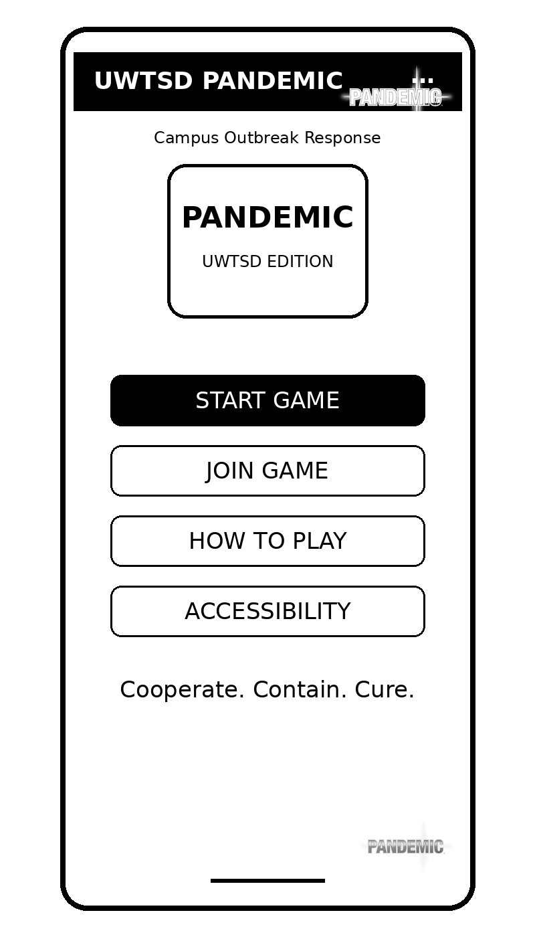
Figure 4 Start Screen wireframe.

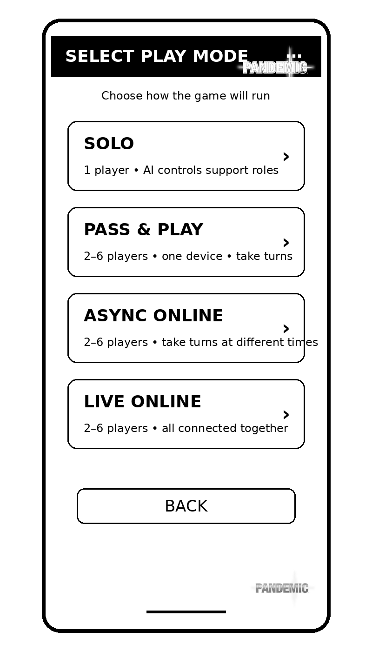
Figure 5 Select Play Mode wireframe.
.

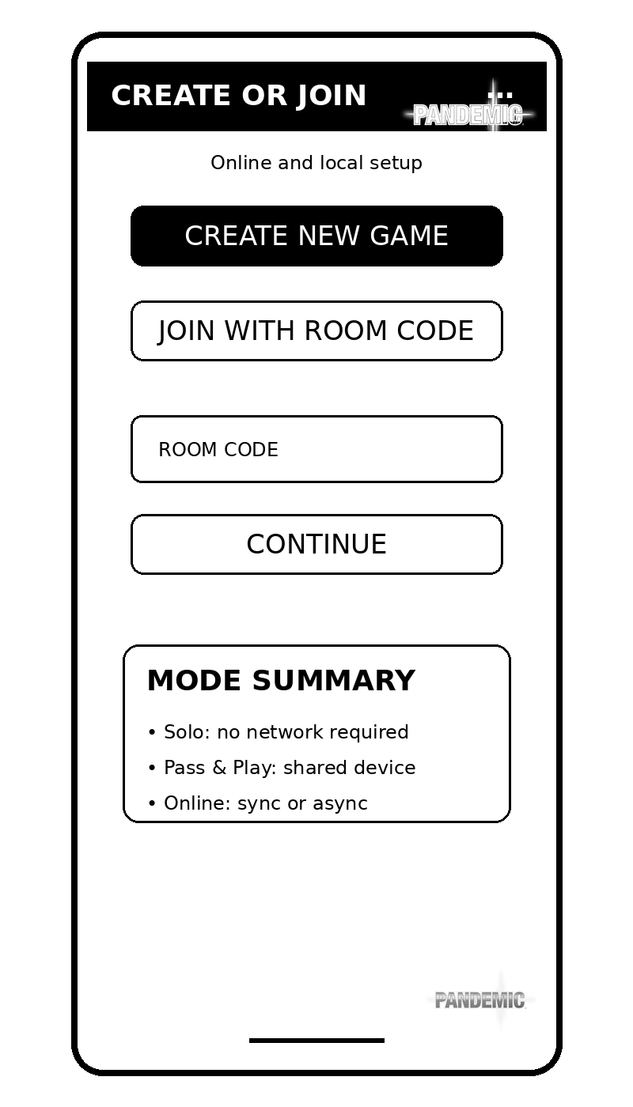
Figure 6 Create or Join Game wireframe.

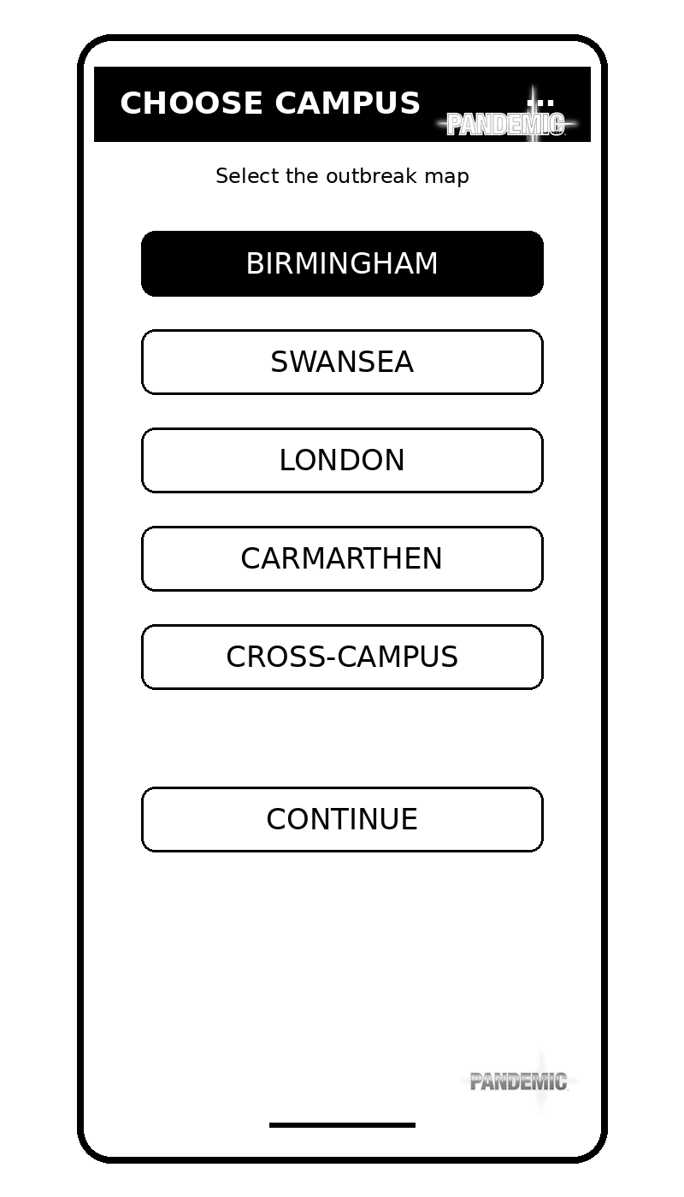
Figure 7 Choose Campus wireframe.

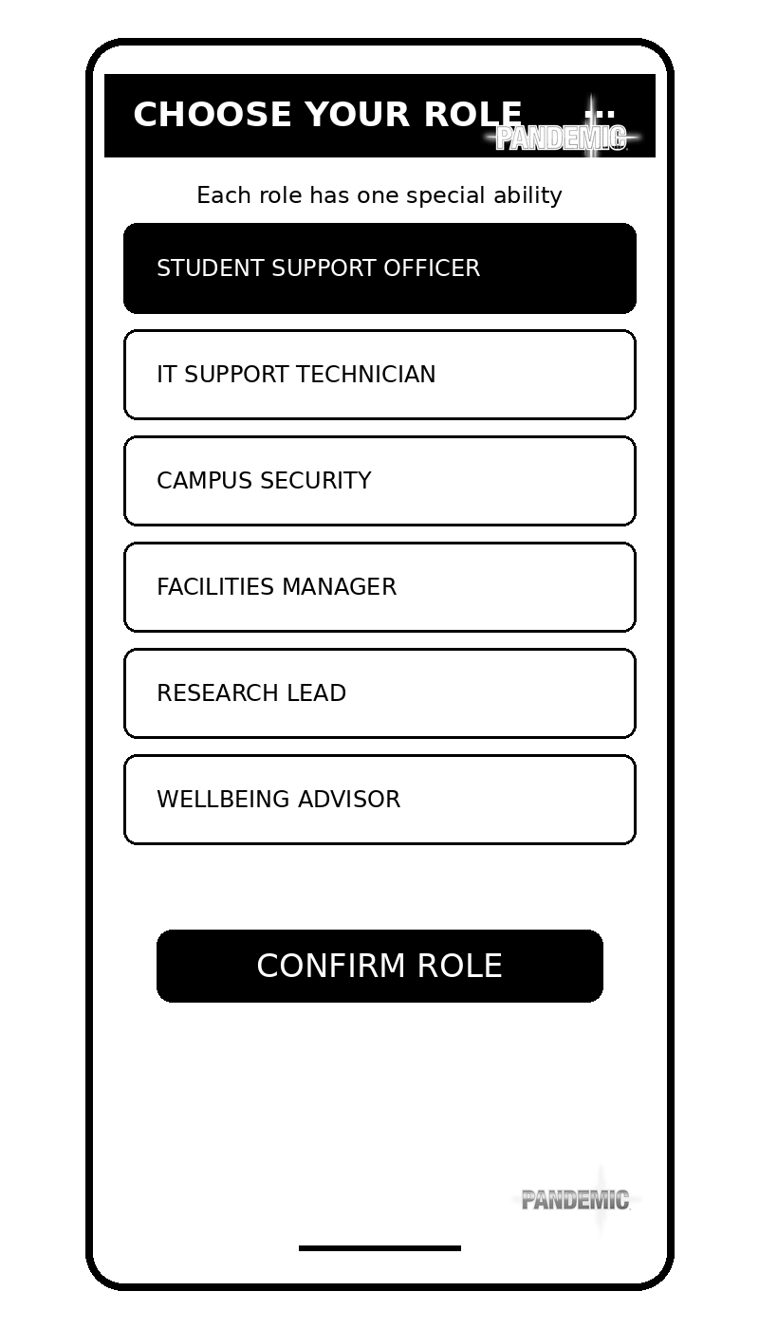
Figure 8 Choose Role wireframe.

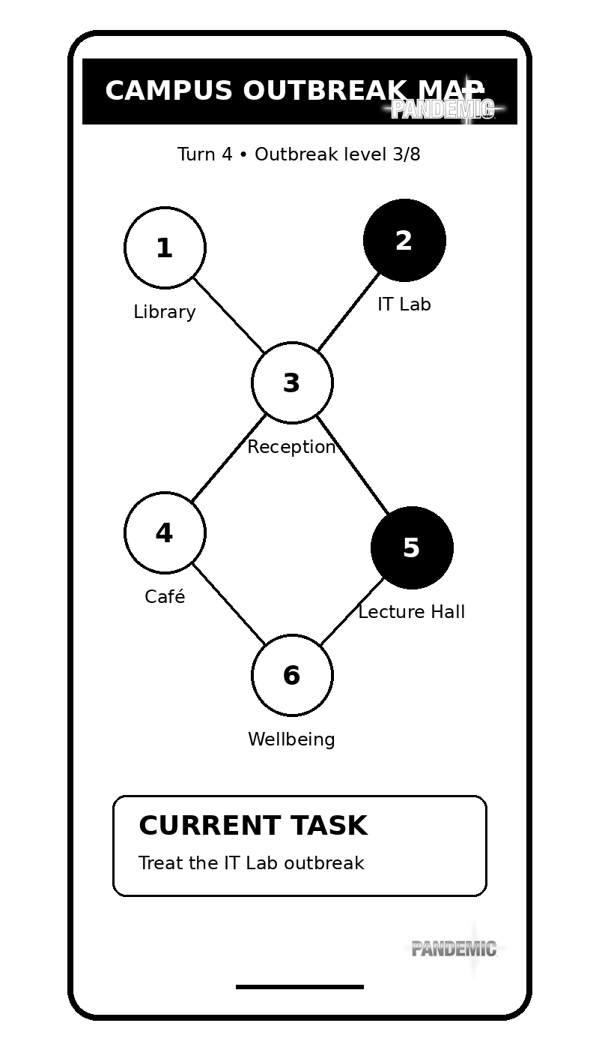
Figure 9 Campus Outbreak Map wireframe.

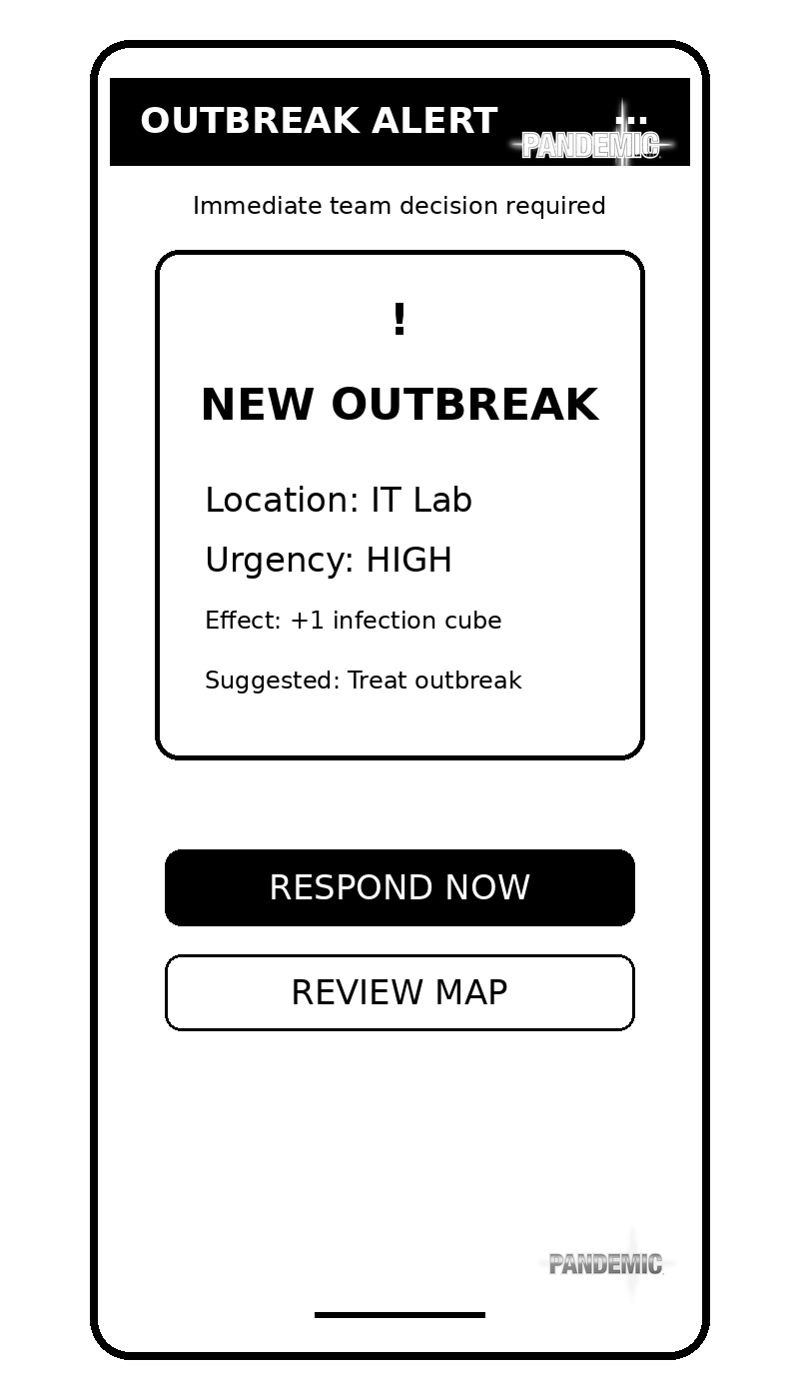
Figure 10 Outbreak Alert wireframe.

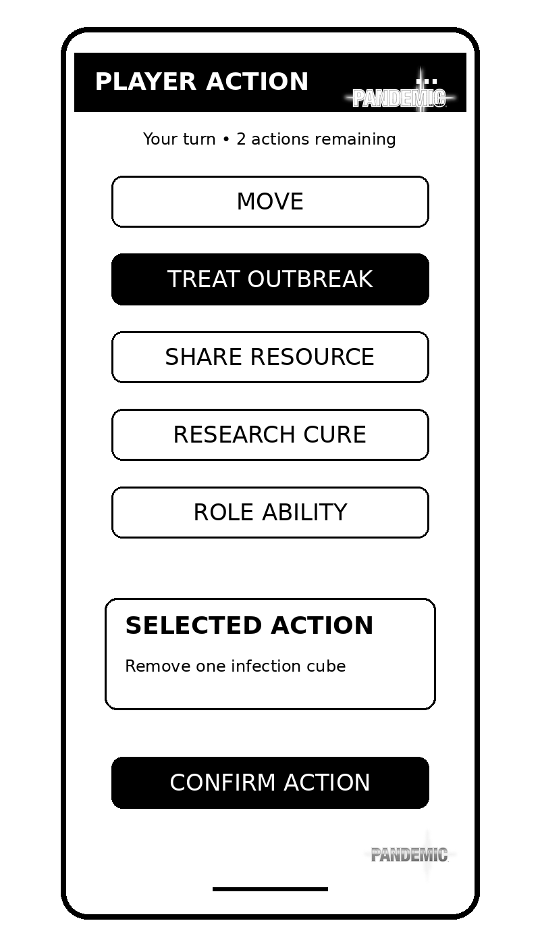
Figure 11 Player Action wireframe.

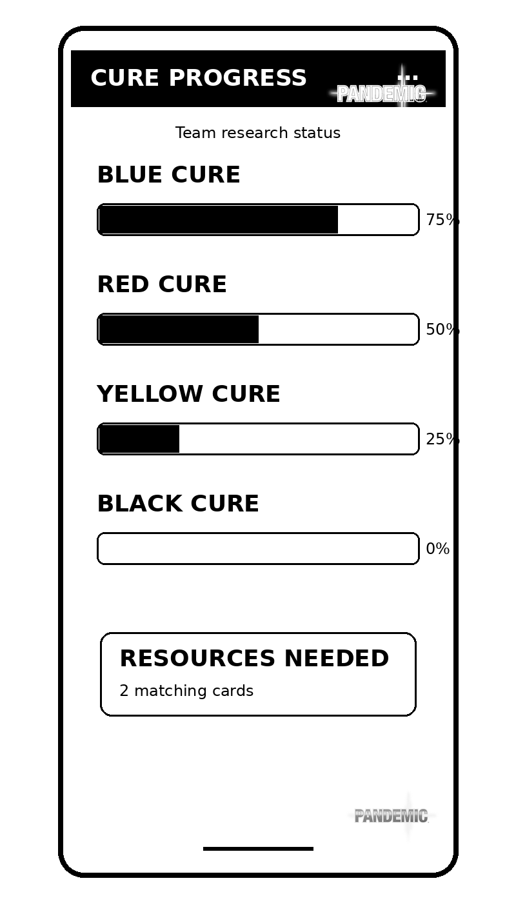
Figure 12 Cure Progress wireframe.

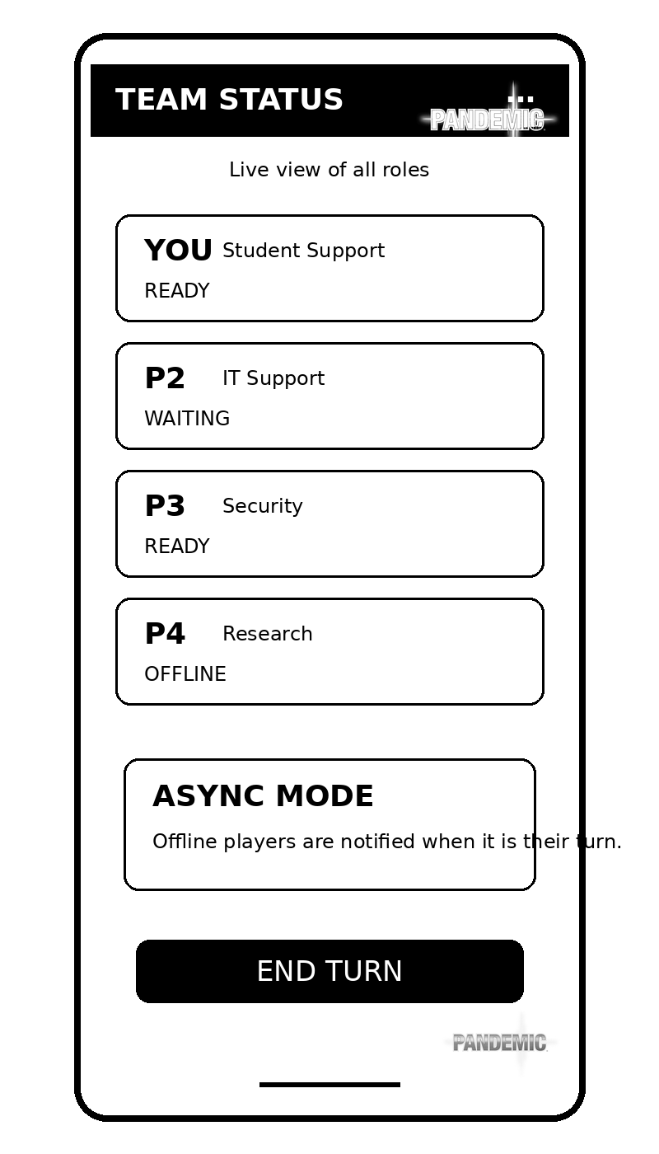
Figure 13 Team Status wireframe.

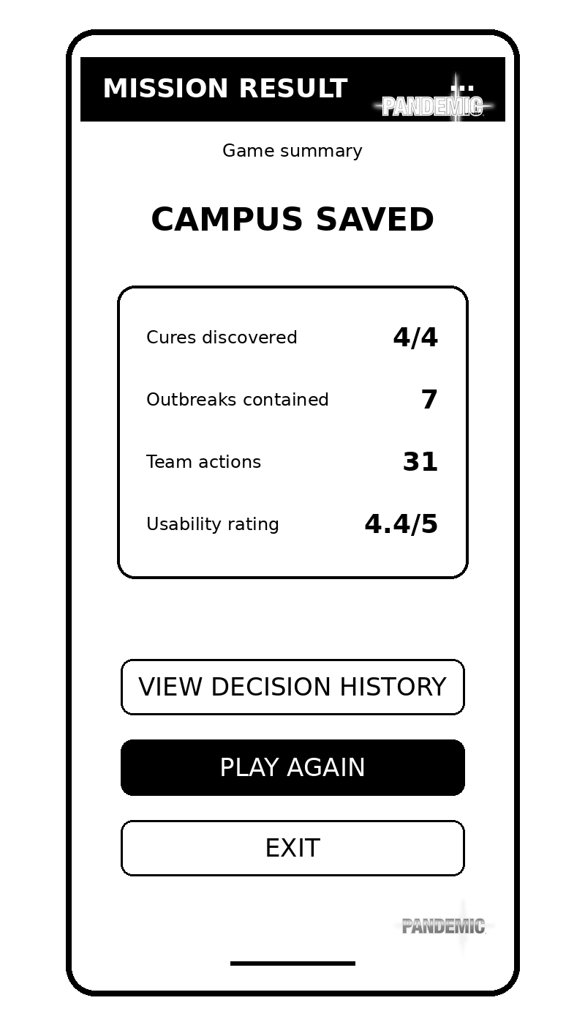
Figure 14 Mission Result wireframe.

Appendix E: Feedback Summary
This appendix will contain genuine questionnaire and usability-test evidence after data collection. The Cognito form will be completed after participants have viewed or used the black-and-white prototype. Results must include the participant total, positive and negative feedback, emotional response, accessibility comments and the design changes made from the evidence.

Appendix E.1: Cognito Forms Questionnaire

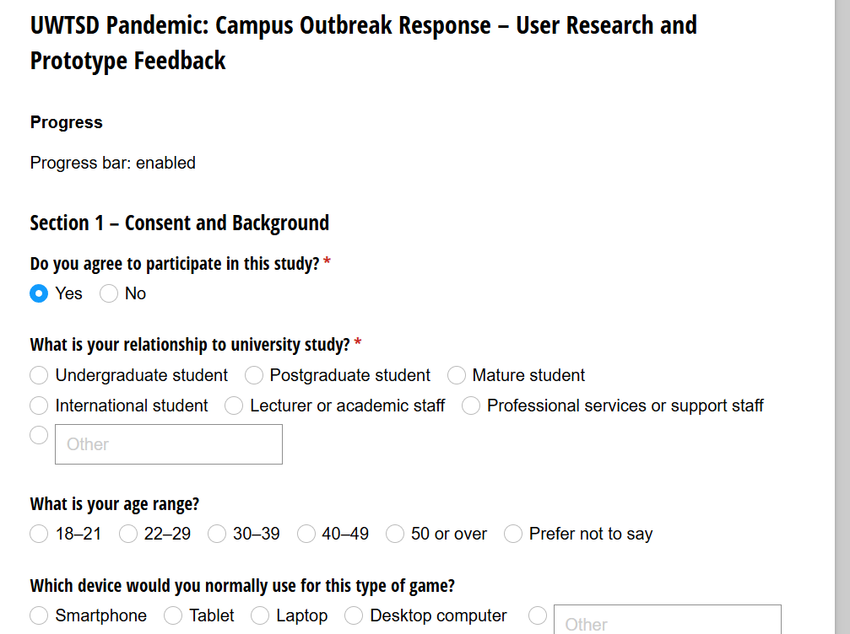

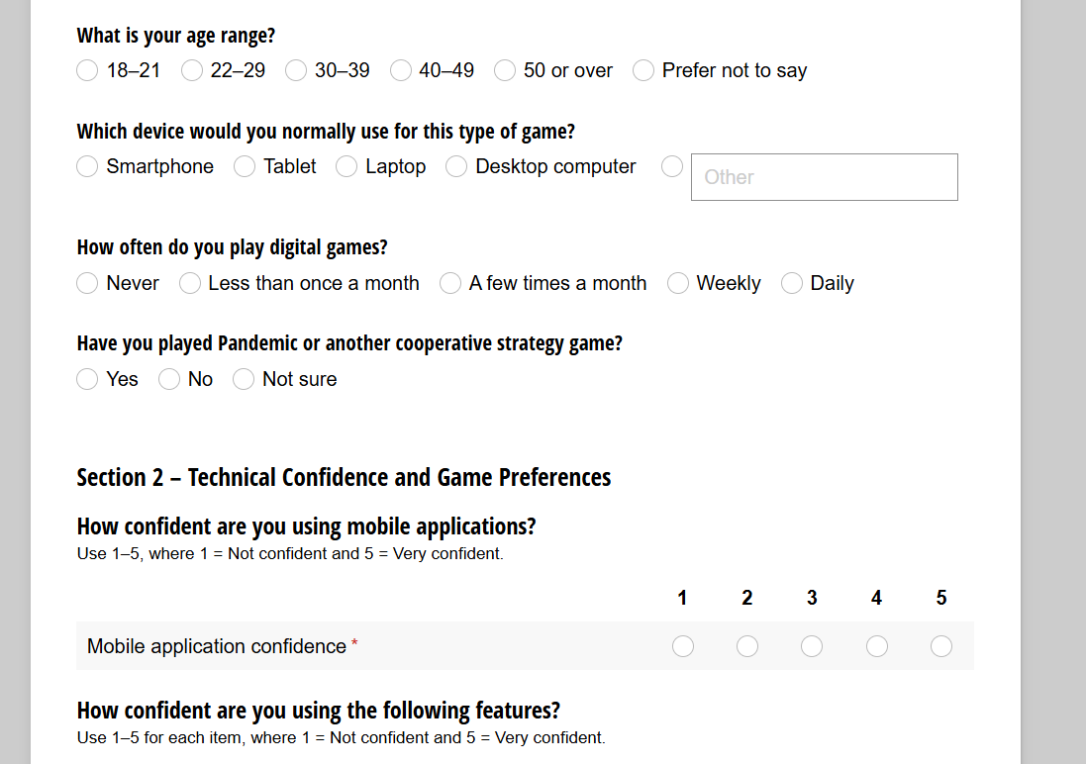

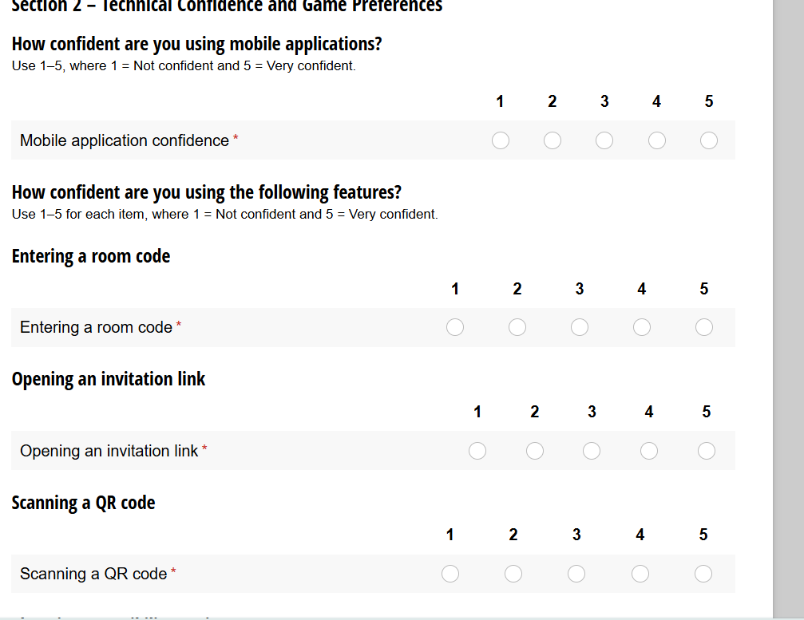

Cognito Forms link: UWTSD Pandemic: Campus Outbreak Response – User Research and Prototype Feedback

Appendix E.2: Black-and-White Interactive HTML Prototype
The black-and-white HTML prototype links five screens and demonstrates navigation and room-code validation.
It supports Component 1 testing; networking, AI and colour styling are reserved for later development.
Interactive prototype link: UWTSD Pandemic Prototype https://raw.githack.com/Oroshimaru1989/root/main/uwtsd-pandemic/index.html
Runnable file supplied separately: UWTSD_Pandemic_Black_White_Interactive_5_Screen.html

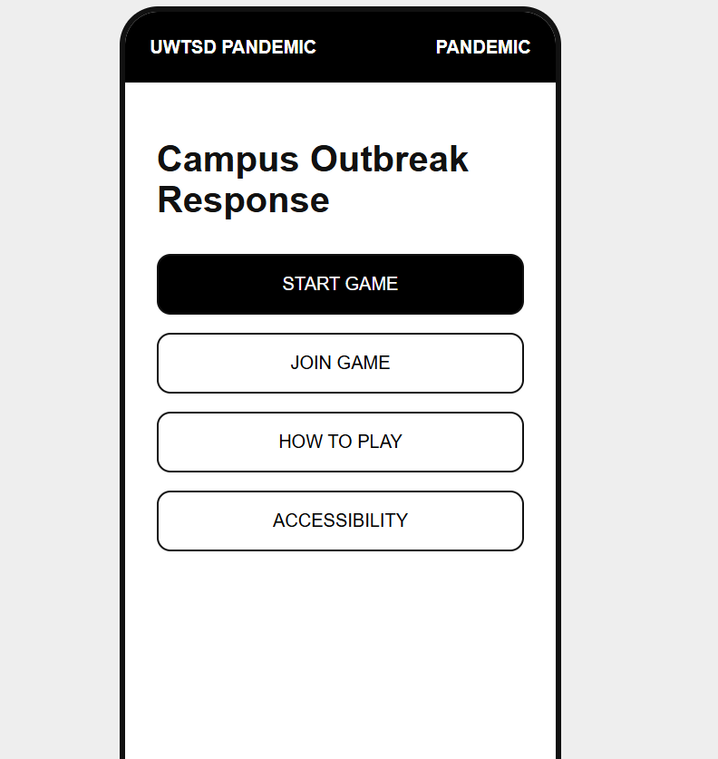
Figure E1. Black-and-white interactive prototype evidence and browser navigation.

Appendix F: Prototype Fidelity
Component 1 uses low-fidelity monochrome wireframes to test layout and navigation quickly [3], [4].
Fidelity level | Main purpose | Detail and interaction | Use in this project
Low fidelity | Test layout and flow | Simple monochrome linked screens | Component 1
Mid fidelity | Refine hierarchy | Improved spacing, icons and feedback | After testing
High fidelity | Simulate final design | Detailed visuals and realistic behaviour | Component 2

F.1 Low-Fidelity Start Screen
Figure F1. Low-fidelity start screen showing basic structure, labels and navigation.

F.2 Mid-Fidelity Start Screen
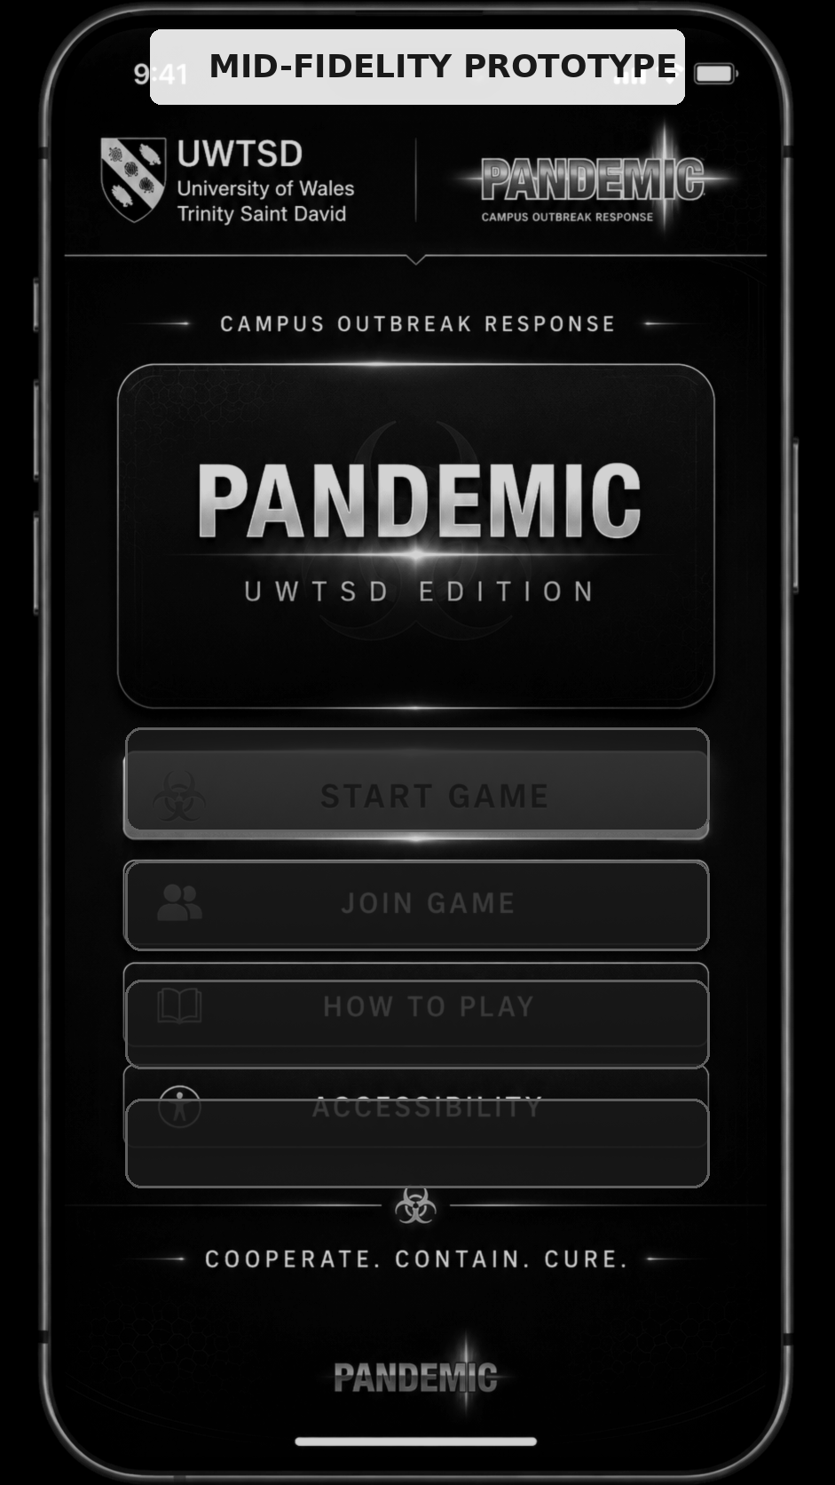
Figure F2. Mid-fidelity start screen showing refined spacing, icons and controls.

F.3 High-Fidelity Monochrome Preview
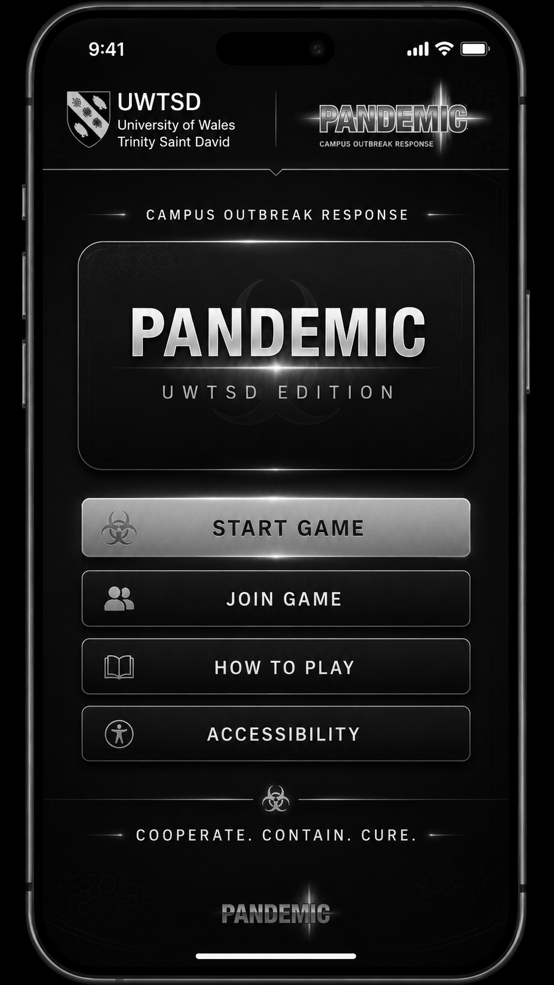
Figure F3. High-fidelity monochrome preview showing the intended visual hierarchy and realistic controls.
The low-fidelity screen is the assessed Component 1 artefact. The mid- and high-fidelity examples illustrate later development only; the final colour design remains reserved for Component 2.

