Student Name: [VASILE FLORIN BUZAN ]  Student ID: [2222994]  Module Title: Foreign Languages & Cultural Awareness  Module Code: BMIH5003  Lecturer: [Heidi Prosser]  Date: [05.02.2024] | 
ASSIGNMENT 1: PORTFOLIO
(4 Components)

Component 1: Professional Reflection (500 words +/- 10%)

Weighting: 25%
The hospitality sector welcomes visitors from all around the world. It survives on diversity. However, this variety also entails a duty to recognize (Alfons Trompenaars, 2019). We need to honor the subtle cultural differences among our visitors. We may establish a warm and inclusive atmosphere for every one of your visitors (Abramson and Moran, 2018). We need to acknowledge and honour cultural differences. It will not only improve their stay. It will help to give them outstanding hospitality (Cooper, 2020). Developing cultural awareness is an ongoing process (Barnard, 2019). Once I was in a situation where a miscommunication happened because of cultural differences.
I was excitedly taking on the early morning rush of breakfast at the hotel's rooftop. I was the manager of the multinational staff of waiters. It was a colourful blend of nations. However, a miscommunication developed at the coffee bar. I saw it and went to resolve the problem. An elegantly attired Japanese businessman walked up to the counter. "Atarashii...?" he said nervously, pointing to a hot saucepan. The waiter didn’t understand. So, he gave him a cup out of the boiling container. He thought he needed new beans. However, an intense frown appeared on his face. He turned his head and repeated "Atarashii" loudly. My knowledge of Japanese was simple hellos and basic commands. After a few desperate hand motions and awkward assistance from Google Translate. I understood “Atarashii" meant hot rather than fresh. Because of my inadequate language skills, I had made a confident assumption. It caused a little cultural mismatch (Maheshkar and Sharma, 2018). My narrow vocabulary had caused me to stumble over the subtleties of language. It was more than just words. So, I couldn’t resolve the issue.
Learning and Skills Development: This encounter acted as a trigger for transformation. I signed up for language classes with an emphasis on terminology. It was related to tourism and interpersonal proficiency. I also focused on active listening. It helps in bridging the communication gap. It uses open-ended inquiries and close observation (Chandan Maheshkar and Jayant Sonwalkar, 2023). I also did some cultural study to learn about the various customs. Additionally, I studied food habits around the world. Managing cultural variations in society. It's crucial to keep this in mind. Every nation has a variety of social cultures and ethnic groups. Acknowledging general national norms is beneficial. It is ready to modify your strategy in light of particular guest requirements and backgrounds.
Future-Proof Skills and Behaviors: I always greet each visitor with a healthy mix of curiosity and respect. I make an effort to actively listen. I tried to understand their requirements above the literal sense of words. This helped me to use non-verbal clues and clarify inquiries. I am using my cultural awareness and sincere desire to understand various customs. Ethnic contexts call for understanding, tact, and an open mind (Christiansen, Branch and Karnowski, 2020). Due to norms and standards of culture. Visitors from other countries may act significantly differently from those from the same country (Deresky, 2017).
References:
Abramson, N.R. and Moran, R. (2018). Managing Cultural Differences: Global Leadership for the 21st Century. 10th Ed. Abingdon: Routledge.
Alfons Trompenaars (2019). Riding the waves of culture [electronic resource]. London: Nicholas Brealey.
Barnard, J. (2019). Index to Cross-Cultural Research Volume 39. Cross-Cultural Research, 39(4), pp.433–434. doi:https://doi.org/10.1177/106939710503900405.
Chandan Maheshkar and Jayant Sonwalkar (2023). Handbook of Research on Cultural and Cross-Cultural Psychology. Vernon Press.
Christiansen, B., Branch, J.D. and Karmowska, J. (2020). Cultural Factors and Performance in 21st Century Businesses. IGI Global.
Cooper, C. (2020). Essentials Of Tourism.
Deresky, H. (2017). International Management: Managing Across Borders and Cultures: Text and Cases. 9th Ed.Harlow: Pearson Education Ltd.
Maheshkar, C. and Sharma, V. (2018). Handbook of Research
on Cross-Cultural Business Education. Hershey: IGI Global.

Component 2: Training Plan (500 words +/- 10%)

Weighting: 25%

Identified cultural misunderstanding (in a few words) :
Recent events have identified clear problems. Our diverse team needs to be more culturally sensitive to avoid miscommunication. It will provide outstanding support for customers from abroad. Developing cultural competency will improve our standing (Edgell, 2020). It will draw in more business, and foster an inclusive workplace (Hampden-Turner and Trompenaars, 2020). Many companies can help us to improve our understanding of different cultures. World Host is a UK-based company (Gelfand and Erez, 2023). It promotes competence in hospitality and travel. It provides a range of guest service initiatives (Hofstede and Minkov, 2010). Those services are intended to give professionals the abilities (Freire and Macedo, 2020). It gives the know-how required to handle foreign tourists (Nedelko, Brzozowski and Pablo, 2020). Hospitality workers may empower themselves to confidently handle foreign guests (Cooper, 2020). They put these extra tactics into practice. They put WorldHost courses into practice. This will guarantee that each visitor has a wonderful and welcoming experience (Deresky, 2017). Apart from that, ongoing training can be arranged within the organization. So, I made a training plan to educate our staff.

Training plan (Why/What//Who/Where/When):
Why | What | Who | Where | when
Avoid misinterpreting cultural differences. Fundamental abilities in guest service are needed. They range from solving issues and interacting to going above and beyond.  There are so many benefits to it. It increases patron loyalty and pleasure.  It improves collaboration as well as interaction among the team.  There is more income as a result of favorable word-of-mouth. It increases good evaluations from guests by repeats business. | - Need to develop interpersonal skills and an understanding of culture via engaging in classes on greetings, nonverbal signs, and dietary limitations.  - Need to grab all the chances to learn a foreign language (fundamental expressions in widely spoken guest languages)  - Need to use the cultural resources collection on the web  - Need to boost visitor happiness and experiences. Role-playing games with scenarios involving guests  - Need to make an effort to listen intently. We need to ask clarifying questions and modify our communication approach.  - Need to act out managing dietary limitations, religious concerns, and communication difficulties  - Need to boost unity and diversity by exchanging individual ethnic experiences and customs.  - Need to encourage teammates to value diversity. | Every employee  Every employee split up into smaller groups  Cultural exchange potlucks and celebrations. | Both an internet platform and a training room  Training area  Staff room or designated space | Phase 1: three weeks for the first training.  Quarterly events
Continuous improvement and feedback | - Post-training questionnaires and analysis of visitor input.  - We need to determine areas that require development. We need to modify the training program accordingly.  - Frequent interaction between employees and multicultural education We need to Promote | Every employee and management team. | All departments | ongoing

References:
Cooper, C. (2020). Essentials Of Tourism.
Deresky, H. (2017). International Management: Managing across Borders and cultures; Text and Cases. 9th ed. Boston, Mass. U.A.: Pearson.
Edgell, D.L. (2020). Managing sustainable tourism: a legacy for the future. London Routledge.
Freire, P. and Macedo, D. (2020). A Dialogue: Culture, Language, and Race. Harvard Educational Review, 65(3), pp.377–403. doi:https://doi.org/10.17763/haer.65.3.12g1923330p1xhj8.
Gelfand, M.J. and Erez, M. (2023). The Oxford Handbook of Cross-Cultural Organizational Behavior. IG publications.
Hampden-Turner, C. and Trompenaars, F. (2020). Riding the Waves of Culture. 4th Ed. London: John Murray Press.
Hofstede, G., Hofstede, G.J. and Minkov, M. (2010). Cultures And organizations: software of the mind. 3rd Ed. New York: McGraw-Hill.
Nedelko, Z. and Brzozowski, M. (eds) ‘Recent advances in the roles of cultural and personal values in organizational behavior’ in Ordóñez de Pablo, P. (2020). Advances in Human Resources Management and Organizational Development Book Series. Hershey: IGI Global.

Component 3: Student Self-Reflection (500 words +/- 10%)

Weighting: 25%
My path to my internship, I understood how cultural awareness is needed in the tourism sector. Previously, my unawareness resulted in inadvertent errors such as misreading hand signals, and failing to notice the limitations (Inkson and Minnaert, 2018). I used realizing how crucial cultural sensitivity is to the hospitality sector. At first, I had a really basic conception of cultural awareness. I learned a lot about cultural differences and sensitivity in my internship program. Throughout to give advice based on my own beliefs. The pivotal moment occurred on a day. I was interning at Premier Inn Hotel. I once assisted a Japanese pair. They seemed reluctant to start eating because they had ordered an international dish. I thought they were picky consumers. But my presumption was wrong. However, a co-worker who saw my error of judgment stepped in. She realized that the pair was ignorant of appropriate manners and the cutlery. Their fear was replaced with smiles and delight with a short example. She gave a couple of sentences of encouragement to make them comfortable. My complacency was crushed by this experience. It broadened my thinking process. Also, the possibility of offending was clear. My curiosity was piqued by shame.
This incident pushed me to explore more through reading and discussions. I participated in online classes on intercultural interaction and consumed materials on ethnography. I sought out other viewpoints from visitors and co-workers. With every exchange, my comprehension grew. I gained knowledge about the complex dance of nonverbal communication. I learned the value of food customs and the influence of individual space preferences. I saw first-hand the benefits of cross-cultural understanding (Hofstede and Minkov, 2010). I worked on the difficulty of my miscommunication and the transformational force of true empathy.
There is one particular discussion that sticks out. A Saudi Arabian couple was reluctant to join the buffet. Because they hadn't been familiar with buffet etiquette. Rather than supposing they were uninterested, I greeted them with a warm smile and proceeded to help them. I navigate the selections by outlining the regional cuisine. Their initial fear disappeared to be replaced by interest and chuckles. By relating their ethnic culinary customs, they enhanced the encounter and fostered a bond that grew between them (GLOBE, 2019). These encounters made me realize that cultural sensitivity is an essential talent for providing outstanding hospitality. It is not merely an item to check. It's about appreciating each guest's intrinsic value, no matter what their circumstances. It's about tearing down our society's blind spots and erecting sympathetic and understanding bridges.
My quest for cultural comprehension remains an ongoing one. It is driven by curiosity, humility, and a dedication to development (Gelfand and Erez, 2023). Every encounter, error, and intimate moment has imparted a priceless lesson (Jackson, 2018). It has molded me into an increasingly considerate and welcoming hospitality expert. Even though this road is far from done, the lessons I've learned will always be with me. I work to create a warm and inviting atmosphere. I make sure each visitor is appreciated, seen, and feel completely at home.
References:
Gelfand, M.J. and Erez, M. (2023). The Oxford Handbook of Cross-Cultural Organizational Behavior. IG publications.
GLOBE (2019). GLOBE Project. [online] Globeproject.com. Available at: https://globeproject.com/.
Hofstede, G. and Minkov, M. (2010). Cultures and organizations: software of the mind: intercultural cooperation and its importance for survival. 3rd ed. New York; London: Mcgraw-Hill.
Inkson, C. and Minnaert, L. (2018). Tourism Management. SAGE.
Jackson, T. (2018). Is cross-cultural management studies morally mute? Cross-cultural management and ethics. International Journal of Cross Cultural Management, 14(3), pp.267–269. doi:https://doi.org/10.1177/1470595814560968.

Component 4: Training Presentation (6 Slides)

Weighting: 25%
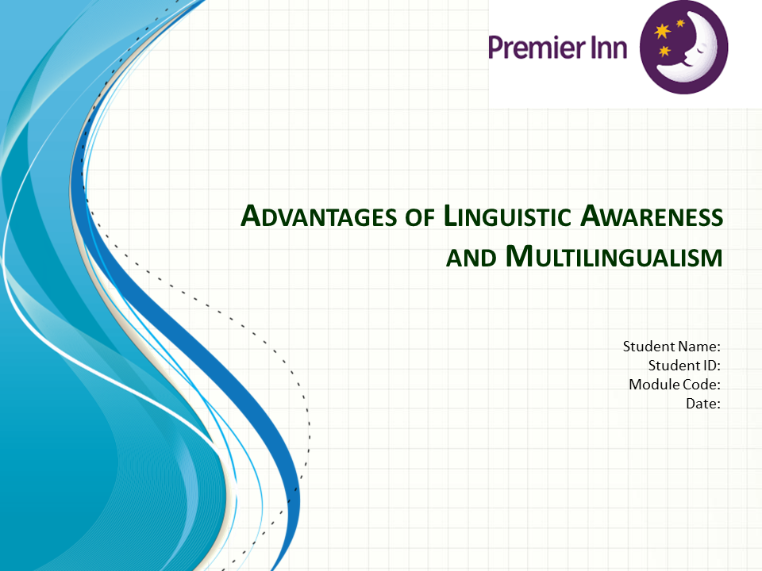
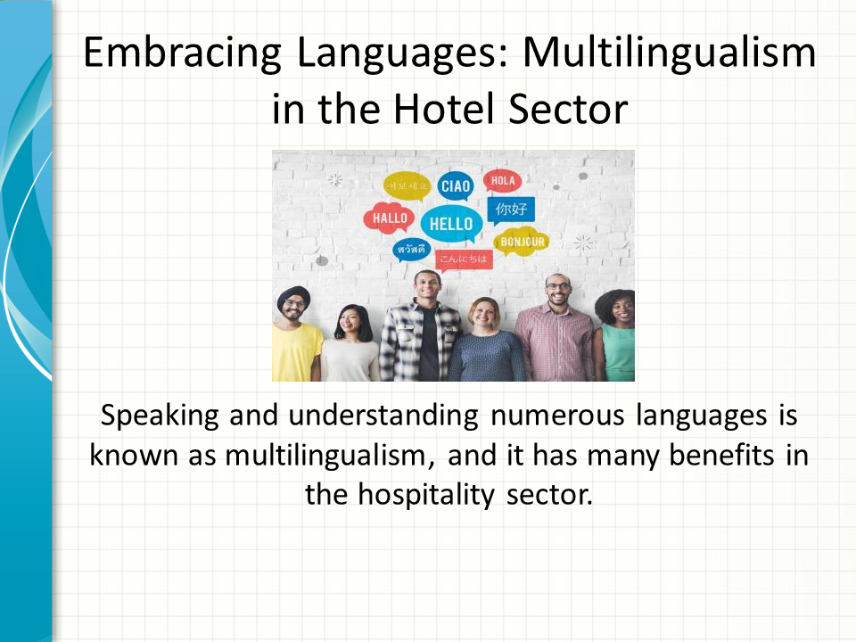
Speaking and understanding numerous languages is known as multilingualism. It has many benefits in the hospitality sector, especially for hotels that host visitors from outside. To avoid miscommunication and cultural errors, we need to learn many languages. It can effectively upsell customers on Premier inn’s services and packages in their native tongue (Premier inn, 2019). So, it could result in increased revenue generation. If we want to get a competitive advantage in the global market, we need to be multilingual. It will help us stand out from the competition and enter emerging markets in the current international travel industry.
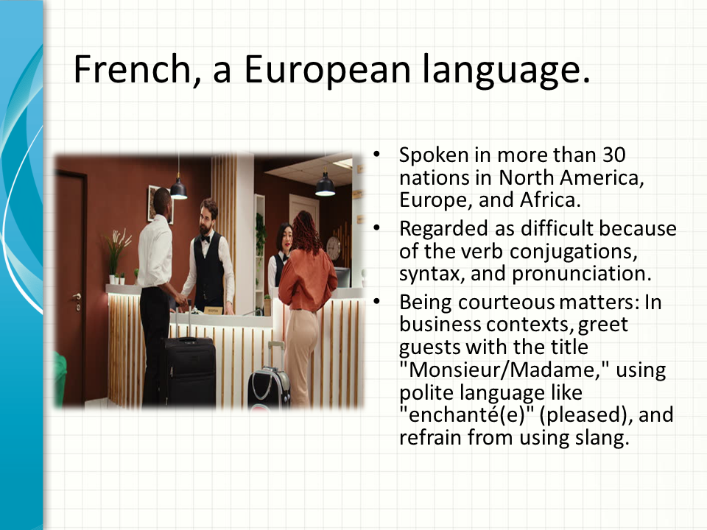
France is a global leader in luxury products, medicines, aircraft, and other industries, and it has the seventh-biggest economy in the world (Luthar, 2019). Proficiency in French is therefore extremely important among those wishing to work in these fields. It is spoken in more than 30 nations in North America, Europe, and Africa. It is regarded as difficult because of the verb conjugations, syntax, and pronunciation. In French, Being courteous matters. In business contexts, greet guests with the title "Monsieur/Madame," using polite language like "enchanté(e)" (pleased), and refrain from using slang. For example, let’s think of a couple checking in from France. A simple greeting in French will make a good first impression and give visitors a sense of importance and comprehension.
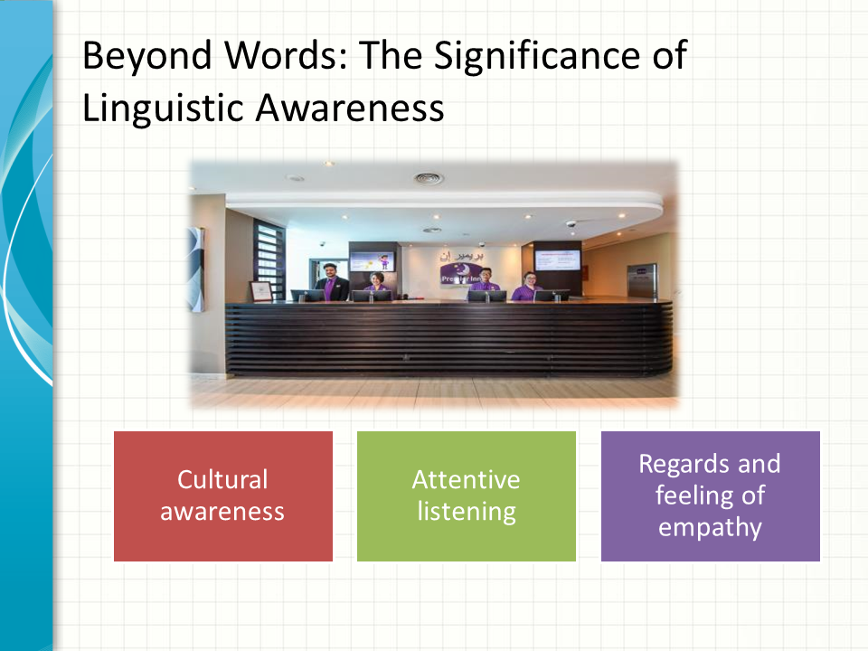
Language proficiency is only one aspect of multilingualism. Other aspects include:
Cultural awareness: We need to be aware of the manners, diets, and greetings. These are unique to each language.
To prevent misconceptions, actively listen, and take note of nonverbal clues. We need to ask clarifying questions when it is necessary.
Regard and feelings of empathy: Be genuinely concerned about the requirements of our guests and modify our message to suit their comfort level.
For example, it’s difficult for a Chinese visitor who needs to speak more English to order breakfast. Providing a menu with pictures or indicating well-known selections demonstrate cultural awareness (Jackson, 2018). It builds confidence.
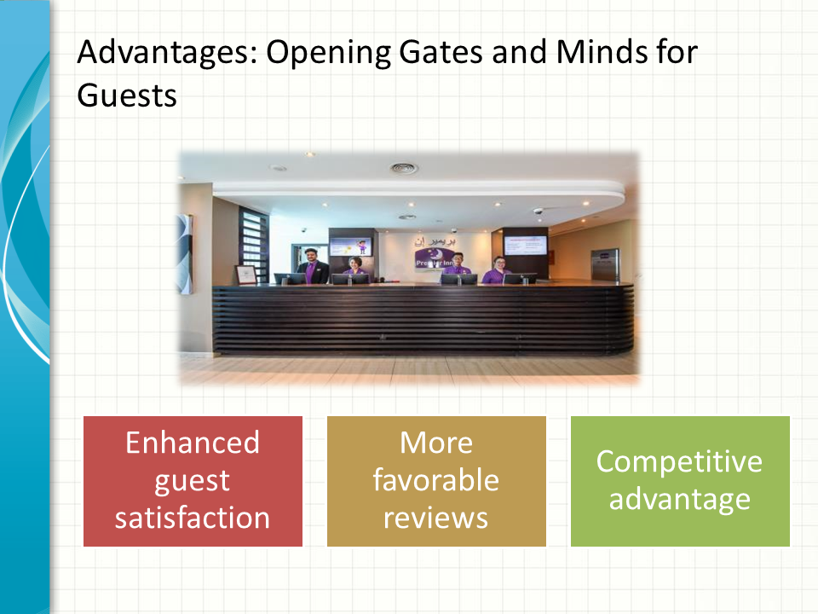
Awareness of languages and workers with multiple languages bring:
Enhanced guest satisfaction: A more seamless and customized level of interaction makes guests' stay more enjoyable.
More favorable reviews: It develops a relationship with visitors resulting in more powerful online recommendations.
Competitive advantage: It draws visitors from a variety of areas and meets their unique requirements.
For instance, we have guest from Spain and we have multilingual receptionists. They can makes suggestions based on the artistic preferences of Spanish relatives elderly. He or she will enable them to enjoy a wonderful day exploring the sights of the area (Inkson and Minnaert, 2018). It will be more comfortable for them and they will feel like home.
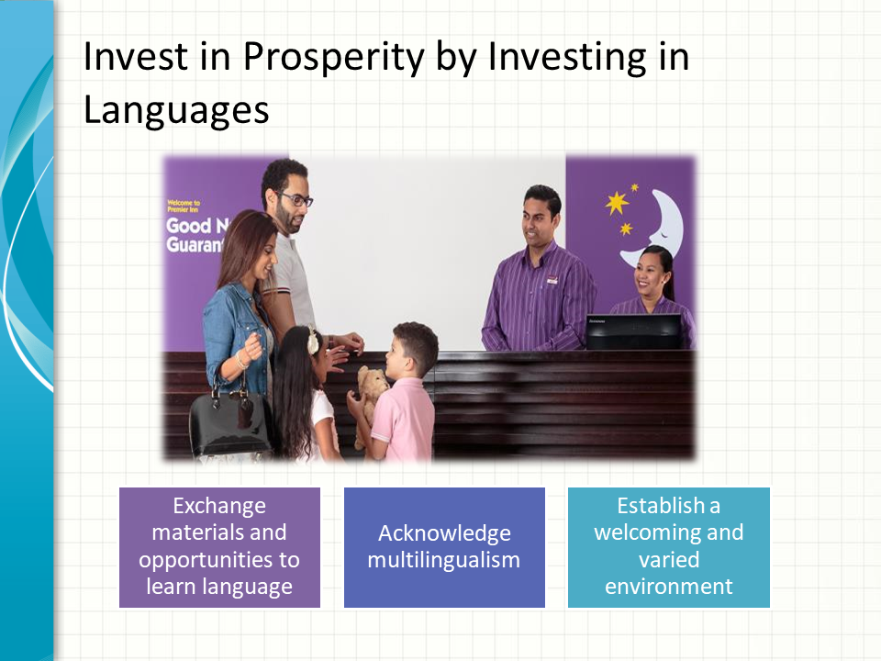
We can create a multilingual team in the following ways:
Promote learning a language by providing in-person instruction, books, online materials, or exchange opportunities.
Acknowledge multilingualism: We need to encourage each other to speak and learn different languages. We need to interact with guests in multiple languages.
Establish a welcoming and varied environment: We need to honor the team's diverse linguistic and cultural backgrounds.
For Example, A multilingual staff member helps another Arabic-speaking client in need of medical attention (Hofstede and Minkov, 2010). He or she can offer vital interpretations and cultural advice, demonstrating our dedication to caring for their needs.
Let's Change Things. Recall that learning a fresh tongue is a lifetime endeavor. Together, we can greet each "Bonjour" with genuine warmth. We can appreciate differences and foster curiosity in everyone.
References (no screenshots):
Hofstede, G. and Minkov, M. (2010). Cultures and organizations : software of the mind : intercultural cooperation and its importance for survival. 3rd ed. New York ; London: Mcgraw-Hill.
Inkson, C. and Minnaert, L. (2018). Tourism Management. SAGE.
Jackson, T. (2018). Is cross-cultural management studies morally mute? Cross-cultural management and ethics. International Journal of Cross Cultural Management, 14(3), pp.267–269. doi:https://doi.org/10.1177/1470595814560968.
Luthar, A. (2019). BBC - Learn Spanish with free online lessons. [online] www.bbc.co.uk. Available at: https://www.bbc.co.uk/languages/spanish/.
Premier inn (2019). Premier Inn Doha Education City. [online] www.luxuryhotelsguides.com. Available at: https://www.luxuryhotelsguides.com/?hotelid=2127309&gad_source=5&gclid=EAIaIQobChMI9pPD3LSHhAMVK6VmAh094QixEAAYASAAEgJlpPD_BwE [Accessed 31 Jan. 2024]

