Slide 1 – Introduction
Good morning, my name is Emma and I help oversee the daily running of the People Services department at Admiral Group Plc. One of the leading organisations within the insurance sector and currently sitting in second place as The Sunday Times: Best Companies to work for 2017 (Dey, 2017). I want to show you how with the help of managers and staff, the People Services department has but in place strategic methods that help us maintain a high standard of happy staff.

Slide 2 – Objectives
Focusing on the UK subsidiaries of Admiral Group (Admiral Insurance, Diamond Insurance, Gladiator Commercial, Elephant Insurance, Bell Insurance & Confused.com); I will discuss with you how, by adhering to our 4 key objectives Admiral Group has maintained a high standard of employment and how we attract, develop and retain each of our valued members of staff.

- Communication
- Equality
- Reward and Recognition
- Fun

Open slide 3

Since launching 25 years ago, Admiral Group has always maintained its philosophy that: “People who like what they do, do it better” (Admiral Group Plc, 2017). We want our employees to enjoy coming to work each day and so we like to incorporate fun in the work place.

Slide 3 - Culture
Since the introduction of the Ministry of Fun (MOF), we have been able to ensure everyone has the opportunity to take part in department and companywide competitions, free events and major celebrations. It is run by employees from telephonists to higher management.

The Ministry of Health (MOH) is in place to promote health and wellbeing within Admiral Group by providing our employees with free fruit, cholesterol and blood pressure checks, subsidised flu jabs and free eye tests. We also support the mental health campaigns and provide external help to those in need. These are just a few of the benefits given to our employees.

As a part of Admiral Group individuals become shareholders. With a dividend payment, twice a year and the chance to gain more shares through performance related incentives, it is high up on the list of benefits when working for Admiral Group.

We want the most from our employees and the way we see it, if you respect your employees, it is reciprocated in hard work and dedication.

As you can see from our most recent survey of over 6000 UK staff, Admiral Group is a great company to work for.
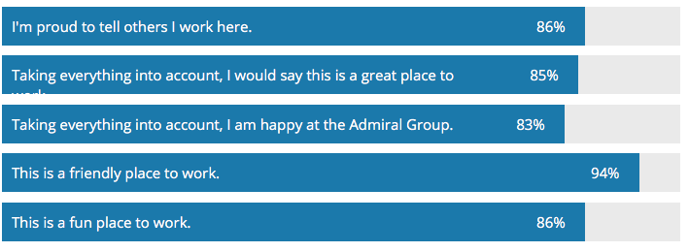
(Admiral Group Plc, 2017)

(Hargreaves & Lansdown, 2018)

Slide 4 -Organisation Objectives
Like all organisations, big or small our priority is to create satisfied customers and happy staff. With over 2 million customers in the UK alone it is paramount that exceptional service is provided. We are moving on from the days of our old systems of I90 and Vectus to a new, more consumer and staff friendly system via Guidewire (Admiral Group Plc, 2016) this will streamline policy details to enable our trained staff to reduce the time a policy holder should spend on the phone to us.

We listen to our staff and customers. We want to know what their thoughts and feelings are about our service and how we can adapt to ameliorate the organisation.

As you can see from our survey, our customers are satisfied and we have exceeded targets set.
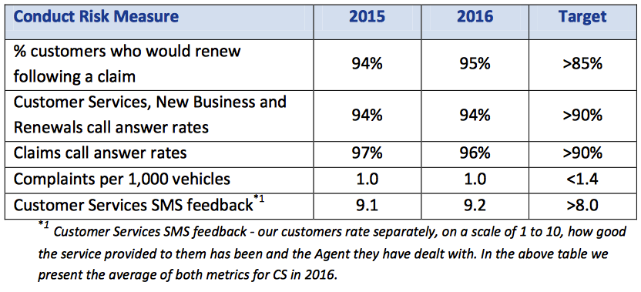
(Admiral Group Plc, 2016)

Of course, our overall objective is to become the UK’s leading insurer and employer!

Slide 5 -Brand Values
Our reputation is not only based on the level of insurance we offer but the expert level of service our staff provides. Staff are the brand ambassadors of an organisation and if we didn’t maintain the high standards and pride in our staff we would not be as successful as we are. An organisation is nothing without hard working, dedicated individuals.

As based on the feedback statistics, customers are happy in the knowledge that they can pick up the telephone to us and we will do all we can to help with their enquiry and not pass them from pillar to post.

Although we have adapted over the years, our commercials represent us as a lively and approachable company. We even use a lot of our own staff in our commercials. We want our consumers to trust that when they call us we will do everything in our abilities to give them the service they deserve.

Our staff believe in our values and working as part of a team to get the job done!

Slide 6 – Attract
We are an organisation which is keep to keep up with the times. We advertise positions in various ways. We still advertise via the press however; our HR team and managers like to get out to meet prospective employees at job fairs across Cardiff, Swansea, Newport and surrounding areas. We also hold open days for people interested in the Admiral way of life. Our last open day in September 2017 proved very successful (Admiraljobs, 2017) and is something we will keep up. We advertise through social media, it’s such a huge part of life and so we thought ‘why not?’. Our most successful recruitment venture was setting up Admiraljobs.co.uk, where we offer an insight of the Admiral Group, it’s staff and benefits.

We also encourage our staff to recommend us if they are happy and we reward that member of staff as well as the applicant if successful.

Slide 7 – Engage
What makes us different?
We are not an ‘us and them’ organisation. We pride ourselves on treating each member of staff as equals and as such follow the principle of an open floor policy. Our managers, including operations managers sit amongst everyone else. This helps them keep in touch with what their teams need on a daily basis. Our CEO David Stevens CBE, is often seen on the floors in the different sites, speaking and laughing with staff and taking the occasional telephone call. He never expects anyone to do anything he isn’t happy to do himself. It is a standard set by his predecessor and company founder Henry Engelhardt.

All levels of staff interact with one and other.

Slide 8 – Training & Development
In 2006 we introduced the Admiral Academy where we train all staff and are proud to be able to offer industry recognised qualifications in partnership with the Institute of Leadership and Management (ILM) (Admiral, 2018) .

Once initial training and a probationary period is completed staff are invited to take part in a variety of courses from improving customer relation skill to Welsh and even doing a degree. We have over 100 training programmes, courses and workshops. Why not have a look at our web page on Admiraljobs.co.uk.

Regardless of whether an individual needs further training to do their role more efficiently or wants to further their career within the organisation, we will always help where we can.

We are passionate about our staff and provide them with any means necessary to help them reach their goal.

To steal a phrase from Richard Branson, we want to “Train people well enough so they can leave, treat them well enough so they don’t want to” (Branson, 2014).

Slide 9 – Retaining
The benefits of being part of the Admiral Family
From previous statements and slides we can see that staff are predominantly happy to come to work each day because we strive to provide a happy environment to work in. We also like to give back to our hard-working staff by offering a variety of benefits. Not only do we have the benefits of the MOF & MOH but many more:
Free annual eye test
Free gym membership
Buy a book scheme
Childcare vouchers
Staff discount
Free life insurance
Moving home advance
Workplace Indian head massage
Subsidised parking
Tickets to local events, the list goes on.

Not forgetting the shares: With up to £3,600 worth of shares awarded to staff each year the shares scheme has become one of the most popular benefits of being part of the Admiral Group.

In partnership with the Chartered Institute of Personnel and Development (CIPD) we work hard to improve quality of work and give staff a voice.
We are committed to our staff and feel that it is this commitment that allows us to be successful in retaining valued members of staff and maintaining our position with a competitive advantage for employment.

Slide 10 – Conclusion

We pride ourselves in upholding the four categories of the Admiral working culture (which we have covered today): Communication, Equality, Reward and Recognition and Fun. By maintaining a high standard in these we will continue to develop and improve our already successful strategies.

Value each member of staff for without them your organisation will crumble. Put the effort in to knowing who your staff are and how you can help them develop their skills and knowledge to the best of their ability.

So, when you leave here think, think about how you would expect your organisation to treat you and how you can pass that on to your colleagues. Thank you for taking to time to listen to me this morning.

Are there any questions?

Slide 11 – References

Works Cited
Admiral Group Plc, 2016. 2016 Corporate and Social Responsibility Report, s.l.: s.n.
Admiral Group Plc, 2016. Our Customers, s.l.: Admiral Group HR.
Admiral Group Plc, 2017. Our Business: BUSINESS MODEL & STRATEGY. [Online]
Available at: https://admiralgroup.co.uk/our-business/business-model-strategy
[Accessed 04 01 2018].
Admiral Group Plc, 2017. OUR CULTURE / OUR STAFF SURVEY. [Online]
Available at: https://admiralgroup.co.uk/our-culture/our-staff-survey
[Accessed 04 01 2018].
Admiral, 2018. Admiral Academy. [Online]
Available at: https://admiraljobs.co.uk/inside-admiral/post/56/Admiral-Academy-develops-top-talent
[Accessed 08 01 2018].
Admiraljobs, 2017. Admiral Open Day: 30th September 2017. [Online]
Available at: https://admiraljobs.co.uk/inside-admiral/post/245/Admiral-Open-Day:-30th-September-2017
[Accessed 05 01 2018].
Branson, R., 2014. Look after your staff. [Online]
Available at: https://www.virgin.com/richard-branson/look-after-your-staff
[Accessed 05 01 2018].
Dey, I., 2017. Appointments. [Online]
Available at: http://appointments.thesundaytimes.co.uk/article/best100companies/
[Accessed 04 01 2017].
Hargreaves & Lansdown, 2018. Share prices & stock markets: Admiral Group (ADM). [Online]
Available at: http://www.hl.co.uk/shares/shares-search-results/a/admiral-group-ord-gbp0.01
[Accessed 19 01 2018].

