LCBB5015 Principles of Marketing
Component 1: Coursework: Individual Report
Company: Admiral Group
Student Name: Xenia Costea
Student ID: 2422705

Table of Contents
1. Introduction 3
2. Situational Analysis 4
3. Critical Analysis and Evaluation 5
4. Conclusion 7
5. References 9

1. Introduction
Introduction to the chosen organisation: The selected organisation is the Admiral Group, which is a foremost UK-based financial services organisation that is in the insurance sector, with its head office in Cardiff, Wales. The company was established in the year 1993, and its main business is the provision of motor, home, travel and pet insurance, plus personal lending services (Admiral Group Plc, 2026). As of 2024, Admiral has a customer base of more than 11.1 million people, and it has around 13,000 employees (Admiral Group Plc, 2025). The company also posted a group turnover of £6.15 billion and a profit before tax of about £839 million (Admiral Group Plc, 2025). Admiral is a firm player in the motor insurance market in the UK, as a result of competitive pricing and online capabilities.
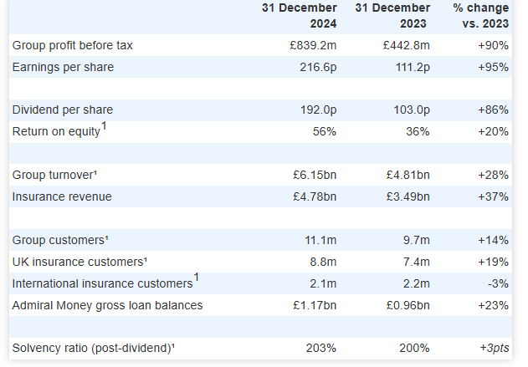
Figure 1: Admiral Group 2024 Results Highlights
Source: (Admiral Group Plc, 2026)
Purpose of this report: The purpose of this report is to perform a situational analysis of Admiral Group in terms of the Five Forces model developed by Porter. This analysis is done to review the competitive environment within which the company conducts its business decisions by analysing the major forces that are present in the industry, including competition, supplier power, buyer power, and threat of substitutes and new entrants.

2. Situational Analysis
The chosen situational analysis model for this organisation is Porter’s five forces. The Five Forces model created by Michael Porter is a strategic tool that is applied in the analysis of industry competitiveness with the help of five forces (The Strategy Institute, 2024).
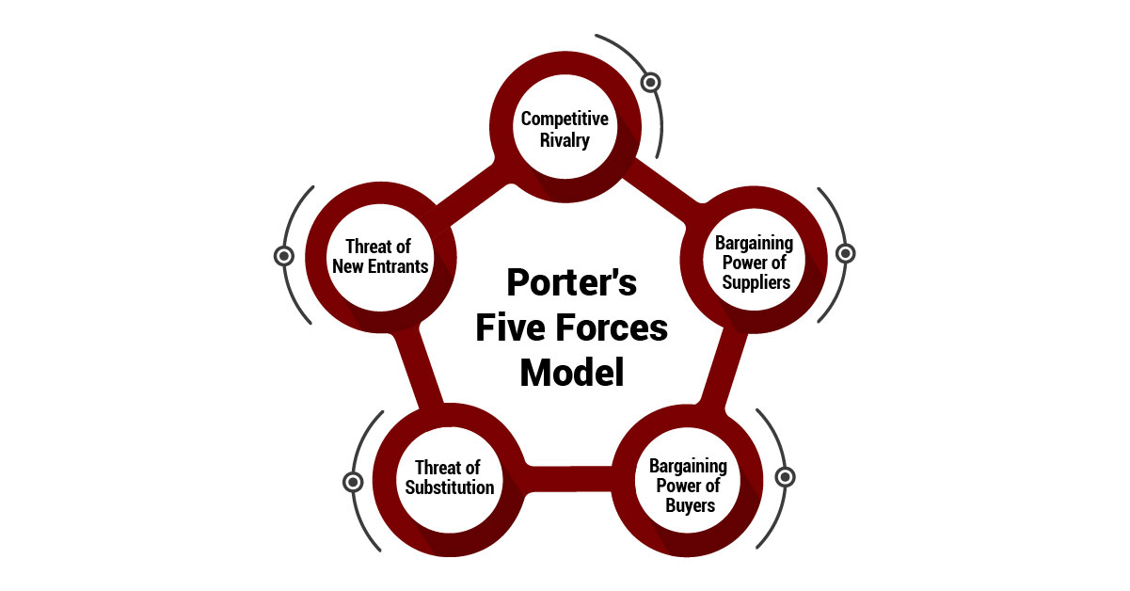
Figure 2: Porter’s five forces model
Source: (The Strategy Institute, 2024)
Threat of New Entrants: Low to Moderate: The UK motor insurance market is highly concentrated, with the top 10 insurers taking more than three-quarters of all market shares, which poses a high barrier (Smith, 2026). Moreover, new firms are restricted by regulatory provisions of the Financial Conduct Authority (FCA) and high capital investment requirements. Entry is also discouraged by brand recognition and economies of scale.
Bargaining Power of Suppliers: Moderate: Suppliers consist of reinsurance companies, repair networks and technology/data suppliers. Admiral Group is known to hold its strong financial position, which is reflected in a solvency ratio of nearly 203%, and that mitigates dependency on any single supplier (Admiral Group Plc, 2025). Nevertheless, the cost of car repairs and the need to outsource those services make suppliers more influential, particularly in times of inflation.
Bargaining Power of Buyers: High: Buyers have high power because of price comparison websites and low switching costs. In the UK, consumers are often able to make comparisons of policies online, and this compels insurers to engage in heavy price competition. Admiral Group's Customer Satisfaction (CSAT) score was rated 9% reflects moderate loyalty (Comparably, 2025). This indicates that the buyers can also readily change to other competitors that can offer them superior value.
Threat of Substitutes: Low: Motor insurance does not have many direct substitutes as it is legally required in the UK. Nevertheless, competing mobility trends like ride services and other means of transportation like buses indirectly influence the demand for car ownership, thus minimally affecting the insurance demand in the long run.
Rivalry in the Industry: High: Competition is fierce with Admiral owning approximately 13-14% of the market share and is in direct competition with other large companies such as Aviva and Direct Line (Beinsure, 2026). Price wars, mergers (such as expansion by Aviva), and aggressive digital strategies drive up competitiveness, putting pressure on profit margin and differentiation of marketing.

3. Critical Analysis and Evaluation
Critical Analysis of Situational Findings: The results of Porter's Five Forces analysis reveal that the environment in which Admiral Group is operating is highly competitive and price sensitive. Competition is further heightened by the presence of more established insurers and the small differentiation of core products. An example would be the UK motor insurance industry, which saw a claims inflation rate of more than 37% in 2023, as repair and labour costs have increased, reducing the profit margin of insurers (Fca.org.uk, 2025). This implies that pricing strategies are limited by external cost pressures, as well as stern competitive rivalry.
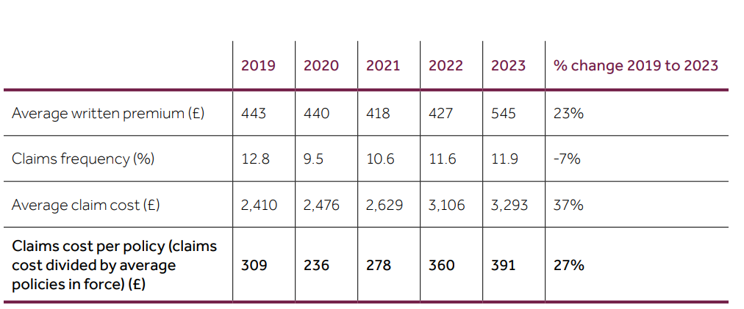
Figure 2: Average written car insurance claim
Source: (Fca.org.uk, 2025)
Impact on Strategic Decision-Making and Overall, Success: These are the competitive forces that have greatly influenced the strategic choices at Admiral, especially pricing, client attraction, and online growth. The firm has to strike a balance between its affordability and profitability as it reacts to regulatory action, including the FCA pricing reform that started in 2022 (FCA.org.uk, 2025). This prohibited price walking and changed the competitive balance. It has made the pricing more transparent and less able to provide selective discounts by the insurers. Moreover, there were nearly 1,394,000 licensed zero-emission vehicles on the road at the end of 2024 (GOV.UK, 2024).
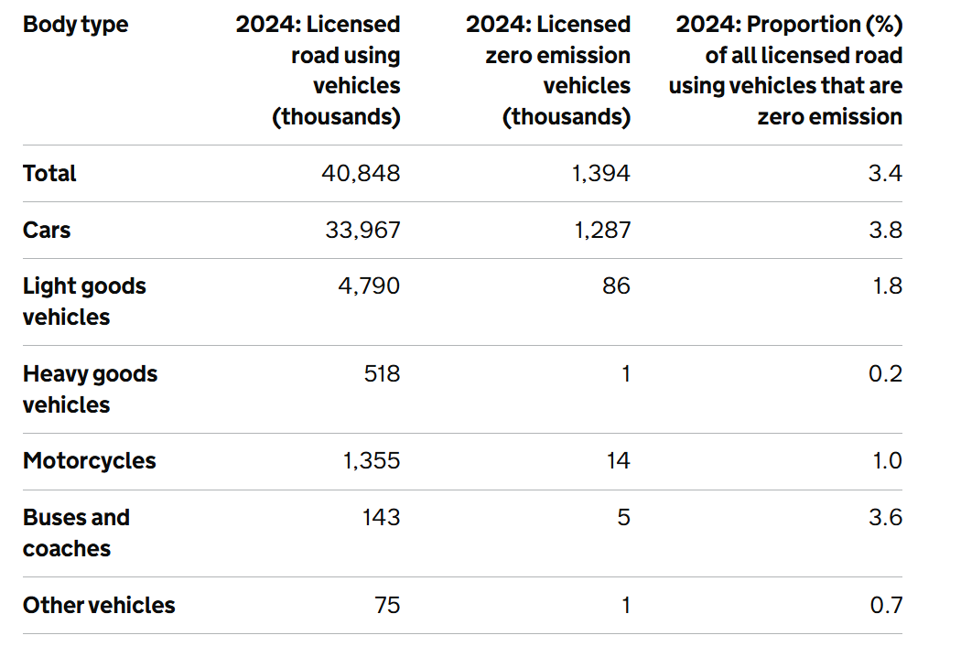
Figure 3: Licensed road using vehicles and licensed zero-emission vehicles
Source: (GOV.UK, 2024)
Application of Academic Theories and Industry Context: Theoretically, Porter's Generic Strategies imply that companies need to develop a competitive advantage by cost leadership or differentiation. This is in line with the multi-brand strategies that Admiral implements, as it is used to reach various customer groups. As per Recamara (2025), nearly 89% of insurers are now investing in digital initiatives, which indicates the increased significance of technological resources. This backs the argument that the sustainability of the success of Admiral will be through exploiting distinct resources to beat the competition in a flooded market.

4. Conclusion
Summary of key findings: The analysis has shown that in the UK insurance sector, Admiral Group has been trading in a highly competitive and price-sensitive environment with a high level of rivalry, buyer power and moderate supplier power, and entry barriers offer a certain amount of structural stability. These forces are important in determining the strategic positioning of the company and bringing forth the necessity of constant innovations and efficiency advancements.
Recommendations: On the basis of these results, it can be recommended that by tailored pricing, better loyalty programs and better service delivery, Admiral can be recommended to become more aggressive in terms of customer retention methods. Moreover, further investment into digital technologies and data analytics will contribute to more effective risk evaluation, performance, and competitive advantage in a saturated market.
Reflection on the important: On the whole, this report shows that situational analysis is essential in strategic planning, given the fact that it helps organisations to identify external pressures, make decisions based on facts and remain competitive in dynamic industries in the long term.

5. References
Admiral Group Plc (2025) Admiral FY24: Admiral Group reports excellent 2024 performance with strong growth in customers, turnover and profit and good strategic progress, Admiral Group Plc. Available at: https://www.admiralgroup.co.uk/news-releases/news-release-details/admiral-fy24-admiral-group-reports-excellent-2024-performance/ (Accessed: 20 March 2026).
Admiral Group Plc (2026) About Us, Admiral Group Plc. Available at: https://admiralgroup.co.uk/our-business (Accessed: 20 March 2026).
Beinsure (2026) Largest UK car insurance companies in 2026, Beinsure. Available at: https://beinsure.com/ranking/largest-uk-car-insurance-companies/ (Accessed: 20 March 2026).
Comparably (2025) Admiral Group NPS & Customer Reviews, Comparably. Available at: https://www.comparably.com/brands/admiral-group (Accessed: 20 March 2026).
Fca.org.uk (2025) Motor insurance claims analysis - multi firm Review 2025, Fca.org.uk. Available at: https://www.fca.org.uk/publication/multi-firm-reviews/motor-insurance-claims-analysis-multi-firm-review-2025.pdf (Accessed: 20 March 2026).
GOV.UK (2024) Vehicle licensing statistics, United Kingdom: 2024, GOV.UK. Available at: https://www.gov.uk/government/statistics/vehicle-licensing-statistics-2024/vehicle-licensing-statistics-united-kingdom-2024 (Accessed: 20 March 2026).
Recamara, J. (2025) UK insurers rapidly embracing Tech Innovations, Insurance Business. Available at: https://www.insurancebusinessmag.com/uk/news/technology/uk-insurers-rapidly-embracing-tech-innovations-554465.aspx (Accessed: 20 March 2026).
Smith, C. (2026) Car Insurance Market in the UK in 2026, WeCovr. Available at: https://wecovr.com/guides/car-insurance-market-in-the-uk-in-2026/ (Accessed: 20 March 2026).
The Strategy Institute (2024) Porter’s five forces: The ultimate competitive strategy blueprint, The Strategy Institute. Available at: https://www.thestrategyinstitute.org/insights/porters-five-forces-the-ultimate-competitive-strategy-blueprint (Accessed: 20 March 2026).

