12/17/2025
University of Wales Trinity Saint David
LONDON CAMPUS
Assessment 2
Component 2 - Coursework
Module Name: Computer Architecture and Operating Systems
Module Code: ACCA 4022
Student Name: Elena Mihail
Student ID: 2437664
Group: 1
Lecturer’s Name: Rehdwan Al-Amri

Table of Contents
Introduction 2
Main body 3
Task 1: Key functions of general Operating Systems 3
Task 2: Use of Windows OS CLI commands 8
Task 3: Use of Linux OS CLI commands 15
Task 4: Use of Windows OS scripts 19
Task 5: Use of Linux OS scripts 22
Conclusion 23
References 25

Introduction
This report aims to explore the key concepts of operating systems through a series of practical tasks conducted in both Windows and Linux environments. The project involves investigating the fundamental functions of the operating system, using command line tools, and creating simple scripts to understand how the different systems work and are managed. By completing these step-by-step activities, the report aims to develop essential technical skills and build a clearer understanding of how operating systems work in real practice.

Main body

Task 1: Key functions of general Operating Systems
Process Management
The operating system manages all processes running on the computer, from open applications to system tasks. Its main function is to create, schedule, and coordinate processes so that processor usage is efficient and the system runs smoothly.
In a single-tasking system, only one process is active, which simplifies its control. In a multitasking system, the operating system must decide how to allocate processors among multiple processes running simultaneously, avoiding deadlocks and optimizing resource usage.
Processes can be processor-bound (requiring more processor time) or I/O-bound (waiting for more input/output operations). The operating system manages this execution so that the processor is not idle while the process performs input/output tasks, assigning it to another waiting process [1].
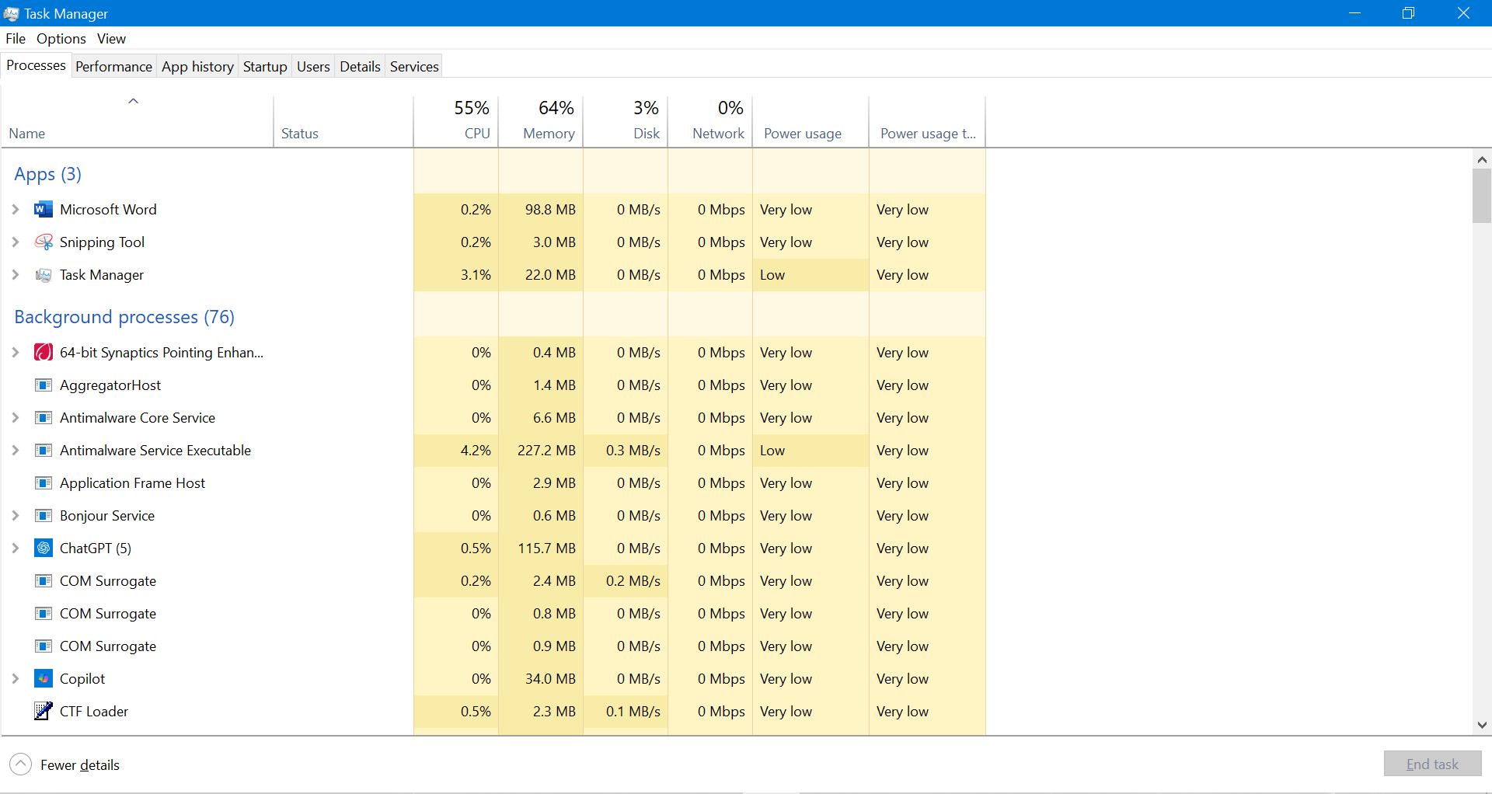
Figure 1: Task Manager showing active processes (Command: Ctrl + Shift + Esc)
The image shows the Windows Task Manager, which displays active processes and CPU and memory usage. This demonstrates how the operating system controls and distributes resources among multiple applications at the same time.

Memory Management
Memory management is responsible for controlling and organizing the computer's main memory. Its goal is to ensure that the operating system, applications, and running processes have the memory they need to function properly.
This is necessary because multiple processes run simultaneously and compete for available memory. Memory management optimizes its use by allocating space to each process and freeing it when it is no longer needed. It also helps prevent problems such as fragmentation and ensures that data from one process is not altered by another, thus maintaining system stability and efficiency [2].
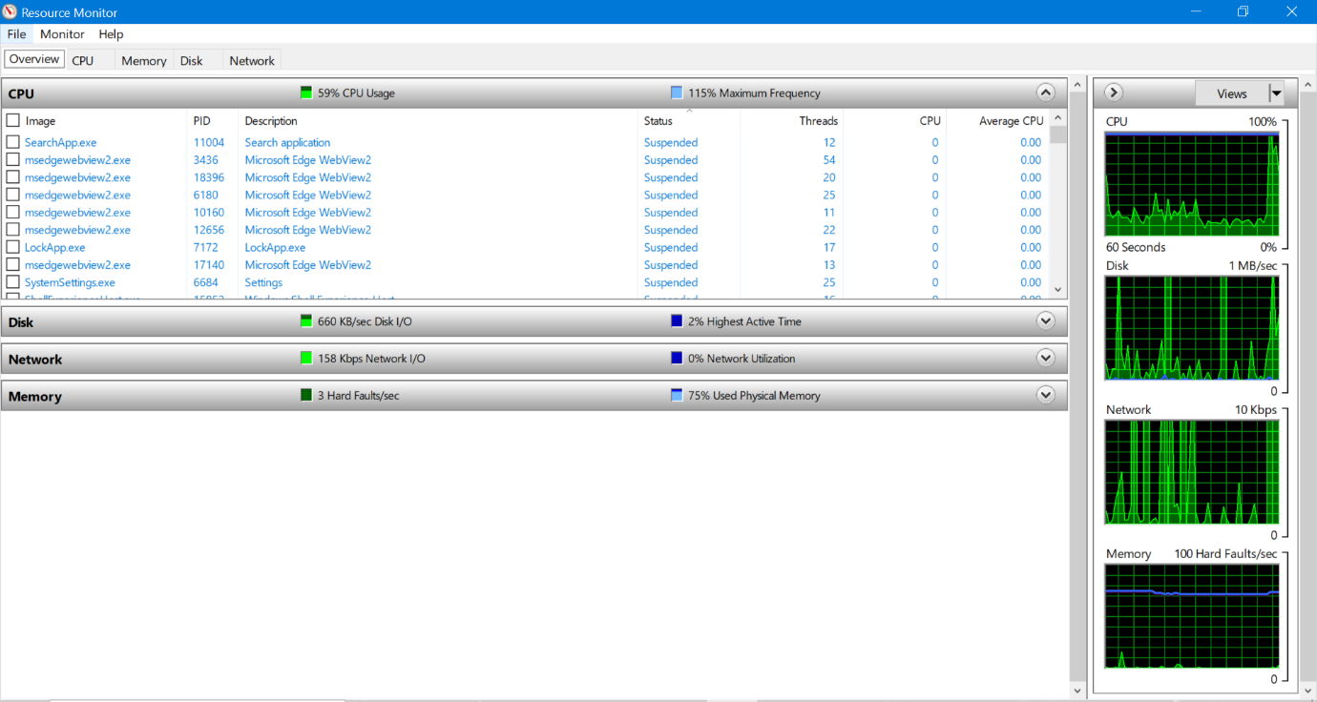
Figure 2: Resource Monitor (Command: Win + R, after write resmon.exe and pulse Enter)
The screenshot shows the system's RAM and virtual memory usage.
• Physical memory (RAM) indicates how much memory is used by active processes.
• Virtual memory (page file) is used when RAM is full; the system temporarily saves data to disk to free up space in main memory.
• You can also see which processes consume the most memory and how it is distributed between the operating system and applications, helping to identify potential bottlenecks or excessive resource usage.
File Management
File management is the process of efficiently organizing, storing, and retrieving digital files. It involves creating a clear folder structure, naming files consistently, and using systems to quickly locate documents. Effective file management ensures data integrity through backups and controls access through permissions. It reduces duplication, improves collaboration, and saves time by making information easier to find. Organizations and individuals benefit from structured file systems, whether on local devices or in the cloud, enabling better workflow, security, and productivity. It is essential for keeping digital information organized and accessible [3].
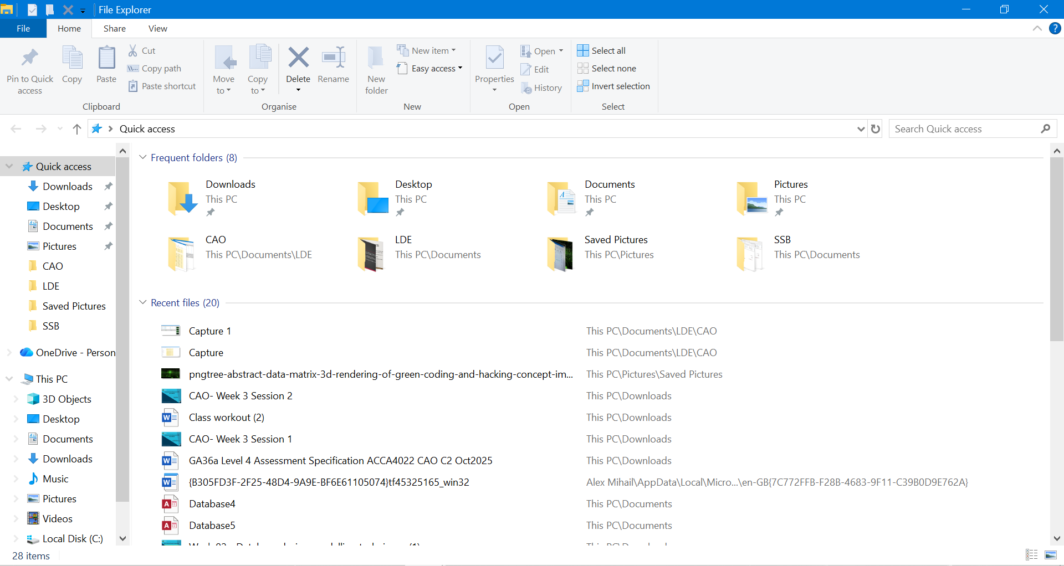
Figure 3: File Explorer
To view and organize files in Windows, I opened File Explorer. Here you can see the main system folders, such as Documents, Downloads, and Desktop. In the photo you can see how they are arranged, which helps you find and manage files easily.
Device Management
Device management is an important function of the operating system that controls and coordinates all the hardware devices on your computer. Its purpose is to ensure that each component, such as a printer, keyboard, or graphics card, works properly and communicates well with the system. To achieve this, it uses programs called drivers, which act as intermediaries between the hardware and software.
In addition, the operating system is responsible for allocating, releasing, and monitoring devices as they are used, preventing errors or conflicts that could affect the overall performance of the computer [4].
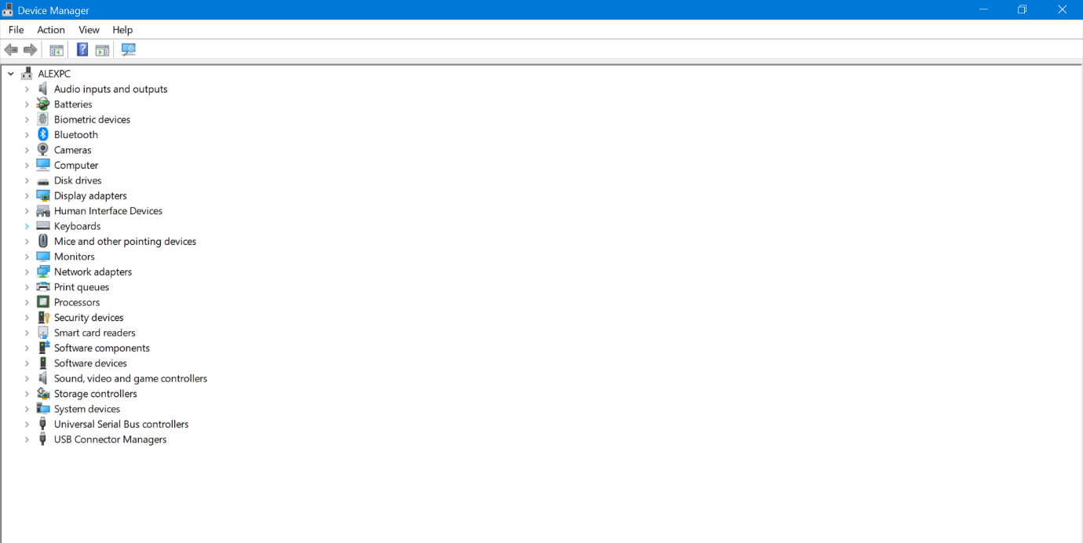
Figure 4: Device Manager (Command: Win + R, after write devmgmt.msc and pulse Enter)
Running devmgmt.msc opens Device Manager, which displays all your computer's hardware components. From there, the operating system allows you to control, update, or troubleshoot connected devices.
Security and User Interface
User account management allows the operating system to control who can access the computer and what permissions each person has. Usernames, passwords, and roles protect information and prevent unauthorized use of the system. In addition, the system can assign administrator or standard privileges based on the tasks required.
This control also allows users to change security settings, manage passwords, and maintain the protection of personal data. Overall, this ensures that the computer is safe and tidy for all users, ensuring the overall security of the system [5].
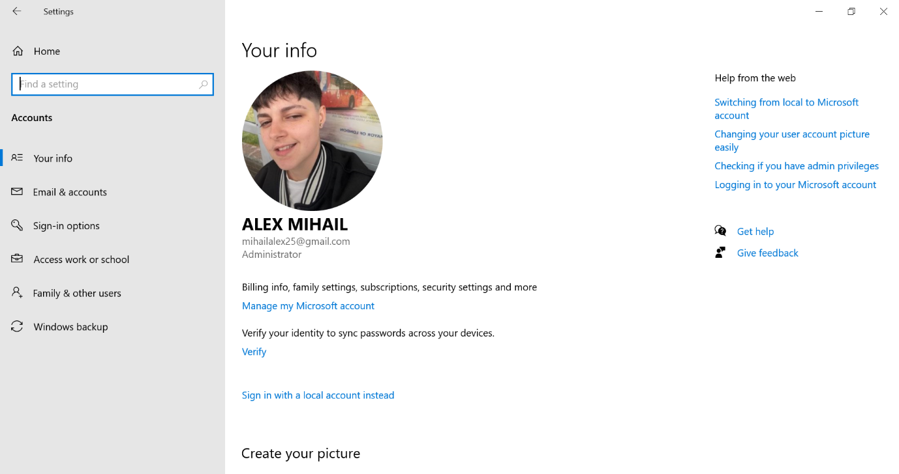
Figure 5: Setting up user accounts in Windows
The image shows the user account settings in Windows, where you can manage personal information, account type (administrator or standard), and security options such as passwords or synchronization.

Task 2: Use of Windows OS CLI commands
Windows offers two main command-line environments: the Command Shell and PowerShell. Both allow direct communication with the operating system using commands, making it easy to automate tasks and perform administrative duties without a graphical interface. The Command Shell was the first tool included in Windows for running commands and batch scripts, while PowerShell extends these capabilities with more advanced cmdlets and a more powerful automation language. Therefore, PowerShell is the recommended choice for modern administrative tasks. In this section, I document ten commands that I ran on my system, along with their options and results.
10. Windows OS commands
1.Command: ipconfig
It displays basic network configuration: IPv4, gateway and adapters. It allows for quick and reliable troubleshooting of connection problems [6].
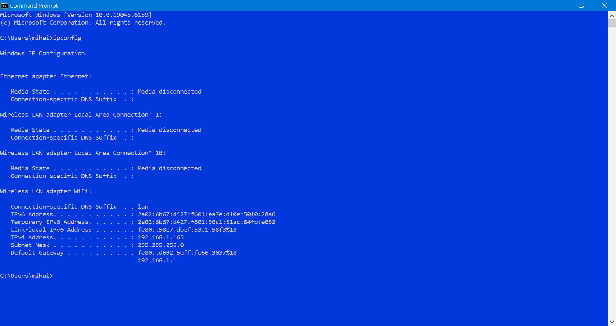
Figure 6: Network configuration
2.Command: ipconfig/all
It provides comprehensive network information, including DNS, MAC and DHCP, useful for detailed system configuration analysis [7].
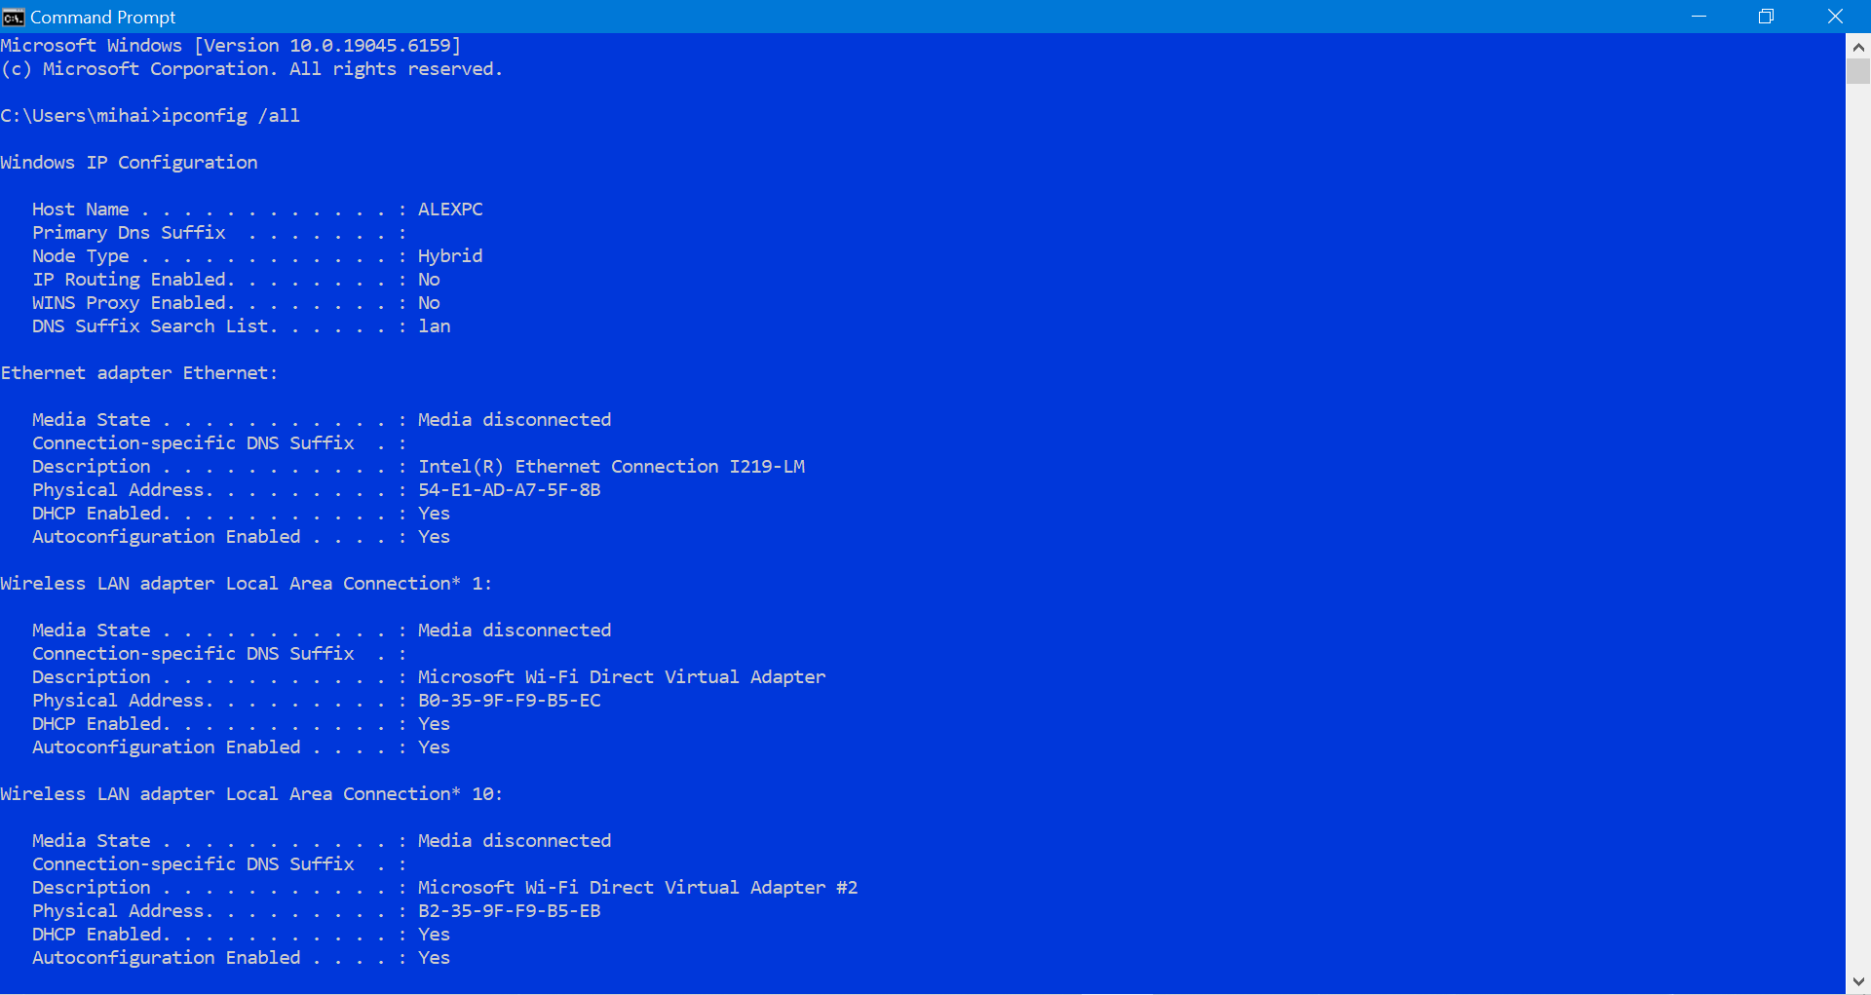
Figure 7a: Full network details (top)
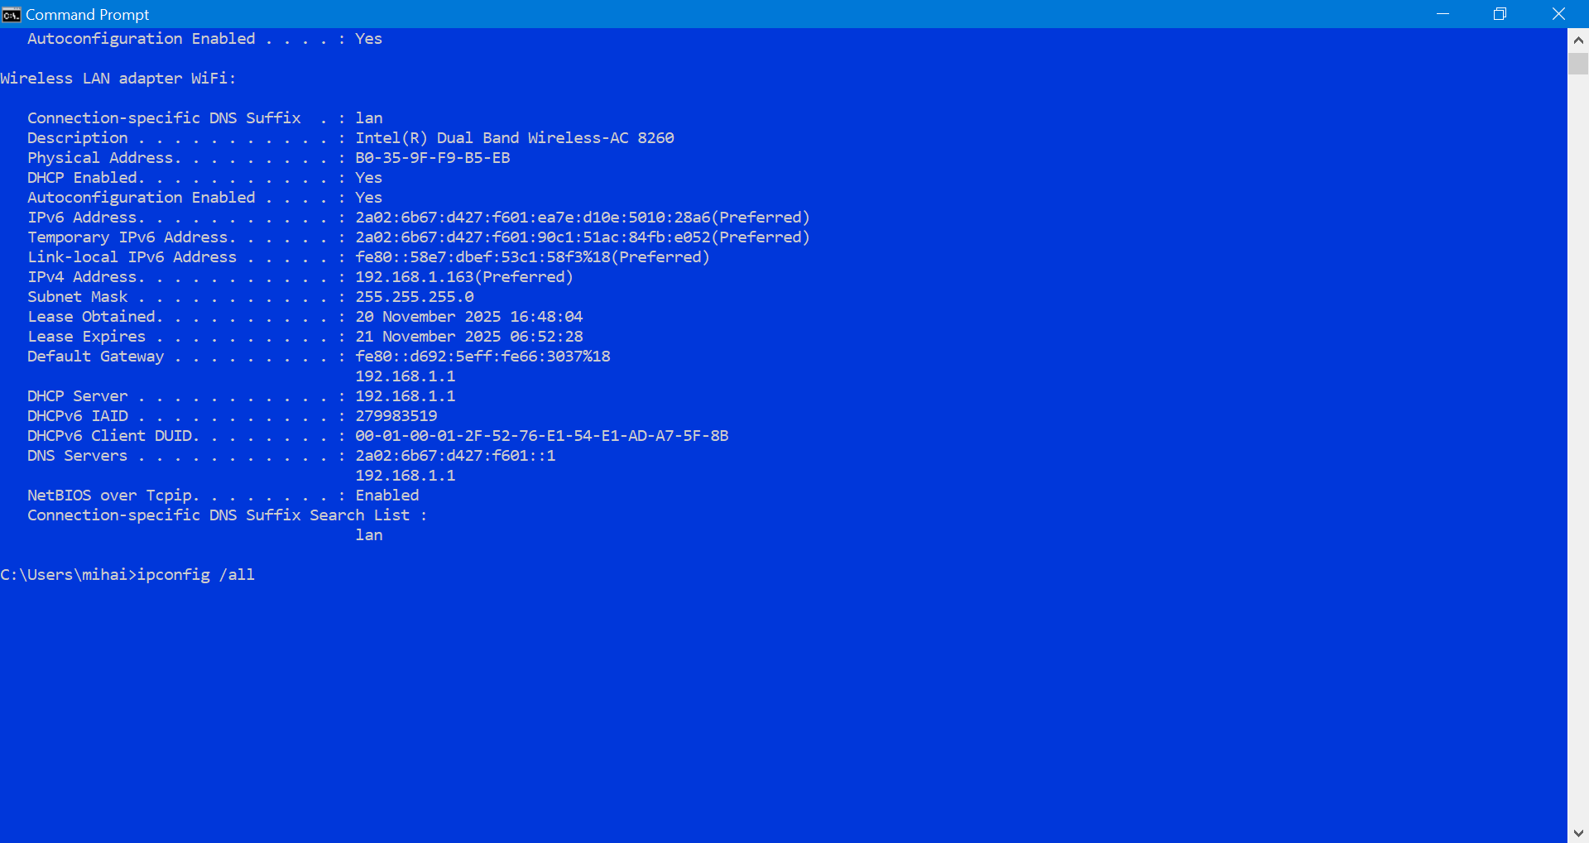
Figure 7b: Full network details (bottom)
3.Command: ping google.com -n 4
It sends four test packets to Google, showing response times and connectivity. It helps identify internet problems quickly [8].
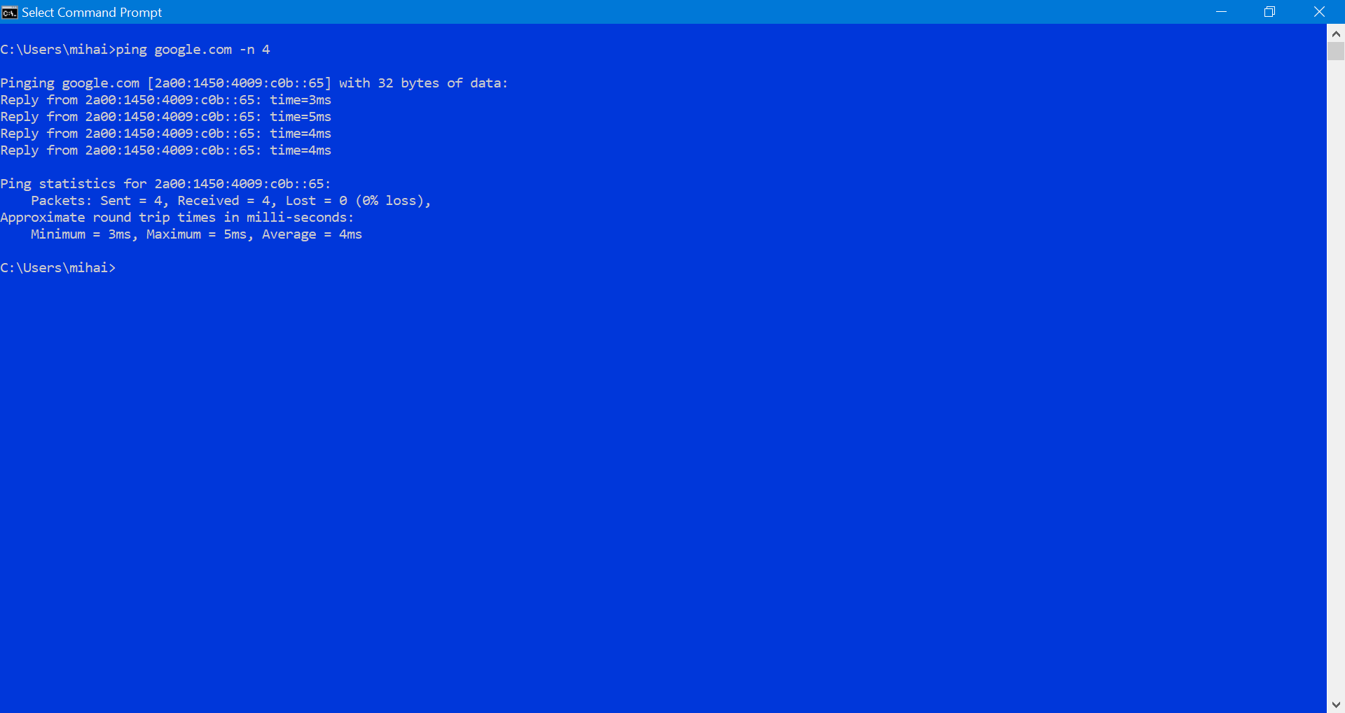
Figure 8: Ping test results
4.Command: tasklist
It displays all running processes, including active applications and services. This is useful for monitoring system resources without changing them [9].
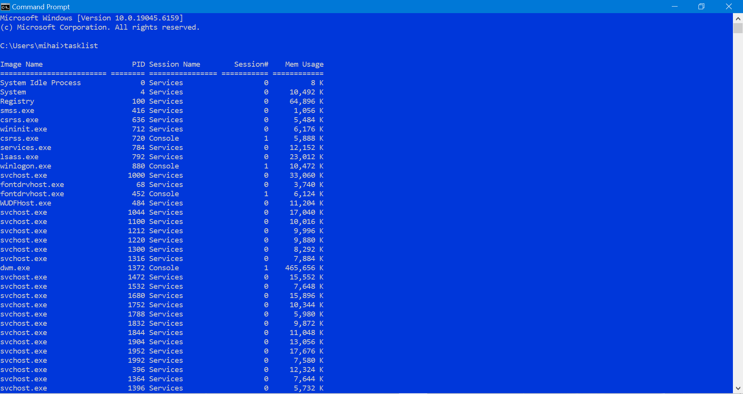
Figure 9: Active processes list
5.Command: taskkill /PID 0 /F
Example of a safe process termination. PID 0 does not exist, so no process is ended, but this demonstrates the correct Taskkill syntax [10].
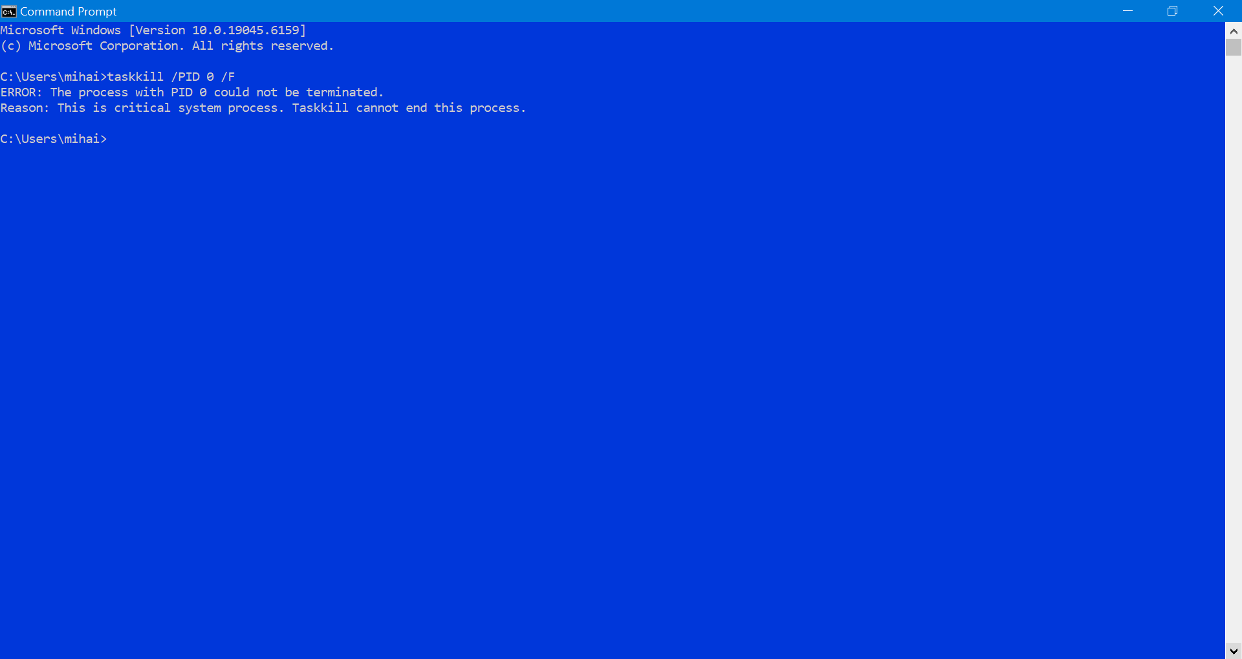
Figure 10: Safe taskkill example
6.Command: systeminfo
Displays complete system information: Windows version, RAM, and BIOS. Useful for complete system diagnostics and monitoring [11].
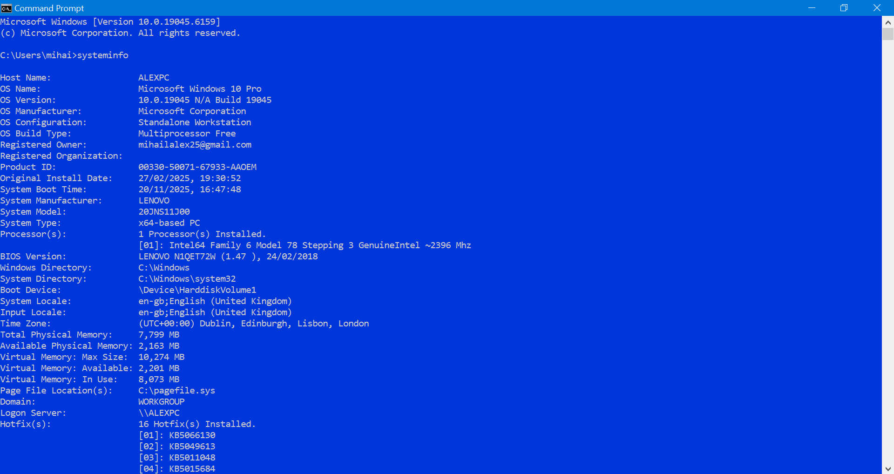
Figure 11: System information
7.Command: dir
Lists files and folders in the current directory, allowing for quick and easy review and organization of contents [12].
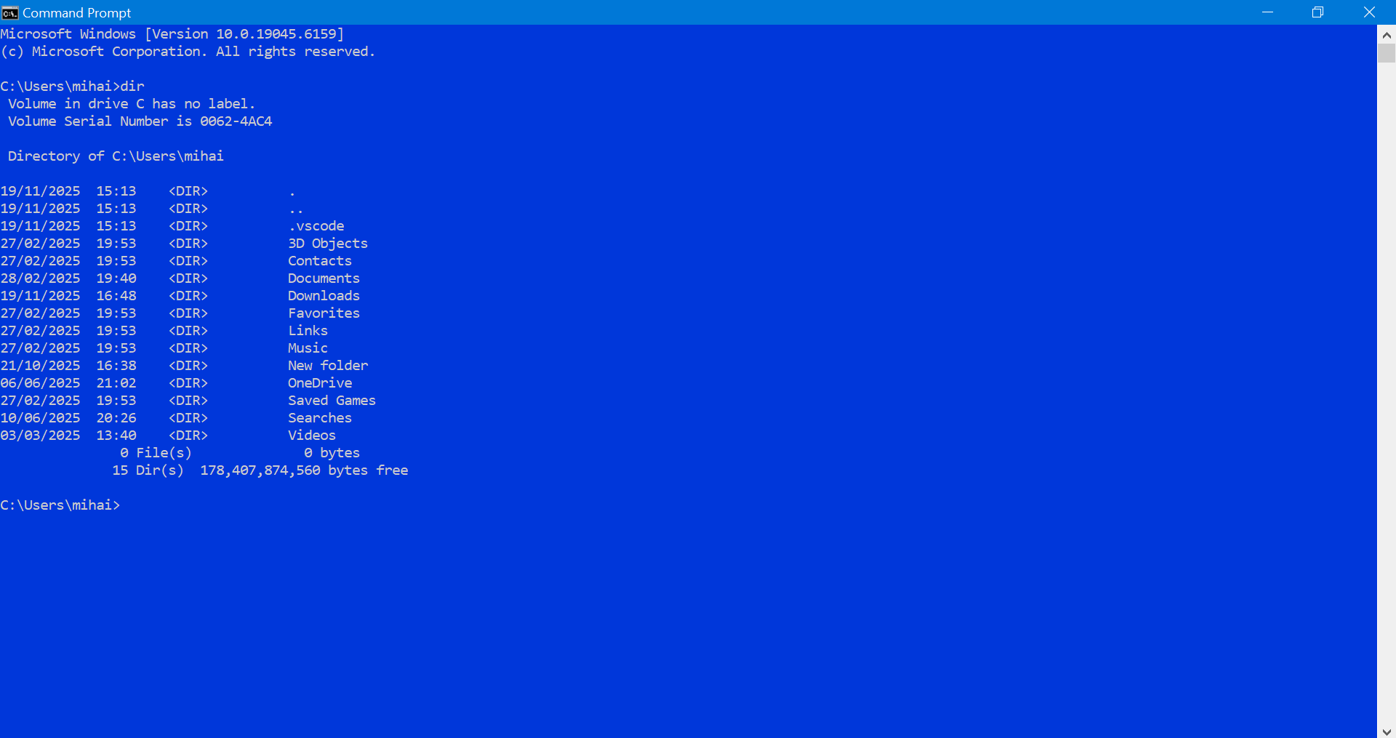
Figure 12: Directory listing
8.Command: dir/ A
Displays hidden and system files, expanding visibility and allowing for complete directory management [13].
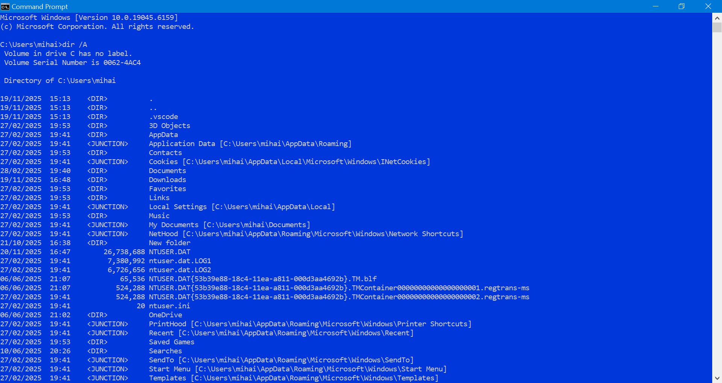
Figure 13: All files view
9.Command: netstat
Displays all active network connections, helping to monitor network activity and detect potential problems or intrusions [14].
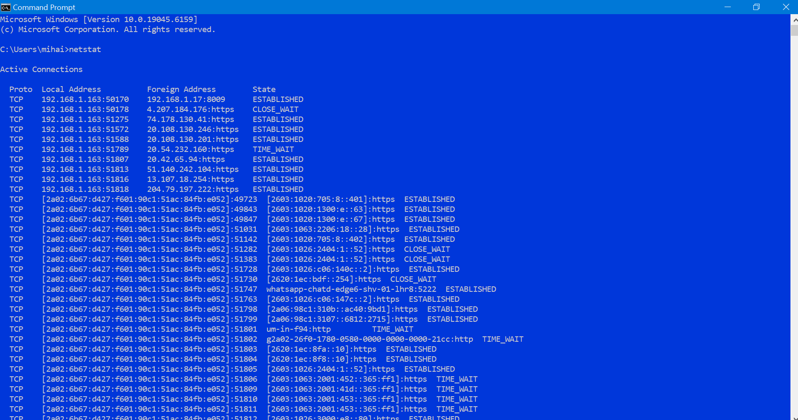
Figure 14: Active connections
10.Command: netstat -ano
Displays network connections with their associated ports and PIDs, useful for security analysis and advanced network management [15].
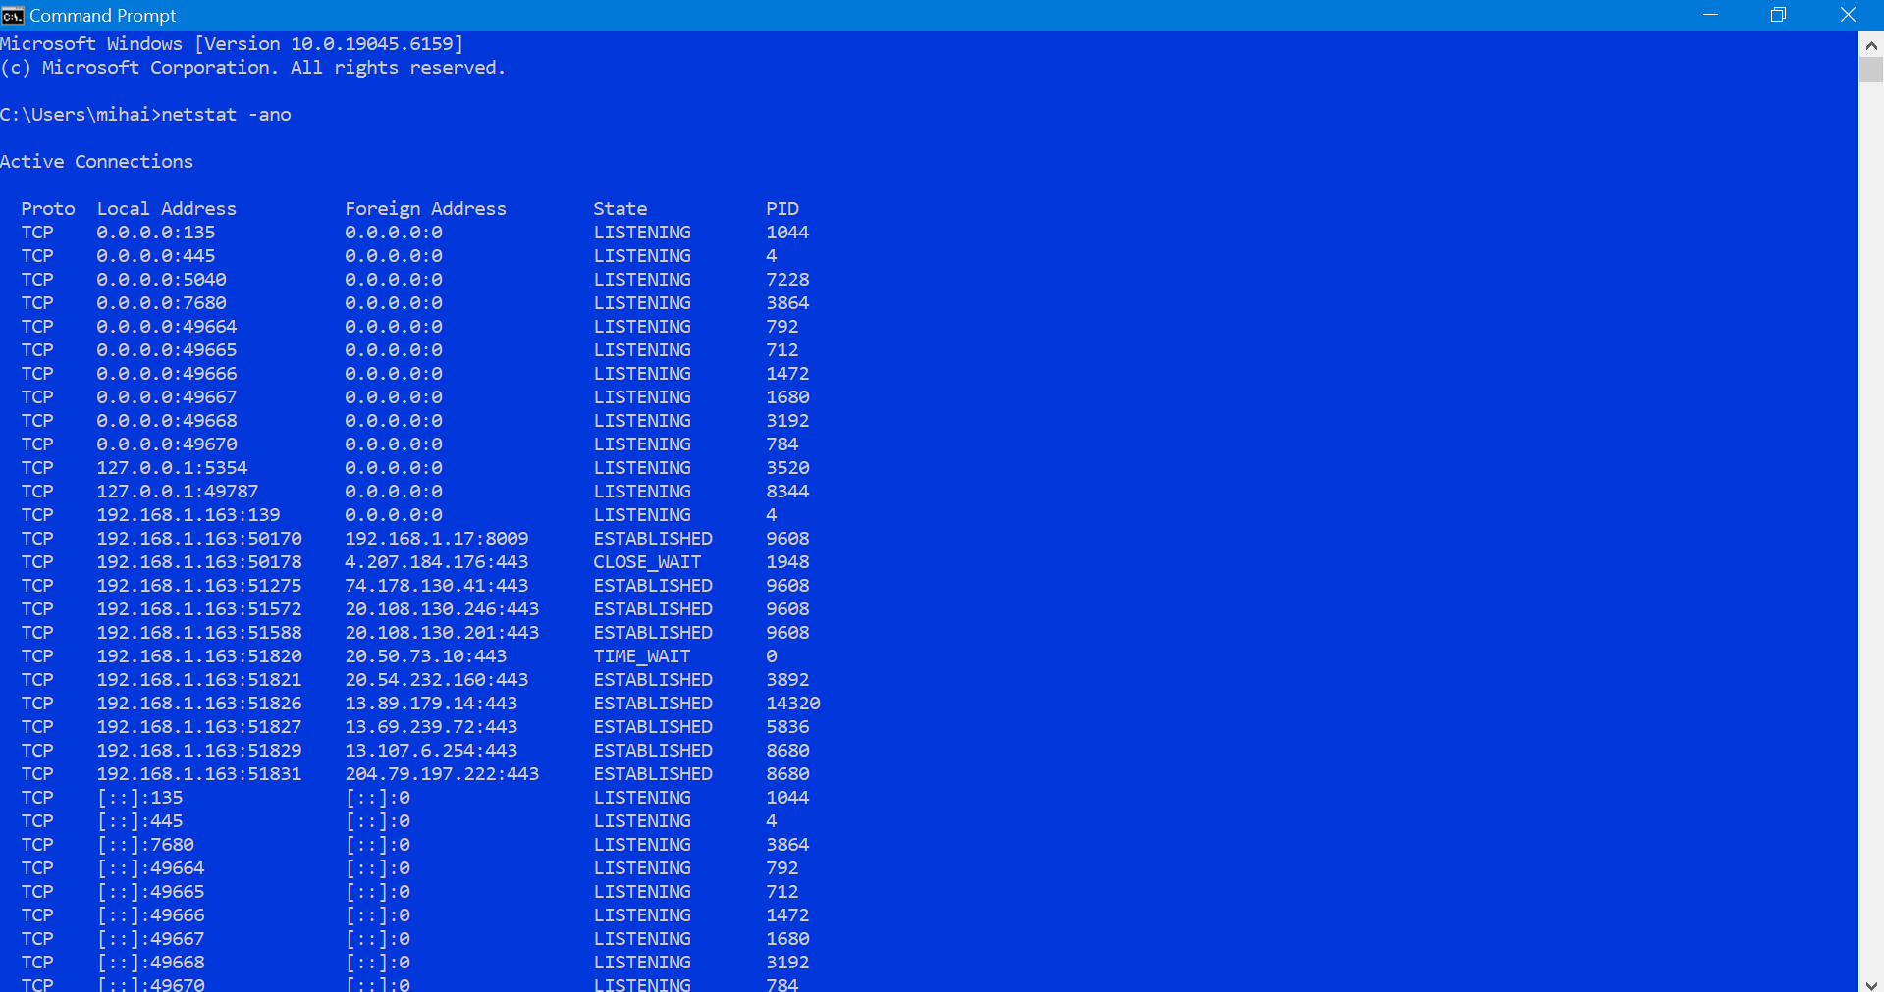
Figure 15: Connections with PIDs

Task 3: Use of Linux OS CLI commands
This section shows the use of ten essential Linux Bash commands executed in the Ubuntu terminal with WSL (Windows Subsystem for Linux). These commands provide the basic functionality of the Linux command line interface, allowing users to navigate the file system, manage files, display information and access system documentation. Each command is presented with a brief explanation of its purpose, followed by a screenshot of the command and its output.
10. Linux OS Bash commands
1.Bash: pwd
The pwd command displays the user’s current working directory. It is useful for confirming the exact location within the Linux filesystem before running further commands.
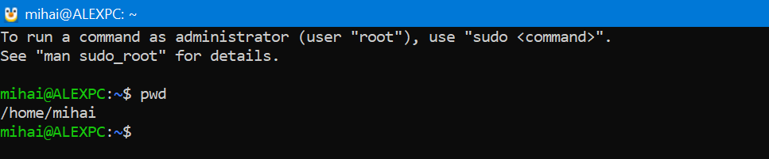
Figure 16: Showing displays user’s
2.Bash: ls -l
This command lists directory contents in long format, showing permissions, owernship, file, size and modification date. It provides a detailed overview of files and directories.
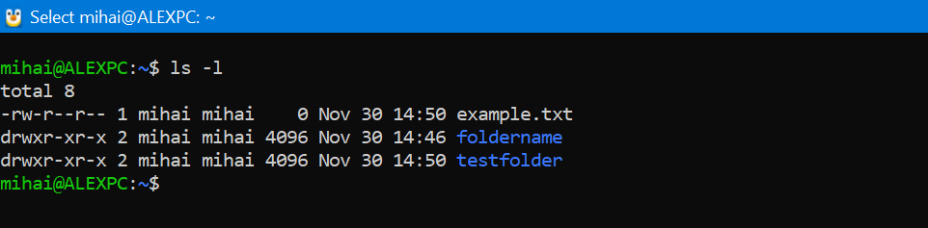
Figure 17: Lists directories

3.Bash: ls
Displays the list of files and directories in the current folder. It is used to quickly check what items are stored in a directory.
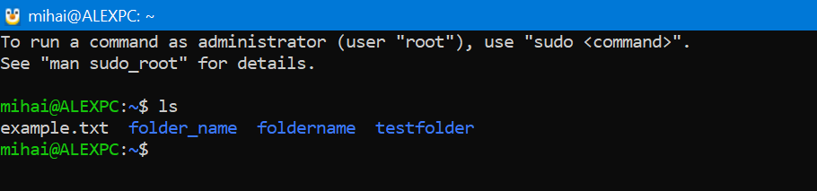
Figure 18: Currents folder
4.Bash: ls -a
Shows all files, including hidden ones that start with a dot (.). This command is useful for viewing configuration files or system-related items.
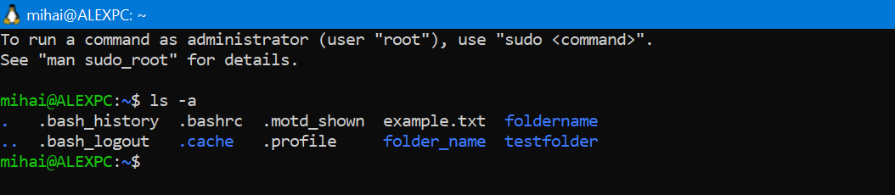
Figure 19: Configuration files or system-related items
5.Bash: date
Print the current system date and time. It is useful for checking time settings or confirming when a command was executed.
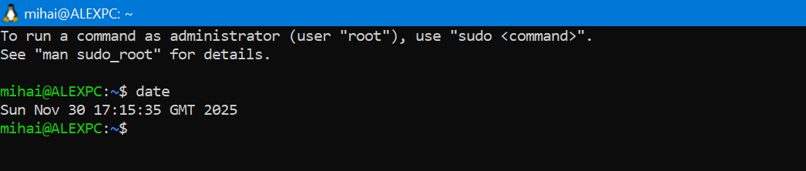
Figure 20: Data & time
6.Bash: whoami
Displays the username of the currently logged-in user. It helps confirm which account is being used in the terminal.
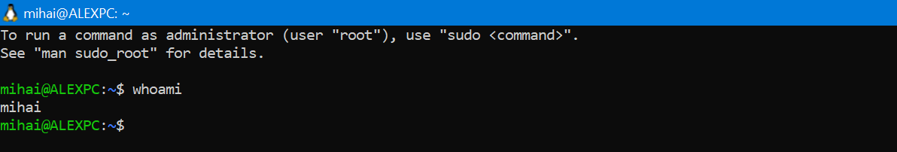
Figure 21: Currently logged-in user.
7.Bash: uname -a
Shows detailed system information including kernel version, architecture and system name. It provides a complete overview of the Linux environment.
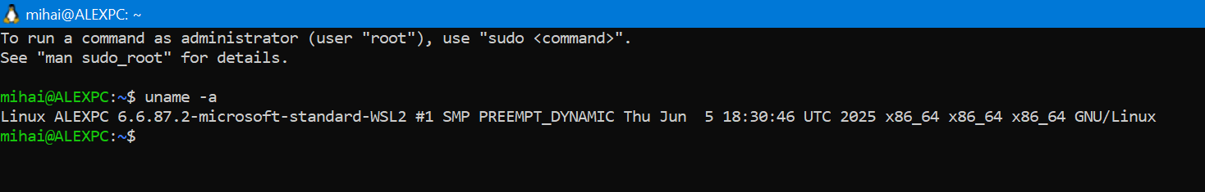
Figure 22: Information including kernel version
8.Bash: who
Lists all users currently logged into the system, In WSL it usually shows only the current user, but it still shows the command’s functionality.
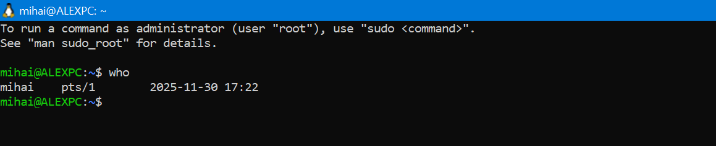
Figure 23: Lists all users currently logged
9.Bash: hostname
Displays the system’s host name (computer name). Useful for showing the machine on a network or in terminal sessions.drd
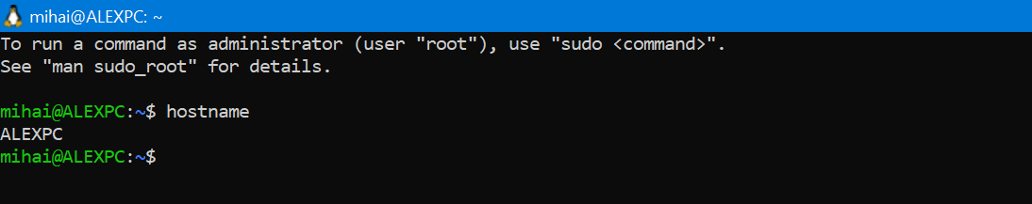
Figure 24: System’s host name
10.Bash: free -h
Shows available and used memory (RAM) in a human-readable format, The -h possibility makes sizes easier to understand (GB/MB). It is commonly used to check system performance.
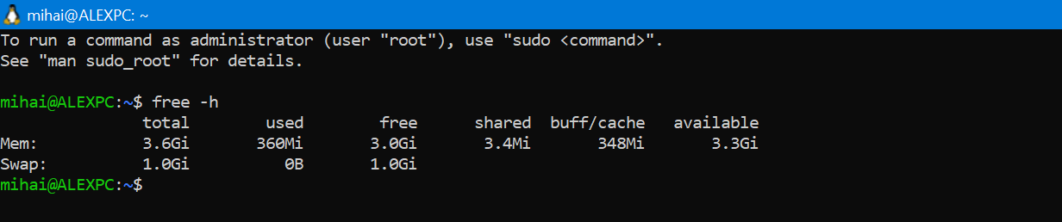
Figure 25: RAM in a human-readable format

Task 4: Use of Windows OS scripts
This section shows the use of two very simple Windows batch scripts to showcase basic operating system automation features. Batch scripts allow users to automatically execute various commands instead of manually typing them at the command prompt. Both scripts were created and tested on a Windows laptop and screenshots were taken to demonstrate their functionality.
The first script created for this task is called system_check.bat. This script uses the ipconfig command to display basic network information, such as the device's IP address and network adapter details. The script begins with @echo off to keep the output clean, then prints a short message and finally executes ipconfig. Upon execution, the script opens a Command Prompt window and displays the information automatically. Figure 26 (System Check Script) shows a screenshot of the script in Notepad, and Figure 27 (Script Running) shows a screenshot of the script running. This script demonstrates very simple automation by executing a system command without requiring user intervention.
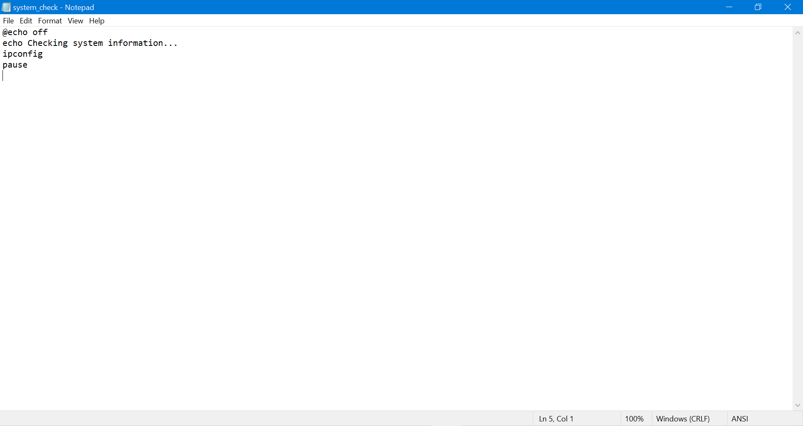
Figure 26: System Check Script
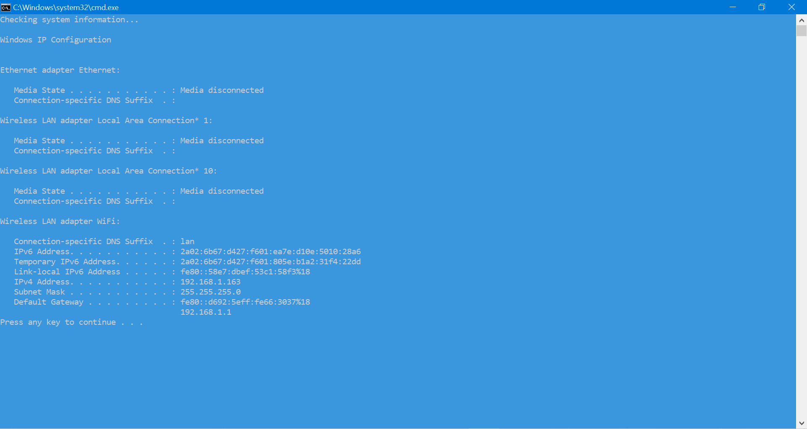
Figure 27: Script Running
The second script for this task is called system_info_log_simple.bat. This script displays the date, time, network information, and running system processes in the Command Prompt window in a clear and organized manner. When executed, it prints the output directly to the screen, making it easy to read and capture as evidence. Screenshots of this script are shown in Figure 28: System Information Script in Notepad and Figure 29: Script Running in CMD. This example demonstrates how to use batch scripts to automate simple tasks, such as checking system information, without requiring advanced programming knowledge.
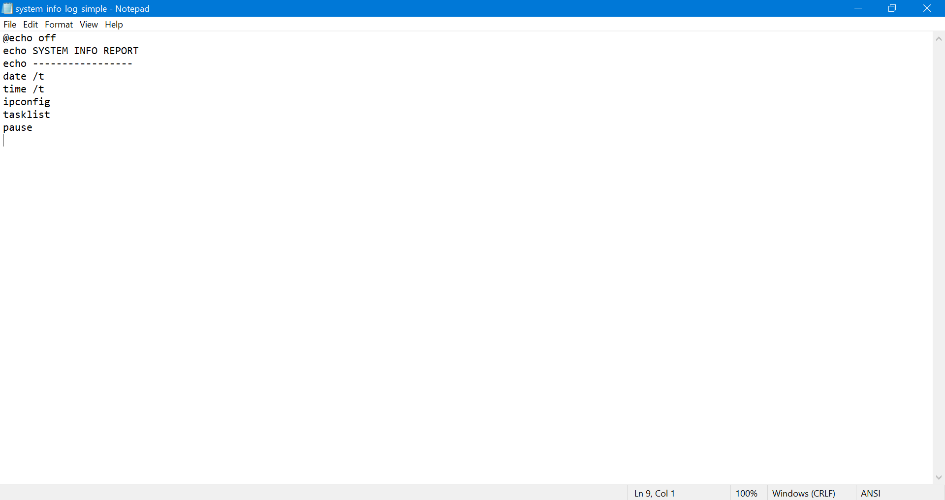
Figure 28: System Information Script
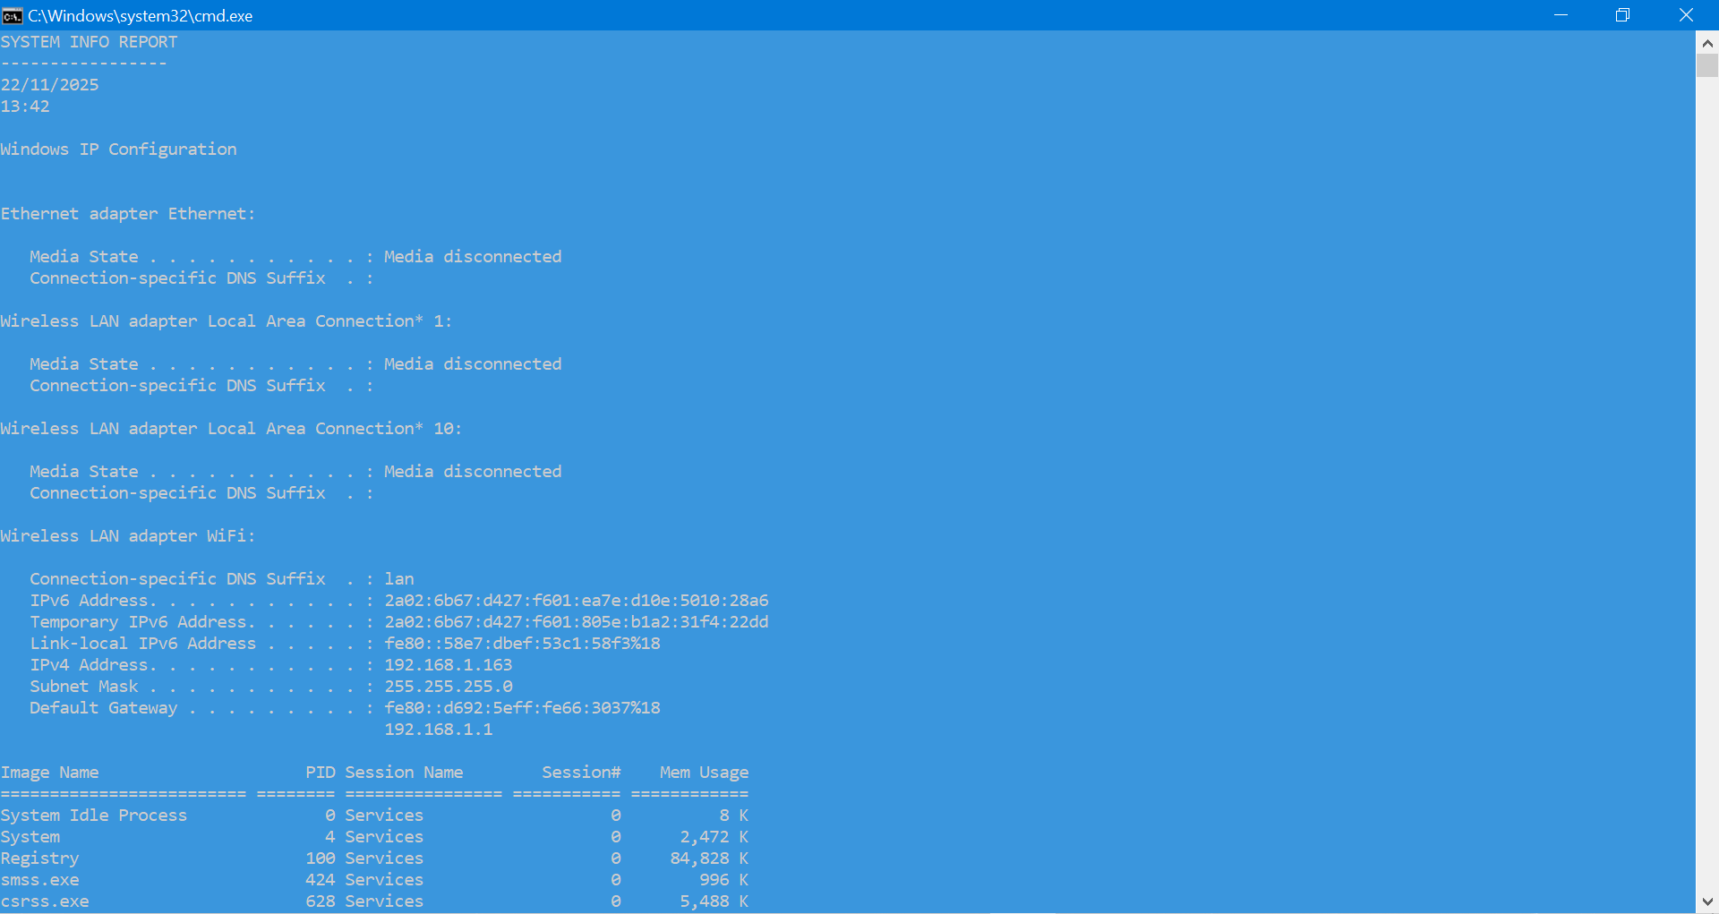
Figure 29: Script Running

Task 5: Use of Linux OS scripts
In this section, I demonstrate how I used Bash scripts in my WSL Linux environment to automate simple tasks and understand the basic structure of Linux scripts. Using Bash scripts allows me to execute commands automatically instead of typing them manually, making it an essential skill for Linux system administration. To do this, I created several basic scripts, ran them in WSL and captured their output [16].
The first script I created, greeting.sh, was designed to display a simple message on the screen using the echo command. I included the shebang (#!/bin/bash) at the beginning of the file so that Linux knew to execute it using the Bash shell. This script helped me understand the basic structure of a Bash script: a header, one or more commands, and execution using the bash command. Although the script is simple, it demonstrates how Bash can be used to automate even the most basic tasks.
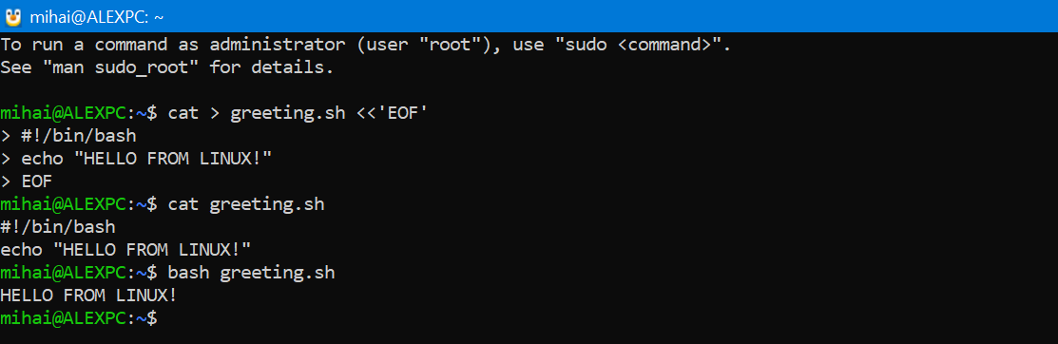
Figure 30: greeting.sh script and its output in WSL, printing a simple message
Next, I created showdate.sh, a script that automatically displays the current system date and time by executing the date command. This example shows how Bash scripts can run built-in Linux utilities without requiring user interaction. A script like this could be used in real-world situations to date and mark logs, schedule tasks, or log system events. Writing this script helped me understand how Bash can execute common terminal commands as part of automated workflows.
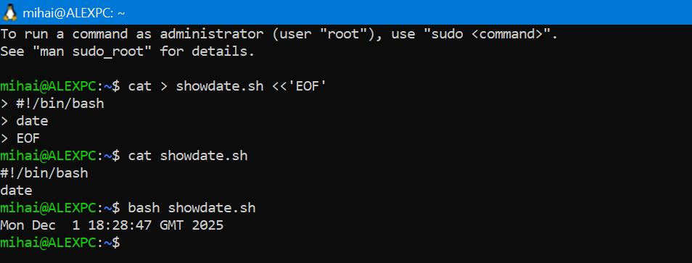
Figure 31: showdate.sh script and its output in WSL, showing the current date & time

The third script I created was showuser.sh, which uses the whoami command to display the logged-in user. This script demonstrates how system and environment information can be retrieved using Bash. Scripts like this are often used in administrative processes, such as checking user permissions or customizing commands based on the active user. 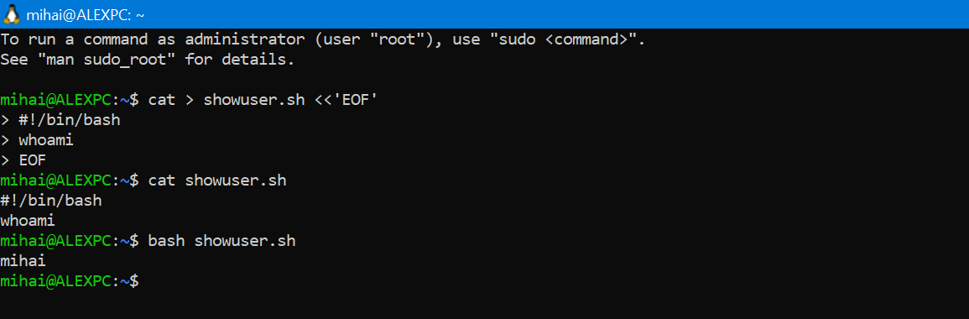
Figure 31: showuser.sh script and its output in WSL displaying the active Linux user

Conclusion
This report demonstrated a practical understanding of key operating system concepts with Windows and Linux environments. By analysing operating system functions, executing CLI commands, and creating simple scripts, the tasks demonstrated how operating systems manage hardware, processes, files, and user interactions. The use of Windows Batch and Linux Bash also highlighted the importance of automation to improve efficiency and reduce repetitive work. Executing tasks using real commands and scripts provided hands-on experience with essential system administration skills. Overall, the report confirms that command-line tools remain essential for managing, monitoring and controlling modern operating systems.

References

[1] | GreeksforGreeks, Introduction of Process Management, Noida, India: GreeksforGreeks, 2025.
[2] | R. Awati and R. Sheldon, “TechTarget,” TechTarget, Inc, 10 December 2024. [Online]. Available: https://www.techtarget.com/whatis/definition/memory-management. [Accessed 21 October 2025].
[3] | “A Comprehensive Guide,” Canto, 2024. [Online]. Available: https://www.canto.com/glossary/file-management/.
[4] | GreeksforGreeks, “Device Management in Operating System,” GreeksforGreeks, 2024. [Online]. Available: https://www.geeksforgeeks.org/operating-systems/device-management-in-operating-system/. [Accessed 21 October 2025].
[5] | Microsoft, “Manage user accounts in Windows Server,” Microsoft Learn, 2025. [Online]. Available: https://learn.microsoft.com/en-us/windows-server/identity/ad-ds/manage-user-accounts-in-windows-server .
[6] | Microsoft, “Ipconfig - Windows Commands,” Microsoft, 2025. [Online]. Available: https://learn.microsoft.com/en-gb/windows-server/administration/windows-commands/ipconfig. [Accessed 20 11 2025].
[7] | Microsoft, “Ipconfig /all - Windows Command,” Microsoft, 2025. [Online]. Available: https://learn.microsoft.com/en-gb/windows-server/administration/windows-commands/ipconfig. [Accessed 20 11 2025].
[8] | Microsoft, “Ping - Windows Commands,” Microsoft, 2025. [Online]. [Accessed 20 11 2025].
[9] | Microsoft, “Tasklist - Windows Commands,” Microsoft, 2025. [Online]. Available: https://learn.microsoft.com/en-us/windows-server/administration/windows-commands/tasklist. [Accessed 20 11 2025].
[10] | Microsoft, “Taskkill /PID 0 /F - Windows Commands,” Microsoft, [Online]. Available: https://learn.microsoft.com/en-us/windows-server/administration/windows-commands/taskkill. [Accessed 20 11 2025].
[11] | Microsoft , “Systeminfo - Commands Windows,” Microsoft , 2025. [Online]. Available: https://learn.microsoft.com/en-gb/windows-server/administration/windows-commands/systeminfo. [Accessed 20 11 2025].
[12] | Microsoft , “Dir - Command Windows,” Microsoft , 2025. [Online]. Available: https://learn.microsoft.com/es-es/windows-server/administration/windows-commands/dir. [Accessed 20 11 2025].
[13] | Microsoft , “Dir/ A - Command Windows,” Microsoft , 2025. [Online]. Available: https://learn.microsoft.com/es-es/windows-server/administration/windows-commands/dir. [Accessed 20 11 2025].
[14] | Microsoft, “Netstat - Command Windows,” Microsoft , 2025. [Online]. Available: https://learn.microsoft.com/en-us/windows-server/administration/windows-commands/netstat. [Accessed 20 11 2025].
[15] | Microsoft , “Netstat -ano - Command Windows,” Microsoft , 2025. [Online]. Available: https://learn.microsoft.com/en-us/windows-server/administration/windows-commands/netstat. [Accessed 20 11 2025].
[16] | G. Project, “Bash Reference Manual,” 2024. [Online]. Available: https://www.gnu.org/software/bash/manual/bash.pdf?utm_source. [Accessed 1 12 2025].

