Blogging to Communicate

LCBB4004 Marketing Fundamentals_A1

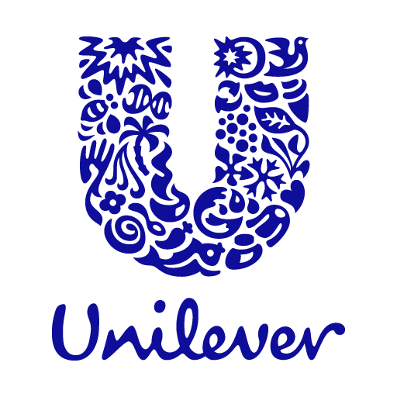
Marketing is an essential component of any business in terms of generating profit and maintaining core functionalities. From the perspective of industrialists, marketing is also known as one of the most activity-based diverse functional area of a business. Which states that the activities that are performed by marketing department within an organization are diverse and covering every concept in a report is close to impossible. As a result, this report will illustrate how marketing performs blog post in order to communicate with their target market. To provide a reader with realistic point of view an organization will be chosen and based on that the assignment will be construct.

Company Overview
Unilever is a British multinational consumer goods manufacturing company that is currently headquartered in London. Their product ranges from customer goods, beauty and personal care products, home care products, food and refreshment-based products, food supplementary based products and many more. In terms of production Unilever is considered as the largest soap producer in the world and it is currently operating in more than 190 countries.
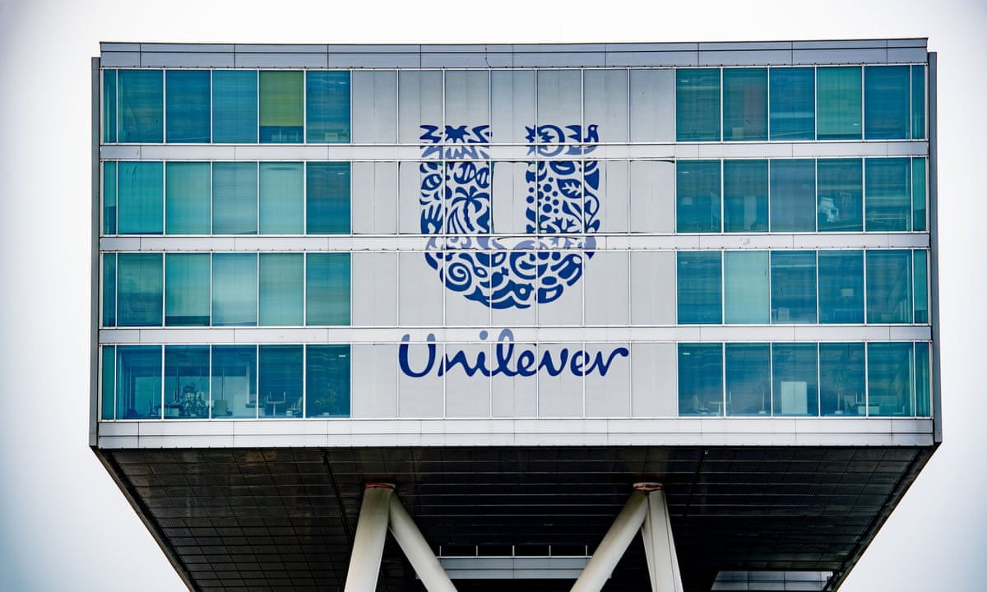
Unilever currently has 400 brands collaborating with them and they are powered by approximately 150,000 employees worldwide. Another great aspect of Unilever is that they have a gender balance in 10,000 managers and 90% of the leaders are from their local markets. Currently Unilever has formulated a purpose where they would ensure sustainable living a common place.

Main Body

Marketing Mix
Product: Unilever offers a vast range of items on the market. Their items are available in a wide range of forms and materials. They provide a variety of items such as soap, shampoo, paste, mouthwash, and so on. Unilever is in charge of offering condiments, toothpaste, cosmetic goods, water purifiers, breakfast films, cleaning agents, minerals, and vitamins, coffee, cosmetic goods, personal care products, snacks, and a variety to their customers (Esch, Arli, Castner, Talukdar and Northey, 2018). Unilever's wide range of products may be divided into three categories: home care, beauty and personal care, and food and beverages. Unilever's goods are extremely diverse, and its affiliation with over 400 companies has allowed them to obtain items that are nearly hard for competitors to master.
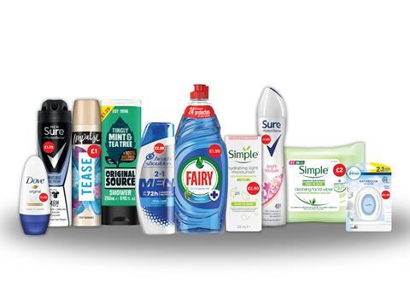
Price: All of Unilever's products are priced differently. There are a lot of products and diverse food products of Unilever they need to maintain various strategies in terms of pricing their products. They try to price their products in a way that corresponds effectively with their customer and they have three types of pricing strategies which are,
- Premium pricing strategy where Unilever charges comparatively high on a certain product
- Market oriented pricing strategy where Unilever charges statically with their competitors
They have priced their products around 10 pounds to 100 pounds prices products. They are working on that everyone buys this product.
Place: Almost all Unilever items are available in local stores, supermarkets, and online markets. These things can be located in a range of local shops throughout cities. Alongside partnership with local super store chains Unilever is responsible for providing their products in Kiosk as well as retailers. Usually in Kiosk they provide only food and beverage items, on the other hand every item that is considered suitable for the customers is taken by the retailers of Unilever.
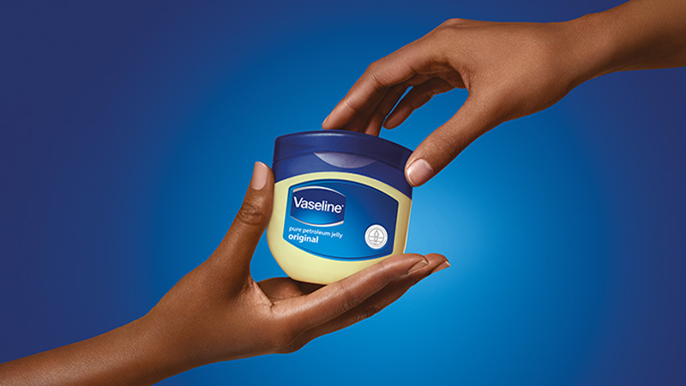
Promotion: Unilever uses a variety of marketing and advertising methods. Unilever spends more than 7 billion euros on promotional activities each year, according to several news sites. Its investment of £1.08 billion in the United Kingdom demonstrates that it is a major television advertiser. It spent almost 168 million pounds sterling on advertising on the Dove brand alone in the same year. This emphasizes Unilever's massive advertising efforts, which, unfortunately, are also costly. Advertising, such as billboards and broadcasts, is a major promotional tool for Unilever. Unilever also use sales marketing strategies including product bundling and discounts. It has almost 3.8 million followers on its official Facebook page, for example. It does, however, only have approximately 107 thousand Instagram followers, which is a tiny fraction of the number of Facebook fans it has.
Physical Evidence: Unilever's items come in a variety of colors, making them effectively recognizable in retailers. These are only advertised in select Unilever stores and are accessible in a variety of colors and styles. As a result, clients will have a less demanding time finding such businesses in swarmed shopping centers. Unilever moreover has a user-friendly website where guests can see high-resolution pictures of its items from different points of view. So, as a physical prove it can be decided that the stores, workplaces and the items itself is considered as the physical confirmations.
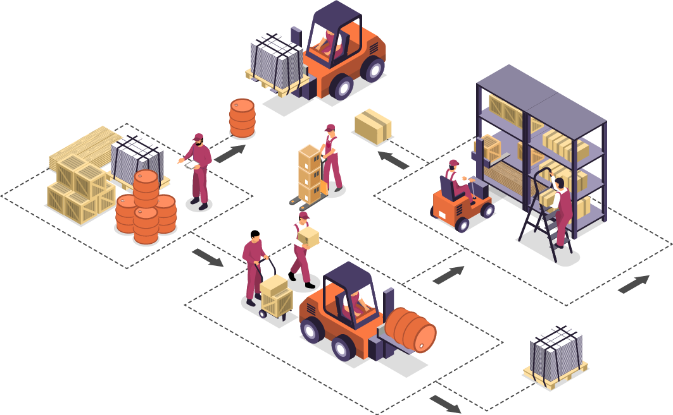
Process: Unilever has to ensure that its products are constantly available in stores. When inventory levels fall below a specific threshold, Unilever has procedures in place to inform merchants. Unilever then supplies them with additional goods while placing orders with new businesses to replace its supply. Customers will always be able to get what they want quickly. Unilever has an online store as well. The exact Unilever product is packed and sent to the delivery service provider when orders are received in the computer system. Unilever also conducts market research regularly to understand customer preferences better. Through feedback, this research method also provides insight into the industry in terms of client wants. Unilever collects customer input through retail outlets, call centers, and social media platforms.
People: Employees in Unilever's sales department play an important role in the company's marketing efforts. This section has covered persuasive strategies as well as how to respect and understand corporate clients' choices. Also, customer service representatives are also employed by Unilever. If a customer has a problem with a product, they should contact this department, which will guide them through the process. Furthermore, departmental employees are taught to cherish clients and to do everything in their power to help them address their problems. These professionals are critical to maintaining or enhancing the end product's quality and quantity. Lastly, Unilever also has people working in retail stores that help consumers on the spot by answering questions and directing them to the best product for their needs.
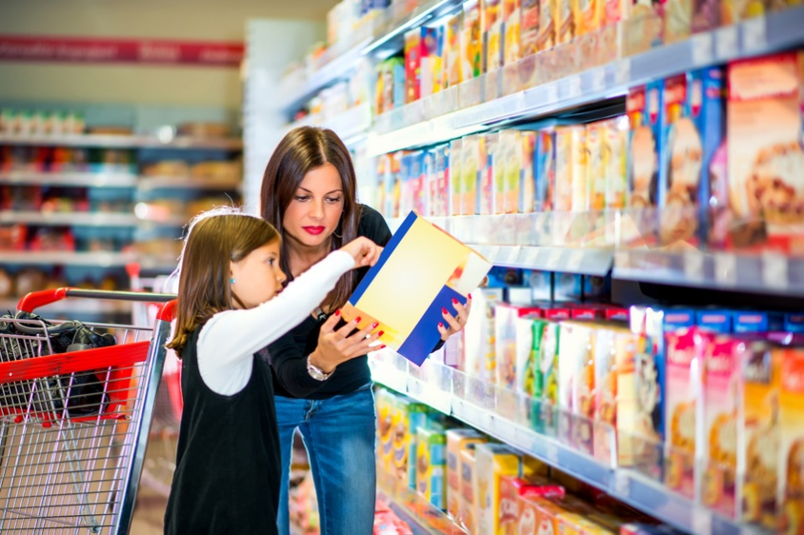

Target Audience of Unilever

Market Targeting
One of the greatest aspects regarding the products that are being sold by Unilever is that the products can be consumed by every single individual in a market (Cvelbar, Grün and Dolnicar, 2017). As they are responsible for providing consumer goods there are hardly any individual who cannot be categorized as a consumer of Unilever. Unilever provides products that are for babies to elderlies. Not to mention in terms of social class individuals who are categorized as poor, rich and average can also be considered as a target market from the perspective of Unilever. However, in order to ensure greater effectiveness of marketing strategy Unilever is concerned to focus their marketing efforts mostly on average or higher middle-class individuals of United Kingdom.

Market Segmentation
Unilever has been operating for more than 130 years and this experience has been very advantageous for Unilever. Because instead of influencing their marketing strategies they usually focus on their products in order to comply with the growing demand of customers. Due to such reasons the market segmentation approach of Unilever constantly changes. For example, currently Unilever has been focusing on the dairy based products such as milk, cookies batter and other milk-based products as well as personal and healthcare products (Hole, Pawar and Bhaskar, 2018). Due to such reason the current market segmentation is based on the occupation as well as the gender. Unilever segments their possible customers and focuses on providing their marketing efforts to housewife’s and female. Because most of the time the individuals who are responsible for buying customer-based products or home-based products are female and who are housewife.
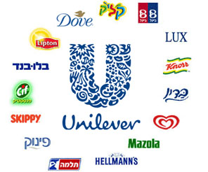

Why Consumer Should Choose Unilever
By 2022, Unilever wants to assist one billion people better their health and wellbeing, enhance the livelihoods of hundreds or even thousands of workers in the supply chain, and decrease negative carbon impact of the company's goods by half. And Unilever was never willing to scrimp on quality. Their first focus is the customer and the customer's opinion on the product. They truly change their product aspects based on the demands and wellness of their customers. They believe in doing better business in order to make the world a better place. They also believe in improving human health.
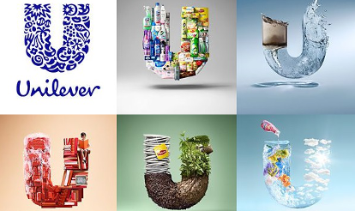

Market Positioning
Almost every product that is produced by Unilever can be seen on every departmental and supermarket store. It is because Unilever corresponds their production with population and so they have created diverse products which is essential for the customers. As the products have low risk in terms of making sales Unilever collaborates with various stores such as Tesco, Asda and Walmart.

Reference
Bala, M. and Verma, D., 2018. A critical review of digital marketing. M. Bala, D. Verma (2018). A Critical Review of Digital Marketing. International Journal of Management, IT & Engineering, 8(10), pp.321-339.
Cvelbar, L.K., Grün, B. and Dolnicar, S., 2017. Which hotel guest segments reuse towels? Selling sustainable tourism services through target marketing. Journal of Sustainable Tourism, 25(7), pp.921-934.
Deepak, R.K.A. and Jeyakumar, S., 2019. Marketing management. Educreation Publishing.
Foreman, S., 2003. Marketing. Henley manager update, 15(1), pp.10-19.
Grewal, D., Hulland, J., Kopalle, P.K. and Karahanna, E., 2020. The future of technology and marketing: A multidisciplinary perspective.
Hole, Y., Pawar, S. and Bhaskar, M.P., 2018. Service marketing and quality strategies. Periodicals of Engineering and Natural Sciences (PEN), 6(1), pp.182-196.
Kotler, P., 2012. Kotler on marketing. Simon and Schuster.
van Esch, P., Arli, D., Castner, J., Talukdar, N. and Northey, G., 2018. Consumer attitudes towards bloggers and paid blog advertisements: what’s new?. Marketing Intelligence & Planning.

