An Evaluation of Open Access Youth Provision in Pembrokeshire during the Covid-19 pandemic.

Julie Bevington
1807298

16th May 2022

ECYW6001
Yr Athrofa: Education and Humanities

DECLARATION FORM


Name of the Programme of Study: BA Hons Youth Work and Social Education

Name of Student (Capital Letters): JULIE BEVINGTON

DECLARATION

I certify that the whole of this work is the result of my individual effort, and that all sources have been acknowledged.

Signed J. Bevington (Student)

Date 16/05/2022

DECLARATION

I am satisfied that this work is the result of the Student’s effort.

Signed .............................................................. (Lecturer)

Date ..............................................................

Contents
Page number
Declaration Form 2
Contents 3
Acknowledgements 4
Abstract 5
Acronyms 6
- Introduction 7 -
- Literature Review
- Methodology / Methods
- Presentation of data
- Discussion, and interpretation of the data
- Conclusion and Recommendations
- References
- Appendices
  - Appendix 1 – Ethics form
  - Appendix 2 – Staff questionnaire
  - Appendix 3 – Focus group participant consent form
  - Appendix 4 – Focus group participant cover letter
  - Appendix 5 – Staff participant cover letter
  - Appendix 6 – Staff participant consent form
  - Appendix 7 – Support services sheet
  - Appendix 8 – Focus group questions
  - Appendix 9 – Focus group responses
  - Appendix 10 – Youth club reopening guidance

Acknowledgements
I would like to take this time to thank those who have supported me throughout the research study and the completion of this dissertation. Firstly thank you to Angharad Lewis for being my Dissertation Supervisor and for all your advice and encouragement. Additionally without the teaching and support from Angharad Lewis, Alan Enoch and Katie Gardner who have contributed to my learning, this dissertation would not have been possible to undertake without the knowledge I have gained during my time with University of Wales Trinity Saint David. I would also like to express my gratitude to my colleagues at Pembrokeshire Youth Service for any support they have shown me or knowledge offered during my studies especially Nadine Farmer. I would also like to express my gratitude to my research participants, as without your participation this study would not have been possible, and not forgetting my family and friends who have been encouraging of my studies.

Abstract

The aim of this study is to examine and evaluate the open access youth provision offered by Pembrokeshire Youth Service throughout the Covid-19 pandemic. It is anticipated that the results of this study will prove insightful for Pembrokeshire Youth Service in regard to implementing any recommendations that may be suggested in the findings.

To gain further knowledge of how Covid-19 has affected Youth Services and young people across the country, wider reading around the subject was undertaken and presented in the literature review in this dissertation. In-depth reading revealed there is a vast amount of published literature on Covid-19 and the impact it has had on young people, however as the relaxation of restrictions is still fairly recent there seems to be a gap in the publication of literature evaluating youth work delivery during the pandemic.

The methodological approach in this study used qualitative research methods. There were two groups of participants. The first group were young people who had attended open access youth provision during the pandemic. Three groups of five young people from three different youth club localities participated in focus groups and six staff participants from the same youth club localities were given questionnaires. The researcher used thematic analysis techniques to identify key theme areas from the responses given by the participants of the study.

The study concluded that young people were simply just happy to be back at youth club despite some of the restrictions that were implemented due to Welsh Government requirements. Some of the issues that the young people articulated could very easily be solved through discussions with management. Whilst other problems raised simply could not be altered, as they were laws that had to be followed from Welsh Government. Staff participants raised the lack of digital competency in themselves and other staff, so recommendations to upskill staff in digital technology with appropriate training was made along with suggestions that managers’ high expectations of large engagement participation numbers during online sessions needed to be addressed, due to issues raised during the qualitative research methods and the literature reviewed.

Acronyms
BERA - British Educational Research Association
UNICEF - United Nations International Children's Emergency Fund
WG – Welsh Government
WHO – World Health Organisation
CWVYS - Council for Wales of Voluntary Youth Services
PCR - Polymerase Chain Reaction

Chapter 1: Introduction

This dissertation has been undertaken by Julie Bevington, a Community Youth Worker in a town in Pembrokeshire, and is an evaluation of open access youth provision in Pembrokeshire during the Covid-19 pandemic. It is anticipated that this research will inform the author and Pembrokeshire Youth Service on what aspects of the open access youth provision offered during the Covid-19 pandemic proved successful or identify any recommendations for future knowledge. Pembrokeshire Youth Service facilitates ten open access youth clubs across Pembrokeshire. There are five in the north of the county, three in the mid and two in the south.

The purpose of this research study is to evaluate the open access youth work provision provided by Pembrokeshire Youth Service in Pembrokeshire during the Covid-19 pandemic. The findings will allow Pembrokeshire Youth Service to gain knowledge on the views and opinions of the young people who attended provisions, and gain insight into what worked well, what did not, and what improvements could be made. As noted by Checkoway and Richards-Schuster (n.d, p. 9) “evaluation is a process in which people join together and develop knowledge for action”. Having this information will help to inform and shape future delivery in the event of further lockdowns or firebreaks. Although Welsh Government restrictions needed to be followed, this evaluation will also inform practitioners of the need for some services or specialist sessions to remain open at some level through future lock downs, as the impacts on some young people during the pandemic have been detrimental. This is affirmed by Flint (2021, no page number) who reports, “youth workers have spoken of children falling into gangs and struggling as clubs remained closed during Covid-19".
The aim of the research project is to evaluate the offered open access provision by Pembrokeshire Youth Service during the pandemic. Research with young people will provide an insight into what worked and what did not. As open access youth provision opened back up after the lockdowns, many restrictions had to be implemented to adhere to Welsh Government (2020) regulations such as implementing one-way systems, maintaining a two-metre social distance between all persons, ensuring face coverings are worn, and the establishment and monitoring of a track and trace system. This research project intends to identify whether the young people were satisfied with the service provided under such measures in place, were they too restrictive, would they have preferred that youth work provision did not open back up until most restrictions had been lifted, or were they pleased that there was a scaled down provision on offer. Feedback from the young people will prove invaluable to understand their experiences of attending an open access youth provision during the pandemic and what improvements could be made so Pembrokeshire Youth Service will be better equipped should there be any future restrictions or lockdowns.
The research will use a qualitative methodology approach, which will explore the young people’s views and experiences, along with the views and experiences of their youth workers. Commentators Hennink, Hutter and Bailey (2020, p.10) state that

Qualitative research is an approach that allows you to examine people’s experiences in detail by using a specific set of research methods such as in-depth interviews, focus group discussions and observations.

(Hennink, Hutter and Bailey, 2020, p. 10)

The skills of a youth worker in conversation and dialogue with young people will also lend themselves positively to a qualitative research method. Three focus group discussions will be facilitated at three different youth club locations and two staff members from each club will be given questionnaires (please see appendix 2) for the purposes of triangulation as this, according to Carter, Bryant-Lukosius, DiCenso, Blyth and Neville (2014, p545.) “tests validity through the convergence of information from different sources.”

Utilising focus groups also allows young people to have their views and opinions listened to in accordance with Article 12 of The United Nations Rights of the Child (UNICEF, 1989, no page number.) that states “children have the right to say what they think should happen, when adults are making decisions that affect them, and to have their opinions taken into account.”

As the focus groups will consist of young people aged eleven to eighteen, a consent form (please see appendix 3) will be sent to all young people’s parents and carers to gain their consent for the young people to engage in the research. BERA (2018, p. 8) advise that
Participants’ voluntary informed consent to be involved in a study will be obtained at the start of the study, and that researchers be open to the possibility that participants may wish, for any reason and at any time, to withdraw their consent.
(BERA, 2018, p. 8)

A cover letter (please see appendix 4) for the young people and staff (please see appendix 5) participating will be devised explaining the aims and objectives of the project, and information on the right to withdraw will be detailed in a young person friendly manner. Staff will also be given a consent form (please see appendix 6). Potential participants will be reassured that their participation is voluntary, they are free to withdraw at any time without providing a reason, and their data will be destroyed in accordance with guidelines from BERA (2018). Talking about the pandemic may bring some unpleasant memories back so to mitigate any risk, before the session commences it will be explained that young people can leave or take a break when needed and the researcher will guide them to appropriate additional support if this is required. Additionally, handouts detailing support services available for young people to access will be given out at the beginning of the session (please see appendix 7).

Findings from the focus groups and questionnaires will then be analysed to detect emerging themes. As Sapin (2009, p. 166) notes, “analysing data identifies emerging patterns and draws conclusions about their meaning and significance”. Once the results of the research have been analysed, the next stage would be to identify any areas for action before finally making recommendations that will help to improve.

The aim of this study is to undertake an evaluation of open access youth provision in Pembrokeshire during the Covid-19 pandemic. Findings of the research will highlight any issues faced and will suggest recommendations to improve the provision and inform future practice in case of further viruses. Implementing any recommendations may prove constructive to enable youth provisions to stay open during a pandemic. This in turn could help young people to ensure that their “physical and mental well-being is maximised and people to fulfil their potential no matter what their background or circumstances” in accordance with the Well-being of Future Generations (Wales) Act 2015 (Welsh Government, 2015, p7).

The evaluation of open access youth provision in Pembrokeshire during the Covid-19 pandemic will begin by undertaking a Literature Review which will enable the researcher to explore what is already known about the themes of the research, and this will take place in the next chapter. Engaging in a Literature Review will help to inform the researcher’s knowledge and understanding of the themes linked to this dissertation as the researcher prepares for engaging in the focus groups with young people and the questionnaires with their youth workers.

Chapter 2 – Literature review
This literature review will look to explore the impact of the Covid -19 pandemic on Youth Services, youth workers’ roles and in particular open access youth provision. This chapter will enable the reader to have an understanding of the consequences holistically upon Youth Services nationally during the pandemic from initial lockdown of the country in 2020 through to the relaxation of restrictions two years later in 2022. Knopf (2006) briefly explains, “a literature review summarizes and evaluates a body of writings about a specific topic”, Randolph (2009, p2) goes further and elaborates that
Conducting a literature review is a means of demonstrating an author’s knowledge about a particular field of study, including vocabulary, theories, key variables and phenomena, and its methods and history.
(Randolph, 2009, p2)

Boote and Beile (2005, p3) suggest and caution that to undertake any “significant research” the researcher needs to embark on literature published within the field of study.

UK Government (2020, page no./no page no.) announced on the 31st of December 2019, that The World Health Organisation (WHO) “was informed of a cluster of cases of pneumonia of unknown cause detected in Wuhan, Hubei Province, China”. By February 2020 this virus had mutated and saw the unprecedented outbreak of a global virus called Covid-19 and labelled a pandemic by WHO reported by BBC News (2020).
The UK Prime Minister, Johnson, (2020, no page number) announced on the 23rd of March 2020 that
From this evening I must give the British people a very simple instruction - you must stay at home. Because the critical thing we must do is, stop the disease spreading between households. That is why people will only be allowed to leave their home for the following very limited purposes:
- shopping for basic necessities, as infrequently as possible
- one form of exercise a day - for example a run, walk, or cycle - alone or with members of your household;
- any medical need, to provide care or to help a vulnerable person; and
- travelling to and from work, but only where this is absolutely necessary and cannot be done from home.

(Johnson, 2020, no page number)

Overnight non-essential businesses, schools, leisure centres, community centres and youth centres closed. A five-mile travel rule was introduced and outdoor areas that are usually relied upon for their health and wellbeing benefits such as beaches and parks were off limits to members of the public.

Young people and children were launched into a world of online home schooling overnight as directed by Welsh Government (2020), and youth workers roles seemingly altered overnight. Gone was the normal face-to-face youth work approach. Work patterns transformed from the traditional after school and evening hours to an unconventional and luxurious nine to five. Noted by Barclay (2022, no page number) “all face-to-face contact was cancelled, but that didn’t mean youth workers could just stop”.

Many local authorities deployed youth workers in to different roles. UK Youth (2021, p2) acknowledge
Youth workers were quick to adapt their services and have been at the forefront of supporting the wider emergency response, often redeploying staff to distribute emergency care packages, support emergency services and transform their buildings in to food banks.

(UK Youth, 2021, p2)

Marshall, O’Prey, Parkinson, Grunhut, Teifi, Usher and Knight (2021, p50) reiterate this by reporting “many youth workers worked in school hubs” and imply a key worker status was bestowed on to youth workers so they could be utilised to deliver school lunches and food parcels to families”. However the bestowed key worker status is argued by a youth worker in the U.K who took park in a study by Batsleer, Beever, St. Croix, Jones, McVeigh, Smith and Amin (2020, no page number) who voiced “being labelled as a key worker is hollow and fake. If youth workers were that key and crucial why are jobs being cut?” Ord (2016, p142) appears to corroborate the view of systemic cuts to youth provision by making reference to the In Defence of Youth Work campaign (2009) that has continued to oppose cuts over many years.
To keep connected with young people, the youth work sector nationally, seemingly transitioned to utilising a digital platform to move youth clubs online. European Parliament (2021, p3) support this by observing
Digital youth work and digital communication with young people and within youth organisations have been until 2020 complementing and additional methods. The pandemic changed this ‘order’ completely because the lockdown, physical distancing rules and other public health regulations have rendered many of the traditional contexts and methods of youth work either impossible or impractical.

(European Parliament, 2021, p3)

Baxter (2020), p1) suggests the challenges in exploring digital technology to try to find the most appropriate platform was not easy but soon decided on the platform “zoom as it was the closest to physical drop-in”. However, European Parliament (2021, p4) seem to contend this by reporting “many organisations and youth workers reported significant difficulties in finding and/or developing new methods and techniques for youth work and non-formal education in online spaces”. The ease or difficulty in identifying a suitable platform to undertake online sessions that worked for young people and staff might not have been down to professional choice or experience but entirely down to the polices within the organisation. UK Youth (2022, p2) advised youth workers to use “a fit-for-purpose system that your organisation has approved”. In theory, this seems easily straightforward to implement, however, just because an organisation has identified the platform to be used, it does not mean it is relatable or appropriate for the young people you are working with. Commentator Gough (2020, no page number) acknowledges
We already know that young people mostly don’t use Facebook; they are much more likely to be on Instagram, Snap chat and the platforms that adults don’t know much about yet. If we as adults want to engage with young people online, we cannot assume they will want to do it in the way we want them to.
Gough (2020, no page number)

Osborn (2020, p 57) disputes Gough’s claims and implies that her group of young people had never met before and had no other option other than to use Zoom to attend certain online courses but feels the success of those sessions was due to the regularity of the meetings.
Osborn (2020, p57) also notes that “the nine people had never met before but after daily meetings for six weeks friendships had been made” and observes that this is down to “the beauty of youth work and it can work, even over Zoom”.
As recalled by Towler (2019, no page number)
Youth centres and projects closed during lockdown, seeing youth workers and youth support workers devising digital methods to make contact with young people and responding to their concerns, needs and requests for assistance.
(Towler, 2019, no page number)

Nevertheless, anecdotally youth workers reported young people’s lack of interest with engaging online. Osborn (2020, p63) suggests that young people’s eagerness to engage online was low and advocates that young people are exhausted. Young people in line with Welsh Government (2020) restrictions saw a rise in their use of screen time. Dataportal (2020, no page number) refers to screen time as
The amount of time spent and the diverse activities performed online using digital devices. For instance, screen time encompasses both, using digital devices for educational purpose as well as for leisure and entertainment.
(Dataportal, 2020, no page number)

Pandya and Lodha (2021, p1) observes, “education, shopping, working, meeting, entertaining and socializing suddenly leaped from offline to online”. However Pandya and Lodha (2021, p1) acknowledge that digital technology is a major advantage to being connected in these times but do also caution that, “prolonged screen time has caused concerns related to its impact on physical and mental health”.
Policymakers such as Welsh Government (2020) instructed all face-to-face delivery to move online. This raises questions and conflicts with The National Occupational Standards for Youth Work standard YW18 and YW19 (CLD Standards Council Scotland, 2019, page number) that states youth work should “explore with young people their wellbeing and work with young people to safeguard their own welfare”. Equally, researchers such as Liu, Wu and Yao (2015, p1254) warn “that children and adolescents who spend more than two hours on screens are at a higher risk of developing depression”. On reflection it must be questioned were expectations of high levels of online interaction simply too much. Researchers such as Liu, Wu and Yao (2015, p1254) warn, “that children and adolescents who spend more than two hours on screens are at a higher risk of developing depression”. Research by Khouja, Munafò, Tilling, Wiles, Joinson, Etchells, John, Hayes, Gage, and Cornish (2019, p10) also identified “that increased computer use at age 16 is associated with an increased risk of depression and anxiety at age 18”.

Whilst youth clubs were closed during the pandemic, it seemingly had a disturbing effect on young people’s mental health. Young people who were receiving support from youth workers previously on a daily basis suddenly found much reduced timeframes of interaction. Bawden (2020, no page number) reports that young people rely on being able to regularly check in with a youth worker when attending youth club on a nightly basis but claims conversations with a young person highlights that during the pandemic support was limited, with a young person claiming “I still get support, but now it’s on the phone and instead of getting an hour, it’s more like twenty minutes”.
Another young person commented that meeting once a week pre Covid with his youth worker was the “only time I eat with another person” and felt “worried about it all ending” when face to face delivery ceased.

The reopening of youth clubs was the most anticipated event for some young people and youth workers, “Gee is counting down the days until she can go back to Creative Networks and see her friends again” (Bawden, 2020, no page number). However Flint and Burgess (2021, no page number) report that reopening of youth clubs was not as straightforward as first perceived and clarify that “in Wales while youth clubs can reopen, children over 11 still have to socially distance so numbers indoors are limited depending on size of venue”. The restrictions were not the only cause for concern when reopening and Flint and Burgess (2021, no page number) also explain that youth workers fear that some of the young people that previously attended youth clubs are now “lost to the streets” and mixed up in gang life, so they need to identify ways to “bring them back and rebuild relationships”. Brenton (cited in Flint and Burgess, 2021, no page number) disagrees with the excitement regarding reopening, as government restrictions made it “impossible to put on indoor sessions” and states that some young people “won’t come back because they are lost to drugs and crime”. The Children’s Commissioner for Wales, Holland (2021, page number/no page number), seems in agreement by commenting, “It’s worrying to hear about youth workers talking of losing touch with young people during the pandemic” and acknowledges that government “needs to listen to these concerns so a response can be as effective as possible”.

To conclude, this literature review has highlighted the impact Covid-19 has had on young people and The Youth Service during the pandemic. It is evident that young people’s mental health and wellbeing has suffered as highlighted by The Children’s Commissioner for Wales (2021) report that “children as young as three are missing friends, relatives and experiences and 40% of seventeen year olds reported that they were sad most of the time”. However as the months passed the report highlighted that some young people began to enjoy time at home and felt they were receiving “good support from schools and youth workers (Children's Commissioner for Wales, 2021, p26). After copious amounts of research, it should be acknowledged that there is a vast amount of literature relating to young people and Covid-19, but there is very little literature published on experiences and vies of the reopening of youth clubs. Nonetheless, as it is only recently that Government restrictions have eased or been lifted that is to be expected.

The gap in published research on the experience and views of the reopening of youth clubs therefore provides a strong rationale for the author’s intention to engage in Evaluation of Open Access youth provision in Pembrokeshire during the Covid-19 Pandemic. To enable the author to further explore this Dissertation question, the next chapter will focus on the research methodology, methods and ethics.

Chapter 3 – Methodology (1767)

This chapter proposes to set out a structure for the research that will provide information on the methodology and the research methods relevant to this study. It will justify the methods chosen and will in addition refer to any ethical issues that may arise. This chapter will work in accordance with the aim of this study, which is to explore the evaluation of open access youth provision in Pembrokeshire during the Covid-19 pandemic.

Research methodology is simply the steps required to complete a specific area of study, it establishes the aims and purpose of the study and gives the researcher a clear plan of action. The first stage of research is to ascertain what is to be researched; the second stage is to select which type of methodology will be applied. Creswell (2014, p22) urges researchers to be mindful that the selection of a methodology should be “based on the nature of the research problem or issue being addressed”. Research methods include qualitative, quantitative or a mixed methodology of both quantitative and qualitative. Creswell (2014, p22) further explains the difference between qualitative and quantitative research as follows, noting how
The distinction between qualitative and quantitative research is framed in terms of using words (qualitative) rather than numbers (quantitative), or using closed-ended questions (quantitative hypotheses) rather than open-ended questions (qualitative interview questions).

(Creswell 2014, p22)

A mixed methodology approach is using both qualitative and quantitative methods; however, when choosing a mixed methodology approach, Creswell & Clark (2007) suggest that a mixed approach should only be used if it adds strength to the research that using a singular qualitative or quantitative method could not achieve as successfully.

This research project will use a qualitative methodological approach, which Santhosh, Rojas and Lyons, (2021, p1) express “focuses on exploring individuals’ perspectives, frequently, structured interviews or focus groups are tools employed for data collection for qualitative research”. This is possibly the most appropriate approach for a youth worker, as the research requires the views and opinions of young people. Sapin (2009) acknowledges the values of youth work, and suggest that youth workers appreciate the young people’s right to be involved and opinions heard and respected. Seers (2012, p. 15) notes how “good qualitative research uses a systematic and rigorous approach that aims to answer questions concerned with what people think or feel about something that has happened”.

Prior to any research commencing it is essential that ethical consideration has been investigated and relevant documentation completed. Blaxter, Hughes and Tight (2001, p.158.) outline the foundations of research ethics as
Being clear about the nature of the agreement, you have entered in to with your research subjects. Ethical research involves getting the informed consent of those who you are going to question, observe or take materials from. It involves reaching agreements about the uses of data, and how its analysis will be reported and disseminated.

(Blaxter, Hughes and Tight, 2001, p.158.)

Therefore, before commencement of research, an ethical approval form will be completed and submitted to The Ethical Approval Committee in line with The University of Wales Trinity Saint David’s Research Ethics & Integrity Code of Practice (2020, p5) which states that “research conducted in and by the University should be undertaken in accordance with commonly agreed standards of good practice”. Once ethical approval has been authorised, consent forms for all research participants need to be distributed. BERA (2018, no page number) affirm, “It is expected that participants’ voluntary informed consent to be involved in a study will be obtained at the start of the study”. Whilst that is sufficient for adult participants, BERA (2018, no page number) also emphasises that
In the case of participants whose capacity, age or other vulnerable circumstance may limit the extent to which they can be expected to understand or agree voluntarily to participate, researchers should also seek the collaboration and approval of those responsible for such participants.

(BERA, 2018, no page number)

Consequently, consent forms will be given to participants parents/guardians (please see appendix 3) along with a covering letter (please see appendix 4) stating the nature and purpose of the study to ensure that “researchers are open and honest with participants” as suggested by BERA (2018, p16). Staff and young people who are participants will also be informed that their participation is entirely voluntary and as Smith (2013, p2) reinforces, they are “choosing to become involved in the work”. Participants will also be made aware of their right to withdraw from the study as the General Medical Council (2014, p.52) suggests researchers respect the participants right to decline or withdraw at any point “with an assurance that this will not adversely affect their relationship with the researcher”.
To further mitigate participants from any adverse effects such as unpleasant memories experienced during the Covid-19 pandemic that may be resurfaced whilst taking part in the study, quiet areas will be available if required and further support from youth workers present. Additionally, participants will be provided with information of support services they can access (please see appendix 6). Once all ethical considerations have been concluded and “permissions obtained, confidentiality maintained and identities protected” (Denscombe, 1998, p.63), the research can commence. No incentives will be given to the participants to take part in this study, however BERA (2018, p19.) convey “researchers’ use of incentives to encourage participation should be commensurate with good sense, such that the level of incentive does not impinge on the free decision to participate”.

The research will consist of conducting focus groups with five young people in three different youth clubs across Pembrokeshire. A focus group is a group of people who are brought together for qualitative research purposes. Kitzinger (1995, page number/no page number) further explains, “focus groups are a form of group interview that capitalises on communication between research participants in order to generate data”. Having five participants in each focus group enables the principal researcher to facilitate a clear and concise participation session. MacIntosh (1981) seems to propose a recommendation of six to ten people per focus group, however Kitzinger (1995) seemingly argues this by proposing four participants can be an acceptable number in a focus group. The delivery of the focus groups will involve structured questions to stay focussed and successful on the task. The National Co-ordinating Centre for Public Engagement (2013, page number/no page number) agrees by claiming, “the key to success is having clear aims and objectives and keeping it enjoyable and useful for the participants, to ensure the information gathered is the most useful”. There are seemingly many benefits of a focus group for all involved. For example, the researcher acquires a wide range of views, knowledge and opinions within a reasonably short time frame, they allow for ideas to be explored more than surveys, and as Kruger and Casey (2009, page number/no page number) claim it “creates a more informal atmosphere that can help people feel more comfortable to speak out”. Kitzinger (1994) highlights that an important benefit of focus groups is the peer interaction that allows for the participants to listen to others then reassess their responses. Goss and Leinbach (1996) also connote that giving young people the opportunity to work jointly in a research study can be very empowering to them, which is one of the five pillars of youth work in accordance with Youth Work in Wales Review Group (2018, p5). Kreuger (1988) implies that focus groups are more beneficial in the preparatory stage of a research study, however Race, Hotch and Parker (1994) contend that notion by suggesting focus groups are particularly suited to evaluating specific projects or tasks.

The principal researcher will lead discussions and be present to remind the participants of Covid-19 restrictions introduced by Welsh Government (2020). The participants in the focus group will take part in discussions regarding the open access provision during the pandemic and will then be given three questions to answer.
- What worked well when you attended youth club provision during the pandemic?
- What didn’t we do very well on?
- What improvements could we make?
These questions will be printed on to thumbs up and thumbs down pictures (please see appendix 7 for images). The young people in the focus group will then stick their responses to the questions on to a giant thumbs up/down (please see appendix 8 for photos).
Two youth workers in the same three locations will be emailed questionnaires (please see appendix 2) to gain qualitative data on their observations and opinions of working in an open access provision during the Covid-19 pandemic. Jones, Baxter and Khanduja, (2013, p6.) propose that “questionnaires are vital tools used to gather information on individual perspectives”. Youth Workers in three different localities have been chosen to comply with triangulation, a method to enhance the reliability and efficiency of the findings. Triangulation is notably affiliated with qualitative research methods and Salkind (2010, page number/no page number) takes the view that “triangulation typically involves examining data from interviews, focus groups, written archives, or other sources”. Polit and Beck (2012, p1) assert that “triangulation involves the use of multiple methods of data collection about the same phenomenon”. Laws, Harper and Marcus (2003, p281) further this, maintaining that “triangulation is to see the same thing from different perspectives and thus be able to confirm or challenge the findings of one method with those of another”. However, Law et al (2003, p281) caution that
There may be a mismatch and even conflict between them. A mismatch does not necessarily mean that the data collection process is flawed – it could just be that people just have very different accounts of similar phenomenon. You need to critically examine the meaning of any mismatches to make sense of them.

(Laws, Harper and Marcus, 2003, p281)

Once all focus groups have been completed and staff questionnaires have been collated, the data will be organised by using thematic analysis. The researcher will used this method to identify and organise any themes of the responses given. Thematic analysis noted by Gupta, Shaheen and Reddy (2018, p197) is “an often-used method of qualitative research provides concise description and interpretation in terms of themes and patterns from a data set”. Once the data has been interpreted, recommendations will be made on the findings of the research. The report on the findings can be requested by staff and young people at anytime. The methodology has generated data on the evaluation of open access youth provision in Pembrokeshire during the Covid-19 pandemic, this is presented in the next chapter, chapter four; Presentation of the data.


Chapter 4 – Presentation of the data

This chapter will present the information gathered whilst engaging in research activity with young people and youth workers, which was collected in the modes outlined in the previous methodology chapter. The results of this research activity will support the researcher’s aim of undertaking an Evaluation of Open Access youth provision in Pembrokeshire during the Covid-19 Pandemic. The data gathered will be separated into areas of key themes identified by the researcher using thematic analysis methods. Thematic analysis according to Caulfield (2019, no page number) requires “examining the data to identify common themes – topics, ideas and patterns of meaning that come up repeatedly”. The sample of the participants in the research study consisted of fifteen young people, five in each of the three focus groups and six members of staff, two from each youth club.
The findings of the research study will be displayed via charts and graphs in addition a brief summary of each key theme as suggested by Bartee, Shriner and Chreech (n.d.) who suggest that displaying data in the form of graphs and charts is easily readable as opposed to lengthy written statements or tables.

Focus group data
The participants of the focus groups will be kept anonymous in accordance with ethical approval (BERA, 2018) however, some non-identifiable data has been recorded and displayed in pie charts representing the following demographic information;
- Age range of participants
- Gender distribution of participants
- Ethnicity
- Locality of clubs participants accessed
Participants of the focus groups will be referred to as participant A1 –A5 for youth club A’s focus group, Participant B1-B5 for youth club B and participant C1-C5 for youth club C. The three focus groups were all asked the same questions;
- What worked well when you attended open access youth provision during the Covid-19 pandemic?
- What did not go well when you attended open access youth provision during the Covid-19 pandemic?
- What improvements could we make?

The data that has been gathered through the focus groups has been examined and separated in to four key theme areas. The data will be displayed via charts and graphs in addition to a brief summary of each key theme as suggested by Bartee, Shriner and Chreech (n.d.) to suggest that displaying data in the form of graphs and charts is easily readable as opposed to lengthy written statements or tables. Quotes from young people and staff will also be utilised to support findings and themes identified.
Figure 1

The age range of participants participating in the three focus groups ranged from eleven to twenty-five, with nine being in to the eleven to thirteen year old range, five in the thirteen to sixteen range and one in the sixteen to twenty five year age range.

Figure 2

The gender distribution of participants were seemingly equal and consisted of seven male and eight female.

Figure 3

Thirteen of the young people in the focus group identified with a white ethnicity, one black and one mixed race.

Figure 4

The focus group participants were equally allotted to the three youth club localities.

Data gathered from the three questions asked during the focus groups were examined and the responses investigated for themes. Responses were placed in to one of four key areas. The first question asked after discussions and reminders of the Covid -19 timeline and rules and regulations in accordance with Welsh Government (2020) was; What worked well when you attended open access youth provision during the Covid-19 pandemic?

Figure 5

The responses given by the focus groups were identified as being associated with the four key themes above; socialising, enjoying activities on offer, assured with the social distancing activities and one way systems implemented and lastly enjoying themselves and having fun. Participant A1 voiced, “There wasn’t people close together so social distancing worked well” whilst participant B3 recalled
“people were happy to be back at youth club whatever rules we had to follow. Not seeing friends for so long made us all feel sad and lost. Being with friends and back doing activities was great”.

Participant C3 offered, “I enjoyed getting involved with the activities again” whilst participant C1 commented, “meeting up with friends and spending time with them was the best”. Participant B4 summarised “just being back in our safe fun space in person was amazing, online activities weren’t as much fun”.

The second question asked to the focus groups was, what did not work very well?

Figure 6

The overall emerging response of what did not work well by the focus group participants, was the booking system that was implemented to only allow ten attendees to adhere to Pembrokeshire Youth Service’s Guidance for Re-opening Youth Clubs was not favoured. (Please see appendix ten for Pembrokeshire Youth Service Guidance for Reopening Youth Clubs). Participant C3 commented “the booking to come to youth club was bad” whilst participant A5 articulated “the booking system only allowed parents to book their children on and some parents like mine forgot until it was too late and fully booked”. Participant B5 questioned, “I can book myself on to leisure centre sessions, why did my parents have to book me in to youth club?” Participant B4 vocalised “with only ten people allowed in at night, the nights booked up really quick meaning some people couldn’t go to youth club for a few weeks”. Participant A3 seemingly agreed with this saying “my mum tried to book but places had already been filled for that week by the Monday afternoon”.

The third and final question asked to the focus groups was, what improvements could we make? The responses given were;
Figure 7

The most highlighted suggestions for improvement were in regards to the booking system. Some participants requested that young people should have been able to book on without the need of parents’ permission whilst others propose designated booking times.
Participant C4 clarified this response by acknowledging that
“most people booked on by email the minute they left youth club, leaving other people not able to book, so booking should have been open one day a week, with a certain time for example on a Friday for the following week and booking lines are open between 5-p.m.”.

Participant A4 stated, “people should have been given certain days to go to club so everyone got a chance”. Participant B5 expressed “more than 10 people should have been let in as we couldn’t do some activities like team building with not many of us”.

Staff data

Participants completing the staff questionnaires will also remain anonymous and will be referred to in this study as staff participant A1 and A2 for youth club A, staff participant B1 and B2 for youth club B and staff participant C1 and C2 for youth club C. Their non-identifiable demographic information has been recorded and presented as;
- Age range of participants
- Gender distribution of participants
- Ethnicity
- Anonymised locality of clubs participants are employed in.

The data identified through the completed staff questionnaires has been split in to four key areas. The questions on the staff questionnaire were:
- Views on how open access youth provision was delivered during the Covid-19 pandemic
- Procedures that did not work well?
- Recommendations for improvement?
- Observations on young people’s personal and social development pre, during and post Covid-19 pandemic.

Figure 8

The ages of the staff participants in the study reported as three members of staff being age 40-50 years old, one member of staff 30-40 years old and two members of staff in the 20-30 age category. This appears to be a good mixed age range for receiving responses from a broad spectrum.

Figure 9

The staff participants comprised of an equal combination of males and females.

Figure 10

All staff participants identified as their ethnicity as being white.

Figure 11

The staff participants consisted of two members of staff from each youth club where the focus groups were facilitated.
The qualitative data identified through the completed staff questionnaires has been linked to four key areas for each of the four questions. The first question for staff participants was:
Figure 12

There were very mixed views on this question, some were very positive and a few were negative. The negative comments were themed in to question three that stated was there anything that did not work well? Five members of staff believed that youth workers had to become more innovative in their delivery methods. Staff participant B1, noted that “youth workers were very good at coming up with solutions for problems” whilst, staff participant C1 takes the view that “immediate online sessions were mobilised swiftly”. Although staff had seemingly taken one week to plan activities that could be delivered online, staff quickly realised that online sessions were not going to be easy as noted by participant B2 who commented, “the need for parental consent for young people to engage online was difficult as incorrect parental contact information was held on our QES system”. Online activities apparently consisted of virtual tours and quizzes, staff participant A2 commented, “the Zoom era had landed”. The majority of the staff participants suggested that they had to adapt to a new way of delivery but felt young people deserved youth work to continue, staff participant A1 notes “delivery was a challenge, there is no way to ignore that, young people wanted the ‘normal’ and we had to provide a ‘new normal’ for our young people”. Staff participant A2 also voiced their views on “being limited on what activities we could deliver with such strict restrictions to abide by, normally our activities involve things like team building but sharing of equipment was prohibited”.

Figure 13

All six staff participants seemed to be in agreement with three themes identified; conflict with management, PPE and changing regulations. Four out of the six members of staff reported that they and young people had had difficulty in to adapting to social distancing and one-way systems. When discussing the reopening of youth club staff participant B2 commented
“we were happy to hear youth club was opening back up, however I don’t think any of us were prepared for what measures needed to be implemented and how the social distancing restrictions would impact on the activities we could deliver”.

Staff participant A1 reported that
“the risk assessment stated young people and staff are to wear face masks, however didn’t supply any youth clubs with any so young people who didn’t have one were refused entry, some team leaders purchased masks out of their own money to give to the young people”.

Staff participant C2 added
“although there was a risk assessment in place for youth clubs, there was often confusion as the risk assessment said one thing, management another and both sometimes conflicted with Welsh Government restrictions or guidance”.
This was also voiced by staff participant B2 who noted
“So many changes in the law made it difficult to keep up to date and what proved the most difficult was the understanding on if an open access youth provision came under education processes or community centre processes. It did feel sometimes like we would sit under the different areas as and when it suited management”.

Figure 14

Six staff participants all commented there were issues with the booking system and online sessions, which mirrored the focus group feedback as noted earlier within this chapter. Staff participants A1, B2 and C3 felt they “lacked the digital skills needed to provide engaging online sessions”. Three staff participants, namely A1, A2, and C2 also voiced opinions on lack of planning time prior to online sessions commencing participant A1 commented, “one week to find a suitable online platform and organise activities to deliver was not enough for team leaders who only work 6 hours a week”. Participant A2 declared, “the planning of online sessions was left to the team leader rather than a whole team approach, sessional staff seemed to be at home being paid to do nothing”. Participant C2 voiced
“being given one week of your normal working hours to plan for online delivery was all well and good for the tech savvy, but us non techies found it a long and difficult process to produce online activities and Kahoot quizzes”.

Staff participant C2 reported, “the booking system was so labour some, it definitely highlighted that the youth service are way behind with their technology”. Staff participant B2 said
“due to the same parents booking their child on when collecting their child at home time unfortunately meant a lot of young people missed out on a booking and sometimes waited a couple of weeks to attend youth club”.

Staff participant C2 voiced
“the Covid-19 vaccination status of some staff members caused animosity amongst some staff teams. Staff, who had refused the vaccination, meant that when they had been in contact with somebody who had Covid-19, then according to Welsh Government that team member had to isolate for ten days. This meant that vaccinated staff were often overworked and were expected to pick up the slack”.

Staff participant A2 mentioned, “I know being vaccinated is a choice but as someone with underlying health conditions I felt weary about being around team members who said they had not been vaccinated”.

Figure 15

All six staff participants made observations of young people at the present time of having issues or problems with four of the identified themes and have speculated on whether it links to the recent pandemic and lockdowns that the young people have endured. For example, staff participant C1 noted
“young people now seem to require a lot more guidance and support to complete the most basic of tasks and their ability to bounce back after a disappointment is not as good as it was.”

Staff participant B1 offered
“I have noticed a difference in the maturity of the young people and believe this is due to the pandemic. When we first returned to face-to-face delivery, it felt like our roles had changed to babysitters. It was like the year 8’s were like year 6’s”.
Staff participant A2 stated
“In my professional opinion, whilst young people have aged and physically got bigger it appears their maturity is still that of primary school aged pupils. Their emotional literacy skills appear underdeveloped and the ability to regulate their behaviour appears limited and are still unable to interact with their peers in a coherent manor. We are now witnessing an increase in play fighting, grabbing and in general infant behaviours”.

Staff participant A1 documented “young people don’t want to take part in planned activities and when they do their attention span is very very limited”.

Presenting this data has demonstrated that from three focus groups with five participants in each and six staff questionnaires there have been some interesting points raised and improvements recommended. The views of the young people participating in the focus groups have proved helpful and staff feedback via the questionnaires are seemingly fairly similar however, it is clear that there are areas for improvement. These results will be analysed and discussed in the next chapter, “Chapter 5, Discussion and Interpretation of the Data”, to enable the researcher to further explore her aim of undertaking and Evaluation of Open Access youth provision in Pembrokeshire during the Covid-19 Pandemic.

Chapter 5 - Discussion and Interpretation of the Data
As part of the author’s Evaluation of Open Access youth provision in Pembrokeshire during the Covid-19 Pandemic, this chapter will analyse the findings of the data presented in chapter four. The Office of Institutional Research (2022, no page number) explains that “data analysis and interpretation is the process of assigning meaning to the collected information and determining the conclusions, significance, and implications of the findings”. The data being discussed and analysed was identified through facilitating three focus groups with young people and questionnaires were given to six members of staff. Four key themes were identified by the researcher using a thematic analysis process for both of the qualitative research methods. Responses to each question will be analysed and discussed making links to the literature reviews in a previous chapter.

During the participatory focus groups, three questions were asked to the participants.
- What worked well when you attended youth club during the pandemic?
- What did not work well?
- What improvements could we make?
The focus group responses in response to the first question, what worked well during the pandemic? were analysed and the researcher identified four clear themes. Forty percent of participants simply enjoyed being back at the youth club, socialising with friends after being isolated during the pandemic. Twenty six percent of the participants expressed being able to have fun again worked well, twenty percent stipulated that taking part in the planned social distancing activities worked well for them.
These responses support Bawden’s (2020) research that declared young people were looking forward to being back with friends in youth club, as mentioned in the literature review.
The second question posed in the focus groups was what did not work well? Sixty percent of the participants voiced that the overall problem with attending youth club during the pandemic was the booking system that was implemented to meet restrictions made by Welsh Government (2020). Pembrokeshire Youth Service devised guidance (Please see appendix 10) that Community Team Leaders had to abide by when reopening youth clubs across the county. On account of the venue size, a maximum of ten young people could attend youth club sessions at any one time. The guidance also specified parents/carers of young people needed to book their child in to a youth club session so a youth worker could ask the parent/carer to complete the Covid-19 medical questionnaire. The majority of the young people (60%) did not approve of the booking system and responses seemed to suggest that some of the young people missed some sessions as parent/carers forgot to book them on or when they remembered the session was already fully booked. The other key themes that were ascertained as ones that did not work well by the focus group participants was the requirement to wear facemasks (20%) and six percent said not being able to go outdoors to do activities during the winter months. The requirement of face masks was implemented by Welsh Government (2020) and the weather and dark evenings were elements that youth club staff could not make improvements on, as agreed by Sapin (2009, p19) who comments that “the values and principles of youth work are not always compatible with legal requirements or organisational policies”.
The third and final questions the researcher asked the focus group participants was, what improvements could we make?
The majority of responses highlighted four key themes. They were, more capacity at youth club sessions (13%) designated booking times (40%), young people being able to book on themselves (33%) and the remaining thirty-three percent stated no improvements were required.

The second research method used in the study were questionnaires. These were distributed to six staff participants who had worked in different youth club locations during the pandemic. The questionnaires asked were as follows:
- Views on open access youth provision during the pandemic
- Procedures that did not work well
- Recommendations for improvement
- Observations on young people’s personal and social development post pandemic.
Responses from the staff questionnaires were arranged in to four key themes. The first question saw a mixed response of both positive and negative comments. The researcher categorised the negative comments in to categories within the second question of what did not work well. The other responses to question one identified a commonalty of themes. Thirty three percent of participants believed staff had developed innovative approaches to working, twenty-six percent suggested staff were good at adapting to change, whilst twenty six percent commented staff dedication was apparent and twenty-six percent had views on the limitations of what activities could be delivered. Whilst analysing the findings of this question, it seems some responses from the staff participant’s conflict with one another.
Twenty six percent of participants believed staff were good at adapting to change however; others noted they felt limited on what activities they could deliver with social distancing restrictions in place. Furthermore, twenty-six percent of the participants stated that staff were good at adapting to change. This raised questions for the researcher in regards to what they actually meant. Was it how effective they had become in changing the way they delivered their practice or as noted by Marshall, O’Prey, Parkinson, Grunhut, Teifi, Usher and Knight (2021, p50) in the literature review could it be the case that they had been deployed to completely different job roles, which they felt was adapting to change?

The second question on the questionnaire was, were there any risk assessment/procedures that did not work well? One hundred percent of staff participants suggested there were issues surrounding Personal Protective Equipment (PPE), conflict with management and the changing of regulations at some point during open access youth provision during the pandemic. Staff highlighted that management had produced one generic risk assessment for all youth clubs and put restrictions on ten young people in youth club settings however, Welsh Government (2020) suggested that the amount of people permitted in a setting depended on the size of the venue. Staff argued that perhaps some settings could have had larger numbers if separate risk assessments had been carried out allowing them to deliver better activities. Brenton (cited in Flint and Burgess, 2021, no page number) seems to concede this notion commenting Government restrictions made it “impossible to put on indoor sessions” as previously mentioned in the literature review. Staff participants criticised management on working procedures that had been written into the risk assessment.
Staff and young people were required to wear coverings during face-to-face contact, however the Service did not provide disposable masks for young people. This resulted in youth workers having to turn young people away from sessions if they did not possess a face covering, which youth workers believed was unfair and culminated in staff purchasing facemasks with their own money.

The third question posed to the staff participants was, if there was anything that did not work well, what was it? Overwhelmingly 100% of participants agreed that the booking system and online activities did not work well. Comments made by the participants seem to corroborate Osborn’s (2020, p63) views that young people did not want to engage online due to pure exhaustion of increased online activities during the day as mentioned in the literature review. Management wanted figures of engagement and refused to believe that young people did not to participate online as “that generation do everything online” as quoted by staff participant B2. Some staff participants made comments regarding the lack of empathy for young people’s exhaustion at the excessive online schooling studies they were already expected to sustain without adding to their workload by expecting them to join youth club sessions online in the evening. These views of the youth workers seem to be consistent with the report mentioned in the literature review by Liu, Wu and Yao (2015, p1254) who warned that excessive screen time impacts adolescents mental health.

Fifty percent of the staff participants wrote about frustrations in regards to the isolation regulations from (Welsh Government, 2021, no page number) that stated

Advice for unvaccinated close contacts remains the same – they are required to self-isolate for 10 days and advised to take PCR tests on day 2 and day 8 following their exposure to a positive case.

(Welsh Government, 2021, no page number)

This caused animosity amongst some staff members who felt they had followed advice and had the vaccine to protect themselves and others, whilst some chose not to. To add to the growing animosity, those who were unvaccinated and had been in close contact of a positive Covid case were required to self-isolate for ten days, resulting in other staff feeling overwhelmed with extra duties to “pick up the slack” in other areas.

The fourth and final question on the staff questionnaire asked have you any observations on the young people’s personal and social development at the present time? One hundred percent of staff participants made observations and remarks on the same four key areas, maturity, emotional literacy, lack of confidence or resilience and attention span. All staff participants made comments relating to the timescale of the young people’s attention span and articulated that project work was difficult to facilitate at present as young people’s concentration is only held for a very short period compared to that of pre Covid. Comments made by one hundred percent of the staff participants suggested that across the county young people seemingly did not have respect for other people’s personal space and a culture of grabbing and play fighting was apparent in all ages not just younger aged young people as previously witnessed.

Upon completion of the research methodology, interpretation of the data and discussion of the findings, it has highlighted the need for improvements to certain elements of the open access youth provision if a lockdown was reintroduced for any reason. Smith (2022, no page number) reports that Wales' chief medical officer Dr. Frank Atherton says, “future lockdowns due to the spread of coronavirus cannot be ruled out, we never know what's round the corner". Recommendations will be discussed further in the next chapter, Chapter Six, Conclusions and Recommendations.

Chapter Six – Conclusion and Recommendations
This chapter of the dissertation will conclude the study, which has been an Evaluation of Open Access youth provision in Pembrokeshire during the Covid-19 Pandemic. The purpose of this study was to investigate what improvements could be made to open access youth provision in the event of future lockdowns. The results of this study have demonstrated that there is very little literature published regarding the implications of reopening open access youth provisions when restrictions allowed, however there is a vast amount of published literature in relation to the effects and impact of Covid-19 on young people.
The qualitative research methodology used in this small-scale participatory research study worked well. Facilitating the focus groups enabled the researcher to explain the questions in more detail and gain clarification on the young people’s responses to better understand their views and opinions. Upon reflection, changes would be made to the staff participant questionnaires, and instead of asking for Views on open access youth provision during the pandemic this would be altered to create two questions. The questions would be positive views on open access youth provision during the pandemic and negative views on open access youth provision during the pandemic as participants had mixed positive and negative comments, which resulted in increased timescales to interpret the data. The researcher acknowledges there were limitations to the study in relation to sample size. The focus group participants had to have attended open access youth provision during the pandemic to be able to give their views however, due to Covid some young people have not returned to youth club, therefore five young people from three different localities who had all attended open access youth provision proved more difficult than first imagined.
There were also difficulties with identifying staff participants who had worked at open access provisions throughout the pandemic due to major staff changes across Pembrokeshire Youth Service in recent years.

The data gathered identified key theme areas as previously discussed in chapter five. In general, the three different focus groups had very similar comments with the three questions posed to them. The majority of the participants were just happy that youth club was reopening and restrictions imposed did not concern them, as they were just happy back being with their friends and having fun. This is verified by Brown and Larson (2009, p74) who declare, “scholars have pointed to peer relationships as one of the most important features of adolescence and praised for contributing to adolescent health and well – being”. This corroborates findings in the Coronavirus and Me report by the Children's Commissioner for Wales (2021, p26) which suggests that during the pandemic a high percentage of young people aged twelve to eighteen year olds reported missing being able to spend time with their friends. When considering the question of what did not work, the main negative response that over seventy-fine percent of participants discussed was the booking system, and they voiced improvements to enhance the system. The staff questionnaires unearthed three key areas for improvement. One hundred percent of participants articulated that the booking system implemented by management, PPE provisions and online sessions needed improvement.

In response to the issues highlighted, three recommendations for improvement would be;
- The booking system
- Online sessions
- PPE / risk assessment

Both staff and young people participants raised concerns regarding the booking system. As previously mentioned in chapter five, Pembrokeshire Youth Service required parents/carers of young people to book their child in to a youth club session so a youth worker could ask the parent/carer to complete the Covid-19 medical questionnaire. Young people expressed issues around this and believed that they should have been able to book themselves on as they do with other activities in the leisure centre. This is an area that needs to be discussed with Managers. The key purpose of youth work according to CLD Standards Council Scotland (2019, p4.)
is to
Enable young people to develop holistically, working with them to facilitate their personal, social and educational development, to enable them to develop their voice, influence and place in society and to reach their full potential.

(CLD Standards Council Scotland, 2019, p4.)

Therefore to enable young people to develop holistically, youth work should encourage young people to take responsibility and promote opportunities that will help them to reach their full potential.
By asking parents/carers to book their young people on to sessions, this could be seen as counteractive to youth work standard YW05 “enable young people to use their learning to enhance their future development and YW10 “facilitate young people’s empowerment through their active involvement in youth work” (CLD Standards Council Scotland, 2019, p11.)

The second recommendation I would make based on the findings of the research study would look to address some of the online sessions. As highlighted in chapter five, young people did not want to engage in the online virtual sessions. Comments from the young people simply confirmed that they were too exhausted with online home school learning to log back on in the evenings to join a virtual youth club session. Managers need feedback on this issue as anecdotally staff comments also suggested that managers were more concerned with engagement figures than the needs of young people. The other recommendation regarding this area of concern was staff participant’s views on digital competence. Although some staff believed they were good at adapting to change, others discussed how they felt they lacked the skills to deliver online sessions effectively due to lack of digital skills. One recommendation would be for Pembrokeshire Youth Service to apply for funding through Taith (WG, 2022) is Taith (2022, no page number). Taith (2022) is
A new programme enabling people in Wales to study, train, volunteer and work all over the world, while allowing organisations in Wales to invite international partners and learners to do the same here in Wales. It will create opportunities to broaden horizons, experience new ways of life, and bring back lessons to share with people at home.

(WG, 2022, no page number).

If funding is successful, the Service could then appoint a member of staff to visit a country where digital youth work projects have proved to be successful for not only youth workers but also young people. Staff could be mentored in countries such as Finland where Hoyla and Reponen (2019, p3) report
Verke is one National Centre of Expertise for Youth Work nominated for developing and maintaining of digital youth work. Verke implemented the fourth survey for Finnish municipalities about digital youth work. The results show that municipal youth workers use a wide range of digital tools actively. It was shown that municipal youth workers and youth work managers have an extremely positive attitude towards digitalisation.
(Hoyla and Reponen, 2019, p3)

Nominated staff members could then peer mentor other staff to improve their digital literacy to carry out online duties with more efficiency and confidence to pass on knowledge to the young people they work with. As Hoyla and Reponen (2019, p8) reveal
The benefits of Digital Youth Work for young people are enormous. Using digital technology with in youth work is a fantastic enabler of these new 20th century skills that are said to be needed in future workplace and society.
(Hoyla and Reponen, 2019, p8)

The third and final recommendation is regarding issues raised regarding PPE and risk assessments. Staff raised concerns in reference to Welsh Government (2020) restrictions that required face covering to be worn in indoor public spaces. Young people had to comply and wear a mask to enter youth club however, masks were not provided for young people, which resulted in some young people being refused entry. A recommendation to Pembrokeshire Youth Service would be to provide any PPE required allowing young people to take part. This would promote and encourage inclusion which is one of the pillars of Youth Work in Wales Principles and Purposes, Youth Work in Wales Review Group (2018). A further recommendation would be that individual risk assessments of youth club venues should be conducted on an individual basis rather than a generic one fits all. Some venues could have accommodated more young people than others which could have allowed youth workers to work with additional young people in accordance with the National Occupational Standards for Youth Work CLD Standards Council Scotland (2019, p11.) to “Initiate, build and maintain purposeful relationships with young people” in what was unprecedented times.

Reference list
2017. Research Ethics & Integrity Code of Practice. [ebook] The University of Wales Trinity St. David, p.4. Available at: <https://www.uwtsd.ac.uk/media/uwtsd-website/content-assets/documents/research/research-ethics-integrity-code-practice.pdf> [Accessed 8 March 2022].

2022. A guide to delivering Digital youth work. 1st ed. [ebook] UK Youth, p.2. Available at: <https://www.ukyouth.org/wp-content/uploads/2021/01/Digital-Youth-Work-Guide.pdf> [Accessed 28 March 2022].

Bartee, L., Shriner, W. and Chreech, C., n.d. Principles of Biology. Open Oregon Educational Resources.

Batsleer, J., Beever, E., De St. Croix, T., Jones, K., McVeigh, G., Smith, C., and Amin, H. 2020. ‘A citizen Enquiry into the Lives of Youth Workers in the time of Covid-19’ Youth and Policy. https://www.youthandpolicy.org/articles/citizen-enquiry-into-the-lives-of-youth-workers-in-civid-19/.

Bawden, A., 2020. Meeting my youth worker is the only time I eat a meal with another person. The Guardian, [online] Available at: <https://www.theguardian.com/society/2020/apr/29/youth-worker-coronavirus-youth-services-young-people-pandemic> [Accessed 4 April 2022].

Baxter, S., 2020. Youth and no work. [online] Youth & Policy. Available at: <https://www.youthandpolicy.org/articles/youth-and-no-work/> [Accessed 23 March 2022].

BBC News, 2020. Coronavirus confirmed as pandemic by World Health Organization. [online] Available at: <https://www.bbc.co.uk/news/world-51839944> [Accessed 23 March 2022].

Bera.ac.uk. 2018. Ethical Guidelines for Educational Research, fourth edition (2018). [online] Available at: <https://www.bera.ac.uk/publication/ethical-guidelines-for-educational-research-2018> [Accessed 16 February 2022].

Blaxter, L., Hughes, C. and Tight, M. (2001) How to Research, 2nd edn. Buckingham: Open University Press. P. 158.

Boote, D. N., & Beile, P. (2005). Scholars before researchers: On the centrality of the dissertation literature review in research preparation. Educational Researcher, 34(6), 3-15.

Brown, B.B. and Larson, J. (2009). Peer Relationships in Adolescence. In Handbook of Adolescent Psychology (eds R.M. Lerner and L. Steinberg). https://doi.org/10.1002/9780470479193.adlpsy002004. P74.

Carter, N., Bryant-Lukosius, D., DiCenso, A., Blythe, J. and Neville, A., 2014. The Use of Triangulation in Qualitative Research. Oncology Nursing Forum, [online] 41(5), pp.545-547. Available at: <http://file:///C:/Users/bevingtonj/Downloads/carter2014%20(2).pdf> [Accessed 20 February 2022].

Caulfield, J., 2019. How to do thematic analysis. [online] Scribbr. Available at: <https://www.scribbr.com/methodology/thematic-analysis/#:~:text=Thematic%20analysis%20is%20a%20method,meaning%20that%20come%20up%20repeatedly.> [Accessed 16 March 2022].

Checkoway, B. and Richards-Schuster, K., n.d. Participatory evaluation with young people. 1st ed. [ebook] Michigan: University of Michigan, p.9. Available at: https://www.participatorymethods.org/sites/participatorymethods.org/files/participatory%20evaluation%20with%20young%20people_Checkoway.pdf [Accessed 20 February 2022].

Children's Commissioner for Wales, 2021. Coronavirus and me. [online] Cardiff: Welsh Government. Available at: <https://www.childcomwales.org.uk/wp-content/uploads/2020/06/FINAL_formattedCVRep_EN.pdf> [Accessed 4 April 2022].

CLD Standards Council Scotland. (2019) Youth Work National Occupational Standards, Glasgow: CLD Standards Council Scotland.
Creswell, J. W. (2014). Research Design: Qualitative, Quantitative, and Mixed Methods Approaches. 4th ed. London: SAGE Publications Ltd.

Creswell, J. W., & Plano Clark, V. L. (2007). Designing and conducting mixed methods research. Thousand Oaks, CA: Sage.

DataReportal (2020). Digital: 2020 Global Digital Overview [Internet]. Available at: https://datareportal.com/reports/digital-2020-global-digital- overview.

Denscomve, M. (1998) The Good Research Guide for Small-Scale Social Research Projects. Buckingham: Open University Press. P63.

European Parliament (2021), Education and youth in post-COVID-19 Europe – crisis effects and policy recommendation, available at https://bit.ly/3zk1BGP, accessed 27 May 2021.

Flint, R. and Burgess, M., 2021. Covid: Youth clubs fear for children 'lost to the streets' in pandemic. BBC News, [online] Available at: <https://www.bbc.co.uk/news/uk-wales-57468462> [Accessed 4 April 2022].

Flint, R., 2021. Covid: Call to help young people hit by service closures. [online] BBC News. Available at: <https://www.bbc.co.uk/news/uk-wales-58584164> [Accessed 20 February 2022].
Good medical practice.(2014) 3rd ed. [ebook] General Medical Council, p.52. Available at: <https://www.gmc-uk.org/> [Accessed 8 March 2022].

Goss J.D., Leinbach T.R. (1996) ‘Focus groups as alternative research practice’, Area 28 (2)

Gough, T., 2020. Youth ministry online. 1st ed. Cambridge: Grove Youth.

Gupta, Shaheen, M., & Reddy, K. P. (2018). Thematic Analysis in Qualitative Research. In Qualitative Techniques for Workplace Data Analysis (p.197). IGI Global. https://doi.org/10.4018/978-1-5225-5366-3.ch009

Hennink, M., Hutter, I. and Bailey, A., 2020. Qualitative Research Methods. 2nd ed. London: Sage, p.10.

Hoyla and Reponen (2019) Youth Work in the Digital World Unit 2. Youth Work eLearning Partnership (YWeLP). Available at <https.//www.youthworkandyou.org/ywelp-module-five/>

IN DEFENCE OF YOUTH WORK. 2009. IN DEFENCE OF YOUTH WORK. [online] Available at: <https://indefenceofyouthwork.com/> [Accessed 13 April 2022].

Johnson, B., 2020. Prime Minister's statement on coronavirus (COVID-19). London: UK Government, p.no page number.

Jones, T., Baxter, M. and Khanduja, V., 2013. A quick guide to survey research. The Annals of The Royal College of Surgeons of England, [online] 95(1), pp.5-7. Available at: <https://www.ncbi.nlm.nih.gov/pmc/articles/PMC3964639/> [Accessed 10 March 2022].

Khouja, J. , Munafo, M., Tilling, K., Wiles, N., Joinson, C., Etchells, P., John, A., Hayes, F., Gage, S., & Cornish, R. (2019). Is screen time associated with anxiety or depression in young people? Results from a UK birth cohort. BMC Public Health, 19(1), 82. [82]. https://doi.org/10.1186/s12889-018-6321-9

Kitzinger J. (1994) ‘The methodology of focus groups: the importance of interaction between research participants’, Sociology of Health 16 (1)

Kitzinger J. (1995) ‘Introducing focus groups’, British Medical Journal 311: 299-302.

Kitzinger, J., 1995. Qualitative Research: Introducing focus groups. BMJ, [online] 311(7000), pp.299-302. Available at: <https://www.bmj.com/content/311/7000/299> [Accessed 8 March 2022].

Knopf, J. W. (2006) “Doing a Literature Review,” PS: Political Science & Politics. Cambridge University Press, 39(1), pp. 127–132. doi: 10.1017/S1049096506060264.
Kreuger R.A. (1988) Focus groups: a practical guide for applied research. London: Sage.

Kreuger, R.A. and Casey, M.A. (2009) Focus Groups: A Practical Guide for Applied Research 4th edition. Thousand Oaks, California: Sage Publications

Laws, S., Harper, c., and Marcus, R. (2003) Research for Development: A Practical Guide. London. Sage p.281.

Liu, M., Wu, L., and Yeo, S. (2015) ‘Dose response association of screen time-bases sedentary behaviour in children and adolescents and depression: a meta-analysis of observational studies’, British Journal of Sports Medicine, 50(20), pp1525-1258. Available at: http://dx.doi.org/10.1136/bjsports-2015-095084 Accessed 28th March 2022.

MacIntosh J. (1981) ‘Focus groups in distance nursing education’, Journal of Advanced Nursing 18: 1981-85.

Marshall, T., O’Prey, L., Parkinson, A., Grunhut, S., Teifi, I., Usher, S. & Knight, E. Research to inform development of the youth work strategy. Cardiff: Welsh Government, GSR report number 01/2021

National Co-ordinating Centre for Public Engagement, 2013. How to organise focus groups. [online] Bristol: Bristol University, p.2. Available at: <https://www.publicengagement.ac.uk/sites/default/files/publication/how_to_organise_focus_groups.pdf> [Accessed 8 March 2022].

Office of Institutional Research. 2022. Analyzing and Interpreting Data - Office of Institutional Research. [online] Available at: <https://institutionalresearch.syr.edu/assessment/asesspp/analyzing-and-interpreting-data/> [Accessed 13 April 2022].

Ord, J., 2016. Youth work process, product and practice. 2nd ed. London: Routledge, p.142.

Osborn, J., 2020. From Isolation to Community. 1st ed. Issachar Press, p.57.

Pandya, A. and Lodha, P., 2021. Social Connectedness, Excessive Screen Time During COVID-19 and Mental Health: A Review of Current Evidence. Frontiers in Human Dynamics, [online] 3. Available at: <https://www.frontiersin.org/articles/10.3389/fhumd.2021.684137/full> [Accessed 28 March 2022].

Patton, M.Q. (1999). Enhancing the quality and credibility of qualitative analysis.

Polit, D.F., & Beck, C.T. (2012). Nursing research: Generating and assessing evidence for nursing practice. Philadelphia, PA: Lippincott Williams and Wilkins

Race K.E., Hotch D.F., Parker T. (1994) ‘Rehabilitation program evaluation: use of focus groups to empower clients’, Evaluation Review 18 (6): 730-40.

Randolph, Justus (2009) "A Guide to Writing the Dissertation Literature Review," Practical Assessment, Research, and Evaluation: Vol. 14, Article 13.
DOI: https://doi.org/10.7275/b0az-8t74
Available at: https://scholarworks.umass.edu/pare/vol14/iss1/1

Salkind, N. J. 2010. Triangulation. In: Neil J. Salkind Editor, 2010. Encyclopedia of Research Design, Thousand Oaks, CA: SAGE Publications, Inc. pp. 1538-1540 Available at: <https://dx.doi.org/10.4135/9781412961288.n469> [Accessed 9 Mar 2022].

Santhosh, L., Rojas, J. and Lyons, P., 2021. Zooming into Focus Groups: Strategies for Qualitative Research in the Era of Social Distancing. ATS Scholar, [online] p.1. Available at: <https://www.atsjournals.org/doi/10.34197/ats-scholar.2020-0127PS>.

Sapin, K., 2009. Essential Skills For Youth Work Practice. 1st ed. London: Sage Publications Ltd.

Seers K. Qualitative data analysis. Evidence-Based Nursing 2012, p 15.
Smith, M. K. (2013) ‘What is youth work? Exploring the history, theory and practice of youth work’, the encyclopedia of informal education, www.infed.org/mobi/what-is-youth-work-exploring-the-history-theory-and-practice-of-work-with-young-people/. Accessed 18th March 2022.

Smith, M., 2022. Future Covid lockdowns cannot be ruled out, says Wales' top doctor. Wales Online, [online] Available at: <https://www.walesonline.co.uk/news/health/coronavirus-covid-lockdown-virus-vaccine-23734091> [Accessed 26 April 2022].

Towler, K., 2019. Youth work in Wales rises to the challenges of the lockdown. [Blog] Education Workforce Council, Available at: <https://www.ewc.wales/site/index.php/en/about/blog-archive/1436-keith-towler-blog.html> [Accessed 28 March 2022].

UK Government, 2020. COVID-19: background information. London: UK Health Security Agency, p.no page number.

UK Youth, 2021. The impact of COVID-19 on young people and the youth sector. [online] London: UK Youth, p.2. Available at: <https://www.ukyouth.org/wp-content/uploads/2021/01/UK-Youth-Covid-19-Impact-Report-.pdf> [Accessed 20 April 2022].

UNICEF,2021. UNCRC Summary. [online] Available at: <https://downloads.unicef.org.uk/wp-content/uploads/2019/10/UNCRC_summary-1_1.pdf?_adal_sd=www.unicef.org.uk.1639592359638&_adal_ca=so%3DGoogle%26me%3Dorganic%26ca%3D(not%2520set)%26co%3D(not%2520set)%26ke%3D(not%2520set).1639592359638&_adal_cw=1639592345184.1639592359638&_adal_id=20e55110-cca9-46c7-92a9-4731f18d4792.1639592345.2.1639592353.1639592345.59349f4f-1460-4c6f-aeca-dddab7c50614.1639592359638&_ga=2.194070635.772885109.1639592345-835146590.1639592344> [Accessed 15 February 2022].

Welsh Government (2015) Well-being of Future Generations Act: The Essentials. Welsh Government, Cardiff. P7.

Welsh Government (2020) The Health Protection (Coronavirus Restrictions) (Wales) Regulations 2020. Cardiff.

Welsh Government, 2020. Timeline of school closures during the coronavirus (COVID-19) pandemic, March 2020 to April 2021. Cardiff: Welsh Government.

Welsh Government, 2021. Written Statement: Self-isolation changes. Cardiff: Welsh Government, p.no page number.

Welsh Government, 2022 Taith. [online] Available at: <https://www.taith.wales/about/> [Accessed 4 May 2022].

Winmill, A., 2022. [online] Urban Devotion Birmingham. Available at: <https://www.urbandevotion.org/> [Accessed 28 March 2022].

Youth Work in Wales Review Group (2018) Youth Work in Wales Principles and Purposes, Cardiff: Youth Work in Wales Review Group.

YouthWorkAndYou.org. 2022. NEW Module 5- Youth work in a digital world - YouthWorkAndYou.org. [online] Available at: https://www.youthworkandyou.org/wp-content/uploads/2019/08/Mod-5-HU-Unit-2-Focus-on-Digital-Youth-Workers.pdf [Accessed 11 May 2022].

Appendix 1 – Ethics form
APPLICATION FOR ETHICAL APPROVAL

In order for research to result in benefit and minimise risk of harm, it must be conducted ethically. A researcher may not be covered by the University’s insurance if ethical approval has not been obtained prior to commencement.

The University follows the OECD Frascati manual definition of research activity: “creative work undertaken on a systematic basis in order to increase the stock of knowledge, including knowledge of man, culture and society, and the use of this stock of knowledge to devise new applications”. As such this covers activities undertaken by members of staff, postgraduate research students, and both taught postgraduate and undergraduate students working on dissertations/projects.

The individual undertaking the research activity is known as the “principal researcher”.

Ethical approval is not required for routine audits, performance reviews, quality assurance studies, testing within normal educational requirements, and literary or artistic criticism.

Please read the notes for guidance before completing ALL sections of the form.

This form must be completed and approved prior to undertaking any research activity. Please see Checklist for details of process for different categories of application.

SECTION A: About You (Principal Researcher)
1 | Full Name: |  | Julie Bevington
2 | Tick all boxes that apply: |  | Member of staff: | ☐ | Honorary research fellow: | ☐
 | Undergraduate Student | ☒ | Taught Postgraduate Student | ☐ | Postgraduate Research Student | ☐

3 | Institute/Academic Discipline/Centre: | Centre for Childhood, Youth and Education.
4 | Campus: | Monkton
5 | E-mail address: | 1807298@student.uwtsd.ac.uk
6 | Contact Telephone Number: | 07926042656
 | For students:
7 | Student Number: | 1807298
8 | Programme of Study: | BA Youth Work and Social Education (ETS endorsed).
9 | Director of Studies/Supervisor: | Angharad Lewis

SECTION B: Approval for Research Activity
1 | Has the research activity received approval in principle?  (please check the Guidance Notes as to the appropriate approval process for different levels of research by different categories of individual) |  | YES | ☒ | NO | ☐
 |  |  |  |  | Date
2 | If Yes, please indicate source of approval (and date where known): Approval in principle must be obtained from the relevant source prior to seeking ethical approval | Research Degrees Committee |  | ☐
2 |  | Institute Research Committee |  | ☐
2 |  | Other (write in)  Angharad Lewis |  | ☒ | 16/11/21

SECTION C: Internal and External Ethical Guidance Materials
 | Please list the core ethical guidance documents that have been referred to during the completion of this form (including any discipline-specific codes of research ethics, location-specific codes of research ethics, and also any specific ethical guidance relating to the proposed methodology). Please tick to confirm that your research proposal adheres to these codes and guidelines. You may add rows to this table if needed.
1 | UWTSD Research Ethics & Integrity Code of Practice | ☒
2 | UWTSD Research Data Management Policy | ☒
3 | BERA ethics and guidance  Durham University’s Community based Participatory Research Guide to Ethical Practice | ☒

SECTION D: External Collaborative Research Activity
If there are external collaborators then you should gain consent from the contact persons to share their personal data with the university. If there are no external collaborators then leave this section blank and continue to section E.
1 | Institution
2 | Contact person name
3 | Contact person e-mail address
4 | Is your research externally funded? |  | YES | ☐ | NO |  | ☐
5 | Are you in receipt of a KESS scholarship? |  | YES | ☐ | NO |  | ☐
6 | Are you specifically employed to undertake this research in either a paid or voluntary capacity? | Voluntary | YES | ☐ | NO | ☐
7 |  | Employed | YES | ☐ | NO | ☐
8 | Is the research being undertaken within an existing UWTSD Athrofa Professional Learning Partnership (APLP)? | If YES then the permission question below does not need to be answered. | YES | ☐ | NO |  | ☐
9 | Has permission to undertake the research has been provided by the partner organisation? | (If YES attach copy)  If NO the application cannot continue | YES | ☐ | NO |  | ☐
Where research activity is carried out in collaboration with an external organisation
10 | Does this organisation have its own ethics approval system? | YES | ☐ | NO | ☐
 | If Yes, please attach a copy of any final approval (or interim approval) from the organisation (this may be a copy of an email if appropriate).
SECTION E: Details of Research Activity
1 | Indicative title: |  | Evaluation of Oopen Access youth provision in Pembrokeshire during the Covid-19 Pandemic.
2 | Proposed start date: |  | 21/12/21 | Proposed end date: | 16/05/2022
Introduction to the Research (maximum 300 words per section)
Ensure that you write for a Non-Specialist Audience when outlining your response to the points below:
- Purpose of Research Activity
- Proposed Research Question
- Aims of Research Activity
- Objectives of Research Activity
Demonstrate, briefly, how Existing Research has informed the proposed activity and explain
- What the research activity will add to the body of knowledge
- How it addresses an area of importance.
3
4 |  | Research Question  Evaluation of open access youth provision in Pembrokeshire during the Covid-19 pandemic.  (this box should expand as you type)
5 |  | Aims of Research Activity  The aim of the research project is to evaluate the offered open access provision by Pembrokeshire Youth Service during the pandemic. Research with young people will provide an insight into what worked and what did not. As open access youth provision opened back up after the lockdowns, many restrictions had to be implemented to adhere to Welsh Government (2021) regulations such as implementing one-way systems, maintaining a two-metre social distance between all persons, ensuring face coverings are worn and monitoring and implementation of a track and trace system. This research project intends to identify whether the young people were satisfied with topics such as the measures in place, were they too restrictive, would they have preferred that youth work provision did not open back up until most restrictions had been lifted, or where they pleased that there was a provision on offer. Feedback from the young people will prove invaluable to understand their experiences of attending an open access youth provision during the pandemic and what improvements could be made so Pembrokeshire Youth Service will be better equipped should there be any future restrictions or lockdowns.  As open access provision is for young people it is important and a young person’s right to listen young people’s views and opinions. Article 12 of The United Nations Rights of the Child (UNICEF, 1989) state that “children have the right to say what they think should happen, when adults are making decisions that affect them, and to have their opinions taken into account”.  (this box should expand as you type)
6 |  | Objectives of Research Activity  To achieve the aim of the research activity a list will be complied of who attended open access provision during the pandemic and consent forms will be sent to all young people’s parents and carers to gain their consent for the young people to engage in the research. Bera (2018, p8) advise that “participants’ voluntary informed consent to be involved in a study will be obtained at the start of the study, and that researchers be open to the possibility that participants may wish, for any reason and at any time, to withdraw their consent”. An information sheet for the young people participating will be devised explaining the aims and objectives of the project, and information on the right to withdraw will be detailed in a young person friendly manner. Potential participants and participants will be reassured that their participation is entirely voluntary, that they can withdraw at any time without providing reason, and that their data can be destroyed if they wish in accordance with Bera (2018). Focus groups/questionnaires to be facilitated at three different youth centres across the county to gain qualitative data on the young people’s views and opinions of the open access provision offered by Pembrokeshire Youth Service during the pandemic. Staff who worked in the open access provision will also be asked their thoughts on how they felt delivering an open access provision during the pandemic.  Data from the focus groups/questionnaires will then be analysed to detect emerging themes. As Sapin (2009, p. 166) notes, “analysing data identifies emerging patterns and draws conclusions about their meaning and significance”. Once the results of the research have been analysed, the next stage would be to identify any areas for action before finally making recommendations that will help to improve and inform future practice.
Proposed methods (maximum 600 words)
Provide a brief summary of all the methods that may be used in the research activity, making it clear what specific techniques may be used. If methods other than those listed in this section are deemed appropriate later, additional ethical approval for those methods will be needed. You do not need to justify the methods here, but should instead describe how you intend to collect the data necessary for you to complete your project.
7 |  | This research project will use a qualitative methodological approach. which “focuses on exploring individuals’ perspectives, frequently, structured interviews or focus groups are tools employed for data collection for qualitative research” (Santhosh, Rojas and Lyons, 2021, p1). This is the most appropriate approach as the research requires the views and opinions of young people. Seers (2012, p. 15) notes how “good qualitative research uses a systematic and rigorous approach that aims to answer questions concerned with what people think or feel about something that has happened” and this will guide the Principal Researcher in her planning for her own research. Focus groups and questionnaires will be used to gain qualitative data from young people and youth workers. The focus groups and/or questionnaires will be carried out in three youth centres in Pembrokeshire. Three different localities have been chosen to comply with triangulation method to enhance the reliability and efficiency of the findings, and “triangulation involves the use of multiple methods of data collection about the same phenomenon” (Polit and Beck, 2021, p1). The focus groups will consist of ten to fifteen young people in each group and three staff at each locality, and will held during youth club sessions. Once all focus groups/questionnaires have been collated, the data will be organised by using thematic analysis. Thematic analysis noted by Gupat and Reddy (2018) is “an often-used method of qualitative research, provides concise description and interpretation in terms of themes and patterns from a data set”. Once the data has been interpreted, recommendations will be made on the findings of the research.
Location of research activity
Identify all locations where research activity will take place.
The research activities will take place in youth club sessions at Milford Haven youth centre, Haverfordwest youth centre and Neyland youth centre.

(this box should expand as you type)
Research activity outside of the UK
If research activity will take place overseas, you are responsible for ensuring that local ethical considerations are complied with and that the relevant permissions are sought. Specify any local guidelines (e.g. from local professional associations/learned societies/universities) that exist and whether these involve any ethical stipulations beyond those usual in the UK (provide details of any licenses or permissions required). Also specify whether there are any specific ethical issues raised by the local context in which the research activity is taking place, for example, particular cultural and/or legal sensitivities or vulnerabilities of participants. If you live in the country where you will do the research then please state this.
n/a

10 | Use of documentation not in the public domain: Are any documents NOT publicly available? | NO | ☒
10 |  | YES | ☐
11 | If Yes, please provide details here of how you will gain access to specific documentation that is not in the public domain and that this is in accordance with the current data protection law of the country in question and that of England and Wales.  (this box should expand as you type)

 | Does your research relate to one or more of the seven aims of the Well-being of Future Generations (Wales) Act 2015? | YES | NO
12 | A prosperous Wales | ☐ | ☒
13 | A resilient Wales | ☐ | ☒
14 | A healthier Wales | ☒ | ☐
15 | A more equal Wales | ☒ | ☐
16 | A Wales of cohesive communities | ☐ | ☒
17 | A Wales of vibrant culture and thriving Welsh language | ☐ | ☒
18 | A globally responsible Wales | ☐ | ☒
19 | If YES to any of the above, please give details:
Evaluating open access provision during a pandemic will highlight any issues faced and will highlight recommendations to improve the provision for the future. By being able to keep youth provisions open during a pandemic could help young people to ensure that their “physical and mental well-being is maximised and people to fulfil their potential no matter what their background or circumstances” in accordance with the Well-being of Future Generations (Wales) Act 2015 (Welsh Government, 2015, p7).

(this box should expand as you type)
SECTION F: Scope of Research Activity
 | Will the research activity include: | YES | NO
1 | Use of a questionnaire or similar research instrument? | ☒ | ☐
2 | Use of interviews? | ☐ | ☒
3 | Use of focus groups? | ☒ | ☐
4 | Use of participant diaries? | ☐ | ☒
5 | Use of video or audio recording? | ☐ | ☒
6 | Use of computer-generated log files? | ☐ | ☒
7 | Participant observation with their knowledge? | ☐ | ☒
8 | Participant observation without their knowledge? | ☐ | ☒
9 | Access to personal or confidential information without the participants’ specific consent? | ☐ | ☒
10 | Administration of any questions, test stimuli, presentation that may be experienced as physically, mentally or emotionally harmful / offensive? | ☐ | ☒
11 | Performance of any acts which may cause embarrassment or affect self-esteem? | ☐ | ☒
12 | Investigation of participants involved in illegal activities? | ☐ | ☒
13 | Use of procedures that involve deception? | ☐ | ☒
14 | Administration of any substance, agent or placebo? | ☐ | ☒
15 | Working with live vertebrate animals? | ☐ | ☒
16 | Procedures that may have a negative impact on the environment? | ☐ | ☒
17 | Other primary data collection methods. Please indicate the type of data collection method(s) below. | ☐ | ☒
 | Details of any other primary data collection method:  (this box should expand as you type) | ☐ | ☒
If NO to every question, then the research activity is (ethically) low risk and may be exempt from some of the following sections (please refer to Guidance Notes).

If YES to any question, then no research activity should be undertaken until full ethical approval has been obtained.

SECTION G: Intended Participants
If there are no participants then do not complete this section, but go directly to section H.

 | Who are the intended participants: | YES | NO
1 | Students or staff at the University? | ☐ | ☒
2 | Adults (over the age of 18 and competent to give consent)? | ☒ | ☐
3 | Vulnerable adults? | ☐ | ☒
4 | Children and Young People under the age of 18? (Consent from Parent, Carer or Guardian will be required) | ☒ | ☐
5 | Prisoners? | ☐ | ☒
6 | Young offenders? | ☐ | ☒
7 | Those who could be considered to have a particularly dependent relationship with the investigator or a gatekeeper? | ☐ | ☒
8 | People engaged in illegal activities? | ☐ | ☒
9 | Others. Please indicate the participants below, and specifically any group who may be unable to give consent. | ☐ | ☒
 | Details of any other participant groups:  (this box should expand as you type) | ☐ | ☒

Participant numbers and source
Provide an estimate of the expected number of participants. How will you identify participants and how will they be recruited?
10 | How many participants are expected? | 30 young people (10 from each youth club)  6 staff (2 from each youth club)  (this box should expand as you type)
11 | Who will the participants be? | Young people and youth service staff  (this box should expand as you type)
12 | How will you identify the participants? | Young people who attended the open access provision during covid and staff who staffed the open access provision.  (this box should expand as you type)

 | Information for participants: | YES | NO | N/A
13 | Will you describe the main research procedures to participants in advance, so that they are informed about what to expect? | ☒ | ☐ | ☐
14 | Will you tell participants that their participation is voluntary? | ☒ | ☐ | ☐
15 | Will you obtain written consent for participation? | ☒ | ☐ | ☐
16 | Will you explain to participants that refusal to participate in the research will not affect their treatment or education (if relevant)? | ☒ | ☐ | ☐
17 | If the research is observational, will you ask participants for their consent to being observed? | ☐ | ☐ | ☒
18 | Will you tell participants that they may withdraw from the research at any time and for any reason? | ☒ | ☐ | ☐
19 | With questionnaires, will you give participants the option of omitting questions they do not want to answer? | ☒ | ☐ | ☐
20 | Will you tell participants that their data will be treated with full confidentiality and that, if published, it will not be identifiable as theirs? | ☒ | ☐ | ☐
21 | Will you debrief participants at the end of their participation, in a way appropriate to the type of research undertaken? | ☒ | ☐ | ☐
22 | If NO to any of above questions, please give an explanation
 | (this box should expand as you type)
 | Information for participants: | YES | NO | N/A
24 | Will participants be paid? | ☐ | ☒ | ☐
25 | Is specialist electrical or other equipment to be used with participants? | ☐ | ☒ | ☐
26 | Are there any financial or other interests to the investigator or University arising from this study? | ☐ | ☒ | ☐
27 | Will the research activity involve deliberately misleading participants in any way, or the partial or full concealment of the specific study aims? | ☐ | ☒ | ☐
28 | If YES to any question, please provide full details
 | (this box should expand as you type)

SECTION H: Anticipated Risks

Outline any anticipated risks that may adversely affect any of the participants, the researchers and/or the University, and the steps that will be taken to address them.

If you have completed a full risk assessment (for example as required by a laboratory, or external research collaborator) you may append that to this form.
1 | Full risk assessment completed and appended? |  |  |  | Yes | ☐
1 |  |  |  |  | No | ☒
2 | Risks to participants  For example: sector-specific health & safety, emotional distress, financial disclosure, physical harm, transfer of personal data, sensitive organisational information
 | Risk to participants:  Talking about the pandemic may bring some unpleasant memories back when the young reflect on their experiences (possible bereavement, feeling of isolation and loneliness, disability and so on).  this box should expand as you type) |  | How you will mitigate the risk to participants:  Focus on the topic and try not to deviate on to other conversations. Before the session, explain that young people can leave or take a break when needed. Guide them to appropriate additional support if this is required. To further mitigate participants from any adverse effects such as unpleasant memories experienced during the Covid-19 pandemic that may be resurfaced whilst taking part in the study, quiet areas will be available if required and further support from youth workers present. Additionally, participants will be provided with information of support services they can access  (this box should expand as you type)
3 | If research activity may include sensitive, embarrassing or upsetting topics (e.g. sexual activity, drug use) or issues likely to disclose information requiring further action (e.g. criminal activity), give details of the procedures to deal with these issues, including any support/advice (e.g. helpline numbers) to be offered to participants. Note that where applicable, consent procedures should make it clear that if something potentially or actually illegal is discovered in the course of a project, it may need to be disclosed to the proper authorities
4 |  | Risks to the investigator  For example: personal health & safety, physical harm, emotional distress, risk of accusation of harm/impropriety, conflict of interest
 |  | Risk to the investigator:  Risk of stress during the process of engaging in the research  (this box should expand as you type) |  | How you will mitigate the risk to the investigator:  Ensure researcher engages proactively in supervision sessions  (this box should expand as you type)
5 |  | University/institutional risks  For example: adverse publicity, financial loss, data protection
 |  | Risk to the University:  If the researcher is not professional or does not follow the procedures set by the university correctly then this could damage the university’s reputation.  (this box should expand as you type) |  | How you will mitigate the risk to the University:  Follow all the correct procedures.  Act professionally at all times, ensuring the researcher adheres to GDPR requirements at all times.  (this box should expand as you type)
6 |  | Environmental risks  For example: accidental spillage of pollutants, damage to local ecosystems
 |  | Risk to the environment:  n/a  (this box should expand as you type) |  | How you will mitigate the risk to environment:  n/a  (this box should expand as you type)

 | Disclosure and Barring Service
 | If the research activity involves children or vulnerable adults, a Disclosure and Barring Service (DBS) certificate must be obtained before any contact with such participants. | YES | NO | N/A
7 | Does your research require you to hold a current DBS Certificate? | ☒ | ☐ | ☐
8 | If YES, please give the certificate number. If the certificate number is not available please write “Pending”; in this case any ethical approval will be subject to providing the appropriate certificate number.
SECTION I: Feedback, Consent and Confidentiality

1 | Feedback  What de-briefing and feedback will be provided to participants, how will this be done and when?
At the end of each focus group, the Principal Researcher will conduct a ‘member-checking’ exercise – this is to ensure that the researcher has understood what the participants have said.

The final results will be offered to the young people and youth workers in the form of an online feedback session should they request this.

(this box should expand as you type)
2 | Informed consent  Describe the arrangements to inform potential participants, before providing consent, of what is involved in participating. Describe the arrangements for participants to provide full consent before data collection begins. If gaining consent in this way is inappropriate, explain how consent will be obtained and recorded in accordance with prevailing data protection legislation.
Participants will be given the information sheets and consent forms for both them and their parents prior to the focus group/questionnaire taking place. They will also be provided with a verbal overview immediately prior to the focus groups/questionnaire to ensure all details of the project have been understood. Youth workers will explain to all the young people involved that their participation is purely voluntary, and that they have the right to withdraw their consent at any time and their decision will be respected.

(this box should expand as you type)
3 | Confidentiality / Anonymity  Set out how anonymity of participants and confidentiality will be ensured in any outputs. If anonymity is not being offered, explain why this is the case.
Information about the nature of the study is provided on the sheet, explaining that participation is voluntary and will make assurances that participants’ confidentiality will be protected, and no names of participants will be disclosed at any time. However, young people will be made aware that if during the sessions a young person discloses that they or someone else is at risk of harm, the information would be passed on to relevant agencies.

(this box should expand as you type)

SECTION J: Data Protection and Storage

 | Does the research activity involve personal data (as defined by the General Data Protection Regulation 2016 “GDPR” and the Data Protection Act 2018 “DPA”)? | YES | NO
1 | “Personal data” means any information relating to an identified or identifiable natural person (‘data subject’). An identifiable natural person is one who can be identified, directly or indirectly, in particular by reference to an identifier such as a name, an identification number, location data, an online identifier or to one or more factors specific to the physical, physiological, genetic, mental, economic, cultural or social identity of that natural person. Any video or audio recordings of participants is considered to be personal data. | ☐ | ☐
 | If YES, provide a description of the data and explain why this data needs to be collected:
2 | (this box should expand as you type)
 | Does it involve special category data (as defined by the GDPR)? | YES | NO
3 | “Special category data” means sensitive personal data consisting of information as to the data subjects’ –  (a) racial or ethnic origin,  (b) political opinions,  (c ) religious beliefs or other beliefs of a similar nature,  (d) membership of a trade union (within the meaning of the Trade Union and Labour Relations (Consolidation) Act 1992),  (e) physical or mental health or condition,  (f) sexual life,  (g) genetics,  (h) biometric data (as used for ID purposes), | ☐ | ☐

 | If YES, provide a description of the special category data and explain why this data needs to be collected:
4 | (this box should expand as you type)

 | Will data from the research activity (collected data, drafts of the thesis, or materials for publication) be stored in any of the following ways? | YES | NO
5 | Manual files (i.e. in paper form)? | ☒ | ☐
6 | University computers? | ☐ | ☒
7 | Private company computers? | ☐ | ☒
8 | Home or other personal computers? | ☐ | ☒
9 | Laptop computers/ CDs/ Portable disk-drives/ memory sticks? | ☐ | ☒
10 | “Cloud” storage or websites? | ☐ | ☒
11 | Other – specify: | ☐ | ☒
12 | For all stored data, explain the measures in place to ensure the security of the data collected, data confidentiality, including details of backup procedures, password protection, encryption, anonymisation and pseudonymisation:
All focus group notes, or paper questionnaires will be kept in a locked cupboard at Milford Haven Youth Club until they can be destroyed.
(this box should expand as you type)

 | Data Protection
 | Will the research activity involve any of the following activities: | YES | NO
13 | Electronic transfer of data in any form? | ☐ | ☒
14 | Sharing of data with others at the University outside of the immediate research team? | ☐ | ☒
15 | Sharing of data with other organisations? | ☐ | ☒
16 | Export of data outside the UK or importing of data from outside the UK? | ☐ | ☒
17 | Use of personal addresses, postcodes, faxes, emails or telephone numbers? | ☐ | ☒
18 | Publication of data that might allow identification of individuals? | ☐ | ☒
19 | Use of data management system? | ☐ | ☒
20 | Data archiving? | ☐ | ☒
21 | If YES to any question, please provide full details, explaining how this will be conducted in accordance with the GDPR and Data Protection Act (2018) (and any international equivalents, where appropriate):
n/a

(this box should expand as you type)
22 | List all who will have access to the data generated by the research activity:
The researcher Julie Bevington

(this box should expand as you type)
23 | List who will have control of, and act as custodian(s) for, data generated by the research activity:
The researcher Julie Bevington

(this box should expand as you type)
24 | Give details of data storage arrangements, including security measures in place to protect the data, where data will be stored, how long for, and in what form. Will data be archived – if so how and if not why not.
All focus group notes, or paper questionnaires will be kept in a locked cupboard at Milford Haven Youth Club until they can be destroyed.

(this box should expand as you type)
25 | Please indicate if your data will be stored in the UWTSD Research Data Repository (see https://researchdata.uwtsd.ac.uk/ ). If so please explain. (Most relevant to academic staff)
No

(this box should expand as you type)
26 | Confirm that you have read the UWTSD guidance on data management (see https://www.uwtsd.ac.uk/library/research-data-management/) | YES | ☒
27 | Confirm that you are aware that you need to keep all data until after your research has completed or the end of your funding | YES | ☒

SECTION K: Declaration
The information which I have provided is correct and complete to the best of my knowledge. I have attempted to identify any risks and issues related to the research activity and acknowledge my obligations and the rights of the participants.

In submitting this application I hereby confirm that I undertake to ensure that the above named research activity will meet the University’s Research Ethics and Integrity Code of Practice which is published on the website: https://www.uwtsd.ac.uk/research/research-ethics/
1 | Signature of applicant: | J. Bevington | Date:  08/12/21

For STUDENT Submissions:
2 | Director of Studies/Supervisor: | Angharad Lewis | Date:  25.01.22
3 | Signature: |  | Date:  25.01.22

For STAFF Submissions:
4 | Academic Director/ Assistant Dean: |  | Date:
5 | Signature: |  | Date:

Checklist: Please complete the checklist below to ensure that you have completed the form according to the guidelines and attached any required documentation:
☒ | I have read the guidance notes supplied before completing the form.
☒ | I have completed ALL RELEVANT sections of the form in full.
☒ | I confirm that the research activity has received approval in principle
☐ | I have attached a copy of final/interim approval from external organisation (where appropriate)
☐ | I have attached a full risk assessment (where appropriate) ONLY TICK IF YOU HAVE ATTACHED A FULL RISK ASSESSMENT
☒ | I understand that it is my responsibility to ensure that the above named research activity will meet the University’s Research Ethics and Integrity Code of Practice.
☒ | I understand that before commencing data collection all documents aimed at respondents (including information sheets, consent forms, questionnaires, interview schedules etc.) must be confirmed by the DoS/Supervisor, module tutor or Academic Director.

RESEARCH STUDENTS AND STAFF ONLY
All communications relating to this application during its processing must be in writing and emailed to pgresearch@uwtsd.ac.uk , with the title ‘Ethical Approval’ followed by your name.
You will be informed of the outcome of your claim by email; therefore it is important that you check your University and personal email accounts regularly.
STUDENTS ON UNDERGRADUATE OR TAUGHT MASTERS PROGRAMMES should submit this form (and receive the outcome) via systems explained to you by the supervisor/module leader.
This form is available electronically from the Academic Office web pages: https://www.uwtsd.ac.uk/academic-office/appendices-and-forms/

Appendix 2 – Staff Questionnaire


- What are your views on how open access youth provision was delivered during the pandemic?

- Were there any procedures/risk assessments that did not work well for you? If so what.

- If there was anything that did not work well, what could have made it better?

- Have you any observations on the young people’s personal/social development during the pandemic or at the present time?

Appendix 3 – Young person consent form

Consent to take part in research

PARTICIPATION CONSENT FORM
Project Title: Evaluation of open access youth provision provided by Pembrokeshire Youth Service during the Covid-19 pandemic.
Name of Researcher: Julie Bevington

Please Initial box
I confirm that I have read and understand the cover letter dated 08/03/2022 for the above study. I have had the opportunity to consider the information, ask questions and have had these answered satisfactorily.

I understand that my participation is voluntary and that I am free to withdraw at any time, without giving any reason.

I understand that any information given by me may be used in future reports, articles or presentations by the researcher.

I understand that my name will not appear in any reports, articles or presentations.

I agree to take part in the above study

Signature of research participant ------------------------------------------ Date:-----------------------------

Signature of Parent/Carer---------------------------------------------------- Date:-----------------------------

Signature of researcher------------------------------------------------------- Date:----------------------------
You may decline to participate in this study. You may end your participation in this study at any time. If you decide to remain anonymous, maintaining your anonymity will be a priority and every practical precaution will be taken to disguise your identity. If you prefer anonymity, there will not be any identifying information on audiotapes or transcripts of this or any interview. No-one will hear any audiotapes or see any transcripts without your prior consent. All materials generated from this or any interview will remain confidential.

Appendix 4 – Young person participant Cover letter

Rhif Adnabod Cyfranogwr:
Participant Identification Number:
PARTICIPANT INFORMATION SHEET

Project Title: Evaluation of open access youth provision in Pembrokeshire during the Covid-19 pandemic.

Dear Participant:

My name is Julie Bevington and I am studying in the Centre for Childhood, Youth and Education at the University of Wales Trinity Saint David.

I would like to invite you to participate in my dissertation research project. This project will evaluate the open access youth provision provided by Pembrokeshire Youth Service during the Covid-19 pandemic and aims to gain an insight on if any improvements could be made so Pembrokeshire Youth Service would better equipped should there be any future restrictions or lockdowns.

Through your participation in the focus group, I hope to ascertain your thoughts, opinions and recommendations on attending the open access youth provision offered during the Covid-19 pandemic.

All feedback will be kept confidential to the researchers involved and at NO time will individual views or opinions be released to the general public. This gives you a chance to express your views in a confidential and anonymous forum and still be able to make a difference. Your participation in this study is voluntary so you can withdraw from the focus group at any stage.

The focus group should take about thirty minutes to complete, but there is no time constraint and the focus groups will be held during a youth club session. There are also no right or wrong answers. Attached to this letter is a consent form to be completed by the participant and parent/carer.

After careful and precise analysis of the data obtained from the focus group, I will be happy to provide you with a copy of the findings at your request. The results of this questionnaire will hopefully enhance my understanding of how successful the open access youth provision across Pembrokeshire was.

I thank you in advance for your time and participation. If any questions do arise, feel free to contact me at your convenience.

Julie Bevington
Milford Haven Youth centre
Priory Road
Milford Haven
Pembrokeshire
SA73 2EE

Appendix 5 – Staff Cover letter

Rhif Adnabod Cyfranogwr:
Participant Identification Number:
PARTICIPANT INFORMATION SHEET

Project Title: Evaluation of open access youth provision in Pembrokeshire during the Covid-19 pandemic.

Dear Participant:

My name is Julie Bevington and I am studying in the Centre for Childhood, Youth and Education at the University of Wales Trinity Saint David.

I would like to invite you to participate in my dissertation research project. This project will evaluate the open access youth provision provided by Pembrokeshire Youth Service during the Covid-19 pandemic and aims to gain an insight on if any improvements could be made so Pembrokeshire Youth Service would better equipped should there be any future restrictions or lockdowns.

Attached to this letter is a short questionnaire developed by myself, which will assess your views and opinions as a youth worker working in an open access youth provision during the Covid-19 pandemic. I believe your opinions will be extremely helpful to me.

Through your participation in the questionnaire, I hope to ascertain your thoughts, opinions and recommendations on youth work during Covid-19.

All questionnaires will be kept strictly confidential to the researchers involved and at NO time will individual questionnaires be released to the general public. This gives you a chance to express your views in a confidential and anonymous forum and still be able to make a difference. Your participation in this study is voluntary so you can withdraw from the questionnaire at any stage.

The questionnaire should take about thirty minutes to complete, but there is no time constraint. There are also no right or wrong answers. Attached to this letter along with the questionnaire is a consent form to be completed.

After careful and precise analysis of the data obtained from this questionnaire, I will be happy to provide you with a copy of the findings at your request. The results of this questionnaire will hopefully enhance my understanding of how successful the open access youth provision across Pembrokeshire was.

I thank you in advance for your time and participation. If any questions do arise, feel free to contact me at your convenience.

Julie Bevington
Milford Haven Youth centre
Priory Road
Milford Haven
Pembrokeshire
SA73 2EE

Appendix 6 – Staff consent form

Consent to take part in research

PARTICIPATION CONSENT FORM
Project Title: Evaluation of open access youth provision provided by Pembrokeshire Youth Service during the Covid-19 pandemic.
Name of Researcher: Julie Bevington

Please Initial box
I confirm that I have read and understand the cover letter dated 08/03/2022 for the above study. I have had the opportunity to consider the information, ask questions and have had these answered satisfactorily.

I understand that my participation is voluntary and that I am free to withdraw at any time, without giving any reason.

I understand that any information given by me may be used in future reports, articles or presentations by the researcher.

I understand that my name will not appear in any reports, articles or presentations.

I agree to take part in the above study

Signature of research participant ------------------------------------------ Date:-----------------------------

Signature of researcher------------------------------------------------------- Date:----------------------------

You may decline to participate in this study. You may end your participation in this study at any time. If you decide to remain anonymous, maintaining your anonymity will be a priority and every practical precaution will be taken to disguise your identity. If you prefer anonymity, there will not be any identifying information on audiotapes or transcripts of this or any interview. No-one will hear any audiotapes or see any transcripts without your prior consent. All materials generated from this or any interview will remain confidential.

Appendix 7 – Support service sheet
Support services for
Young people!



Offer counselling remotely, via Zoom, an online platform using text, audio or video link or over the phone. For school age children/young people in Ceredigion, Carmarthenshire and Pembrokeshire.
Tel: 0800 0385778 / 01239 614566



The School-based Counselling Service consists of a group of professionally qualified and experienced therapists who are based across Pembrokeshire schools. Counselling offers children and young people a safe space to talk about the things that may be worrying them such as losing someone close, family relationships, bullying, health worries or anxiety about school work, nothing is off limits. school.counsellor@pembrokeshire.gov.uk Telephone: 01437 776473

Appendix 8 – Questions for focus group



What didn’t we do very well on?

What worked well when you attended youth club during the pandemic?


What could we improve on?

Appendix 9 – Focus group responses

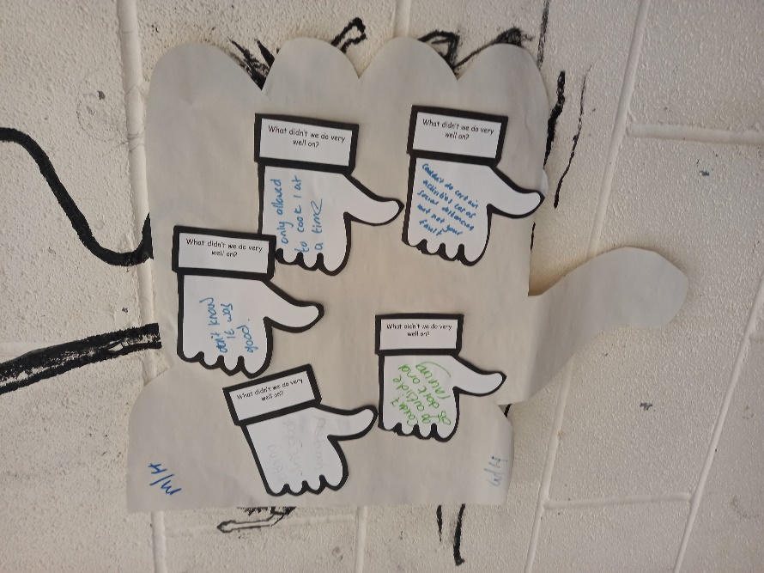

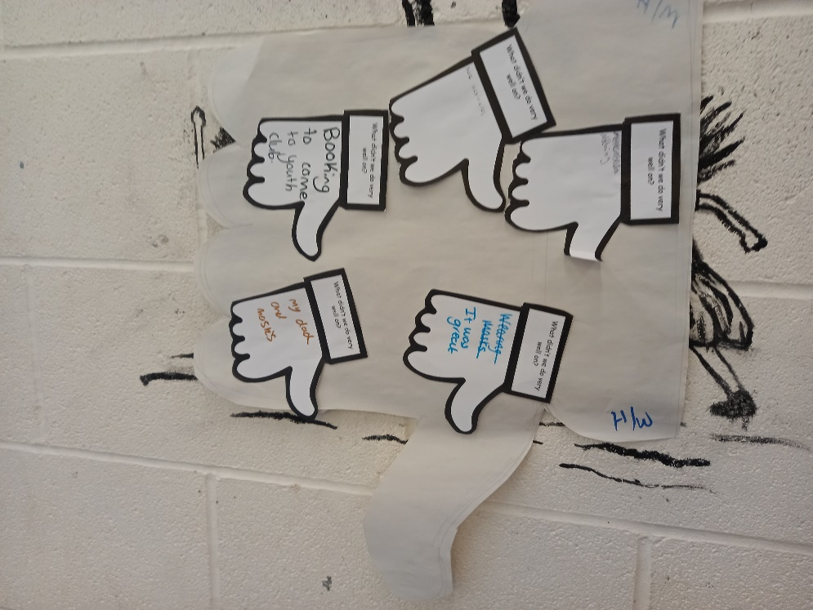

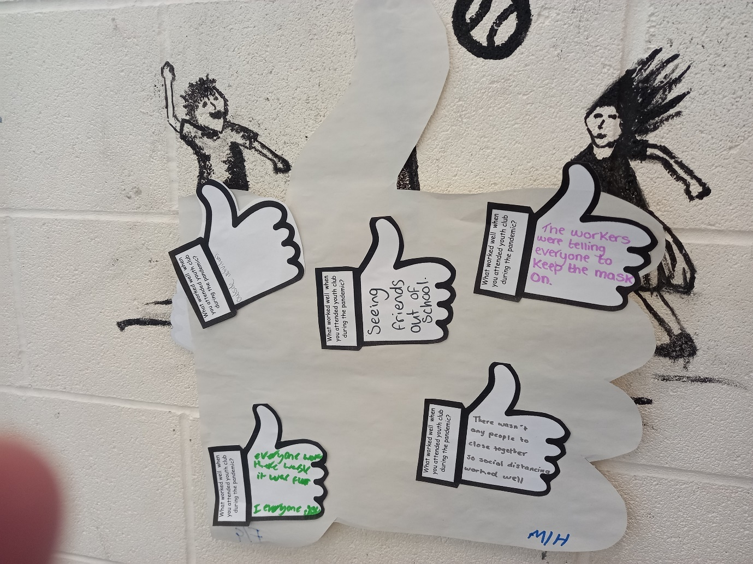

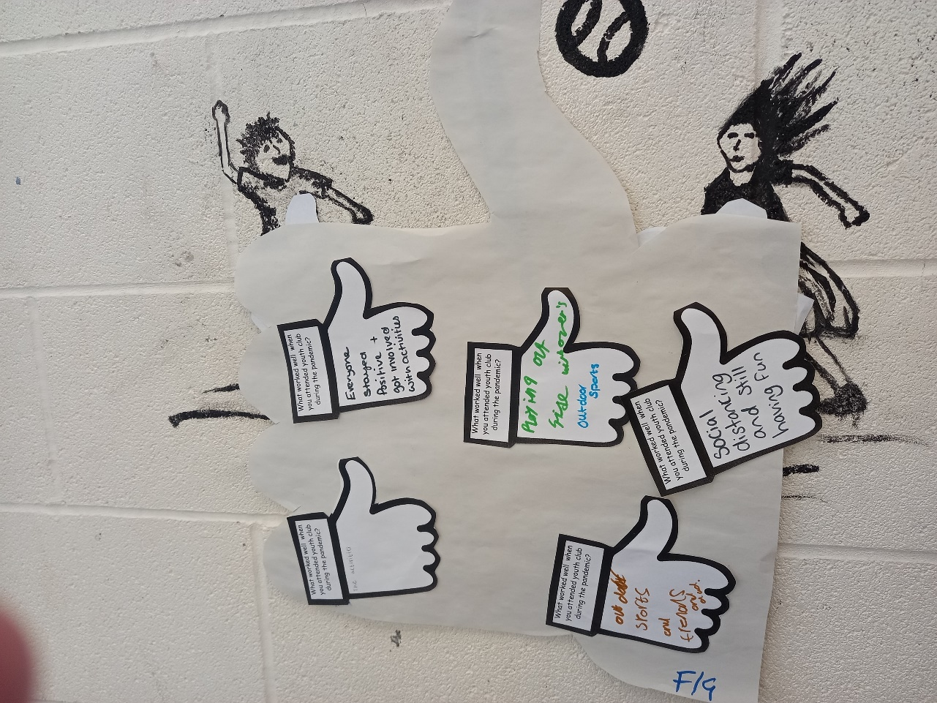

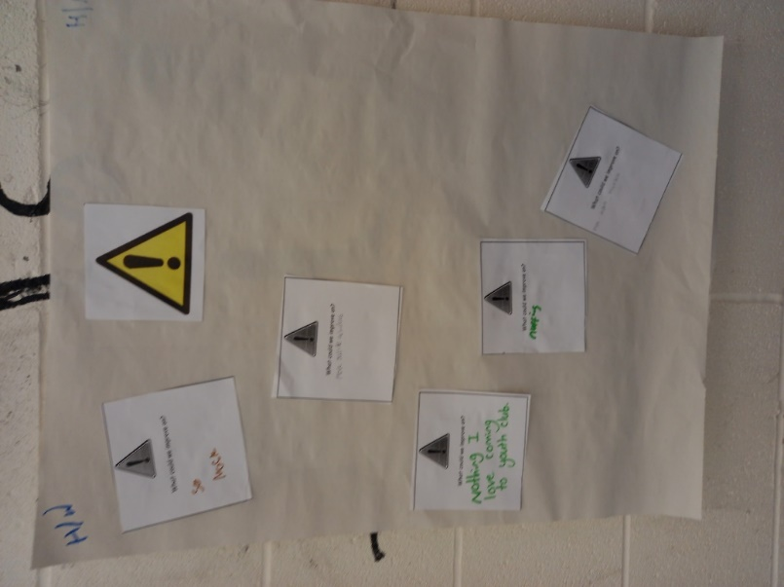

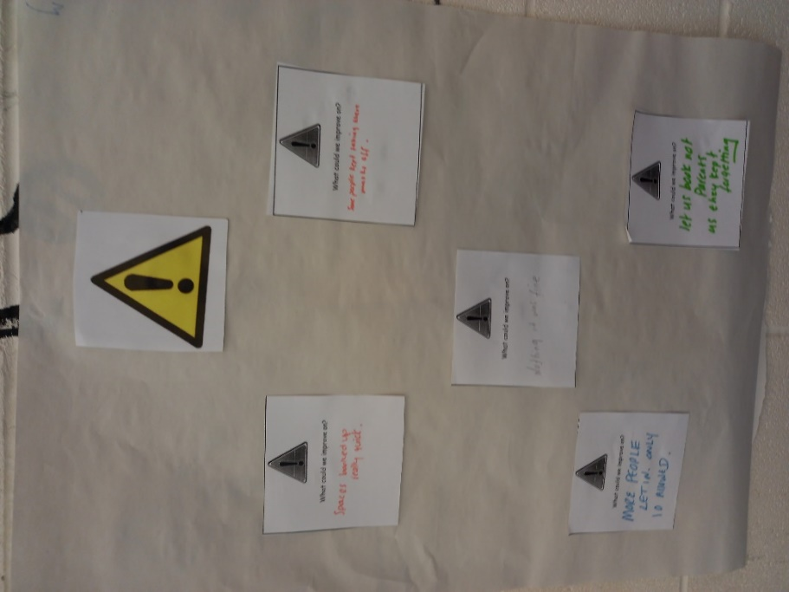

Appendix 10 – Pembrokeshire Youth Service- Guidance for Reopening Youth Clubs

Guidance for reopening youth clubs in relation to Covid-19
Purpose:
To set out recommendations and measures that can be taken to reopen youth clubs safely.
General Principles:
- To ensure the safety of staff and young people, youth club settings must follow WG social distancing rules at all times (https://gov.wales/coronavirus-social-distancing-guidance).
- Individual youth clubs need to look at the number of young people who regularly attend youth club sessions, the ages of young people, and the indoor and outdoor space available.
- The number of young people accessing youth club provision will need to be limited (up to a maximum of 10 in each setting), to ensure social-distancing is able to take place. We need to be mindful of staff and young people’s safety and well-being.
- Youth clubs should consider staggering access to the provision to reflect the need of different ages e.g. for 1 night per week provision the first hour could be for Years 7 & 8 and the second hour for years 9+. Youth clubs who operate 3 nights per week could provide 1 session per week for Years 7 & 8, 1 session for Year 9 & 1 session for Years 10+
- Where sessions are split between age ranges, the overlap where some young people are leaving and others are arriving will need to be managed. Youth club team leaders should enforce a one way system for entry to and exit from the building wherever possible.
Two metre social distancing will be required to help maintain COVID-19 security in youth work settings, both for young people and for staff.

Key points for Community Youth Team Manager and Youth Club Team Leaders when determining staffing and rotas:

- All staff will be required to complete the All Wales COVID-19 Workforce Risk Assessment Tool prior to youth clubs reopening;
- Do individuals have domestic and family circumstances that need to be taken into consideration;
- Do any staff have any underlying health conditions;
- Individual knowledge, skills, experience and qualifications.

Which staff should self-isolate?

- If anyone becomes unwell with symptoms of COVID-19 in a youth club setting, they should be sent home and advised to follow the self-isolation guidance and to apply for a coronavirus test.
- Staff who have symptoms of coronavirus or live with someone who has symptoms will need to self-isolate for 14 days (7 days if they live alone). Detailed guidance can be found on the NHS website - https://www.nhs.uk/conditions/coronavirus-covid-19/self-isolation-advice/ .
- After this period and providing they no longer have symptoms (or anyone in their household) they should return to work. Youth club staff will be expected to contribute to the provision at their youth club setting.

Guidance for staff and young people that fall into the ‘shield’ category

Those who have previously followed shielding advice no longer need to do so. You can now follow the same rules as the rest of the population in Wales. This means:
- You no longer need to stay 2 metres or 3 steps away from people you live with or who are part of your extended household.
- You can now go to work, if you cannot work from home, as long as the business is COVID secure (has taken reasonable measures to minimise risk to employees)
- Children and young people who have been shielding can return to school when schools re-start.
- You can now go out for any reason, including going to shops to buy food but you should stay 2 metres or 3 steps from other people.

Delivery Model

- A COVID-19 risk assessment will be completed for each individual youth club setting, taking account of the core guidance on staying safe, social distancing and determining capacity. The risk assessment will be circulated to all staff.
- Use of outdoor spaces - activities taking place outdoors are far safer than those taking place indoors and, for this reason, all youth club staff should utilise outdoor areas wherever possible.
- Ventilation when indoors – indoor activities should take place in ventilated areas of the building and with doors or windows open when possible.
- Face coverings for youth workers – all staff will be provided with clear face shields/visors and will need to wear them. Clear face coverings are especially important to communicate with young people with any level of hearing loss.
- Face coverings for young people –young people are required to bring face coverings to all youth club settings and must wear them if they cannot adhere to 2 metre social distancing.
- In order to comply with social distancing, parents/carers will need to book a place for young people to attend each youth club session; this will be done through text message, phone call or e-mail to the youth club team leader. Applications for places will be managed by youth club team leaders locally with whom parents/carers have relationships and where there is oversight of the number of places that can be managed on a sessional basis.
- There will be no option to turn up without a confirmed booking. The number of young people who will be able to attend each setting will depend on the size of the space available, but will be kept to a maximum of 10 per session. The only exception will be in relation to safeguarding young people.
- Consent will be obtained for all young people under the age of 18 to attend –questionnaire around displaying signs/symptoms of Covid 19 will be implemented for both young people and staff (Annex A). During conversation with any parent/carer or young people the questions attached to Annex A below must be followed and recorded. Only when youth club team leaders are satisfied that the signs and symptoms of Covid-19 are not present can a place to attend a youth club session be offered.
- Entry to the youth club should be controlled by youth workers and young people will be required to give their names before entering the building so that staff can confirm they have booked a place to attend the session. The questionnaire (Annex A) will be asked again before allowing young people entry to the youth club. If anyone becomes unwell with symptoms of COVID-19 in a setting, they should be sent home and advised to follow the self-isolation guidance and to apply for a coronavirus test.
- Test, Trace, Protect - Youth Club Team Leaders must check that they have up to date details and contact information on QES for all young people attending the youth club provision.
- Young people will be discouraged from congregating outside youth club premises. In the event of a young person turning up without booking a place, they will be asked to leave and their parents/carers called if necessary.
- Should young people not adhere to social distancing their parents/carers will be informed and the young person will be asked to leave the session.

Working Practices
- The building and equipment should be cleaned prior to the delivery of each youth club session.
- For indoor and outdoor activities, planning and supervision must ensure that social distancing is observed and consideration given to designated separate areas.
- Hand washing facilities should be available and young people attending should be directed to wash their hands immediately on entry to the building.
- Once young people have left the building a disinfectant spray should be used to wipe down surfaces and equipment ready for the next session.

Annex A
COVID-19 Questionnaire
Question | Circle the response
- Has anyone in the household been diagnosed with COVID 19? | Yes / No
- Are you self-isolating? | Yes / No
If Yes for either - Do not allow young person to attend youth club session
Discuss with manager on how to meet young person’s needs.
- Are any of your household over the age of 70? | Yes / No
- Do any of your household have a chronic/long-term illness? | Yes / No
- Is anyone in your household pregnant? | Yes / No
- Does anyone in your household have a low immunity? | Yes / No
If YES to any – you may allow a young person to attend the youth club session only when you have received parental consent.

You must also ask the following questions

- Is anyone in your household unwell? | Yes / No
- Does that member of the household have a high temperature? | Yes / No
- Does that member of the household have a continuous cough? | Yes / No
If YES - do not allow young person to attend youth club session
Discuss with family around seeking medical advice (such as dialling 111) as well as manager on how to meet young person’s needs.
If NO the young person can access the youth club session

If anyone becomes unwell with symptoms of COVID-19 in a youth club setting, they should be sent home and advised to follow the self-isolation guidance and to apply for a coronavirus test.

