Show Reel

Show reel links (both links have the show reel on it in case one of the links stop working):

Link 1: https://drive.google.com/file/d/1lKNLeBMh4KCwPnYd7aby7q3OdUFHhYL1/view?usp=sharing

Link 2:
https://youtu.be/mnFQ5VnvNww

Business Card
front:
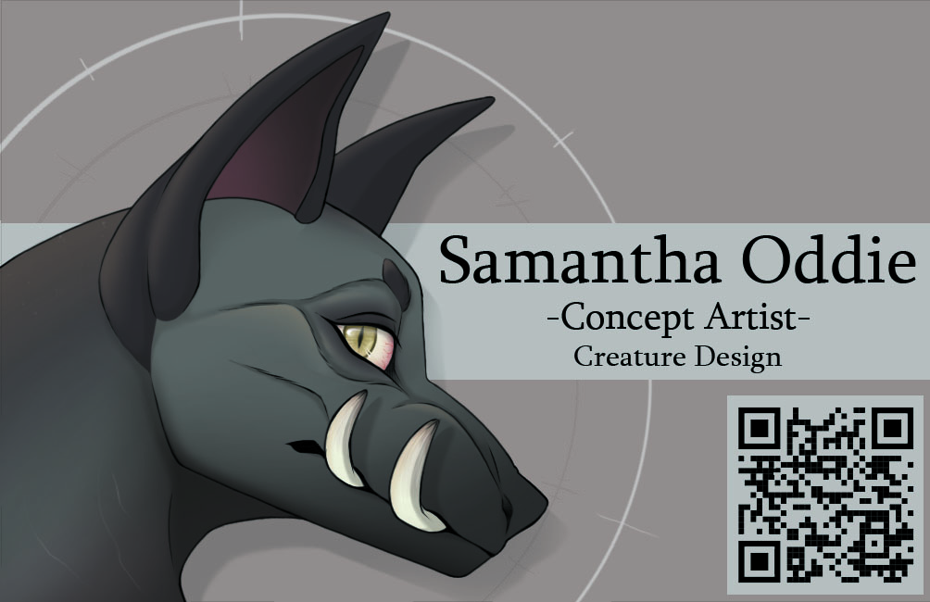

back:
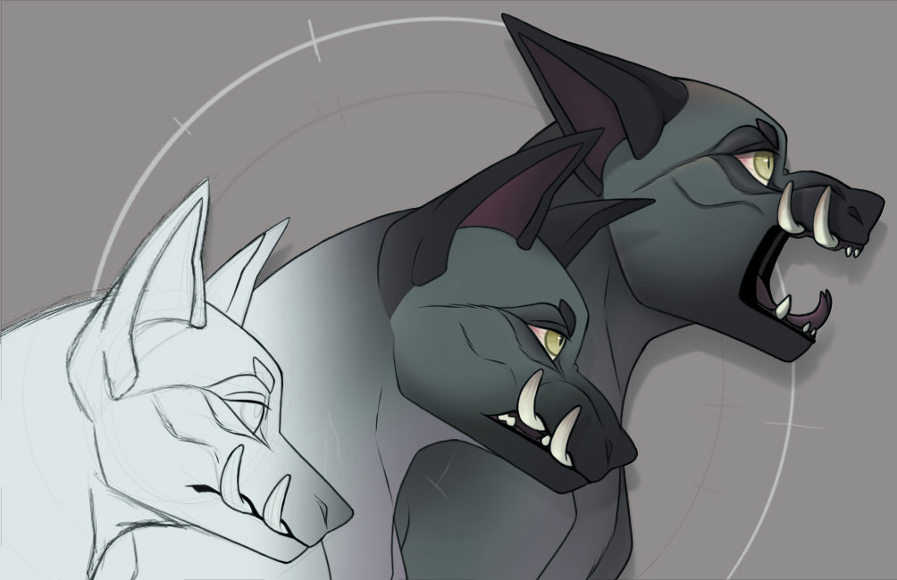
Bibliography
Slip.Stream, Not That Easy. (Unknown). Available: https://slip.stream/search?searchType=musicSearch&search=Not+That+Easy

C. Peters. (2021). 2D Animation Showreel | July 2021 [Video]. Available: https://www.youtube.com/watch?v=M0VDO8xrngY

S. Cederlund. (2021). 2021 ANIMATION REEL [Video]. Available: https://www.youtube.com/watch?v=un48-UkoC8Y&t=23s

B. Javoraj. (2014). Javoraj – Concept Art Showreel [Video]. Available: https://www.youtube.com/watch?v=UpsYAfz-WCg&t=9s

P. W. P. Yee (2020). Concept Art Showreel 2020 [Video]. Available: https://www.youtube.com/watch?v=2pP2WPNAZMY

L. Armagau. (2019). Léa ARMANGAU - Demoreel 2019 - Concept Art [Video] Available: https://www.youtube.com/watch?v=xmPtEGwST7Y&t=7s

C. Peters. (2018). My business card arrived [Image]. Available: https://twitter.com/finchwing/status/1002592323975467009

J. Smith. (2013). Business Card [Image]. Available: https://jasminesmithart.wordpress.com/2013/05/14/business-card/

R. H. Wong. (2015). "Orange Circus" Personal Business Card Design Ver.2015 [Image]. Available: https://www.behance.net/gallery/36785105/Orange-Circus-Personal-Business-Card-Design-Ver2015

R. Broyde. (2018). Business cards for CRX came in [Image]. Available: https://twitter.com/kyrin21/status/1029847574897819648

