

Methods and Search Strategy Academic Poster

Student name: Saica Bi
Student ID: 2220163

Module name: Independant project
Module code:BMHP6020
Diabetes in south Asian communities.

01 Introduction and Research Aim  This methods chapter outlines how the research was conducted using a secondary, thematic analysis of existing literature. It explains the search strategy, selection process, and ethical considerations. The aim is to explore factors contributing to the high prevalence of type 2 diabetes among South Asian communities in the UK. | 02 Search Strategy  A search strategy is a structured plan used to locate relevant evidence in secondary research. I applied this by identifying key terms, using Boolean operators, and searching academic databases such as Google Scholar and PubMed. This systematic approach ensured I gathered credible, recent, and relevant literature for my dissertation.
03 Searching for Information  Conducted iterative database searches (PubMed, Scopus, Google Scholar, UWTSD Library) using keywords and Boolean operators; applied filters (2010–2025, English, UK focus, peer-reviewed); screened titles/abstracts, retrieved full texts, recorded sources in a tracking table and quality appraisal process. | 04 Results. This chapter explains the desk-based approach used to review existing literature on diabetes in South Asian communities. A structured search strategy was applied using keywords, Boolean operators and credible databases, including Google Scholar and PubMed (Greenhalgh, 2019). Filters such as year, peer-reviewed status and UK-focused studies improved relevance. Sources were validated using the CRAAP framework (Blakeslee, 2004). Thematic coding enabled identification of patterns that informed the themes presented in Chapter 4, ensuring systematic and ethical analysis.  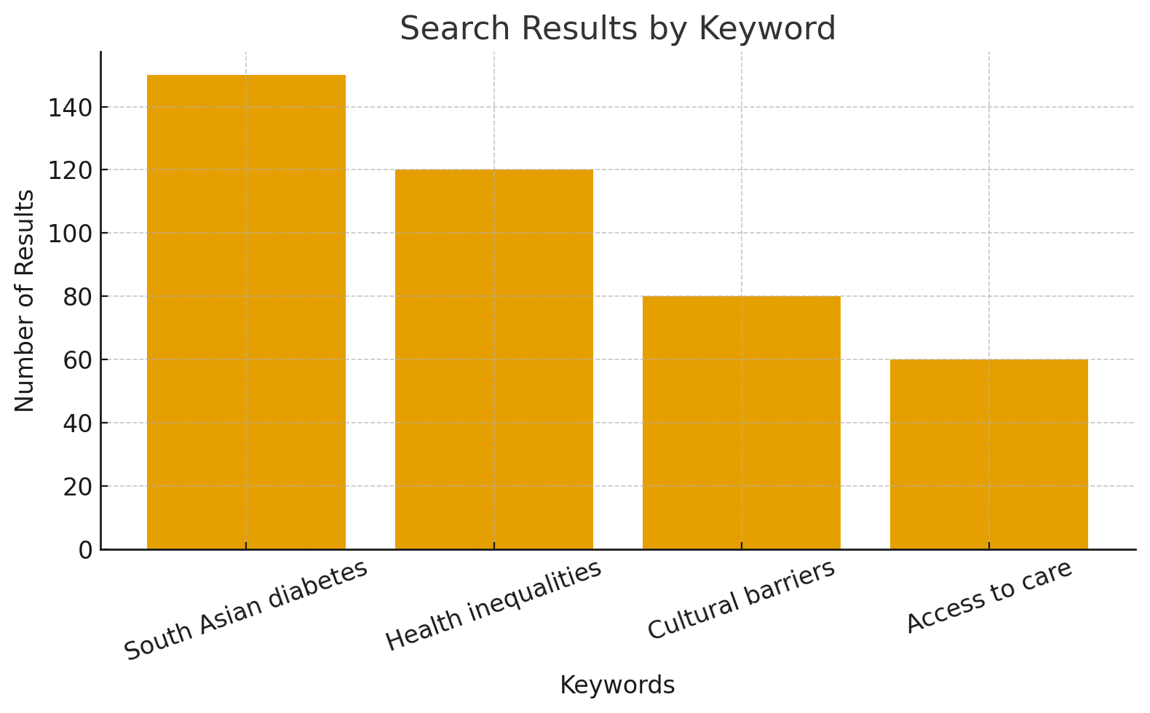  (Greenhalgh, 2019).
05 Research Validation and Analysis
Research validation in secondary studies ensures sources are credible, accurate, and trustworthy (Bell & Waters, 2018). I applied validation through critical appraisal and reliability checks, acknowledging limitations such as bias in published literature. Thematic analysis (Braun & Clarke, 2006) enabled me to identify recurring patterns and develop themes for Chapter 4.

06 Inclusion Criteria The inclusion criteria focused on peer-reviewed studies published within the last 10 years examining diabetes among South Asian communities. Only UK-based and fully accessible online sources were included. Key articles meeting these criteria were Douglas et al. (2019), Goff et al. (2020), and Patel et al. (2021), all providing high-quality evidence on ethnic diabetes disparities. | 07 Exclusion Criteria  The exclusion criteria removed studies published over 10 years ago to ensure findings reflected current diabetes patterns in South Asian communities (Greenhalgh et al., 2021). Research conducted outside the UK was excluded to maintain contextual relevance (Public Health England, 2019). Articles that were not fully accessible online were also excluded, as incomplete sources reduce reliability and transparency (Aveyard, 2019).
08 Ethical Considerations
Because this dissertation used secondary research, no direct contact with participants occurred, reducing risks and safeguarding ethical integrity (Aveyard, 2019). Ethical practice was upheld by accurately representing existing research, using Harvard referencing to avoid plagiarism and ensure academic honesty (Bryman, 2016). All sources were evaluated for credibility, transparency and reliability, reflecting best practices for ethical secondary analysis (Coughlan & Cronin, 2017). Care was taken to present evidence objectively and avoid bias, ensuring findings on diabetes in South Asian communities were reported responsibly and respectfully.
Ethics in Secondary Research.

References
British Psychological Society (BPS) 2021, Code of Human Research Ethics, British Psychological Society, ( 22 November 2025, https://www.bps.org.uk/guidelines-and-policy/bps-code-human-research-ethics.

British Educational Research Association (BERA) 2018, Ethical Guidelines for Educational Research, 4th edn, BERA, London,( Accssesd 21 November 2025), https://www.bera.ac.uk/publication/ethical-guidelines-for-educational-research-2018.

Economic and Social Research Council (ESRC) 2023, ESRC Framework for Research Ethics, UK Research and Innovation, (Accessed 21 November 2025), https://www.ukri.org/councils/esrc/guidance-for-applicants/research-ethics/.

General Data Protection Regulation (GDPR) 2018, EU General Data Protection Regulation, Accessed 21 November 2025), https://gdpr-info.eu/.

University of Oxford 2022, Research Integrity and Ethics, University of Oxford, (Accessed 21 November 2025), https://researchsupport.admin.ox.ac.uk/governance/ethics.

University of Edinburgh 2023, Good Practice in Research: Integrity & Ethics, University of Edinburgh, (Accessed 21 November 2025), https://www.ed.ac.uk/research-office/research-integrity.

Blakeslee, S. (2004) The CRAAP Test. Meriam Library, California State University. Available at: https://library.csuchico.edu (Accessed: 10 November 2025).

‌

