KING KONG:

ANTHROPOMOPHISM AND THE CHANGING FACE.

By

Anuwar Yussuf Khamis

This dissertation is submitted in a partial fulfilment of the requirements for the Degree of Bachelor of Arts in 3D Computer Animation, at the University of Wales, Trinity Saint Davids, Swansea.
September, 2019.

DECLARATION

This work has not been accepted in substance for any degree and is not been concurrently submitted in candidature for any degree.

This dissertation is being submitted in partial fulfilment of the requirements for the degree of a Bachelor of Arts (BA) in 3D Computer Animation.

This dissertation is the result of my own independent work/investigation, except where otherwise stated. Other sources are acknowledged before hand, and immediately after quotation and references are given in these quotations. A bibliography is appended.

I hereby give consent for my dissertation, if accepted, to be available for photocopying and for inter-library loan, and for the title and summary to be made available to outside organisations.

………………………… …………………………
Anuwar Yussuf Khamis Scott Smith
(Supervisor)

……………………….
(Date).
i
DEDICATION

To

My mother Mashavu Ali, who brought me up and encouraged me to study and work hard. My mother has tirelessly taken care of me, since childhood, through the good and the bad times. I praise her efforts concerning me and the family as a whole, I love her so much.

And

My father Yussuf Khamis Yussuf who taught me to be strong while facing the challenges of life. “Never give up in life,” is everyday words of advice. These words have consistently heartened me.

My parents really toiled in me, with the love and support that only parents can give, making sure that I went to school and that I studied. I must show how much I care for them.

I also dedicate this work to

All family members, who kept praying, supporting and helping throughout the time of my studies. Consistent words of wisdom from the family had kept me comfortable during my studies here.

Thank you all.
ii

ACKNOWLEDGEMENT

May I praise Allah, the most Gracious and most Merciful, whose mercy extends over all things, I convey humble gratitude and I asked for his blessing to give me health and strength to undertake these studies.

Education has always being praised to be the key for life especially in this world of globalisation and information age where the world has been like a single village. Prophet Mohammad (SAW) told us and I quote, “find knowledge/education even China”. He mentioned ‘even China’ because by the time there were communication and transportation barriers, and China was very far.

I am greatly indebted to my supervisors, Mr. Rob Charter for their invaluable advice and assistance, to whom I owe gratitude for guidance, encouragements and above all the friendly working relationship which made me feel confident throughout the time I did this study.

Finally, I feel infinitely indebted to my extended family that has continued to be a great source of encouragements.

iii
ABSTRACT

For more than eight decades since its inception King Kong (1933) it has passed different changes including characters and technology at large. The King Kong (1933) Kong was appeared as a monster, a huge, ape-like creature who kills people in the jungle of the Island and technology used were stop motion animation, matte painting, rear projection and miniatures, all of which were regarded by many as a pioneering achievement of the art form. The Kong stop motion armatures were animated under the supervision of Willis O’Brien. King Kong (1976) is the re-make of the 1933’s version but the technology used combination of a man in a suit, full-size animatronics and rotoscoping. It is the evolution of motion picture special effects tools.
Additionally, in the King Kong (2005) version, the King Kong takes the old story (1933 and 1976), with a few twists and polishes it with special effects that create the most human, the most believable, King Kong up to the present time. The CGI effects used in this version. Furthermore, the Kong: Skull Island (2017) version is an environmental conservation story, he looks as a big and bad ape but is a ruler of the island and a defender, saving the human invaders as well as attacking them when they provoke him. The Kong: Skull Island (2017) used CGI and S/FX animation technology.
The technology changes, the development of story ideas and the development of the animation industry resulting the popularity of the King Kong’s versions (1933 – 2017) to date. King Kong has become one of the world's most famous movie icons, having inspired a number of sequels, remakes, spin-offs, imitators, parodies, cartoons, books, comics, video games, theme park rides, and a stage play. His role in the different narratives varies, ranging from a rampaging monster to a tragic antihero.

iv

CONTENTS

Declaration …………………………………………………. i
Abstract …………………………………………………. ii
Acknowledgement …………………………………………. iii
Dedication …………………………………………. iv
Table of Contents …………………………………………. v

INTRODUCTION …………………………………………. 1

CHAPTER 1:

ANTHROPOMORPHISM: MEANING, FUNCTION AND TECHNIQUE

ANTHROPOMORPHISM: MEANING,
FUNCTION AND TECHNIQUE …………………………… 9

CHAPTER 2:

KING KONG: BIRTH AND THE ORIGIN

THE BIRTH OF KONG ……………………………… 11

COMPUTER ANIMATION: EVOLUTION OF CREATURE
ANIMATION ……………………………… 13

CHAPTER 3:

KING KONG: ANTHROPOMORPHISING AND THE CHANGING FACE

KING KONG (1933): …..…………………………. 15
KING KONG (1976) ……………………………… 21

KING KONG (2005) ……………………………… 24

KONG: SKULL ISLAND (2017) ………………………… 28

APPENDICES …………………………………………. 31
V
INTRODUCTION:

Specifically, the research seeks to pinpoint the reasons for the King Kong (1933) changing its face to the King Kong (1976), King Kong (2005) and Kong: Skull Island (2017). In the King Kong (1933), Kong appeared as a monster, a huge, ape-like creature who kills people in the jungle of the Island in an attempt to possess a beautiful young people. Why King Kong murders an innocent people?
In the King Kong (1976) almost has the same story outline as the original King Kong (1933). An expedition of the United States based Petrox company, is exploring in search of petrol. A strange island where they arrive is the home of a giant ape, King Kong, that is captured by the expedition in order to make money exhibiting it to the world. When in the city, the huge gorilla becomes restless, trying to return home. What are the reasons of King Kong’s captured? A woman gets capture by big gorilla, big gorilla falls head over heels for a woman and big gorilla gets killed. What are the differences between King Kong (1933) and King Kong (1976)?
In the King Kong (2005) shows the meaningful bond between Kong and Ann. Kong sees Ann as a favored pet and cares for her as much as any of us love our pets. Ann is captivated by the magnificence of Kong and is grateful to him for saving her life. Is there any relationship between King Kong (2005) and King Kong (1976)?
Further, Kong: Skull Island (2017) is a re-imagined version of the classic King Kong story. Kong’s uncharted Skull Island is inhabited by physical real looking creatures that have evolved into much larger versions of those found elsewhere on earth. There is also an indigenous human population that has Kong, survived for generations. Kong is considered as an idol on the island and maintain the symbiosis of all life forms, maintaining a balance in the exceptional eco-system. Who is a King Kong and why King Kong is a popular feature among various media?
On the animation point view, on the modern days of movie/film production computer animation is playing a vital role in every step of production, from recording, editing and rendering, animation playing a big role. Why and how animation is important in the media (movie/film) production? Is King Kong movies exploring the animation of the time?
In the chapter 1, I will examine the meaning, function and the technique of using anthropomorphism. The chapter also will sketch a brief picture of the introduction and development of anthropomorphism in relation with the animation techniques.
In order to further contextualise the debate, in chapter 2, I will give an historical background of King Kong and reasoning out the birth of King Kong and its originality. In this part, I will analyse the motives of the introduction of King Kong movies from 1933 – 2017. I will also examine the reasons why has become one of the world's most famous movie icons.
In chapter 3, I will discuss the level of the anthropomorphism and the changing face of the King Kong in the King Kong (1933), King Kong (1976), King Kong (2005) and Kong: Skull Island (2017).

OBJECTIVES OF THE STUDY:
- To sketch out the reasons for the changing face of King Kong (1933), King Kong (1976), King Kong (2005) and King Kong: Skull Island (2017) and researching the evidence of the changing.
- To analyse the impacts and differences of the Kong creature (2017), King Kong (2005) and King Kong (1976) in comparison to the Willis O’Brien (1933) King Kong. Is there any evidence of these Kong’s changes?
- To evaluate the future of the King Kong following the introduction of new technologies in the animation.

METHODOLOGY:
This dissertation uses historical and archival research materials, using King Kong (1933), King Kong (1976), King Kong (2005) and Kong: Skull Island (2017) movies/films, You Tube and archival materials relating the King Kong stories. Books, journal articles, image banks, films, are the most usual source of information and ideas relating to this study. Additionally, observation from the experience of the author.

Chapter 1:

ANTHROPOMORPHISM: MEANING, FUNCTION AND TECHNIQUE:

Because of the importance of the anthropomorphism in the animal creature I will examine the meaning, function and the technique of using anthropomorphism. I will also sketch a brief picture of the introduction and development of anthropomorphism in relation with the animation techniques.
Anthropomorphism is a literary device that can be defined as a technique in which a writer ascribes human traits, ambitions, emotions, or entire behaviors to animals, non-human beings, natural phenomena, or objects. Lennklo (2010) define anthropomorphism as the attribution of human characteristics and qualities to animals or deities. In examples of anthropomorphism, the animal or deity in question is actually behaving like a human, such as in the case of talking animals or deities involving themselves in the affairs of humans as in ancient Greek dramas.
In relation to this McLarren (1990) argues that the definition of anthropomorphism and the definition of personification are very similar, as they both involve attributing human emotions and qualities to non-human beings. Personification, unlike anthropomorphism, can relate to inanimate objects and concepts as well, such as talking about “blind justice” or “whispering trees.” Anthropomorphism also is different in that it involves imagining an animal actually displaying human traits such as speaking or wearing clothing, whereas personification is the projection of traits onto something that is not actually acting in a human way (Vaz, 2005).
In this scenario Kevles (2010) asserted on the function of anthropomorphism that the primary one is to make a wider appeal to the readers. With the use of objects or animals, the story can become visually appealing and non-threatening to readers. Hence, it could attract the attention of a wide audience (including children) by presenting animated characters in tales and animated movies. In literature, it serves as an effective tool for creating political and social satires. Hence, it has a wider scope than merely to entertain children.
According to Huston (2012) anthropomorphism is often used in children's stories to teach concepts or make abstract ideas easier to understand. For example, a picture book about animals might draw an ant with visibly large muscles who is lifting weights at the gym to reinforce the idea that ants have tremendous strength relative to their body size. The characters in Thomas: The Tank Engine, Clifford: The Big Red Dog, and Martha Speaks are all examples of anthropomorphism.
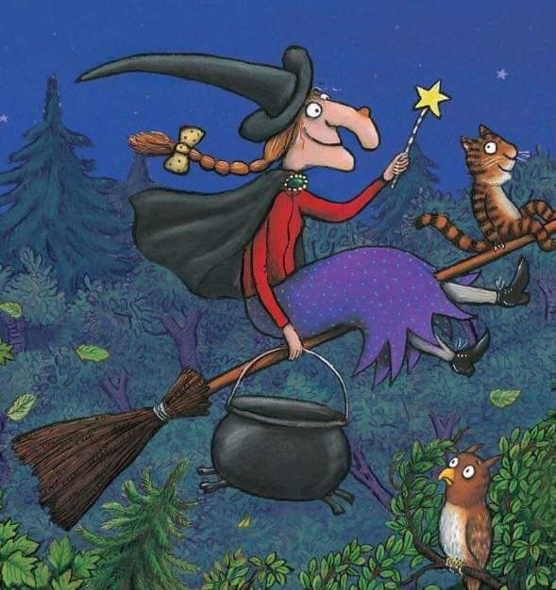
An example of anthropomorphosis whereby animals have the characteristics of human being.

Junko (2010) asserted on anthropomorphism on commercials and advertisements that animals are often used in advertising, especially in commercials. When given human characteristics, and used in several commercials over a longer period of time, anthropomorphic animal spokespersons are born. These animals are neither real animals nor humans. They are hybrids, or fake animals. Fake in the sense that they are fictive, they lack an existing model and they are an assembly of many things. Commercials that feature such animals are often successful in that they are popular and increase sales. The fake animals seem to plea and be able to convince of almost anything.
In literature or film, anthropomorphism can be used as a tool to explore controversial issues. For example, Animal Farm by George Orwell (1945) is a critique of the corruption of socialist ideals in the Soviet Union. Orwell was a socialist, but he believed the totalitarian regime in Stalinist Russia had betrayed the key principles of socialism. He conveyed this message through a story about farm animals rebelling against the oppression of their human caretakers.
“Comrades, you have heard already about the strange dream that I had last night. But I will come to the dream later. I have something else to say first. I do not think, comrades, that I shall be with you for many months longer, and before I die, I feel it my duty to pass on to you which wisdom I have acquired. I have had a long life; I have had much time for thoughts as I lay alone in my stall, and I think I may say that I understand the nature of life on this earth as well as any animal now living. It is about this that I wish to speak to you … Man is the only creature that consumes without producing. He does not give milk, he does not lay eggs, he is too weak to pull the plough … Sometime the work was hard; the implements had designed for human beings and not for animals … But pigs were so clever that they could think of a way round very difficulty …”

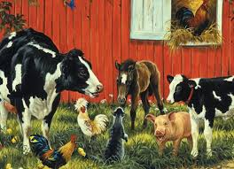
The meeting of animals in the farm that represents real people during the Stallinists in Russia (Orwell, 1945)

Orwell’s novel Animal Farm (1945) is an example of anthropomorphism written for adults. Orwell uses the animals on a farm to represent real people who had a role in the Russian Revolution. The pigs, Old Major, in this novel represent the leaders of the revolution, and their subsequent corruption. In the above extract, there is a nod to the fact that the animals are not fully equipped to run the farm, and yet come up with other creative solutions.
In the Jungle Book by Rudyard Kipling (1894): “Come soon,” said Mother Wolf, “little naked son of mine; for, listen, child of man, I loved thee more than ever I loved my cubs.”

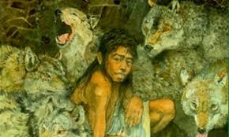
Mowgli and his friends who likes conversations and emotions (Jungle Book, 1894)

Rudyard’s novel The Jungle Book (1894), includes many talking animals as characters who either befriend the human child Mowgli or antagonize him. Mowgli is first raised by a family of wolves, the mother of which clearly cares for him. Later Mowgli makes friends with the panther Bagheera and the bear Baloo, while running into trouble with Ka the snake and the tiger Shere Khan. All of these animals and many more have complex emotions and have conversations with Mowgli. Finally, however, Mowgli leaves the animal world to find a more permanent place in the world of humans.
In the Odyssey of Homer by Homer (1794): “Oh for shame, how mortals put the blame on us gods, for they say evils come from us, but it is they, rather who by their own recklessness win sorrow beyond what is given …”

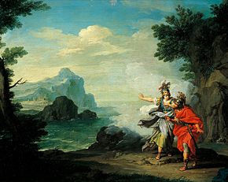
Evils in the human forms who have close relationships with humans (Homer, 1794)

Most, if not all, Greek tales includes deities who have human forms, emotions, and motivations, and meddle in the affairs of the mortals. Even Zeus, king of the gods in Greek mythology, is not above jealousy, anger, and revenge. In this quote from Zeus in Homer’s The Odyssey (1794), he laments the fact that humans blame gods for their own problems and seems resentful of this. However, it is quite true that he is the source of many problems that humans have in Greek tales, as when he is displeased for whatever reason he causes trouble.
In the Harry Potter and the Chamber of Secrets by JK Rowling (2014): “They believed that I was the monster that dwells in what they call the Chamber of Secrets …”

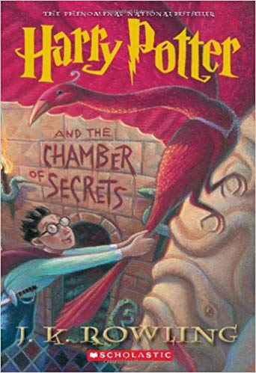
Harry Potter and the Chamber of Secrets (2014)
A recurring character in the Harry Potter series by JK Rowling (2014) is the gigantic spider, Aragog. Aragon is able to speak English to Harry and other characters, but does so only when necessary. The assumption is that the character Hagrid has only civilized Aragog as far as can be done; Aragog still maintains beastly qualities. However, Aragog does have some human emotions, such as love for Hagrid. There are a few other examples of anthropomorphic characters in JK Rowling’s series, such as the talking ghosts like Nearly-Headless Nick, and creatures such as Dobby and Nagini.

In the A Dog’s Tale by Mark Twain (1903): “My father was a St. Bernard, my mother was a collie, but I am a Presbyterian. This is what my mother told me, I do not know these nice distinctions myself. To me they are only fine large words meaning nothing. My mother had a fondness for such; she liked to say them, and see other dogs look surprised and envious, as wondering how she got so much education … When I was well grown, at last, I was sold and taken away, and I never saw her again. She was broken-hearted, and so was I, and we cried; but she comforted me as well as she could …”
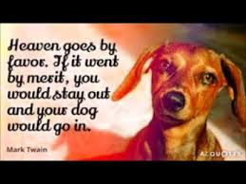
The hero dog which is describing his life as a puppy (a Dog’s Tale, 1903)
The hero of this story is a dog, which is describing his life as a puppy. The story is told from the loyal pet’s perception. The dog possesses human traits like emotions, shame, fear, anguish, happiness, and hopelessness.
However, in religious point of view, some religions, scholars, and philosophers objected to anthropomorphic deities. Xenophanes (570-480 BCE) said that "the greatest god" resembles man "neither in form nor in mind". Thus, Judaism and Islam reject an anthropomorphic deity, believing that God is beyond human comprehension (Kevles, 2010).
To sum up, it has been said that anthropomorphism is considered an innate tendency of human psychology. For instance, when we assign human characteristics to nonhuman entities, we are deciding what is worthy of our time and care. Again, describing pets as loving when they cuddle us after a bad day allows us to view them as members of the family. However, this tendency is not always helpful. Viewing pets as equal members of the family can be problematic if it means you fail to take precautions to protect others, such as infants or disabled adults, from an animal with the ability to cause physical harm.
Chapter 2:
KING KONG: BIRTH AND THE ORIGIN
In this chapter, I will offer a historical background of King Kong and reasoning out the birth of King Kong and its originality. Further, I will analyse the motives of the introduction of King Kong movies from 1933 – 2017. I will also examine the reasons why King Kong has become one of the world's most famous movie icons.
King Kong is a giant movie monster, resembling an enormous gorilla, that has appeared in various media since 1933. The character first appeared in the 1933 film King Kong from RKO Pictures, which received universal acclaim upon its initial release and re-releases.
In 1976, Dino De Laurenti is produced a modern remake of the original film directed by John Guillermin. A sequel, King Kong Lives, followed a decade later featuring a Lady Kong. Another remake of the original, this time set in 1933, was released in 2005 from filmmaker Peter Jackson.
The character King Kong has become one of the world's most famous movie icons, having inspired a number of sequels, remakes, spin-offs, imitators, parodies, cartoons, books, comics, video games, theme park rides, and a stage play. His role in the different narratives varies, ranging from a rampaging monster to a tragic antihero.

THE BIRTH OF KONG:
In interview given at the time of King Kong’s release and in all years thereafter, Merian Cooper (Producer Director of King Kong, 1933) claimed that the Kong story come to him fully formed. In interview, according to Morton (2005) Cooper alternately explained that his inspiration came from either a book about the newly discovered dragons of Komodo or sight of an airplane flying past the top of the New York skyscraper. The evidence suggests, however, that as with most creative work, the concept actually developed in phase, each with its own particular inspiration and influences.
As previously noted, Cooper had been fascinated with gorillas ever since he read Paul du Chiallu’s book, but the creative chain of events that eventually led to Kong began in earnest in Africa during the filming of The Four Feather (Morton, 2005). In the course of the production, Cooper became intrigued by a tribe of baboons that lived near the location, and he began studying their lifestyle, behavior and social interactions.
Cooper was also fascinated by Burden’s description of the dragon and began imagining exciting scenes in which his gorillas would fight them. He planned to realise these scenes by filming the gorillas in their natural habitat (mostly likely in Congo) and the dragons on Komodo and then intercutting the two, with some sort of artificial stand-ins used for joint shots (Vaz, 2005). As Cooper worked on his idea throughout 1929 – 1930, he decided it would be dramatically more potent to focus on a single gorilla rather than a group. True to the popular conception of the time, Cooper characterized his ape as a ferocious, rampaging menace (Vaz, 2005).
Determined to settle the exhibitor by including a love story, according to Van Hise (1993), Cooper decided to include a woman in the tale as well, a notion sparkled by the fact that Burden’s wife had accompanied him on his trip. Inspired by the incident in du Chiallu’s book in which an ape carried off a woman, as well as by a strong taste for melodrama, Cooper decided that at some point in the story the gorilla would do the same with the woman from the expedition.
In some of these same interviews, Cooper also claimed that he had already decided at this point to make his gorilla giant, although he never explained where such an unusual idea came from. He also claimed that he intended to use special effects to increase the ape’s size, but given that the two of the techniques he mentions wanting to use (rear screen projection and travelling matter) were not considered viable at the time he was allegedly planning the film, it seems highly unlikely that this was the case (Van Hise, 1993). It is more applausable to think that the idea of making Kong a giant came later (Morton, 2005).

COMPUTER ANIMATION: EVOLUTION OF CREATURE ANIMATION
On the modern days of movie/film production computer animation is playing a vital role in every step of production, from recording, editing and rendering, animation playing a big role. Why and how animation is important in the media (movie/film) production?
Creature animation is a specialised part of the animation process which involves bringing realistic animals and creatures to life. It is often distinguished from character animation, which involves breathing life into animated characters and creating the illusion of thought, feeling and emotion (Bancroft and Glen, (2006)).
According to Maltin (2006) creature animators create highly realistic motion in animals or creatures; examples include the dinosaurs animated in the 1993 Steven Spielberg film Jurassic Park. Since dinosaurs cannot be filmed or observed in motion, the animators studied other living creatures such as birds and lizards in order to re-create how a dinosaur might move and behave.
Four years earlier, in 1989, the pioneering digital animation studio Industrial Light & Magic created a water creature for the James Cameron film The Abyss. Again, not knowing how a water creature might move, considerable effort was required by the animators to imagine how such a creature might perform and behave.
The animation used in the King Kong (1933 – 2017) were linear according to the time and development of technology at the time. The technology used in the King Kong (1933) is different with the technique of technology used in Kong: Skull Island (2017). For instance, the animation used in King Kong (1933) is stop motion animation, matte painting, rear projection and miniatures, all of which were regarded by many as a pioneering achievement of the art form. The Kong stop motion armatures were animated under the supervision of Willis O’Brien. King Kong (1976) is a combination of a man in a suit, full-size animatronics and rotoscoping. King Kong (2005) used CGI effects while Kong: Skull Island (2017) used CGI and S/FX animation technology. The following chapter is the level of anthropomorphizing and the changing face of the King Kong.

Chapter 3:

KING KONG: THE LEVEL OF ANTHROPOMORPHISING AND THE CHANGING FACE

Kong actually changes size and facial features several times throughout the movie, depending upon which model they were shooting and the action of the Kong. In this chapter, I will discuss the level of the anthropomorphism and the changing face of the King Kong in the King Kong (1933), King Kong (1976), King Kong (2005) and Kong: Skull Island (2017). I will also examine the animation techniques used in these films.

KING KONG (1933):
The film contained many revolutionary technical innovations for its time (rear projection, miniature models about 18 inches in height, and trick photography, etc.), and some of the most phenomenal stop-motion animation sequences and special effects. The film has numerous memorable moments, including Kong's battle with a giant snake in a misty cavern, his struggle against a flying pterodactyl, the screaming woman held captive in Kong's giant clenched palm, and the finale with the defiant Kong atop the Empire State Building while circling aircraft shoot him down.
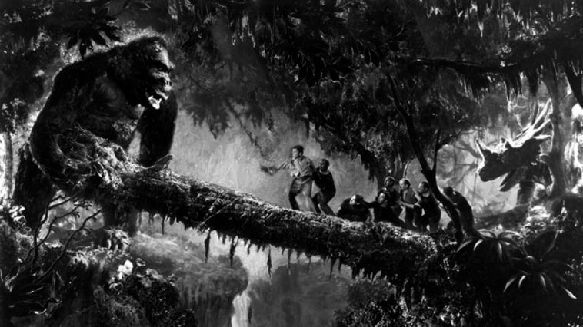
King Kong kills many people in the jungle across the log bridge

The brutish Kong makes an extremely memorable first appearance. The mighty ape is first heard as he comes angrily thrashing through the jungle, bending nearby trees. Horrible roars, growls, and sounds are heard from an indistinct shape. When he comes into view, he is tremendous - a thirty-foot tall giant ape, much bigger than a gorilla.
As she sees the crisis, strong Beast-lover approach the platform, Ann struggles to free herself. She lets out shrill screams in absolute terror, just like in the practice session. Her eyes signify complete fear and helplessness. With raw sexual impulses that have been incited and aroused by a rolling-eye view of the white girl, Kong flares his teeth and snarls, beats his chest and let’s go mighty roars. As he comes closer to sneer at her, he releases her from the stakes, and she slumps into a faint.
Film Director, Denham and the crew, with Driscoll in the lead of the rescue party, go in pursuit into the village but arrive too late to save her from Kong's grasp. The captain and half of the sailors remain to guard the gate, while the others enter the open gate of the wall and start their trek into the thick jungle.
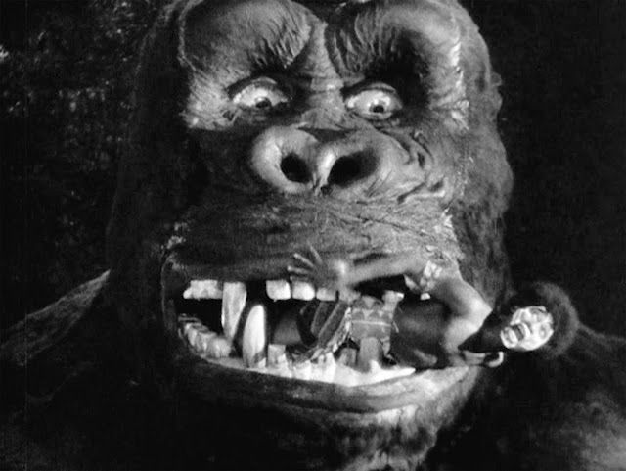
King Kong (1933) shows Kong as a creature who kills a bunch of innocent people

Kong, carrying Ann, crosses a log bridge over a deep crater. In a clearing, he hears the approaching pursuit so he places Ann high in the fork of an upright dead tree. He returns to the location of the pursuing search party to do battle, finding Driscoll and seven of the surviving sailors crossing the deep ravine.
The giant ape tries to reach for the annoying Driscoll one more time but he is interrupted by Ann's screams of terror. She has just seen a vicious, flesh-eating dinosaur approaching in the glade in the background. As she delivers a piercing scream, the Rex scratches its ear. Kong leaves his prey, hastily leaps over a fallen log, and returns to his golden-haired Ann just as the huge, monstrous creature is ready to put his large jaws on her. This is called one of many rescues that Kong performs for his new beloved.
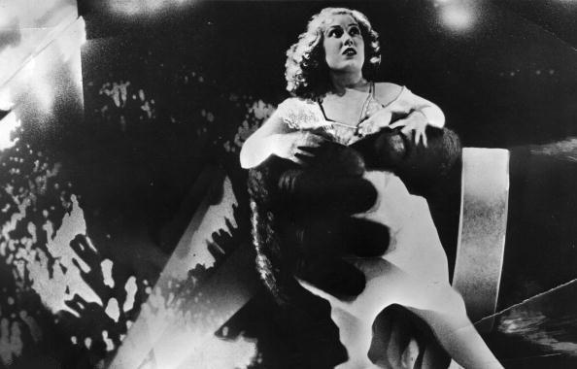
King Kong (1933) holds Ann for her escapes before examines her carefully.

In the wrestling fight, Kong reels backward against the tree where Ann is sitting. The camera follows the tree as it crashes down to the ground, pinning Ann there - miraculously, she is uninjured. From the ground-level perspective, the two creatures are even more frightening and awesome. At the end of their struggle, Kong beats his massive breast in triumph.
Retrieving Ann, Kong takes her to the upper part of his cave, emerging on a ledge that overlooks the island. He announces himself with more chest-thumping, causing Ann to swoon into a faint. Sitting down, the Beast is fascinated and mystified by his bride's Beauty and doesn't intend to harm her. Fumbling with her like an adolescent teen, he holds Ann in his hand and examines her carefully, slowly peeling off some of her outer clothes and scrutinizing the flimsy material. When she awakens in his hand and struggles to get free, he strokes and teases her affectionately and then sniffs his fingers. Possibly he has fallen in love with her.

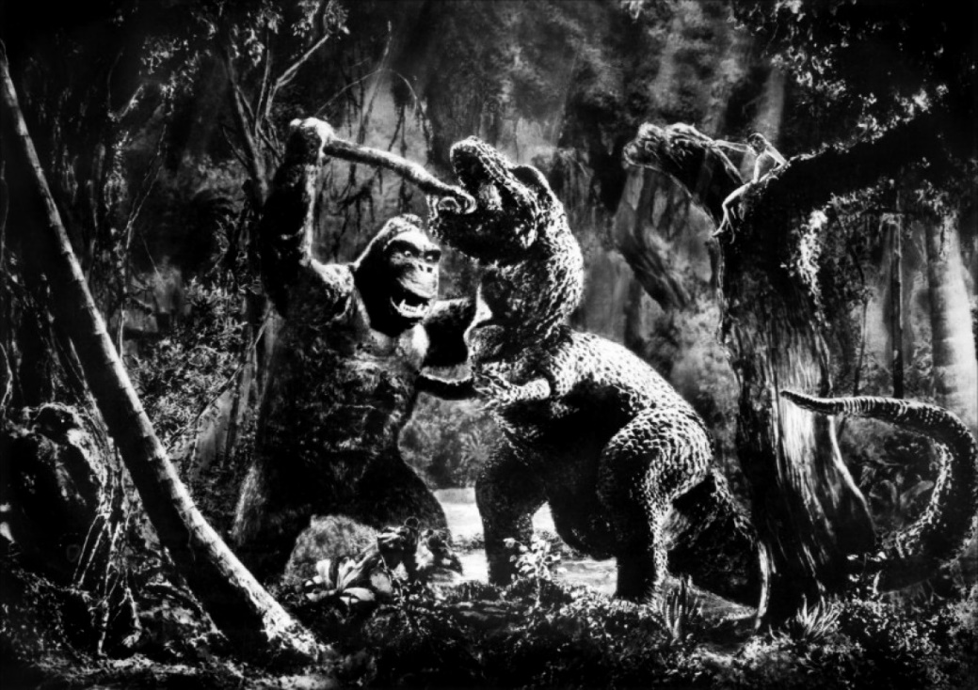
King Kong (1933) in fighting with dinosaur in the jungle battle

Analytically, the apparent size of Kong (1933) changed from 18 feet to 24 feet. This was the sensible decision of Director Cooper, who felt the Kong’s size was not impressive enough in New York. The publicity materials would later state Kong’s height was 60 feet, almost 3 times the average height as he is actually depicted in the film.
Further, there were two Kong puppets, with differently shape heads and faces. The long faced Kong puppet was used for many of the dinosaur fighting scenes and the top of the Empire State Building. The blunt-headed Kong was used in scenes with Ann tied to the alter and for many of the New York city climbing scenes. There was also a single-sized full mechanical head built for some of the close-ups. This Kong had extremely white teeth. In contrary, in close-up of his face, King Kong has more teeth than he does when his whole body is shown.
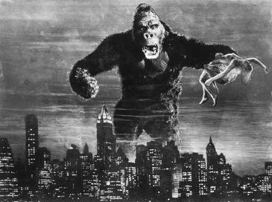
Kong stands above NYC carrying a woman in his hands

The analysis also reveals that when Kong is fighting with the miniature planes the length of the lower wings is the same as the upper while the actual footage of the planes used the lower wingspans are shorter than the upper. When Kong tears Ann’s dress, he leaves her left shoulder completely bare. After this there is a string-like strap over it in all shots of her in the rest of the jungle sequence.
However, being located in the South Pacific north of Java and Sumatra Islands, the island which Kong lives should be inhabited by Asian people. Instead, the natives and their costumes to be Africans. One of the sailors is almost eaten alive by an Apatosaurus. Apatosaurus is actually a plant eating dinosaur and therefore did not eat meat. If you look further and carefully the Apatosaurs also has razor teeth which Apatosaurs did not have in real life. Above all, despite being a huge Kong is seen walking or running on two legs. Gorillas like all great apes apart from humans actually knuckle walk most of the time. The following part is King Kong (1976).
KING KONG (1976):

Basically, King Kong (1976) is almost has the same story outline as the original King Kong (1933) A woman gets capture by big gorilla, big gorilla falls head over heels of a woman and big gorilla gets killed.
The following are the differences from the original (1933) and re-make (1976) of the film King Kong:
Original movie (1933) Carl Denham is taking the crew to film an unknown creature on Skull Island while the new version (1976) Fred Wilson of the United States’ Petrox Oil Company is heading to an unknown island in the Indian Ocean to look for an oil.
The 1933 version Carl Denham finds a female to film a movie for him. New movie, they find a female in a raft floating in the ocean.
In the 1933 version there is no stowaway except son of Kong while the 1976 version stowaway emerged. In the 1933 version King Kong is a stop-motion animation gorilla and the 1976 version King Kong is a guy in a gorilla suit.
In the 1933 version King Kong climbs the Empire State Building and falls to his death while the 1976 version King Kong climbs the World Trade Centers and dies.
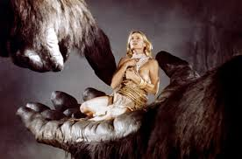
The giant arm of King Kong holding Jessica Lang

Additionally, at the end of the original version a police officer remarks to Carl Denham that the planes got him and Carl Denham replies back "Oh, no, it wasn't the airplanes. It was Beauty killed the Beast." There is no famous last line in the new version.
Also in the original version King Kong battle a Tyrannosaurus, Elasmosaurus and Pteranodon and in the remake (the 1976 version) the only creature King Kong battles is a snake. Further analysis on the 1976 King Kong’ version reveals that the difference between these two versions of the King Kong story is mainly, the special effects capabilities of the production during that period. The 1933 version is a stop motion animation puppet while the 1976 version is a man dressed in a gorilla suit. The King Kong genre (1976 version) describes as the evolution of motion picture special effects tools when re-portraying the same story.

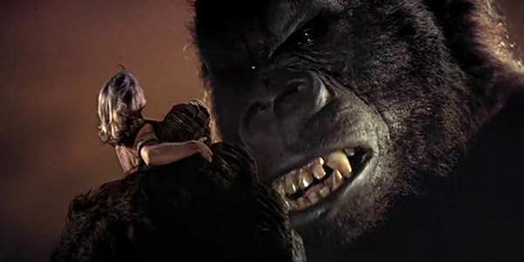
This face of the King Kong depicts lovely mood and friendship between Kong and Jessica

Additionally, the Kong’s eye emotion is real and genuine. His body movements and gestures in response to the movie characters and surroundings make the viewing experience more convincing helped by forced perspective and some film compositing. Humans naturally respond to and identify with something real. The following part is King Kong (2005).

KING KONG (2005):

The 2005 version of King Kong takes the old story (1933 and 1976), with a few twists and polishes it with special effects that create the most human, the most believable, King Kong to date. Aspiring and desperate actress Ann Darrow (Naomi Watts) accepts a role offered by the producer Carl Denham (Jack Black) who promises her exotic travels aboard the ship he has procured.
However, there is some controversy with what happens between Ann and Kong. In the original (1933), Kong is a monster and even though he is fascinated with Ann, she is terrified of him from when she first lays eyes on him to the finale.
In this film and the 1976 version there is a connection with Ann and Kong, in the 1976 version it looks like senseless and comes across campy, but in 2005 version it seems very believable because Kong is an intelligent creature, an ape, not a monster.
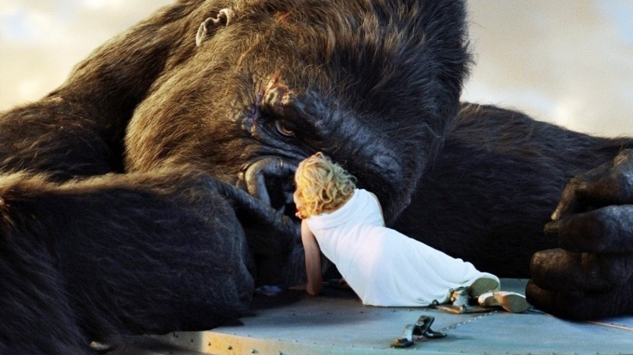
King Kong and Ann are in the deep compassion mood with everyone needs each other.

Ann's sentiments for the ape are more like 'compassion' than 'love'; understanding of the divided nature of that giant creature, on the human side of sentience in many ways, yet constrained to be something else because of what he is.

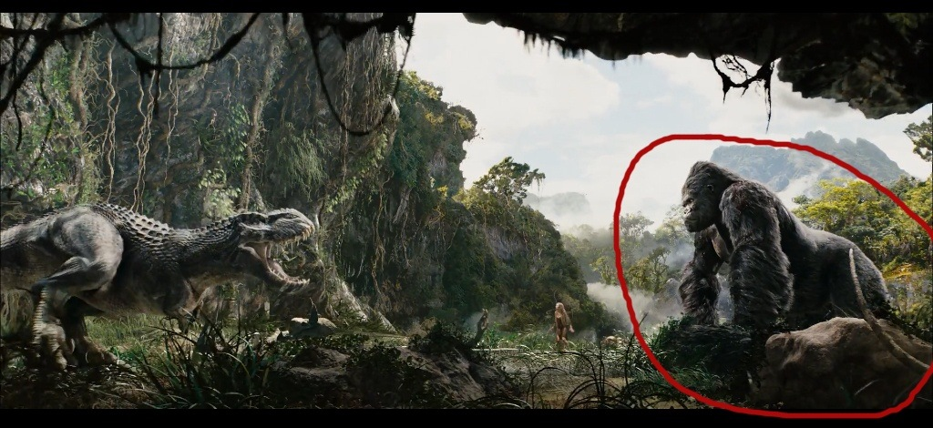
The fighting scene between King Kong and dinosaur – the part appears in original version of King Kong (1933)

Kong's human mirror-image, driven by the same instincts, but here they are constrained by his civilized upbringing. He is not a fighting machine, but a playwright-yet everything he does, shortly after meeting Ann, is essentially driven by the same motives as King Kong's: to protect her.
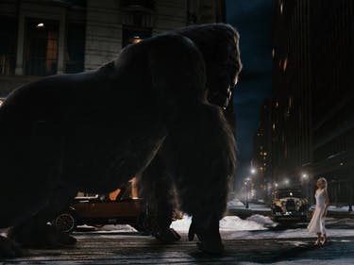
King Kong holds the street of New York in favour of Ann
He does not understand this at first; civilization and its essentially trivial accessories prevent him from seeing that which truly matters to him. But in the end, after the ape has fallen to his death, he's at the top of the Empire State Building with her. That is where Kong ends, and it is a very emotional scene. That said, the relationship between Ann and Kong is terrific. Kong's emotions seem real. His eyes aren't quite life-like, but they are trying to be.
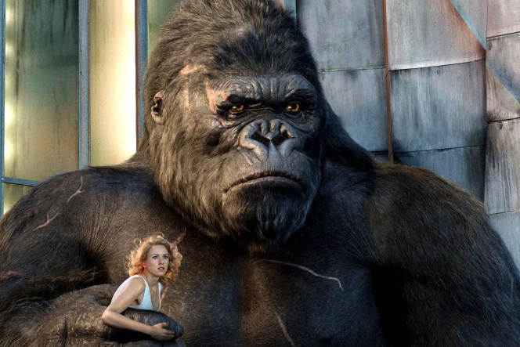
The sense of belonging mood – King Kong holds Ann in a possession atmosphere

The special effects are well done (in this 2005 version) and can live up to expectations, especially the ones for Kong but not so much the dinosaurs. Regardless this new (2005) edition of a classic tale of ‘Beauty and the Beast’ has a level of emotion the classic 1930s version lacked.
Further, in this film you can certainly attention about Kong as more than a monster, but as an intelligent creature that just wants to be left alone. Further, they make Kong look so real, as you think that they found a giant gorilla on an abandoned island. Although this is not true, they do make him believable. They are also other bugs and jungle scenes throughout the movie that are very realistic. The following part is King Kong: Skull Island (2017).

KING KONG: SKULL ISLAND (2017):

This is the update of the King Kong story returns to the 1970s, just at the end of the Vietnam War. Like the 1976 King Kong, which used the story primarily as a symbol for the increasing environmental movement, Kong: Skull Island explores both the impact of Vietnam syndrome on the military establishment and a growing awareness of the fragility of ecosystems.
This new take on the classic Kong story sees a group of scientists recruit a military escort to help them reach Skull Island. The scientists secretly believe that large prehistoric creatures live on the island and they quickly learn how right they are.
The military incursion quickly draws the anger of Kong, who serves as the would be protector of the island, and scatters the exploration. The survivors, on the other hands have to walk across the island to their extraction point while fending off attacks from the cruel wildlife, all while the military commander sees killing Kong as his chance at the improvement and glory.
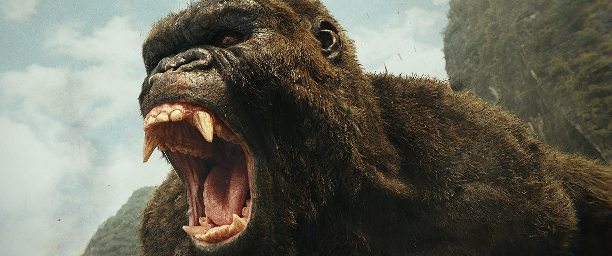
King Kong shows his kingship and the defender of the Skull Island.
Thus, Kong Skull Island gives another look at the big, bad ape. This time were stranded on the island and at the sympathy of Kong and other brutal creatures. Unlike the earlier versions, this Kong is ruler and beauty will not bring down this beast.
There are some great actions scenes and facial expressions that makes believe this ape is for real. Kong is both ruler of this island and its defender, saving the human invaders as well as attacking them when they provoke him.
While Kong is front and center in his cruelty, Kong Skull Island shows that there is more to his nature than just destruction. However, there are brief hints at his gentler side. That makes this monster less one-dimensional and more appealing.
Analytically, there are differences from the original King Kong (1933) to Kong: Skull Island: The original was a straight up jungle adventure movie that turned into a three-way romantic triangle with King Kong being given heart and motivation in his clinging to, protecting, and ultimately dying for Ann Darrow.

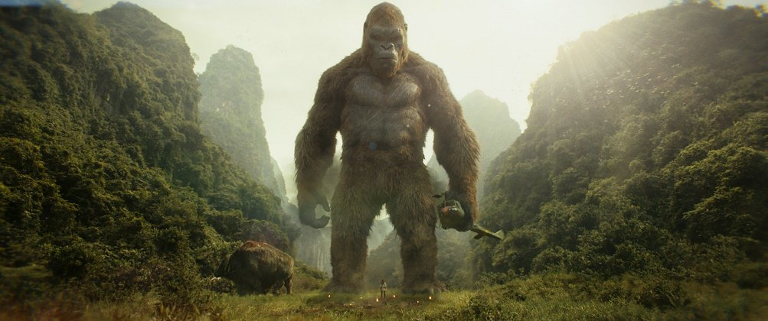
King Kong holds a helicopter on his hand showing his restless in the protection of the Skull Island
Kong: Skull Island has no romantic inclinations but he is given heart by way of being discovered to be an orphan, a youngling still growing but overseeing and protecting his world, from the monstrous occupants of Skull Island and curious but painful man and their machines. He has empathy and oversight for the gentler inhabitants of Skull Island but shows himself a fearsome fighter against the threatening and shocking skull crawlers.
In King Kong (1933) Kong delivered the beat down to many prehistoric monsters and thus demonstrated his kingly title. In Kong: Skull Island he is not yet king but instead is its prince. His parents have been killed and his reign is challenged. He is on his way to becoming king and though he does not battle with as many monsters but he displays his heart, his courage, and his ingenuity.
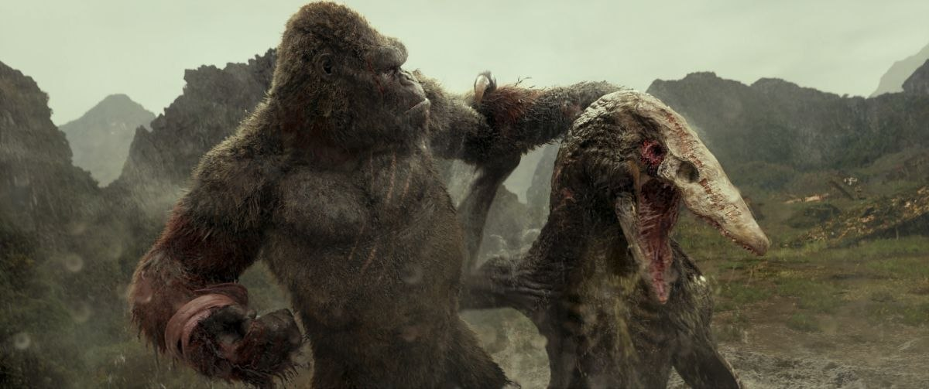
Kong tears apart the gigantic, razor-sharp jaws of the dinosaur

Thus, Kong: Skull Island may have outdone itself in probably in every believable way. Not only, Kong: Skull Island is a fantastic rousing adventure but also it is a timely stamp on one of the most divisive periods in America’s history though it exists as a fiction. It combines fascinating human conflict and challenges.

CONCLUSION:
The popularity of the character King Kong as one of the world's most famous movie icons diverges as having inspired a number of sequels, remakes, spin-offs, imitators, parodies, cartoons, books, comics, video games, theme park rides, and a stage play. His role-model in the different narratives varies, ranging from a rampaging monster to a tragic antihero. This is reasoning of the story ideas, story and the emerge of the development of new technology.
Willis O’Brien in the King Kong, the original version of 1933 focused on the technology at that time which is low on the modern days (2017) of Harry Hausen’s technology. To make sure the production is perfect, Willis before coming making the actual King Kong he looks into facts and fictions, the technology designed was difficult but he managed to use clay motion and stop motion which was useful at that time.
The technology changes can be vividly seen in the King Kong (1976) and King Kong (2005). But the maturity and the modern days’ technology used in the Kong: Skull Island (2017), high advanced technology and soft wares with graphical effects that makes the King Kong movies attract number of audiences.
To sum up, King Kong movies are among the better movies that not only develop but also developing according to time, the means the changing face of King Kong probably will re-make accordingly depending on the story nature and technology concerned.

Bibliography:
Bancroft, T; Glen, K (2006). Creating Characters with Personality: For Film, TV, Animation, Video Games, and Graphic Novels. Watson-Guptill.
Broberg G, Roll-Hansen N, (1996) (ed.) Eugenics and the Welfare State: Sterilization policy in Denmark, Sweden, Norway, and Finland: East Lansing: Michigan State University Press.
Goldner, Orville; Turner, George E. (1975). The Making of King Kong: The Story Behind a Film Classic. A.S Barnes and Co. Inc.
https://www.fxguide.com
https://www.massivesoftware.com
Homer, W (1794) The Odyssey of Homer: Bryant- Dover Publication (UK)
Hutson, M (2012). The 7 Laws of Magical Thinking: How Irrational Beliefs Keep Us Happy, Healthy, and Sane. New York: Hudson Street Press.
JK Rowling (2014) Chamber of Secrets: Bloomsbury (UK)
Kevles, D (2010) Eugenics and Human Right (in) https://literarydevices.net/anthropomorphism/
Lasseter, J (July 1987). "Principles of Traditional Animation applied to 3D Computer Animation". ACM Computer Graphics.
Lennklo, D (2010) Anthropomorphic animals in commercials: Why fake animals tell good stories (in) https://literarydevices.net/anthropomorphism/
Lord, P; Sibley, B (1998). Creating 3-D animation: The Aardman Book of Filmmaking. New York: Harry N. Abrams.
Maltin, L (2006). Leonard Maltin's Movie and Video Guide (2007 ed.). New York: Plume.
Mark, T (1903) A Dog’s Tale: Harper and Brothers (USA)
Mattesi, M (2002). Force: Dynamic Life Drawing for Animators, Second Edition. Focal Press.
Morton, R (2005). King Kong: The History of a Movie Icon. Applause Theater and Cinema Books.
McLaren, A (1990) Our Own Master Race: Eugenics in Canada, 1885-1945. Toronto: McClelland and Stewart.
Orwell, G (1945) The Animal Farm, London: Penguin Group.
Osipa, J (2005). Stop Staring: Facial Modeling and Animation Done Right (2nd ed.). John Wiley & Sons.
Rudyard, K (1894) Jungle Book, McMillan: UK
Sibley, B (2000). Chicken Run: Hatching the Movie. New York: Abrams.
Sito, T (2013). Moving Innovation: A History of Computer Animation. Massachusetts: MIT Press.
Smith, M (November 11, 2016). "Kong: Skull Island unleashes exclusive first look at the movie monster'". Entertainment Weekly.
Van Hise, J (1993). Hot Blooded Dinosaur Movies. Pioneer Books Inc.
Vaz, Mark Cotta (2005). Living Dangerously: The Adventures of Merian C. Cooper, Creator of King Kong. Villard. ISBN 1-4000-6276-4.
Whitaker, H; John, H (2002). Timing for Animation. Focal Press.

