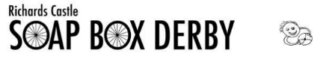
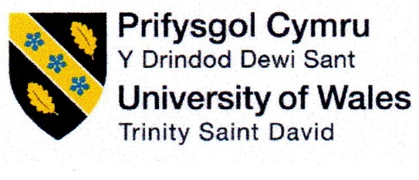

Module Code: M4X01506
Integrating Project
Assignment 1

Richard’s Castle Soapbox Derby

Team Don’t drop the soap…box

Written by:
Evan Morcom (1802426)
Sam Johns (1804234)
Lloyd John (1802396)
Ben Gilbert (1801217)
Joseph McKay (1804886)
Lewis Aubrey (1802539)

Intro
For this project, our team name is ‘Don’t drop the soap…box’. The task at hand is to design, create and compete in a ‘soapbox’ style car. We will be working as a team to complete the project whilst adhering to Richard’s Castle soapbox derby regulations.
For our first meeting we set out to delegate tasks to each team member and familiarise ourselves with the regulations of the competition.
Chassis: Ben Gilbert and Sam Johns
Suspension: Evan Morcom and Lewis Aubrey
Steering: Lewis Aubrey and Evan Morcom
Brakes: Lloyd John and Joe Mckay
Wheels: Joe Mckay and Lloyd John
Body and aero: Sam Johns and Ben Gilbert

We have created a Gantt chart to help out with us with keep on track with our project and make sure we complete the project before the deadline, here is our chart;
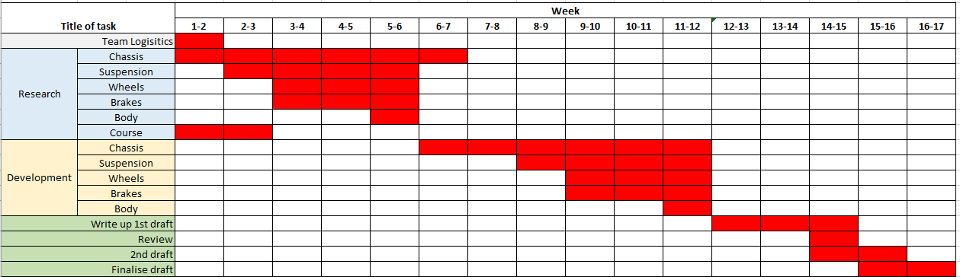

Suspension

Design 1 (REALISTIC, SMALL BUDGET)
Front suspension

For our realistic build, we will adopt the rubber cone suspension design, this style of suspension was used on classic Mini’s from the late 1950’s all the way to 2001. The suspension the team will be using on our soapbox, unfortunately will just be for comfort purposes not giving us an advantage with grip. The soapbox is gravity powered and won’t weigh much, so any moving parts will cost us time and potentially a place on the podium.
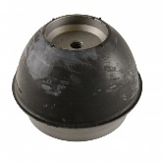
Originally, we looked into solid mounting the whole soapbox so no movement in any of the kart apart from cushioning the seat for driver comfort. The reason we turned away from this is because after seeing course previews and other kart course runs, solid mount karts tend to have a hard time on the corners as they would bounce and skip across the narrow track and affectively lose grip and time.
We as a team, are hoping with a little bit of give in the suspension, we can minimise our kart from skipping and keep the tyres on the floor the whole way down the course. We will have to create a bump stop to guarantee the kart doesn’t compress too much and hits the floor or goes captive and have a hard impact when under compression again.
We have decided we are going to use a springer spindle but with a rubber cone as cushioning. The common method is to use a C or U shape piece of metal however your alignment is then fixed, we will be using rose joints as we can adjust how much we pull in or push out the thread, therefore adjusting camber easily and cheap.
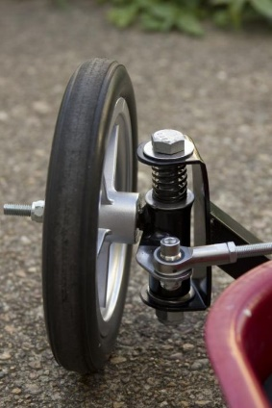
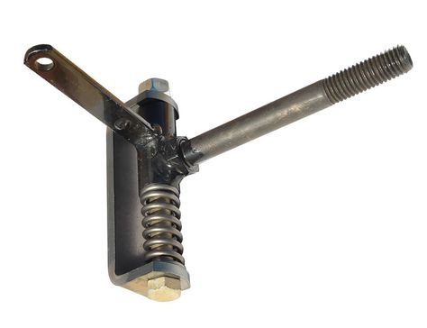

https://www.gopowersports.com/springer-spindles/
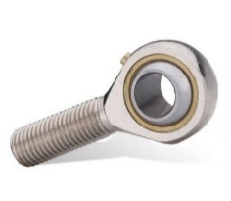
https://www.pinterest.co.uk/pin/748371663054194851
https://www.amazon.co.uk/SAKAC-Bearing-Bronze-Thread-Economy/dp/B01D8W4LFQ

Rear suspension

The rear suspension will use the method as the front with the differences being, on the upright there will be no mount for a track rod end for the steering. However, there will be a Post mount bracket tab for our hydraulic brakes to attach.

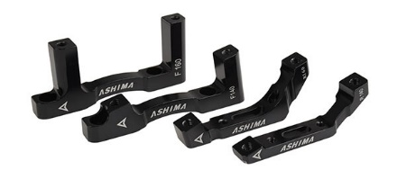
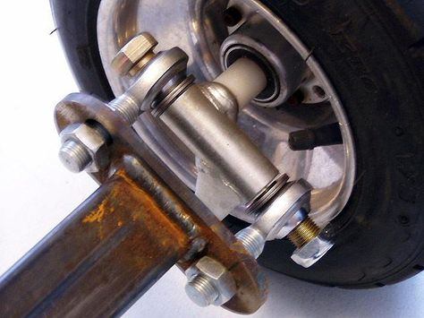

https://fairwheelbikes.com/ashima-flat-post-disc-brake-adapter/
http://www.diygokarts.com/vb/showthread.php?t=13891

Materials for suspension
For the materials on the budget setup, we will be using mild steel box section and mild steel plate. We have chosen this as it’s cheap and readily available. Mild steel is easier to weld compared to aluminium. Also the main chassis is going to be made with mild steel, therefore, we can weld the suspension directly to the chassis rather than nut and bolt method.

Design 2 (EXPENSIVE, NO BUDGET)
Front suspension
Double wishbone;
We will be using a double wishbone set up on the front of our soapbox, this style of suspension has been tried and tested by many race teams and commercial manufacturers. This style uses two control arms, an upright or steering knuckle and a suspension strut (coil over). By adjusting the length of the two control arms, you can adjust the camber and changing the mounting point of the upright, you can adjust the caster, toe will be adjusted with the track rod end.
There are many different style of setting these double wishbone style suspension, car manufacturers tend to form pieces of metal and have a solid piece of material as shown below;

This is from a Mazda MX5 suspension and is front upper control arm;
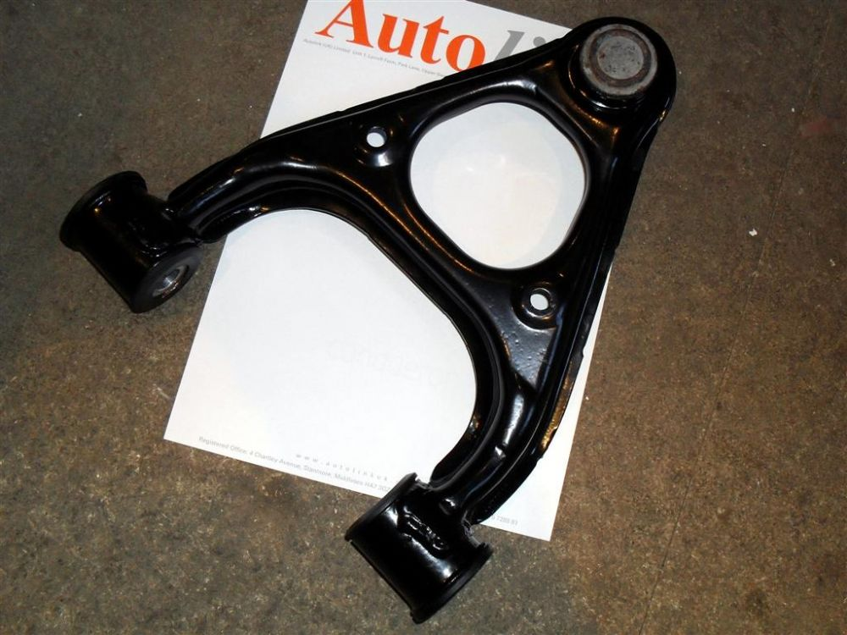

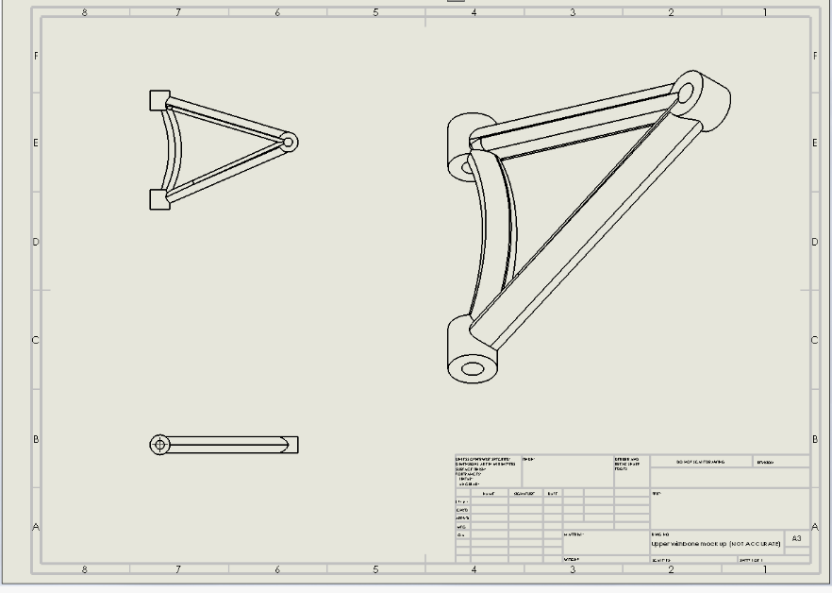
Our soapbox will be using a tubular control arms, this is a sketch that we made on Solidworks;

Steering

In this project we have been tasked with coming up with three individual designs on different price points, in this section I will discuss our budget design that is simple and cost effective.
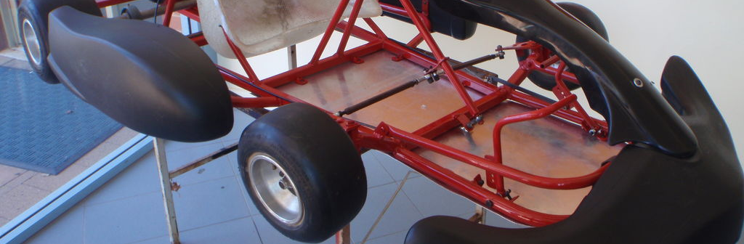

In the image above we will replicate this and using two tie rods attached to a pivot, this will allow direct steering and instant response. We will design and fabricate a steering column using to ideal length which is dependent on the driver’s height and preference. At the top of the steering column we have decided to use a very small steering wheel which will be a welded T piece onto which will mount the brake lever. At the point of contact on the pivot point which bolts both tie rods together we will use a rubber bush to reduce harshness and vibrations throughout the soapbox.

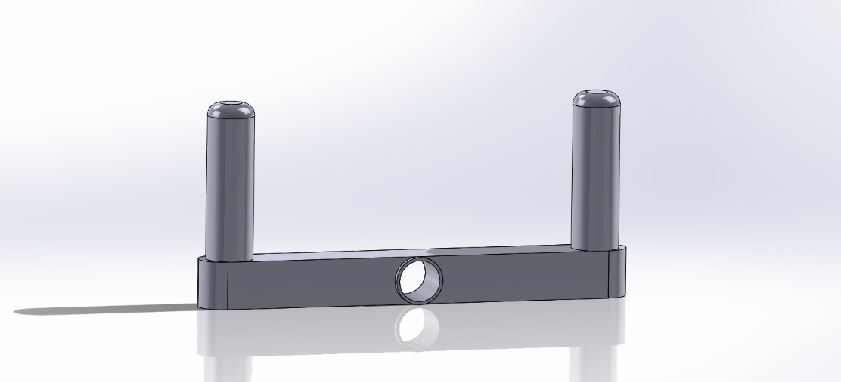

In this method we are going to fabricate a mounting point on both stub axles to mount the tie rod ends onto, we will bolt the ends onto a rose joint system for strength and durability.
The benefits to using this system are that it is a very simple design that is also cost effective, this will allow us to stay within our budget for the build.
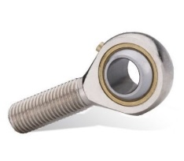
Here is a similar rose joint that will bolt into the tie rod, this will the bolt onto the mounting point on the axle.
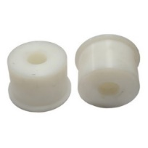
This is similar to the rubber bushing that we will use on the pivot, this will eliminate any harshness in the steering.

For our mid-range design I have decided to use the same layout and design as the budget setup, this is because the setup is ideal for the purpose its intended for, the main difference I will implement is using a higher quality material. After thoughts I decided to use a more expensive T45 aluminium, this is because it is still durable but is significantly lighter, this would be very beneficial for the soap box due to keeping the total weight to a minimum. This may give us an edge over any competitors still using steel.
This would remain our design but would be fabricated using T45 aluminium.
This is similar to the tubing we would use, it is 6061 T6 tubing which is aircraft grade aluminium, and this is more expensive than mild steel but will be a significant amount

Wheels and Brakes

Our group have been set a challenge, to design a soap box car. Three of the most important things about kart racing are going, handling and braking. In this templet we have researched many products to see which will be best for our kart.
To start we have decided to use push bike wheels we were think of use 26inch mountain bike wheels to have a higher rolling speed. However we came to realise that they wouldn’t be very good handling wise. Therefore we decided to use BMX rims to improve handling because we would have a lower centre of gravity.
BMX wheels are very strong and light but one of the main reasons we choose BMX wheels because of its shape of the tyre. The tyre will be very similar to a motorbike tyre. When a motorbike in running in a straight line it would be using minimum surface area, however when the bike will bank into a corner It will use much more surface area of the tyre. This what we are trying to replicate.

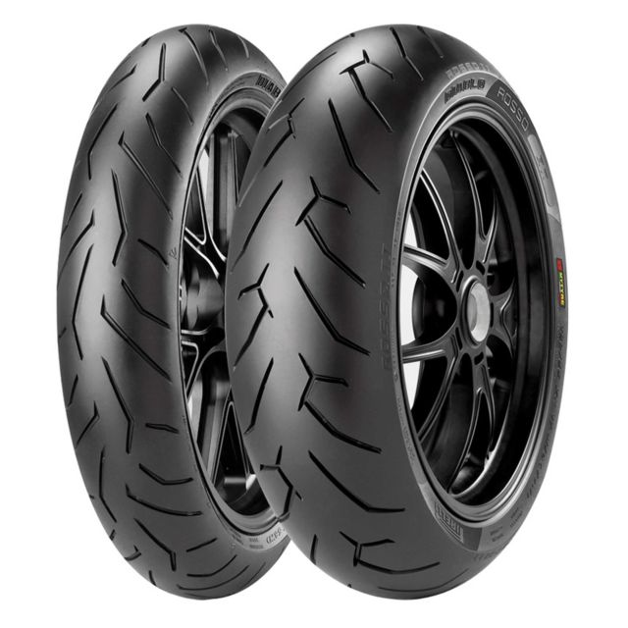
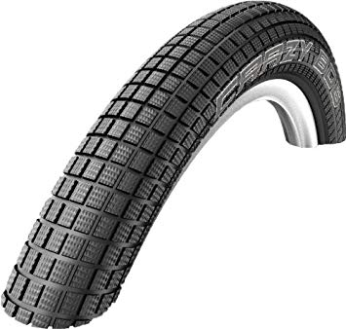

For tread pattern we decided not to go for a semi-slick tyre mainly because we simply wouldn’t get the tyre hot enough for it to grip. We decided to use a crazy bob tyre. This tyre is best suited for the terrain we will be racing on. They are fast rolling and have high grip.
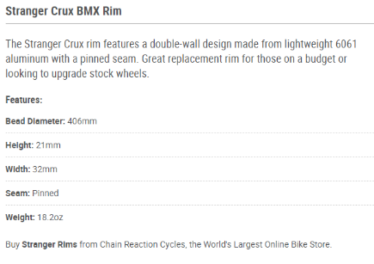
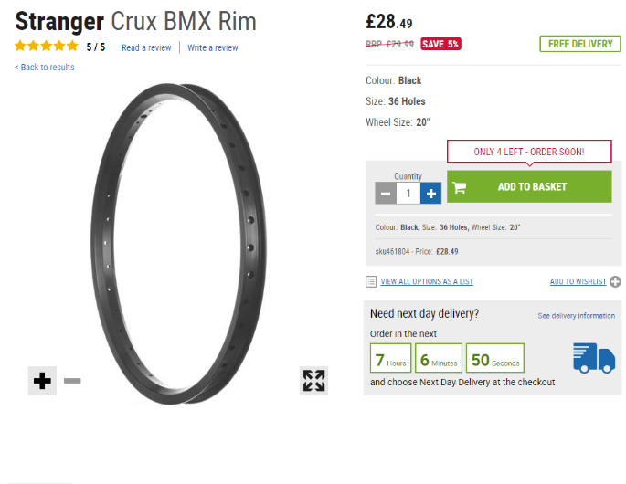

For our front rims we are using a 20inch stranger crux BMX rim. It is a very basic rim but very strong, is it a fairly narrow wheel 32mm therefore we won’t suffer from heavy steering.

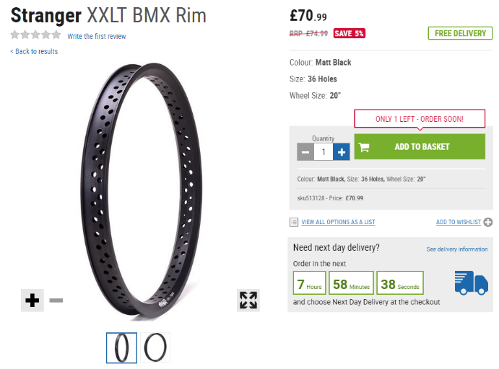
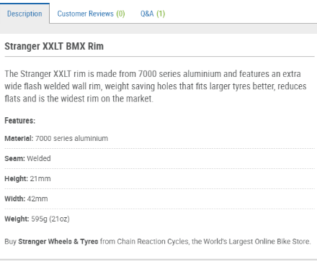

For the rear we’ll be running stranger XXLT they are a much wider wheel with a width of 42mm. the benefits of this wheel are the width for extra grip and the weight of the wheels. They only weigh 21oz they cut the weight by drilling holes in the wheels but still keeping the rim strong.

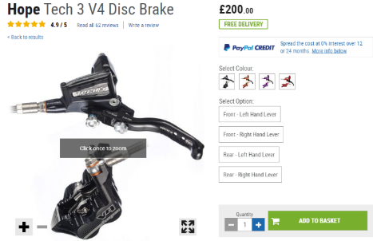
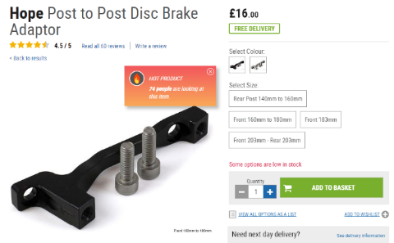
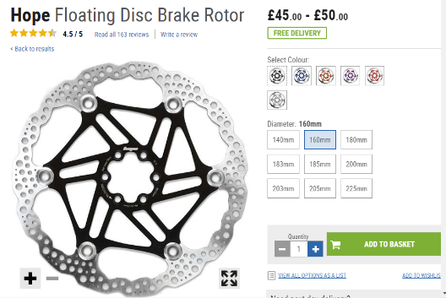
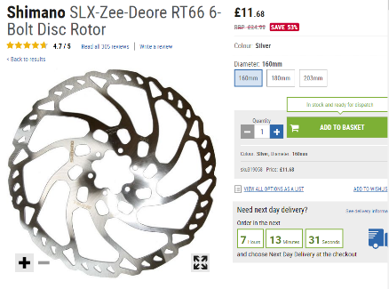
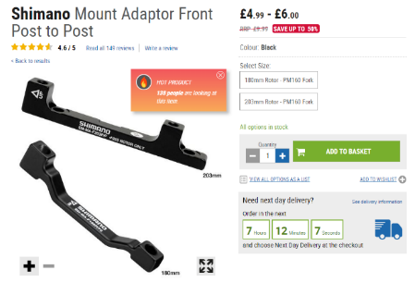
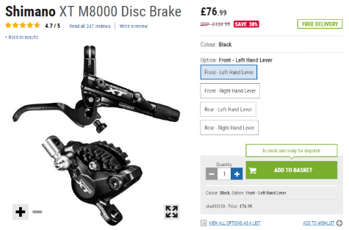
For our high end braking setup we will be using the Hope Tech 3 V4 disc brake setup. This is similar to the Shimano setup that we have used in the budget setup however is a much better part. The hope setup will be able to provide the best possible braking power from a mountain bike hydraulic setup. The hope system uses a 4 piston design meaning that the calliper can provide a huge amount of stopping force. It also has adjustable bite point meaning it can be tailored to the users personal preference.
Along with the hope setup, we are using the matching hope post mount to allow us to remove the calliper to service or repair the calliper.
For our brake discs, we are using the hope floating disc setup (225mm). By using a floating type brake disc it allows the user to easily and quickly swap out worn discs. The large 225mm size of the disc also helps to provide massive braking force whilst also being able to dissipate heat efficiently.
Richard’s castle soapbox track is a reasonably steep downhill course in which you gain a fair amount of speed. This means that the braking system is important for our safety and to help the soapbox to get round tight corners.
We have decided for our budget setup to run a Shimano XT m8000 pre bled hydraulic disc brake setup. This mid-range part has plenty of braking power for our application as well as being easy to implement thanks to it being a pre bled, ready to install system. Although there are cheaper systems on the market we decided that due to the braking system being such an important part of the soapbox that it would be best not to cheap out on the brakes.
Along with the XT callipers, we have a Shimano post-to-post disc brake adapter that will be used to mount the calliper to our chassis whilst also allowing the calliper to be removed easily for servicing or repairs.
For the brake disc we have decided to use a Shimano RT66 6 bolt disc (160mm). This is ideal for our budget setup as it is very cheap yet has all the features and quality required for our application. It also has the correct bolt pattern to match our wheel hubs.

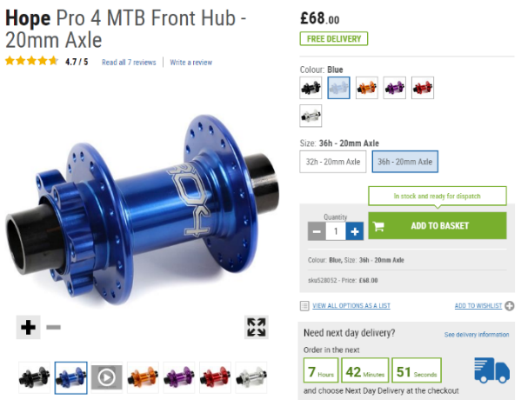
For our wheel hub we are using the Hope Pro 4 front hub. We are using this part as it has a unique hollow axle design meaning that we can bolt it to our steering system. This would not be possible with a conventional male axle style front hub. It also uses a 36 hole design meaning that our wheel will be strong enough to cope with the forces that it will encounter on our soapbox runs. As well as allowing us to mount our wheel to our chassis, this hub has built in mounting holes for our brake discs meaning we will not have to fabricate a bracket separately.

Chassis
Chassis research:
Types of chassis considered for the project:
- Space frame
- Ladder frame
- Monocoque

Space frame Analysis:
The space frame chassis was originally developed from 1898-1908 by Alexander Graham Bell based on his invention of the Tetrahedral truss. The space frame was intended by Bell for use in nautical and aeronautical engineering to make rigid frames.
The main benefits of the spaceframe chassis are strength/rigidity, the fact that they are lightweight and the versatility of the design. A space frame is made up of interlocking struts in a geometric pattern.
The space frame takes the natural strength of an equilateral triangle, when pressure is applied to the point at the top the two sides connected to the point compress naturally, but are given stability by the bottom leg that prevents further collapse of the shape. (Truitt, unknown).
The space frame would be good for our application as it would create a structurally rigid chassis while also keeping the weight down. Space frames are used in many lightweight performance cars such as the Ariel Atom and MEV Exocet.
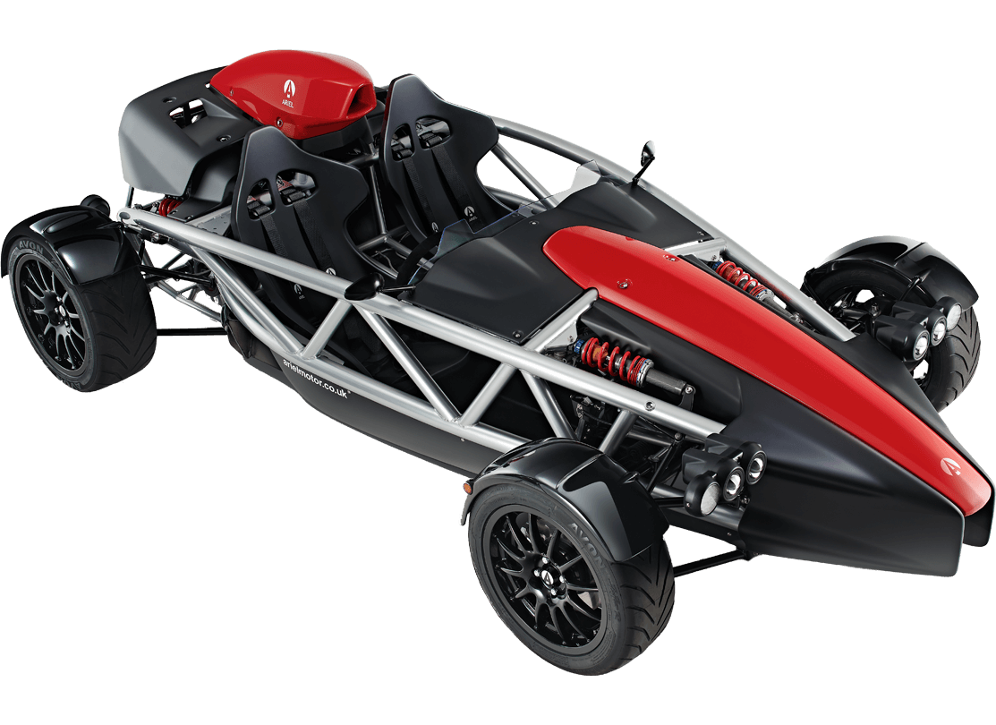
The Ariel Atom 4 (pictured) shows perfectly how triangulation is used in an automotive space frame chassis.
Available at: https://www.arielmotor.co.uk/atom/overview/ (2019)
One downside to the space frame is that it encloses many of the mechanical components of a vehicle which can inhibit access. Another possible issue is that a space frame chassis requires either MIG or TIG welding to assemble. This can be a time consuming and difficult process with TIG welding producing better results but requiring far more time and skill.
Ladder Frame Analysis:
A Ladder frame chassis consists of two main chassis rails running parallel with the length of the vehicle and then two or more smaller beams perpendicular to the chassis rails connecting the two sides together. The construction roughly resembles that of a ladder which is where the name comes from. The ladder frame chassis has been used in automotive design since the early days of the car, examples include the Ford Model T. The ladder frame was used as it was simple to construct which meant the cars could be made cheaper and therefore sold cheaper as well. The simplicity of the ladder frame has led to it being used in many vehicles since and the design is still being used in cars today, such as the 2019 Suzuki Jimny.
A ladder frame is tough and great for carrying heavy loads for an extended period. A ladder frame vehicle sits higher off the ground. This makes it susceptible to torsional flexing, otherwise known as leaning through the corners. (Horn, 2017)
This may not seem like a brilliant design for a soapbox racer, however the ladder frame design was also the basis of early go kart chassis’. This particular design of kart chassis is still being used today in the form of ‘yard karts’. Yard karts are popular in America as they can be easily assembled from kits and then enjoyed in the wide open spaces available to many people. Therefore if this design can be used effectively in a go kart then it should be transferrable to a soapbox racer.
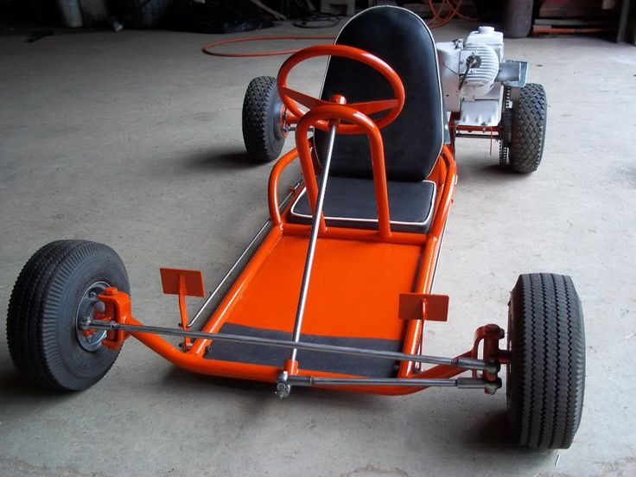
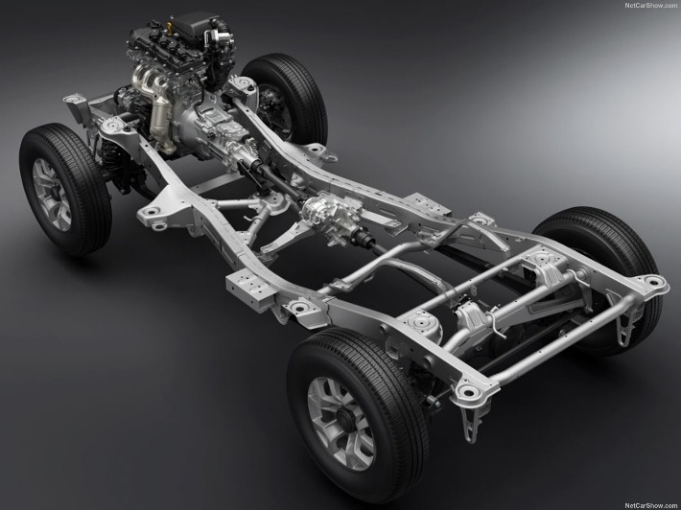
Example of an American ‘yard kart’
Available at: http://sciencereengineered.com/manco-go-kart-parts/manco-go-kart-parts-new-152-best-karts-amp-creations-images-on-pinterest/ (2019)
2019 Suzuki Jimny uses a ladder frame chassis
Available at: https://www.pakwheels.com/blog/suzuki-jimny-2019-one-step-closer-launch/ (2019)

Monocoque Chassis Analysis:
The monocoque design was originally developed in the aeronautical industry, the first aircraft to adopt this design was the 1912 Deperdussin Monocoque. This aircraft was constructed from poplar veneer that were laminated and glued together forming an outer shell which also doubled up as a main load bearing component. This negated the need for a separate structure to bear the load of the outer aerodynamic shell which massively reduced the weight of the aircraft. It wasn’t long before this technique was adopted by car manufacturers and in 1922 Lancia launched the Lambda, the first production car to feature a monocoque chassis. It took a while for the design to really catch on; in the 1960’s the design was developed to become the ‘Unit body’ or Unibody as it’s more commonly known. Unibody is slightly different from a true monocoque as the structural integrity is provided by tubes and bulkheads rather than the actual skin of the vehicle.
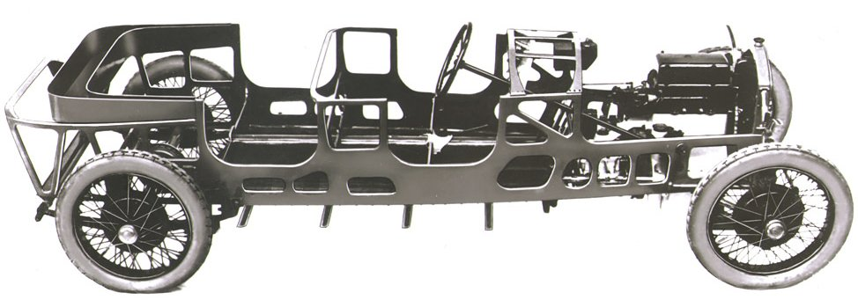
Lancia Lambda, the first production car to feature a monocoque chassis
Available at: https://www.google.com/url?sa=i&source=images&cd=&cad=rja&uact=8&ved=2ahUKEwiL1oW9gIfgAhWLt1kKHSjaBwcQjRx6BAgBEAU&url=https%3A%2F%2Fsimanaitissays.com%2F2013%2F10%2F11%2Flancia-lambda%2F&psig=AOvVaw3mYbqRDAkutMVtgybjpfYp&ust=1548439394515537 (2019)

In the world of motor racing monocoque chassis cars were pioneered as early as 1915 when Harry Blood campaigned the Carnelian at Indianapolis. However the biggest development came in 1962 when Colin Chapman came up with the Lotus 25. Chapman started with a tub just wide enough to fit a driver made out of box section, the box section was then filled with rubber bags to hold fuel. At the hands of Jim Clark the Lotus 25 went on to dominate the Formula 1 world championship in 1963 taking a record number of race wins at the time and prompting other manufacturers to adopt the monocoque chassis.
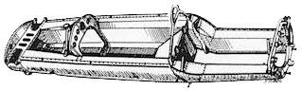
Lotus 25 monocoque chassis
Available at: http://www.grandprixhistory.org/lotus25.htm (2019)

In the world of soapbox racers carbon fibre monocoque chassis’ have been used to create some of the fastest, lightest and most aerodynamic racers. Companies such as Bentley and McLaren took part in a gravity racer challenge at Goodwood in 2000 creating incredible vehicles to send down the famous Goodwood hill climb course. Many of these racers used carbon fibre or fibreglass monocoque construction. However while this method would create an amazing chassis for our project it would not be an economically viable option. Furthermore it would be incredibly difficult to fabricate a monocoque chassis with the equipment we have access to.

Conclusion:
From this research we decided that we would use a Space frame chassis for our realistic design as it is cost effective without compromising handling, weight or rigidity. For our budget design we would use the ladder frame as our base as it is the cheapest and easiest to construct design. Finally for our ‘money is no object’ unrealistic design we would use the monocoque as it will create the ultimate gravity racer but will also be well out of reach from a cost and manufacturing point of view.

Chassis Designs:

Low Budget chassis:
For our low budget design we went with a design similar to the ladder frame. The chassis is first comprised of a rectangular frame made out of box section steel. The corners are joined by welding the lengths of box section together after the two parts have been cut at a 45° angle. This will improve the strength of the frame and will also look more aesthetically pleasing than welding the end of the main rails to the side of the cross members. From here two more cross members are added in to stiffen the chassis and mount the steering column support and roll bar into place. These will also serve as extra mounting points for the aluminium floor pan which will be bolted or riveted in place from the underside of the chassis. The cross members will be made out of the same box section steel and will be welded straight to the frame rails. The rear axle will be mounted on top of the box section. We chose to do this as cutting a hole in the box section would compromise rigidity and mounting the axle underneath would affect ground clearance. The axle will be mounted through two pillow block bearings, one on each frame rail. At the front the steering knuckles will be mounted to tabs welded onto the outside of the frame rails. The steering column will be connected at the bottom to another tab mounted on the inside of the front cross member. At the top the column will be held in place with the steering bush from a go kart whoch in turn will be bolted to a support structure made out of box section welded to the second cross member. The seat will be bolted to two flat steel rails welded to inside of the frame rails. Behind the seat sits the roll bar which again will be made out of the same box section steel; it will be welded to the top of the frame rails in line with where the third cross member is welded in. The roll bar will be constructed in the same way as the main chassis frame with 45° angle welds for added strength, it will reach ()mm above the drivers head as per the regulations.

The figure below shows the sketches of the design.

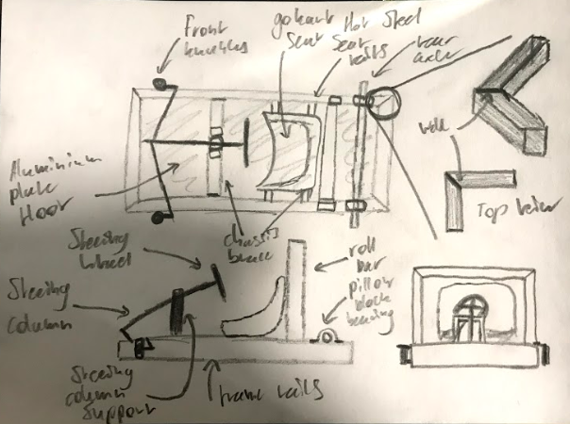

High Budget Chassis:
For the high budget design we decided that a carbon fibre monocoque was the way to go as it is light weight, rigid and would negate the need for a separate aerodynamic body. The monocoque design means that all suspension components bolt directly to the chassis. Whereas the steering column support would have to be mounted to a small aluminium tube frame bolted to the monocoque. We decided against fitting a rear axle as it wouldn’t be needed, this is because we decided that this design should have a disk brake on each corner rather than a single brake on the rear. The lack of an axle would also save weight and improve the cornering capabilities of the racer. The mandatory roll hoop will be made out of bent aluminium tube bolted to the monocoque. For this design I took inspiration from the gravity racer that Guy Martin used to break the world record for a gravity powered vehicle.
The figure below shows the sketch of the high budget chassis.
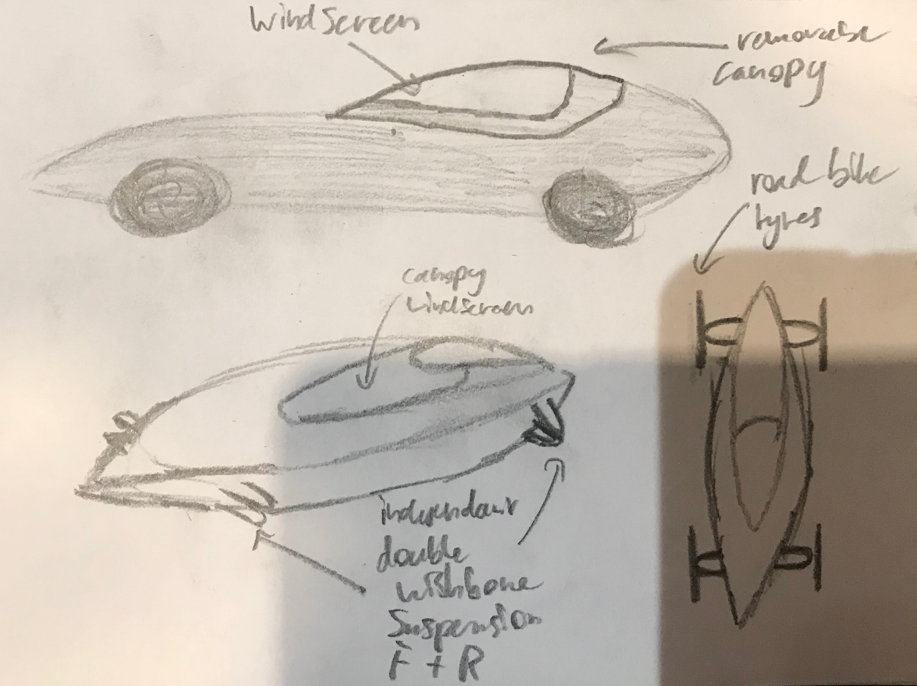

Realistic design:
Last but by no means least is our realistic design, this would be the one that we carry forward. Therefore it will need to be cost effective as well as being able to perform on the track. For this reason we decided that a space frame design would be best because it would be possible to manufacture on our budget and is also one of the best options in terms of chassis strength and rigidity. The spaceframe design is also lightweight due to the large amounts of open space between the tubes that make it up.

Body and Aero
The main purpose of the body on the soapbox is to cover any sharp areas and deflected the air off any areas of major resistance. Therefore the aero side of the body is not that important as we won’t be reaching high enough speeds for any aerodynamic parts to take effect. For this reason the body needs to be lightweight, cheap and easy to make.
The first design we explored was using polythene stretched over the chassis. This will create a light weight, cost effective body that can easily be stretched over the chassis and clamped into place while also providing enough wind deflection to make the racer aerodynamic.
The second idea we explored was using fabric and resin. This idea came from Bad Obsession Motorsport project binky where they used lycra sheet and resin to create wheel arches for the car. Upon further investigation we found that other soapbox racers use a similar design using duvet covers stretched over the chassis and then hardened with resin. The final finish gives the bodywork a fibreglass like appearance while being significantly lighter and much easier to fabricate. We think that this would create a much more aesthetically pleasing design than the polythene and would also allow us to paint the body.

Conclusion
To conclude and reflect on our work, we as team are pleased with how our designs have turned out. However, we are very aware we have plenty of room for improvement to develop our design and team skills. There is still a lot of work to be done before we have a finished product but we believe that we have solid groundworks for a good soapbox racer to carry forward.

Meeting Recordings

Meeting 1 – 3/10/18
Meeting starts in y Fforwm at 11:04am
Plans to allocate jobs roles for each team member has been proposed. 11:06am
Discussing what jobs roles are needed to complete task. 11:08-11:15am
Allocating job roles to each team member. 11:16-11:23am
General discussion about what the team wants for a final product for the project so we can set a target. 11:24-11:32am
Recapping meeting highlights. 11:33-11:35am
Meeting 1 ends. 11:36am

Meeting 2 – 15/10/18
Meeting starts in IQ Building at 12:48pm
Announcement that the meeting will be short and will only be a checkup. 12:50pm
Each team member showed and discussed their progress made within the role given. 12:51-1:04pm
Everyone is happy with each other’s progress made and had decided we are on target for completion. 1:06pm
Recap on meeting and decision is made to continue working the way we are. 1:08pm
Meeting 2 ends. 1:09pm

Meeting 3 – 05/11/18
Meeting starts in Y Ffowrm at 11:29am
Group update once again as this week is “project week”. 11:30-11:36am
Setting targets to be achieved during project week. 11:37-11:40am
All team members are happy and are ready to continue working. 11:41am
Meeting 3 ends. 11:42am

Meeting 4 – 19/11/18
Meeting starts in Y Fforwm at 3:02pm
Team discussing and gives feedback of progress made during “project week”. 3:05pm
Team members present all work created up to date, report is coming together professionally. 3:06-3:28pm
Existing sections that are still to be completed are being discussed and how they are going to be tackled. 3:29-3:34pm
Everyone now knows we have made excellent progress but there is still work to be done. 3:36pm
Team decides we will not have another meeting until after holidays and will come back together in the New Year.

Meeting 5 – 05/01/19
Meeting starts in Y Fforwm at 10:00am
Team reunites after Christmas holiday and has general discussion. 10:01-10:09am
Team discusses and recaps on work completed since meeting 4. 10:10-10:18am
The team realized the report is very near completion and has decided it only needs ‘tidying up’. 11:19 -11:21am
All team members decide to call meeting off and complete report. 11:22am
Meeting 5 ends 11:24am – Report is completed by late afternoon.

References
Reference list:
Truitt, B (unknown) Study available at: https://study.com/academy/lesson/space-frame-definition-structures-design.html (Accessed: 21st November 2018)

Horn, G (2017) Leisure wheels Available at: https://www.leisurewheels.co.za/blogs/ladder-frames-monocoques/ (Accessed: 21st November 2018)

