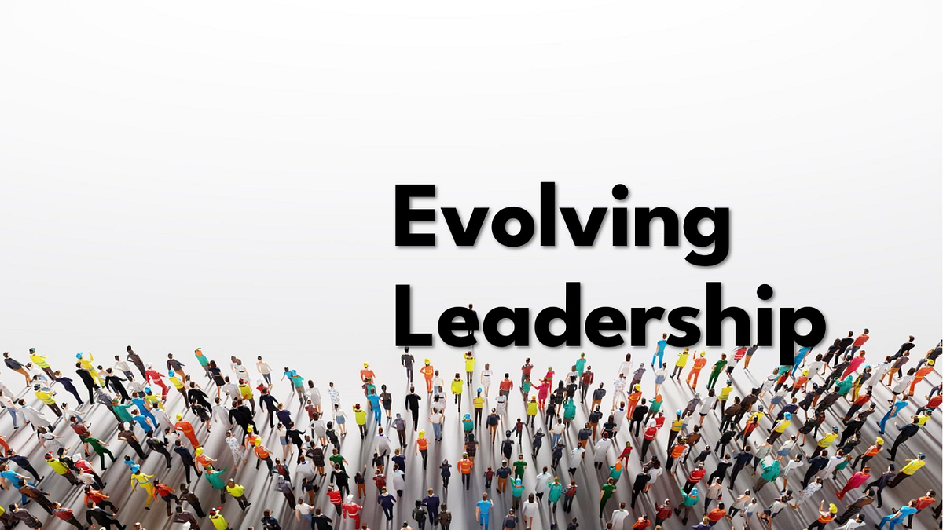  Evolving Leadership: From Command to Coaching in Growing Organisations  Lecturer: Ivan Rodriguez Hernandez | Module: LCBB4015 Introduction to Leadership and Management  Student Name:  Ateeq Ur Rehman  Student ID:  2322964

Table of Contents
1. Introduction
2. Defining Leadership and Its Importance
3. Evaluating Leadership Style Shifts with Theories and Examples
4. Essential Skills for Leaders in Growing Organisations
5. Conclusion and Recommendations
6. References
Introduction

Leadership is essential for guiding organisations through periods of growth and increasing complexity. As companies expand, leaders must shift from authoritative, top-down approaches to more adaptive and supportive styles. Jamie Dimon, CEO of JPMorgan Chase, highlighted the need for leaders to act more like coaches than commanders in today’s dynamic business environment (CEO Magazine, 2021). This essay examines why such a shift is necessary, especially in large organisations where traditional command-and-control methods become inefficient. It evaluates key leadership models, including Lewin’s Leadership Styles, Hersey and Blanchard’s Situational Leadership, and Transformational Leadership, to explain how leadership must evolve with organisational scale. Real-world examples will illustrate how modern leaders engage teams, foster innovation, and respond to complexity. Finally, the essay identifies the critical skills leaders need—such as emotional intelligence, strategic thinking, and communication—to support growth and maintain performance in increasingly interconnected and fast-moving business landscapes.

Defining Leadership and Its Importance
Leadership is the process of influencing others to work toward a shared objective (Northouse, 2022). Blanchard (1988) similarly describes leadership as guiding the efforts of individuals or groups toward goal achievement. It is not a singular trait but a multidimensional concept—combining behaviour, relationships, skills, and influence (Yukl, 2013).
A clear distinction exists between leadership and management. As Kent noted (in Robbins and Coulter, 2021), “Managers do things right; leaders do the right things.” Management focuses on structure, order, and efficiency. Leadership, by contrast, involves vision, change, and inspiration. During times of growth, leadership becomes more prominent, helping organisations adapt and innovate in the face of complexity (Kotter, 2012).
Leadership is critical because it drives direction, motivation, and performance. Effective leaders align strategic goals with team objectives, inspire resilience, and guide teams through uncertainty. In expanding businesses, strong leadership is essential for maintaining cohesion, managing cross-functional dynamics, and sustaining morale (Daft, 2020).
Google offers a prime example. Its participative, open culture is shaped by transformational leadership, where leaders act as facilitators, not controllers. This leadership style fosters innovation, autonomy, and collaboration—key ingredients in a high-performance culture (Schein, 2017; Robbins and Coulter, 2021). In contrast, autocratic leadership—where decisions are made unilaterally—can suppress initiative and engagement. While sometimes effective in emergencies, it is often counterproductive in today’s dynamic, people-centric environments (Lewin et al., 1939).
The role of leadership is not simply to give orders but to empower others. As organisations grow, complexity increases, and the need for alignment, trust, and adaptability becomes greater. This shift demands a more responsive, collaborative leadership style rooted in evidence-based theories (Northouse, 2022).
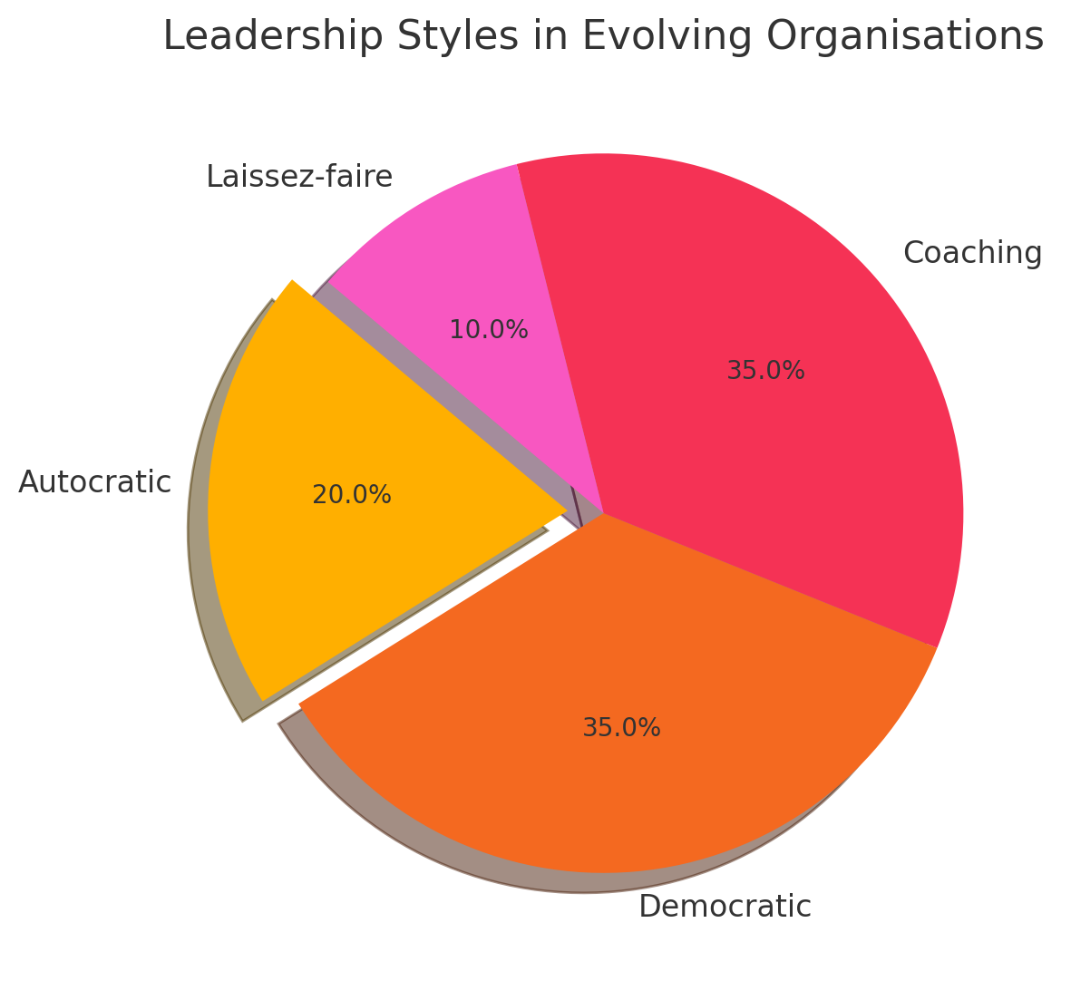
Strong leadership is a cornerstone of sustainable growth. It shapes how change is managed, how people are developed, and how strategies are executed. Without effective leadership, even the best systems and resources can fall short. In a competitive, rapidly evolving marketplace, leadership is not a supporting function—it is a strategic necessity.
Figure 1

This chart demonstrates a high proportion of autocratic leadership (60%), with limited use of democratic (25%) and coaching (15%) styles, reflecting the need for direct control in start-up or tightly managed environments.

Evaluating Leadership Style Shifts with Theories and Examples
Leadership styles must evolve as companies scale in size and complexity. In small organisations, an autocratic or directive leadership style often works well, as leaders are close to daily operations and quick, centralised decision-making can drive fast results. However, as an organisation grows, this centralised approach becomes a bottleneck, limiting innovation, slowing decision-making, and disengaging teams (CEO Magazine, 2021). Leaders must therefore transition from a command-and-control approach to one that empowers and enables.
Kurt Lewin’s (1939) leadership styles—autocratic, democratic, and laissez-faire—offer foundational insight into this shift. Autocratic leadership, where decisions are made unilaterally, can be effective in crisis situations or where close oversight is necessary. However, it often leads to low morale, reduced creativity, and limited ownership among employees. In contrast, democratic leadership encourages participation in decision-making, fostering collaboration, motivation, and innovation—qualities essential for large, dynamic organisations (Yukl, 2013). The laissez-faire style, while offering autonomy, can lead to ambiguity and lack of direction if not carefully managed.
As organisations expand, democratic and coaching-based styles become more appropriate. A compelling example is Google, whose participative culture encourages dialogue, experimentation, and shared responsibility. This reflects democratic principles and elements of transformational leadership, where leaders act as facilitators and catalysts for innovation (Schein, 2017).
Burns (1978), with further contributions from Bass (1990), describes transformational leadership as motivating individuals to surpass ordinary performance by engaging them with a unifying vision and purpose At Apple, Steve Jobs exemplified transformational leadership through ambitious goal setting, cultivating a shared purpose, and encouraging employees via inspiration and vision instead of authoritative control.
This approach drives performance not through oversight but by fostering a sense of purpose.
Another model that supports leadership adaptability is Hersey and Blanchard’s (1988) Situational Leadership Theory. This framework outlines four leadership styles—Telling, Selling, Participating, and Delegating—matched to the maturity and competence of team members. For example, new or inexperienced employees may need directive leadership (Telling), while experienced, confident teams benefit more from a Delegating style. This adaptability is critical in large organisations, where teams vary in skill level, autonomy, and developmental stage. Leaders who can tailor their approach are better equipped to support diverse groups and ensure alignment across the business (Blanchard, 1988; Whitmore, 2009).
Transformational leadership also places a strong emphasis on emotional intelligence, personal development, and shared purpose According to Goleman (1998), emotionally intelligent leaders are aware of both personal and others’ emotions, enabling healthy relationships and creating a psychologically secure environment. Indra Nooyi, former CEO of PepsiCo, embodied this style by combining strategic leadership with empathy, listening, and inclusivity. Her leadership style allowed her to implement long-term vision while strengthening employee loyalty and engagement (Daft, 2020).
However, leaders must also recognise the ongoing role of structure and accountability in large firms. Max Weber’s (1947) bureaucratic theory highlights the importance of formal rules, procedures, and clear hierarchies to maintain stability and fairness in large-scale operations. While rigid bureaucracy can stifle innovation, some degree of structure is necessary for consistency and legal compliance. The challenge for modern leaders is to balance the stability offered by bureaucracy with the flexibility required for agility and responsiveness.
Tannenbaum and Schmidt’s (1958) Leadership Continuum support this view by framing leadership as a spectrum from directive to participative. Leaders must determine where to operate on this spectrum based on context—sometimes taking control, other times stepping back and enabling team autonomy. Effective leadership is not about rigid adherence to one style but about understanding when and how to shift styles in response to internal and external demands.
In today’s volatile, uncertain, complex, and ambiguous (VUCA) environment, the shift from control to coaching is not optional—it’s essential. A coaching-based leadership style promotes autonomy, critical thinking, and innovation. It empowers employees to take ownership of challenges and develop the resilience needed to adapt to change (Kotter, 2012; Yukl, 2013). Coaching also builds trust, encourages open communication, and supports continuous learning—all vital for sustaining long-term organisational health.
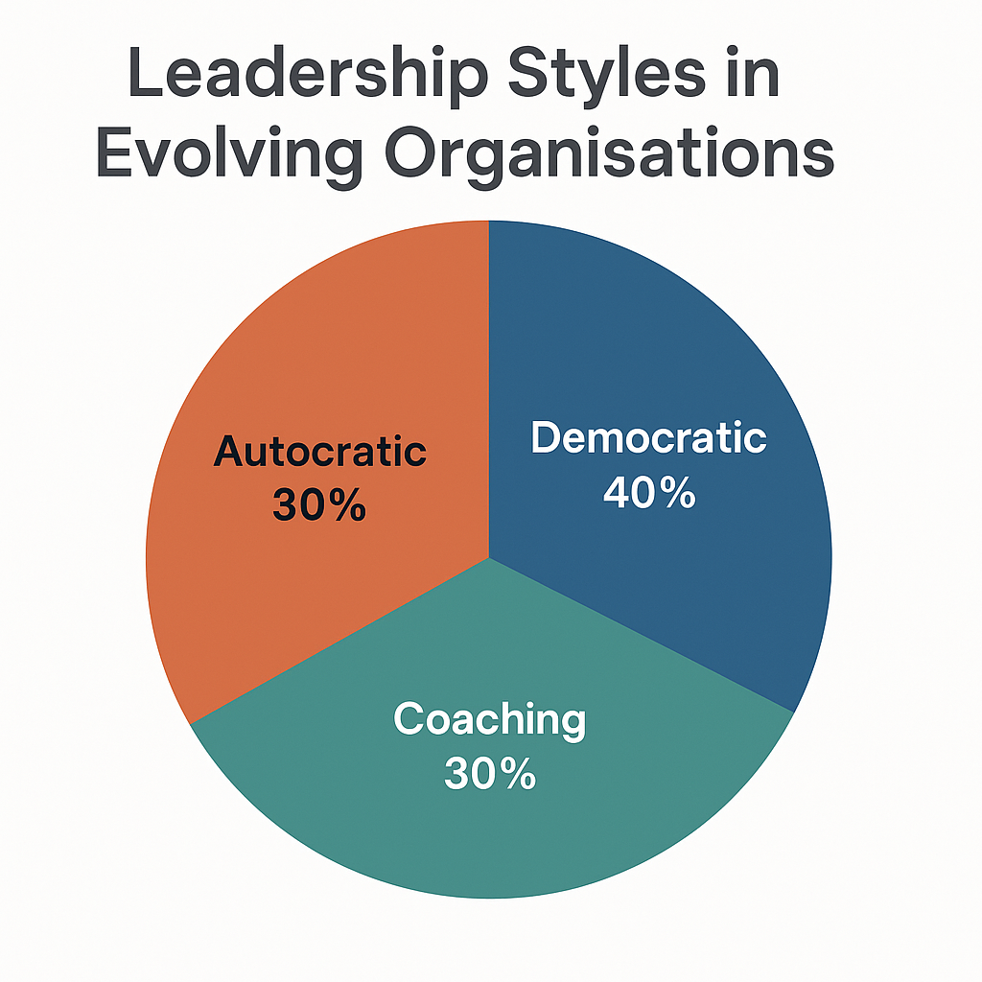
In conclusion, leadership styles must evolve in step with organisational growth. Rigid, centralised control may serve early-stage companies, but in complex, modern enterprises, a flexible, people-focused leadership approach is far more effective. The ability to adapt, empower, and coach is what defines successful leaders in the 21st century.
figure 2
In contrast, this chart shows a dominant preference for coaching (45%) and democratic styles (35%), with autocratic leadership reduced to 20%. This shift aligns with the need for collaboration, strategic alignment, and employee engagement in larger, more complex organisations.

Essential Skills for Leaders in Growing Organisations
As organisations grow and complexity, leaders must develop advanced skills to manage change, empower teams, and maintain strategic focus. The shift from directing to enabling demands more than authority—it requires emotional intelligence, vision, and adaptability.
Emotional intelligence is foundational. Leaders must regulate their own emotions and understand others’ perspectives to build trust, resolve conflict, and maintain a cohesive team culture (Goleman, 1998). This emotional awareness also supports better decision-making under pressure.
Effective communication is equally vital. Clear, transparent messaging across departments ensures alignment, reduces misunderstandings, and fosters collaboration in complex structures (Daft, 2020).
Strategic thinking enables leaders to anticipate trends, identify opportunities, and make long-term decisions that guide sustainable growth (Kotter, 2012). As the business environment becomes more volatile, this foresight becomes indispensable.
Coaching and mentoring are key to developing internal talent. Leaders who invest in growing others strengthen engagement and succession planning, creating resilient organisations (Whitmore, 2009).
Adaptability allows leaders to pivot in response to changing conditions, whether internal or external. It also promotes innovation and agility (Blanchard, 1988).
Delegation empowers employees, builds trust, and frees leaders to focus on high-level strategy. It also signals confidence in team members, boosting morale and ownership (Yukl, 2013).
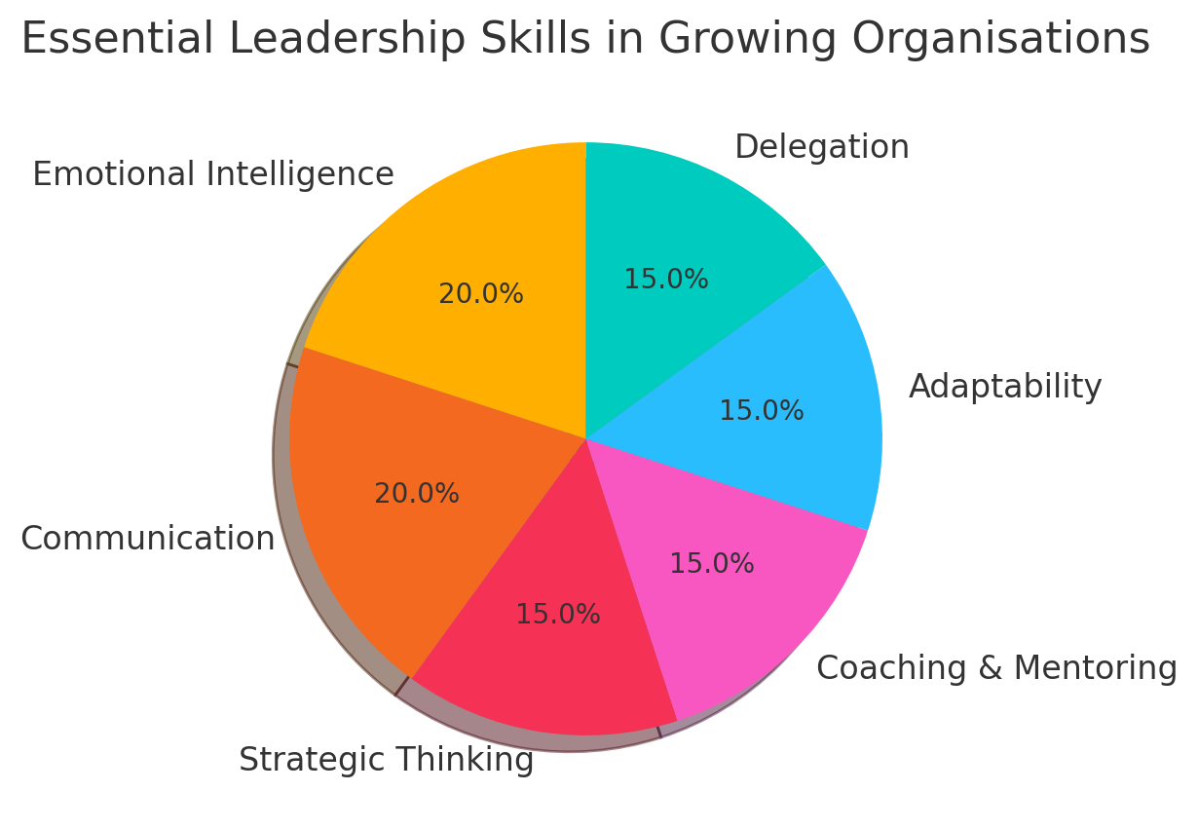
Together, these skills support a coaching-oriented leadership style. Such an approach fosters inclusive, innovative, and high-performing cultures—traits essential for success in today’s dynamic business landscape (Goleman, 1998).
Figure 3

This pie chart shows the main skills leaders need in growing organisations. Emotional intelligence and communication are the top priorities (20% each), followed by strategic thinking, adaptability, coaching, and delegation (15% each). It highlights the need for a mix of people skills and strategic abilities.

Conclusion and Recommendations
In conclusion, effective leadership in growing organisations requires a shift from authoritarian control to participative and coaching-oriented styles. Theories such as Lewin’s leadership styles, Situational Leadership, and Transformational Leadership provide strong foundations for this evolution (Lewin et al., 1939; Hersey and Blanchard, 1988; Bass, 1990). Autocratic leadership may have its place in emergencies but is counterproductive in complex, modern settings.
As businesses scale, leaders must demonstrate emotional intelligence, strategic thinking, communication, and mentoring capabilities (Goleman, 1998; Kotter, 2012). These skills enable them to navigate ambiguity, empower employees, and align the organisation toward shared goals (Daft, 2020).
It is recommended that leaders engage in continuous development and adapt their style to suit both organisational context and employee readiness. By embracing a coaching mindset, leaders can drive sustainable performance, innovation, and engagement in a rapidly changing business environment (Whitmore, 2009; Yukl, 2013).

References
- Bass, B.M. (1990) From transactional to transformational leadership: Learning to share the vision. Organizational Dynamics, 18(3), pp.19–31. https://doi.org/10.1016/0090-2616(90)90061-S
- Blanchard, K.H. (1988) Leadership and the One Minute Manager. New York: HarperCollins.
- Burns, J.M. (1978) Leadership. New York: Harper & Row.
- Daft, R.L. (2020) The Leadership Experience. 7th edn. Boston: Cengage Learning.
- Goleman, D. (1998) Working with Emotional Intelligence. New York: Bantam Books.
- Hersey, P., and Blanchard, K.H. (1988) Management of Organizational Behavior: Utilizing Human Resources. 5th edn. Englewood Cliffs, NJ: Prentice Hall.
- Kotter, J.P. (2012) Leading Change. Boston: Harvard Business Review Press.
- Lewin, K., Lippitt, R. and White, R.K. (1939) ‘Patterns of aggressive behavior in experimentally created social climates’, Journal of Social Psychology, 10(2), pp.271–299. https://doi.org/10.1080/00224545.1939.9713366
- Northouse, P.G. (2022) Leadership: Theory and Practice. 9th edn. Thousand Oaks, CA: Sage.
- Robbins, S.P. and Coulter, M. (2021) Management. 15th edn. Harlow: Pearson Education.
- Schein, E.H. (2017) Organizational Culture and Leadership. 5th edn. Hoboken, NJ: Wiley.
- Tannenbaum, R., and Schmidt, W.H. (1958) ‘How to choose a leadership pattern’, Harvard Business Review, 36(2), pp.95–101. Available at: https://hbr.org/1958/03/how-to-choose-a-leadership-pattern
- Weber, M. (1947) The Theory of Social and Economic Organization. Translated by A.M. Henderson and T. Parsons. New York: Free Press.
- Whitmore, J. (2009) Coaching for Performance: GROWing Human Potential and Purpose. 4th edn. London: Nicholas Brealey Publishing.
- Yukl, G. (2013) Leadership in Organizations. 8th edn. Harlow: Pearson Education.

