Problem
Analysis and Solution
Development

Module Name: Analysing and Solving Problems
Module Code: ACCA 4019
Student Name: Olga Kozmenko
Student ID: 2335644
Group:2
Lecturer’s Name: Dr Redhwan Al-amri

Table of Contents
Table of Contents 1
1. Introduction 2
2. Deconstruct the Problem 2
2.1 MoSCoW Technique Requirement 2
2.2 Variables Identification 3
3. Proposed Solution 4
3.1 Flowchart 4
3.2 Flowchart Explanation 4
4.Reflection and Justification 5
4.1 Abstract thinking 5
4.2 Sub-dividing 6
4.3 Justification of solution 6
4.4 Limitation 6
4.5 Assumption 6
5.Conclusion 7
6.References 7

Introduction
A local college is struggling to manage its classrooms effectively. Some rooms are overcrowded, while others stay empty for most of the day. This leads to timetable clashes and wastes time for both staff and students who have to move between classes.
This report looks at why the problem occurs and suggests a practical solution. The MoSCoW technique is applied to identify what the solution must do. A flowchart is used to show the logical steps of the approach. The problem-solving methods used are also discussed and reflected upon.

Deconstruct the Problem
When looking at the classroom allocation problem more closely, it becomes clear that it cannot be traced back to one single cause. The issues seem to build on each other — a wrong assumption at the data level leads to a flawed rule, and that flawed rule leads to a poor outcome in practice.
When breaking the problem down, a few recurring issues stand out. First, room loads are unbalanced: large groups are placed in small rooms, while small groups occupy large spaces. Second, timetable conflicts occur due to overlapping time slots and double bookings. Third, movement logistics are not considered — transitions between buildings are too long and travel time is not included in the schedule. Fourth, the scheduling process relies on human decisions, which introduces subjectivity and inconsistency. Finally, there is no centralised system, meaning that changes are not synchronised across departments [6].

MoSCoW Technique Requirement
To figure out what the solution actually needs to do, the MoSCoW technique was applied [1]. This method divides requirements into four categories and helps to focus on what is truly necessary before moving to the design stage.

Category | Requirements
Must have | Room capacity must be matched to group size. Time conflicts must be eliminated. Each group must be assigned to one room per time slot. A central scheduling system must be used.
Should have | Travel time between classes should be minimised. Room equipment (such as projectors or laboratories) should be considered. The schedule should be easy to update when changes occur.
Could have | Teacher preferences could be taken into account. Room usage analytics could be provided. Automatic notifications could be sent to staff and students when changes are made.
Won't have | Full personalisation for individual students is not included. Manual exceptions made for personal convenience without system justification are excluded from this solution.

Variables Identification
Variable | Description
N_rooms | Total number of available rooms in the college
Capacity_room | Maximum number of students each room can accommodate
N_groups | Total number of student groups requiring a room
Size_group | Number of students in each group
Time_slots | Available time intervals in the weekly timetable
Equipment | Room requirements such as projectors or laboratory facilities
Location | Physical position of each room within the building
Transition_time | Time required for students and staff to move between rooms
Teacher_availability | Time periods when each teacher is available to teach
The following variables were identified as relevant to the solution. Each one represents a piece of information that the scheduling algorithm needs to make correct decisions.

3. Proposed Solution

3.1 Flowchart
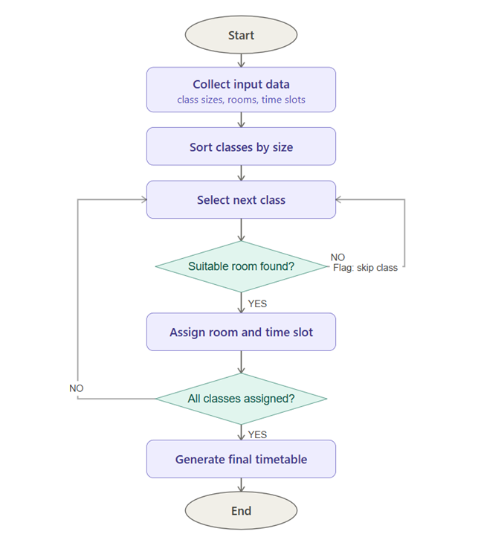

3.2 Flowchart Explanation
The flowchart shows a step-by-step process for allocating rooms to classes. It is built around two decision points. The first checks whether a suitable room is available for the selected class, based on capacity, time slot, and equipment. The second checks whether all classes have been processed. Together, these two checks make sure that every class is considered and that no room is booked twice.
The approach addresses the three main issues from the problem scenario. Overcrowded rooms are avoided because only rooms with enough capacity are selected. Underused spaces are reduced because the largest groups are placed first, leaving smaller rooms for smaller classes. Timetable conflicts are prevented through the availability check, which ensures no room is assigned to two classes at the same time.

Step 1 Collect input data. The process starts by gathering all the information needed: a list of student groups and their sizes, a list a rooms with their capacities and equipment, and a list of available time slots. Getting this data right matters a lot - if the room capacities or group sizes are wrong from the start, every decision the algorithm makes afterwards will be based on faulty information [2].
Step 2 Sort classes by size. All classes are arranged from the largest group to the smallest. Large groups have fewer rooms that can fit them, so they need to be placed first. This ordering reduces the number of conflicts and makes the whole process more efficient [3].
Step 3 Select next unscheduled class. The algorithm picks the first class from the sorted list that has not yet been assigned a room. This step repeats each time the loop runs, until all classes have been handled.
Step 4 Check for a suitable room. This is the main decision point. The system looks for a room that meets three conditions: the capacity must be equal to or greater than the group size; the room must be free at the required time; and the room must have the right equipment if needed. If all three conditions are met, the class moves to the assignment step.
Step 5 Flag unschedulable class. If no suitable room is found, the class is flagged and the algorithm moves on to the next one. Flagged classes are listed separately so that a member of staff can review them manually. This keeps the algorithm running without stopping when no match is available.
Step 6 Assign room and time slot. Once a suitable room is confirmed, the class is assigned to it. The room is immediately marked as occupied for that time period so that it cannot be booked again.
Step 7 Check completion. After each assignment, the system checks whether any classes are still unscheduled. If there are, the loop goes back to Step 3. This continues until every class has either been assigned or flagged.
Step 8 Generate final timetable. When all classes have been processed, the system produces the final timetable showing each class, its room, and its time slot. This output can be shared with staff and students.

4.Reflection and Justification

Abstract thinking
Working with abstract thinking was something that took a little time to understand at first. The initial instinct was to think about specific rooms and specific timetables, which made everything feel very complicated. Once the focus shifted to only the essential properties - capacity, group size, time slot, and equipment - the logic became much clearer. Removing the physical details made it easier to see the underlying rules. It also became clear that the same algorithm could work in a different college with very little adjustment, which shows the value of keeping the model general [4].

Sub-dividing
Dividing the problem into three layers — resources, demand, and constraints — was probably the most useful step in the whole process. Before doing that, the problem felt like one big issue with no obvious starting point. Once each layer was separated, it became possible to work on one part without losing track of the others [5].
The constraints layer turned out to be the trickiest to define. Some constraints are strict — for example, a room cannot hold more students than its stated capacity. Others are more flexible, such as teacher preferences. Deciding which was which helped clarify what the algorithm actually needed to enforce.

Justification of solution
A greedy algorithm was chosen mainly because it is straightforward to follow and does not require specialist software. Whether a more complex optimization approach might give better results was considered, but given the scope of this task, the greedy a method seemed the more realistic choice. Sorting groups from largest to smallest before allocation is a simple idea, but it makes a real difference — larger groups are harder to place, so dealing with them first reduces the number of conflicts later [3].

Limitation
One thing noticed while building the flowchart is that the algorithm always produces some output, but it cannot guarantee that the output is the best possible arrangement. If a large group is placed in a room that would have suited two smaller groups better, the algorithm does not go back and reconsider. That is the main trade-off of a greedy approach [2].
Movement between rooms was also harder to include than expected. To do this properly, the physical layout of the building would need to be known, which adds complexity that goes beyond a simple scheduling algorithm. Teacher preferences and fixed room bookings are also not fully incorporated, so some manual adjustment of the final output may still be needed [4].

Assumption
A few assumptions had to be made to keep the solution workable. The most important a one is that all input data is accurate. If a room is listed as having capacity for 30 students but actually fits 20 comfortably, the algorithm will not catch that error. Time slots are also assumed to be standardised and non-overlapping, which may not always be true in a college where some classes run longer than others. These assumptions simplify the model, but they are worth keeping in mind when thinking about how the solution would perform in a real setting

5.Conclusion
This report has looked at a classroom allocation a problem at a local college and proposed a structured solution based on a greedy algorithm. The problem was broken down using the MoSCoW technique, which helped to identify what the solution must do and what it can leave aside. A flowchart was designed to show the logical steps of the allocation process, and each step was explained in detail.
The proposed approach is practical and can be scaled up if the college grows. It addresses the three main issues identified in the problem: overcrowded rooms, underused spaces, and timetable conflicts. There are limitations, particularly around a data accuracy and movement between rooms, but the solution provides a clear and logical starting point for improving classroom management.

6.References
1. D. Clegg and R. Barker, Case Method Fast-Track: A RAD Approach. Wokingham: Addison-Wesley, 1994.
2. M. Pinedo, Scheduling: Theory, Algorithms, and Systems, 5th ed. New York: Springer, 2016.
3. S. Even, A. Itai, and A. Shamir, “On the complexity of timetable and multicommodity flow problems,” SIAM Journal on Computing, vol. 5, no. 4, pp. 691–703, 1976.
4. E. K. Burke and S. Petrovic, “Recent research directions in automated timetabling,” European Journal of Operational Research, vol. 140, no. 2, pp. 266–280, 2002.
5. R. Lewis, A Guide to Graph Coloring: Algorithms and Applications. New York: Springer, 2016.
6. G. Laporte, “The art and science of designing timetables,” Operations Research, vol. 53, no. 6, pp. 989–1004, 2005.

